UNITED STATES
SECURITIES AND EXCHANGE COMMISSION
Washington, D.C. 20549
FORM |  |  | 10-Q
(Mark One)
☒ QUARTERLY REPORT PURSUANT TO SECTION 13 OR 15(d) OF THE SECURITIES EXCHANGE ACT OF 1934
For the quarterly period ended March 31, 2025
OR
☐ TRANSITION REPORT PURSUANT TO SECTION 13 OR 15(d) OF THE SECURITIES EXCHANGE ACT OF 1934
For the transition period from ___________ to ____________
Commission File Number: |  |  | 1-11961
CARRIAGE SERVICES, INC.
(Exact name of registrant as specified in its charter)
Delaware |  |  | 76-0423828
(State or other jurisdiction of  incorporation or organization) |  |  | (I.R.S. Employer  Identification No.)
3040 Post Oak Boulevard, Suite 300
Houston, Texas, 77056
(Address of principal executive offices)
(713) 332-8400
(Registrant’s telephone number, including area code)
Securities registered pursuant to Section 12(b) of the Act:
Title of each class |  |  | Trading Symbol |  |  | Name of each exchange on which registered
Common Stock, par value $.01 per share |  |  | CSV |  |  | New York Stock Exchange
Indicate by check mark whether the registrant (1) has filed all reports required to be filed by Section 13 or 15(d) of the Securities Exchange Act of 1934 during the preceding 12 months (or for such shorter period that the registrant was required to file such reports), and (2) has been subject to such filing requirements for the past 90 days. Yes ☒ No ☐
Indicate by check mark whether the registrant has submitted electronically and posted on its corporate Web site, if any, every Interactive Data File required to be submitted and posted pursuant to Rule 405 of Regulation S-T (§ 232.405 of this chapter) during the preceding 12 months (or for such shorter period that the registrant was required to submit and post such files). Yes ☒ No ☐
Indicate by check mark whether the registrant is a large accelerated filer, an accelerated filer, a non-accelerated filer, a smaller reporting company, or an emerging growth company. See the definitions of “large accelerated filer”, “accelerated filer” and “smaller reporting company,” and “emerging growth company” in Rule 12b-2 of the Securities Exchange Act of 1934.
Large accelerated filer |  |  | ☐ |  |  |  |  |  |  |  |  |  |  |  |  |  |  |  |  |  |  |  |  | Accelerated filer |  |  | ☒
Non-accelerated filer |  |  | ☐ |  |  |  |  |  |  |  |  |  |  |  |  |  |  |  |  |  |  |  |  | Smaller reporting company |  |  | ☐
 |  |  |  |  |  |  |  |  |  |  |  |  |  |  |  |  |  |  |  |  |  |  |  | Emerging growth company |  |  | ☐
If an emerging growth company, indicate by check mark if the registrant has elected not to use the extended transition period for complying with any new or revised financial accounting standards provided pursuant to Section 13(a) of the Exchange Act. ☐
Indicate by check mark whether the registrant is a shell company (as defined in Rule 12b-2 of the Exchange Act). Yes ☐ No ☒
The number of shares of the registrant’s Common Stock, $.01 par value per share, outstanding as of April 25, 2025 was 15,692,935.

CARRIAGE SERVICES, INC.
INDEX
 |  |  | Page
PART I – FINANCIAL INFORMATION
Item 1. Financial Statements |  |  | 3
Unaudited Consolidated Balance Sheets as of March 31, 2025 and December 31, 2024 |  |  | 3
Unaudited Consolidated Statements of Operations for the Three Months ended March 31, 2025 and 2024 |  |  | 4
Unaudited Consolidated Statements of Cash Flows for the Three Months ended March 31, 2025 and 2024 |  |  | 5
Unaudited Consolidated Statements of Changes in Stockholders' Equity for the Three Months ended March 31, 2025 and 2024 |  |  | 6
Condensed Notes to Consolidated Financial Statements |  |  | 7
Cautionary Statement on Forward–Looking Statements |  |  | 34
Item 2. Management’s Discussion and Analysis of Financial Condition and Results of Operations |  |  | 36
Item 3. Quantitative and Qualitative Disclosures About Market Risk |  |  | 46
Item 4. Controls and Procedures |  |  | 47
PART II – OTHER INFORMATION
Item 1. Legal Proceedings |  |  | 48
Item 1A. Risk Factors |  |  | 48
Item 2. Unregistered Sales of Equity Securities and Use of Proceeds |  |  | 49
Item 3. Defaults Upon Senior Securities |  |  | 49
Item 4. Mine Safety Disclosures |  |  | 49
Item 5. Other Information |  |  | 49
Item 6. Exhibits |  |  | 49
SIGNATURE |  |  | 50
INDEX OF EXHIBITS |  |  | 51

2

PART I – FINANCIAL INFORMATION

Item 1.Financial Statements.

CARRIAGE SERVICES, INC.
CONSOLIDATED BALANCE SHEETS
(unaudited and in thousands, except share data)
 |  |  | March 31,  2025 |  |  |  |  |  | December 31,  2024
ASSETS
Current assets:
Cash and cash equivalents |  |  | $ | 4,643 |  |  |  |  | $ | 1,165
Accounts receivable, net |  |  | 32,590 |  |  |  |  |  | 30,193
Inventories |  |  | 7,857 |  |  |  |  |  | 7,920
Prepaid and other current assets |  |  | 4,719 |  |  |  |  |  | 4,123
Current assets held for sale |  |  | 91 |  |  |  |  |  | 1,135
Total current assets |  |  | 49,900 |  |  |  |  |  | 44,536
Preneed cemetery trust investments |  |  | 103,817 |  |  |  |  |  | 98,120
Preneed funeral trust investments |  |  | 108,290 |  |  |  |  |  | 106,219
Preneed cemetery receivables, net |  |  | 50,034 |  |  |  |  |  | 50,958
Receivables from preneed funeral trusts, net |  |  | 22,239 |  |  |  |  |  | 22,372
Property, plant and equipment, net |  |  | 273,422 |  |  |  |  |  | 273,004
Cemetery property, net |  |  | 109,283 |  |  |  |  |  | 109,576
Goodwill |  |  | 410,703 |  |  |  |  |  | 414,859
Intangible and other non-current assets, net |  |  | 40,744 |  |  |  |  |  | 40,427
Operating lease right-of-use assets |  |  | 14,378 |  |  |  |  |  | 14,953
Cemetery perpetual care trust investments |  |  | 88,624 |  |  |  |  |  | 85,103
Non-current assets held for sale |  |  | 3,795 |  |  |  |  |  | 19,453
Total assets |  |  | $ | 1,275,229 |  |  |  |  | $ | 1,279,580
LIABILITIES AND STOCKHOLDERS' EQUITY
Current liabilities:
Current portion of debt and lease obligations |  |  | $ | 4,192 |  |  |  |  | $ | 3,914
Accounts payable |  |  | 14,107 |  |  |  |  |  | 15,427
Accrued and other liabilities |  |  | 34,058 |  |  |  |  |  | 38,460
Current liabilities held for sale |  |  | 154 |  |  |  |  |  | 240
Total current liabilities |  |  | 52,511 |  |  |  |  |  | 58,041
Acquisition debt, net of current portion |  |  | 4,856 |  |  |  |  |  | 4,895
Long-term liabilities held for sale |  |  | 1,963 |  |  |  |  |  | 13,842
Credit facility |  |  | 118,470 |  |  |  |  |  | 135,382
Senior notes |  |  | 396,774 |  |  |  |  |  | 396,597
Obligations under finance leases, net of current portion |  |  | 9,152 |  |  |  |  |  | 6,045
Obligations under operating leases, net of current portion |  |  | 13,379 |  |  |  |  |  | 14,035
Deferred preneed cemetery revenue |  |  | 60,214 |  |  |  |  |  | 61,767
Deferred preneed funeral revenue |  |  | 39,152 |  |  |  |  |  | 39,261
Deferred tax liability |  |  | 53,893 |  |  |  |  |  | 51,429
Other long-term liabilities |  |  | 1,058 |  |  |  |  |  | 1,179
Deferred preneed cemetery receipts held in trust |  |  | 103,817 |  |  |  |  |  | 98,120
Deferred preneed funeral receipts held in trust |  |  | 108,290 |  |  |  |  |  | 106,219
Care trusts’ corpus |  |  | 88,638 |  |  |  |  |  | 84,218
Total liabilities |  |  | 1,052,167 |  |  |  |  |  | 1,071,030
Commitments and contingencies:
Stockholders’ equity:
Common stock, $0.01 par value; 80,000,000 shares authorized and 27,321,003 and 26,881,355 shares issued, respectively and 15,692,935 and 15,253,537 shares outstanding, respectively |  |  | 273 |  |  |  |  |  | 269
Additional paid-in capital |  |  | 237,407 |  |  |  |  |  | 243,825
Retained earnings |  |  | 264,135 |  |  |  |  |  | 243,209
Treasury stock, at cost; 11,627,818 shares |  |  | (278,753) |  |  |  |  |  | (278,753)
Total stockholders’ equity |  |  | 223,062 |  |  |  |  |  | 208,550
Total liabilities and stockholders’ equity |  |  | $ | 1,275,229 |  |  |  |  | $ | 1,279,580
The accompanying condensed notes are an integral part of these Consolidated Financial Statements.

3

CARRIAGE SERVICES, INC.
CONSOLIDATED STATEMENTS OF OPERATIONS
(unaudited and in thousands, except per share data)
 |  |  |  |  | Three months ended March 31,
 |  |  |  |  |  |  |  |  | 2025 |  |  |  |  |  | 2024
Revenue:
Service revenue |  |  |  |  |  |  |  |  | $ | 53,010 |  |  |  |  | $ | 49,699
Property and merchandise revenue |  |  |  |  |  |  |  |  | 45,586 |  |  |  |  |  | 45,502
Other revenue |  |  |  |  |  |  |  |  | 8,473 |  |  |  |  |  | 8,292
 |  |  |  |  |  |  |  |  | 107,069 |  |  |  |  |  | 103,493
Field costs and expenses:
Cost of service |  |  |  |  |  |  |  |  | 24,577 |  |  |  |  |  | 23,708
Cost of merchandise |  |  |  |  |  |  |  |  | 32,609 |  |  |  |  |  | 31,950
Cemetery property amortization |  |  |  |  |  |  |  |  | 1,828 |  |  |  |  |  | 1,756
Field depreciation expense |  |  |  |  |  |  |  |  | 3,322 |  |  |  |  |  | 3,467
Regional and unallocated funeral and cemetery costs |  |  |  |  |  |  |  |  | 5,235 |  |  |  |  |  | 3,842
Other expenses |  |  |  |  |  |  |  |  | 1,656 |  |  |  |  |  | 1,508
 |  |  |  |  |  |  |  |  | 69,227 |  |  |  |  |  | 66,231
Gross profit |  |  |  |  |  |  |  |  | 37,842 |  |  |  |  |  | 37,262
Corporate costs and expenses:
General, administrative and other |  |  |  |  |  |  |  |  | 12,048 |  |  |  |  |  | 16,240
Net (gain) loss on divestitures, disposals and impairments charges |  |  |  |  |  |  |  |  | (5,770) |  |  |  |  |  | 1,545
Operating income |  |  |  |  |  |  |  |  | 31,564 |  |  |  |  |  | 19,477
Interest expense |  |  |  |  |  |  |  |  | 7,298 |  |  |  |  |  | 8,712
Other, net |  |  |  |  |  |  |  |  | (1,988) |  |  |  |  |  | 43
Income before income taxes |  |  |  |  |  |  |  |  | 26,254 |  |  |  |  |  | 10,722
Expense for income taxes |  |  |  |  |  |  |  |  | 8,191 |  |  |  |  |  | 3,519
(Benefit) expense related to discrete income tax items |  |  |  |  |  |  |  |  | (2,863) |  |  |  |  |  | 230
Total expense for income taxes |  |  |  |  |  |  |  |  | 5,328 |  |  |  |  |  | 3,749
Net income |  |  |  |  |  |  |  |  | $ | 20,926 |  |  |  |  | $ | 6,973
Basic earnings per common share: |  |  |  |  |  |  |  |  | $ | 1.35 |  |  |  |  | $ | 0.46
Diluted earnings per common share: |  |  |  |  |  |  |  |  | $ | 1.34 |  |  |  |  | $ | 0.45
Dividends declared per common share: |  |  |  |  |  |  |  |  | $ | 0.1125 |  |  |  |  | $ | 0.1125
Weighted average number of common and common equivalent shares outstanding:
Basic |  |  |  |  |  |  |  |  | 15,243 |  |  |  |  |  | 14,876
Diluted |  |  |  |  |  |  |  |  | 15,389 |  |  |  |  |  | 15,309
The accompanying condensed notes are an integral part of these Consolidated Financial Statements.

4

CARRIAGE SERVICES, INC.
CONSOLIDATED STATEMENTS OF CASH FLOWS
(unaudited and in thousands)
 |  |  | Three months ended March 31,
 |  |  | 2025 |  |  |  |  |  | 2024
Cash flows from operating activities:
Net income |  |  | $ | 20,926 |  |  |  |  | $ | 6,973
Adjustments to reconcile net income to net cash provided by operating activities:
Depreciation and amortization |  |  | 5,401 |  |  |  |  |  | 5,460
Provision for credit losses |  |  | 1,074 |  |  |  |  |  | 782
Stock-based compensation expense |  |  | 1,753 |  |  |  |  |  | 489
Deferred income tax (benefit) expense |  |  | 2,464 |  |  |  |  |  | (2,342)
Amortization of intangibles |  |  | 335 |  |  |  |  |  | 332
Amortization of debt issuance costs |  |  | 127 |  |  |  |  |  | 176
Amortization and accretion of debt |  |  | 138 |  |  |  |  |  | 132
Net (gain) loss on divestitures, disposals and impairment charges |  |  | (5,770) |  |  |  |  |  | 1,545
Gain on sale of excess real property |  |  | (1,988) |  |  |  |  |  | —
Changes in operating assets and liabilities that provided (used) cash:
Accounts and preneed receivables |  |  | (2,585) |  |  |  |  |  | (1,800)
Inventories, prepaid and other current assets |  |  | (537) |  |  |  |  |  | 814
Intangible and other non-current assets |  |  | (633) |  |  |  |  |  | (834)
Preneed funeral and cemetery trust investments |  |  | (8,005) |  |  |  |  |  | (15,255)
Accounts payable |  |  | (2,840) |  |  |  |  |  | 862
Accrued and other liabilities |  |  | (3,544) |  |  |  |  |  | 4,831
Deferred preneed funeral and cemetery revenue |  |  | (1,534) |  |  |  |  |  | 2,267
Deferred preneed funeral and cemetery receipts held in trust |  |  | 9,010 |  |  |  |  |  | 15,271
Net cash provided by operating activities |  |  | 13,792 |  |  |  |  |  | 19,703
Cash flows from investing activities:
Proceeds from divestitures and sale of other assets |  |  | 18,660 |  |  |  |  |  | 10,877
Proceeds from insurance claims |  |  | — |  |  |  |  |  | 46
Capital expenditures |  |  | (3,163) |  |  |  |  |  | (3,551)
Net cash provided by investing activities |  |  | 15,497 |  |  |  |  |  | 7,372
Cash flows from financing activities:
Borrowings from the credit facility |  |  | 7,100 |  |  |  |  |  | 13,600
Payments against the credit facility |  |  | (24,100) |  |  |  |  |  | (38,600)
Payments on acquisition debt and obligations under finance leases |  |  | (148) |  |  |  |  |  | (152)
Proceeds from the exercise of stock options and employee stock purchase plan contributions |  |  | 688 |  |  |  |  |  | 347
Taxes paid on restricted stock and performance award vestings and exercise of stock options |  |  | (7,629) |  |  |  |  |  | (418)
Dividends paid on common stock |  |  | (1,722) |  |  |  |  |  | (1,686)
Net cash used in financing activities |  |  | (25,811) |  |  |  |  |  | (26,909)
Net increase in cash and cash equivalents |  |  | 3,478 |  |  |  |  |  | 166
Cash and cash equivalents at beginning of period |  |  | 1,165 |  |  |  |  |  | 1,523
Cash and cash equivalents at end of period |  |  | $ | 4,643 |  |  |  |  | $ | 1,689
The accompanying notes are an integral part of these Consolidated Financial Statements.

5

CARRIAGE SERVICES, INC.
CONSOLIDATED STATEMENTS OF CHANGES IN STOCKHOLDERS’ EQUITY
(unaudited and in thousands)

 |  |  | Three months ended March 31, 2025
 |  |  | Shares Outstanding |  |  |  |  |  | Common Stock |  |  |  |  |  | Additional Paid-in Capital |  |  |  |  |  | Retained Earnings |  |  |  |  |  | Treasury Stock |  |  |  |  |  | Total
Balance - December 31, 2024 |  |  | 15,254 |  |  |  |  |  | $ | 269 |  |  |  |  | $ | 243,825 |  |  |  |  | $ | 243,209 |  |  |  |  | $ | (278,753) |  |  |  |  | $ | 208,550
Net income |  |  | — |  |  |  |  |  | — |  |  |  |  |  | — |  |  |  |  |  | 20,926 |  |  |  |  |  | — |  |  |  |  |  | 20,926
Issuance of common stock from employee stock purchase plan |  |  | 11 |  |  |  |  |  | — |  |  |  |  |  | 367 |  |  |  |  |  | — |  |  |  |  |  | — |  |  |  |  |  | 367
Issuance of common stock to directors and board advisor |  |  | 2 |  |  |  |  |  | — |  |  |  |  |  | 77 |  |  |  |  |  | — |  |  |  |  |  | — |  |  |  |  |  | 77
Issuance of common stock |  |  | 271 |  |  |  |  |  | 3 |  |  |  |  |  | (3) |  |  |  |  |  | — |  |  |  |  |  | — |  |  |  |  |  | —
Issuance of restricted common stock |  |  | 115 |  |  |  |  |  | 1 |  |  |  |  |  | (1) |  |  |  |  |  | — |  |  |  |  |  | — |  |  |  |  |  | —
Exercise of stock options |  |  | 77 |  |  |  |  |  | — |  |  |  |  |  | 321 |  |  |  |  |  | — |  |  |  |  |  | — |  |  |  |  |  | 321
Restricted common stock, performance awards and stock options surrendered for taxes paid |  |  | (49) |  |  |  |  |  | — |  |  |  |  |  | (7,629) |  |  |  |  |  | — |  |  |  |  |  | — |  |  |  |  |  | (7,629)
Stock-based compensation expense |  |  | — |  |  |  |  |  | — |  |  |  |  |  | 1,676 |  |  |  |  |  | — |  |  |  |  |  | — |  |  |  |  |  | 1,676
Dividends on common stock |  |  | — |  |  |  |  |  | — |  |  |  |  |  | (1,722) |  |  |  |  |  | — |  |  |  |  |  | — |  |  |  |  |  | (1,722)
Other |  |  | 12 |  |  |  |  |  | — |  |  |  |  |  | 496 |  |  |  |  |  | — |  |  |  |  |  | — |  |  |  |  |  | 496
Balance - March 31, 2025 |  |  | 15,693 |  |  |  |  |  | $ | 273 |  |  |  |  | $ | 237,407 |  |  |  |  | $ | 264,135 |  |  |  |  | $ | (278,753) |  |  |  |  | $ | 223,062

 |  |  | Three months ended March 31, 2024
 |  |  | Shares Outstanding |  |  |  |  |  | Common Stock |  |  |  |  |  | Additional Paid-in Capital |  |  |  |  |  | Retained Earnings |  |  |  |  |  | Treasury Stock |  |  |  |  |  | Total
Balance - December 31, 2023 |  |  | 15,000 |  |  |  |  |  | $ | 266 |  |  |  |  | $ | 241,291 |  |  |  |  | $ | 210,256 |  |  |  |  | $ | (278,753) |  |  |  |  | $ | 173,060
Net income |  |  | — |  |  |  |  |  | — |  |  |  |  |  | — |  |  |  |  |  | 6,973 |  |  |  |  |  | — |  |  |  |  |  | 6,973
Issuance of common stock from employee stock purchase plan |  |  | 16 |  |  |  |  |  | — |  |  |  |  |  | 347 |  |  |  |  |  | — |  |  |  |  |  | — |  |  |  |  |  | 347
Issuance of common stock to directors and board advisor |  |  | 4 |  |  |  |  |  | — |  |  |  |  |  | 113 |  |  |  |  |  | — |  |  |  |  |  | — |  |  |  |  |  | 113
Issuance of restricted common stock |  |  | 157 |  |  |  |  |  | 2 |  |  |  |  |  | (2) |  |  |  |  |  | — |  |  |  |  |  | — |  |  |  |  |  | —
Restricted common stock and stock options surrendered for taxes paid |  |  | (43) |  |  |  |  |  | — |  |  |  |  |  | (418) |  |  |  |  |  | — |  |  |  |  |  | — |  |  |  |  |  | (418)
Stock-based compensation expense |  |  | — |  |  |  |  |  | — |  |  |  |  |  | 376 |  |  |  |  |  | — |  |  |  |  |  | — |  |  |  |  |  | 376
Dividends on common stock |  |  | — |  |  |  |  |  | — |  |  |  |  |  | (1,686) |  |  |  |  |  | — |  |  |  |  |  | — |  |  |  |  |  | (1,686)
Other |  |  | 31 |  |  |  |  |  | — |  |  |  |  |  | 790 |  |  |  |  |  | — |  |  |  |  |  | — |  |  |  |  |  | 790
Balance - March 31, 2024 |  |  | 15,165 |  |  |  |  |  | $ | 268 |  |  |  |  | $ | 240,811 |  |  |  |  | $ | 217,229 |  |  |  |  | $ | (278,753) |  |  |  |  | $ | 179,555

The accompanying condensed notes are an integral part of these Consolidated Financial Statements.

6
NOTES TO CONSOLIDATED FINANCIAL STATEMENTS

1. BASIS OF PRESENTATION AND SUMMARY OF SIGNIFICANT ACCOUNTING POLICIES
The Company

Carriage Services, Inc. (“Carriage,” the “Company,” “we,” “us,” or “our”) is a leading provider of funeral and cemetery services and merchandise in the United States. Our operations are reported in two business segments: Funeral Home Operations, which currently accounts for approximately 70% of our total revenue and Cemetery Operations, which currently accounts for approximately 30% of our total revenue. At March 31, 2025, we operated 160 funeral homes in 25 states and 28 cemeteries in 10 states.
Our funeral home operations are principally service businesses that generate revenue from sales of burial and cremation services and related merchandise, such as caskets and urns. Funeral services include consultation, the removal and preparation of remains, the sale of caskets and related funeral merchandise, the use of funeral home facilities for visitation and memorial services and transportation services. We provide funeral services and products on both an “atneed” (time of death) and “preneed” (planned prior to death) basis.
Our cemetery operations generate revenue primarily through sales of cemetery interment rights (primarily grave sites, lawn crypts, mausoleum spaces and niches), related cemetery merchandise (such as memorial markers, outer burial containers and monuments) and services (interments, inurnments and installation of cemetery merchandise). We provide cemetery services and products on both an atneed and preneed basis.

Principles of Consolidation and Interim Condensed Disclosures
Our unaudited Consolidated Financial Statements include the Company and its subsidiaries. All intercompany balances and transactions have been eliminated. Our interim Consolidated Financial Statements are unaudited, but include all adjustments, which consist of normal, recurring accruals, that are necessary for a fair presentation of our financial position and results of operations as of and for the interim periods presented.
There have been no material changes in our accounting policies previously disclosed in Part II, Item 8 “Financial Statements and Supplementary Data” in Note 1 in our Annual Report on Form 10-K for the year ended December 31, 2024. In addition, our unaudited Consolidated Financial Statements have been prepared in a manner consistent with the accounting principles described in our Annual Report on Form 10-K for the year ended December 31, 2024 unless otherwise disclosed herein, and should be read in conjunction therewith.
Use of Estimates
The preparation of our Consolidated Financial Statements requires us to make estimates and judgments that affect the reported amounts of assets, liabilities, revenue and expenses. On an ongoing basis, we evaluate our critical estimates and judgments, which include those related to the impairment of goodwill and the fair value measurements used in business combinations. These policies are considered critical because they may result in fluctuations in our reported results from period to period due to the significant judgments, estimates and assumptions about complex and inherently uncertain matters and because the use of different judgments, assumptions or estimates could have a material impact on our financial condition or results of operations. Actual results may differ from these estimates and such estimates may change if the underlying conditions or assumptions change. Historical performance should not be viewed as indicative of future performance because there can be no assurance the margins, operating income and net earnings, as a percentage of revenue, will be consistent from period to period.
Cash and Cash Equivalents
We consider all highly liquid investments purchased with an original maturity of three months or less to be cash equivalents.
Inventory
Inventory consists primarily of caskets, outer burial containers and cemetery monuments and markers and is recorded at the lower of its cost basis or net realizable value. Inventory is relieved using specific identification in fulfillment of performance obligations on our contracts.
Held for Sale
At March 31, 2025, the assets and liabilities of non-core funeral home and cemetery businesses expected to be sold within the next twelve months, which have met the criteria for such classification, have been classified as held for sale.
7
NOTES TO CONSOLIDATED FINANCIAL STATEMENTS (continued)
The table below presents the carrying amounts of the assets and liabilities included as part of the expected sale (in thousands):
 |  |  | March 31, 2025 |  |  |  |  |  | December 31, 2024
Accounts receivable, net |  |  | $ | 36 |  |  |  |  | $ | 833
Inventories |  |  | 52 |  |  |  |  |  | 302
Prepaid and other current assets |  |  | 3 |  |  |  |  |  | —
Current assets held for sale |  |  | $ | 91 |  |  |  |  | $ | 1,135
Preneed cemetery trust investments |  |  | $ | 1,059 |  |  |  |  | $ | 4,876
Preneed funeral trust investments |  |  | 405 |  |  |  |  |  | 2,197
Preneed cemetery receivables, net |  |  | 3 |  |  |  |  |  | 1,671
Receivables from funeral preneed trusts, net |  |  | 27 |  |  |  |  |  | —
Property, plant and equipment, net |  |  | 1,554 |  |  |  |  |  | 4,898
Cemetery property, net |  |  | 128 |  |  |  |  |  | 3,362
Intangible and other non-current assets, net |  |  | 223 |  |  |  |  |  | 215
Operating lease right-of-use assets |  |  | 74 |  |  |  |  |  | —
Cemetery perpetual care trust investments |  |  | 322 |  |  |  |  |  | 2,234
Non-current assets held for sale |  |  | $ | 3,795 |  |  |  |  | $ | 19,453
Current portion of operating lease obligations |  |  | $ | 22 |  |  |  |  | $ | —
Accounts payable |  |  | 18 |  |  |  |  |  | 94
Accrued and other liabilities |  |  | 114 |  |  |  |  |  | 146
Current liabilities held for sale |  |  | $ | 154 |  |  |  |  | $ | 240
Obligations under operating leases, net of current portion |  |  | $ | 53 |  |  |  |  | $ | —
Deferred preneed cemetery revenue |  |  | 97 |  |  |  |  |  | 3,517
Deferred preneed funeral revenue |  |  | 27 |  |  |  |  |  | 1,018
Deferred preneed cemetery receipts held in trust |  |  | 1,059 |  |  |  |  |  | 4,876
Deferred preneed funeral receipts held in trust |  |  | 405 |  |  |  |  |  | 2,197
Care trusts’ corpus |  |  | 322 |  |  |  |  |  | 2,234
Long-term liabilities held for sale |  |  | $ | 1,963 |  |  |  |  | $ | 13,842

Property, Plant and Equipment
Property, plant and equipment is comprised of the following (in thousands):
 |  |  | March 31, 2025 |  |  |  |  |  | December 31, 2024
Land |  |  | $ | 85,462 |  |  |  |  | $ | 86,609
Buildings and improvements |  |  | 264,733 |  |  |  |  |  | 265,231
Furniture, equipment and vehicles |  |  | 70,863 |  |  |  |  |  | 72,052
Property, plant and equipment, at cost |  |  | 421,058 |  |  |  |  |  | 423,892
Less: accumulated depreciation |  |  | (146,082) |  |  |  |  |  | (145,990)
Property, plant and equipment, net |  |  | $ | 274,976 |  |  |  |  | $ | 277,902
Less: Held for sale |  |  | (1,554) |  |  |  |  |  | (4,898)
Property, plant and equipment, net |  |  | $ | 273,422 |  |  |  |  | $ | 273,004
During the three months ended March 31, 2025, we sold two funeral homes and three cemeteries that had a carrying value of property, plant and equipment of $3.4 million, which was included in the gain on sale and recorded in Net (gain) loss on divestitures, disposals and impairment charges on our Consolidated Statements of Operations, more fully described in Note 4 to the Consolidated Financial Statements.
Additionally, during the three months ended March 31, 2025, we sold real property for $2.9 million, with a carrying value of $0.9 million, resulting in a $2.0 million gain on the sale, which was recorded in Net (gain) loss on divestitures, disposals and impairment charges on our Consolidated Statements of Operations.
8
NOTES TO CONSOLIDATED FINANCIAL STATEMENTS (continued)
During the three months ended March 31, 2024, we sold six funeral homes and one cemetery that had a carrying value of property, plant and equipment of $3.1 million, which was included in the loss on sale and recorded in Net (gain) loss on divestitures, disposals and impairment charges on our Consolidated Statements of Operations.
Our growth and maintenance capital expenditures totaled $1.6 million for both the three months ended March 31, 2025 and 2024. In addition, we recorded depreciation expense of $3.5 million and $3.6 million for the three months ended March 31, 2025 and 2024, respectively.
Cemetery Property
Cemetery property was $109.4 million and $112.9 million, net of accumulated amortization of $71.4 million and $72.6 million at March 31, 2025 and December 31, 2024, respectively. When cemetery property is sold, the value of the cemetery property (interment right costs) is expensed as amortization using the specific identification method in the period in which the sale of the interment right is recognized as revenue. Our growth capital expenditures for cemetery property development totaled $1.6 million and $2.0 million for the three months ended March 31, 2025 and 2024, respectively. We recorded amortization expense for cemetery interment rights of $1.8 million for both the three months ended March 31, 2025 and 2024.
During the three months ended March 31, 2025, we sold three cemeteries that had a carrying value of cemetery property of $3.3 million, which was included in the gain on sale and recorded in Net (gain) loss on divestitures, disposals and impairment charges on our Consolidated Statements of Operations, more fully described in Note 4 to the Consolidated Financial Statements.
During the three months ended March 31, 2024, we sold one cemetery that had a carrying value of cemetery property of $0.8 million, which was included in the loss on sale and recorded in Net (gain) loss on divestitures, disposals and impairment charges on our Consolidated Statements of Operations.
Income Taxes
Income tax expense was $5.3 million and $3.7 million for the three months ended March 31, 2025 and 2024, respectively. Our operating tax rate before discrete items was 31.2% and 32.8% for the three months ended March 31, 2025 and 2024, respectively.
Subsequent Events
We have evaluated events and transactions during the period subsequent to March 31, 2025 through the date the financial statements were issued for potential recognition or disclosure in the accompanying consolidated financial statements covered by this report.

2. RECENTLY ISSUED ACCOUNTING STANDARDS
Income Taxes
In December 2023, the FASB issued ASU, Income Taxes - Improvements to Income Tax Disclosures to enhance the transparency about income tax information through improvements to income tax disclosures primarily related to rate reconciliation and income taxes paid information. The amendments in this update require that public business entities on an annual basis (1) disclose specific categories in the rate reconciliation; and (2) provide additional information for reconciling items that meet a quantitative threshold (if the effect of those reconciling items is equal to or greater than five percent of the amount computed by multiplying pretax income (loss) by the applicable statutory income tax rate). The amendments in this update also require that all entities disclose on an annual basis (1) the amount of net income taxes paid disaggregated by federal and state taxes; and (2) the amount of net income taxes paid disaggregated by individual jurisdictions in which net income taxes paid is equal to or greater than five percent of total net income taxes paid. The amendments are effective for annual periods beginning after December 15, 2024 and therefore were effective for us for our fiscal year beginning January 1, 2025 and for interim periods within our fiscal year beginning January 1, 2026. The adoption had no material impact on our consolidated financial statements as it modified disclosure requirements only.
Accounting Pronouncements Not Yet Adopted
Expense Disaggregation
In November 2024, the FASB issued ASU 2024-03, Income Statement-Reporting Comprehensive Income-Expense Disaggregation Disclosures. Additionally, in January 2025, the FASB issued ASU 2025-01 to clarify the effective date of ASU 2024-03. The standard provides guidance to expand disclosures related to the disaggregation of income statement expenses. The amendments in this update require, in the notes to the financial statements, disclosure of specified information about certain costs and expenses, which includes purchases of inventory, employee compensation, depreciation and intangible asset amortization included in each relevant expense caption. This guidance is effective for fiscal years beginning after December 15,
9
NOTES TO CONSOLIDATED FINANCIAL STATEMENTS (continued)
2026, and interim periods within annual reporting periods beginning after December 15, 2027, on a retrospective or prospective basis, with early adoption permitted. We expect the adoption will have no material impact on our consolidated financial statements as it modifies disclosure requirements only.

3. GOODWILL

The following table presents changes in goodwill in the accompanying Consolidated Balance Sheets (in thousands):
 |  |  | March 31, 2025 |  |  |  |  |  | December 31, 2024
Goodwill at the beginning of the period |  |  | $ | 414,859 |  |  |  |  | $ | 423,643
Decrease in goodwill related to divestitures |  |  | (4,156) |  |  |  |  |  | (8,784)
Goodwill at the end of the period |  |  | $ | 410,703 |  |  |  |  | $ | 414,859
During the three months ended March 31, 2025, we allocated $4.2 million of goodwill to the sale of two funeral homes and three cemeteries which was recorded in Net (gain) loss on divestitures, disposals and impairment charges on our Consolidated Statements of Operations, of which $2.6 million was allocated to our funeral home segment and $1.6 million was allocated to our cemetery segment.
During the three months ended March 31, 2024, we allocated $8.7 million of goodwill to the sale of six funeral homes and one cemetery which was recorded in Net (gain) loss on divestitures, disposals and impairment charges on our Consolidated Statements of Operations, of which $7.8 million was allocated to our funeral homes segment and $1.0 million was allocated to our cemetery segment.

4. DIVESTED OPERATIONS

During the three months ended March 31, 2025, we sold two funeral homes and three cemeteries for an aggregate of $15.8 million. During the three months ended March 31, 2024, we sold six funeral homes and one cemetery for an aggregate of $10.9 million.

The operating results of these divested funeral homes and cemeteries are reflected on our Consolidated Statements of Operations as shown in the table below (in thousands):
 |  |  |  |  | Three months ended, March 31,
 |  |  |  |  |  |  | 2025 |  |  |  |  |  | 2024
Revenue |  |  |  |  |  |  | $ | 1,653 |  |  |  |  | $ | 1,151
Operating income |  |  |  |  |  |  | 476 |  |  |  |  |  | 122
Net gain (loss) on divestitures(1) |  |  |  |  |  |  | 5,937 |  |  |  |  |  | (1,501)
Income tax (expense) benefit |  |  |  |  |  |  | (2,001) |  |  |  |  |  | 452
Net gain (loss) from divested operations, after tax |  |  |  |  |  |  | $ | 4,412 |  |  |  |  | $ | (927)
(1) |  |  | Net loss on divestitures is recorded in Net (gain) loss on divestitures, disposals and impairment charges on our Consolidated Statements of Operations.

5. RECEIVABLES
Accounts Receivable

Our funeral receivables are recorded in Accounts receivable, net and primarily consist of amounts due for funeral services already performed.
Atneed cemetery receivables and preneed cemetery receivables with payments expected to be received within one year from the balance sheet date are also recorded in Accounts receivable, net. Preneed cemetery receivables with payments expected to be received beyond one year from the balance sheet date are recorded in Preneed cemetery receivables, net.

10

NOTES TO CONSOLIDATED FINANCIAL STATEMENTS (continued)
Accounts receivable is comprised of the following (in thousands):
 |  |  | March 31, 2025
Column1 |  |  | Funeral |  |  |  |  |  | Cemetery |  |  |  |  |  | Corporate |  |  |  |  |  | Held for Sale |  |  |  |  |  | Total
Trade and financed receivables |  |  | $ | 8,104 |  |  |  |  | $ | 23,963 |  |  |  |  | $ | — |  |  |  |  | $ | (36) |  |  |  |  | $ | 32,031
Other receivables |  |  | 585 |  |  |  |  |  | 343 |  |  |  |  |  | 1,080 |  |  |  |  |  | — |  |  |  |  |  | 2,008
Allowance for credit losses |  |  | (303) |  |  |  |  |  | (1,146) |  |  |  |  |  | — |  |  |  |  |  | — |  |  |  |  |  | (1,449)
Accounts receivable, net |  |  | $ | 8,386 |  |  |  |  | $ | 23,160 |  |  |  |  | $ | 1,080 |  |  |  |  | $ | (36) |  |  |  |  | $ | 32,590

 |  |  | December 31, 2024
Column1 |  |  | Funeral |  |  |  |  |  | Cemetery |  |  |  |  |  | Corporate |  |  |  |  |  | Held for Sale |  |  |  |  |  | Total
Trade and financed receivables |  |  | $ | 7,085 |  |  |  |  | $ | 24,355 |  |  |  |  | $ | — |  |  |  |  | $ | (833) |  |  |  |  | $ | 30,607
Other receivables |  |  | 557 |  |  |  |  |  | 345 |  |  |  |  |  | — |  |  |  |  |  | — |  |  |  |  |  | 902
Allowance for credit losses |  |  | (302) |  |  |  |  |  | (1,014) |  |  |  |  |  | — |  |  |  |  |  | — |  |  |  |  |  | (1,316)
Accounts receivable, net |  |  | $ | 7,340 |  |  |  |  | $ | 23,686 |  |  |  |  | $ | — |  |  |  |  | $ | (833) |  |  |  |  | $ | 30,193
Other receivables include supplier rebates, commissions due from third-party insurance companies and perpetual care income receivables. We do not provide an allowance for credit losses for these receivables as we have historically not had any collectability issues nor do we expect any in the foreseeable future.
The following table summarizes the activity in our allowance for credit losses by portfolio segment for the three months ended March 31, 2025 (in thousands):
 |  |  | January 1, 2025 |  |  |  |  |  | Provision for Credit Losses |  |  |  |  |  | Write Offs |  |  |  |  |  | Recoveries |  |  |  |  |  | March 31, 2025
Trade and financed receivables:
Funeral |  |  | $ | (302) |  |  |  |  | $ | (251) |  |  |  |  | $ | 412 |  |  |  |  | $ | (162) |  |  |  |  | $ | (303)
Cemetery |  |  | (1,014) |  |  |  |  |  | (332) |  |  |  |  |  | 200 |  |  |  |  |  | — |  |  |  |  |  | (1,146)
Total allowance for credit losses on trade and financed receivables |  |  | $ | (1,316) |  |  |  |  | $ | (583) |  |  |  |  | $ | 612 |  |  |  |  | $ | (162) |  |  |  |  | $ | (1,449)

Balances due on undelivered preneed funeral trust contracts have been reclassified to reduce Deferred preneed funeral revenue on our Consolidated Balance Sheets of $9.7 million and $10.2 million at March 31, 2025 and December 31, 2024, respectively. As these performance obligations are to be completed after the date of death, we cannot quantify the recognition of revenue in future periods. However, we estimate an average maturity period of ten years for preneed funeral contracts.

Cemetery Receivables
Our cemetery receivables are comprised of the following (in thousands):
 |  |  | March 31, 2025 |  |  |  |  |  | December 31, 2024
Interment rights |  |  | $ | 79,440 |  |  |  |  | $ | 79,436
Merchandise and services |  |  | 12,480 |  |  |  |  |  | 13,128
Unearned finance charges |  |  | 5,001 |  |  |  |  |  | 4,983
Cemetery receivables |  |  | $ | 96,921 |  |  |  |  | $ | 97,547
11

NOTES TO CONSOLIDATED FINANCIAL STATEMENTS (continued)
The components of our cemetery receivables are as follows (in thousands):
 |  |  | March 31, 2025 |  |  |  |  |  | December 31, 2024
Cemetery receivables |  |  | $ | 96,921 |  |  |  |  | $ | 97,547
Less: unearned finance charges |  |  | (5,001) |  |  |  |  |  | (4,983)
Cemetery receivables, at amortized cost |  |  | $ | 91,920 |  |  |  |  | $ | 92,564
Less: allowance for contract cancellation and credit losses |  |  | (3,447) |  |  |  |  |  | (3,018)
Less: balances due on undelivered cemetery preneed contracts |  |  | (15,619) |  |  |  |  |  | (13,576)
Less: amounts in accounts receivable |  |  | (22,817) |  |  |  |  |  | (23,341)
Preneed cemetery receivables, net including HFS |  |  | $ | 50,037 |  |  |  |  | $ | 52,629
Less: Held for sale |  |  | (3) |  |  |  |  |  | (1,671)
Preneed cemetery receivables, net |  |  | $ | 50,034 |  |  |  |  | $ | 50,958
The following table summarizes the activity in our allowance for credit losses for Preneed cemetery receivables, net for the three months ended March 31, 2025 (in thousands):
 |  |  | January 1, 2025 |  |  |  |  |  | Provision for Credit Losses |  |  |  |  |  | Write Offs |  |  |  |  |  |  |  | March 31, 2025
Total allowance for credit losses on Preneed cemetery receivables, net |  |  | $ | (2,004) |  |  |  |  | $ | (491) |  |  |  |  | $ | 194 |  |  |  |  |  |  | $ | (2,301)
The amortized cost basis of our cemetery receivables by year of origination as of March 31, 2025 is as follows (in thousands):
 |  |  | 2025 |  |  |  |  |  | 2024 |  |  |  |  |  | 2023 |  |  |  |  |  | 2022 |  |  |  |  |  | 2021 |  |  |  |  |  | Prior |  |  |  |  |  | Total
Total cemetery receivables, at amortized cost |  |  | $ | 11,923 |  |  |  |  | $ | 43,549 |  |  |  |  | $ | 19,397 |  |  |  |  | $ | 10,910 |  |  |  |  | $ | 4,283 |  |  |  |  | $ | 1,858 |  |  |  |  | $ | 91,920
The aging of past due cemetery receivables as of March 31, 2025 is as follows (in thousands):
 |  |  | 31-60 Past Due |  |  |  |  |  | 61-90 Past Due |  |  |  |  |  | 91-120 Past Due |  |  |  |  |  | >120 Past Due |  |  |  |  |  | Total Past Due |  |  |  |  |  | Current |  |  |  |  |  | Total
Recognized revenue |  |  | $ | 1,336 |  |  |  |  | $ | 1,334 |  |  |  |  | $ | 439 |  |  |  |  | $ | 3,018 |  |  |  |  | $ | 6,127 |  |  |  |  | $ | 70,174 |  |  |  |  | $ | 76,301
Deferred revenue |  |  | 440 |  |  |  |  |  | 154 |  |  |  |  |  | 82 |  |  |  |  |  | 771 |  |  |  |  |  | 1,447 |  |  |  |  |  | 19,173 |  |  |  |  |  | 20,620
Total contracts |  |  | $ | 1,776 |  |  |  |  | $ | 1,488 |  |  |  |  | $ | 521 |  |  |  |  | $ | 3,789 |  |  |  |  | $ | 7,574 |  |  |  |  | $ | 89,347 |  |  |  |  | $ | 96,921

Balances due on undelivered preneed cemetery contracts have been reclassified to reduce Deferred preneed cemetery revenue on our Consolidated Balance Sheets. The transaction price allocated to preneed merchandise and service performance obligations that were unfulfilled were $15.6 million and $13.6 million at March 31, 2025 and December 31, 2024, respectively. As these performance obligations are to be completed after the date of death, we cannot quantify the recognition of revenue in future periods. However, we estimate an average maturity period of eight years for preneed cemetery contracts.

6. FAIR VALUE MEASUREMENTS
We evaluated our financial assets and liabilities for those that met the criteria of the disclosure requirements and fair value framework. The carrying values of cash and cash equivalents, accounts receivable and accounts payable approximate the fair values of those instruments due to the short-term nature of the instruments. The fair values of our receivables on preneed cemetery contracts are impracticable to estimate because of the lack of a trading market and the diverse number of individual contracts with varying terms. Our acquisition debt and Credit Facility (as defined in Note 10) and Senior Notes (as defined in Note 11) are classified within Level 2 of the Fair Value Measurements hierarchy.
At March 31, 2025, the carrying value and fair value of our Credit Facility was $120.0 million. We believe that our Credit Facility bears interest at a rate that approximates prevailing market rates for instruments with similar characteristics and therefore, the carrying value of our Credit Facility approximates fair value. We estimate the fair value of our acquisition debt utilizing an income approach, which uses a present value calculation to discount payments based on current market rates as of the reporting date. At March 31, 2025, the carrying value of our acquisition debt was $5.4 million, which approximated its fair value. The fair value of our Senior Notes was $364.4 million at March 31, 2025, based on the last traded or broker quoted price.

We identified investments in fixed income securities, common stock and mutual funds presented within the preneed and perpetual care trust investments categories on our Consolidated Balance Sheets as having met the criteria for fair value measurement. Where quoted prices are available in an active market, investments held by the trusts are classified as Level 1
12

NOTES TO CONSOLIDATED FINANCIAL STATEMENTS (continued)
investments pursuant to the three-level valuation hierarchy. Our Level 1 investments include cash, common stock and equity mutual funds. Where quoted market prices are not available for the specific security, then fair values are estimated by using quoted prices of similar securities in active markets or inputs other than quoted prices that can corroborate observable market data. These investments are fixed income securities, including U.S. agency obligations, foreign debt, corporate debt, preferred stocks, certificates of deposit and fixed income mutual funds and other investments, all of which are classified within Level 2 of the valuation hierarchy.
In addition, we have an investment in a limited partnership fund, whose fair value has been estimated using the net asset value per share (“NAV”) practical expedient described in ASC 820-10-35-59, Fair Value Measurement of Investments in Certain Entities That Calculate Net Asset Value per Share (or Its Equivalent) and therefore, has not been classified in the fair value hierarchy. The investment strategy of this fund is to generate attractive, risk-adjusted returns over a multi-year performance period through the construction of a concentrated portfolio of investments possessing certain distinct business attributes that suggest the potential for long-term value creation. The value of the investments in this fund cannot be liquidated at March 31, 2025 because the investments include restrictions that do not allow for liquidation until 2027. As of March 31, 2025, we do not have an unfunded commitment for this investment.
Furthermore, we have two investments in real estate debt and structured credit (“alternative investments”), whose fair value has been estimated using NAV and therefore, has not been classified in the fair value hierarchy. The investment strategy for these alternative investments is to create capital growth, income generation, and risk-adjusted returns. Capital growth is achieved by identifying high-potential investments that are appreciated over time. Income generation may involve dividends, rental income, or interest from various investments. Risk-adjusted returns focus on balancing potential profits with acceptable levels of risk, often through diversification and careful asset allocation. The real estate debt is approximately 39% of the total alternative investment and can be liquidated with a 40-day notice period and cannot exceed 5% of the total fund’s value. The structured credit is approximately 61% of the total alternative investment and can be liquidated with a 15-day notice period with no restrictions. As of March 31, 2025, we do not have an unfunded commitment for these investments.
Our receivables from preneed funeral trusts represent assets in trusts which are controlled and operated by third parties in which we do not have a controlling financial interest (less than 50%) in the trust assets. We account for these investments at cost. See Notes 7 and 8 to our Consolidated Financial Statements for the fair value hierarchy levels of our trust investments.

7. TRUST INVESTMENTS
Preneed trust investments represent trust fund assets that we are generally permitted to withdraw as the services and merchandise are provided to customers. Preneed funeral and cemetery contracts are secured by payments from customers, less amounts not required by law to be deposited into trust. These earnings are recognized in Other revenue on our Consolidated Statements of Operations, when a service is performed or merchandise is delivered. Trust management fees charged by our wholly owned registered investment advisory firm (“CSV RIA”) are included as revenue in the period in which they are earned. Our investments are diversified across multiple industry segments using a balanced allocation strategy to minimize long-term risk. We do not intend to sell and it is likely that we will not be required to sell the securities prior to their anticipated recovery.
Cemetery perpetual care trust investments represent a portion of the proceeds from the sale of cemetery property interment rights that we are required by various state laws to deposit into perpetual care trust funds. The income earned from these perpetual care trusts offsets maintenance expenses for cemetery property and memorials. This trust fund income is recognized in Other revenue.
Changes in the fair value of our trust fund assets (Preneed funeral, cemetery and perpetual care trust investments) are offset by changes in the fair value of our trust fund liabilities (Deferred preneed funeral and cemetery receipts held in trust and Care trusts’ corpus) and reflected in Other, net. There is no impact on earnings until such time the services are performed, or the merchandise is delivered, causing the contract to be withdrawn from the trust in accordance with state regulations and the gain or loss is allocated to the contract.
We rely on our trust investments to provide funding for the various contractual obligations that arise upon maturity of the underlying preneed contracts. Because of the long-term relationship between the establishment of trust investments and the required performance of the underlying contractual obligations, the impact of current market conditions that may exist at any given time is not necessarily indicative of our ability to generate profit on our future performance obligations.
13

NOTES TO CONSOLIDATED FINANCIAL STATEMENTS (continued)
Preneed Cemetery Trust Investments
The components of Preneed cemetery trust investments on our Consolidated Balance Sheets are as follows (in thousands):
 |  |  | March 31, 2025 |  |  |  |  |  | December 31, 2024
Preneed cemetery trust investments, at market value |  |  | $ | 108,073 |  |  |  |  | $ | 106,143
Less: allowance for contract cancellation |  |  | (3,197) |  |  |  |  |  | (3,147)
Preneed cemetery trust investments |  |  | $ | 104,876 |  |  |  |  | $ | 102,996
Less: Held for sale |  |  | (1,059) |  |  |  |  |  | (4,876)
Preneed cemetery trust investments |  |  | $ | 103,817 |  |  |  |  | $ | 98,120
The cost and market values associated with preneed cemetery trust investments at March 31, 2025 are detailed below (in thousands):
 |  |  | Fair Value Hierarchy Level |  |  |  |  |  | Cost |  |  |  |  |  | Unrealized Gains |  |  |  |  |  | Unrealized Losses |  |  |  |  |  | Fair Market Value
Cash and money market accounts |  |  | 1 |  |  |  |  |  | $ | 26,369 |  |  |  |  | $ | — |  |  |  |  | $ | — |  |  |  |  | $ | 26,369
Fixed income securities:
U.S. agency obligations |  |  | 2 |  |  |  |  |  | 526 |  |  |  |  |  | — |  |  |  |  |  | (35) |  |  |  |  |  | 491
Foreign debt |  |  | 2 |  |  |  |  |  | 5,296 |  |  |  |  |  | 710 |  |  |  |  |  | (8) |  |  |  |  |  | 5,998
Corporate debt |  |  | 2 |  |  |  |  |  | 4,278 |  |  |  |  |  | 140 |  |  |  |  |  | (140) |  |  |  |  |  | 4,278
Preferred stock |  |  | 2 |  |  |  |  |  | 359 |  |  |  |  |  | 1 |  |  |  |  |  | (108) |  |  |  |  |  | 252
Certificates of deposit |  |  | 2 |  |  |  |  |  | 79 |  |  |  |  |  | — |  |  |  |  |  | (5) |  |  |  |  |  | 74
Common stock |  |  | 1 |  |  |  |  |  | 27,322 |  |  |  |  |  | 5,252 |  |  |  |  |  | (3,147) |  |  |  |  |  | 29,427
Limited partnership fund |  |  |  |  |  |  |  |  | 3,506 |  |  |  |  |  | — |  |  |  |  |  | (222) |  |  |  |  |  | 3,284
Mutual funds:
Equity |  |  | 1 |  |  |  |  |  | 533 |  |  |  |  |  | 43 |  |  |  |  |  | (11) |  |  |  |  |  | 565
Fixed income |  |  | 2 |  |  |  |  |  | 24,979 |  |  |  |  |  | 75 |  |  |  |  |  | (1,690) |  |  |  |  |  | 23,364
Alternative investments |  |  |  |  |  |  |  |  | 13,324 |  |  |  |  |  | — |  |  |  |  |  | — |  |  |  |  |  | 13,324
Trust securities |  |  |  |  |  |  |  |  | $ | 106,571 |  |  |  |  | $ | 6,221 |  |  |  |  | $ | (5,366) |  |  |  |  | $ | 107,426
Accrued investment income |  |  |  |  |  |  |  |  | $ | 647 |  |  |  |  |  |  |  |  |  |  |  |  |  |  |  |  | $ | 647
Preneed cemetery trust investments |  |  |  |  |  |  |  |  |  |  |  |  |  |  |  |  |  |  |  |  |  |  |  |  |  |  | $ | 108,073
Market value as a percentage of cost |  |  |  |  |  |  |  |  |  |  |  |  |  |  |  |  |  |  |  |  |  |  |  |  |  |  | 100.8 |  | %
The estimated maturities of the fixed income securities (excluding mutual funds) included above are as follows (in thousands):
Due in one year or less |  |  | $ | —
Due in one to five years |  |  | 2,895
Due in five to ten years |  |  | 209
Thereafter |  |  | 7,989
Total fixed income securities |  |  | $ | 11,093
14

NOTES TO CONSOLIDATED FINANCIAL STATEMENTS (continued)
The cost and market values associated with preneed cemetery trust investments at December 31, 2024 are detailed below (in thousands):
 |  |  | Fair Value Hierarchy Level |  |  |  |  |  | Cost |  |  |  |  |  | Unrealized Gains |  |  |  |  |  | Unrealized Losses |  |  |  |  |  | Fair Market Value
Cash and money market accounts |  |  | 1 |  |  |  |  |  | $ | 23,215 |  |  |  |  | $ | — |  |  |  |  | $ | — |  |  |  |  | $ | 23,215
Fixed income securities:
U.S. agency obligations |  |  | 2 |  |  |  |  |  | 664 |  |  |  |  |  | 1 |  |  |  |  |  | (46) |  |  |  |  |  | $ | 619
Foreign debt |  |  | 2 |  |  |  |  |  | 8,575 |  |  |  |  |  | 1,431 |  |  |  |  |  | (8) |  |  |  |  |  | 9,998
Corporate debt |  |  | 2 |  |  |  |  |  | 8,500 |  |  |  |  |  | 365 |  |  |  |  |  | (256) |  |  |  |  |  | 8,609
Preferred stock |  |  | 2 |  |  |  |  |  | 2,833 |  |  |  |  |  | 479 |  |  |  |  |  | (176) |  |  |  |  |  | 3,136
Certificates of deposit |  |  | 2 |  |  |  |  |  | 79 |  |  |  |  |  | — |  |  |  |  |  | (5) |  |  |  |  |  | 74
Common stock |  |  | 1 |  |  |  |  |  | 29,325 |  |  |  |  |  | 4,322 |  |  |  |  |  | (3,381) |  |  |  |  |  | 30,266
Limited partnership fund |  |  |  |  |  |  |  |  | 3,530 |  |  |  |  |  | 84 |  |  |  |  |  | — |  |  |  |  |  | 3,614
Mutual funds:
Equity |  |  | 1 |  |  |  |  |  | 911 |  |  |  |  |  | 85 |  |  |  |  |  | — |  |  |  |  |  | 996
Fixed income |  |  | 2 |  |  |  |  |  | 27,268 |  |  |  |  |  | 94 |  |  |  |  |  | (2,376) |  |  |  |  |  | 24,986
Trust securities |  |  |  |  |  |  |  |  | $ | 104,900 |  |  |  |  | $ | 6,861 |  |  |  |  | $ | (6,248) |  |  |  |  | $ | 105,513
Accrued investment income |  |  |  |  |  |  |  |  | $ | 630 |  |  |  |  |  |  |  |  |  |  |  |  |  |  |  |  | $ | 630
Preneed cemetery trust investments |  |  |  |  |  |  |  |  |  |  |  |  |  |  |  |  |  |  |  |  |  |  |  |  |  |  | $ | 106,143
Market value as a percentage of cost |  |  |  |  |  |  |  |  |  |  |  |  |  |  |  |  |  |  |  |  |  |  |  |  |  |  | 100.6 |  | %
The following table summarizes our fixed income securities (excluding mutual funds) within our preneed cemetery trust investments in an unrealized loss position at March 31, 2025, aggregated by major security type and length of time in a continuous unrealized loss position (in thousands):
 |  |  | March 31, 2025
 |  |  | In Loss Position Less than 12 months |  |  |  |  |  |  |  |  |  |  |  | In Loss Position Greater than 12 months |  |  |  |  |  |  |  |  |  |  |  | Total
 |  |  | Fair market value |  |  |  |  |  | Unrealized Losses |  |  |  |  |  | Fair market value |  |  |  |  |  | Unrealized Losses |  |  |  |  |  | Fair market value |  |  |  |  |  | Unrealized Losses
Fixed income securities:
U.S. agency obligations |  |  | $ | — |  |  |  |  | $ | — |  |  |  |  | $ | 491 |  |  |  |  | $ | (35) |  |  |  |  | $ | 491 |  |  |  |  | $ | (35)
Foreign debt |  |  | — |  |  |  |  |  | — |  |  |  |  |  | 210 |  |  |  |  |  | (8) |  |  |  |  |  | 210 |  |  |  |  |  | (8)
Corporate debt |  |  | 266 |  |  |  |  |  | (10) |  |  |  |  |  | 79 |  |  |  |  |  | (130) |  |  |  |  |  | 345 |  |  |  |  |  | (140)
Preferred stock |  |  | 13 |  |  |  |  |  | — |  |  |  |  |  | 194 |  |  |  |  |  | (108) |  |  |  |  |  | 207 |  |  |  |  |  | (108)
Certificates of deposit |  |  | — |  |  |  |  |  | — |  |  |  |  |  | 74 |  |  |  |  |  | (5) |  |  |  |  |  | 74 |  |  |  |  |  | (5)
Total fixed income securities with an unrealized loss |  |  | $ | 279 |  |  |  |  | $ | (10) |  |  |  |  | $ | 1,048 |  |  |  |  | $ | (286) |  |  |  |  | $ | 1,327 |  |  |  |  | $ | (296)
15

NOTES TO CONSOLIDATED FINANCIAL STATEMENTS (continued)
The following table summarizes our fixed income securities (excluding mutual funds) within our preneed cemetery trust investments in an unrealized loss position at December 31, 2024, aggregated by major security type and length of time in a continuous unrealized loss position (in thousands):
 |  |  | December 31, 2024
 |  |  | In Loss Position Less than 12 months |  |  |  |  |  |  |  |  |  |  |  | In Loss Position Greater than 12 months |  |  |  |  |  |  |  |  |  |  |  | Total
 |  |  | Fair market value |  |  |  |  |  | Unrealized Losses |  |  |  |  |  | Fair market value |  |  |  |  |  | Unrealized Losses |  |  |  |  |  | Fair market value |  |  |  |  |  | Unrealized Losses
Fixed income securities:
U.S. agency obligations |  |  | $ | — |  |  |  |  | $ | — |  |  |  |  | $ | 479 |  |  |  |  | $ | (46) |  |  |  |  | $ | 479 |  |  |  |  | $ | (46)
Foreign debt |  |  | — |  |  |  |  |  | — |  |  |  |  |  | 211 |  |  |  |  |  | (8) |  |  |  |  |  | 211 |  |  |  |  |  | (8)
Corporate debt |  |  | 1,274 |  |  |  |  |  | (139) |  |  |  |  |  | 94 |  |  |  |  |  | (117) |  |  |  |  |  | 1,368 |  |  |  |  |  | (256)
Preferred stock |  |  | 889 |  |  |  |  |  | (5) |  |  |  |  |  | 891 |  |  |  |  |  | (171) |  |  |  |  |  | 1,780 |  |  |  |  |  | (176)
Certificates of deposit |  |  | — |  |  |  |  |  | — |  |  |  |  |  | 74 |  |  |  |  |  | (5) |  |  |  |  |  | 74 |  |  |  |  |  | (5)
Total fixed income securities with an unrealized loss |  |  | $ | 2,163 |  |  |  |  | $ | (144) |  |  |  |  | $ | 1,749 |  |  |  |  | $ | (347) |  |  |  |  | $ | 3,912 |  |  |  |  | $ | (491)
Preneed cemetery trust investment security transactions recorded in Other, net on our Consolidated Statements of Operations are as follows (in thousands):
 |  |  |  |  |  | Three months ended March 31,
 |  |  |  |  |  |  |  | 2025 |  |  |  |  |  | 2024
Investment income |  |  |  |  |  |  |  | $ | 647 |  |  |  |  | $ | 539
Realized gains |  |  |  |  |  |  |  | 2,003 |  |  |  |  |  | 10,576
Realized losses |  |  |  |  |  |  |  | (1,603) |  |  |  |  |  | (3,764)
Unrealized gains (losses), net |  |  |  |  |  |  |  | 855 |  |  |  |  |  | (6,959)
Expenses and taxes |  |  |  |  |  |  |  | (224) |  |  |  |  |  | (634)
Net change in deferred preneed cemetery receipts held in trust |  |  |  |  |  |  |  | (1,678) |  |  |  |  |  | 242
 |  |  |  |  |  |  |  | $ | — |  |  |  |  | $ | —
Purchases and sales of investments in the preneed cemetery trusts are as follows (in thousands):
 |  |  |  |  |  | Three months ended March 31,
 |  |  |  |  |  | 2025 |  |  |  |  |  | 2024
Purchases |  |  |  |  |  | $ | (3,506) |  |  |  |  | $ | (4,326)
Sales |  |  |  |  |  | 18,069 |  |  |  |  |  | 16,560
Preneed Funeral Trust Investments
Preneed funeral trust investments represent trust fund assets that we are permitted to withdraw as services and merchandise are provided to customers. Preneed funeral contracts are secured by payments from customers, less retained amounts not required to be deposited into trust.
The components of Preneed funeral trust investments on our Consolidated Balance Sheets are as follows (in thousands):
 |  |  | March 31, 2025 |  |  |  |  |  | December 31, 2024
Preneed funeral trust investments, at market value |  |  | $ | 111,997 |  |  |  |  | $ | 111,721
Less: allowance for contract cancellation |  |  | (3,302) |  |  |  |  |  | (3,305)
Preneed funeral trust investments |  |  | $ | 108,695 |  |  |  |  | $ | 108,416
Less: Held for sale |  |  | (405) |  |  |  |  |  | (2,197)
Preneed funeral trust investments |  |  | $ | 108,290 |  |  |  |  | $ | 106,219
16

NOTES TO CONSOLIDATED FINANCIAL STATEMENTS (continued)
The cost and market values associated with preneed funeral trust investments at March 31, 2025 are detailed below (in thousands):
 |  |  | Fair Value Hierarchy Level |  |  |  |  |  | Cost |  |  |  |  |  | Unrealized Gains |  |  |  |  |  | Unrealized Losses |  |  |  |  |  | Fair Market Value
Cash and money market accounts |  |  | 1 |  |  |  |  |  | $ | 35,199 |  |  |  |  | $ | — |  |  |  |  | $ | — |  |  |  |  | $ | 35,199
Fixed income securities:
U.S agency obligations |  |  | 2 |  |  |  |  |  | 304 |  |  |  |  |  | — |  |  |  |  |  | (24) |  |  |  |  |  | 280
Foreign debt |  |  | 2 |  |  |  |  |  | 5,045 |  |  |  |  |  | 682 |  |  |  |  |  | (7) |  |  |  |  |  | 5,720
Corporate debt |  |  | 2 |  |  |  |  |  | 3,888 |  |  |  |  |  | 134 |  |  |  |  |  | (9) |  |  |  |  |  | 4,013
Common stock |  |  | 1 |  |  |  |  |  | 24,394 |  |  |  |  |  | 4,833 |  |  |  |  |  | (2,630) |  |  |  |  |  | 26,597
Limited partnership fund |  |  |  |  |  |  |  |  | 3,372 |  |  |  |  |  | — |  |  |  |  |  | (213) |  |  |  |  |  | 3,159
Mutual funds:
Equity |  |  | 1 |  |  |  |  |  | 400 |  |  |  |  |  | 14 |  |  |  |  |  | (11) |  |  |  |  |  | 403
Fixed income |  |  | 2 |  |  |  |  |  | 22,794 |  |  |  |  |  | 37 |  |  |  |  |  | (1,493) |  |  |  |  |  | 21,338
Other investments |  |  | 2 |  |  |  |  |  | 1,884 |  |  |  |  |  | — |  |  |  |  |  | — |  |  |  |  |  | 1,884
Alternative investments |  |  |  |  |  |  |  |  | 12,814 |  |  |  |  |  | — |  |  |  |  |  | — |  |  |  |  |  | 12,814
Trust securities |  |  |  |  |  |  |  |  | $ | 110,094 |  |  |  |  | $ | 5,700 |  |  |  |  | $ | (4,387) |  |  |  |  | $ | 111,407
Accrued investment income |  |  |  |  |  |  |  |  | $ | 590 |  |  |  |  |  |  |  |  |  |  |  |  |  |  |  |  | $ | 590
Preneed cemetery trust investments |  |  |  |  |  |  |  |  |  |  |  |  |  |  |  |  |  |  |  |  |  |  |  |  |  |  | $ | 111,997
Market value as a percentage of cost |  |  |  |  |  |  |  |  |  |  |  |  |  |  |  |  |  |  |  |  |  |  |  |  |  |  | 101.2 |  | %
The estimated maturities of the fixed income securities (excluding mutual funds) included above are as follows (in thousands):
Due in one year or less |  |  | $ | —
Due in one to five years |  |  | 2,482
Due in five to ten years |  |  | 96
Thereafter |  |  | 7,435
Total fixed income securities |  |  | $ | 10,013
17

NOTES TO CONSOLIDATED FINANCIAL STATEMENTS (continued)
The cost and market values associated with preneed funeral trust investments at December 31, 2024 are detailed below (in thousands):
 |  |  | Fair Value Hierarchy Level |  |  |  |  |  | Cost |  |  |  |  |  | Unrealized Gains |  |  |  |  |  | Unrealized Losses |  |  |  |  |  | Fair Market Value
Cash and money market accounts |  |  | 1 |  |  |  |  |  | $ | 33,735 |  |  |  |  | $ | — |  |  |  |  | $ | — |  |  |  |  | $ | 33,735
Fixed income securities:
U.S agency obligations |  |  | 2 |  |  |  |  |  | 387 |  |  |  |  |  | — |  |  |  |  |  | (30) |  |  |  |  |  | 357
Foreign debt |  |  | 2 |  |  |  |  |  | 8,193 |  |  |  |  |  | 1,373 |  |  |  |  |  | (7) |  |  |  |  |  | 9,559
Corporate debt |  |  | 2 |  |  |  |  |  | 7,941 |  |  |  |  |  | 351 |  |  |  |  |  | (134) |  |  |  |  |  | 8,158
Preferred stock |  |  | 2 |  |  |  |  |  | 2,577 |  |  |  |  |  | 460 |  |  |  |  |  | (218) |  |  |  |  |  | 2,819
Common stock |  |  | 1 |  |  |  |  |  | 26,293 |  |  |  |  |  | 3,989 |  |  |  |  |  | (2,876) |  |  |  |  |  | 27,406
Limited partnership fund |  |  |  |  |  |  |  |  | 3,392 |  |  |  |  |  | 80 |  |  |  |  |  | — |  |  |  |  |  | 3,472
Mutual funds:
Equity |  |  | 1 |  |  |  |  |  | 763 |  |  |  |  |  | 41 |  |  |  |  |  | — |  |  |  |  |  | 804
Fixed income |  |  | 2 |  |  |  |  |  | 24,952 |  |  |  |  |  | 83 |  |  |  |  |  | (2,118) |  |  |  |  |  | 22,917
Other investments |  |  | 2 |  |  |  |  |  | 1,910 |  |  |  |  |  | — |  |  |  |  |  | — |  |  |  |  |  | 1,910
Trust securities |  |  |  |  |  |  |  |  | $ | 110,143 |  |  |  |  | $ | 6,377 |  |  |  |  | $ | (5,383) |  |  |  |  | $ | 111,137
Accrued investment income |  |  |  |  |  |  |  |  | $ | 584 |  |  |  |  |  |  |  |  |  |  |  |  |  |  |  |  | $ | 584
Preneed cemetery trust investments |  |  |  |  |  |  |  |  |  |  |  |  |  |  |  |  |  |  |  |  |  |  |  |  |  |  | $ | 111,721
Market value as a percentage of cost |  |  |  |  |  |  |  |  |  |  |  |  |  |  |  |  |  |  |  |  |  |  |  |  |  |  | 100.9 |  | %
The following table summarizes our fixed income securities (excluding mutual funds) within our preneed funeral trust investment in an unrealized loss position at March 31, 2025, aggregated by major security type and length of time in a continuous unrealized loss position (in thousands):
 |  |  | March 31, 2025
 |  |  | In Loss Position Less than 12 months |  |  |  |  |  |  |  |  |  |  |  | In Loss Position Greater than 12 months |  |  |  |  |  |  |  |  |  |  |  | Total
 |  |  | Fair market value |  |  |  |  |  | Unrealized Losses |  |  |  |  |  | Fair market value |  |  |  |  |  | Unrealized Losses |  |  |  |  |  | Fair market value |  |  |  |  |  | Unrealized Losses
Fixed income securities:
U.S agency obligations |  |  | $ | — |  |  |  |  | $ | — |  |  |  |  | $ | 280 |  |  |  |  | $ | (24) |  |  |  |  | $ | 280 |  |  |  |  | $ | (24)
Foreign debt |  |  | — |  |  |  |  |  | — |  |  |  |  |  | 202 |  |  |  |  |  | (7) |  |  |  |  |  | 202 |  |  |  |  |  | (7)
Corporate debt |  |  | 256 |  |  |  |  |  | (9) |  |  |  |  |  | — |  |  |  |  |  | — |  |  |  |  |  | 256 |  |  |  |  |  | (9)
Total fixed income securities with an unrealized loss |  |  | $ | 256 |  |  |  |  | $ | (9) |  |  |  |  | $ | 482 |  |  |  |  | $ | (31) |  |  |  |  | $ | 738 |  |  |  |  | $ | (40)
18

NOTES TO CONSOLIDATED FINANCIAL STATEMENTS (continued)
The following table summarizes our fixed income securities (excluding mutual funds) within our preneed funeral trust investment in an unrealized loss position at December 31, 2024, aggregated by major security type and length of time in a continuous unrealized loss position (in thousands):
 |  |  | December 31, 2024
 |  |  | In Loss Position Less than 12 months |  |  |  |  |  |  |  |  |  |  |  | In Loss Position Greater than 12 months |  |  |  |  |  |  |  |  |  |  |  | Total
 |  |  | Fair market value |  |  |  |  |  | Unrealized Losses |  |  |  |  |  | Fair market value |  |  |  |  |  | Unrealized Losses |  |  |  |  |  | Fair market value |  |  |  |  |  | Unrealized Losses
Fixed income securities:
U.S agency obligations |  |  | $ | — |  |  |  |  | $ | — |  |  |  |  | $ | 274 |  |  |  |  | $ | (30) |  |  |  |  | $ | 274 |  |  |  |  | $ | (30)
Foreign debt |  |  | — |  |  |  |  |  | — |  |  |  |  |  | 203 |  |  |  |  |  | (7) |  |  |  |  |  | 203 |  |  |  |  |  | (7)
Corporate debt |  |  | 1,225 |  |  |  |  |  | (133) |  |  |  |  |  | — |  |  |  |  |  | (1) |  |  |  |  |  | 1,225 |  |  |  |  |  | (134)
Preferred stock |  |  | 842 |  |  |  |  |  | (4) |  |  |  |  |  | 717 |  |  |  |  |  | (214) |  |  |  |  |  | 1,559 |  |  |  |  |  | (218)
Total fixed income securities with an unrealized loss |  |  | $ | 2,067 |  |  |  |  | $ | (137) |  |  |  |  | $ | 1,194 |  |  |  |  | $ | (252) |  |  |  |  | $ | 3,261 |  |  |  |  | $ | (389)
Preneed funeral trust investment security transactions recorded in Other, net on our Consolidated Statements of Operations are as follows (in thousands):
 |  |  |  |  |  | Three months ended March 31,
 |  |  |  |  |  | 2025 |  |  |  |  |  | 2024
Investment income |  |  |  |  |  | $ | 473 |  |  |  |  | $ | 436
Realized gains |  |  |  |  |  | 1,927 |  |  |  |  |  | 9,780
Realized losses |  |  |  |  |  | (1,709) |  |  |  |  |  | (3,209)
Unrealized gains (losses), net |  |  |  |  |  | 1,313 |  |  |  |  |  | (5,848)
Expenses and taxes |  |  |  |  |  | (105) |  |  |  |  |  | (371)
Net change in deferred preneed funeral receipts held in trust |  |  |  |  |  | (1,899) |  |  |  |  |  | (788)
 |  |  |  |  |  | $ | — |  |  |  |  | $ | —
Purchases and sales of investments in the preneed funeral trusts are as follows (in thousands):
 |  |  |  |  |  | Three months ended March 31,
 |  |  |  |  |  | 2025 |  |  |  |  |  | 2024
Purchases |  |  |  |  |  | $ | (3,372) |  |  |  |  | $ | (4,003)
Sales |  |  |  |  |  | 17,359 |  |  |  |  |  | 15,118
Cemetery Perpetual Care Trust Investments
Care trusts’ corpus on our Consolidated Balance Sheets represent the corpus of those trusts plus undistributed income. The components of Care trusts’ corpus are as follows (in thousands):
 |  |  | March 31, 2025 |  |  |  |  |  | December 31, 2024
Cemetery perpetual care trust investments, at market value |  |  | $ | 88,946 |  |  |  |  | $ | 87,337
Obligations due to (due from) trust |  |  | 14 |  |  |  |  |  | (885)
Care trusts’ corpus, including HFS |  |  | $ | 88,960 |  |  |  |  | $ | 86,452
Less: Held for sale |  |  | (322) |  |  |  |  |  | (2,234)
Care trusts' corpus |  |  | $ | 88,638 |  |  |  |  | $ | 84,218
19

NOTES TO CONSOLIDATED FINANCIAL STATEMENTS (continued)
The following table reflects the cost and market values associated with the trust investments held in perpetual care trust funds at March 31, 2025 (in thousands):
 |  |  | Fair Value Hierarchy Level |  |  |  |  |  | Cost |  |  |  |  |  | Unrealized Gains |  |  |  |  |  | Unrealized Losses |  |  |  |  |  | Fair Market Value
Cash and money market accounts |  |  | 1 |  |  |  |  |  | $ | 15,220 |  |  |  |  | $ | — |  |  |  |  | $ | — |  |  |  |  | $ | 15,220
Fixed income securities:
Foreign debt |  |  | 2 |  |  |  |  |  | 5,005 |  |  |  |  |  | 647 |  |  |  |  |  | (7) |  |  |  |  |  | 5,645
Corporate debt |  |  | 2 |  |  |  |  |  | 4,334 |  |  |  |  |  | 165 |  |  |  |  |  | (322) |  |  |  |  |  | 4,177
Preferred stock |  |  | 2 |  |  |  |  |  | 567 |  |  |  |  |  | — |  |  |  |  |  | (71) |  |  |  |  |  | 496
Common stock |  |  | 1 |  |  |  |  |  | 24,278 |  |  |  |  |  | 4,772 |  |  |  |  |  | (2,859) |  |  |  |  |  | 26,191
Limited partnership fund |  |  |  |  |  |  |  |  | 3,122 |  |  |  |  |  | — |  |  |  |  |  | (198) |  |  |  |  |  | 2,924
Mutual funds:
Equity |  |  | 1 |  |  |  |  |  | 467 |  |  |  |  |  | 33 |  |  |  |  |  | (10) |  |  |  |  |  | 490
Fixed income |  |  | 2 |  |  |  |  |  | 22,784 |  |  |  |  |  | 102 |  |  |  |  |  | (1,564) |  |  |  |  |  | 21,322
Alternative investments |  |  |  |  |  |  |  |  | 11,862 |  |  |  |  |  | — |  |  |  |  |  | — |  |  |  |  |  | 11,862
Trust securities |  |  |  |  |  |  |  |  | $ | 87,639 |  |  |  |  | $ | 5,719 |  |  |  |  | $ | (5,031) |  |  |  |  | $ | 88,327
Accrued investment income |  |  |  |  |  |  |  |  | $ | 619 |  |  |  |  |  |  |  |  |  |  |  |  |  |  |  |  | $ | 619
Preneed cemetery trust investments |  |  |  |  |  |  |  |  |  |  |  |  |  |  |  |  |  |  |  |  |  |  |  |  |  |  | $ | 88,946
Market value as a percentage of cost |  |  |  |  |  |  |  |  |  |  |  |  |  |  |  |  |  |  |  |  |  |  |  |  |  |  | 100.8 |  | %
The estimated maturities of the fixed income securities (excluding mutual funds) included above are as follows (in thousands):
Due in one year or less |  |  | $ | —
Due in one to five years |  |  | 2,410
Due in five to ten years |  |  | 289
Thereafter |  |  | 7,619
Total fixed income securities |  |  | $ | 10,318
The following table reflects the cost and market values associated with the trust investments held in perpetual care trust funds at December 31, 2024 (in thousands):
 |  |  | Fair Value Hierarchy Level |  |  |  |  |  | Cost |  |  |  |  |  | Unrealized Gains |  |  |  |  |  | Unrealized Losses |  |  |  |  |  | Fair Market Value
Cash and money market accounts |  |  | 1 |  |  |  |  |  | $ | 14,054 |  |  |  |  | $ | — |  |  |  |  | $ | — |  |  |  |  | $ | 14,054
Fixed income securities:
Foreign debt |  |  | 2 |  |  |  |  |  | 7,770 |  |  |  |  |  | 1,262 |  |  |  |  |  | (7) |  |  |  |  |  | 9,025
Corporate debt |  |  | 2 |  |  |  |  |  | 7,942 |  |  |  |  |  | 357 |  |  |  |  |  | (402) |  |  |  |  |  | 7,897
Preferred stock |  |  | 2 |  |  |  |  |  | 2,725 |  |  |  |  |  | 418 |  |  |  |  |  | (148) |  |  |  |  |  | 2,995
Common stock |  |  | 1 |  |  |  |  |  | 25,563 |  |  |  |  |  | 3,866 |  |  |  |  |  | (3,036) |  |  |  |  |  | 26,393
Limited partnership fund |  |  |  |  |  |  |  |  | 3,078 |  |  |  |  |  | 73 |  |  |  |  |  | — |  |  |  |  |  | 3,151
Mutual funds:
Equity |  |  | 1 |  |  |  |  |  | 789 |  |  |  |  |  | 68 |  |  |  |  |  | — |  |  |  |  |  | 857
Fixed income |  |  | 2 |  |  |  |  |  | 24,374 |  |  |  |  |  | 111 |  |  |  |  |  | (2,115) |  |  |  |  |  | 22,370
Trust securities |  |  |  |  |  |  |  |  | $ | 86,295 |  |  |  |  | $ | 6,155 |  |  |  |  | $ | (5,708) |  |  |  |  | $ | 86,742
Accrued investment income |  |  |  |  |  |  |  |  | $ | 595 |  |  |  |  |  |  |  |  |  |  |  |  |  |  |  |  | $ | 595
Preneed cemetery trust investments |  |  |  |  |  |  |  |  |  |  |  |  |  |  |  |  |  |  |  |  |  |  |  |  |  |  | $ | 87,337
Market value as a percentage of cost |  |  |  |  |  |  |  |  |  |  |  |  |  |  |  |  |  |  |  |  |  |  |  |  |  |  | 100.5 |  | %
20

NOTES TO CONSOLIDATED FINANCIAL STATEMENTS (continued)
The following table summarizes our fixed income securities (excluding mutual funds) within our perpetual care trust investment in an unrealized loss position at March 31, 2025, aggregated by major security type and length of time in a continuous unrealized loss position (in thousands):
 |  |  | March 31, 2025
 |  |  | In Loss Position Less than 12 months |  |  |  |  |  |  |  |  |  |  |  | In Loss Position Greater than 12 months |  |  |  |  |  |  |  |  |  |  |  | Total
 |  |  | Fair market value |  |  |  |  |  | Unrealized Losses |  |  |  |  |  | Fair market value |  |  |  |  |  | Unrealized Losses |  |  |  |  |  | Fair market value |  |  |  |  |  | Unrealized Losses
Fixed income securities:
Foreign debt |  |  | $ | — |  |  |  |  | $ | — |  |  |  |  | $ | 187 |  |  |  |  | $ | (7) |  |  |  |  | $ | 187 |  |  |  |  | $ | (7)
Corporate debt |  |  | 237 |  |  |  |  |  | (8) |  |  |  |  |  | 282 |  |  |  |  |  | (314) |  |  |  |  |  | 519 |  |  |  |  |  | (322)
Preferred stock |  |  | — |  |  |  |  |  | — |  |  |  |  |  | 496 |  |  |  |  |  | (71) |  |  |  |  |  | 496 |  |  |  |  |  | (71)
Total fixed income securities with an unrealized loss |  |  | $ | 237 |  |  |  |  | $ | (8) |  |  |  |  | $ | 965 |  |  |  |  | $ | (392) |  |  |  |  | $ | 1,202 |  |  |  |  | $ | (400)
The following table summarizes our fixed income securities within our perpetual care trust investment in an unrealized loss position at December 31, 2024, aggregated by major security type and length of time in a continuous unrealized loss position (in thousands):
 |  |  | December 31, 2024
 |  |  | In Loss Position Less than 12 months |  |  |  |  |  |  |  |  |  |  |  | In Loss Position Greater than 12 months |  |  |  |  |  |  |  |  |  |  |  | Total
 |  |  | Fair market value |  |  |  |  |  | Unrealized Losses |  |  |  |  |  | Fair market value |  |  |  |  |  | Unrealized Losses |  |  |  |  |  | Fair market value |  |  |  |  |  | Unrealized Losses
Fixed income securities:
Foreign debt |  |  | $ | — |  |  |  |  | $ | — |  |  |  |  | $ | 184 |  |  |  |  | $ | (7) |  |  |  |  | $ | 184 |  |  |  |  | $ | (7)
Corporate debt |  |  | 1,111 |  |  |  |  |  | (121) |  |  |  |  |  | 316 |  |  |  |  |  | (281) |  |  |  |  |  | 1,427 |  |  |  |  |  | (402)
Preferred stock |  |  | 764 |  |  |  |  |  | (4) |  |  |  |  |  | 1,086 |  |  |  |  |  | (144) |  |  |  |  |  | 1,850 |  |  |  |  |  | (148)
Total fixed income securities with an unrealized loss |  |  | $ | 1,875 |  |  |  |  | $ | (125) |  |  |  |  | $ | 1,586 |  |  |  |  | $ | (432) |  |  |  |  | $ | 3,461 |  |  |  |  | $ | (557)
Perpetual care trust investment security transactions recorded in Other, net on our Consolidated Statements of Operations are as follows (in thousands):
 |  |  |  | Three months ended March 31,
 |  |  |  | 2025 |  |  |  |  |  | 2024
Realized gains |  |  |  | $ | 251 |  |  |  |  | $ | 1,306
Realized losses |  |  |  | (201) |  |  |  |  |  | (426)
Unrealized gains (losses), net |  |  |  | 688 |  |  |  |  |  | (6,069)
Net change in care trusts’ corpus |  |  |  | (738) |  |  |  |  |  | 5,189
 |  |  |  | $ | — |  |  |  |  | $ | —
Perpetual care trust investment security transactions recorded in Other revenue are as follows (in thousands):
 |  |  |  | Three months ended March 31,
 |  |  |  | 2025 |  |  |  |  |  | 2024
Investment income |  |  |  | $ | 2,487 |  |  |  |  | $ | 3,129
Realized losses |  |  |  | (672) |  |  |  |  |  | (374)
Total |  |  |  | $ | 1,815 |  |  |  |  | $ | 2,755
Purchases and sales of investments in the perpetual care trusts are as follows (in thousands):
 |  |  |  | Three months ended March 31,
 |  |  |  | 2025 |  |  |  |  |  | 2024
Purchases |  |  |  | $ | (3,122) |  |  |  |  | $ | (3,649)
Sales |  |  |  | 15,963 |  |  |  |  |  | 14,661

21

NOTES TO CONSOLIDATED FINANCIAL STATEMENTS (continued)
8. RECEIVABLES FROM PRENEED FUNERAL TRUSTS
Our receivables from preneed funeral trusts represent assets in trusts which are controlled and operated by third parties in which we do not have a controlling financial interest (less than 50%) in the trust assets. We account for these investments at cost. Receivables from preneed funeral trusts are as follows (in thousands):
 |  |  | March 31, 2025 |  |  |  |  |  | December 31, 2024
Preneed funeral trust funds, at cost |  |  | $ | 22,955 |  |  |  |  | $ | 23,063
Less: allowance for contract cancellation |  |  | (689) |  |  |  |  |  | (691)
Receivables from preneed funeral trusts, net including HFS |  |  | $ | 22,266 |  |  |  |  | $ | 22,372
Less: Held for sale |  |  | (27) |  |  |  |  |  | —
Receivables from preneed funeral trusts, net |  |  | $ | 22,239 |  |  |  |  | $ | 22,372
The following summary reflects the composition of the assets held in trust and controlled by third parties to satisfy our future obligations related to the underlying preneed funeral contracts at March 31, 2025 and December 31, 2024. The cost basis includes reinvested interest and dividends that have been earned on the trust assets. Fair value includes unrealized gains and losses on trust assets.
The composition of the preneed trust funds at March 31, 2025 is as follows (in thousands):
 |  |  | Historical Cost Basis |  |  |  |  |  | Fair Value
Cash and cash equivalents |  |  | $ | 6,860 |  |  |  |  | $ | 6,860
Fixed income investments |  |  | 12,803 |  |  |  |  |  | 12,803
Mutual funds and common stocks |  |  | 3,288 |  |  |  |  |  | 3,090
Annuities |  |  | 4 |  |  |  |  |  | 4
Total |  |  | $ | 22,955 |  |  |  |  | $ | 22,757
The composition of the preneed trust funds at December 31, 2024 is as follows (in thousands):
 |  |  | Historical Cost Basis |  |  |  |  |  | Fair Value
Cash and cash equivalents |  |  | $ | 6,826 |  |  |  |  | $ | 6,826
Fixed income investments |  |  | 12,998 |  |  |  |  |  | 12,998
Mutual funds and common stocks |  |  | 3,235 |  |  |  |  |  | 2,999
Annuities |  |  | 4 |  |  |  |  |  | 4
Total |  |  | $ | 23,063 |  |  |  |  | $ | 22,827

9. INTANGIBLE AND OTHER NON-CURRENT ASSETS
Intangible and other non-current assets are as follows (in thousands):
 |  |  | March 31, 2025 |  |  |  |  |  | December 31, 2024
Trade names |  |  | $ | 28,116 |  |  |  |  | $ | 28,116
Internally developed software, net of accumulated amortization of $831 and $764, respectively |  |  | 6,307 |  |  |  |  |  | 5,601
Capitalized commissions on preneed contracts, net of accumulated amortization  of $4,616 and $4,653, respectively |  |  | 4,773 |  |  |  |  |  | 4,991
Prepaid agreements not-to-compete, net of accumulated amortization of $3,654 and $3,543, respectively |  |  | 814 |  |  |  |  |  | 923
Non-current prepaid and other intangibles, net of accumulated amortization of $142 and $109, respectively |  |  | 908 |  |  |  |  |  | 1,011
Other |  |  | 49 |  |  |  |  |  | —
Intangible and other non-current assets, net including HFS |  |  | $ | 40,967 |  |  |  |  | $ | 40,642
Less: Held for sale |  |  | (223) |  |  |  |  |  | (215)
Intangible and other non-current assets, net |  |  | $ | 40,744 |  |  |  |  | $ | 40,427

22

NOTES TO CONSOLIDATED FINANCIAL STATEMENTS (continued)
Trade Names
Our trade names have indefinite lives and therefore are not amortized. During the three months ended March 31, 2024, two of the funeral homes that we sold had a carrying value of tradenames of $0.2 million, which was included in the loss on sale and recorded in Net (gain) loss on divestitures, disposals and impairment charges on our Consolidated Statements of Operations.

Internally Developed Software
Internally developed software is amortized on a straight-line basis typically over three to five years. Amortization expense was $0.1 million for both the three months ended March 31, 2025 and 2024.
Capitalized Commissions
We capitalize sales commissions and other direct selling costs related to preneed cemetery merchandise and services and preneed funeral trust contracts as these costs are incremental and recoverable costs of obtaining a contract with a customer. Our capitalized commissions on preneed contracts are amortized on a straight-line basis over the average maturity period of ten years for our preneed funeral trust contracts and eight years for our preneed cemetery merchandise and services contracts.

Amortization expense was $0.2 million for both the three months ended March 31, 2025 and 2024.

Prepaid Agreements Not-to-Compete
Prepaid agreements not-to-compete are amortized over the term of the respective agreements, generally ranging from one to ten years. Amortization expense was $0.1 million for both the three months ended March 31, 2025 and 2024.
Non-current Prepaid and Other Intangibles
Non-current prepaid agreements are related to software licenses that have been prepaid for multiple years. These agreements are amortized on a straight-line basis over the term of the respective agreements, generally ranging from two to three years. Other intangible assets relate to intellectual property and are amortized on a straight-line basis, typically over three years. Amortization expense was immaterial for both the three months ended March 31, 2025 and 2024.

The aggregate amortization expense for our capitalized commissions, prepaid not-to-compete agreements, internal-use software and non-current prepaid and other agreements as of March 31, 2025 is as follows (in thousands):
 |  |  | Capitalized Commissions |  |  |  |  |  | Prepaid Agreements Not-to-compete |  |  |  |  |  | Internally Developed Software |  |  |  |  |  | Non-current Prepaid and Other Intangibles
Years ending December 31,
Remainder of 2025 |  |  | $ | 834 |  |  |  |  | $ | 281 |  |  |  |  | $ | 1,032 |  |  |  |  | $ | 381
2026 |  |  | 790 |  |  |  |  |  | 262 |  |  |  |  |  | 1,363 |  |  |  |  |  | 467
2027 |  |  | 739 |  |  |  |  |  | 142 |  |  |  |  |  | 1,362 |  |  |  |  |  | 60
2028 |  |  | 668 |  |  |  |  |  | 78 |  |  |  |  |  | 1,164 |  |  |  |  |  | —
2029 |  |  | 572 |  |  |  |  |  | 38 |  |  |  |  |  | 1,109 |  |  |  |  |  | —
Thereafter |  |  | 1,170 |  |  |  |  |  | 13 |  |  |  |  |  | 277 |  |  |  |  |  | —
Total amortization expense |  |  | $ | 4,773 |  |  |  |  | $ | 814 |  |  |  |  | $ | 6,307 |  |  |  |  | $ | 908

10. CREDIT FACILITY AND ACQUISITION DEBT
At March 31, 2025, our senior secured revolving credit facility (as amended, the “Credit Facility”) was comprised of: (i) a $250.0 million revolving credit facility, including a $15.0 million subfacility for letters of credit and a $10.0 million swingline, and (ii) an accordion or incremental option allowing for future increases in the facility size by an additional amount of up to $75.0 million in the aggregate in the form of increased revolving commitments or incremental term loans.
Our obligations under the Credit Facility are unconditionally guaranteed on a joint and several basis by the same subsidiaries which guarantee the Senior Notes (as defined in Note 11) and certain of our subsequently acquired or organized domestic subsidiaries (collectively, the “Subsidiary Guarantors”).
On July 31, 2024, the Company entered into a fourth amendment, (the “Credit Facility Amendment”), to our Credit Facility, with the financial institutions party thereto, as lenders, and Bank of America, N.A., as administrative agent. The Credit Facility Amendment provided, among other things, for (i) the extension of the maturity date of the Credit Facility to July 31, 2029, provided that, if the Senior Notes (as defined in the Credit Facility) have a stated maturity date that is prior to July 31, 2029, then the maturity date shall instead be the date that is 91 days prior to the stated maturity date of the Senior Notes; (ii) the
23

NOTES TO CONSOLIDATED FINANCIAL STATEMENTS (continued)
establishment of Term Secured Overnight Financing Rate (“SOFR”) as a benchmark rate and the removal of BSBY from the Credit Facility, including conforming revisions to certain defined terms under the Credit Facility; (iii) the conversion of each existing BSBY Rate Loan (as defined in the Credit Facility prior to giving effect to the Credit Facility Amendment) to a Term SOFR Loan (as defined in the Credit Facility); (iv) modifications to the definitions of “Applicable Rate” and “Applicable Fee Rate” to change the applicable rates and pricing levels set forth in each pricing grid; (v) the removal of certain mandatory prepayments arising from the issuance of either Equity Interests or Debt (as both are defined by the Credit Facility); and (vi) modifications to the permitted investments covenant, relating to the Company’s ability to make certain acquisitions, subject to the satisfaction of certain conditions therein.
The Credit Facility contains customary affirmative covenants, including, but not limited to, covenants with respect to the use of proceeds, payment of taxes and other obligations, continuation of the Company’s business and the maintenance of existing rights and privileges, the maintenance of property and insurance, among others.
In addition, the Credit Facility also contains customary negative covenants, including, but not limited to, covenants that restrict (subject to certain exceptions) the ability of the Company and the Subsidiary Guarantors to incur indebtedness, grant liens, make investments, engage in mergers and acquisitions, and pay dividends and other restricted payments, and certain financial maintenance covenants. At March 31, 2025, we were subject to the following financial covenants under our Credit Facility: (A) a Total Leverage Ratio not to exceed 5.00 to 1.00 and (B) a Fixed Charge Coverage Ratio (as defined in the Credit Facility) of not less than 1.20 to 1.00 as of the end of any period of four consecutive fiscal quarters. These financial maintenance covenants are calculated for the Company and its subsidiaries on a consolidated basis. We were in compliance with all of the covenants contained in our Credit Facility at March 31, 2025.
Our Credit Facility and acquisition debt consisted of the following (in thousands):
 |  |  | March 31, 2025 |  |  |  |  |  | December 31, 2024
Credit Facility |  |  | $ | 120,000 |  |  |  |  | $ | 137,000
Debt issuance costs, net of accumulated amortization of $3,035 and $2,947, respectively |  |  | (1,530) |  |  |  |  |  | (1,618)
Total Credit Facility |  |  | $ | 118,470 |  |  |  |  | $ | 135,382
Acquisition debt |  |  | $ | 5,437 |  |  |  |  | $ | 5,466
Less: current portion |  |  | (581) |  |  |  |  |  | (571)
Total acquisition debt, net of current portion |  |  | $ | 4,856 |  |  |  |  | $ | 4,895
At March 31, 2025, we had outstanding borrowings under the Credit Facility of $120.0 million. We also had one letter of credit for $2.2 million under the Credit Facility. The letter of credit will expire on November 25, 2025 and is expected to automatically renew annually and secures our obligations under our various self-insured policies. At March 31, 2025, we had $127.8 million of availability under the Credit Facility.

The interest expense and amortization of debt issuance costs related to our Credit Facility are as follows (in thousands):
 |  |  |  |  | Three months ended March 31,
 |  |  |  |  |  |  | 2025 |  |  |  |  |  | 2024
Credit Facility interest expense |  |  |  |  |  |  | $ | 2,499 |  |  |  |  | $ | 3,916
Credit Facility amortization of debt issuance costs |  |  |  |  |  |  | 88 |  |  |  |  |  | 138

At March 31, 2025, our outstanding borrowings under our Credit Facility bore interest at a prime rate or the SOFR rate, plus an applicable margin based on our leverage ratio. At March 31, 2025, the prime rate margin was equivalent to 1.50% and the SOFR term margin was 2.50%. The weighted average interest rate on our Credit Facility was 6.9% and 8.9% for the three months ended March 31, 2025 and 2024, respectively.

Acquisition debt consists of deferred purchase price and promissory notes payable to sellers. A majority of the deferred purchase price and notes bear no interest and are discounted at imputed interest rates ranging from 6.5% to 7.3%. Original maturities typically range from nine to twenty years.
The imputed interest expense related to our acquisition debt is as follows (in thousands):
 |  |  | Three months ended March 31,
 |  |  | 2025 |  |  |  |  |  | 2024
Acquisition debt imputed interest expense |  |  | $ | 94 |  |  |  |  | $ | 104

24

NOTES TO CONSOLIDATED FINANCIAL STATEMENTS (continued)
11. SENIOR NOTES
The carrying value of our 4.25% senior notes due 2029 (the “Senior Notes”) is reflected on our Consolidated Balance Sheets as follows (in thousands):
 |  |  | March 31, 2025 |  |  |  |  |  | December 31, 2024
Principal amount |  |  | $ | 400,000 |  |  |  |  | $ | 400,000
Debt discount, net of accumulated amortization of $1,986 and $1,848, respectively |  |  | (2,514) |  |  |  |  |  | (2,652)
Debt issuance costs, net of accumulated amortization of $565 and $526, respectively |  |  | (712) |  |  |  |  |  | (751)
Carrying value of the Senior Notes |  |  | $ | 396,774 |  |  |  |  | $ | 396,597
At March 31, 2025, the fair value of the Senior Notes, which are Level 2 measurements, was $364.4 million.

The Senior Notes were issued under an indenture, dated as of May 13, 2021 (the “Indenture”), among the Company, the Subsidiary Guarantors and Wilmington Trust, National Association, as trustee. The Senior Notes are unsecured, senior obligations and are fully and unconditionally guaranteed on a senior unsecured basis, jointly and severally by each of the Subsidiary Guarantors. The Senior Notes mature on May 15, 2029, unless earlier redeemed or purchased and bear interest at 4.25% per year, which is payable semi-annually in arrears on May 15 and November 15 of each year, beginning on November 15, 2021.
The Indenture contains restrictive covenants limiting our ability and our Restricted Subsidiaries (as defined in the Indenture) to, among other things, incur additional indebtedness or issue certain preferred shares, create liens on certain assets to secure debt, pay dividends or make other equity distributions, purchase or redeem capital stock, make certain investments, sell assets, agree to certain restrictions on the ability of Restricted Subsidiaries to make payments to us, consolidate, merge, sell or otherwise dispose of all or substantially all assets, or engage in transactions with affiliates. The Indenture also contains customary events of default.
The interest expense and amortization of debt discount and debt issuance costs related to our Senior Notes are as follows (in thousands):
 |  |  |  |  | Three months ended March 31,
 |  |  |  |  |  |  | 2025 |  |  |  |  |  | 2024
Senior Notes interest expense |  |  |  |  |  |  | $ | 4,250 |  |  |  |  | $ | 4,250
Senior Notes amortization of debt discount |  |  |  |  |  |  | 138 |  |  |  |  |  | 132
Senior Notes amortization of debt issuance costs |  |  |  |  |  |  | 39 |  |  |  |  |  | 38

The debt discount and the debt issuance costs are being amortized using the effective interest method over the remaining term of approximately 50 months of the Senior Notes. The effective interest rates on the unamortized debt discount and the unamortized debt issuance costs for the Senior Notes for both the three months ended March 31, 2025 and 2024 were 4.42% and 4.30%, respectively.

25

NOTES TO CONSOLIDATED FINANCIAL STATEMENTS (continued)
12. LEASES
Our lease obligations consist of operating and finance leases related to real estate, vehicles and equipment. The components of lease cost are as follows (in thousands):
 |  |  |  |  |  |  |  | Three months ended March 31,
 |  |  |  | Income Statement Classification |  |  |  | 2025 |  |  |  |  |  | 2024
Operating lease cost |  |  |  | Facilities and grounds expense(1) |  |  |  | $ | 993 |  |  |  |  | $ | 978
Short-term lease cost |  |  |  | Facilities and grounds expense(1) |  |  |  | 56 |  |  |  |  |  | 18
Variable lease cost |  |  |  | Facilities and grounds expense(1) |  |  |  | (60) |  |  |  |  |  | 104
Finance lease cost:
Depreciation of leased assets |  |  |  | Depreciation and amortization(2) |  |  |  | $ | 147 |  |  |  |  | $ | 126
Interest on lease liabilities |  |  |  | Interest expense |  |  |  | 188 |  |  |  |  |  | 125
Total finance lease cost |  |  |  |  |  |  |  | 335 |  |  |  |  |  | 251
Total lease cost |  |  |  |  |  |  |  | $ | 1,324 |  |  |  |  | $ | 1,351
(1) |  |  | Facilities and grounds expense is included within Cost of service and General, administrative and other on our Consolidated Statements of Operations.
(2) |  |  | Depreciation and amortization expense is included within Field depreciation expense and General, administrative and other on our Consolidated Statements of Operations.
Supplemental cash flow information related to our leases is as follows (in thousands):
 |  |  |  | Three months ended March 31,
 |  |  |  | 2025 |  |  |  |  |  | 2024
Cash paid for operating leases included in operating activities |  |  |  | $ | 1,072 |  |  |  |  | $ | 1,071
Cash paid for finance leases included in financing activities |  |  |  | 308 |  |  |  |  |  | 277
Right-of-use assets obtained in exchange for new leases are as follows (in thousands):
 |  |  |  | Three months ended March 31,
 |  |  |  | 2025 |  |  |  |  |  | 2024
Right-of-use assets obtained in exchange for new operating lease liabilities |  |  |  | $ | 159 |  |  |  |  | $ | 852
Right-of-use assets obtained in exchange for new finance lease liabilities |  |  |  | 3,483 |  |  |  |  |  | —

26

NOTES TO CONSOLIDATED FINANCIAL STATEMENTS (continued)
Supplemental balance sheet information related to leases is as follows (in thousands):
Lease Type |  |  |  |  |  | Balance Sheet Classification |  |  |  |  |  | March 31, 2025 |  |  |  |  |  | December 31, 2024
Operating lease right-of-use assets |  |  |  |  |  | Operating lease right-of-use assets, including HFS |  |  |  |  |  | $ | 14,452 |  |  |  |  | $ | 14,953
 |  |  |  |  |  | Less: Held for sale |  |  |  |  |  | (74) |  |  |  |  |  | —
 |  |  |  |  |  | Operating lease right-of-use assets |  |  |  |  |  | $ | 14,378 |  |  |  |  | $ | 14,953
Finance lease right-of-use assets |  |  |  |  |  | Property, plant and equipment, net |  |  |  |  |  | $ | 12,047 |  |  |  |  | $ | 8,564
Accumulated depreciation |  |  |  |  |  | Property, plant and equipment, net |  |  |  |  |  | (3,361) |  |  |  |  |  | (3,214)
Finance lease right-of-use assets, net |  |  |  |  |  |  |  |  |  |  |  | $ | 8,686 |  |  |  |  | $ | 5,350
Operating lease current liabilities |  |  |  |  |  | Current portion of operating lease obligations |  |  |  |  |  | $ | 2,843 |  |  |  |  | $ | 2,810
Finance lease current liabilities |  |  |  |  |  | Current portion of finance lease obligations |  |  |  |  |  | 790 |  |  |  |  |  | 533
Total current lease liabilities |  |  |  |  |  | Total current lease liabilities, including HFS |  |  |  |  |  | $ | 3,633 |  |  |  |  | $ | 3,343
 |  |  |  |  |  | Less: Held for sale |  |  |  |  |  | (22) |  |  |  |  |  | —
 |  |  |  |  |  | Total current lease liabilities |  |  |  |  |  | $ | 3,611 |  |  |  |  | $ | 3,343
Operating lease non-current liabilities |  |  |  |  |  | Obligations under operating leases, net of current portion |  |  |  |  |  | $ | 13,432 |  |  |  |  | $ | 14,035
Finance lease non-current liabilities |  |  |  |  |  | Obligations under finance leases, net of current portion |  |  |  |  |  | 9,152 |  |  |  |  |  | 6,045
Total non-current lease liabilities |  |  |  |  |  | Total non-current lease liabilities, including HFS |  |  |  |  |  | $ | 22,584 |  |  |  |  | $ | 20,080
 |  |  |  |  |  | Less: Held for sale |  |  |  |  |  | (53) |  |  |  |  |  | —
 |  |  |  |  |  | Total non-current lease liabilities |  |  |  |  |  | $ | 22,531 |  |  |  |  | $ | 20,080
Total lease liabilities, including HFS |  |  |  |  |  |  |  |  |  |  |  | $ | 26,217 |  |  |  |  | $ | 23,423
The average lease terms and discount rates at March 31, 2025 are as follows:
 |  |  |  | Weighted-average remaining lease term (years) |  |  |  |  |  | Weighted-average discount rate
Operating leases |  |  |  | 6.9 |  |  |  |  |  | 8.1 |  | %
Finance leases |  |  |  | 18.8 |  |  |  |  |  | 8.4 |  | %
The aggregate future lease payments for non-cancelable operating and finance leases at March 31, 2025 are as follows (in thousands):
 |  |  |  | Operating |  |  |  |  |  | Finance
Lease payments due:
Remainder of 2025 |  |  |  | $ | 3,055 |  |  |  |  | $ | 989
2026 |  |  |  | 3,985 |  |  |  |  |  | 1,328
2027 |  |  |  | 3,743 |  |  |  |  |  | 1,338
2028 |  |  |  | 3,393 |  |  |  |  |  | 1,097
2029 |  |  |  | 2,970 |  |  |  |  |  | 1,031
Thereafter |  |  |  | 3,906 |  |  |  |  |  | 16,693
Total lease payments |  |  |  | $ | 21,052 |  |  |  |  | $ | 22,476
Less: Interest |  |  |  | (4,777) |  |  |  |  |  | (12,534)
Present value of lease liabilities, including HFS |  |  |  | $ | 16,275 |  |  |  |  | $ | 9,942
At March 31, 2025, we had no significant operating or finance leases that had not yet commenced.

27

NOTES TO CONSOLIDATED FINANCIAL STATEMENTS (continued)
13. STOCKHOLDERS’ EQUITY

Restricted Stock
Restricted stock activity is as follows (in thousands, except shares):
 |  |  |  |  | Three months ended March 31,
 |  |  |  |  |  |  | 2025 |  |  |  |  | 2024
 |  |  |  |  |  |  |  |  | Shares |  |  | Fair Value |  |  |  |  |  | Shares |  |  | Fair Value
Granted(1) |  |  |  |  |  |  |  |  | 114,684 |  |  | $ | 4,764 |  |  |  |  | 156,630 |  |  | $ | 3,834
Returned for payroll taxes |  |  |  |  |  |  |  |  | 28,656 |  |  | $ | 1,168 |  |  |  |  | 16,315 |  |  | $ | 418
Cancelled |  |  |  |  |  |  |  |  | — |  |  | $ | — |  |  |  |  | 26,240 |  |  | $ | 841
(1) |  |  | Restricted stock granted during the three months ended March 31, 2025 and 2024 vests over a three-year period, if the employee has remained continuously employed by us during the vesting period, at a weighted average stock price of $41.54 and $24.48, respectively.

We recorded stock-based compensation expense, which is included in General, administrative and other expenses, for restricted stock awards of $0.7 million and $0.5 million, for the three months ended March 31, 2025 and 2024, respectively.

Stock Options
Stock option grants and cancellations are as follows (in thousands, except shares):
 |  |  | Three months ended March 31,
 |  |  | 2025 |  |  |  |  |  |  |  |  | 2024
 |  |  | Shares |  |  | Fair Value |  |  |  |  |  | Shares |  |  | Fair Value
Granted(1) |  |  | — |  |  | $ | — |  |  |  |  | 370,590 |  |  | $ | 3,830
Cancelled |  |  | 1,180 |  |  | $ | 15 |  |  |  |  | 294,728 |  |  | $ | 3,757
(1) |  |  | Stock options granted during the three months ended March 31, 2024 had a weighted average price of $24.48. The fair value of these options was calculated using the Black-Scholes option pricing model. The options granted in 2024 vest over a three-year period and have a ten-year term. These options will vest if the employee has remained continuously employed by us through the vesting period.
Additional stock option activity is as follows (in thousands, except shares):
 |  |  |  |  | Three months ended March 31,
 |  |  |  |  |  |  | 2025 |  |  |  |  | 2024
 |  |  |  |  |  |  |  |  | Shares |  |  | Cash |  |  |  |  |  | Shares |  |  | Cash
Exercised(1) |  |  |  |  |  |  |  |  | 190,415 |  |  | $ | 321 |  |  |  |  | — |  |  | $ | —
Returned for option price(2) |  |  |  |  |  |  |  |  | 112,858 |  |  | $ | 4,493 |  |  |  |  | — |  |  | $ | —
Returned for payroll taxes(3) |  |  |  |  |  |  |  |  | 20,016 |  |  | $ | 799 |  |  |  |  | — |  |  | $ | —
(1) |  |  | Stock options exercised during the three months ended March 31, 2025 had a weighted average exercise price of $25.28 with an aggregate intrinsic value of $2.7 million.
(2) |  |  | Represents shares withheld/cash received for the payment of the option price.
(3) |  |  | Represents shares withheld/cash paid for the payment of payroll taxes.

We recorded stock-based compensation expense, which is included in General, administrative and other expenses, for stock options of $0.8 million and $0.2 million, for the three months ended March 31, 2025 and 2024, respectively.

Performance Awards
During the three months ended March 31, 2025, we granted performance awards to our executive leadership team payable in shares. These awards will vest, if at all, provided that certain predetermined performance metrics related to the Company's adjusted consolidated EBITDA (adjusted earnings before interest tax depreciation and amortization) are achieved during the period commencing on the grant date, March 7, 2025, through March 31, 2028, subject to certification by the Compensation Committee of the Board of Directors (“Board”) and the individual remaining continuously employed by us through such date.
28

NOTES TO CONSOLIDATED FINANCIAL STATEMENTS (continued)
The performance award activity for the three months ended March 31, 2025 is as follows (in thousands, except shares):

 |  |  | Three months ended March 31,
 |  |  | 2025 |  |  |  |  |  |  |  |  | 2024
 |  |  | Shares |  |  | Fair Value |  |  |  |  |  | Shares |  |  | Fair Value
Granted(1) |  |  | 90,894 |  |  | $ | 3,508 |  |  |  |  | — |  |  | $ | —
Returned for payroll taxes |  |  | 142,070 |  |  | $ | 5,662 |  |  |  |  | — |  |  | $ | —
Cancelled |  |  | — |  |  | $ | — |  |  |  |  | 80,276 |  |  | $ | 871
(1) |  |  | The fair value of the performance awards granted during the three months ended March 31, 2025 was calculated using the stock price on the grant date of $38.59.

For the three months ended March 31, 2025 and 2024, we recorded stock-based compensation expense of $0.1 million and stock-based compensation benefit of $0.4 million, respectively, for performance awards, which is included in General, administrative and other expenses.

Employee Stock Purchase Plan
ESPP activity is as follows:
 |  |  |  |  | Three months ended March 31,
 |  |  |  |  |  |  | 2025 |  |  |  |  | 2024
 |  |  |  |  |  |  |  |  | Shares |  |  | Price |  |  |  |  |  | Shares |  |  | Price
ESPP |  |  |  |  |  |  |  |  | 11,135 |  |  | $ | 32.94 |  |  |  |  | 16,296 |  |  | $ | 21.26
The fair value of the right (option) to purchase shares under the ESPP is estimated at the date of purchase with the four quarterly purchase dates using the following assumptions:
 |  |  | 2025
Dividend yield |  |  | 1.16%
Expected volatility |  |  | 28.78%
Risk-free interest rate |  |  | 4.36%, 4.25%, 4.21%, 4.17%
Expected life (years) |  |  | 0.25, 0.50, 0.75, 1.00

We recorded stock-based compensation expense, which is included in General, administrative and other expenses and Regional and unallocated funeral and cemetery costs, for the ESPP totaling $0.1 million and $0.2 million for the three months ended March 31, 2025 and 2024, respectively.

Common Stock
Good To Great Incentive Program
Common stock issued to certain employees under this incentive program is as follows (in thousands, except shares):
 |  |  | Three months ended March 31,
 |  |  | 2025 |  |  |  |  |  |  |  |  | 2024
 |  |  | Shares |  |  | Fair Value |  |  |  |  |  | Shares |  |  | Fair Value
Granted(1) |  |  | 11,958 |  |  | $ | 496 |  |  |  |  | 31,470 |  |  | $ | 790
(1) |  |  | Common stock granted during the three months ended March 31, 2025 and 2024 had a grant date stock price of $41.54 and $25.08, respectively.
Non-Employee Director and Board Advisor Compensation
Non-Employee Director and Board Advisor common stock activity is as follows (in thousands, except shares):
 |  |  |  |  | Three months ended March 31,
 |  |  |  |  |  |  | 2025 |  |  |  |  | 2024
 |  |  |  |  |  |  |  |  | Shares |  |  | Fair Value |  |  |  |  |  | Shares |  |  | Fair Value
Board of Directors(1) |  |  |  |  |  |  |  |  | 1,866 |  |  | $ | 72 |  |  |  |  | 3,999 |  |  | $ | 108
Advisor to the Board(1) |  |  |  |  |  |  |  |  | 129 |  |  | $ | 5 |  |  |  |  | 184 |  |  | $ | 5
(1) |  |  | Common stock granted during the three months ended March 31, 2025 and 2024 had a grant date stock price of $38.75 and $27.04, respectively.

29

NOTES TO CONSOLIDATED FINANCIAL STATEMENTS (continued)
We recorded compensation expense, which is included in General, administrative and other expenses, related to annual retainers, including the value of stock granted to non-employee Directors and an advisor to our Board, of $0.3 million and $0.5 million for the three months ended March 31, 2025 and 2024, respectively.

Share Repurchase
We did not repurchase any shares during the three months ended March 31, 2025 and 2024. At March 31, 2025, our share repurchase program had $48.9 million authorized for repurchases.
Cash Dividends
Our Board declared the following dividends payable on the dates below (in thousands, except per share amounts):
2025 |  |  | Per Share |  |  | Dollar Value
March 1st |  |  | $ | 0.1125 |  | $ | 1,722
2024 |  |  | Per Share |  |  | Dollar Value
March 1st |  |  | $ | 0.1125 |  | $ | 1,686

14. EARNINGS PER SHARE

The following table sets forth the computation of the basic and diluted earnings per share (in thousands, except per share data):
 |  |  |  |  | Three months ended March 31,
 |  |  |  |  |  |  | 2025 |  |  |  |  |  | 2024
Numerator for basic and diluted earnings per share:
Net income |  |  |  |  |  |  | $ | 20,926 |  |  |  |  | $ | 6,973
Less: Earnings allocated to unvested restricted stock |  |  |  |  |  |  | (347) |  |  |  |  |  | (101)
Income attributable to common stockholders |  |  |  |  |  |  | $ | 20,579 |  |  |  |  | $ | 6,872
Denominator:
Denominator for basic earnings per common share – weighted average shares outstanding |  |  |  |  |  |  | 15,243 |  |  |  |  |  | 14,876
Effect of dilutive securities:
Stock options |  |  |  |  |  |  | 146 |  |  |  |  |  | 17
Performance awards |  |  |  |  |  |  | — |  |  |  |  |  | 416
Denominator for diluted earnings per common share – weighted average shares outstanding |  |  |  |  |  |  | 15,389 |  |  |  |  |  | 15,309
Basic earnings per common share: |  |  |  |  |  |  | $ | 1.35 |  |  |  |  | $ | 0.46
Diluted earnings per common share: |  |  |  |  |  |  | $ | 1.34 |  |  |  |  | $ | 0.45
Stock options excluded from the computation of diluted earnings per share because the inclusion of such stock options would result in an antidilutive effect are as follows (in thousands):
 |  |  |  |  | Three months ended March 31,
 |  |  |  |  |  |  | 2025 |  |  |  |  |  | 2024
Antidilutive stock options |  |  |  |  |  |  | 189 |  |  |  |  |  | 1,565

30

NOTES TO CONSOLIDATED FINANCIAL STATEMENTS (continued)

15. SEGMENT REPORTING

The tables below present revenue, disaggregated by major source for each of our reportable segments, as well as, significant segment expenses, other segment expenses, operating income (loss), depreciation and amortization, interest expense, income (loss) before income taxes, income tax expense (benefit), total assets, long-lived assets, goodwill, capital expenditures and number of operating locations by segment as follows, (in thousands, except number of operating locations) for the three months ended March 31, 2025 and 2024, respectively:

Three months ended, March 31, 2025 |  |  | Funeral |  |  |  |  |  | Cemetery |  |  |  |  |  | Corporate |  |  |  |  |  | Total
Revenue
Services |  |  | $ | 47,949 |  |  |  |  | $ | 5,061 |  |  |  |  | $ | — |  |  |  |  | $ | 53,010
Merchandise |  |  | 21,556 |  |  |  |  |  | 4,039 |  |  |  |  |  | — |  |  |  |  |  | 25,595
Cemetery property |  |  | — |  |  |  |  |  | 19,991 |  |  |  |  |  | — |  |  |  |  |  | 19,991
Other revenue |  |  | 5,114 |  |  |  |  |  | 3,359 |  |  |  |  |  | — |  |  |  |  |  | 8,473
Total revenue |  |  | 74,619 |  |  |  |  |  | 32,450 |  |  |  |  |  | — |  |  |  |  |  | 107,069
Less:(1)
Salaries, benefits and commission expenses |  |  | 17,977 |  |  |  |  |  | 9,919 |  |  |  |  |  | — |  |  |  |  |  | 27,896
Cost of merchandise |  |  | 8,132 |  |  |  |  |  | 1,331 |  |  |  |  |  | — |  |  |  |  |  | 9,463
Allocated overhead costs(2) |  |  | 3,227 |  |  |  |  |  | 1,331 |  |  |  |  |  | — |  |  |  |  |  | 4,558
Facilities and grounds expenses |  |  | 2,929 |  |  |  |  |  | 1,205 |  |  |  |  |  | — |  |  |  |  |  | 4,134
General and administrative expenses(3) |  |  | 3,021 |  |  |  |  |  | 895 |  |  |  |  |  | — |  |  |  |  |  | 3,916
Other segment expenses(4) |  |  | 11,146 |  |  |  |  |  | 2,344 |  |  |  |  |  | 12,048 |  |  |  |  |  | 25,538
Operating income (loss) |  |  | $ | 28,187 |  |  |  |  | $ | 15,425 |  |  |  |  | $ | (12,048) |  |  |  |  | $ | 31,564
Interest expense |  |  | $ | 280 |  |  |  |  | $ | 3 |  |  |  |  | $ | 7,015 |  |  |  |  | $ | 7,298
Depreciation and amortization |  |  | $ | 2,826 |  |  |  |  | $ | 2,324 |  |  |  |  | $ | 251 |  |  |  |  | $ | 5,401
Income (loss) before income taxes |  |  | $ | 30,069 |  |  |  |  | $ | 16,016 |  |  |  |  | $ | (19,831) |  |  |  |  | $ | 26,254
Income tax expense (benefit) |  |  | $ | 6,104 |  |  |  |  | $ | 3,251 |  |  |  |  | $ | (4,027) |  |  |  |  | $ | 5,328
Total assets |  |  | $ | 777,995 |  |  |  |  | $ | 470,875 |  |  |  |  | $ | 26,359 |  |  |  |  | $ | 1,275,229
Long-lived assets |  |  | $ | 624,384 |  |  |  |  | $ | 200,427 |  |  |  |  | $ | 11,247 |  |  |  |  | $ | 836,058
Goodwill |  |  | $ | 354,314 |  |  |  |  | $ | 56,389 |  |  |  |  | $ | — |  |  |  |  | $ | 410,703
Capital expenditures |  |  | $ | 727 |  |  |  |  | $ | 1,852 |  |  |  |  | $ | 584 |  |  |  |  | $ | 3,163
Number of operating locations at year end |  |  | 160 |  |  |  |  |  | 28 |  |  |  |  |  | — |  |  |  |  |  | 188
(1) The significant expense categories and amounts align with the segment-level information that is regularly provided to the Chief Operating Decision Maker ("CODM").
(2) Allocated overhead costs include: property insurance costs, property tax expenses and corporate overhead fees allocated to the field, such as information technology, human resources, legal and finance.
(3) General and administrative expenses include: professional services, travel and meals expenses, computer software expenses and office supplies.
(4) The Corporate segment's other segment expenses primarily include general, administrative and other expenses, net loss on divestitures, disposals and impairment charges and amortization and depreciation expenses. The Funeral and Cemetery segment's other segment expenses primarily include transportation costs, other funeral costs, non-payroll related promotional costs, net loss on divestitures, disposals and impairment charges and amortization and depreciation expenses.

31

NOTES TO CONSOLIDATED FINANCIAL STATEMENTS (continued)

Three months ended March 31, 2024 |  |  | Funeral |  |  |  |  |  | Cemetery |  |  |  |  |  | Corporate |  |  |  |  |  | Total
Revenue
Services |  |  | $ | 44,807 |  |  |  |  | $ | 4,892 |  |  |  |  | $ | — |  |  |  |  | $ | 49,699
Merchandise |  |  | 22,659 |  |  |  |  |  | 4,140 |  |  |  |  |  | — |  |  |  |  |  | 26,799
Cemetery property |  |  | — |  |  |  |  |  | 18,703 |  |  |  |  |  | — |  |  |  |  |  | 18,703
Other revenue |  |  | 4,365 |  |  |  |  |  | 3,927 |  |  |  |  |  | — |  |  |  |  |  | 8,292
Total revenue |  |  | 71,831 |  |  |  |  |  | 31,662 |  |  |  |  |  | — |  |  |  |  |  | 103,493
Less:(1)
Salaries, benefits and commission expenses |  |  | 18,298 |  |  |  |  |  | 8,897 |  |  |  |  |  | — |  |  |  |  |  | 27,195
Cost of merchandise |  |  | 7,843 |  |  |  |  |  | 1,156 |  |  |  |  |  | — |  |  |  |  |  | 8,999
Allocated overhead costs(2) |  |  | 3,296 |  |  |  |  |  | 1,156 |  |  |  |  |  | — |  |  |  |  |  | 4,452
Facilities and grounds expenses |  |  | 2,694 |  |  |  |  |  | 1,180 |  |  |  |  |  | — |  |  |  |  |  | 3,874
General and administrative expenses(3) |  |  | 2,773 |  |  |  |  |  | 923 |  |  |  |  |  | — |  |  |  |  |  | 3,696
Other segment expenses(4) |  |  | 13,853 |  |  |  |  |  | 5,708 |  |  |  |  |  | 16,239 |  |  |  |  |  | 35,800
Operating income (loss) |  |  | $ | 23,074 |  |  |  |  | $ | 12,642 |  |  |  |  | $ | (16,239) |  |  |  |  | $ | 19,477
Interest expense |  |  | $ | 225 |  |  |  |  | $ | 4 |  |  |  |  | $ | 8,483 |  |  |  |  | $ | 8,712
Depreciation and amortization |  |  | $ | 2,968 |  |  |  |  | $ | 2,255 |  |  |  |  | $ | 237 |  |  |  |  | $ | 5,460
Income (loss) before income taxes |  |  | $ | 22,869 |  |  |  |  | $ | 12,709 |  |  |  |  | $ | (24,856) |  |  |  |  | $ | 10,722
Income tax expense (benefit) |  |  | $ | 7,996 |  |  |  |  | $ | 4,444 |  |  |  |  | $ | (8,691) |  |  |  |  | $ | 3,749
Total assets |  |  | $ | 790,358 |  |  |  |  | $ | 452,517 |  |  |  |  | $ | 17,644 |  |  |  |  | $ | 1,260,519
Long-lived assets |  |  | $ | 635,574 |  |  |  |  | $ | 207,062 |  |  |  |  | $ | 6,099 |  |  |  |  | $ | 848,735
Goodwill |  |  | $ | 356,878 |  |  |  |  | $ | 58,017 |  |  |  |  | $ | — |  |  |  |  | $ | 414,895
Capital expenditures |  |  | $ | 1,168 |  |  |  |  | $ | 2,233 |  |  |  |  | $ | 150 |  |  |  |  | $ | 3,551
Number of operating locations at year end |  |  | 165 |  |  |  |  |  | 31 |  |  |  |  |  | — |  |  |  |  |  | 196
(1) The significant expense categories and amounts align with the segment-level information that is regularly provided to the CODM.
(2) Allocated overhead costs include: property insurance costs, property tax expenses and corporate overhead fees allocated to the field, such as information technology, human resources, legal and finance.
(3) General and administrative expenses include: professional services, travel and meals expenses, computer software expenses and office supplies.
(4) The Corporate segment's other segment expenses primarily include general, administrative and other expenses, net loss on divestitures, disposals and impairment charges and amortization and depreciation expenses. The Funeral and Cemetery segment's other segment expenses primarily include transportation costs, other funeral costs, non-payroll related promotional costs, net loss on divestitures, disposals and impairment charges and amortization and depreciation expenses.

32

NOTES TO CONSOLIDATED FINANCIAL STATEMENTS (continued)

16. SUPPLEMENTARY DATA
Balance Sheets
The following table presents the detail of certain balance sheet accounts (in thousands):
 |  |  | March 31, 2025 |  |  |  |  |  | December 31, 2024
Prepaid and other current assets:
Prepaid expenses |  |  | $ | 4,230 |  |  |  |  | $ | 3,987
State income tax receivable |  |  | 355 |  |  |  |  |  | —
Other current assets |  |  | 137 |  |  |  |  |  | 136
Total prepaid and other current assets, including HFS |  |  | $ | 4,722 |  |  |  |  | $ | 4,123
Less: Held for sale |  |  | (3) |  |  |  |  |  | —
Total prepaid and other current assets |  |  | $ | 4,719 |  |  |  |  | $ | 4,123
Current portion of debt and lease obligations:
Acquisition debt |  |  | $ | 581 |  |  |  |  | $ | 571
Finance lease obligations |  |  | 790 |  |  |  |  |  | 533
Operating lease obligations |  |  | 2,843 |  |  |  |  |  | 2,810
Total current portion of debt and lease obligations, including HFS |  |  | $ | 4,214 |  |  |  |  | $ | 3,914
Less: Held for sale |  |  | (22) |  |  |  |  |  | —
Total current portion of debt and lease obligations |  |  | $ | 4,192 |  |  |  |  | $ | 3,914
Accrued and other liabilities:
Incentive compensation |  |  | $ | 2,707 |  |  |  |  | $ | 12,860
Insurance |  |  | 4,308 |  |  |  |  |  | 3,584
Unrecognized tax benefit |  |  | 3,493 |  |  |  |  |  | 3,471
Vacation |  |  | 3,114 |  |  |  |  |  | 2,803
Interest |  |  | 6,521 |  |  |  |  |  | 2,288
Salaries and wages |  |  | 4,838 |  |  |  |  |  | 4,867
Employee meetings and award trips |  |  | 2,158 |  |  |  |  |  | 1,550
Income tax payable |  |  | 1,931 |  |  |  |  |  | 208
Commissions |  |  | 1,252 |  |  |  |  |  | 1,218
Perpetual care trust payable |  |  | 656 |  |  |  |  |  | 2,143
Ad valorem taxes |  |  | 1,249 |  |  |  |  |  | 2,314
Other accrued liabilities |  |  | 1,945 |  |  |  |  |  | 1,300
Total accrued and other liabilities, including HFS |  |  | $ | 34,172 |  |  |  |  | $ | 38,606
Less: Held for sale |  |  | (114) |  |  |  |  |  | (146)
Total accrued and other liabilities |  |  | $ | 34,058 |  |  |  |  | $ | 38,460
Other long-term liabilities:
Incentive compensation |  |  | $ | 1,009 |  |  |  |  | $ | 996
Deferred compensation |  |  | 49 |  |  |  |  |  | —
Other long-term liabilities |  |  | — |  |  |  |  |  | 183
Total other long-term liabilities |  |  | $ | 1,058 |  |  |  |  | $ | 1,179

Cash Flow
The following information is supplemental disclosure for the Consolidated Statements of Cash Flows (in thousands):
 |  |  | Three months ended March 31,
 |  |  | 2025 |  |  |  |  |  | 2024
Cash paid for interest and financing costs |  |  | $ | 2,705 |  |  |  |  | $ | 4,083
Cash paid for taxes |  |  | 1,475 |  |  |  |  |  | 461

33

CAUTIONARY STATEMENT ON FORWARD-LOOKING STATEMENTS
In addition to historical information, this Quarterly Report on Form 10-Q contains certain statements and information that may constitute forward-looking statements within the meaning of the Private Securities Litigation Reform Act of 1995. All statements, other than statements of historical information, should be deemed to be forward-looking statements. Words such as “may”, “will”, “estimate”, “intend”, “believe”, “expect”, “seek”, “project”, “forecast”, “foresee”, “should”, “would”, “could”, “plan”, “anticipate” and other similar words or expressions may be used to identify forward-looking statements; however, the absence of these words does not mean that the statements are not forward-looking. These forward-looking statements include, but are not limited to, statements regarding any projections of earnings, revenue, cash flow, investment returns, capital allocation, debt levels, equity performance, death rates, market share growth, cost inflation, overhead, including talent recruitment, field and corporate incentive compensation, preneed sales or other financial items; any statements of the plans, strategies, objectives and timing of management for future operations or financing activities, including, but not limited to, capital allocation, organizational performance, execution of our strategic objectives and growth strategy, planned divestitures, technology improvements, product development, the ability to obtain credit or financing, anticipated integration, performance and other benefits of recently completed and anticipated acquisitions, and cost management and debt reductions; any statements of the plans, timing and objectives of management for acquisition and divestiture activities; any statements regarding future economic and market conditions or performance; any statements of belief; and any statements of assumptions underlying any of the foregoing and are based on our current expectations and beliefs concerning future developments and their potential effect on us. While we believe these assumptions concerning future events are reasonable as and when made, there can be no assurance that future developments affecting us will be those that we anticipate. All comments concerning our expectations for future revenue and operating results are based on our forecasts for our existing operations and do not include the potential impact of any future acquisitions. Our forward-looking statements involve significant risks and uncertainties (some of which are beyond our control) and assumptions that could cause actual results to differ materially from our historical experience and our present expectations or projections. Important factors that could cause actual results to differ materially from those in the forward-looking statements include, but are not limited to:
•our ability to find and retain skilled personnel;
•the effects of our talent recruitment efforts, incentive and compensation plans and programs, including such effects on our Standards Operating Model and the Company’s operational and financial performance;
•our ability to execute our strategic objectives and growth strategy, if at all;
•the potential adverse effects on the Company's business, financial and equity performance if management fails to meet the expectations of its strategic objectives and growth plan;
•the execution of our Standards Operating Model and strategic acquisition framework;
•the effects of competition;
•changes in the number of deaths in our markets, which are not predictable from market to market or over the short term;
•changes in consumer preferences and our ability to adapt to or meet those changes;
•our ability to generate preneed sales, including implementing our cemetery portfolio sales strategy, product development and optimization plans;
•the investment performance of our funeral and cemetery trust funds;
•fluctuations in interest rates, including, but not limited to, the effects of increased borrowing costs under our Credit Facility and our ability to minimize such costs, if at all;
•the effects of inflation on our operational and financial performance, including the increased overall costs for our goods and services, the impact on customer preferences as a result of changes in discretionary income, and our ability, if at all, to mitigate such effects;
•our ability to obtain debt or equity financing on satisfactory terms to fund additional acquisitions, expansion projects, working capital requirements and the repayment or refinancing of indebtedness;
•our ability to meet the timing, objectives and expectations related to our capital allocation framework, including our forecasted rates of return, planned uses of free cash flow and future capital allocation, including debt repayment plans, internal growth projects, potential strategic acquisitions, share repurchases, or dividend increases;
•our ability to meet the projected financial and performance guidance of our full year outlook, if at all;
•the timely and full payment of death benefits related to preneed funeral contracts funded through life insurance contracts;
•the financial condition of third-party insurance companies that fund our preneed funeral contracts;
•increased or unanticipated costs, such as merchandise, goods, insurance or taxes, and our ability to mitigate or minimize such costs, if at all;
•our level of indebtedness and the cash required to service our indebtedness;
34

•changes in federal income tax laws and regulations and the implementation and interpretation of these laws and regulations by the Internal Revenue Service;
•effects of the application of other applicable laws and regulations, including changes in such regulations or the interpretation thereof;
•the potential impact of epidemics and pandemics, including any new or emerging public health threats, on customer preferences and on our business;
•government, social, business and other actions that have been and will be taken in response to pandemics and epidemics, including potential responses to any new or emerging public health threats;
•effects and expense of litigation;
•consolidation in the funeral and cemetery industry;
•our ability to identify and consummate strategic acquisitions, if at all, and successfully integrate acquired businesses with our existing businesses, including expected performance and financial improvements related thereto;
•the effects of any additional imposition or changes in tariffs or trade agreements including, but not limited to, any potential disruptions in international trade, any increased inflationary pressures on the economy or costs for our goods, and our ability, if at all, to mitigate such effects;
•economic, financial and stock market fluctuations;
•interruptions or security lapses of our information technology, including any cybersecurity or ransomware incidents;
•adverse developments affecting the financial services industry;
•acts of war or terrorists acts and the governmental or military response to such acts;
•our failure to maintain effective control over financial reporting; and
•other factors and uncertainties inherent in the funeral and cemetery industry.
For additional information regarding known material factors that could cause our actual results to differ from our projected results, please see (i) Part II, Item 1A “Risk Factors” in this Quarterly Report on Form 10-Q and (ii) Part I, Item 1A “Risk Factors” in our Annual Report on Form 10-K for the year ended December 31, 2024.
Investors are cautioned not to place undue reliance on forward-looking statements, which speak only as of the date hereof. We undertake no obligation to publicly update or revise any forward-looking statements after the date they are made, whether as a result of new information, future events or otherwise.

35

Item 2. MANAGEMENT’S DISCUSSION AND ANALYSIS OF FINANCIAL CONDITION AND RESULTS OF OPERATIONS.
OVERVIEW
General
We operate in two business segments: Funeral Home Operations, which currently accounts for approximately 70% of our total revenue and Cemetery Operations, which currently accounts for approximately 30% of our total revenue. At March 31, 2025, we operated 160 funeral homes in 25 states and 28 cemeteries in 10 states.
Our funeral home operations are principally service businesses that generate revenue from sales of burial and cremation services and related merchandise, such as caskets and urns. Funeral services include consultation, the removal and preparation of remains, the sale of caskets and related funeral merchandise, the use of funeral home facilities for visitation and memorial services and transportation services. We provide funeral services and products on both an “atneed” (time of death) and “preneed” (planned prior to death) basis.
Our cemetery operations generate revenue primarily through sales of cemetery interment rights (primarily grave sites, lawn crypts, mausoleum spaces and niches), related cemetery merchandise (such as memorial markers, outer burial containers and monuments) and services (interments, inurnments and installation of cemetery merchandise). We provide cemetery services and products on both an atneed and preneed basis.

COMPANY DEVELOPMENTS
Board and Leadership Changes
Effective January 2, 2025, John Enwright was appointed to serve as the Company’s Senior Vice President, Chief Financial Officer and Treasurer (Principal Financial Officer). In connection with the appointment of Mr. Enwright as the Company’s Senior Vice President, Chief Financial Officer and Treasurer (Principal Financial Officer), effective January 2, 2025, Kathryn Shanley ceased serving as the Company’s Interim Principal Financial Officer. Ms. Shanley continues to serve as the Company’s Chief Accounting Officer (Principal Accounting Officer).
On February 24, 2025, upon the recommendation of the Corporate Governance Committee of the Company, the Board unanimously elected Donald D. Patteson, Jr. to serve as the Company’s Non-Executive Chair of the Board, effective on that date. Prior to his appointment as Chair of the Board, Mr. Patteson served as the Chair of the Audit Committee and as a member of the Compensation and Corporate Governance Committees. Mr. Patteson has been a director of the Company since 2011. He succeeds Chad Fargason, who continues to serve on the Board and as a member of the Audit, Compensation and Corporate Governance Committees.
Additionally, on February 24, 2025, upon the recommendation of the Corporate Governance Committee of the Company, the Board elected Dr. Edmondo Robinson as the Chair of the Audit Committee, effective on that date. The election of Dr. Robinson as the Chair of the Audit Committee was as a result of Mr. Patteson being elected the Company’s Non-Executive Chair of the Board. Dr. Robinson joined the Company’s Board in 2024 and has served on each of the Audit, Compensation, and Corporate Governance Committees since 2024.
Divestitures
During the three months ended March 31, 2025, we sold two funeral homes and three cemeteries for an aggregate of $15.8 million resulting in a gain of $5.9 million. Additionally, we sold real property for $2.9 million resulting in a gain of $2.0 million.
Macroeconomic, Inflationary, Borrowing Cost and Volume Trends
During the first quarter of 2025, consumer spending on discretionary items saw a mixed performance. Based on various economic indicators, overall consumer spending remained strong, particularly among high-income earners, but it appears there was a shift towards more cautious spending, especially for middle and low-income households. We believe this caution was influenced by factors like rising inflation, additional tariffs, and a more uncertain economic outlook. Broad economic indicators have indicated that consumer confidence in the U.S. economy has been dropping over the past five months and may continue to drop, which could further influence consumer spending and the demand for our products and services. Additionally, the U.S. has adopted new and increased tariffs on countries and specific goods, subject to evolving exemptions, with additional tariff increases proposed but currently on pause. Those policies, along with retaliatory actions by some trading partners and ongoing negotiations around trade policy, have led to increased volatility and unpredictability for global trade. Given the potential of rising tariffs, we evaluated, and continue to evaluate, our current vendor agreements for our major vendors to ensure, to the extent possible, we adequately addressed any associated risks. Two vendors are currently impacted because they source a higher
36

number of imported products from countries which have higher tariff impacts. To mitigate this risk, these vendors have shifted the source of their products to countries that have a lower tariff impact.
We also continue to monitor the impacts of inflationary costs to our business. While we are encouraged by the stabilization of inflationary costs that we have continued to experience in the first quarter of 2025 and throughout 2024, we are unable to forecast with any certainty whether inflationary costs will continue to moderate in future periods, as the ultimate scope and duration of these impacts remain unknown at this time. More broadly, the U.S. economy continues to experience the impact of several years of higher rates of inflation, which has impacted a wide variety of industries and sectors, with consumers facing rising prices. Such inflation may negatively impact consumer discretionary spending, including the amount that consumers are able to spend on our services, although we have not experienced any material impacts to date and our industry has been largely resilient to similar adverse economic and market environments in the past.
Although such conditions have not materially impacted our business to date and we expect these trends to continue in 2025, we will continue to assess these impacts and take the appropriate steps, if necessary, to mitigate any changes in consumer preferences or additional cost increases, if possible.
In addition, after giving effect to the Credit Facility Amendment, executed during the third quarter of 2024, we continue to experience lower variable interest rates under our Credit Facility, which resulted in lower borrowing costs in the first quarter of 2025 compared to the same period in the prior year. Further contributing to our lower borrowing costs was the pay down of $17 million on our revolving credit facility during the first quarter of 2025.
During the first quarter of 2025, we experienced higher funeral volumes compared to the same period in the prior year, which we believe was related to a delay in the flu season, resulting in continued fluctuations in the death rate. Although we expect fluctuations in the death rate to continue, we are unable to predict or forecast the duration or variation of the death rate with any certainty. Regardless of these fluctuations in the death rate, we continue to focus on expanding market share, cost management and executing on our strategic operational plans.

LIQUIDITY AND CAPITAL RESOURCES
Overview
Our primary sources of liquidity and capital resources are internally generated cash flows from operating activities and availability under our Credit Facility.
We generate cash in our operations primarily from atneed sales and delivery of preneed sales. We also generate cash from earnings on our cemetery perpetual care trusts. Based on our recent operating results, current cash position and anticipated future cash flows, we do not anticipate any significant liquidity constraints in the foreseeable future. We have the ability to draw on our Credit Facility, as needed, subject to its customary terms and conditions.
For 2025, our plan is to remain focused on executing our strategic objectives and growth strategy. This includes prioritizing our capital allocation for debt repayments, the payment of dividends and debt obligations, internal growth capital expenditures, and general corporate purposes, as allowed under our Credit Facility. We expect to fund these payments using cash on hand and borrowings under our Credit Facility. We believe that our existing and anticipated cash resources, including, as needed, additional borrowings or other financings that we may be able to obtain, will be sufficient to meet our anticipated working capital requirements, capital expenditures, scheduled debt payments, commitments and dividends for the next 12 months, as well as our long-term financial obligations.
However, if our capital allocations and expenditures or acquisition plans change, we may need to access the capital markets or seek further borrowing capacity from our lenders to obtain additional funding and we may not be able to obtain such funding on terms and conditions that are acceptable to us. Further, to the extent operating cash flow or access to and cost of financing sources are materially different than expected, future liquidity may be adversely affected. For additional information regarding known material factors that could cause cash flow or access to and cost of finance sources to differ from our expectations, please read Part I, Item 1A, “Risk Factors” in our Annual Report on Form 10-K for the year ended December 31, 2024.
Cash Flows
We began 2025 with $1.2 million in cash and ended the year with $4.6 million in cash. At March 31, 2025, we had borrowings of $120.0 million outstanding on our Credit Facility compared to $137.0 million at December 31, 2024.
37

The following table sets forth the elements of cash flow (in thousands):
 |  |  | Three months ended March 31,
 |  |  | 2025 |  |  |  |  |  | 2024
Cash and cash equivalents at beginning of period |  |  | $ | 1,165 |  |  |  |  | $ | 1,523
Net cash provided by operating activities |  |  | 13,792 |  |  |  |  |  | 19,703
Proceeds from divestitures and sale of other assets |  |  | 18,660 |  |  |  |  |  | 10,877
Proceeds from insurance claims |  |  | — |  |  |  |  |  | 46
Capital expenditures |  |  | (3,163) |  |  |  |  |  | (3,551)
Net cash provided by investing activities |  |  | 15,497 |  |  |  |  |  | 7,372
Net payments on our credit facility, acquisition debt and finance lease obligations |  |  | (17,148) |  |  |  |  |  | (25,152)
Net payments on employee equity plans |  |  | (6,941) |  |  |  |  |  | (71)
Dividends paid on common stock |  |  | (1,722) |  |  |  |  |  | (1,686)
Net cash used in financing activities |  |  | (25,811) |  |  |  |  |  | (26,909)
Cash and cash equivalents at end of period |  |  | $ | 4,643 |  |  |  |  | $ | 1,689
Operating Activities
For the three months ended March 31, 2025, cash provided by operating activities was $13.8 million compared to $19.7 million for the three months ended March 31, 2024, a decrease of $5.9 million primarily due to unfavorable working capital changes related to accounts payable and accrued liabilities.
Investing Activities
Our investing activities resulted in a net cash outflow of $15.5 million for the three months ended March 31, 2025 compared to $7.4 million for the three months ended March 31, 2024, an increase of $8.1 million.
Acquisition and Divestiture Activity
During the three months ended March 31, 2025, we sold two funeral homes and three cemeteries for an aggregate of $15.8 million. Additionally, we sold real property for $2.9 million.
During the three months ended March 31, 2024, we sold six funeral homes and one cemetery for an aggregate of $10.9 million.
Capital Expenditures
For the three months ended March 31, 2025, our capital expenditures (comprised of growth and maintenance spend) totaled $3.2 million compared to $3.6 million for the year ended March 31, 2024, a decrease of $0.4 million.
The following tables present our growth and maintenance capital expenditures (in thousands):
 |  |  | Three months ended March 31,
Growth |  |  | 2025 |  |  |  |  |  | 2024
Cemetery development |  |  | $ | 1,602 |  |  |  |  | $ | 2,000
Renovations at certain businesses |  |  | 35 |  |  |  |  |  | 362
Other |  |  | 116 |  |  |  |  |  | 27
Total Growth |  |  | $ | 1,753 |  |  |  |  | $ | 2,389
 |  |  | Three months ended March 31,
Maintenance |  |  | 2025 |  |  |  |  |  | 2024
General equipment and furniture |  |  | $ | 893 |  |  |  |  | $ | 623
Facility repairs and improvements |  |  | 268 |  |  |  |  |  | 302
Vehicles |  |  | 32 |  |  |  |  |  | 14
Paving roads and parking lots |  |  | 123 |  |  |  |  |  | 60
Other |  |  | 94 |  |  |  |  |  | 163
Total Maintenance |  |  | $ | 1,410 |  |  |  |  | $ | 1,162
38

Financing Activities
Our financing activities resulted in a net cash outflow of $25.8 million for the year ended March 31, 2025, compared to a net cash outflow of $26.9 million for the year ended March 31, 2024, a decrease of $1.1 million.
During the three months ended March 31, 2025, we had net payments on our Credit Facility, acquisition debt and finance leases of $17.1 million, net payments on our employee equity plans of $6.9 million, and paid dividends of $1.7 million.
During the three months ended March 31, 2024, we had net payments on our Credit Facility, acquisition debt and finance leases of $25.2 million and paid dividends of $1.7 million.
Dividends
Our Board declared the following dividends payable on the dates below (in thousands, except per share amounts):
2025 |  |  | Per Share |  |  |  |  |  | Dollar Value
March 1st |  |  | $ | 0.1125 |  |  |  |  | $ | 1,722
2024 |  |  | Per Share |  |  |  |  |  | Dollar Value
March 1st |  |  | $ | 0.1125 |  |  |  |  | $ | 1,686
Share Repurchases
We did not repurchase any shares during the three months ended March 31, 2025 and 2024. At March 31, 2025, our share repurchase program had $48.9 million authorized for repurchases.
Credit Facility, Lease Obligations and Acquisition Debt
The outstanding principal of our Credit Facility, lease obligations and acquisition debt at March 31, 2025 is as follows (in thousands):
 |  |  | March 31, 2025
Credit Facility |  |  | $ | 120,000
Operating leases |  |  | 16,275
Finance leases |  |  | 9,942
Acquisition debt |  |  | 5,437
Total |  |  | $ | 151,654
Credit Facility
At March 31, 2025, our senior secured revolving credit facility (as amended, the “Credit Facility”) was comprised of: (i) a $250.0 million revolving credit facility, including a $15.0 million subfacility for letters of credit and a $10.0 million swingline, and (ii) an accordion or incremental option allowing for future increases in the facility size by an additional amount of up to $75.0 million in the aggregate in the form of increased revolving commitments or incremental term loans.
Our obligations under the Credit Facility are unconditionally guaranteed on a joint and several basis by the same subsidiaries which guarantee the Senior Notes (as defined in Note 11) and certain of our subsequently acquired or organized domestic subsidiaries (collectively, the “Subsidiary Guarantors”).
On July 31, 2024, the Company entered into a fourth amendment, (the “Credit Facility Amendment”), to our Credit Facility, with the financial institutions party thereto, as lenders, and Bank of America, N.A., as administrative agent. The Credit Facility Amendment provided, among other things, for (i) the extension of the maturity date of the Credit Facility to July 31, 2029, provided that, if the Senior Notes (as defined in the Credit Facility) have a stated maturity date that is prior to July 31, 2029, then the maturity date shall instead be the date that is 91 days prior to the stated maturity date of the Senior Notes; (ii) the establishment of Term Secured Overnight Financing Rate (“SOFR”) as a benchmark rate and the removal of BSBY from the Credit Facility, including conforming revisions to certain defined terms under the Credit Facility; (iii) the conversion of each existing BSBY Rate Loan (as defined in the Credit Facility prior to giving effect to the Credit Facility Amendment) to a Term SOFR Loan (as defined in the Credit Facility); (iv) modifications to the definitions of “Applicable Rate” and “Applicable Fee Rate” to change the applicable rates and pricing levels set forth in each pricing grid; (v) the removal of certain mandatory prepayments arising from the issuance of either Equity Interests or Debt (as both are defined by the Credit Facility); and (vi) modifications to the permitted investments covenant, relating to the Company’s ability to make certain acquisitions, subject to the satisfaction of certain conditions therein.
39

The Credit Facility contains customary affirmative covenants, including, but not limited to, covenants with respect to the use of proceeds, payment of taxes and other obligations, continuation of the Company’s business and the maintenance of existing rights and privileges, the maintenance of property and insurance, among others.
In addition, the Credit Facility also contains customary negative covenants, including, but not limited to, covenants that restrict (subject to certain exceptions) the ability of the Company and the Subsidiary Guarantors to incur indebtedness, grant liens, make investments, engage in mergers and acquisitions, and pay dividends and other restricted payments, and certain financial maintenance covenants. At March 31, 2025, we were subject to the following financial covenants under our Credit Facility: (A) a Total Leverage Ratio not to exceed 5.00 to 1.00 and (B) a Fixed Charge Coverage Ratio (as defined in the Credit Facility) of not less than 1.20 to 1.00 as of the end of any period of four consecutive fiscal quarters. These financial maintenance covenants are calculated for the Company and its subsidiaries on a consolidated basis. We were in compliance with all of the covenants contained in our Credit Facility at March 31, 2025.
At March 31, 2025, we had outstanding borrowings under the Credit Facility of $120.0 million. We also had one letter of credit for $2.2 million under the Credit Facility. The letter of credit will expire on November 25, 2025 and is expected to automatically renew annually and secures our obligations under our various self-insured policies. At March 31, 2025, we had $127.8 million of availability under the Credit Facility.
At March 31, 2025, our outstanding borrowings under our Credit Facility bore interest at a prime rate or the SOFR rate, plus an applicable margin based on our leverage ratio. At March 31, 2025, the prime rate margin was equivalent to 1.50% and the SOFR term margin was 2.50%. The weighted average interest rate on our Credit Facility was 6.9% and 8.9% for the three months ended March 31, 2025 and 2024, respectively.
The interest expense and amortization of debt issuance costs related to our Credit Facility are as follows (in thousands):
 |  |  | Three months ended March 31,
 |  |  | 2025 |  |  |  |  |  | 2024
Credit Facility interest expense |  |  | $ | 2,499 |  |  |  |  | $ | 3,916
Credit Facility amortization of debt issuance costs |  |  | 88 |  |  |  |  |  | 138
The interest payments on our remaining borrowings under the Credit Facility will be determined based on the average outstanding balance of our borrowings and the prevailing interest rate during that time.
Lease Obligations
Our lease obligations consist of operating and finance leases. We lease certain office facilities, certain funeral homes, vehicles and equipment under operating leases with original terms ranging from one to twenty years. Many leases include one or more options to renew, some of which include options to extend the leases for up to forty years. In addition, we lease certain other funeral homes, vehicles and equipment under finance leases with original terms ranging from three and a half to forty years.
The components of lease cost are as follows (in thousands):
 |  |  | Three months ended March 31,
 |  |  | 2025 |  |  |  |  |  | 2024
Operating lease cost |  |  | $ | 993 |  |  |  |  | $ | 978
Short-term lease cost |  |  | 56 |  |  |  |  |  | 18
Variable lease cost |  |  | (60) |  |  |  |  |  | 104
Finance lease cost:
Depreciation of leased assets |  |  | $ | 147 |  |  |  |  | $ | 126
Interest on lease liabilities |  |  | 188 |  |  |  |  |  | 125
At March 31, 2025, non-cancelable operating and finance lease obligations were $33.2 million with $5.7 million payable within 12 months.
40

Acquisition Debt
Acquisition debt consists of deferred purchase price and promissory notes payable to sellers. A majority of the deferred purchase price and notes bear no interest and are discounted at imputed interest rates ranging from 6.5% to 7.3%. Original maturities typically range from nine to twenty years.
The imputed interest expense related to our acquisition debt is as follows (in thousands):
 |  |  | Three months ended March 31,
 |  |  | 2025 |  |  |  |  |  | 2024
Acquisition debt imputed interest expense |  |  | $ | 94 |  |  |  |  | $ | 104
At March 31, 2025, acquisition debt obligations were $8.2 million, with $0.9 million payable within 12 months.
Senior Notes
At March 31, 2025, the principal amount of our 4.25% Senior Notes due in May 2029 (the “Senior Notes”) was $400.0 million. The Senior Notes were issued under an indenture, dated as of May 13, 2021 (the “Indenture”), among the Company, the Subsidiary Guarantors and Wilmington Trust, National Association, as trustee. The Senior Notes are unsecured, senior obligations and are fully and unconditionally guaranteed on a senior unsecured basis, jointly and severally by each of the Subsidiary Guarantors. The Senior Notes mature on May 15, 2029, unless earlier redeemed or purchased and bear interest at 4.25% per year, which is payable semi-annually in arrears on May 15 and November 15 of each year, beginning on November 15, 2021.
The Indenture contains restrictive covenants limiting our ability and our Restricted Subsidiaries (as defined in the Indenture) to, among other things, incur additional indebtedness or issue certain preferred shares, create liens on certain assets to secure debt, pay dividends or make other equity distributions, purchase or redeem capital stock, make certain investments, sell assets, agree to certain restrictions on the ability of Restricted Subsidiaries to make payments to us, consolidate, merge, sell or otherwise dispose of all or substantially all assets, or engage in transactions with affiliates. The Indenture also contains customary events of default.
The debt discount and the debt issuance costs are being amortized using the effective interest method over the remaining term of approximately 50 months of the Senior Notes. The effective interest rates on the unamortized debt discount and the unamortized debt issuance costs for the Senior Notes for both the three months ended March 31, 2025 and 2024 were 4.42% and 4.30%, respectively.
The fair value of the Senior Notes, which are Level 2 measurements, was $364.4 million at March 31, 2025.
The interest expense and amortization of debt discount and debt issuance costs related to our Senior Notes are as follows (in thousands):
 |  |  | Three months ended March 31,
 |  |  | 2025 |  |  |  |  |  | 2024
Senior Notes interest expense |  |  | $ | 4,250 |  |  |  |  | $ | 4,250
Senior Notes amortization of debt discount |  |  | 138 |  |  |  |  |  | 132
Senior Notes amortization of debt issuance costs |  |  | 39 |  |  |  |  |  | 38
We have future interest payments on our outstanding balance of $76.5 million, with $17.0 million payable within 12 months.

FINANCIAL HIGHLIGHTS

Below are our financial highlights (in thousands except for volumes and averages):
 |  |  |  |  | Three months ended March 31,
 |  |  |  |  |  |  | 2025 |  |  |  |  |  | 2024
Total revenue |  |  |  |  |  |  | $ | 107,069 |  |  |  |  | $ | 103,493
Funeral contracts |  |  |  |  |  |  | 12,172 |  |  |  |  |  | 12,091
Average revenue per funeral contract excluding preneed interest |  |  |  |  |  |  | $ | 5,710 |  |  |  |  | $ | 5,580
Preneed interment rights (property) sold |  |  |  |  |  |  | 3,236 |  |  |  |  |  | 3,437
Average price per preneed interment right sold |  |  |  |  |  |  | $ | 5,419 |  |  |  |  | $ | 4,849
Gross profit |  |  |  |  |  |  | $ | 37,842 |  |  |  |  | $ | 37,262
Net income |  |  |  |  |  |  | $ | 20,926 |  |  |  |  | $ | 6,973

41

Revenue for the three months ended March 31, 2025 increased $3.6 million compared to the three months ended March 31, 2024. We experienced an 11.8% increase in the average price per interment right sold, offset by a 5.8% decrease in the number of preneed interment rights (property) sold. Additionally, we experienced a 2.3% increase in the average revenue per funeral contract excluding preneed interest and a 0.7% increase in funeral contract volume. The increase in cemetery revenue highlights the effectiveness of our preneed cemetery sales growth plan, as we continue to focus on executing our strategic goals. The increase in average revenue per funeral contract highlights the successful execution of our enhanced pricing strategy and the increase in funeral contract volume is primarily a result of a delayed flu season, which contributed to higher death rates in the first quarter of 2025 compared to the same period in the prior year.
Gross profit for the three months ended March 31, 2025 increased $0.6 million compared to the three months ended March 31, 2024, primarily due to the increase in revenue from our funeral home segment, which was offset by an increase in operating expenses in our cemetery segment.
Net income for the three months ended March 31, 2025 increased $14.0 million compared to the three months ended March 31, 2024. We experienced a $9.4 million increase in gain on sale of divestitures and real property, a $4.2 million decrease in general, administrative and other expenses, a $1.4 million decrease in interest expense, and a $0.6 million increase in gross profit; offset by a $1.6 million increase in income tax expense.

Further discussion of revenue and the components of gross profit for our funeral home and cemetery segments is presented under “– Results of Operations.”
Further discussion of general, administrative and other expenses, interest expense, income taxes and other components of income and expenses are presented under “– Other Financial Statement Items.”

REPORTING AND NON-GAAP FINANCIAL MEASURES
We also present our financial performance in our “Condensed Operating and Financial Trend Report” (“Trend Report”) as reported in our earnings release for the three months ended March 31, 2025, dated April 30, 2025, and discussed in the corresponding earnings conference call. This Trend Report is used as a supplemental financial statement by management and investors to compare our current financial performance with our previous results and with the performance of other companies. We do not intend for this information to be considered in isolation or as a substitute for other measures of performance prepared in accordance with United States generally accepted accounting principles (“GAAP”). The Trend Report is a non-GAAP statement that also provides insight into underlying trends in our business.
Below is a reconciliation of gross profit (a GAAP financial measure) to adjusted operating profit (a non-GAAP financial measure) (in thousands):
 |  |  |  |  | Three months ended March 31,
 |  |  |  |  |  |  | 2025 |  |  |  |  |  | 2024
Gross profit |  |  |  |  |  |  | $ | 37,842 |  |  |  |  | $ | 37,262
Cemetery property amortization |  |  |  |  |  |  | 1,828 |  |  |  |  |  | 1,756
Field depreciation expense |  |  |  |  |  |  | 3,322 |  |  |  |  |  | 3,467
Regional and unallocated funeral and cemetery costs |  |  |  |  |  |  | 5,235 |  |  |  |  |  | 3,842
Adjusted operating profit(1) |  |  |  |  |  |  | $ | 48,227 |  |  |  |  | $ | 46,327
(1) |  |  | Adjusted operating profit is defined as gross profit plus cemetery property amortization, field depreciation expense and regional and unallocated funeral and cemetery costs.
Our operations are reported in two business segments: Funeral Home and Cemetery. Below is a breakdown of adjusted operating profit (a non-GAAP financial measure) by segment (in thousands):
 |  |  |  |  | Three months ended March 31,
 |  |  |  |  |  |  | 2025 |  |  |  |  |  | 2024
Funeral Home |  |  |  |  |  |  | $ | 33,179 |  |  |  |  | $ | 30,602
Cemetery |  |  |  |  |  |  | 15,048 |  |  |  |  |  | 15,725
Adjusted operating profit |  |  |  |  |  |  | $ | 48,227 |  |  |  |  | $ | 46,327
Adjusted operating profit margin(1) |  |  |  |  |  |  | 45.0% |  |  |  |  |  | 44.8%
(1) |  |  | Adjusted operating profit margin is defined as adjusted operating profit as a percentage of revenue.
42

Further discussion of adjusted operating profit for our funeral home and cemetery segments is presented under “Results of Operations.”

RESULTS OF OPERATIONS
The following is a discussion of our results of operations for the three months ended March 31, 2025 and 2024.
The term “operating” in the funeral home and cemetery segments refers to all funeral homes and cemeteries that we owned and operated in the current reporting period, excluding certain funeral home and cemetery businesses that we have divested in such period.
The term “divested” when discussed in the funeral home segment refers to two funeral homes we sold during the three months ended March 31, 2025, and six funeral home we sold during the three months ended March 31, 2024.
The term “divested” when discussed in the cemetery segment refers to three cemeteries we sold during the three months ended March 31, 2025, and one cemetery we sold during the three months ended March 31, 2024.
The term “ancillary” in the funeral home segment represents our flower shop, monument business, pet cremation business and online cremation businesses.
Cemetery property amortization, field depreciation expense and regional and unallocated funeral and cemetery costs, are not included in adjusted operating profit, a non-GAAP financial measure. Adding back these items will result in gross profit, a GAAP financial measure.

Funeral Home Segment

The following table sets forth certain information regarding our revenue and adjusted operating profit for our funeral home operations (in thousands):
 |  |  | Three months ended March 31,
 |  |  | 2025 |  |  |  |  |  | 2024
Revenue:
Operating |  |  | $ | 69,090 |  |  |  |  | $ | 66,048
Divested |  |  | 415 |  |  |  |  |  | 1,418
Ancillary |  |  | 1,032 |  |  |  |  |  | 1,247
Other |  |  | 4,082 |  |  |  |  |  | 3,118
Total |  |  | $ | 74,619 |  |  |  |  | $ | 71,831
Adjusted operating
Operating |  |  | $ | 29,540 |  |  |  |  | $ | 27,349
Divested |  |  | 120 |  |  |  |  |  | 277
Ancillary |  |  | 188 |  |  |  |  |  | 173
Other |  |  | 3,331 |  |  |  |  |  | 2,803
Total |  |  | $ | 33,179 |  |  |  |  | $ | 30,602
The following consolidated operating measures reflect the significant metrics over this comparative period:
Contract volume |  |  | 12,172 |  |  |  |  |  | 12,091
Average revenue per contract, excluding preneed funeral trust earnings |  |  | $ | 5,710 |  |  |  |  | $ | 5,580
Average revenue per contract, including preneed funeral trust earnings |  |  | $ | 5,869 |  |  |  |  | $ | 5,756
Cremation rate |  |  | 60% |  |  |  |  |  | 59%
Funeral home operating revenue increased $3.0 million for the three months ended March 31, 2025, compared to the three months ended March 31, 2024. The increase in operating revenue is primarily driven by a 2.3% increase in the average revenue per contract excluding preneed interest and a 0.7% increase in contract volume. The increase in average revenue per funeral contract highlights the successful execution of our enhanced pricing strategy and the increase in funeral contract volume is primarily a result of a delayed flu season, which contributed to higher death rates in the first quarter of 2025 compared to the same period in the prior year.
43

Funeral home adjusted operating profit for the three months ended March 31, 2025 increased $2.2 million when compared to the same period in 2024, primarily due to the increase in operating revenue. The comparable operating profit margin increased 140 basis points to 42.8%. Operating expenses as a percentage of revenue decreased 1.3%, with the largest decrease in salaries and benefits expenses of 1.1% and transportation costs of 0.3%, while other operating expenses remained relatively flat. This reflects the continued progress we have made successfully executing on our cost management initiatives this quarter.
Ancillary revenue, which represents revenue from our flower shop, monument business, pet cremation business and online cremation businesses, decreased $0.2 million, while ancillary adjusted operating profit remained flat for the three months ended March 31, 2025, compared to the three months ended March 31, 2024. The decrease in ancillary revenue is primarily due to a decision to cease the operations of a cremation focused business at our Bakersfield, CA business, which did not contribute materially to adjusted operating profit.
Other revenue and other adjusted operating profit, which consists of preneed funeral insurance commissions and earnings from delivered preneed funeral trust and insurance contracts, increased $1.0 million and $0.5 million, respectively, for the three months ended March 31, 2025, compared to the same period in 2024. These increases are primarily due to an increase of $1.1 million in our general agency commission income for the first quarter of 2025 compared to the same period in 2024, which is a result of our continued focus on growth of our preneed funeral sales through our strategic partnership with a national insurance provider.

Cemetery Segment

The following table sets forth certain information regarding our revenue and adjusted operating profit for our cemetery operations (in thousands):
 |  |  | Three months ended March 31,
 |  |  | 2025 |  |  |  |  |  | 2024
Revenue:
Operating |  |  | $ | 27,938 |  |  |  |  | $ | 26,405
Divested |  |  | 1,153 |  |  |  |  |  | 1,330
Other |  |  | 3,359 |  |  |  |  |  | 3,927
Total |  |  | $ | 32,450 |  |  |  |  | $ | 31,662
Adjusted operating profit
Operating |  |  | $ | 11,365 |  |  |  |  | $ | 11,535
Divested |  |  | 385 |  |  |  |  |  | 382
Other |  |  | 3,298 |  |  |  |  |  | 3,808
Total |  |  | $ | 15,048 |  |  |  |  | $ | 15,725
The following consolidated measures reflect the significant metrics over this comparative period:
Preneed revenue as a percentage of operating revenue |  |  | 67% |  |  |  |  |  | 65%
Preneed revenue (in thousands) |  |  | $ | 19,575 |  |  |  |  | $ | 17,993
Atneed revenue (in thousands) |  |  | $ | 9,516 |  |  |  |  | $ | 9,742
Number of preneed interment rights sold |  |  | 3,236 |  |  |  |  |  | 3,437
Average price per interment right sold |  |  | $ | 5,419 |  |  |  |  | $ | 4,849
Cemetery operating revenue increased $1.5 million for the three months ended March 31, 2025, compared to the three months ended March 31, 2024, as we experienced an 11.8% increase in the average price per interment right sold, offset by a 5.8% decrease in the number of preneed interment rights (property) sold. Cemetery atneed revenue, which represents approximately 33.0% of our total operating revenue, decreased $0.2 million for the three months ended March 31, 2025, compared to the same period in 2024, primarily due to a decrease in delivered merchandise and services across our cemetery portfolio. The increase in cemetery revenue highlights the effectiveness of our preneed cemetery sales growth plan, as we continue to focus on executing our strategic objectives.
Cemetery adjusted operating profit decreased $0.2 million for the three months ended March 31, 2025, compared to the three months ended March 31, 2024, primarily due to an increase in operating expenses as a percentage of revenue. The comparable operating profit margin decreased 300 basis points to 40.7%. Operating expenses as a percentage of revenue increased 3.0%, with the largest increases in promotional expenses of 2.2%, allowance for credit losses of 0.9%, and salaries
44

and benefits expenses of 0.7%, slightly offset by decreases in merchandise costs of 0.5% and general and administrative expenses of 0.3%.
Other revenue and other adjusted operating profit, which consist of preneed cemetery trust revenue and preneed cemetery finance charges, decreased $0.6 million and $0.5 million, respectively, for the three months ended March 31, 2025, compared to the three months ended March 31, 2024, primarily due to a decrease in expected earnings for the current year in our perpetual care trust fund compared to earnings in prior year.
Cemetery property amortization. Cemetery property amortization totaled $1.8 million for the three months ended March 31, 2025, an increase of $0.1 million compared to the three months ended March 31, 2024, primarily driven by the increase in property sold across our cemetery portfolio.
Field depreciation. Depreciation expense for our field businesses totaled $3.3 million for the three months ended March 31, 2025, a decrease of $0.1 million compared to the three months ended March 31, 2024, primarily driven by our business decision to lease vehicles rather than purchase them.
Regional and unallocated funeral and cemetery costs. Regional and unallocated funeral and cemetery costs consist of salaries and benefits for regional management, field incentive compensation and other related costs for field infrastructure. Regional and unallocated funeral and cemetery costs totaled $5.2 million for the three months ended March 31, 2025, an increase of $1.4 million compared to the three months ended March 31, 2024, primarily driven by a $1.4 million increase in leadership and development expenses.

Other Financial Statement Items

General, administrative and other. General, administrative and other expenses, which include salaries and benefits and cash and equity incentive compensation for our Houston support office, totaled $12.0 million for the three months ended March 31, 2025, a decrease of $4.2 million compared to the same period in 2024, primarily driven by the following: i) a $4.3 million decrease in salary and benefits expenses and incentive compensation costs, primarily driven by termination expense recorded in the first quarter of 2024 for our former Executive Chairman of the Board pursuant to his Transition Agreement, and ii) a $1.2 million decrease in consulting fees related to the Company's previously concluded review of strategic alternatives. These decreases were offset by an $0.8 million increase in professional fees primarily related to the development of our digital transformation project and a $0.5 million increase in all other expenses.

Net (gain) loss on divestitures, disposals and impairment charges. The components of Net (gain) loss on divestitures, disposals and impairment charges are as follows (in thousands):
 |  |  |  |  | Three months ended March 31,
 |  |  |  |  |  |  | 2025 |  |  |  |  |  | 2024
Impairment of goodwill, intangibles and PPE |  |  |  |  |  |  | $ | 117 |  |  |  |  | $ | —
Net (gain) loss on divestitures |  |  |  |  |  |  | (5,937) |  |  |  |  |  | 1,501
Net loss on disposals of fixed assets |  |  |  |  |  |  | 50 |  |  |  |  |  | 44
Total |  |  |  |  |  |  | $ | (5,770) |  |  |  |  | $ | 1,545
During the three months ended March 31, 2025, we sold two funeral homes and three cemeteries for an aggregate gain of $5.9 million. We also recognized an impairment of $0.1 million on land held for sale during the three months ended March 31, 2025.
During the three months ended March 31, 2024, we sold six funeral homes and one cemetery for a loss of $1.5 million.
Interest expense. Interest expense related to its respective debt arrangement is as follows (in thousands):
 |  |  |  |  | Three months ended March 31,
 |  |  |  |  |  |  | 2025 |  |  |  |  |  | 2024
Senior Notes |  |  |  |  |  |  | $ | 4,428 |  |  |  |  | $ | 4,420
Credit Facility |  |  |  |  |  |  | 2,587 |  |  |  |  |  | 4,054
Finance leases |  |  |  |  |  |  | 188 |  |  |  |  |  | 125
Acquisition debt |  |  |  |  |  |  | 94 |  |  |  |  |  | 104
Other |  |  |  |  |  |  | 1 |  |  |  |  |  | 9
Total |  |  |  |  |  |  | $ | 7,298 |  |  |  |  | $ | 8,712
Other, net. During the three months ended March 31, 2025, we recorded a $2.0 million gain on the sale of other real property not used in business operations. We did not record any gain or loss activity during the three months ended March 31, 2024.
45

Income taxes. Income tax expense totaled $5.3 million for the three months ended March 31, 2025, an increase of $1.6 million compared to the three months ended March 31, 2024. Our operating tax rate before discrete items was 31.2% and 32.8% for the three months ended March 31, 2025 and 2024, respectively.

CRITICAL ACCOUNTING ESTIMATES
The preparation of our Consolidated Financial Statements requires us to make estimates and assumptions that affect the reported amounts of assets, liabilities, revenue and expenses. Understanding our accounting policies and the extent to which our management uses judgment, assumptions and estimates in applying these policies is integral to understanding our Consolidated Financial Statements. Our critical accounting policies are more fully described in Part II, Item 8 “Financial Statements and Supplementary Data” in Note 1 in our Annual Report on Form 10-K for the year ended December 31, 2024.
We have identified Business Combinations and Goodwill as those accounting policies that require significant judgments, assumptions and estimates and that have a significant impact on our financial condition and results of operations. These policies are considered critical because they may result in fluctuations in our reported results from period to period due to the significant judgments, estimates and assumptions about complex and inherently uncertain matters and because the use of different judgments, assumptions or estimates could have a material impact on our financial condition or results of operations. Actual results may differ from these estimates and such estimates may change if the underlying conditions or assumptions change. Historical performance should not be viewed as indicative of future performance because there can be no assurance the margins, operating income and net earnings, as a percentage of revenue, will be consistent from period to period. We evaluate our critical accounting estimates and judgments required by our policies on an ongoing basis and update them as appropriate based on changing conditions.

Item 3. QUANTITATIVE AND QUALITATIVE DISCLOSURES ABOUT MARKET RISK.
In the ordinary course of business, we are typically exposed to a variety of market risks. Currently, these are primarily related to interest rate risk and changes in the values of securities associated with the preneed and perpetual care trusts. Management is actively involved in monitoring exposure to market risk and developing and utilizing appropriate risk management techniques when appropriate and when available at a reasonable price. We are not exposed to any other significant market risks other than those related to the impact of health and safety concerns from epidemics and pandemics and inflation which are described in more detail in Part 1, Item 1A, Risk Factors in this Form 10-K for the year ended December 31, 2024.
The following quantitative and qualitative information is provided about financial instruments to which we are a party at March 31, 2025 and from which we may incur future gains or losses from changes in market conditions. We do not enter into derivative or other financial instruments for speculative or trading purposes.
Hypothetical changes in interest rates and the values of securities associated with the preneed and perpetual care trusts chosen for the following estimated sensitivity analysis are considered to be reasonable near-term changes generally based on consideration of past fluctuations for each risk category. However, since it is not possible to accurately predict future changes in interest rates, these hypothetical changes may not necessarily be an indicator of probable future fluctuations.
The following information about our market-sensitive financial instruments constitutes a “forward-looking statement.”
In connection with our preneed funeral operations and preneed cemetery merchandise and service sales, the related funeral and cemetery trust funds own investments in equity and debt securities and mutual funds, which are sensitive to current market prices. Cost and market values of such investments at March 31, 2025 are presented in Part 1, Item 1, Financial Statements, Note 7 to our Consolidated Financial Statements in this Quarterly Report on Form 10-Q. The sensitivity of the fixed income securities is such that a 0.25% change in interest rates causes an approximate 0.82% change in the value of the fixed income securities.
We monitor current and forecasted interest rate risk in the ordinary course of business and seek to maintain optimal financial flexibility, quality and solvency. As of March 31, 2025, we had outstanding borrowings under the Credit Facility of $120.0 million. Any further borrowings or voluntary prepayments against the Credit Facility or any change in the floating rate would cause a change in interest expense. We have the option to pay interest under our Credit Facility at either the prime rate or the Term SOFR rate, plus an applicable margin based on our leverage ratio. At March 31, 2025, the prime rate margin was equivalent to 1.5% and the SOFR rate margin was 2.5%. Assuming the outstanding balance remains unchanged, a change of 100 basis points in our borrowing rate would result in a change in income before taxes of $1.2 million. We have not entered into interest rate hedging arrangements in the past. Management continually evaluates the cost and potential benefits of interest rate hedging arrangements.
Our Senior Notes bear interest at the fixed annual rate of 4.25%. We may redeem the Senior Notes, in whole or in part, at the redemption price of 102.13% on or after May 15, 2024, 101.06% on or after May 15, 2025 and 100% on or after May 15, 2026, plus accrued and unpaid interest, if any, to, but excluding, the redemption date. At March 31, 2025, the carrying value of
46

the Senior Notes on our Consolidated Balance Sheets was $396.8 million and the fair value of the Senior Notes was $364.4 million based on the last traded or broker quoted price as reported by Financial Industry Regulatory Authority. Increases in market interest rates may cause the value of the Senior Notes to decrease, but such changes will not affect our interest costs.
The remainder of our long-term debt and leases consist of non interest-bearing notes and fixed rate instruments that do not trade in a market and do not have a quoted market value. Any increase in market interest rates causes the fair value of those liabilities to decrease, but such changes will not affect our interest costs.

Item 4. CONTROLS AND PROCEDURES.

Management’s Evaluation of Disclosure Controls and Procedures
Our management, including our principal executive and principal financial officers, has evaluated the effectiveness of the design and operation of our disclosure controls and procedures (as defined in Rules 13a-15(e) and 15d-15(e) of the Exchange Act) as of the end of the period covered by this Quarterly Report on Form 10-Q. Our disclosure controls and procedures are designed to ensure that the information required to be disclosed by us in reports that we file or submit under the Exchange Act is recorded, processed, summarized and reported within the time periods specified in the SEC's rules and forms, and to ensure that such information is accumulated and communicated to management, including our principal executive and principal financial officers, as appropriate, to allow timely decisions regarding required disclosure. Based on such evaluation, our principal executive and principal financial officers have concluded that our disclosure controls and procedures are effective at March 31, 2025 and that the unaudited condensed consolidated financial statements included in this Quarterly Report on Form 10-Q fairly present, in all material respects, our financial condition, results of operations, and cash flows for the periods presented in conformity with US GAAP.
Changes in Internal Control over Financial Reporting
There was no change in our system of internal control over financial reporting (defined in Rules 13a-15(f) or 15d-15(f) under the Exchange Act) during the fiscal quarter covered by this Quarterly Report on Form 10-Q that has materially affected, or is reasonably likely to materially affect, our internal control over financial reporting.

47

PART II - OTHER INFORMATION

Item 1.Legal Proceedings.
We and our subsidiaries are parties to a number of legal proceedings that arise from time to time in the ordinary course of our business. While the outcome of these proceedings cannot be predicted with certainty, we do not expect these matters to have a material adverse effect on our financial statements.
We self-insure against certain risks and carry insurance with coverage and coverage limits for risk in excess of the coverage amounts consistent with our assessment of risks in our business and of an acceptable level of financial exposure. Although there can be no assurance that self-insurance reserves and insurance will be sufficient to mitigate all damages, claims, or contingencies, we believe that the reserves and our insurance provides reasonable coverage for known asserted and unasserted claims. In the event we sustain a loss from a claim and the insurance carrier disputes coverage or coverage limits, we may record a charge in a different period than the recovery, if any, from the insurance carrier.
Denning v. Carriage Services, Inc., et al., Superior Court of California, Ventura County, Case No. 2024 CU OE 028098. On July 29, 2024, a wage and hour class action was filed against the Company and several of its subsidiaries. Plaintiff, a former employee, seeks monetary damages on behalf of herself and other similarly situated current and former non-exempt employees as the putative class for the alleged failure to pay legally mandated compensation and reimbursement expenses. As of March 31, 2025, we are unable to reasonably estimate the possible loss or ranges of loss, if any. The prospective class has not been certified by a court of competent jurisdiction and the Company intends to vigorously defend itself in all respects.
Frost v. Rolling Hills Memorial Park, Superior Court of California, Contra Costa County, Case No. C24-02653. On October 4, 2024, a consumer class action was filed against the Company’s subsidiary, Rolling Hills Memorial Park. Plaintiff, an owner of an interment right and purchaser of merchandise and services from Rolling Hills Memorial Park, seeks monetary damages on behalf of herself and other similarly situated current and former consumers and owners of interment rights as the putative class for the alleged failure to properly set cemetery merchandise and maintain the perpetual care cemetery. As of March 31, 2025, we are unable to reasonably estimate the possible loss or ranges of loss, if any. The prospective class has not been certified by a court of competent jurisdiction and the Company intends to vigorously defend itself in all respects.

Item 1A.Risk Factors.
In light of recent developments regarding U.S. foreign trade policies, we are supplementing the risk factors set out under Part I, Item 1A “Risk Factors” in our Annual Report on Form 10-K for the year ended December 31, 2024 with the updated risk factor set out below. Readers should carefully consider the updated risk factor below and the factors discussed in Part I, Item 1A “Risk Factors” in our Annual Report on Form 10-K for the year ended December 31, 2024, which could materially affect our business, financial condition or future results. The risks described in this Quarterly Report on Form 10-Q and our Annual Report on Form 10-K for the year ended December 31, 2024 are not the only risks we face. Additional risks and uncertainties not currently known to us or that we currently deem to be immaterial also may materially adversely affect our business, financial condition or future results.
GENERAL RISKS
Economic Conditions and Natural Disasters
Changes in U.S. foreign trade policies, including the imposition of additional tariffs and other trade barriers, and efforts to withdraw from or materially modify international trade agreements, may materially and adversely affect our business, operations and financial condition.
Changes in U.S. foreign trade policies could lead to the imposition of additional trade barriers and tariffs on the foreign import of certain materials and products. For example, in April 2025, the U.S. government imposed an additional tariff on all countries for goods imported into the U.S. and individualized reciprocal higher tariffs for other countries, such as China, Mexico and Canada. Although several of these announced U.S. tariffs have been followed by announcements of temporary pauses for 90 days, along with limited exemptions, it is uncertain whether and to what extent they may become effective following this period. These actions have caused substantial uncertainty and volatility in financial markets and may result in additional retaliatory measures or costs on U.S. goods. We cannot predict what additional changes to trade policy will be announced or made by the U.S. government, including whether existing tariff policies will be maintained or modified, what products may be subject to such policies or whether the entry into new bilateral or multilateral trade agreements will occur, nor can we predict the effects that any such changes would have on our business. However, such steps, if adopted, could result in additional inflationary pressures on the U.S. economy and increase the costs of goods we offer our customers and may negatively impact the supply chain on which we depend to supply merchandise to our funeral home and cemetery locations. Although we may take measures to mitigate the effects of these impacts, if these measures are not effective, there can be no assurance that such changes in U.S. trade policy or in laws and policies governing foreign trade would not materially and adversely affect our business, financial condition, results of operations and liquidity.

48

Item 2. Unregistered Sales of Equity Securities and Use of Proceeds.
The following table sets forth certain information with respect to repurchases of our common stock during the quarter ended March 31, 2025:
Period |  |  |  |  |  | Total Number of Shares Purchased |  |  |  |  |  | Average Price Paid Per Share |  |  |  |  |  | Total Number of Shares Purchased as Part of Publicly Announced Program |  |  |  |  |  | Dollar Value of Shares That May Yet Be Purchased Under the Program(1)
January 1, 2025 - January 31, 2025 |  |  |  |  |  | — |  |  |  |  |  | $ | — |  |  |  |  | — |  |  |  |  |  | $ | 48,898,769
February 1, 2025 - February 28, 2025 |  |  |  |  |  | 170,726 |  |  |  |  |  | $ | 40.00 |  |  |  |  | — |  |  |  |  |  | $ | 48,898,769
March 1, 2025 - March 31, 2025 |  |  |  |  |  | — |  |  |  |  |  | $ | — |  |  |  |  | — |  |  |  |  |  | $ | 48,898,769
Total for quarter ended March 31, 2025 |  |  |  |  |  | 170,726 |  |  |  |  |  |  |  |  |  |  |  | —
(1) |  |  | See Part I, Item 1, Financial Statements, Note 13 for additional information on our publicly announced share repurchase program.

Item 3.Defaults Upon Senior Securities.
Not applicable.

Item 4.Mine Safety Disclosures.
Not applicable.

Item 5.Other Information.
Rule 10b5-1 and Non-Rule 10b5-1 Trading Arrangements
During the fiscal quarter ended March 31, 2025, no director or officer (as determined in Rule 16a-1(f) of the Securities Exchange Act of 1934, as amended) of the Company adopted or terminated any Rule 10b5-1 trading arrangements or non-Rule 10b5-1 trading arrangements as such term is defined in Item 408(a) of Regulation S-K.

Item 6.Exhibits.
The exhibits required to be filed pursuant to the requirements of Item 601 of Regulation S-K are set forth in the Exhibit Index accompanying this Quarterly Report on Form 10-Q and are incorporated herein by reference.

49

SIGNATURES
Pursuant to the requirements of the Securities Exchange Act of 1934, as amended, the registrant has duly caused this report to be signed on its behalf by the undersigned thereunto duly authorized.

 |  |  |  |  |  | CARRIAGE SERVICES, INC.
Date: |  |  | May 2, 2025 |  |  | /s/ John Enwright
 |  |  |  |  |  | John Enwright
 |  |  |  |  |  | Senior Vice President, Chief Financial Officer and Treasurer
 |  |  |  |  |  | (Principal Financial Officer)

50

CARRIAGE SERVICES, INC.
INDEX OF EXHIBITS
Exhibit No. |  |  |  |  |  | Description
3.1 |  |  |  |  |  | Amended and Restated Certificate of Incorporation, as amended, of the Company. Incorporated by reference to Exhibit 3.1 to the Company’s Annual Report on Form 10-K for its fiscal year ended December 31, 1996, filed on March 20, 1997.
3.2 |  |  |  |  |  | Certificate of Amendment dated May 7, 1997. Incorporated by reference to Exhibit 10.2 to the Company’s Quarterly Report on Form 10-Q for its fiscal quarter ended September 30, 1997, filed on November 14, 1997.
3.3 |  |  |  |  |  | Certificate of Amendment dated May 7, 2002. Incorporated by reference to Exhibit 3.1 to the Company’s Quarterly Report on Form 10-Q for its fiscal quarter ended June 30, 2002, filed on August 13,2002.
3.4 |  |  |  |  |  | Amended and Restated By-Laws of Carriage Services, Inc. dated June 21, 2023. Incorporated by reference to Exhibit 3.1 to the Company’s Current Report on Form 8-K filed on June 22, 2023.
*10.1 |  |  |  |  |  | Employment Agreement dated April 1, 2022, by and between the Company and Rob Franch. †
*10.2 |  |  |  |  |  | First Amendment to the Employment Agreement dated April 29, 2024, by and between the Company and Rob Franch. †
*10.3 |  |  |  |  |  | Employment Agreement dated February 23, 2022, by and between the Company and Shane Pudenz. †
*10.4 |  |  |  |  |  | First Amendment to the Employment Agreement dated April 30, 2024, by and between the Company and Shane Pudenz. †
*10.5 |  |  |  |  |  | Form of Performance Award under Carriage Services, Inc. 2017 Omnibus Incentive Plan. †
*31.1 |  |  |  |  |  | Certification of Periodic Financial Reports by Carlos R. Quezada in satisfaction of Section 302 of the Sarbanes-Oxley Act of 2002.
*31.2 |  |  |  |  |  | Certification of Periodic Financial Reports by John Enwright in satisfaction of Section 302 of the Sarbanes-Oxley Act of 2002.
**32 |  |  |  |  |  | Certification of Periodic Financial Reports by Carlos R. Quezada and John Enwright in satisfaction of Section 906 of the Sarbanes-Oxley Act of 2002 and 18 U.S.C. Section 1350.
*101.INS |  |  |  |  |  | XBRL Instance Document - the instance document does not appear in the Interactive Data File because XBRL tags are embedded within the Inline XBRL document.
*101.SCH |  |  |  |  |  | Inline XBRL Taxonomy Extension Schema Documents.
*101.CAL |  |  |  |  |  | Inline XBRL Taxonomy Extension Calculation Linkbase Document.
*101.LAB |  |  |  |  |  | Inline XBRL Taxonomy Extension Label Linkbase Document.
*101.PRE |  |  |  |  |  | Inline XBRL Taxonomy Extension Presentation Linkbase Document.
*101.DEF |  |  |  |  |  | Inline XBRL Taxonomy Extension Definition Linkbase Document.
*104 |  |  |  |  |  | Cover Page Interactive Data File (formatted as Inline XBRL and contained in Exhibit 101).
__________________
(*) |  |  | Filed herewith.
(**) |  |  | Furnished herewith.
(†) |  |  | Management contract or compensatory plan or arrangement.
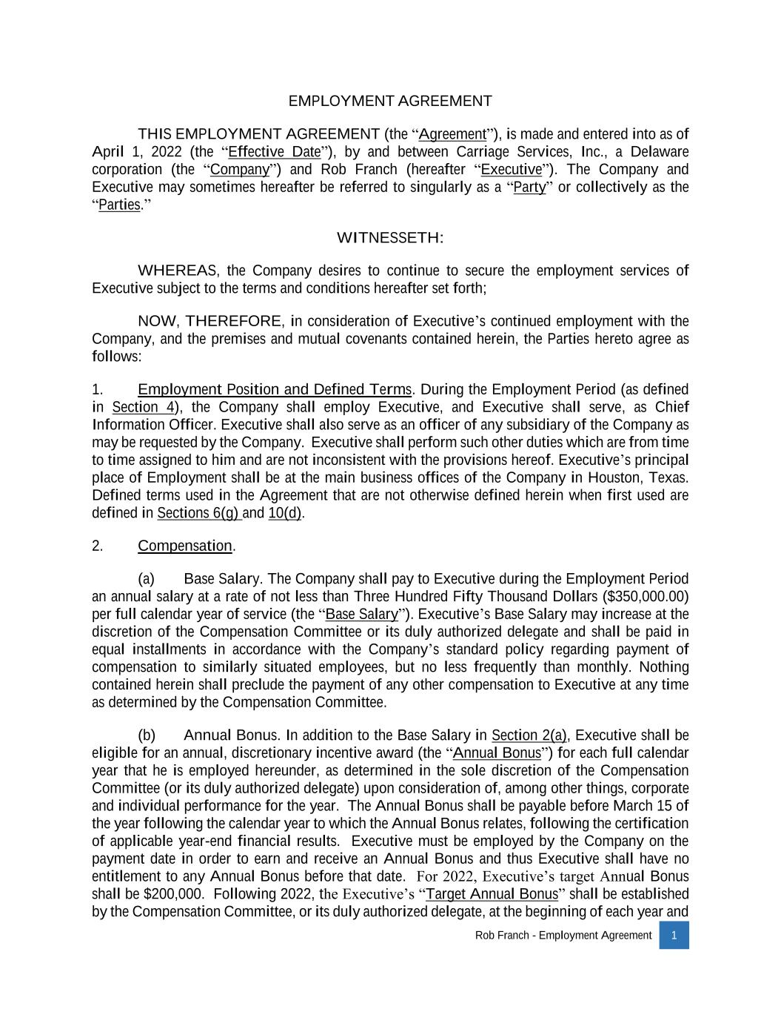
51
Rob Franch - Employment Agreement 1 EMPLOYMENT AGREEMENT THIS EMPLOYMENT AGREEMENT (the “Agreement”), is made and entered into as of April 1, 2022 (the “Effective Date”), by and between Carriage Services, Inc., a Delaware corporation (the “Company”) and Rob Franch (hereafter “Executive”). The Company and Executive may sometimes hereafter be referred to singularly as a “Party” or collectively as the “Parties.” WITNESSETH: WHEREAS, the Company desires to continue to secure the employment services of Executive subject to the terms and conditions hereafter set forth; NOW, THEREFORE, in consideration of Executive’s continued employment with the Company, and the premises and mutual covenants contained herein, the Parties hereto agree as follows: 1. Employment Position and Defined Terms. During the Employment Period (as defined in Section 4), the Company shall employ Executive, and Executive shall serve, as Chief Information Officer. Executive shall also serve as an officer of any subsidiary of the Company as may be requested by the Company. Executive shall perform such other duties which are from time to time assigned to him and are not inconsistent with the provisions hereof. Executive’s principal place of Employment shall be at the main business offices of the Company in Houston, Texas. Defined terms used in the Agreement that are not otherwise defined herein when first used are defined in Sections 6(g) and 10(d). 2. Compensation. (a) Base Salary. The Company shall pay to Executive during the Employment Period an annual salary at a rate of not less than Three Hundred Fifty Thousand Dollars ($350,000.00) per full calendar year of service (the “Base Salary”). Executive’s Base Salary may increase at the discretion of the Compensation Committee or its duly authorized delegate and shall be paid in equal installments in accordance with the Company’s standard policy regarding payment of compensation to similarly situated employees, but no less frequently than monthly. Nothing contained herein shall preclude the payment of any other compensation to Executive at any time as determined by the Compensation Committee. (b) Annual Bonus. In addition to the Base Salary in Section 2(a), Executive shall be eligible for an annual, discretionary incentive award (the “Annual Bonus”) for each full calendar year that he is employed hereunder, as determined in the sole discretion of the Compensation Committee (or its duly authorized delegate) upon consideration of, among other things, corporate and individual performance for the year. The Annual Bonus shall be payable before March 15 of the year following the calendar year to which the Annual Bonus relates, following the certification of applicable year-end financial results. Executive must be employed by the Company on the payment date in order to earn and receive an Annual Bonus and thus Executive shall have no entitlement to any Annual Bonus before that date. For 2022, Executive’s target Annual Bonus shall be $200,000. Following 2022, the Executive’s “Target Annual Bonus” shall be established by the Compensation Committee, or its duly authorized delegate, at the beginning of each year and

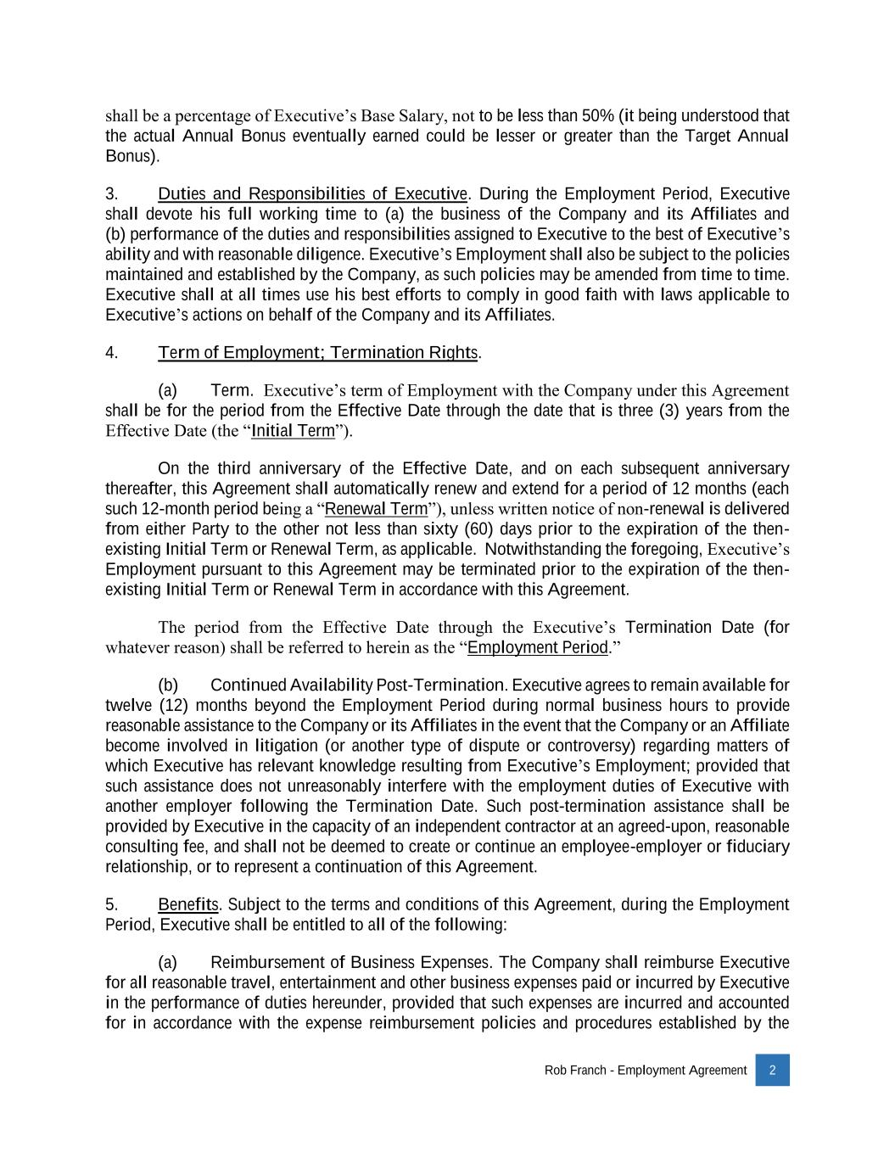
Rob Franch - Employment Agreement 2 shall be a percentage of Executive’s Base Salary, not to be less than 50% (it being understood that the actual Annual Bonus eventually earned could be lesser or greater than the Target Annual Bonus). 3. Duties and Responsibilities of Executive. During the Employment Period, Executive shall devote his full working time to (a) the business of the Company and its Affiliates and (b) performance of the duties and responsibilities assigned to Executive to the best of Executive’s ability and with reasonable diligence. Executive’s Employment shall also be subject to the policies maintained and established by the Company, as such policies may be amended from time to time. Executive shall at all times use his best efforts to comply in good faith with laws applicable to Executive’s actions on behalf of the Company and its Affiliates. 4. Term of Employment; Termination Rights. (a) Term. Executive’s term of Employment with the Company under this Agreement shall be for the period from the Effective Date through the date that is three (3) years from the Effective Date (the “Initial Term”). On the third anniversary of the Effective Date, and on each subsequent anniversary thereafter, this Agreement shall automatically renew and extend for a period of 12 months (each such 12-month period being a “Renewal Term”), unless written notice of non-renewal is delivered from either Party to the other not less than sixty (60) days prior to the expiration of the then- existing Initial Term or Renewal Term, as applicable. Notwithstanding the foregoing, Executive’s Employment pursuant to this Agreement may be terminated prior to the expiration of the then- existing Initial Term or Renewal Term in accordance with this Agreement. The period from the Effective Date through the Executive’s Termination Date (for whatever reason) shall be referred to herein as the “Employment Period.” (b) Continued Availability Post-Termination. Executive agrees to remain available for twelve (12) months beyond the Employment Period during normal business hours to provide reasonable assistance to the Company or its Affiliates in the event that the Company or an Affiliate become involved in litigation (or another type of dispute or controversy) regarding matters of which Executive has relevant knowledge resulting from Executive’s Employment; provided that such assistance does not unreasonably interfere with the employment duties of Executive with another employer following the Termination Date. Such post-termination assistance shall be provided by Executive in the capacity of an independent contractor at an agreed-upon, reasonable consulting fee, and shall not be deemed to create or continue an employee-employer or fiduciary relationship, or to represent a continuation of this Agreement. 5. Benefits. Subject to the terms and conditions of this Agreement, during the Employment Period, Executive shall be entitled to all of the following: (a) Reimbursement of Business Expenses. The Company shall reimburse Executive for all reasonable travel, entertainment and other business expenses paid or incurred by Executive in the performance of duties hereunder, provided that such expenses are incurred and accounted for in accordance with the expense reimbursement policies and procedures established by the

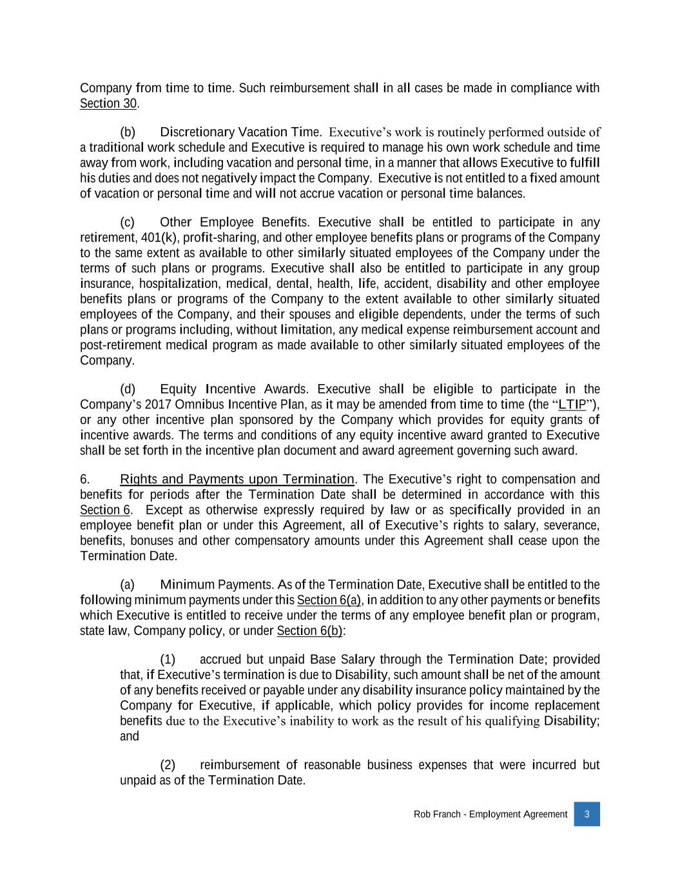
Rob Franch - Employment Agreement 3 Company from time to time. Such reimbursement shall in all cases be made in compliance with Section 30. (b) Discretionary Vacation Time. Executive’s work is routinely performed outside of a traditional work schedule and Executive is required to manage his own work schedule and time away from work, including vacation and personal time, in a manner that allows Executive to fulfill his duties and does not negatively impact the Company. Executive is not entitled to a fixed amount of vacation or personal time and will not accrue vacation or personal time balances. (c) Other Employee Benefits. Executive shall be entitled to participate in any retirement, 401(k), profit-sharing, and other employee benefits plans or programs of the Company to the same extent as available to other similarly situated employees of the Company under the terms of such plans or programs. Executive shall also be entitled to participate in any group insurance, hospitalization, medical, dental, health, life, accident, disability and other employee benefits plans or programs of the Company to the extent available to other similarly situated employees of the Company, and their spouses and eligible dependents, under the terms of such plans or programs including, without limitation, any medical expense reimbursement account and post-retirement medical program as made available to other similarly situated employees of the Company. (d) Equity Incentive Awards. Executive shall be eligible to participate in the Company’s 2017 Omnibus Incentive Plan, as it may be amended from time to time (the “LTIP”), or any other incentive plan sponsored by the Company which provides for equity grants of incentive awards. The terms and conditions of any equity incentive award granted to Executive shall be set forth in the incentive plan document and award agreement governing such award. 6. Rights and Payments upon Termination. The Executive’s right to compensation and benefits for periods after the Termination Date shall be determined in accordance with this Section 6. Except as otherwise expressly required by law or as specifically provided in an employee benefit plan or under this Agreement, all of Executive’s rights to salary, severance, benefits, bonuses and other compensatory amounts under this Agreement shall cease upon the Termination Date. (a) Minimum Payments. As of the Termination Date, Executive shall be entitled to the following minimum payments under this Section 6(a), in addition to any other payments or benefits which Executive is entitled to receive under the terms of any employee benefit plan or program, state law, Company policy, or under Section 6(b): (1) accrued but unpaid Base Salary through the Termination Date; provided that, if Executive’s termination is due to Disability, such amount shall be net of the amount of any benefits received or payable under any disability insurance policy maintained by the Company for Executive, if applicable, which policy provides for income replacement benefits due to the Executive’s inability to work as the result of his qualifying Disability; and (2) reimbursement of reasonable business expenses that were incurred but unpaid as of the Termination Date.

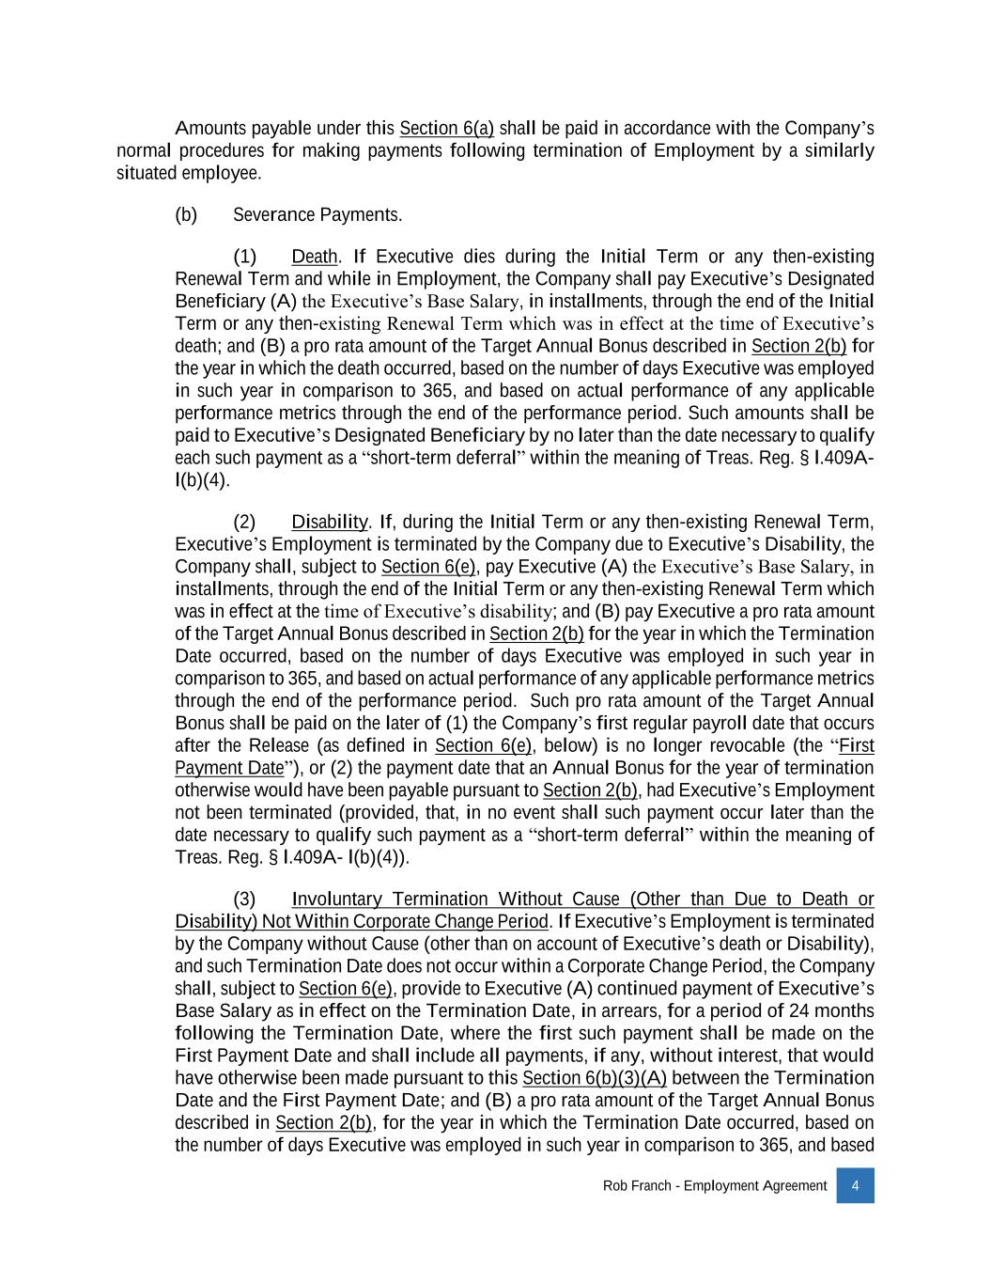
Rob Franch - Employment Agreement 4 Amounts payable under this Section 6(a) shall be paid in accordance with the Company’s normal procedures for making payments following termination of Employment by a similarly situated employee. (b) Severance Payments. (1) Death. If Executive dies during the Initial Term or any then-existing Renewal Term and while in Employment, the Company shall pay Executive’s Designated Beneficiary (A) the Executive’s Base Salary, in installments, through the end of the Initial Term or any then-existing Renewal Term which was in effect at the time of Executive’s death; and (B) a pro rata amount of the Target Annual Bonus described in Section 2(b) for the year in which the death occurred, based on the number of days Executive was employed in such year in comparison to 365, and based on actual performance of any applicable performance metrics through the end of the performance period. Such amounts shall be paid to Executive’s Designated Beneficiary by no later than the date necessary to qualify each such payment as a “short-term deferral” within the meaning of Treas. Reg. § l.409A l(b)(4). (2) Disability. If, during the Initial Term or any then-existing Renewal Term, Executive’s Employment is terminated by the Company due to Executive’s Disability, the Company shall, subject to Section 6(e), pay Executive (A) the Executive’s Base Salary, in installments, through the end of the Initial Term or any then-existing Renewal Term which was in effect at the time of Executive’s disability; and (B) pay Executive a pro rata amount of the Target Annual Bonus described in Section 2(b) for the year in which the Termination Date occurred, based on the number of days Executive was employed in such year in comparison to 365, and based on actual performance of any applicable performance metrics through the end of the performance period. Such pro rata amount of the Target Annual Bonus shall be paid on the later of (1) the Company’s first regular payroll date that occurs after the Release (as defined in Section 6(e), below) is no longer revocable (the “First Payment Date”), or (2) the payment date that an Annual Bonus for the year of termination otherwise would have been payable pursuant to Section 2(b), had Executive’s Employment not been terminated (provided, that, in no event shall such payment occur later than the date necessary to qualify such payment as a “short-term deferral” within the meaning of Treas. Reg. § l.409A l(b)(4)). (3) Involuntary Termination Without Cause (Other than Due to Death or Disability) Not Within Corporate Change Period. If Executive’s Employment is terminated by the Company without Cause (other than on account of Executive’s death or Disability), and such Termination Date does not occur within a Corporate Change Period, the Company shall, subject to Section 6(e), provide to Executive (A) continued payment of Executive’s Base Salary as in effect on the Termination Date, in arrears, for a period of 24 months following the Termination Date, where the first such payment shall be made on the First Payment Date and shall include all payments, if any, without interest, that would have otherwise been made pursuant to this Section 6(b)(3)(A) between the Termination Date and the First Payment Date; and (B) a pro rata amount of the Target Annual Bonus described in Section 2(b), for the year in which the Termination Date occurred, based on the number of days Executive was employed in such year in comparison to 365, and based

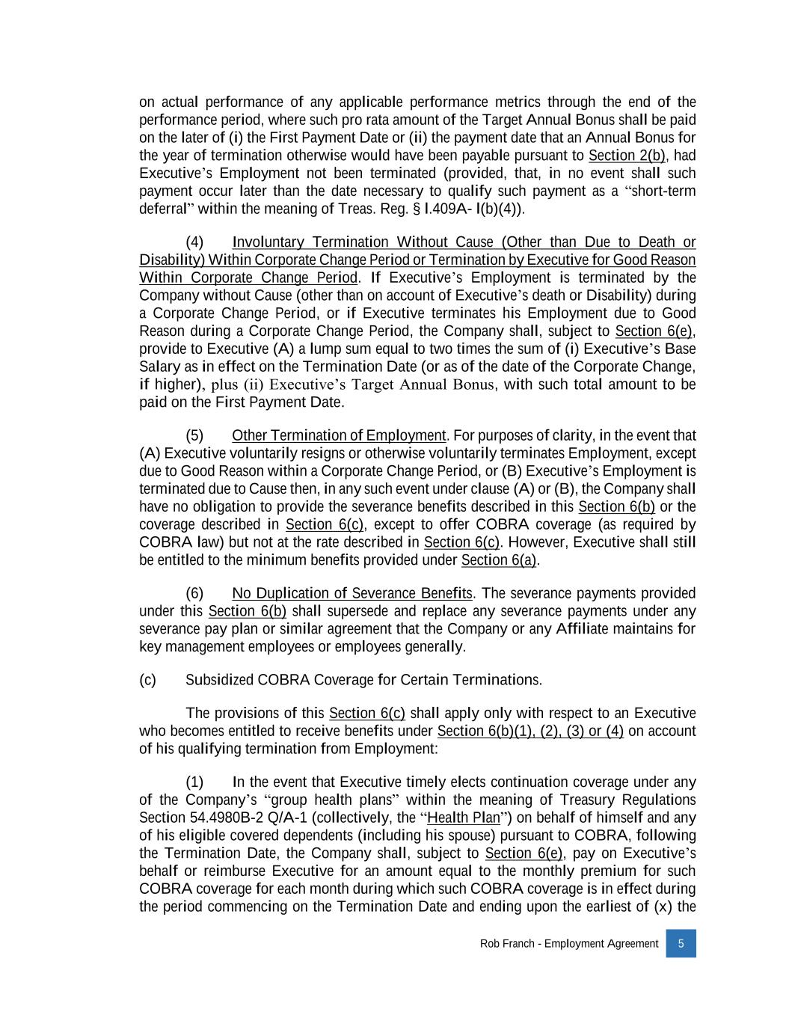
Rob Franch - Employment Agreement 5 on actual performance of any applicable performance metrics through the end of the performance period, where such pro rata amount of the Target Annual Bonus shall be paid on the later of (i) the First Payment Date or (ii) the payment date that an Annual Bonus for the year of termination otherwise would have been payable pursuant to Section 2(b), had Executive’s Employment not been terminated (provided, that, in no event shall such payment occur later than the date necessary to qualify such payment as a “short-term deferral” within the meaning of Treas. Reg. § l.409A l(b)(4)). (4) Involuntary Termination Without Cause (Other than Due to Death or Disability) Within Corporate Change Period or Termination by Executive for Good Reason Within Corporate Change Period. If Executive’s Employment is terminated by the Company without Cause (other than on account of Executive’s death or Disability) during a Corporate Change Period, or if Executive terminates his Employment due to Good Reason during a Corporate Change Period, the Company shall, subject to Section 6(e), provide to Executive (A) a lump sum equal to two times the sum of (i) Executive’s Base Salary as in effect on the Termination Date (or as of the date of the Corporate Change, if higher), plus (ii) Executive’s Target Annual Bonus, with such total amount to be paid on the First Payment Date. (5) Other Termination of Employment. For purposes of clarity, in the event that (A) Executive voluntarily resigns or otherwise voluntarily terminates Employment, except due to Good Reason within a Corporate Change Period, or (B) Executive’s Employment is terminated due to Cause then, in any such event under clause (A) or (B), the Company shall have no obligation to provide the severance benefits described in this Section 6(b) or the coverage described in Section 6(c), except to offer COBRA coverage (as required by COBRA law) but not at the rate described in Section 6(c). However, Executive shall still be entitled to the minimum benefits provided under Section 6(a). (6) No Duplication of Severance Benefits. The severance payments provided under this Section 6(b) shall supersede and replace any severance payments under any severance pay plan or similar agreement that the Company or any Affiliate maintains for key management employees or employees generally. (c) Subsidized COBRA Coverage for Certain Terminations. The provisions of this Section 6(c) shall apply only with respect to an Executive who becomes entitled to receive benefits under Section 6(b)(1), (2), (3) or (4) on account of his qualifying termination from Employment: (1) In the event that Executive timely elects continuation coverage under any of the Company’s “group health plans” within the meaning of Treasury Regulations Section 54.4980B-2 Q/A-1 (collectively, the “Health Plan”) on behalf of himself and any of his eligible covered dependents (including his spouse) pursuant to COBRA, following the Termination Date, the Company shall, subject to Section 6(e), pay on Executive’s behalf or reimburse Executive for an amount equal to the monthly premium for such COBRA coverage for each month during which such COBRA coverage is in effect during the period commencing on the Termination Date and ending upon the earliest of (x) the

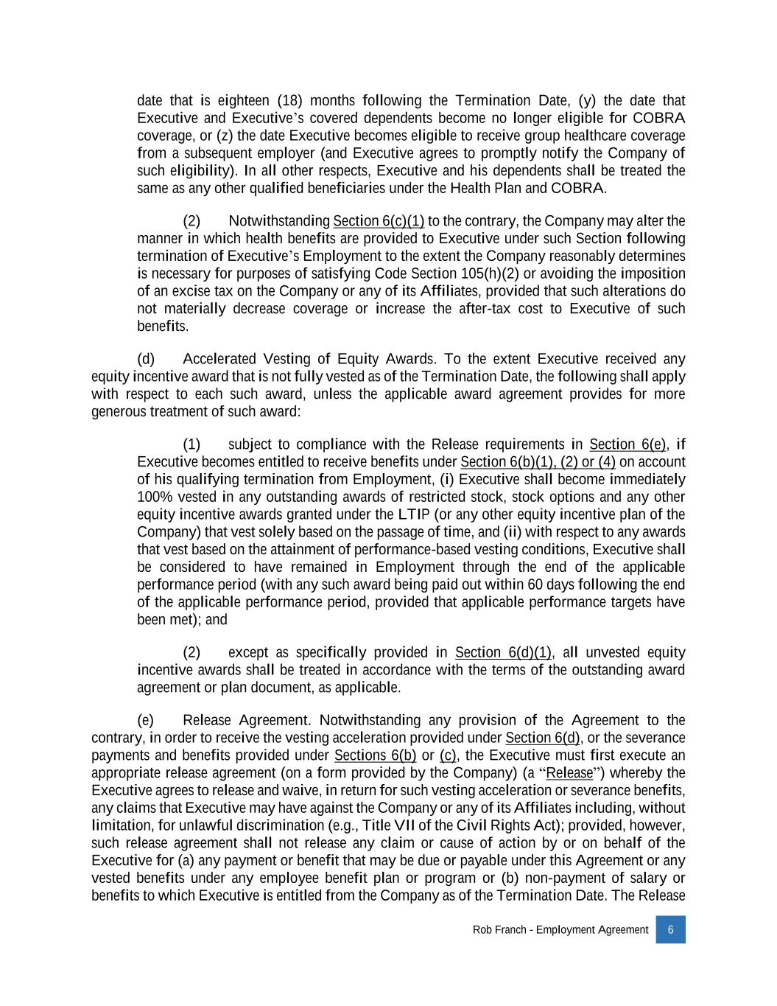
Rob Franch - Employment Agreement 6 date that is eighteen (18) months following the Termination Date, (y) the date that Executive and Executive’s covered dependents become no longer eligible for COBRA coverage, or (z) the date Executive becomes eligible to receive group healthcare coverage from a subsequent employer (and Executive agrees to promptly notify the Company of such eligibility). In all other respects, Executive and his dependents shall be treated the same as any other qualified beneficiaries under the Health Plan and COBRA. (2) Notwithstanding Section 6(c)(1) to the contrary, the Company may alter the manner in which health benefits are provided to Executive under such Section following termination of Executive’s Employment to the extent the Company reasonably determines is necessary for purposes of satisfying Code Section 105(h)(2) or avoiding the imposition of an excise tax on the Company or any of its Affiliates, provided that such alterations do not materially decrease coverage or increase the after-tax cost to Executive of such benefits. (d) Accelerated Vesting of Equity Awards. To the extent Executive received any equity incentive award that is not fully vested as of the Termination Date, the following shall apply with respect to each such award, unless the applicable award agreement provides for more generous treatment of such award: (1) subject to compliance with the Release requirements in Section 6(e), if Executive becomes entitled to receive benefits under Section 6(b)(1), (2) or (4) on account of his qualifying termination from Employment, (i) Executive shall become immediately 100% vested in any outstanding awards of restricted stock, stock options and any other equity incentive awards granted under the LTIP (or any other equity incentive plan of the Company) that vest solely based on the passage of time, and (ii) with respect to any awards that vest based on the attainment of performance-based vesting conditions, Executive shall be considered to have remained in Employment through the end of the applicable performance period (with any such award being paid out within 60 days following the end of the applicable performance period, provided that applicable performance targets have been met); and (2) except as specifically provided in Section 6(d)(1), all unvested equity incentive awards shall be treated in accordance with the terms of the outstanding award agreement or plan document, as applicable. (e) Release Agreement. Notwithstanding any provision of the Agreement to the contrary, in order to receive the vesting acceleration provided under Section 6(d), or the severance payments and benefits provided under Sections 6(b) or (c), the Executive must first execute an appropriate release agreement (on a form provided by the Company) (a “Release”) whereby the Executive agrees to release and waive, in return for such vesting acceleration or severance benefits, any claims that Executive may have against the Company or any of its Affiliates including, without limitation, for unlawful discrimination (e.g., Title VII of the Civil Rights Act); provided, however, such release agreement shall not release any claim or cause of action by or on behalf of the Executive for (a) any payment or benefit that may be due or payable under this Agreement or any vested benefits under any employee benefit plan or program or (b) non-payment of salary or benefits to which Executive is entitled from the Company as of the Termination Date. The Release

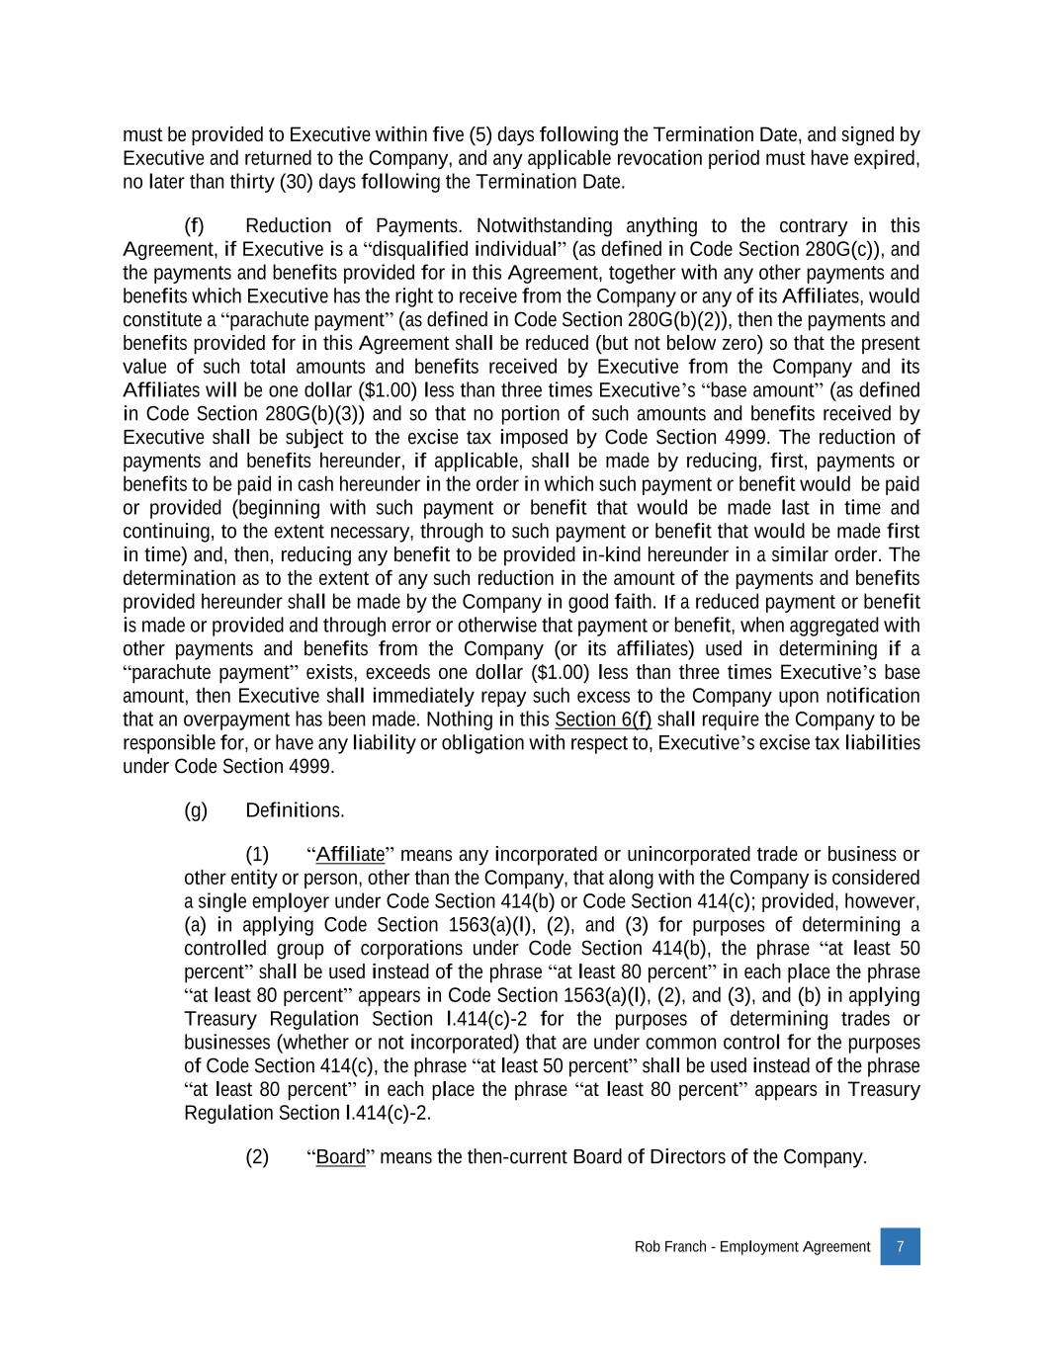
Rob Franch - Employment Agreement 7 must be provided to Executive within five (5) days following the Termination Date, and signed by Executive and returned to the Company, and any applicable revocation period must have expired, no later than thirty (30) days following the Termination Date. (f) Reduction of Payments. Notwithstanding anything to the contrary in this Agreement, if Executive is a “disqualified individual” (as defined in Code Section 280G(c)), and the payments and benefits provided for in this Agreement, together with any other payments and benefits which Executive has the right to receive from the Company or any of its Affiliates, would constitute a “parachute payment” (as defined in Code Section 280G(b)(2)), then the payments and benefits provided for in this Agreement shall be reduced (but not below zero) so that the present value of such total amounts and benefits received by Executive from the Company and its Affiliates will be one dollar ($1.00) less than three times Executive’s “base amount” (as defined in Code Section 280G(b)(3)) and so that no portion of such amounts and benefits received by Executive shall be subject to the excise tax imposed by Code Section 4999. The reduction of payments and benefits hereunder, if applicable, shall be made by reducing, first, payments or benefits to be paid in cash hereunder in the order in which such payment or benefit would be paid or provided (beginning with such payment or benefit that would be made last in time and continuing, to the extent necessary, through to such payment or benefit that would be made first in time) and, then, reducing any benefit to be provided in-kind hereunder in a similar order. The determination as to the extent of any such reduction in the amount of the payments and benefits provided hereunder shall be made by the Company in good faith. If a reduced payment or benefit is made or provided and through error or otherwise that payment or benefit, when aggregated with other payments and benefits from the Company (or its affiliates) used in determining if a “parachute payment” exists, exceeds one dollar ($1.00) less than three times Executive’s base amount, then Executive shall immediately repay such excess to the Company upon notification that an overpayment has been made. Nothing in this Section 6(f) shall require the Company to be responsible for, or have any liability or obligation with respect to, Executive’s excise tax liabilities under Code Section 4999. (g) Definitions. (1) “Affiliate” means any incorporated or unincorporated trade or business or other entity or person, other than the Company, that along with the Company is considered a single employer under Code Section 414(b) or Code Section 414(c); provided, however, (a) in applying Code Section 1563(a)(l), (2), and (3) for purposes of determining a controlled group of corporations under Code Section 414(b), the phrase “at least 50 percent” shall be used instead of the phrase “at least 80 percent” in each place the phrase “at least 80 percent” appears in Code Section 1563(a)(l), (2), and (3), and (b) in applying Treasury Regulation Section l.414(c)-2 for the purposes of determining trades or businesses (whether or not incorporated) that are under common control for the purposes of Code Section 414(c), the phrase “at least 50 percent” shall be used instead of the phrase “at least 80 percent” in each place the phrase “at least 80 percent” appears in Treasury Regulation Section l.414(c)-2. (2) “Board” means the then-current Board of Directors of the Company.

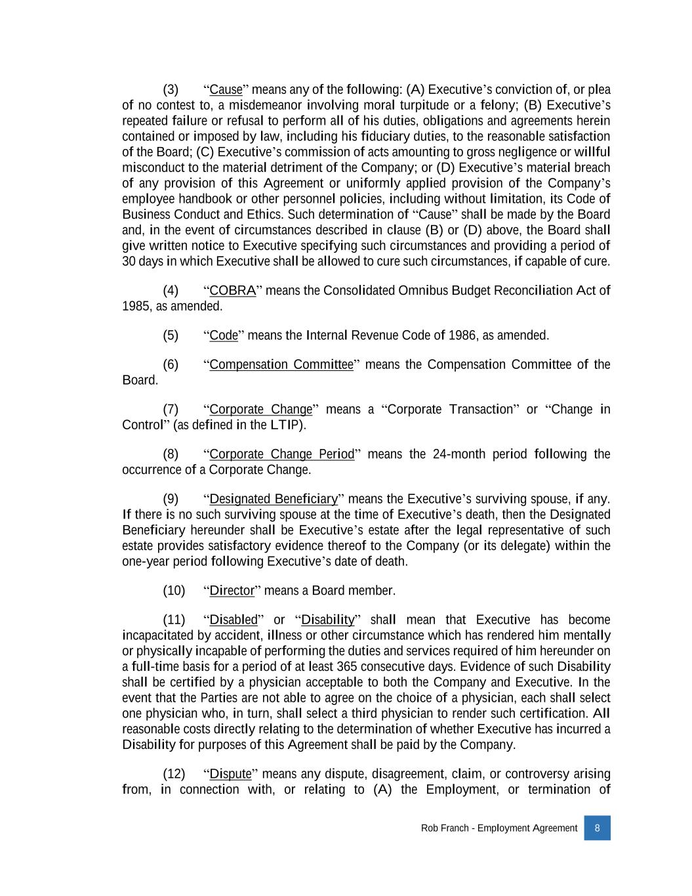
Rob Franch - Employment Agreement 8 (3) “Cause” means any of the following: (A) Executive’s conviction of, or plea of no contest to, a misdemeanor involving moral turpitude or a felony; (B) Executive’s repeated failure or refusal to perform all of his duties, obligations and agreements herein contained or imposed by law, including his fiduciary duties, to the reasonable satisfaction of the Board; (C) Executive’s commission of acts amounting to gross negligence or willful misconduct to the material detriment of the Company; or (D) Executive’s material breach of any provision of this Agreement or uniformly applied provision of the Company’s employee handbook or other personnel policies, including without limitation, its Code of Business Conduct and Ethics. Such determination of “Cause” shall be made by the Board and, in the event of circumstances described in clause (B) or (D) above, the Board shall give written notice to Executive specifying such circumstances and providing a period of 30 days in which Executive shall be allowed to cure such circumstances, if capable of cure. (4) “COBRA” means the Consolidated Omnibus Budget Reconciliation Act of 1985, as amended. (5) “Code” means the Internal Revenue Code of 1986, as amended. (6) “Compensation Committee” means the Compensation Committee of the Board. (7) “Corporate Change” means a “Corporate Transaction” or “Change in Control” (as defined in the LTIP). (8) “Corporate Change Period” means the 24-month period following the occurrence of a Corporate Change. (9) “Designated Beneficiary” means the Executive’s surviving spouse, if any. If there is no such surviving spouse at the time of Executive’s death, then the Designated Beneficiary hereunder shall be Executive’s estate after the legal representative of such estate provides satisfactory evidence thereof to the Company (or its delegate) within the one-year period following Executive’s date of death. (10) “Director” means a Board member. (11) “Disabled” or “Disability” shall mean that Executive has become incapacitated by accident, illness or other circumstance which has rendered him mentally or physically incapable of performing the duties and services required of him hereunder on a full-time basis for a period of at least 365 consecutive days. Evidence of such Disability shall be certified by a physician acceptable to both the Company and Executive. In the event that the Parties are not able to agree on the choice of a physician, each shall select one physician who, in turn, shall select a third physician to render such certification. All reasonable costs directly relating to the determination of whether Executive has incurred a Disability for purposes of this Agreement shall be paid by the Company. (12) “Dispute” means any dispute, disagreement, claim, or controversy arising from, in connection with, or relating to (A) the Employment, or termination of

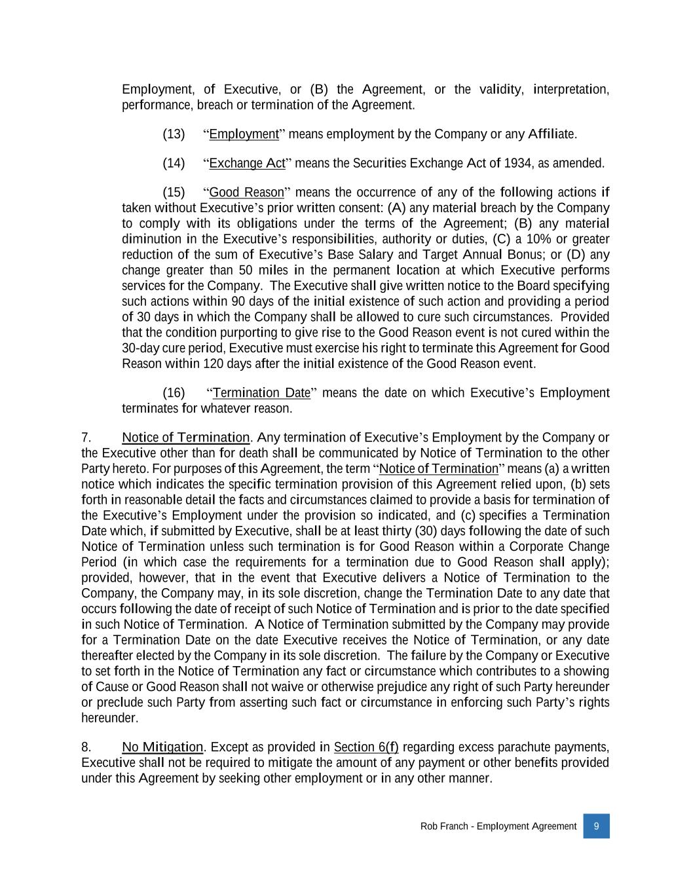
Rob Franch - Employment Agreement 9 Employment, of Executive, or (B) the Agreement, or the validity, interpretation, performance, breach or termination of the Agreement. (13) “Employment” means employment by the Company or any Affiliate. (14) “Exchange Act” means the Securities Exchange Act of 1934, as amended. (15) “Good Reason” means the occurrence of any of the following actions if taken without Executive’s prior written consent: (A) any material breach by the Company to comply with its obligations under the terms of the Agreement; (B) any material diminution in the Executive’s responsibilities, authority or duties, (C) a 10% or greater reduction of the sum of Executive’s Base Salary and Target Annual Bonus; or (D) any change greater than 50 miles in the permanent location at which Executive performs services for the Company. The Executive shall give written notice to the Board specifying such actions within 90 days of the initial existence of such action and providing a period of 30 days in which the Company shall be allowed to cure such circumstances. Provided that the condition purporting to give rise to the Good Reason event is not cured within the 30-day cure period, Executive must exercise his right to terminate this Agreement for Good Reason within 120 days after the initial existence of the Good Reason event. (16) “Termination Date” means the date on which Executive’s Employment terminates for whatever reason. 7. Notice of Termination. Any termination of Executive’s Employment by the Company or the Executive other than for death shall be communicated by Notice of Termination to the other Party hereto. For purposes of this Agreement, the term “Notice of Termination” means (a) a written notice which indicates the specific termination provision of this Agreement relied upon, (b) sets forth in reasonable detail the facts and circumstances claimed to provide a basis for termination of the Executive’s Employment under the provision so indicated, and (c) specifies a Termination Date which, if submitted by Executive, shall be at least thirty (30) days following the date of such Notice of Termination unless such termination is for Good Reason within a Corporate Change Period (in which case the requirements for a termination due to Good Reason shall apply); provided, however, that in the event that Executive delivers a Notice of Termination to the Company, the Company may, in its sole discretion, change the Termination Date to any date that occurs following the date of receipt of such Notice of Termination and is prior to the date specified in such Notice of Termination. A Notice of Termination submitted by the Company may provide for a Termination Date on the date Executive receives the Notice of Termination, or any date thereafter elected by the Company in its sole discretion. The failure by the Company or Executive to set forth in the Notice of Termination any fact or circumstance which contributes to a showing of Cause or Good Reason shall not waive or otherwise prejudice any right of such Party hereunder or preclude such Party from asserting such fact or circumstance in enforcing such Party’s rights hereunder. 8. No Mitigation. Except as provided in Section 6(f) regarding excess parachute payments, Executive shall not be required to mitigate the amount of any payment or other benefits provided under this Agreement by seeking other employment or in any other manner.

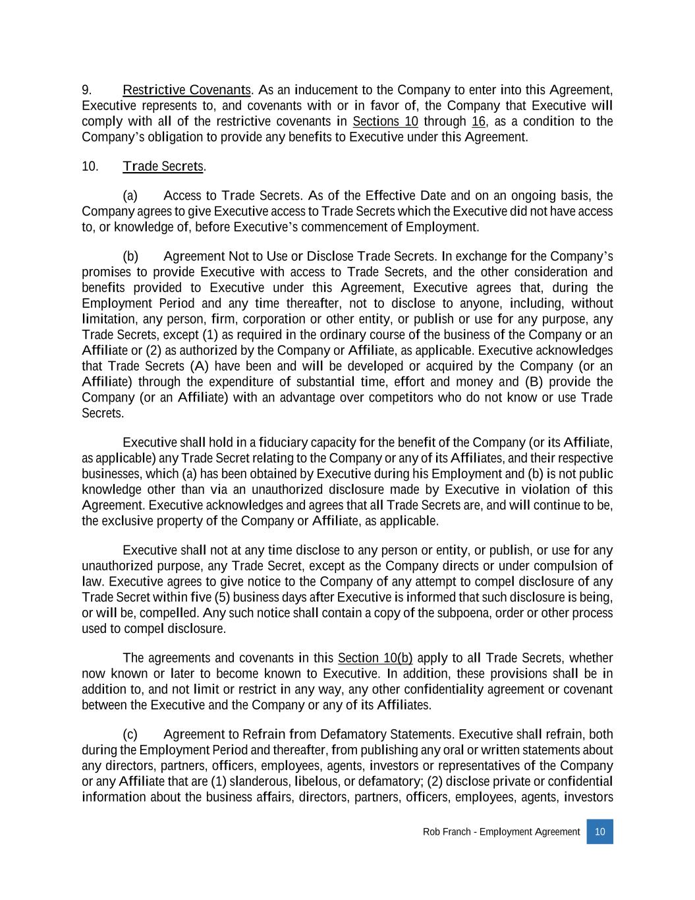
Rob Franch - Employment Agreement 10 9. Restrictive Covenants. As an inducement to the Company to enter into this Agreement, Executive represents to, and covenants with or in favor of, the Company that Executive will comply with all of the restrictive covenants in Sections 10 through 16, as a condition to the Company’s obligation to provide any benefits to Executive under this Agreement. 10. Trade Secrets. (a) Access to Trade Secrets. As of the Effective Date and on an ongoing basis, the Company agrees to give Executive access to Trade Secrets which the Executive did not have access to, or knowledge of, before Executive’s commencement of Employment. (b) Agreement Not to Use or Disclose Trade Secrets. In exchange for the Company’s promises to provide Executive with access to Trade Secrets, and the other consideration and benefits provided to Executive under this Agreement, Executive agrees that, during the Employment Period and any time thereafter, not to disclose to anyone, including, without limitation, any person, firm, corporation or other entity, or publish or use for any purpose, any Trade Secrets, except (1) as required in the ordinary course of the business of the Company or an Affiliate or (2) as authorized by the Company or Affiliate, as applicable. Executive acknowledges that Trade Secrets (A) have been and will be developed or acquired by the Company (or an Affiliate) through the expenditure of substantial time, effort and money and (B) provide the Company (or an Affiliate) with an advantage over competitors who do not know or use Trade Secrets. Executive shall hold in a fiduciary capacity for the benefit of the Company (or its Affiliate, as applicable) any Trade Secret relating to the Company or any of its Affiliates, and their respective businesses, which (a) has been obtained by Executive during his Employment and (b) is not public knowledge other than via an unauthorized disclosure made by Executive in violation of this Agreement. Executive acknowledges and agrees that all Trade Secrets are, and will continue to be, the exclusive property of the Company or Affiliate, as applicable. Executive shall not at any time disclose to any person or entity, or publish, or use for any unauthorized purpose, any Trade Secret, except as the Company directs or under compulsion of law. Executive agrees to give notice to the Company of any attempt to compel disclosure of any Trade Secret within five (5) business days after Executive is informed that such disclosure is being, or will be, compelled. Any such notice shall contain a copy of the subpoena, order or other process used to compel disclosure. The agreements and covenants in this Section 10(b) apply to all Trade Secrets, whether now known or later to become known to Executive. In addition, these provisions shall be in addition to, and not limit or restrict in any way, any other confidentiality agreement or covenant between the Executive and the Company or any of its Affiliates. (c) Agreement to Refrain from Defamatory Statements. Executive shall refrain, both during the Employment Period and thereafter, from publishing any oral or written statements about any directors, partners, officers, employees, agents, investors or representatives of the Company or any Affiliate that are (1) slanderous, libelous, or defamatory; (2) disclose private or confidential information about the business affairs, directors, partners, officers, employees, agents, investors

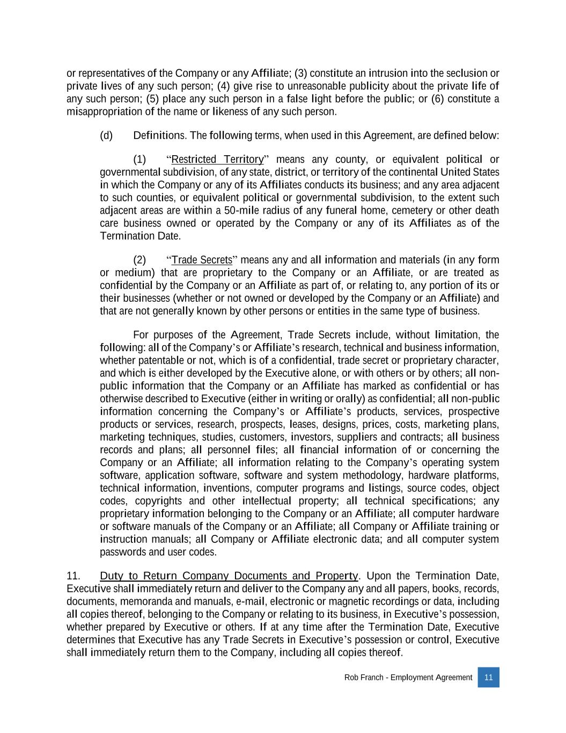
Rob Franch - Employment Agreement 11 or representatives of the Company or any Affiliate; (3) constitute an intrusion into the seclusion or private lives of any such person; (4) give rise to unreasonable publicity about the private life of any such person; (5) place any such person in a false light before the public; or (6) constitute a misappropriation of the name or likeness of any such person. (d) Definitions. The following terms, when used in this Agreement, are defined below: (1) “Restricted Territory” means any county, or equivalent political or governmental subdivision, of any state, district, or territory of the continental United States in which the Company or any of its Affiliates conducts its business; and any area adjacent to such counties, or equivalent political or governmental subdivision, to the extent such adjacent areas are within a 50-mile radius of any funeral home, cemetery or other death care business owned or operated by the Company or any of its Affiliates as of the Termination Date. (2) “Trade Secrets” means any and all information and materials (in any form or medium) that are proprietary to the Company or an Affiliate, or are treated as confidential by the Company or an Affiliate as part of, or relating to, any portion of its or their businesses (whether or not owned or developed by the Company or an Affiliate) and that are not generally known by other persons or entities in the same type of business. For purposes of the Agreement, Trade Secrets include, without limitation, the following: all of the Company’s or Affiliate’s research, technical and business information, whether patentable or not, which is of a confidential, trade secret or proprietary character, and which is either developed by the Executive alone, or with others or by others; all non- public information that the Company or an Affiliate has marked as confidential or has otherwise described to Executive (either in writing or orally) as confidential; all non-public information concerning the Company’s or Affiliate’s products, services, prospective products or services, research, prospects, leases, designs, prices, costs, marketing plans, marketing techniques, studies, customers, investors, suppliers and contracts; all business records and plans; all personnel files; all financial information of or concerning the Company or an Affiliate; all information relating to the Company’s operating system software, application software, software and system methodology, hardware platforms, technical information, inventions, computer programs and listings, source codes, object codes, copyrights and other intellectual property; all technical specifications; any proprietary information belonging to the Company or an Affiliate; all computer hardware or software manuals of the Company or an Affiliate; all Company or Affiliate training or instruction manuals; all Company or Affiliate electronic data; and all computer system passwords and user codes. 11. Duty to Return Company Documents and Property. Upon the Termination Date, Executive shall immediately return and deliver to the Company any and all papers, books, records, documents, memoranda and manuals, e-mail, electronic or magnetic recordings or data, including all copies thereof, belonging to the Company or relating to its business, in Executive’s possession, whether prepared by Executive or others. If at any time after the Termination Date, Executive determines that Executive has any Trade Secrets in Executive’s possession or control, Executive shall immediately return them to the Company, including all copies thereof.

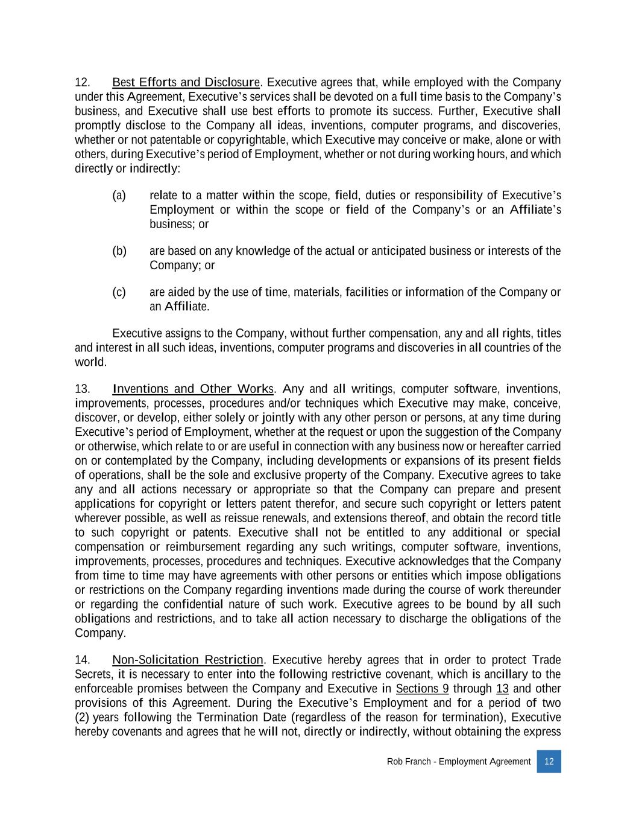
Rob Franch - Employment Agreement 12 12. Best Efforts and Disclosure. Executive agrees that, while employed with the Company under this Agreement, Executive’s services shall be devoted on a full time basis to the Company’s business, and Executive shall use best efforts to promote its success. Further, Executive shall promptly disclose to the Company all ideas, inventions, computer programs, and discoveries, whether or not patentable or copyrightable, which Executive may conceive or make, alone or with others, during Executive’s period of Employment, whether or not during working hours, and which directly or indirectly: (a) relate to a matter within the scope, field, duties or responsibility of Executive’s Employment or within the scope or field of the Company’s or an Affiliate’s business; or (b) are based on any knowledge of the actual or anticipated business or interests of the Company; or (c) are aided by the use of time, materials, facilities or information of the Company or an Affiliate. Executive assigns to the Company, without further compensation, any and all rights, titles and interest in all such ideas, inventions, computer programs and discoveries in all countries of the world. 13. Inventions and Other Works. Any and all writings, computer software, inventions, improvements, processes, procedures and/or techniques which Executive may make, conceive, discover, or develop, either solely or jointly with any other person or persons, at any time during Executive’s period of Employment, whether at the request or upon the suggestion of the Company or otherwise, which relate to or are useful in connection with any business now or hereafter carried on or contemplated by the Company, including developments or expansions of its present fields of operations, shall be the sole and exclusive property of the Company. Executive agrees to take any and all actions necessary or appropriate so that the Company can prepare and present applications for copyright or letters patent therefor, and secure such copyright or letters patent wherever possible, as well as reissue renewals, and extensions thereof, and obtain the record title to such copyright or patents. Executive shall not be entitled to any additional or special compensation or reimbursement regarding any such writings, computer software, inventions, improvements, processes, procedures and techniques. Executive acknowledges that the Company from time to time may have agreements with other persons or entities which impose obligations or restrictions on the Company regarding inventions made during the course of work thereunder or regarding the confidential nature of such work. Executive agrees to be bound by all such obligations and restrictions, and to take all action necessary to discharge the obligations of the Company. 14. Non-Solicitation Restriction. Executive hereby agrees that in order to protect Trade Secrets, it is necessary to enter into the following restrictive covenant, which is ancillary to the enforceable promises between the Company and Executive in Sections 9 through 13 and other provisions of this Agreement. During the Executive’s Employment and for a period of two (2) years following the Termination Date (regardless of the reason for termination), Executive hereby covenants and agrees that he will not, directly or indirectly, without obtaining the express

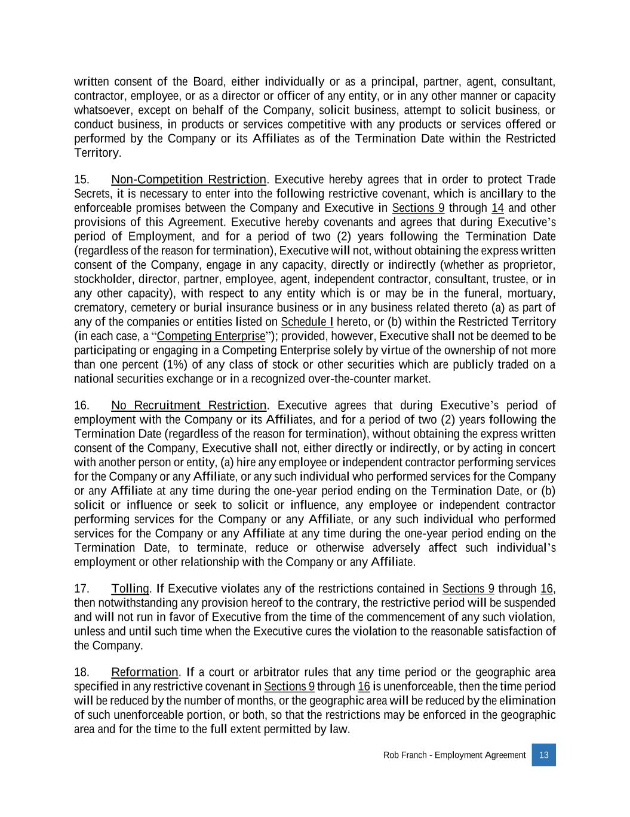
Rob Franch - Employment Agreement 13 written consent of the Board, either individually or as a principal, partner, agent, consultant, contractor, employee, or as a director or officer of any entity, or in any other manner or capacity whatsoever, except on behalf of the Company, solicit business, attempt to solicit business, or conduct business, in products or services competitive with any products or services offered or performed by the Company or its Affiliates as of the Termination Date within the Restricted Territory. 15. Non-Competition Restriction. Executive hereby agrees that in order to protect Trade Secrets, it is necessary to enter into the following restrictive covenant, which is ancillary to the enforceable promises between the Company and Executive in Sections 9 through 14 and other provisions of this Agreement. Executive hereby covenants and agrees that during Executive’s period of Employment, and for a period of two (2) years following the Termination Date (regardless of the reason for termination), Executive will not, without obtaining the express written consent of the Company, engage in any capacity, directly or indirectly (whether as proprietor, stockholder, director, partner, employee, agent, independent contractor, consultant, trustee, or in any other capacity), with respect to any entity which is or may be in the funeral, mortuary, crematory, cemetery or burial insurance business or in any business related thereto (a) as part of any of the companies or entities listed on Schedule I hereto, or (b) within the Restricted Territory (in each case, a “Competing Enterprise”); provided, however, Executive shall not be deemed to be participating or engaging in a Competing Enterprise solely by virtue of the ownership of not more than one percent (1%) of any class of stock or other securities which are publicly traded on a national securities exchange or in a recognized over-the-counter market. 16. No Recruitment Restriction. Executive agrees that during Executive’s period of employment with the Company or its Affiliates, and for a period of two (2) years following the Termination Date (regardless of the reason for termination), without obtaining the express written consent of the Company, Executive shall not, either directly or indirectly, or by acting in concert with another person or entity, (a) hire any employee or independent contractor performing services for the Company or any Affiliate, or any such individual who performed services for the Company or any Affiliate at any time during the one-year period ending on the Termination Date, or (b) solicit or influence or seek to solicit or influence, any employee or independent contractor performing services for the Company or any Affiliate, or any such individual who performed services for the Company or any Affiliate at any time during the one-year period ending on the Termination Date, to terminate, reduce or otherwise adversely affect such individual’s employment or other relationship with the Company or any Affiliate. 17. Tolling. If Executive violates any of the restrictions contained in Sections 9 through 16, then notwithstanding any provision hereof to the contrary, the restrictive period will be suspended and will not run in favor of Executive from the time of the commencement of any such violation, unless and until such time when the Executive cures the violation to the reasonable satisfaction of the Company. 18. Reformation. If a court or arbitrator rules that any time period or the geographic area specified in any restrictive covenant in Sections 9 through 16 is unenforceable, then the time period will be reduced by the number of months, or the geographic area will be reduced by the elimination of such unenforceable portion, or both, so that the restrictions may be enforced in the geographic area and for the time to the full extent permitted by law.

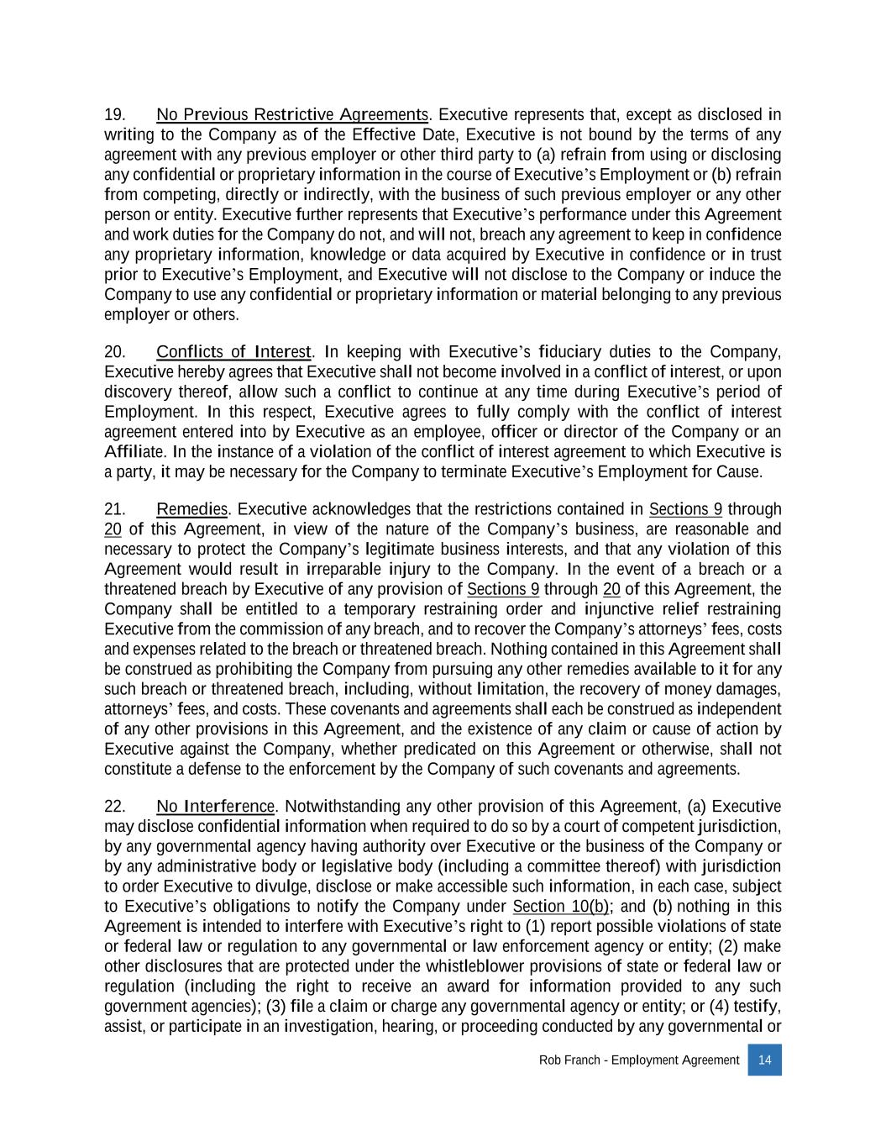
Rob Franch - Employment Agreement 14 19. No Previous Restrictive Agreements. Executive represents that, except as disclosed in writing to the Company as of the Effective Date, Executive is not bound by the terms of any agreement with any previous employer or other third party to (a) refrain from using or disclosing any confidential or proprietary information in the course of Executive’s Employment or (b) refrain from competing, directly or indirectly, with the business of such previous employer or any other person or entity. Executive further represents that Executive’s performance under this Agreement and work duties for the Company do not, and will not, breach any agreement to keep in confidence any proprietary information, knowledge or data acquired by Executive in confidence or in trust prior to Executive’s Employment, and Executive will not disclose to the Company or induce the Company to use any confidential or proprietary information or material belonging to any previous employer or others. 20. Conflicts of Interest. In keeping with Executive’s fiduciary duties to the Company, Executive hereby agrees that Executive shall not become involved in a conflict of interest, or upon discovery thereof, allow such a conflict to continue at any time during Executive’s period of Employment. In this respect, Executive agrees to fully comply with the conflict of interest agreement entered into by Executive as an employee, officer or director of the Company or an Affiliate. In the instance of a violation of the conflict of interest agreement to which Executive is a party, it may be necessary for the Company to terminate Executive’s Employment for Cause. 21. Remedies. Executive acknowledges that the restrictions contained in Sections 9 through 20 of this Agreement, in view of the nature of the Company’s business, are reasonable and necessary to protect the Company’s legitimate business interests, and that any violation of this Agreement would result in irreparable injury to the Company. In the event of a breach or a threatened breach by Executive of any provision of Sections 9 through 20 of this Agreement, the Company shall be entitled to a temporary restraining order and injunctive relief restraining Executive from the commission of any breach, and to recover the Company’s attorneys’ fees, costs and expenses related to the breach or threatened breach. Nothing contained in this Agreement shall be construed as prohibiting the Company from pursuing any other remedies available to it for any such breach or threatened breach, including, without limitation, the recovery of money damages, attorneys’ fees, and costs. These covenants and agreements shall each be construed as independent of any other provisions in this Agreement, and the existence of any claim or cause of action by Executive against the Company, whether predicated on this Agreement or otherwise, shall not constitute a defense to the enforcement by the Company of such covenants and agreements. 22. No Interference. Notwithstanding any other provision of this Agreement, (a) Executive may disclose confidential information when required to do so by a court of competent jurisdiction, by any governmental agency having authority over Executive or the business of the Company or by any administrative body or legislative body (including a committee thereof) with jurisdiction to order Executive to divulge, disclose or make accessible such information, in each case, subject to Executive’s obligations to notify the Company under Section 10(b); and (b) nothing in this Agreement is intended to interfere with Executive’s right to (1) report possible violations of state or federal law or regulation to any governmental or law enforcement agency or entity; (2) make other disclosures that are protected under the whistleblower provisions of state or federal law or regulation (including the right to receive an award for information provided to any such government agencies); (3) file a claim or charge any governmental agency or entity; or (4) testify, assist, or participate in an investigation, hearing, or proceeding conducted by any governmental or

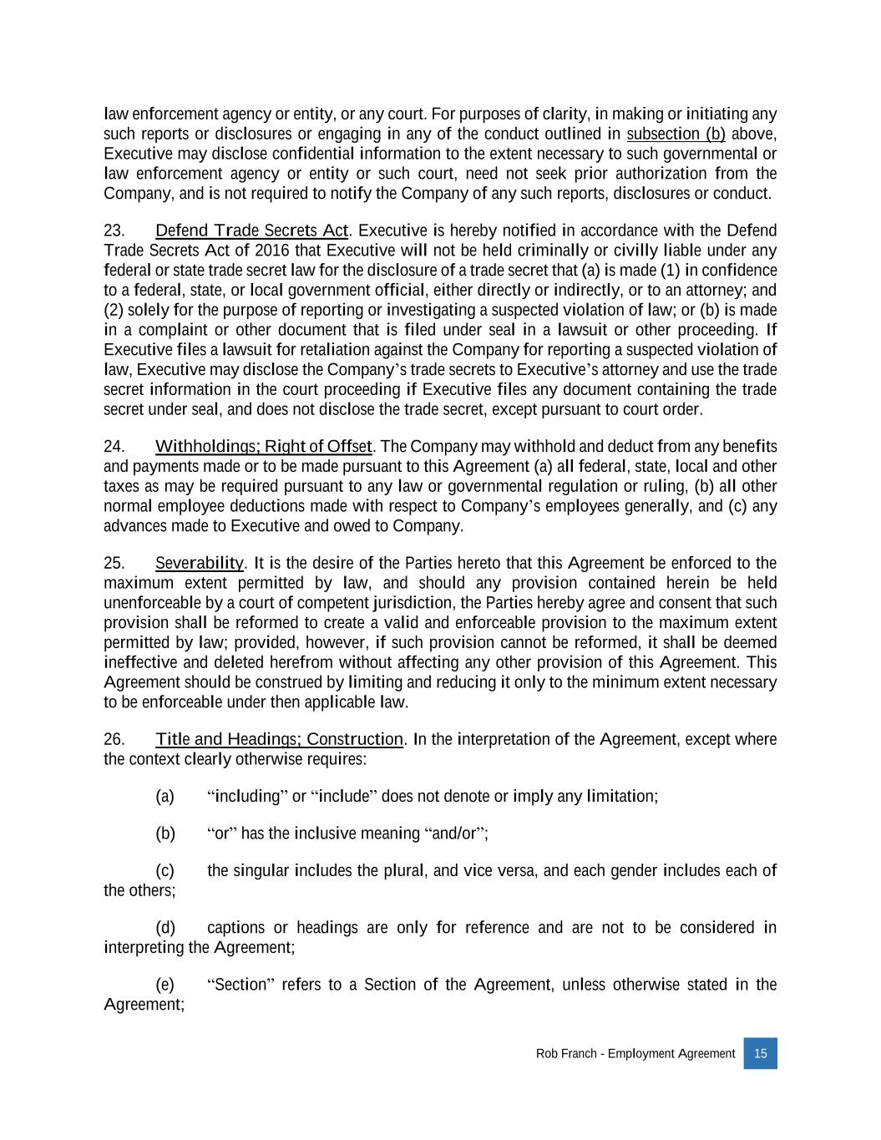
Rob Franch - Employment Agreement 15 law enforcement agency or entity, or any court. For purposes of clarity, in making or initiating any such reports or disclosures or engaging in any of the conduct outlined in subsection (b) above, Executive may disclose confidential information to the extent necessary to such governmental or law enforcement agency or entity or such court, need not seek prior authorization from the Company, and is not required to notify the Company of any such reports, disclosures or conduct. 23. Defend Trade Secrets Act. Executive is hereby notified in accordance with the Defend Trade Secrets Act of 2016 that Executive will not be held criminally or civilly liable under any federal or state trade secret law for the disclosure of a trade secret that (a) is made (1) in confidence to a federal, state, or local government official, either directly or indirectly, or to an attorney; and (2) solely for the purpose of reporting or investigating a suspected violation of law; or (b) is made in a complaint or other document that is filed under seal in a lawsuit or other proceeding. If Executive files a lawsuit for retaliation against the Company for reporting a suspected violation of law, Executive may disclose the Company’s trade secrets to Executive’s attorney and use the trade secret information in the court proceeding if Executive files any document containing the trade secret under seal, and does not disclose the trade secret, except pursuant to court order. 24. Withholdings; Right of Offset. The Company may withhold and deduct from any benefits and payments made or to be made pursuant to this Agreement (a) all federal, state, local and other taxes as may be required pursuant to any law or governmental regulation or ruling, (b) all other normal employee deductions made with respect to Company’s employees generally, and (c) any advances made to Executive and owed to Company. 25. Severability. It is the desire of the Parties hereto that this Agreement be enforced to the maximum extent permitted by law, and should any provision contained herein be held unenforceable by a court of competent jurisdiction, the Parties hereby agree and consent that such provision shall be reformed to create a valid and enforceable provision to the maximum extent permitted by law; provided, however, if such provision cannot be reformed, it shall be deemed ineffective and deleted herefrom without affecting any other provision of this Agreement. This Agreement should be construed by limiting and reducing it only to the minimum extent necessary to be enforceable under then applicable law. 26. Title and Headings; Construction. In the interpretation of the Agreement, except where the context clearly otherwise requires: (a) “including” or “include” does not denote or imply any limitation; (b) “or” has the inclusive meaning “and/or”; (c) the singular includes the plural, and vice versa, and each gender includes each of the others; (d) captions or headings are only for reference and are not to be considered in interpreting the Agreement; (e) “Section” refers to a Section of the Agreement, unless otherwise stated in the Agreement;

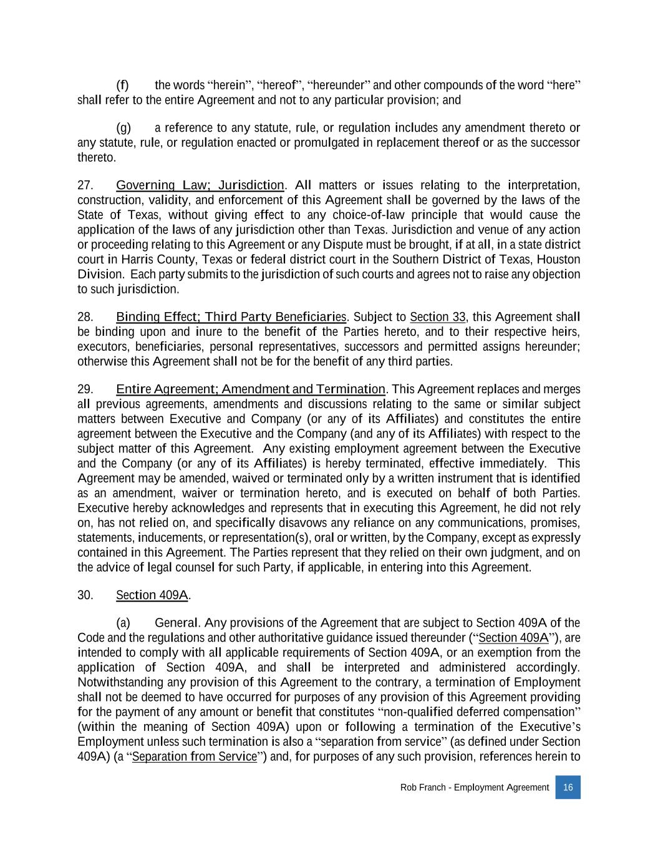
Rob Franch - Employment Agreement 16 (f) the words “herein”, “hereof”, “hereunder” and other compounds of the word “here” shall refer to the entire Agreement and not to any particular provision; and (g) a reference to any statute, rule, or regulation includes any amendment thereto or any statute, rule, or regulation enacted or promulgated in replacement thereof or as the successor thereto. 27. Governing Law; Jurisdiction. All matters or issues relating to the interpretation, construction, validity, and enforcement of this Agreement shall be governed by the laws of the State of Texas, without giving effect to any choice-of-law principle that would cause the application of the laws of any jurisdiction other than Texas. Jurisdiction and venue of any action or proceeding relating to this Agreement or any Dispute must be brought, if at all, in a state district court in Harris County, Texas or federal district court in the Southern District of Texas, Houston Division. Each party submits to the jurisdiction of such courts and agrees not to raise any objection to such jurisdiction. 28. Binding Effect; Third Party Beneficiaries. Subject to Section 33, this Agreement shall be binding upon and inure to the benefit of the Parties hereto, and to their respective heirs, executors, beneficiaries, personal representatives, successors and permitted assigns hereunder; otherwise this Agreement shall not be for the benefit of any third parties. 29. Entire Agreement; Amendment and Termination. This Agreement replaces and merges all previous agreements, amendments and discussions relating to the same or similar subject matters between Executive and Company (or any of its Affiliates) and constitutes the entire agreement between the Executive and the Company (and any of its Affiliates) with respect to the subject matter of this Agreement. Any existing employment agreement between the Executive and the Company (or any of its Affiliates) is hereby terminated, effective immediately. This Agreement may be amended, waived or terminated only by a written instrument that is identified as an amendment, waiver or termination hereto, and is executed on behalf of both Parties. Executive hereby acknowledges and represents that in executing this Agreement, he did not rely on, has not relied on, and specifically disavows any reliance on any communications, promises, statements, inducements, or representation(s), oral or written, by the Company, except as expressly contained in this Agreement. The Parties represent that they relied on their own judgment, and on the advice of legal counsel for such Party, if applicable, in entering into this Agreement. 30. Section 409A. (a) General. Any provisions of the Agreement that are subject to Section 409A of the Code and the regulations and other authoritative guidance issued thereunder (“Section 409A”), are intended to comply with all applicable requirements of Section 409A, or an exemption from the application of Section 409A, and shall be interpreted and administered accordingly. Notwithstanding any provision of this Agreement to the contrary, a termination of Employment shall not be deemed to have occurred for purposes of any provision of this Agreement providing for the payment of any amount or benefit that constitutes “non-qualified deferred compensation” (within the meaning of Section 409A) upon or following a termination of the Executive’s Employment unless such termination is also a “separation from service” (as defined under Section 409A) (a “Separation from Service”) and, for purposes of any such provision, references herein to

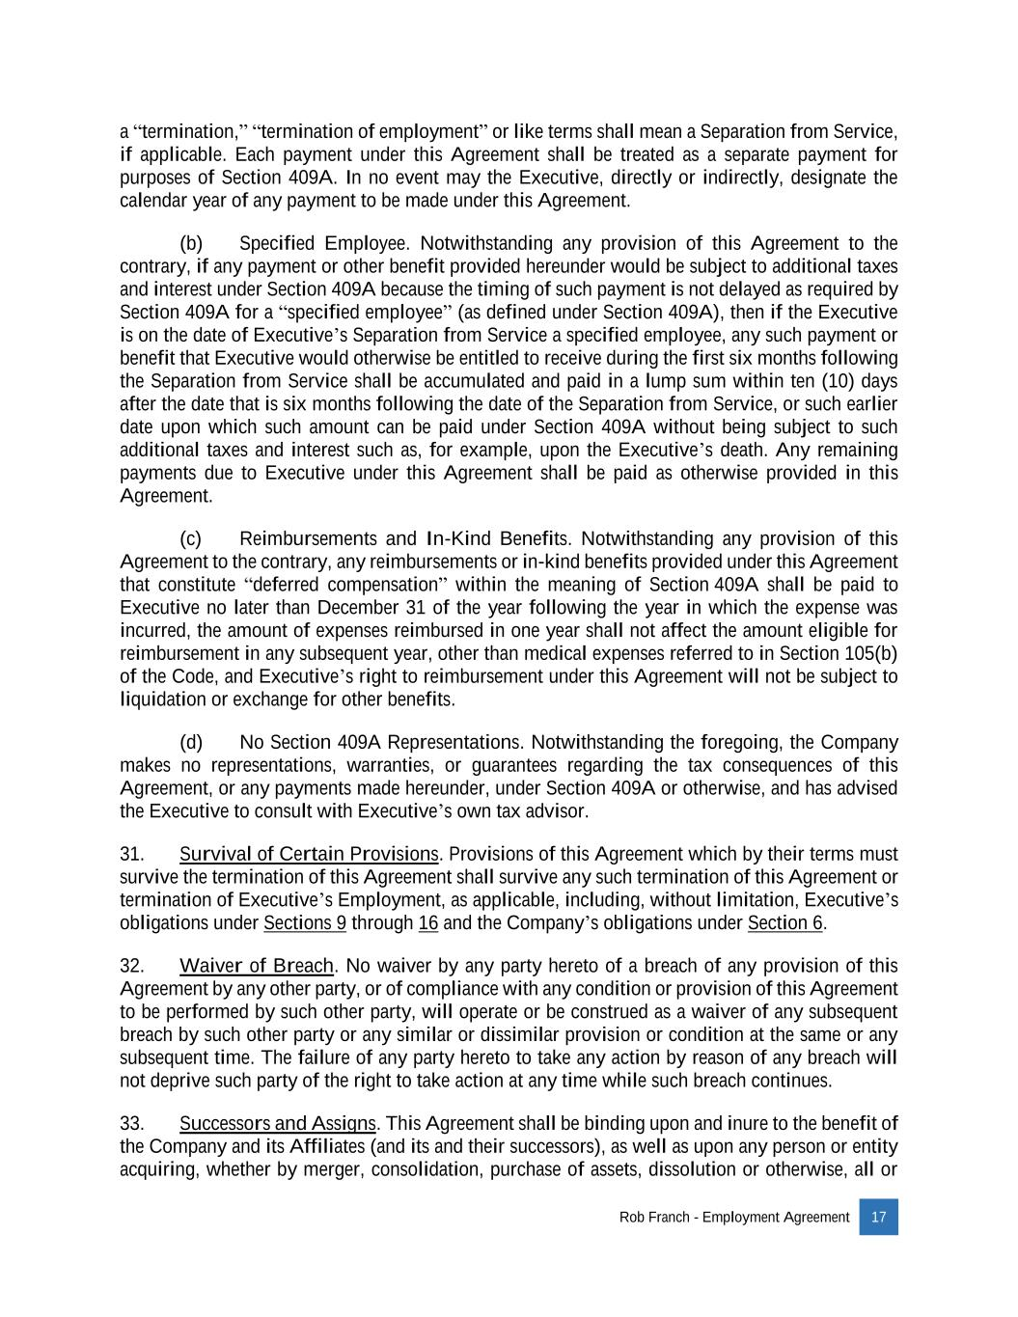
Rob Franch - Employment Agreement 17 a “termination,” “termination of employment” or like terms shall mean a Separation from Service, if applicable. Each payment under this Agreement shall be treated as a separate payment for purposes of Section 409A. In no event may the Executive, directly or indirectly, designate the calendar year of any payment to be made under this Agreement. (b) Specified Employee. Notwithstanding any provision of this Agreement to the contrary, if any payment or other benefit provided hereunder would be subject to additional taxes and interest under Section 409A because the timing of such payment is not delayed as required by Section 409A for a “specified employee” (as defined under Section 409A), then if the Executive is on the date of Executive’s Separation from Service a specified employee, any such payment or benefit that Executive would otherwise be entitled to receive during the first six months following the Separation from Service shall be accumulated and paid in a lump sum within ten (10) days after the date that is six months following the date of the Separation from Service, or such earlier date upon which such amount can be paid under Section 409A without being subject to such additional taxes and interest such as, for example, upon the Executive’s death. Any remaining payments due to Executive under this Agreement shall be paid as otherwise provided in this Agreement. (c) Reimbursements and In-Kind Benefits. Notwithstanding any provision of this Agreement to the contrary, any reimbursements or in-kind benefits provided under this Agreement that constitute “deferred compensation” within the meaning of Section 409A shall be paid to Executive no later than December 31 of the year following the year in which the expense was incurred, the amount of expenses reimbursed in one year shall not affect the amount eligible for reimbursement in any subsequent year, other than medical expenses referred to in Section 105(b) of the Code, and Executive’s right to reimbursement under this Agreement will not be subject to liquidation or exchange for other benefits. (d) No Section 409A Representations. Notwithstanding the foregoing, the Company makes no representations, warranties, or guarantees regarding the tax consequences of this Agreement, or any payments made hereunder, under Section 409A or otherwise, and has advised the Executive to consult with Executive’s own tax advisor. 31. Survival of Certain Provisions. Provisions of this Agreement which by their terms must survive the termination of this Agreement shall survive any such termination of this Agreement or termination of Executive’s Employment, as applicable, including, without limitation, Executive’s obligations under Sections 9 through 16 and the Company’s obligations under Section 6. 32. Waiver of Breach. No waiver by any party hereto of a breach of any provision of this Agreement by any other party, or of compliance with any condition or provision of this Agreement to be performed by such other party, will operate or be construed as a waiver of any subsequent breach by such other party or any similar or dissimilar provision or condition at the same or any subsequent time. The failure of any party hereto to take any action by reason of any breach will not deprive such party of the right to take action at any time while such breach continues. 33. Successors and Assigns. This Agreement shall be binding upon and inure to the benefit of the Company and its Affiliates (and its and their successors), as well as upon any person or entity acquiring, whether by merger, consolidation, purchase of assets, dissolution or otherwise, all or

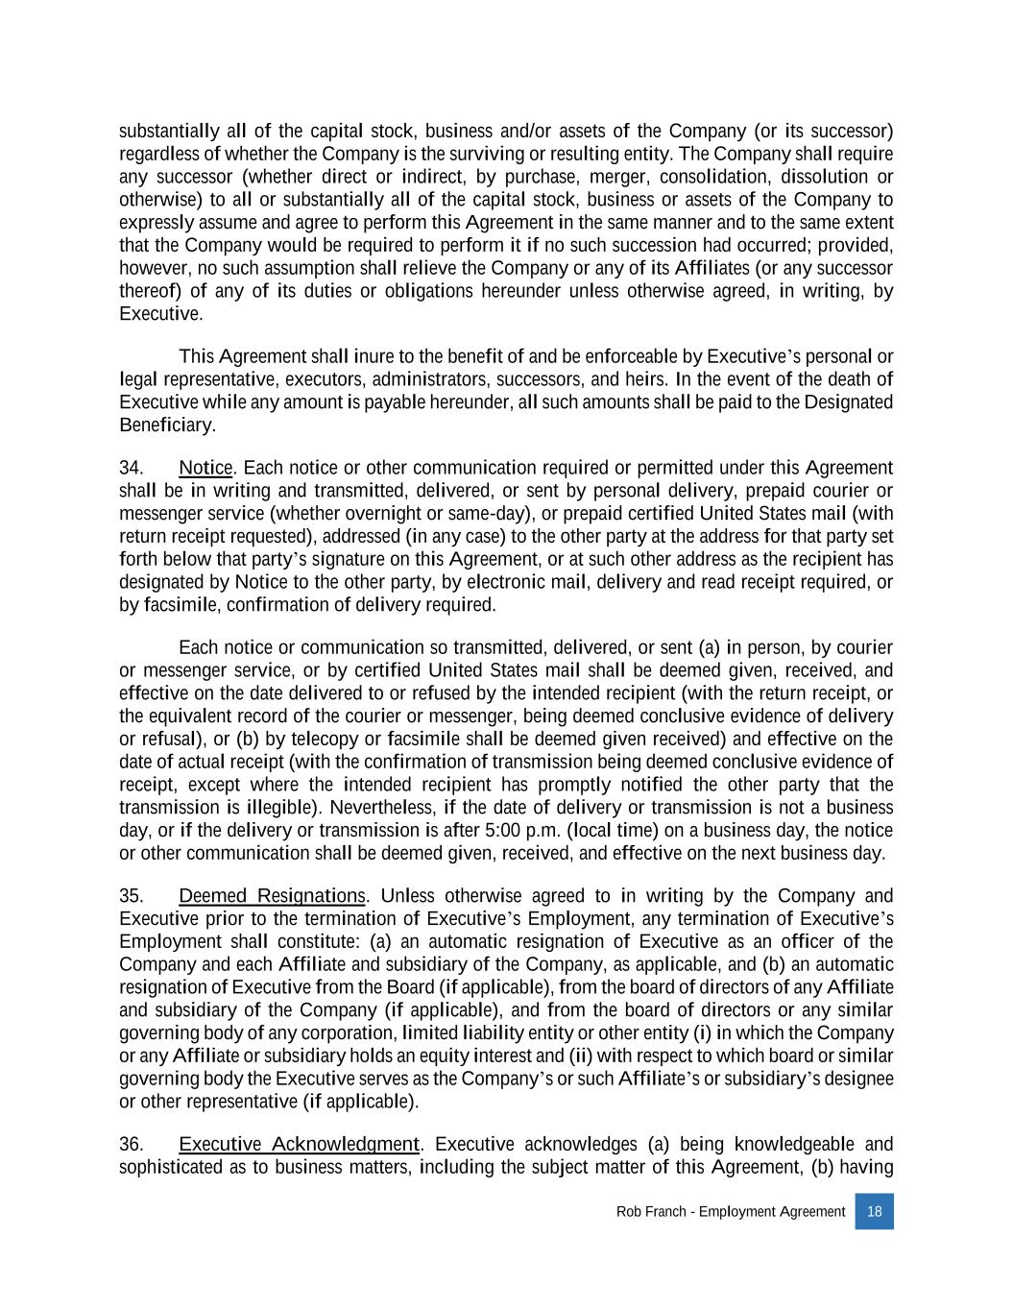
Rob Franch - Employment Agreement 18 substantially all of the capital stock, business and/or assets of the Company (or its successor) regardless of whether the Company is the surviving or resulting entity. The Company shall require any successor (whether direct or indirect, by purchase, merger, consolidation, dissolution or otherwise) to all or substantially all of the capital stock, business or assets of the Company to expressly assume and agree to perform this Agreement in the same manner and to the same extent that the Company would be required to perform it if no such succession had occurred; provided, however, no such assumption shall relieve the Company or any of its Affiliates (or any successor thereof) of any of its duties or obligations hereunder unless otherwise agreed, in writing, by Executive. This Agreement shall inure to the benefit of and be enforceable by Executive’s personal or legal representative, executors, administrators, successors, and heirs. In the event of the death of Executive while any amount is payable hereunder, all such amounts shall be paid to the Designated Beneficiary. 34. Notice. Each notice or other communication required or permitted under this Agreement shall be in writing and transmitted, delivered, or sent by personal delivery, prepaid courier or messenger service (whether overnight or same-day), or prepaid certified United States mail (with return receipt requested), addressed (in any case) to the other party at the address for that party set forth below that party’s signature on this Agreement, or at such other address as the recipient has designated by Notice to the other party, by electronic mail, delivery and read receipt required, or by facsimile, confirmation of delivery required. Each notice or communication so transmitted, delivered, or sent (a) in person, by courier or messenger service, or by certified United States mail shall be deemed given, received, and effective on the date delivered to or refused by the intended recipient (with the return receipt, or the equivalent record of the courier or messenger, being deemed conclusive evidence of delivery or refusal), or (b) by telecopy or facsimile shall be deemed given received) and effective on the date of actual receipt (with the confirmation of transmission being deemed conclusive evidence of receipt, except where the intended recipient has promptly notified the other party that the transmission is illegible). Nevertheless, if the date of delivery or transmission is not a business day, or if the delivery or transmission is after 5:00 p.m. (local time) on a business day, the notice or other communication shall be deemed given, received, and effective on the next business day. 35. Deemed Resignations. Unless otherwise agreed to in writing by the Company and Executive prior to the termination of Executive’s Employment, any termination of Executive’s Employment shall constitute: (a) an automatic resignation of Executive as an officer of the Company and each Affiliate and subsidiary of the Company, as applicable, and (b) an automatic resignation of Executive from the Board (if applicable), from the board of directors of any Affiliate and subsidiary of the Company (if applicable), and from the board of directors or any similar governing body of any corporation, limited liability entity or other entity (i) in which the Company or any Affiliate or subsidiary holds an equity interest and (ii) with respect to which board or similar governing body the Executive serves as the Company’s or such Affiliate’s or subsidiary’s designee or other representative (if applicable). 36. Executive Acknowledgment. Executive acknowledges (a) being knowledgeable and sophisticated as to business matters, including the subject matter of this Agreement, (b) having

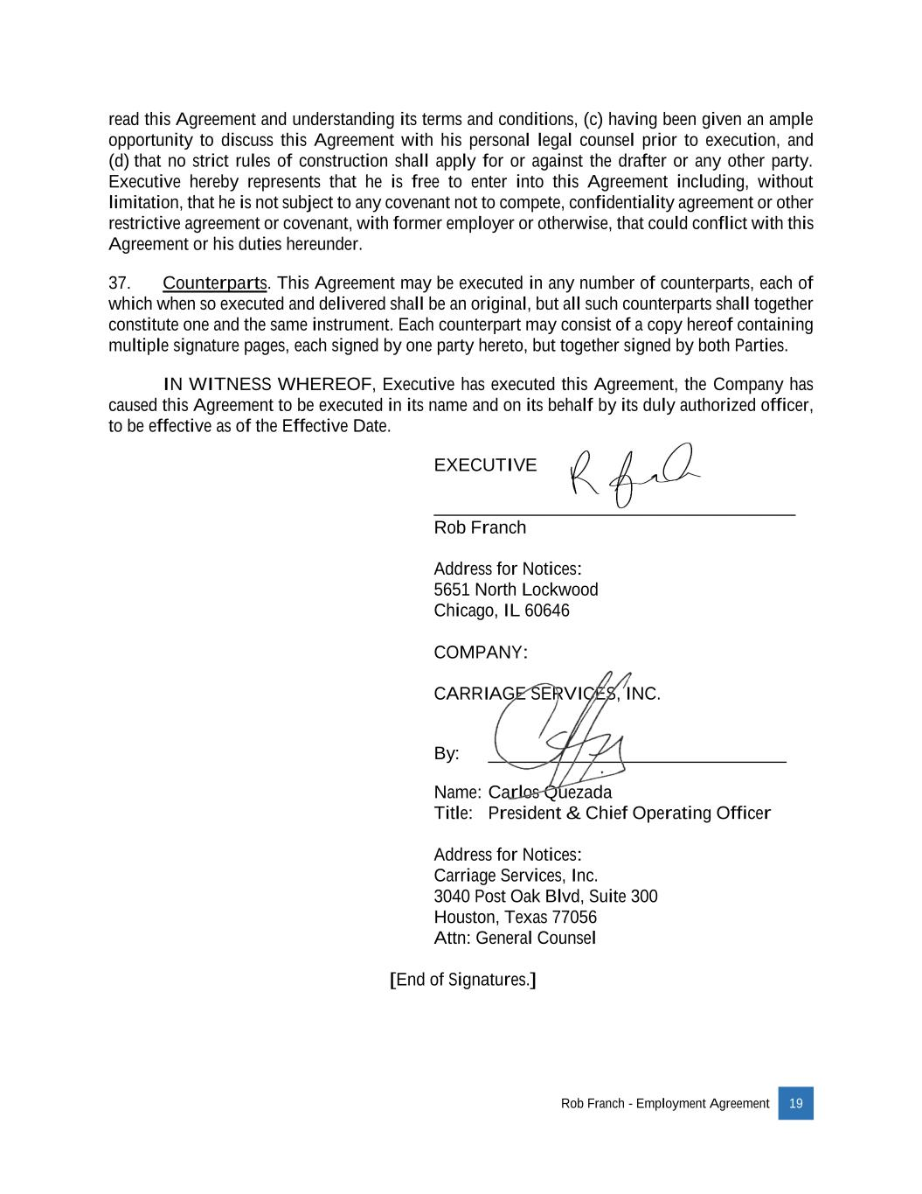
Rob Franch - Employment Agreement 19 read this Agreement and understanding its terms and conditions, (c) having been given an ample opportunity to discuss this Agreement with his personal legal counsel prior to execution, and (d) that no strict rules of construction shall apply for or against the drafter or any other party. Executive hereby represents that he is free to enter into this Agreement including, without limitation, that he is not subject to any covenant not to compete, confidentiality agreement or other restrictive agreement or covenant, with former employer or otherwise, that could conflict with this Agreement or his duties hereunder. 37. Counterparts. This Agreement may be executed in any number of counterparts, each of which when so executed and delivered shall be an original, but all such counterparts shall together constitute one and the same instrument. Each counterpart may consist of a copy hereof containing multiple signature pages, each signed by one party hereto, but together signed by both Parties. IN WITNESS WHEREOF, Executive has executed this Agreement, the Company has caused this Agreement to be executed in its name and on its behalf by its duly authorized officer, to be effective as of the Effective Date. EXECUTIVE: ________________________________________ Rob Franch Address for Notices: 5651 North Lockwood Chicago, IL 60646 COMPANY: CARRIAGE SERVICES, INC. By: _________________________________ Name: Carlos Quezada Title: President & Chief Operating Officer Address for Notices: Carriage Services, Inc. 3040 Post Oak Blvd, Suite 300 Houston, Texas 77056 Attn: General Counsel [End of Signatures.]

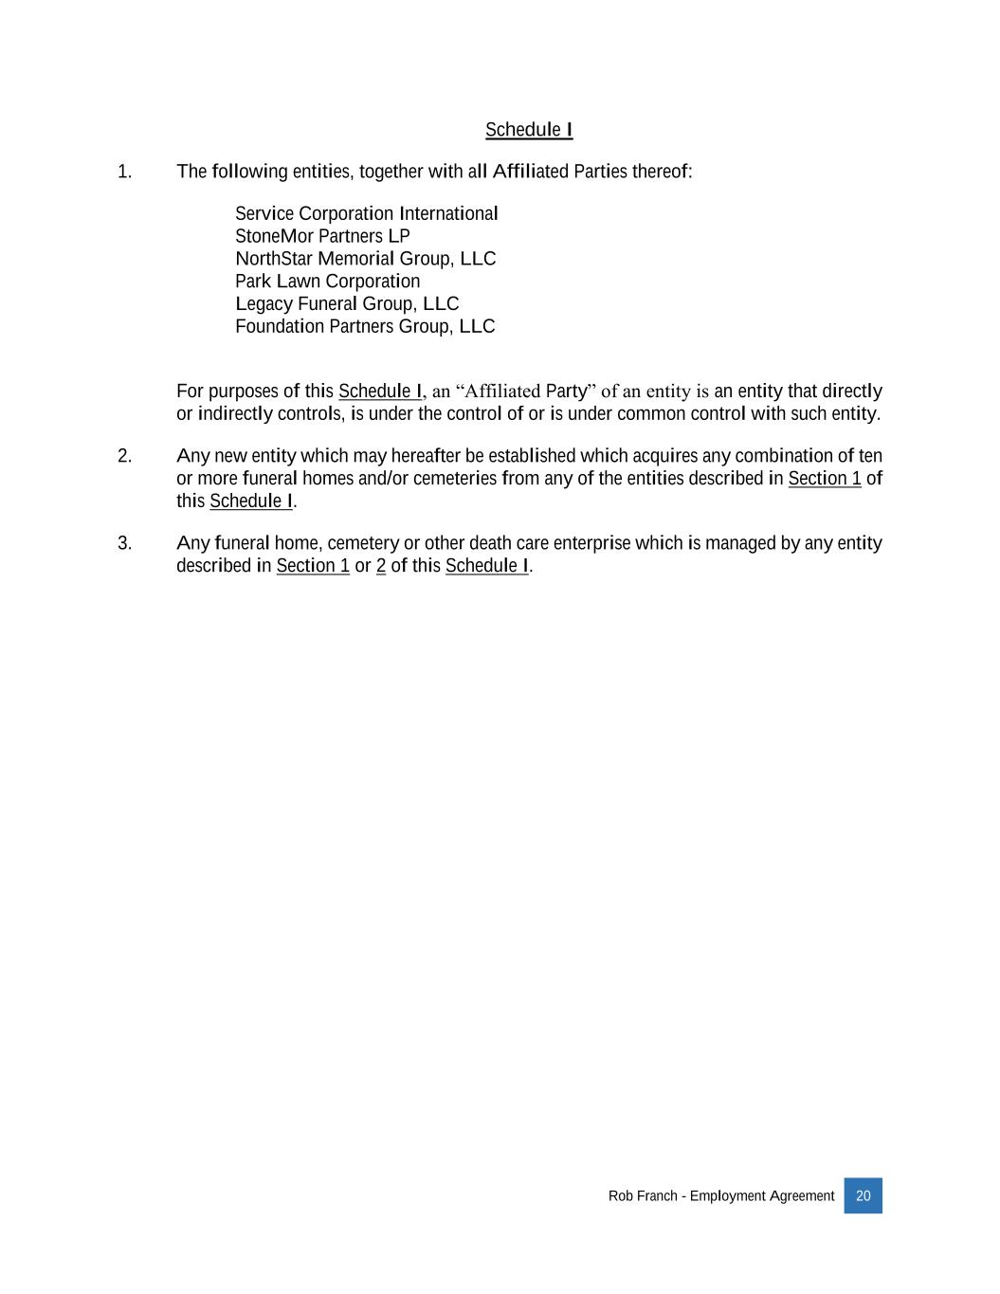
Rob Franch - Employment Agreement 20 Schedule I 1. The following entities, together with all Affiliated Parties thereof: Service Corporation International StoneMor Partners LP NorthStar Memorial Group, LLC Park Lawn Corporation Legacy Funeral Group, LLC Foundation Partners Group, LLC For purposes of this Schedule I, an “Affiliated Party” of an entity is an entity that directly or indirectly controls, is under the control of or is under common control with such entity. 2. Any new entity which may hereafter be established which acquires any combination of ten or more funeral homes and/or cemeteries from any of the entities described in Section 1 of this Schedule I. 3. Any funeral home, cemetery or other death care enterprise which is managed by any entity described in Section 1 or 2 of this Schedule I.

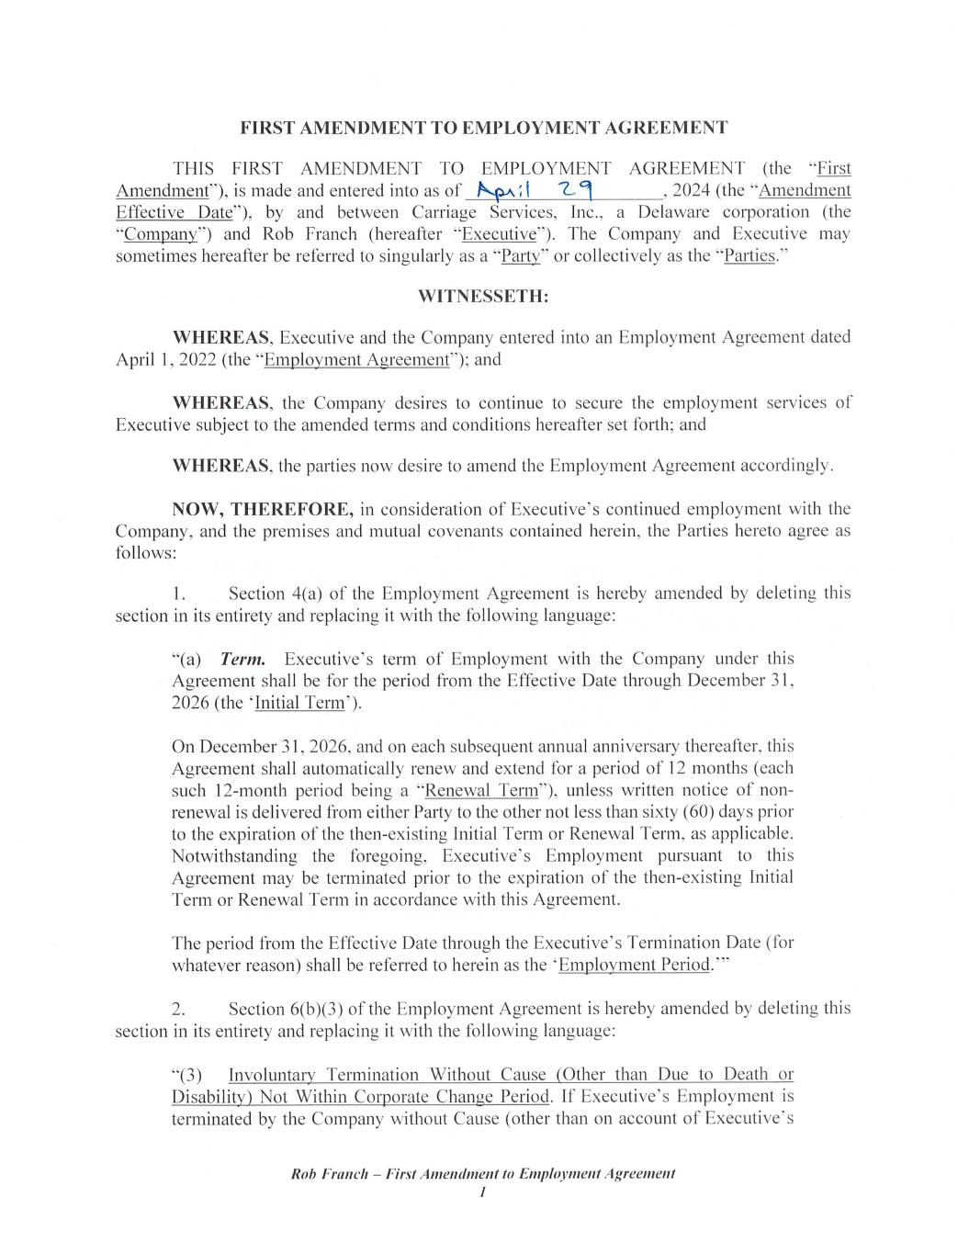

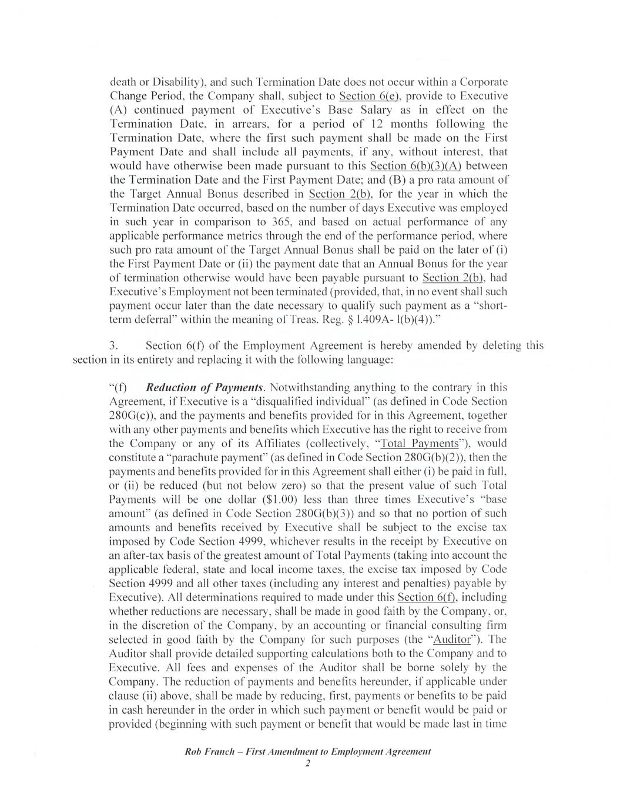

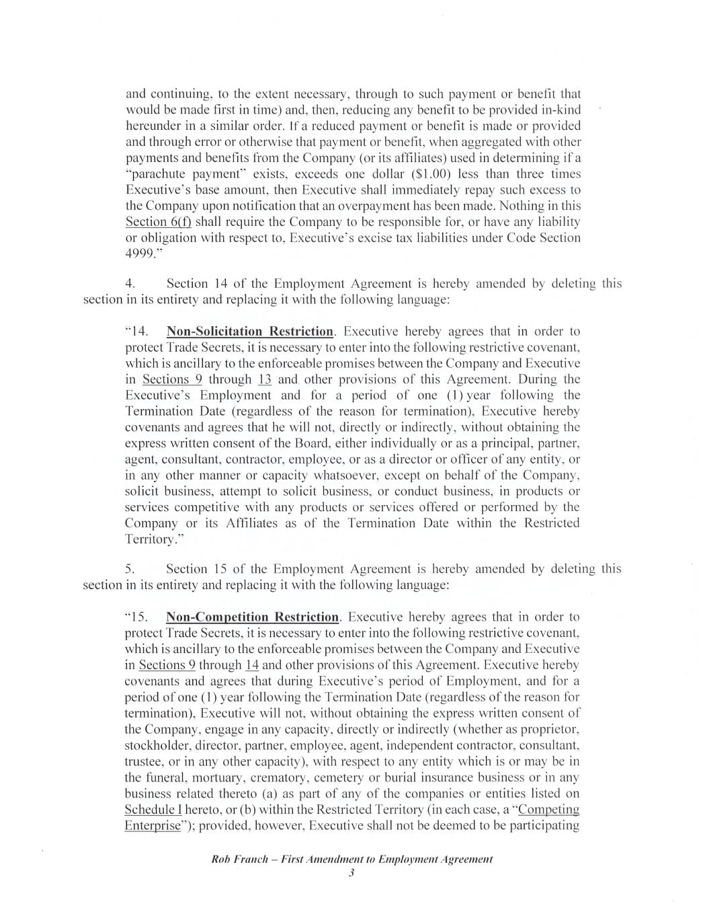

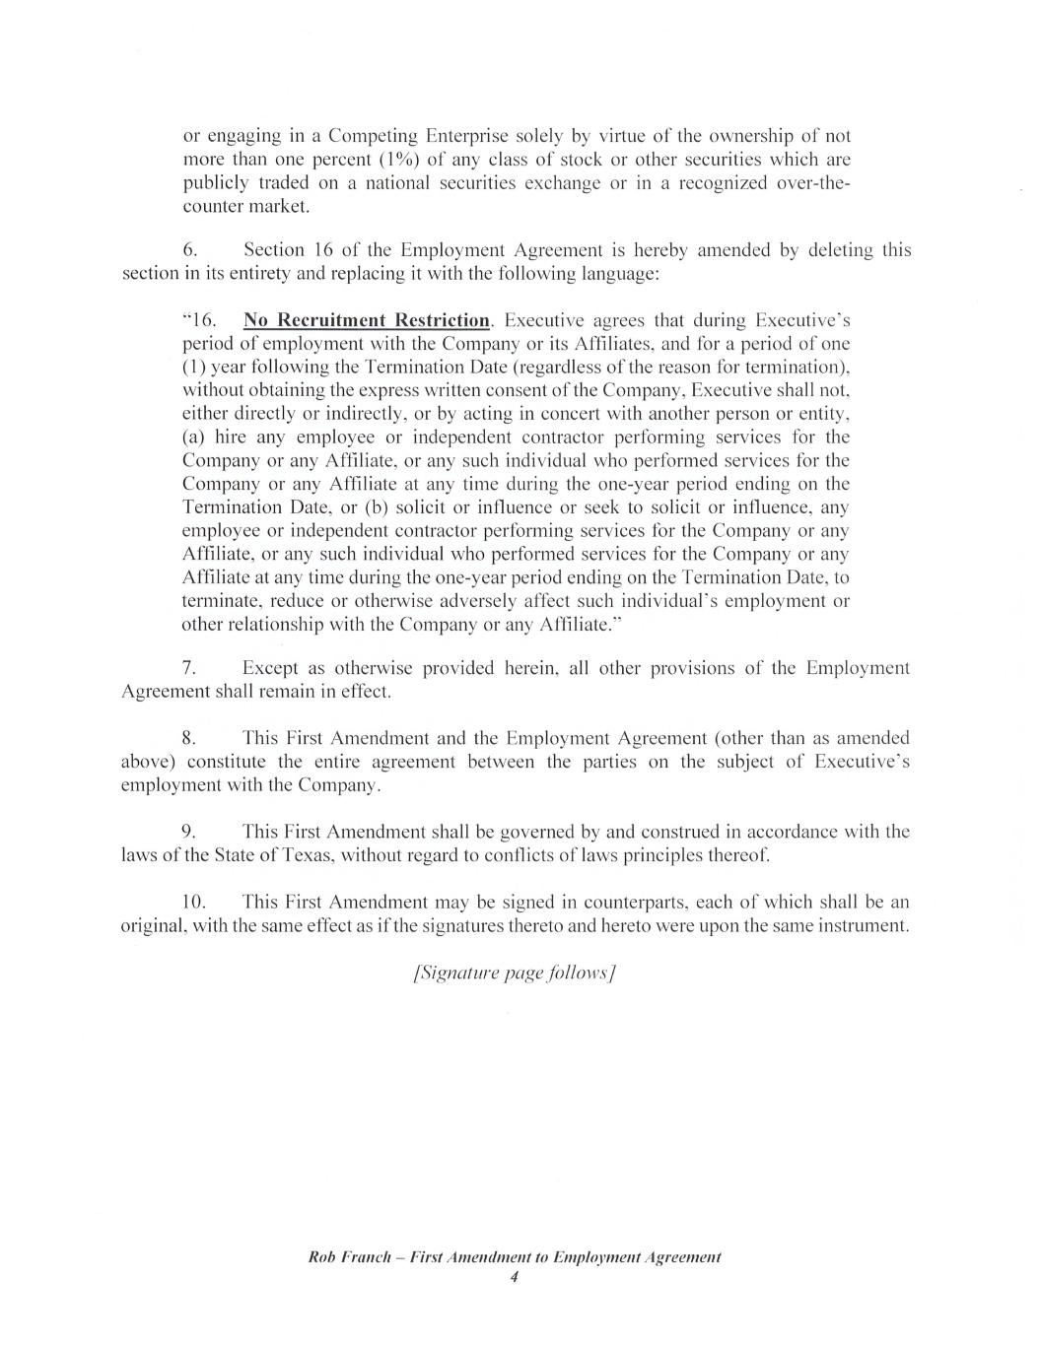

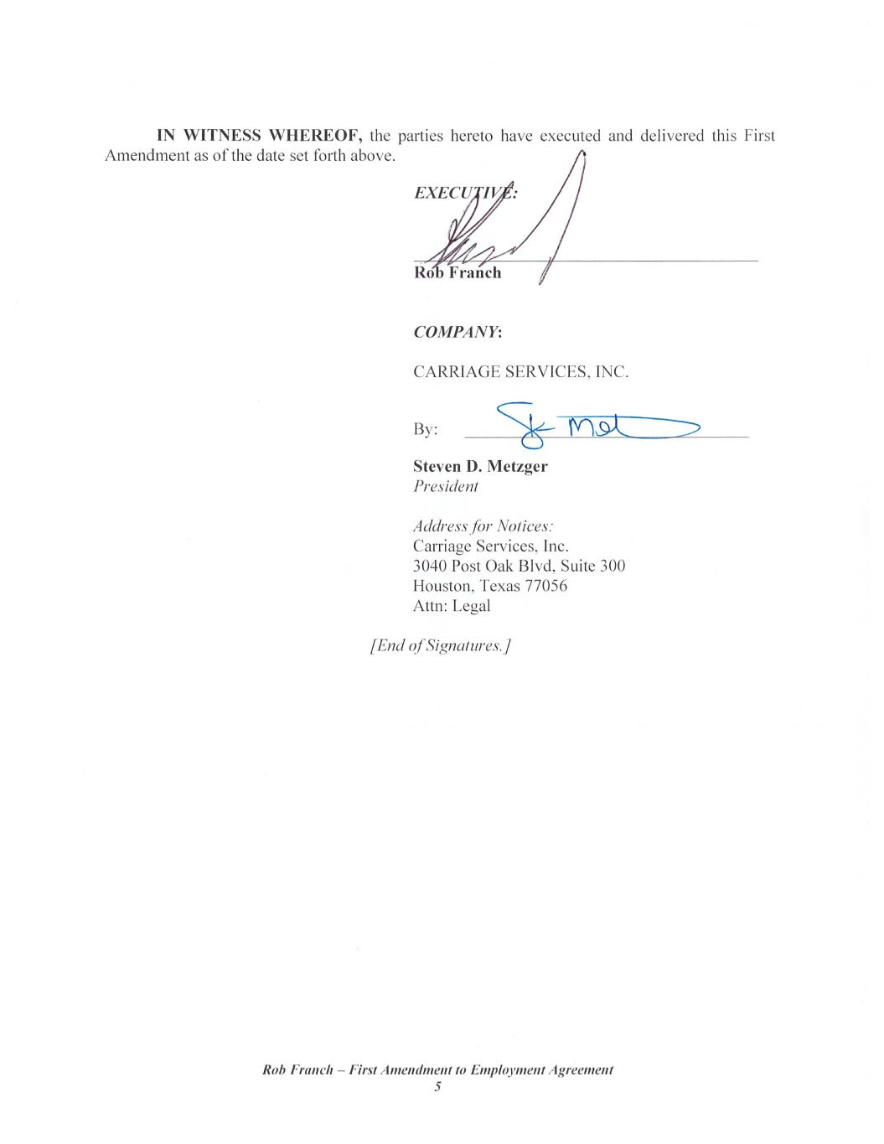

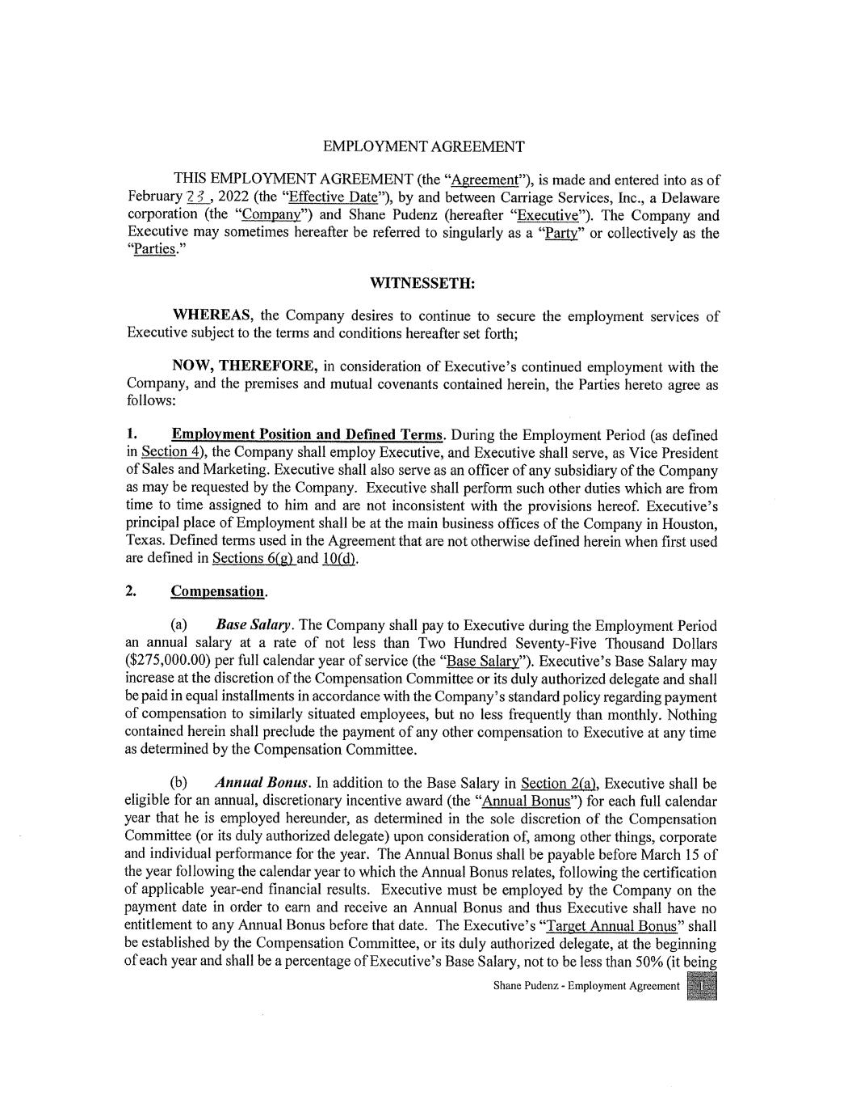

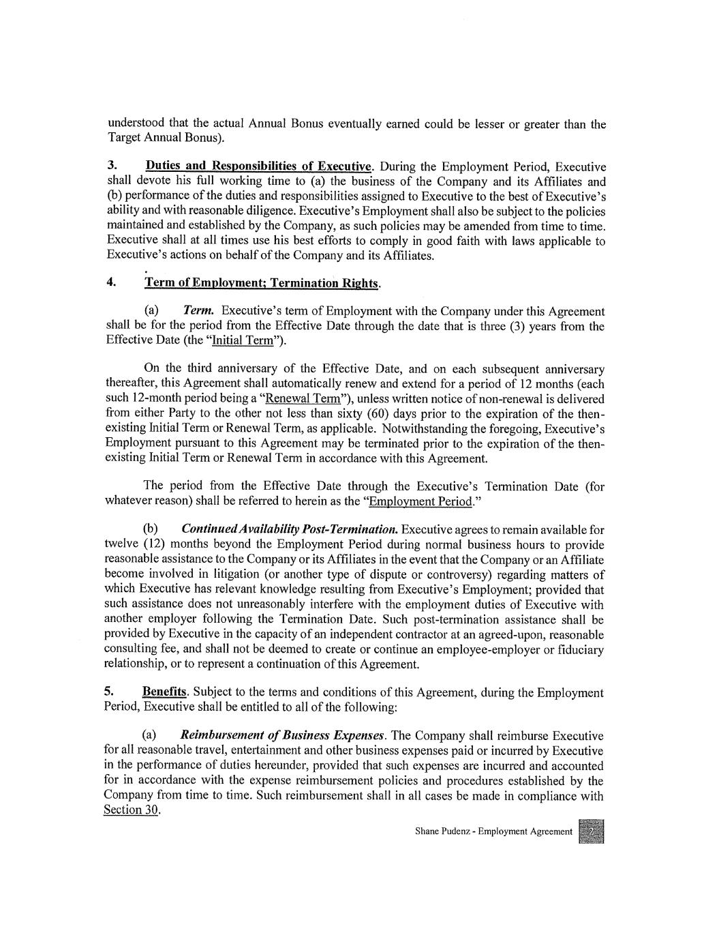

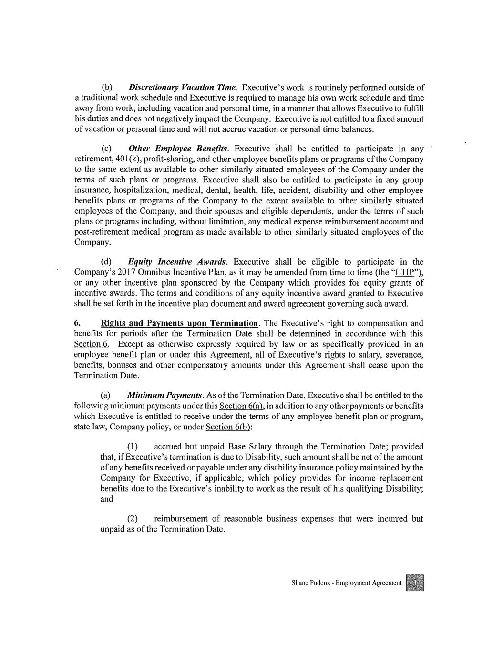

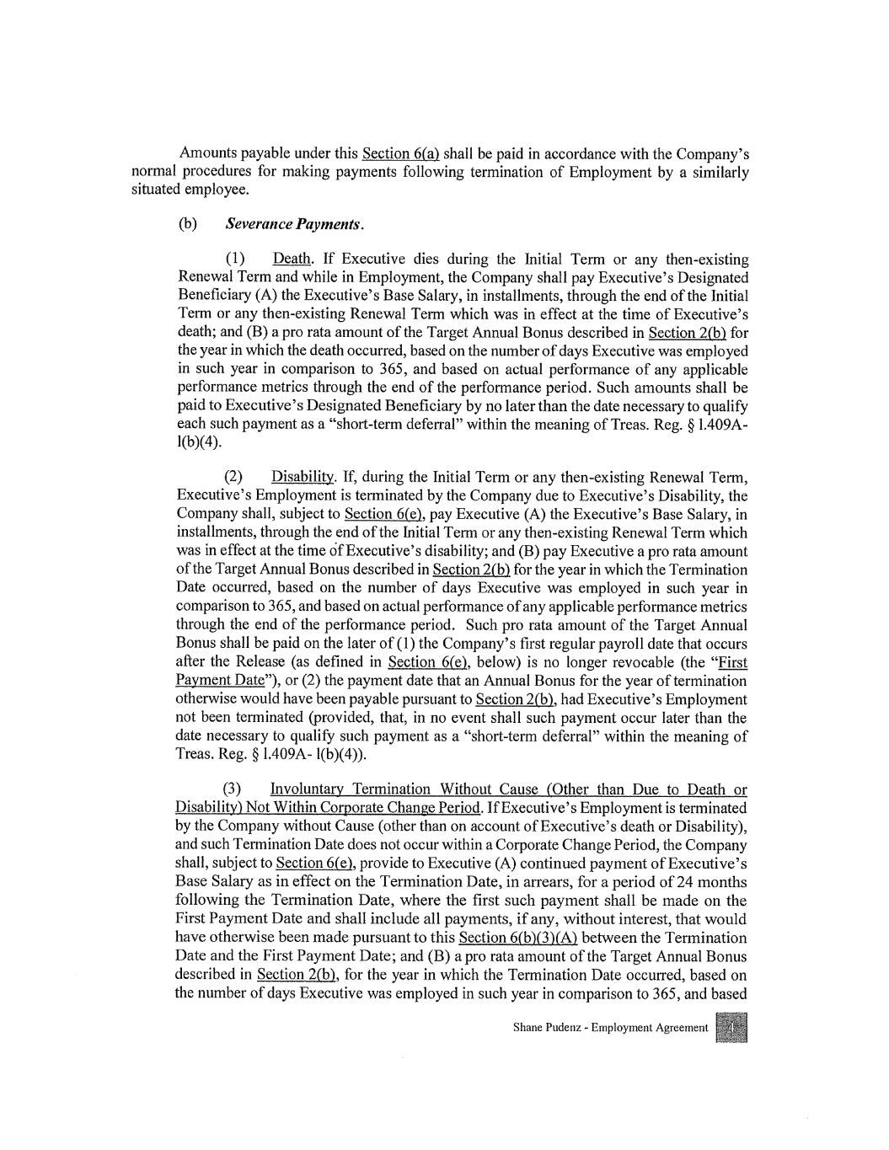

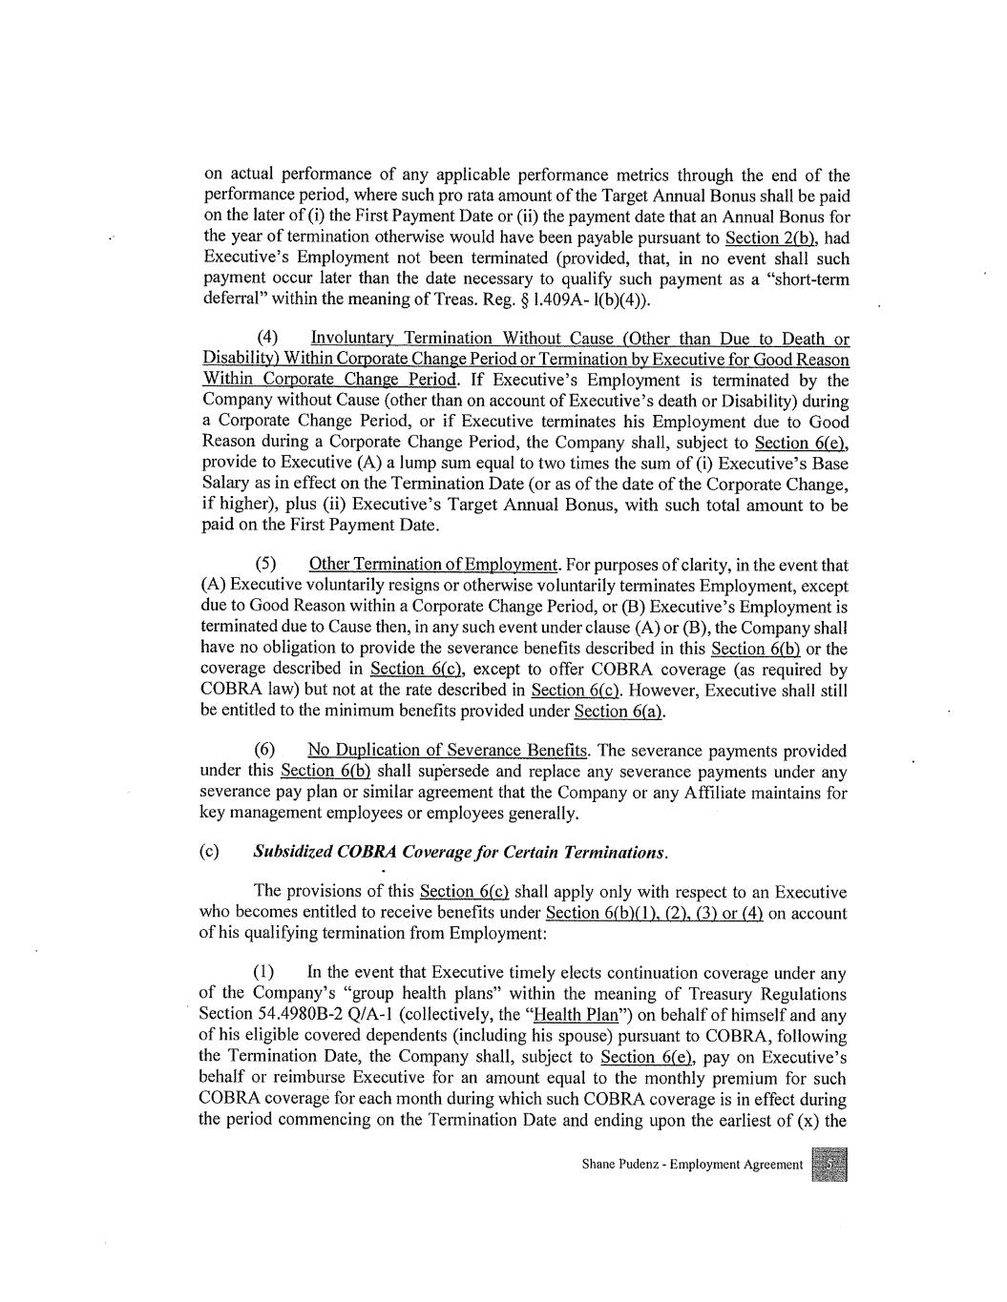

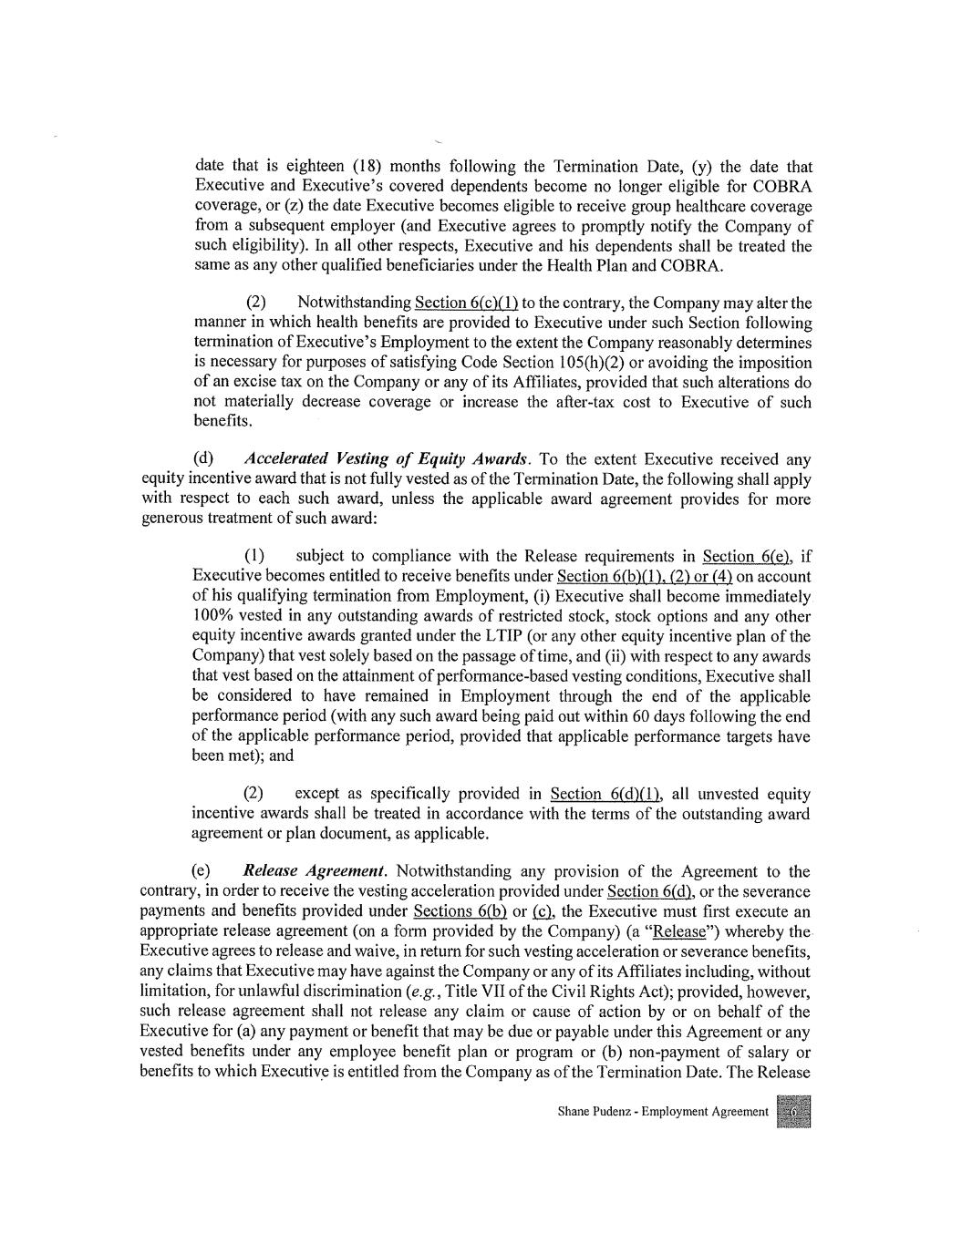

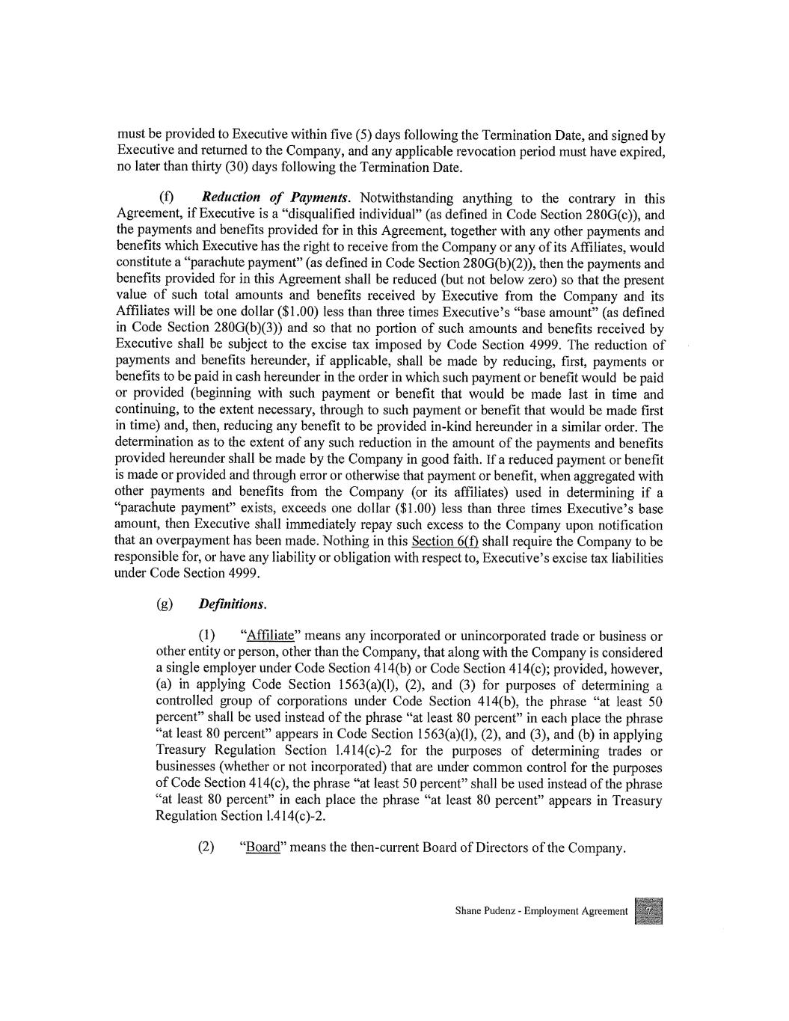

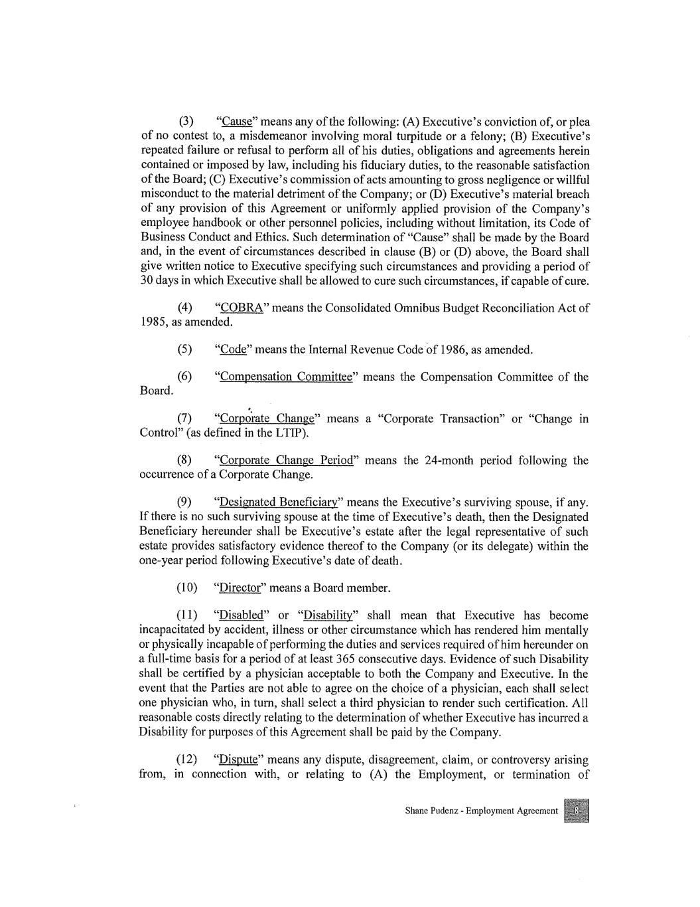

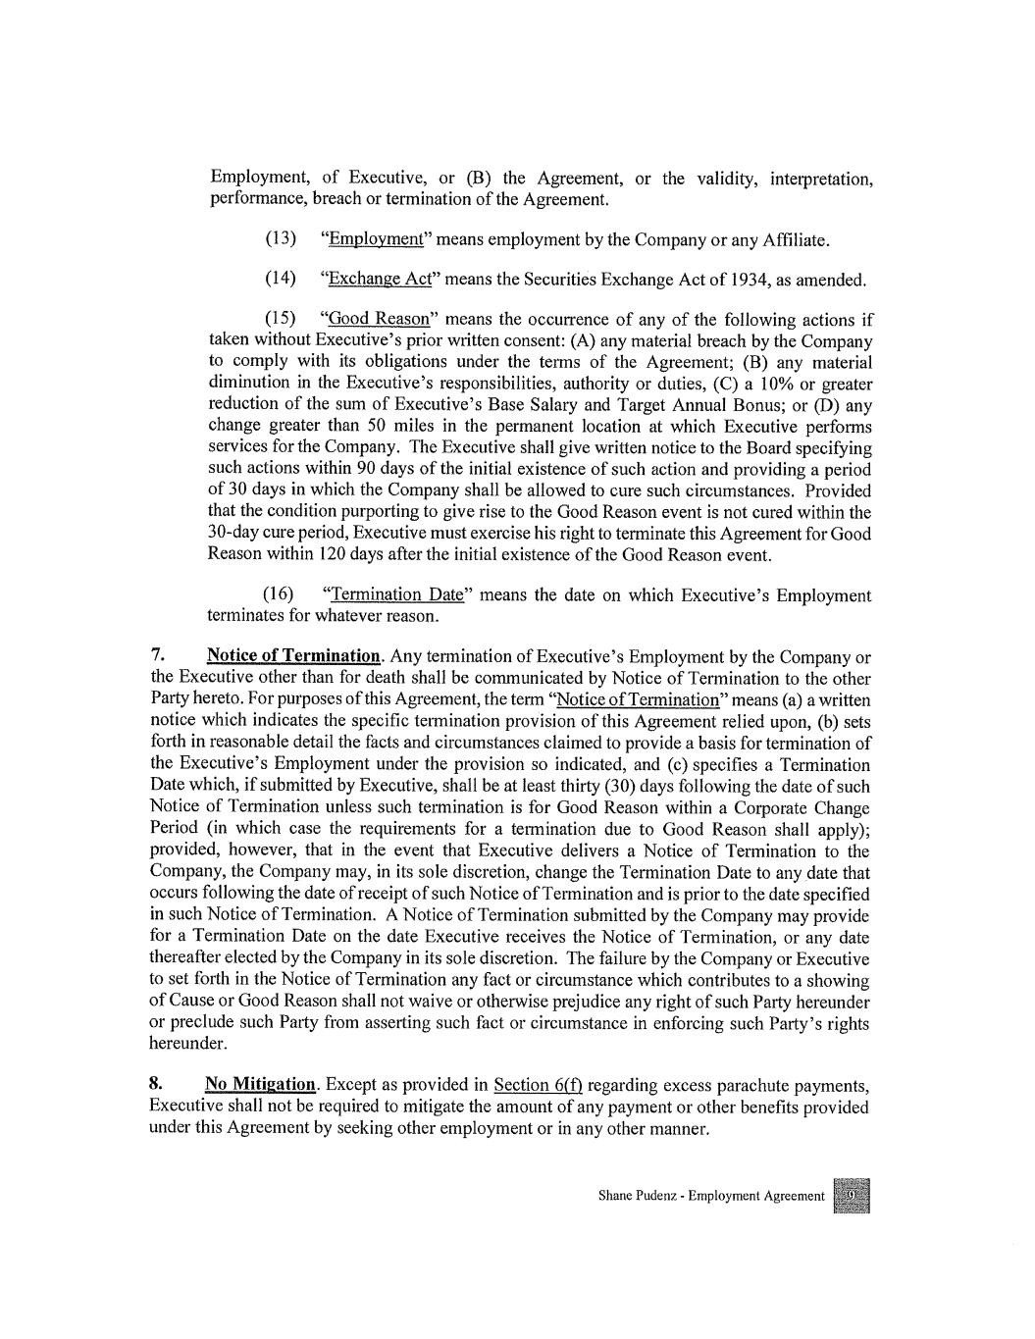

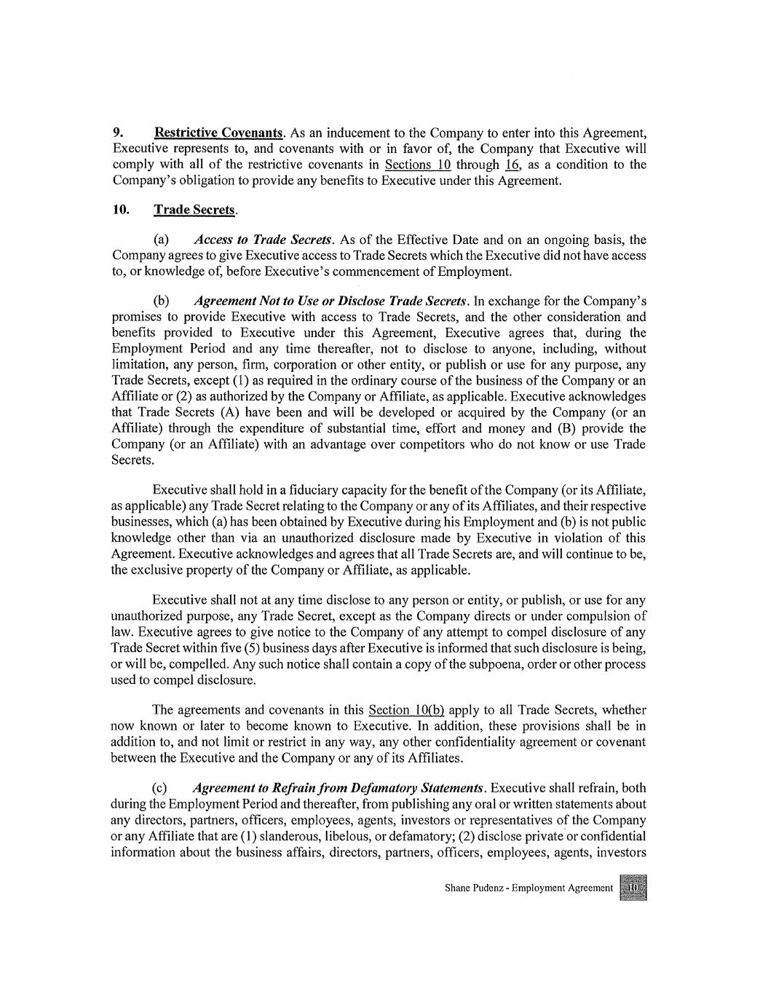

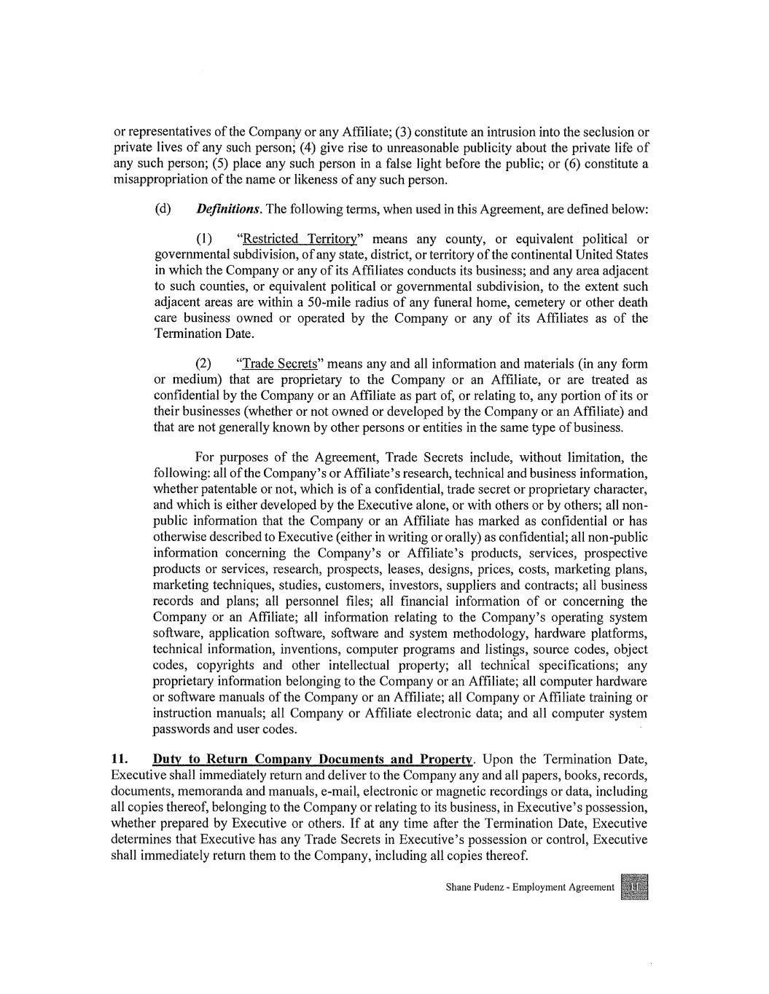

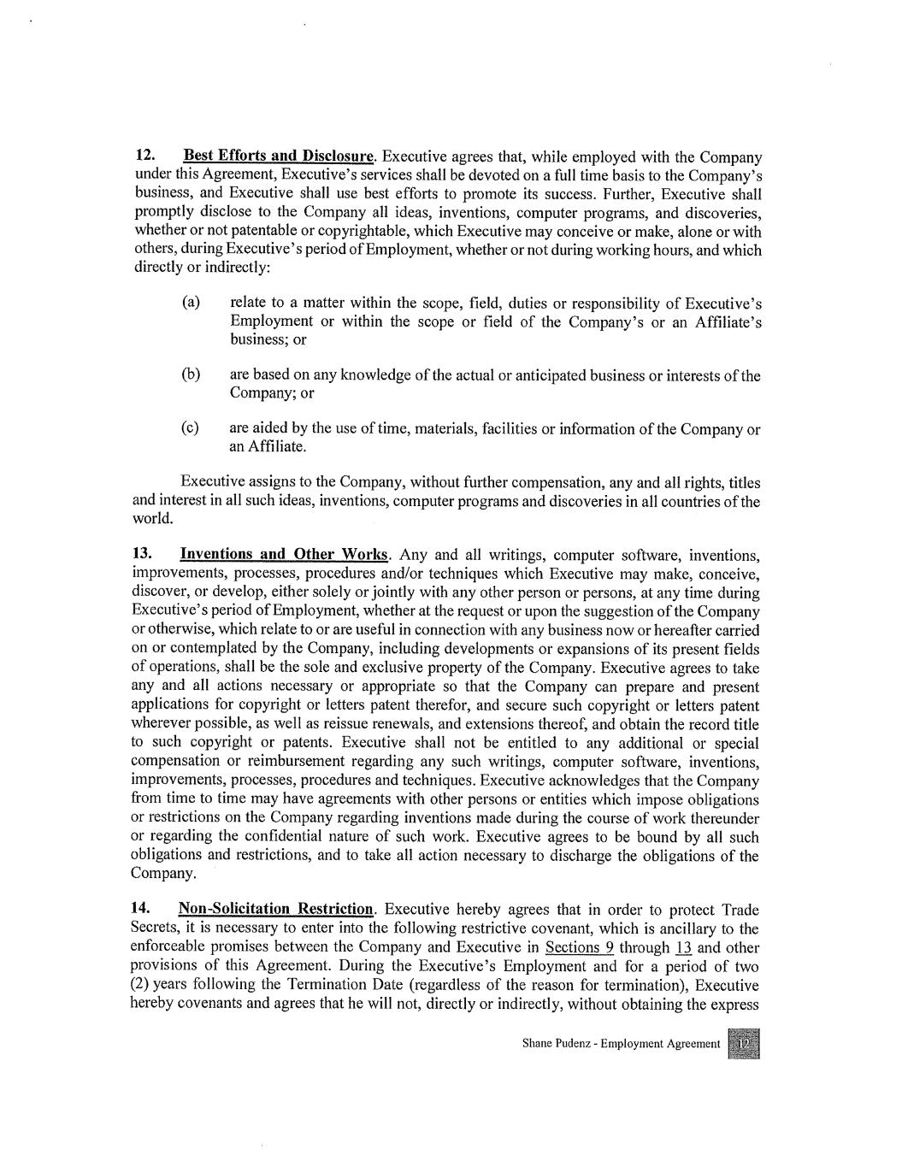

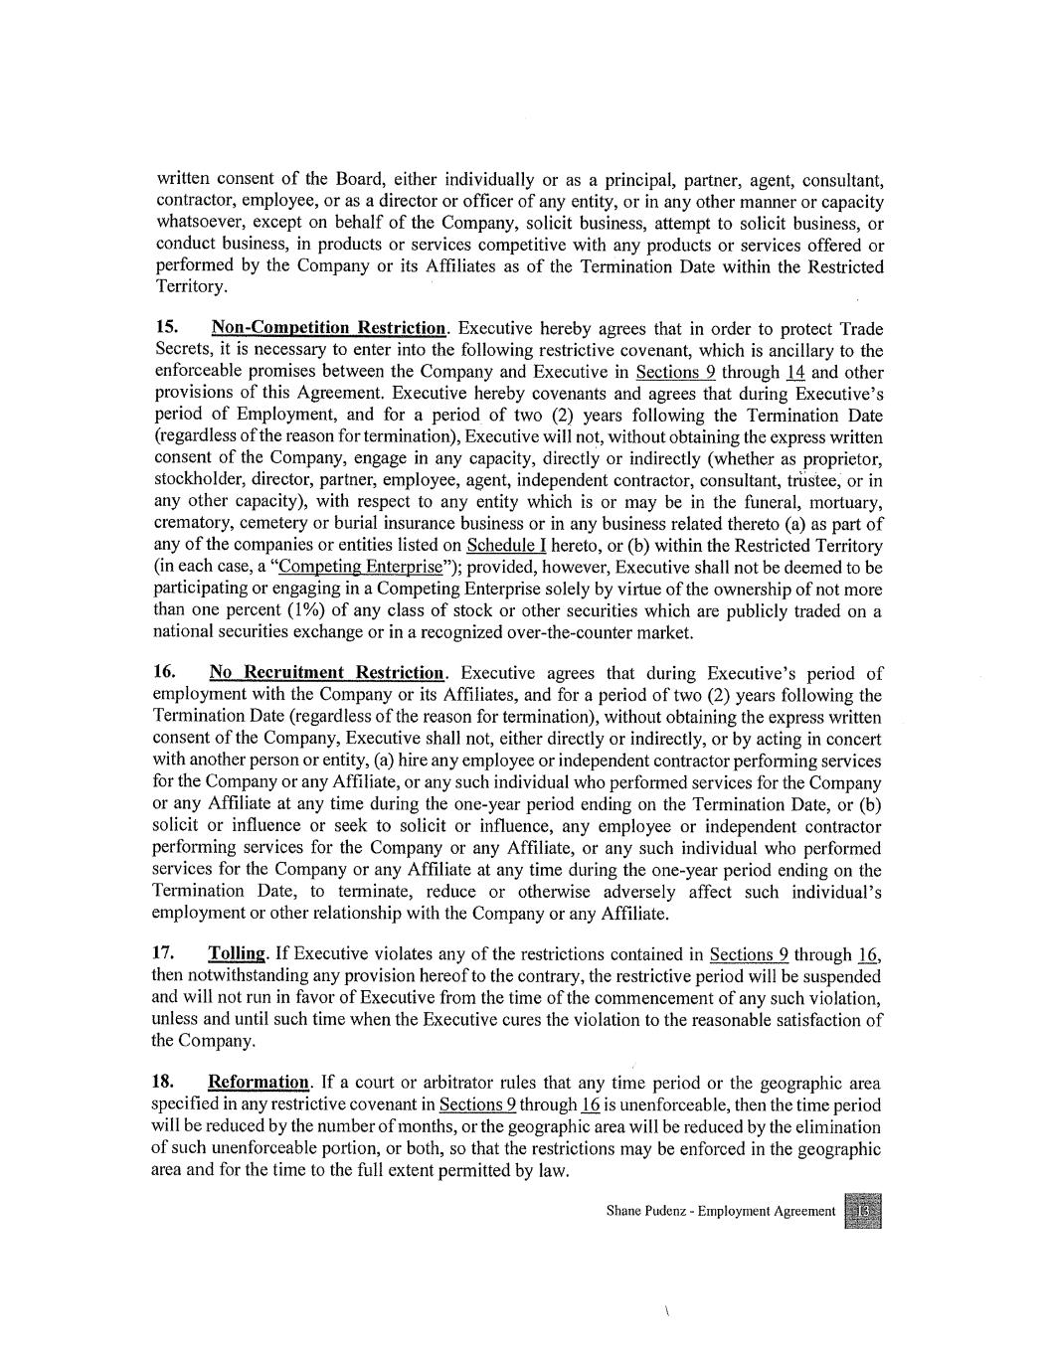

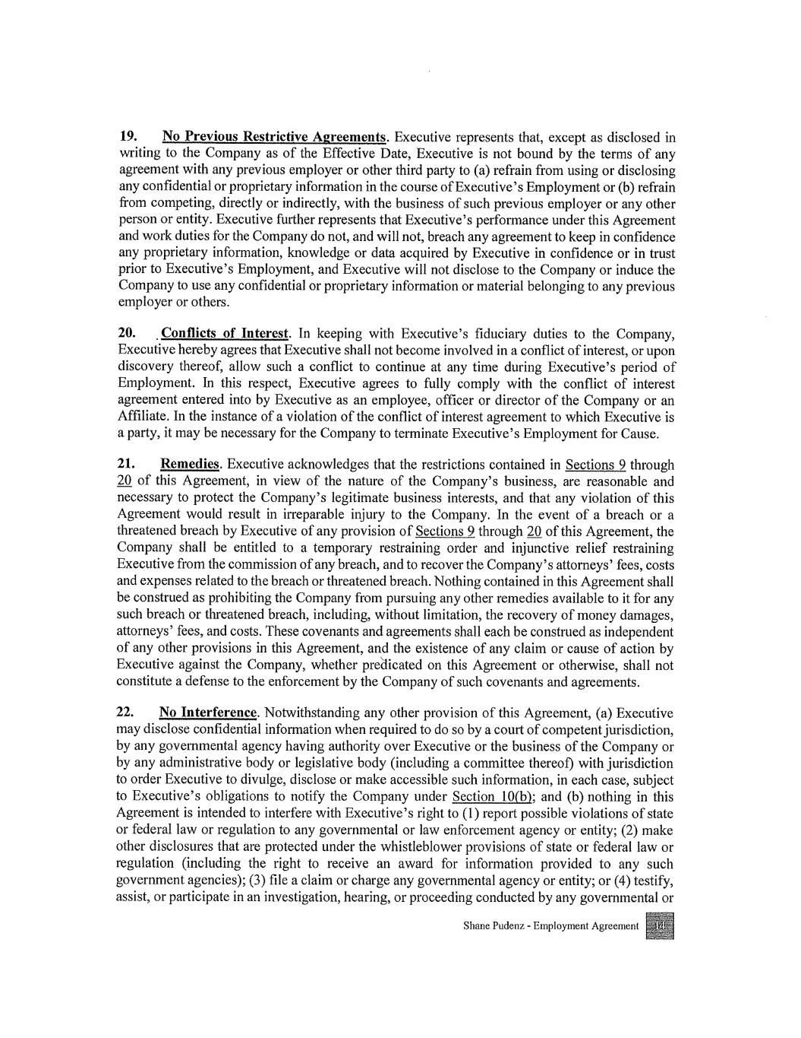

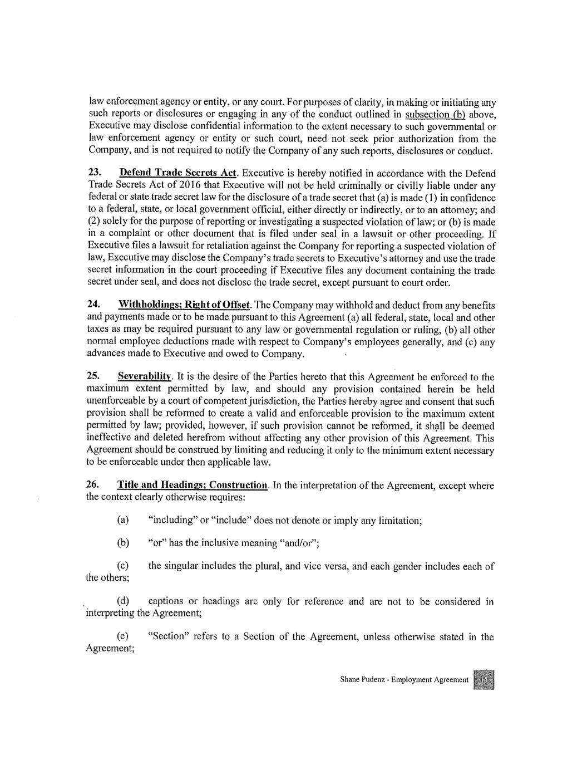

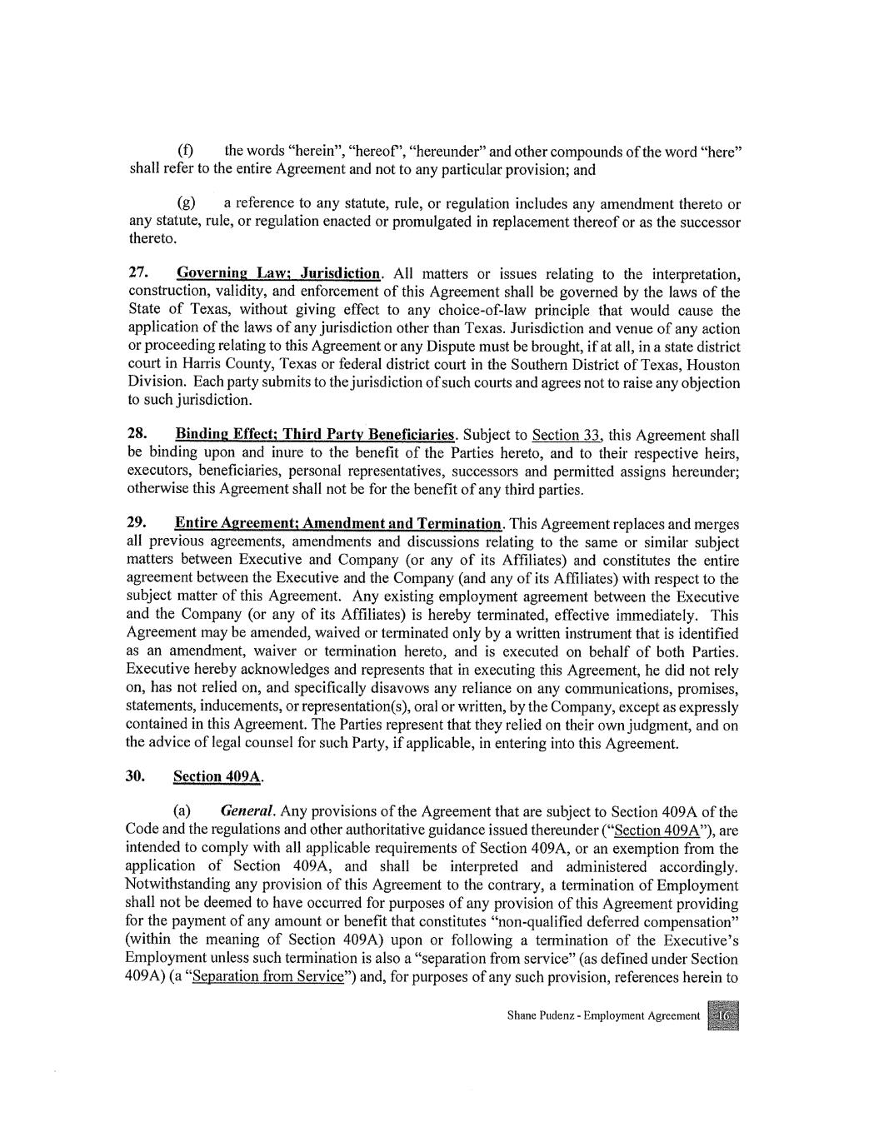

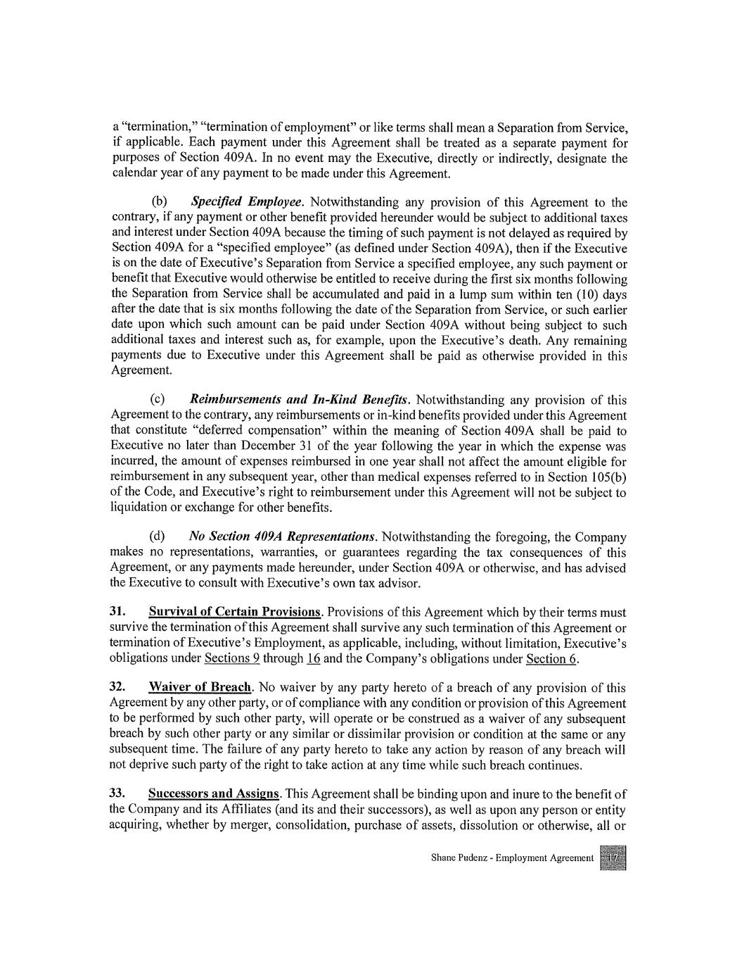

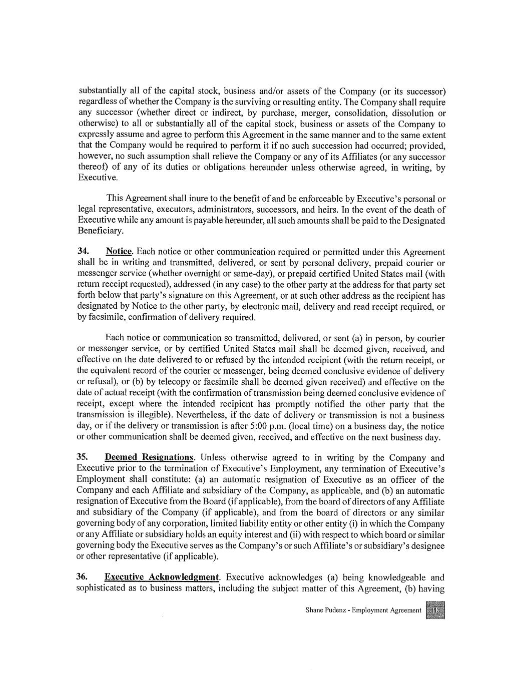

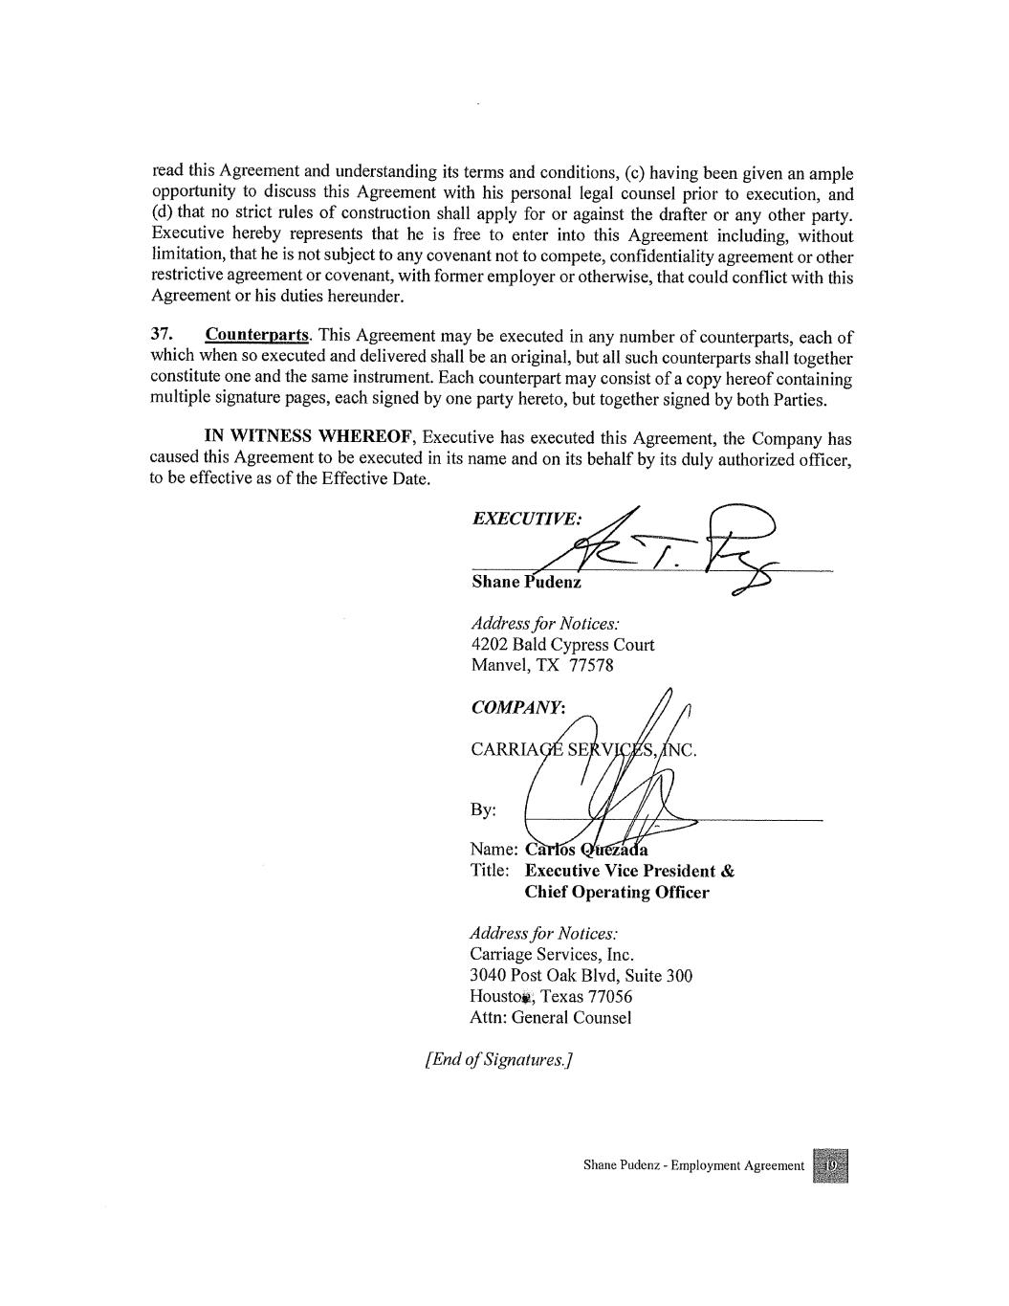

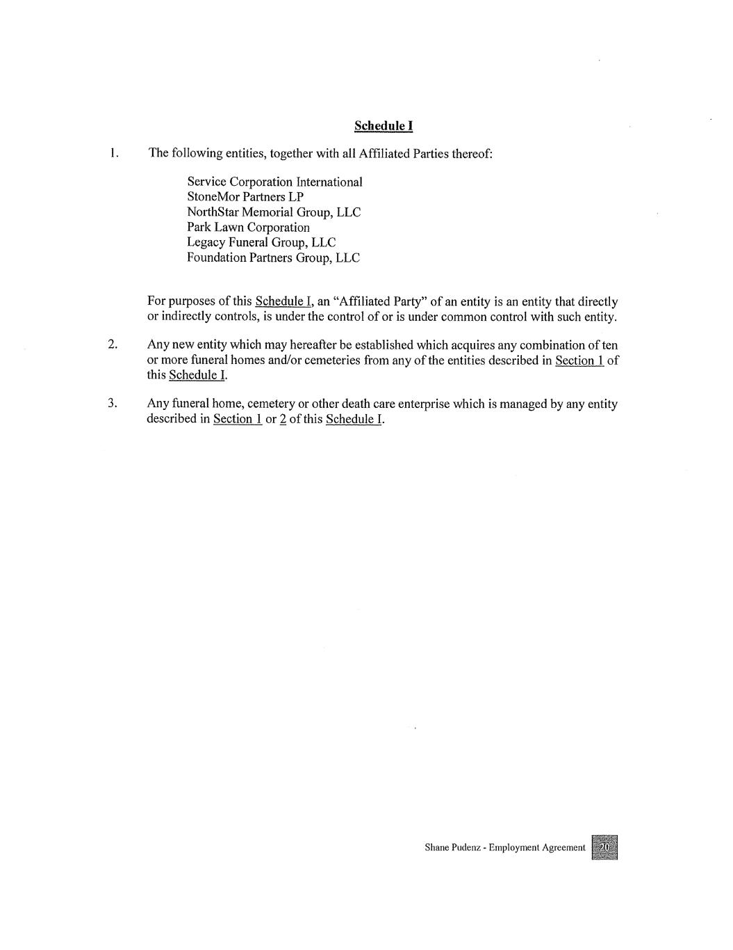

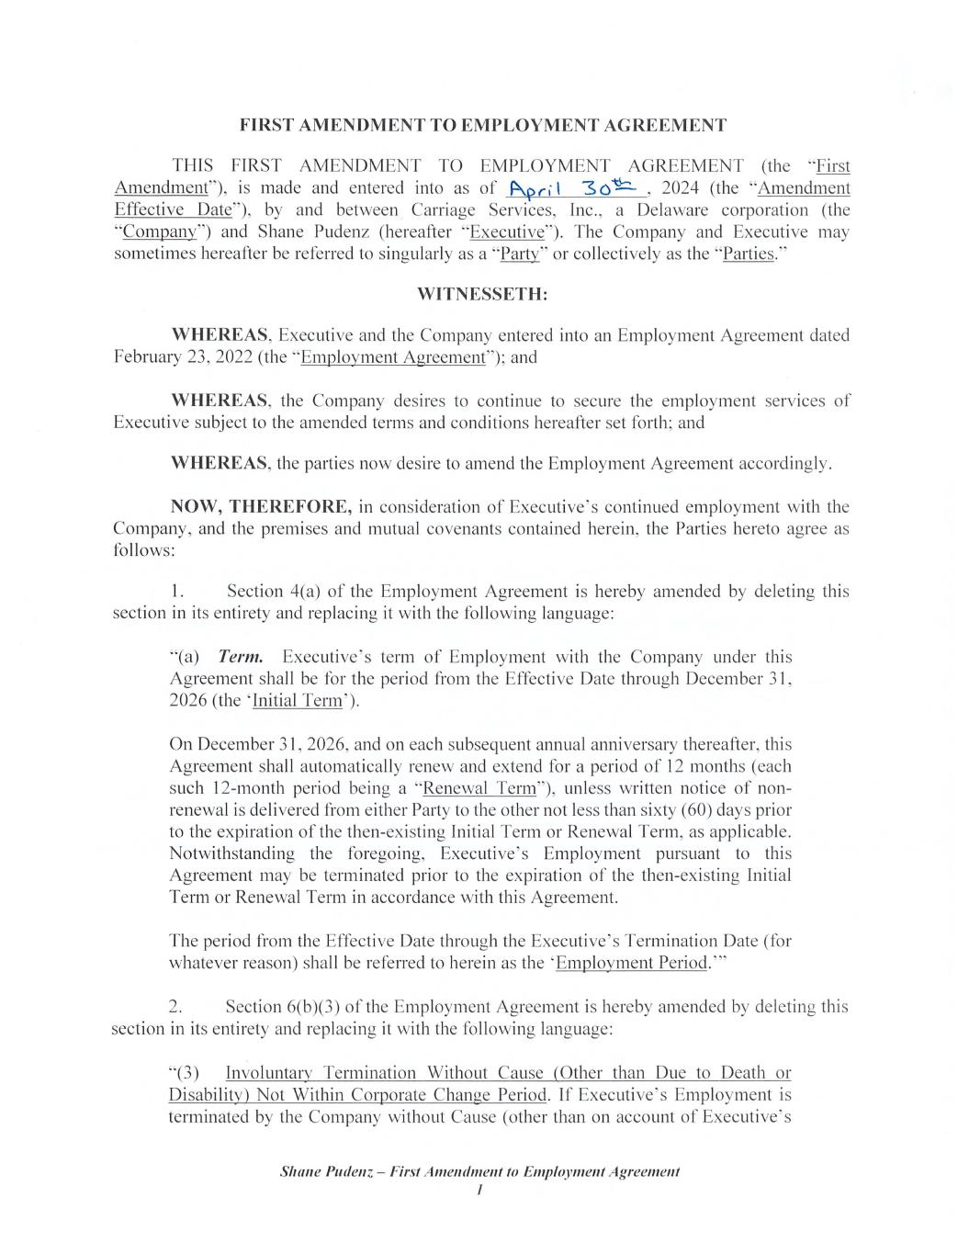

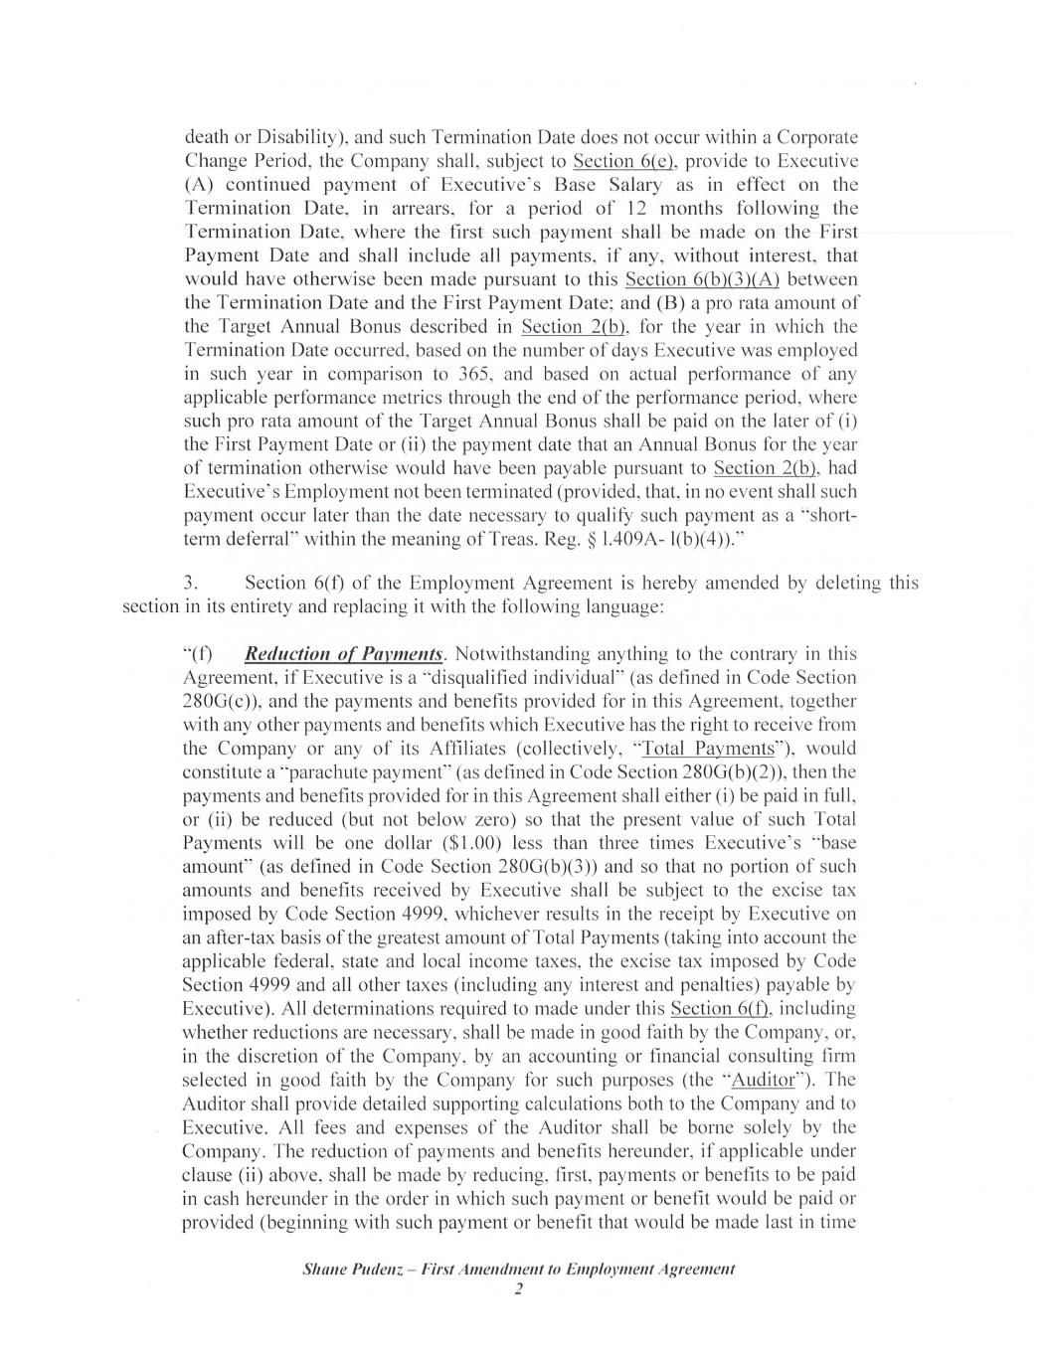

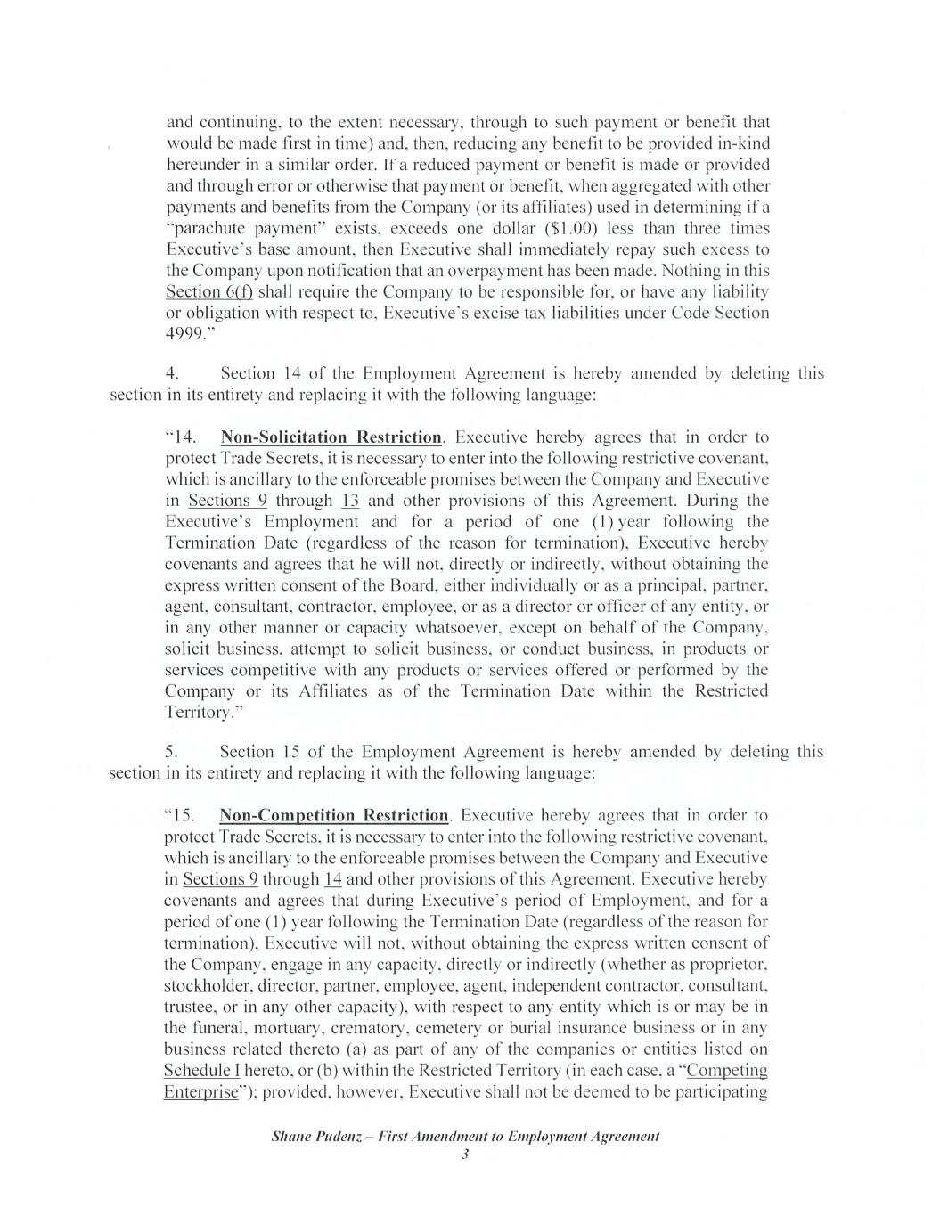

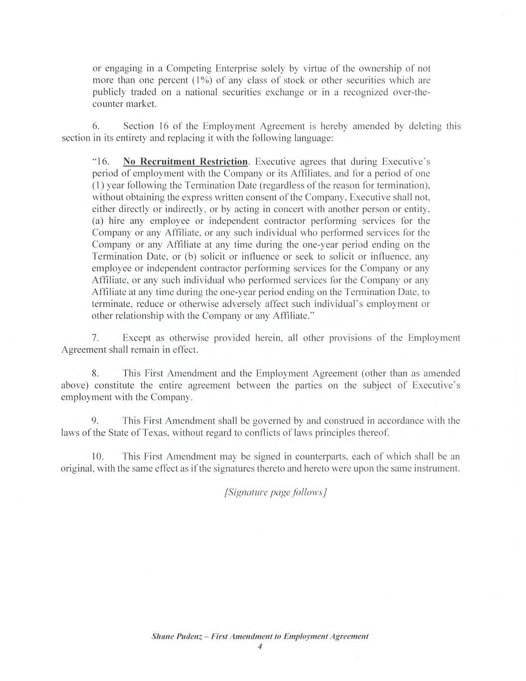

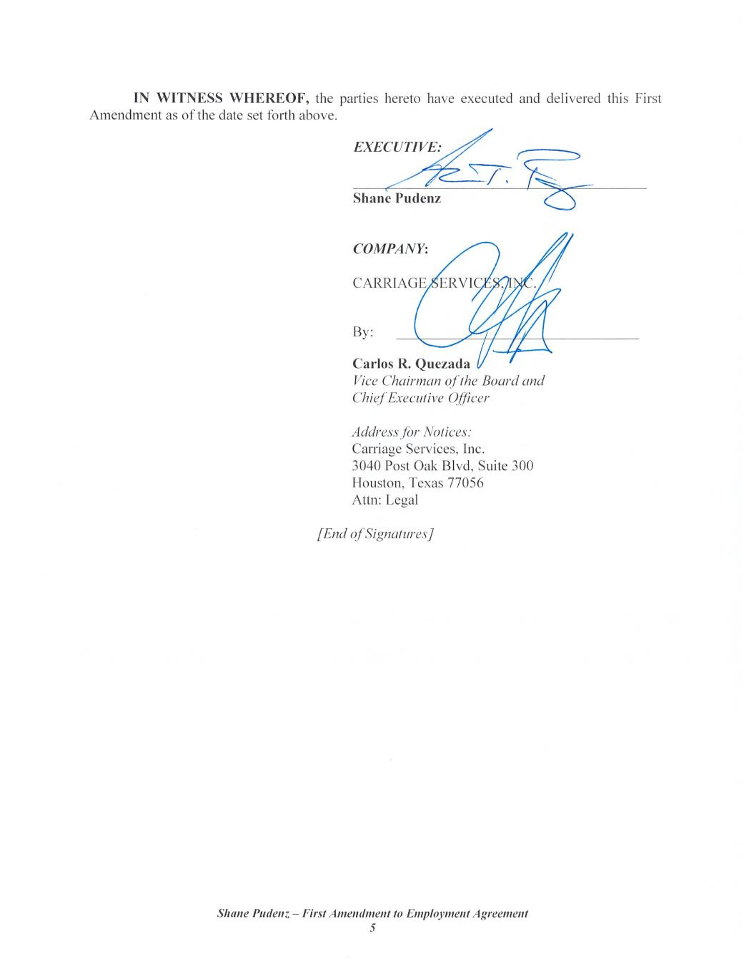


1 of 7 CARRIAGE SERVICES, INC. 2017 OMNIBUS INCENTIVE PLAN 2025 LONG-TERM INCENTIVE PERFORMANCE AWARD This Performance Award Agreement (this “Agreement”) is made and entered into as of March 7, 2025 (the “Grant Date”) by and between Carriage Services, Inc. (the “Company”) and __________________________ (the “Employee”). Capitalized terms that are used in this Agreement, but not defined herein, have the meanings ascribed to them in the Company’s 2017 Omnibus Incentive Plan (the “Plan”). 1. Grant of Performance Award. Pursuant to the terms and conditions set forth in the Plan and this Agreement, the Company hereby grants to the Employee a Stock Award in the form of a Performance Award pursuant to which the Employee may earn shares of the Company’s common stock (the “Award”). The target number of shares of common stock subject to the Award is _______________ shares (the “Target Performance Shares”).1 Notwithstanding the foregoing, and subject to the terms of this Agreement, the aggregate number of shares of common stock that the Employee actually earns pursuant to the Award (up to a maximum of 200% of the Target Performance Shares) shall be calculated by the Company’s Compensation Committee (the “Committee”) based upon the Payout definition as outlined in Exhibit I attached hereto). 2. Performance Period. For purposes of this Agreement, the term “Performance Period” shall be the period commencing on the Grant Date and ending on March 31, 2028. 3. Performance Criteria. (a) The performance criteria applicable to the Award are set forth on Exhibit I attached hereto (the “Performance Criteria”), which exhibit is hereby incorporated by reference. All determinations of whether the Performance Criteria have been achieved (and, if applicable, the extent of any such achievement), the number of shares of common stock earned by the Employee, and all other matters related to this Section 3, shall be made by the Committee in its sole discretion. (b) If any of the Performance Criteria are achieved during the Performance Period, the Committee shall review and certify in writing, (i) whether, and to what extent, the Performance Criteria for the Performance Period has been achieved, and (ii) the number of shares of common stock that the Employee has earned, if any, subject to compliance with the requirements of Section 4. Such certification shall be final, conclusive, and binding on the Employee, and on all other persons, to the maximum extent permitted by law. 1 The Target Performance Shares are based on Employee’s annual long-term incentive award target and the closing price of CSV stock of $38.59 on March 7, 2025.

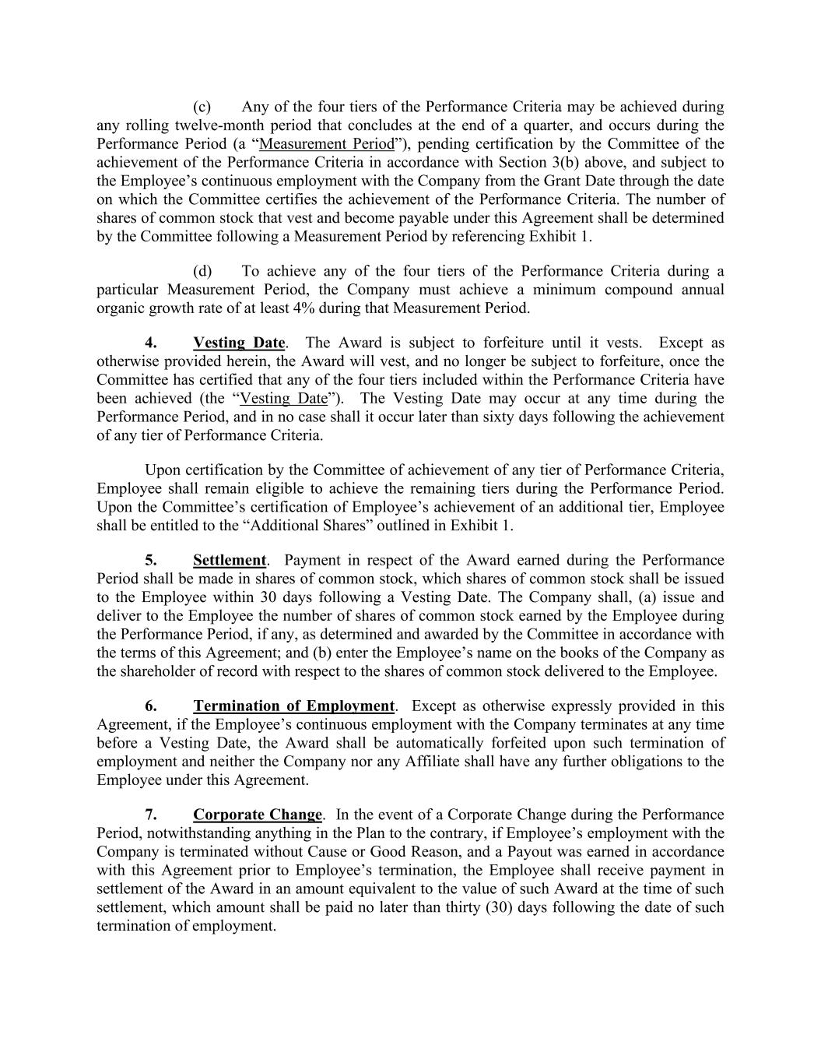
(c) Any of the four tiers of the Performance Criteria may be achieved during any rolling twelve-month period that concludes at the end of a quarter, and occurs during the Performance Period (a “Measurement Period”), pending certification by the Committee of the achievement of the Performance Criteria in accordance with Section 3(b) above, and subject to the Employee’s continuous employment with the Company from the Grant Date through the date on which the Committee certifies the achievement of the Performance Criteria. The number of shares of common stock that vest and become payable under this Agreement shall be determined by the Committee following a Measurement Period by referencing Exhibit 1. (d) To achieve any of the four tiers of the Performance Criteria during a particular Measurement Period, the Company must achieve a minimum compound annual organic growth rate of at least 4% during that Measurement Period. 4. Vesting Date. The Award is subject to forfeiture until it vests. Except as otherwise provided herein, the Award will vest, and no longer be subject to forfeiture, once the Committee has certified that any of the four tiers included within the Performance Criteria have been achieved (the “Vesting Date”). The Vesting Date may occur at any time during the Performance Period, and in no case shall it occur later than sixty days following the achievement of any tier of Performance Criteria. Upon certification by the Committee of achievement of any tier of Performance Criteria, Employee shall remain eligible to achieve the remaining tiers during the Performance Period. Upon the Committee’s certification of Employee’s achievement of an additional tier, Employee shall be entitled to the “Additional Shares” outlined in Exhibit 1. 5. Settlement. Payment in respect of the Award earned during the Performance Period shall be made in shares of common stock, which shares of common stock shall be issued to the Employee within 30 days following a Vesting Date. The Company shall, (a) issue and deliver to the Employee the number of shares of common stock earned by the Employee during the Performance Period, if any, as determined and awarded by the Committee in accordance with the terms of this Agreement; and (b) enter the Employee’s name on the books of the Company as the shareholder of record with respect to the shares of common stock delivered to the Employee. 6. Termination of Employment. Except as otherwise expressly provided in this Agreement, if the Employee’s continuous employment with the Company terminates at any time before a Vesting Date, the Award shall be automatically forfeited upon such termination of employment and neither the Company nor any Affiliate shall have any further obligations to the Employee under this Agreement. 7. Corporate Change. In the event of a Corporate Change during the Performance Period, notwithstanding anything in the Plan to the contrary, if Employee’s employment with the Company is terminated without Cause or Good Reason, and a Payout was earned in accordance with this Agreement prior to Employee’s termination, the Employee shall receive payment in settlement of the Award in an amount equivalent to the value of such Award at the time of such settlement, which amount shall be paid no later than thirty (30) days following the date of such termination of employment.

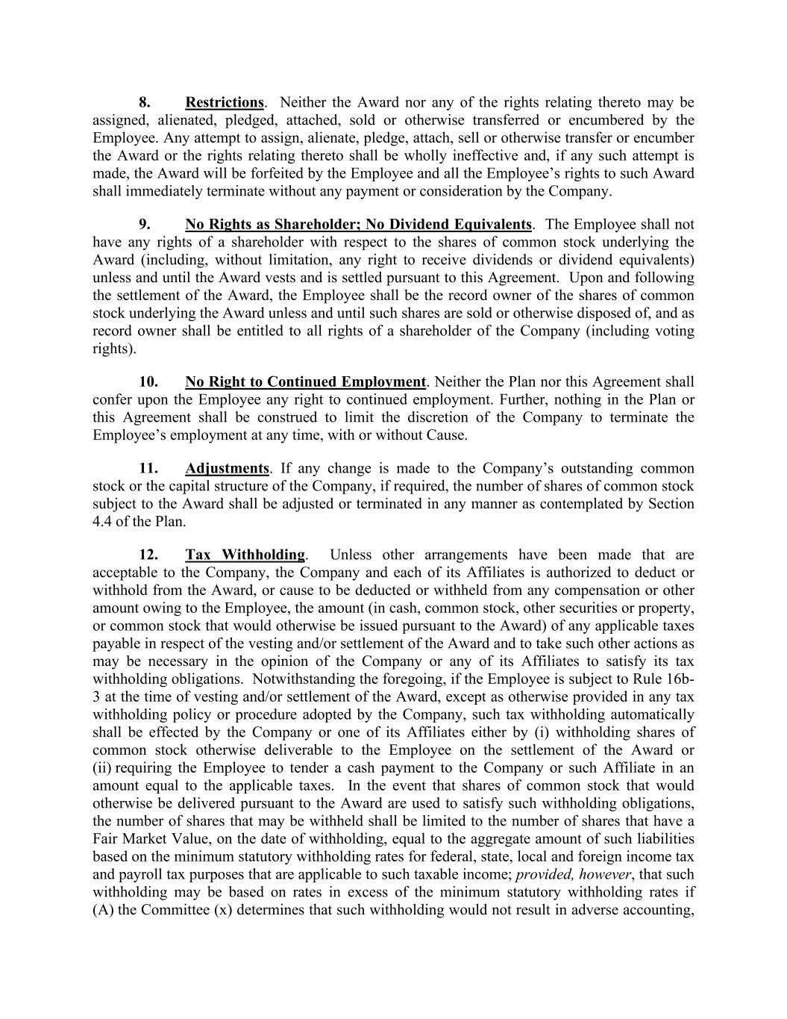
8. Restrictions. Neither the Award nor any of the rights relating thereto may be assigned, alienated, pledged, attached, sold or otherwise transferred or encumbered by the Employee. Any attempt to assign, alienate, pledge, attach, sell or otherwise transfer or encumber the Award or the rights relating thereto shall be wholly ineffective and, if any such attempt is made, the Award will be forfeited by the Employee and all the Employee’s rights to such Award shall immediately terminate without any payment or consideration by the Company. 9. No Rights as Shareholder; No Dividend Equivalents. The Employee shall not have any rights of a shareholder with respect to the shares of common stock underlying the Award (including, without limitation, any right to receive dividends or dividend equivalents) unless and until the Award vests and is settled pursuant to this Agreement. Upon and following the settlement of the Award, the Employee shall be the record owner of the shares of common stock underlying the Award unless and until such shares are sold or otherwise disposed of, and as record owner shall be entitled to all rights of a shareholder of the Company (including voting rights). 10. No Right to Continued Employment. Neither the Plan nor this Agreement shall confer upon the Employee any right to continued employment. Further, nothing in the Plan or this Agreement shall be construed to limit the discretion of the Company to terminate the Employee’s employment at any time, with or without Cause. 11. Adjustments. If any change is made to the Company’s outstanding common stock or the capital structure of the Company, if required, the number of shares of common stock subject to the Award shall be adjusted or terminated in any manner as contemplated by Section 4.4 of the Plan. 12. Tax Withholding. Unless other arrangements have been made that are acceptable to the Company, the Company and each of its Affiliates is authorized to deduct or withhold from the Award, or cause to be deducted or withheld from any compensation or other amount owing to the Employee, the amount (in cash, common stock, other securities or property, or common stock that would otherwise be issued pursuant to the Award) of any applicable taxes payable in respect of the vesting and/or settlement of the Award and to take such other actions as may be necessary in the opinion of the Company or any of its Affiliates to satisfy its tax withholding obligations. Notwithstanding the foregoing, if the Employee is subject to Rule 16b- 3 at the time of vesting and/or settlement of the Award, except as otherwise provided in any tax withholding policy or procedure adopted by the Company, such tax withholding automatically shall be effected by the Company or one of its Affiliates either by (i) withholding shares of common stock otherwise deliverable to the Employee on the settlement of the Award or (ii) requiring the Employee to tender a cash payment to the Company or such Affiliate in an amount equal to the applicable taxes. In the event that shares of common stock that would otherwise be delivered pursuant to the Award are used to satisfy such withholding obligations, the number of shares that may be withheld shall be limited to the number of shares that have a Fair Market Value, on the date of withholding, equal to the aggregate amount of such liabilities based on the minimum statutory withholding rates for federal, state, local and foreign income tax and payroll tax purposes that are applicable to such taxable income; provided, however, that such withholding may be based on rates in excess of the minimum statutory withholding rates if (A) the Committee (x) determines that such withholding would not result in adverse accounting,

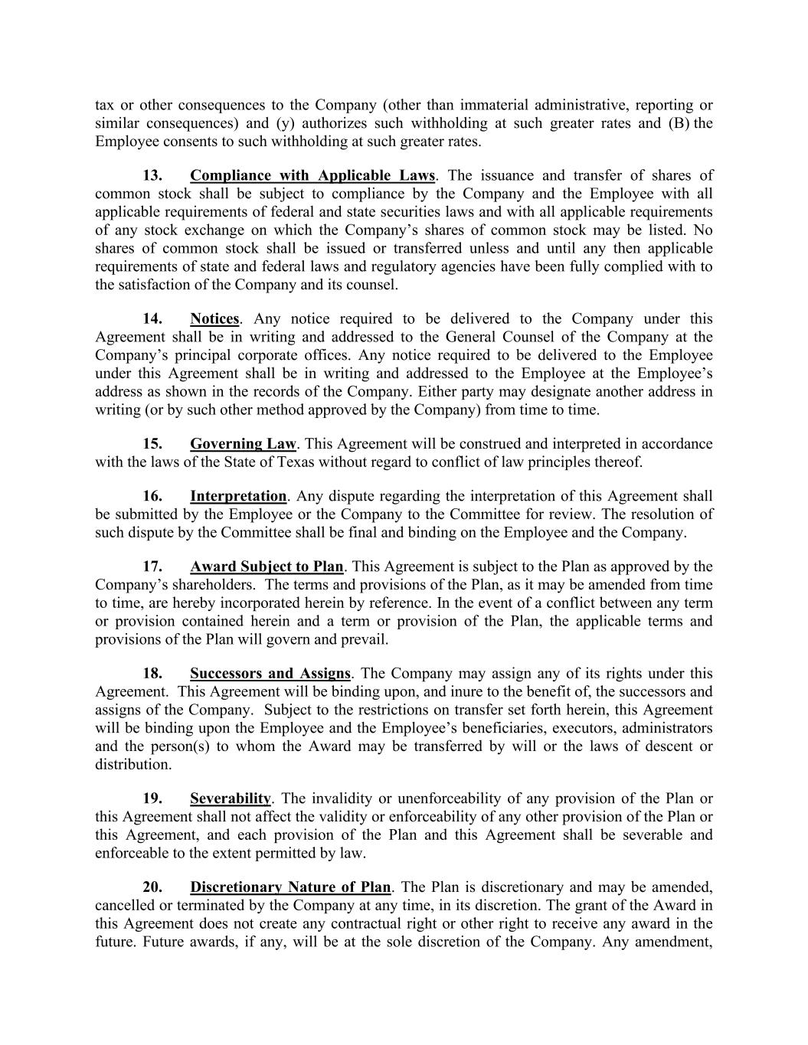
tax or other consequences to the Company (other than immaterial administrative, reporting or similar consequences) and (y) authorizes such withholding at such greater rates and (B) the Employee consents to such withholding at such greater rates. 13. Compliance with Applicable Laws. The issuance and transfer of shares of common stock shall be subject to compliance by the Company and the Employee with all applicable requirements of federal and state securities laws and with all applicable requirements of any stock exchange on which the Company’s shares of common stock may be listed. No shares of common stock shall be issued or transferred unless and until any then applicable requirements of state and federal laws and regulatory agencies have been fully complied with to the satisfaction of the Company and its counsel. 14. Notices. Any notice required to be delivered to the Company under this Agreement shall be in writing and addressed to the General Counsel of the Company at the Company’s principal corporate offices. Any notice required to be delivered to the Employee under this Agreement shall be in writing and addressed to the Employee at the Employee’s address as shown in the records of the Company. Either party may designate another address in writing (or by such other method approved by the Company) from time to time. 15. Governing Law. This Agreement will be construed and interpreted in accordance with the laws of the State of Texas without regard to conflict of law principles thereof. 16. Interpretation. Any dispute regarding the interpretation of this Agreement shall be submitted by the Employee or the Company to the Committee for review. The resolution of such dispute by the Committee shall be final and binding on the Employee and the Company. 17. Award Subject to Plan. This Agreement is subject to the Plan as approved by the Company’s shareholders. The terms and provisions of the Plan, as it may be amended from time to time, are hereby incorporated herein by reference. In the event of a conflict between any term or provision contained herein and a term or provision of the Plan, the applicable terms and provisions of the Plan will govern and prevail. 18. Successors and Assigns. The Company may assign any of its rights under this Agreement. This Agreement will be binding upon, and inure to the benefit of, the successors and assigns of the Company. Subject to the restrictions on transfer set forth herein, this Agreement will be binding upon the Employee and the Employee’s beneficiaries, executors, administrators and the person(s) to whom the Award may be transferred by will or the laws of descent or distribution. 19. Severability. The invalidity or unenforceability of any provision of the Plan or this Agreement shall not affect the validity or enforceability of any other provision of the Plan or this Agreement, and each provision of the Plan and this Agreement shall be severable and enforceable to the extent permitted by law. 20. Discretionary Nature of Plan. The Plan is discretionary and may be amended, cancelled or terminated by the Company at any time, in its discretion. The grant of the Award in this Agreement does not create any contractual right or other right to receive any award in the future. Future awards, if any, will be at the sole discretion of the Company. Any amendment,


modification, or termination of the Plan shall not constitute a change or impairment of the terms and conditions of the Employee’s employment with the Company. 21. Entire Agreement. This Agreement constitutes the entire agreement of the parties with regard to the subject matter hereof, and contains all the covenants, promises, representations, warranties and agreements between the parties with respect to the Award granted hereby; provided, however, that the terms of this Agreement shall not modify, and shall be subject to the terms and conditions of, any employment and/or severance agreement between the Company and it Affiliates and the Employee in effect as of the date a determination is to be made under this Agreement. Without limiting the scope of the preceding sentence, except as provided therein, all prior understandings and agreements, if any, among the parties hereto relating to the subject matter hereof are hereby null and void and of no further force and effect. 22. Amendment. The Committee has the right to amend, alter, suspend, discontinue or cancel the Award, prospectively or retroactively; provided, however, that no such amendment shall adversely affect the Employee’s material rights under this Agreement without the Employee’s consent. 23. Section 409A. Neither the Award nor any of the amounts that may be payable pursuant to this Agreement are intended to constitute or provide for a deferral of compensation that is subject to Section 409A of the Code and the Treasury regulations and other interpretive guidance issued thereunder (collectively, “Section 409A”). Notwithstanding the foregoing, (a) the Company makes no representations that the Award or any amounts payable under this Agreement are exempt from Section 409A and in no event shall the Company or any of its Affiliates be liable for all or any portion of any taxes, penalties, interest or other expenses that may be incurred by the Employee on account of non-compliance with Section 409A, and (b) if any payment provided for under this Agreement would be subject to additional taxes and interest under Section 409A if the Employee’s receipt of such payment is not delayed in accordance with the requirements of Section 409A(a)(2)(B)(i) of the Code, then such payment shall not be provided to the Employee (or the Employee’s estate, if applicable) until the earlier of, (i) the date of the Employee’s death or (ii) the date that is six months after the date of the Employee’s separation from service with the Company. 24. No Impact on Other Benefits. The value of the Award is not part of the Employee’s normal or expected compensation for purposes of calculating any severance, retirement, welfare, insurance or similar employee benefit. 25. Acceptance. The Employee hereby acknowledges receipt of a copy of the Plan and this Agreement. The Employee has read and understands the terms and provisions thereof and accepts the Award subject to all of the terms and conditions of the Plan and this Agreement. The Employee acknowledges that there may be adverse tax consequences upon the vesting or settlement of the Award or disposition of the underlying shares and that the Employee has been advised to consult a tax advisor prior to such vesting, settlement, or disposition. The Employee acknowledges and agrees that none of the Board, the Committee, the Company, or any of their respective Affiliates have made any representation or warranty as to the tax consequences to the Employee as a result of the receipt of the Award or the vesting, settlement or disposition thereof.


26. Clawback. Notwithstanding any provision in this Agreement to the contrary, this Award and all common stock issued hereunder shall be subject to any applicable clawback policies or procedures adopted in accordance with the Plan. 27. Counterparts. This Agreement may be executed in one or more counterparts, each of which shall be deemed an original and all of which together shall constitute one instrument. Delivery of an executed counterpart of this Agreement by facsimile or pdf attachment to electronic mail shall be effective as delivery of a manually executed counterpart of this Agreement. IN WITNESS WHEREOF, the Company has caused this Agreement to be executed by its duly authorized officer, and the Employee has executed this Agreement, effective for all purposes as provided above. CARRIAGE SERVICES, INC. By: __________________________________________ EMPLOYEE _____________________________________________

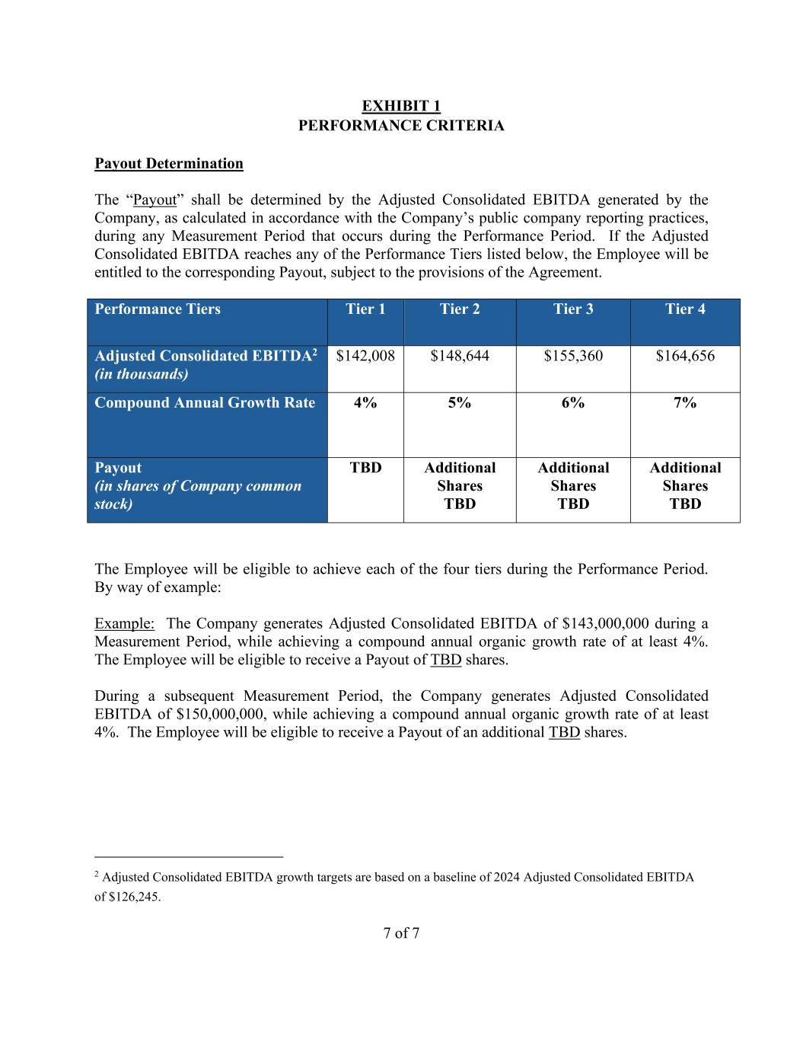
7 of 7 EXHIBIT 1 PERFORMANCE CRITERIA Payout Determination The “Payout” shall be determined by the Adjusted Consolidated EBITDA generated by the Company, as calculated in accordance with the Company’s public company reporting practices, during any Measurement Period that occurs during the Performance Period. If the Adjusted Consolidated EBITDA reaches any of the Performance Tiers listed below, the Employee will be entitled to the corresponding Payout, subject to the provisions of the Agreement. Performance Tiers Tier 1 Tier 2 Tier 3 Tier 4 Adjusted Consolidated EBITDA2 (in thousands) $142,008 $148,644 $155,360 $164,656 Compound Annual Growth Rate 4% 5% 6% 7% Payout (in shares of Company common stock) TBD Additional Shares TBD Additional Shares TBD Additional Shares TBD The Employee will be eligible to achieve each of the four tiers during the Performance Period. By way of example: Example: The Company generates Adjusted Consolidated EBITDA of $143,000,000 during a Measurement Period, while achieving a compound annual organic growth rate of at least 4%. The Employee will be eligible to receive a Payout of TBD shares. During a subsequent Measurement Period, the Company generates Adjusted Consolidated EBITDA of $150,000,000, while achieving a compound annual organic growth rate of at least 4%. The Employee will be eligible to receive a Payout of an additional TBD shares. 2 Adjusted Consolidated EBITDA growth targets are based on a baseline of 2024 Adjusted Consolidated EBITDA of $126,245.

EXHIBIT 31.1
I, Carlos R. Quezada, certify that:
1.I have reviewed this report on Form 10-Q of Carriage Services, Inc. (the “registrant”);
2.Based on my knowledge, this report does not contain any untrue statement of a material fact or omit to state a material fact necessary to make the statements made, in light of the circumstances under which such statements were made, not misleading with respect to the period covered by this report;
3.Based on my knowledge, the financial statements, and other financial information included in this report, fairly present in all material respects the financial condition, results of operations and cash flows of the registrant as of, and for, the periods presented in this report;
4.The registrant’s other certifying officer(s) and I are responsible for establishing and maintaining disclosure controls and procedures (as defined in Exchange Act Rules 13a-15(e) and 15d-15(e)) and internal control over financial reporting (as defined in Exchange Act Rules 13a-15(f) and 15d-15(f)) for the registrant and have:
a.Designed such disclosure controls and procedures, or caused such disclosure controls and procedures to be designed under our supervision, to ensure that material information relating to the registrant, including its consolidated subsidiaries, is made known to us by others within those entities, particularly during the period in which this report is being prepared;
b.Designed such internal control over financial reporting, or caused such internal control over financial reporting to be designed under our supervision, to provide reasonable assurance regarding the reliability of financial reporting and the preparation of financial statements for external purposes in accordance with generally accepted accounting principles;
c.Evaluated the effectiveness of the registrant’s disclosure controls and procedures and presented in this report our conclusions about the effectiveness of the disclosure controls and procedures, as of the end of the period covered by this report based on such evaluation; and
d.Disclosed in this report any change in the registrant’s internal control over financial reporting that occurred during the registrant’s most recent fiscal quarter (the registrant’s fourth fiscal quarter in the case of an annual report) that has materially affected, or is reasonably likely to materially affect, the registrant’s internal control over financial reporting; and
5.The registrant’s other certifying officer(s) and I have disclosed, based on our most recent evaluation of internal control over financial reporting, to the registrant’s auditors and the audit committee of the registrant’s board of directors (or persons performing the equivalent functions):
a.All significant deficiencies and material weaknesses in the design or operation of internal control over financial reporting which are reasonably likely to adversely affect the registrant’s ability to record, process, summarize and report financial information; and
b.Any fraud, whether or not material, that involves management or other employees who have a significant role in the registrant’s internal control over financial reporting.

Dated: |  |  | May 2, 2025 |  |  |  |  |  | /s/ Carlos R. Quezada
 |  |  |  |  |  |  |  |  | Carlos R. Quezada
 |  |  |  |  |  |  |  |  | Chief Executive Officer and Vice Chairman of the Board
 |  |  |  |  |  |  |  |  | (Principal Executive Officer)

EXHIBIT 31.2
I, John Enwright, certify that:
1.I have reviewed this report on Form 10-Q of Carriage Services, Inc. (the “registrant”);
2.Based on my knowledge, this report does not contain any untrue statement of a material fact or omit to state a material fact necessary to make the statements made, in light of the circumstances under which such statements were made, not misleading with respect to the period covered by this report;
3.Based on my knowledge, the financial statements, and other financial information included in this report, fairly present in all material respects the financial condition, results of operations and cash flows of the registrant as of, and for, the periods presented in this report;
4.The registrant’s other certifying officer(s) and I are responsible for establishing and maintaining disclosure controls and procedures (as defined in Exchange Act Rules 13a-15(e) and 15d-15(e)) and internal control over financial reporting (as defined in Exchange Act Rules 13a-15(f) and 15d-15(f)) for the registrant and have:
a.Designed such disclosure controls and procedures, or caused such disclosure controls and procedures to be designed under our supervision, to ensure that material information relating to the registrant, including its consolidated subsidiaries, is made known to us by others within those entities, particularly during the period in which this report is being prepared;
b.Designed such internal control over financial reporting, or caused such internal control over financial reporting to be designed under our supervision, to provide reasonable assurance regarding the reliability of financial reporting and the preparation of financial statements for external purposes in accordance with generally accepted accounting principles;
c.Evaluated the effectiveness of the registrant’s disclosure controls and procedures and presented in this report our conclusions about the effectiveness of the disclosure controls and procedures, as of the end of the period covered by this report based on such evaluation; and
d.Disclosed in this report any change in the registrant’s internal control over financial reporting that occurred during the registrant’s most recent fiscal quarter (the registrant’s fourth fiscal quarter in the case of an annual report) that has materially affected, or is reasonably likely to materially affect, the registrant’s internal control over financial reporting; and
5.The registrant’s other certifying officer(s) and I have disclosed, based on our most recent evaluation of internal control over financial reporting, to the registrant’s auditors and the audit committee of the registrant’s board of directors (or persons performing the equivalent functions):
a.All significant deficiencies and material weaknesses in the design or operation of internal control over financial reporting which are reasonably likely to adversely affect the registrant’s ability to record, process, summarize and report financial information; and
b.Any fraud, whether or not material, that involves management or other employees who have a significant role in the registrant’s internal control over financial reporting.

Dated: |  |  | May 2, 2025 |  |  |  |  |  | /s/ John Enwright
 |  |  |  |  |  |  |  |  | John Enwright
 |  |  |  |  |  |  |  |  | Senior Vice President, Chief Financial Officer and Treasurer
 |  |  |  |  |  |  |  |  | (Principal Financial Officer)

EXHIBIT 32

Certification of
Chief Executive Officer and Principal Financial Officer
under Section 906 of the
Sarbanes Oxley Act of 2002, 18 U.S.C. § 1350

In connection with the Quarterly Report on Form 10-Q of Carriage Services, Inc. (the “Company”), as filed with the Securities and Exchange Commission on the date hereof (the “Report”), Carlos R. Quezada, Chief Executive Officer of the Company, and John Enwright, Senior Vice President, Chief Financial Officer and Treasurer of the Company, each certify, pursuant to 18 U.S.C. Section 1350, as adopted pursuant to Section 906 of the Sarbanes-Oxley Act of 2002, that, to his or her knowledge:

(1) the Report fully complies with the requirements of Section 13(a) or 15(d) of the Securities Exchange Act of 1934, as amended; and

(2) the information contained in the Report fairly presents, in all material respects, the financial condition and results of operations of the Company.

Dated: |  |  | May 2, 2025 |  |  |  |  |  | /s/ Carlos R. Quezada
 |  |  |  |  |  |  |  |  | Carlos R. Quezada
 |  |  |  |  |  |  |  |  | Chief Executive Officer and Vice Chairman of the Board
 |  |  |  |  |  |  |  |  | (Principal Executive Officer)
 |  |  |  |  |  |  |  |  | /s/ John Enwright
 |  |  |  |  |  |  |  |  | John Enwright
 |  |  |  |  |  |  |  |  | Senior Vice President, Chief Financial Officer and Treasurer
 |  |  |  |  |  |  |  |  | (Principal Financial Officer)

