UNITED STATES
SECURITIES AND EXCHANGE COMMISSION
Washington, D.C. 20549
FORM |  |  | 10-Q
(Mark One)
☒ QUARTERLY REPORT PURSUANT TO SECTION 13 OR 15(d) OF THE SECURITIES EXCHANGE ACT OF 1934
For the quarterly period ended March 31, 2023
OR
☐ TRANSITION REPORT PURSUANT TO SECTION 13 OR 15(d) OF THE SECURITIES EXCHANGE ACT OF 1934
For the transition period from ___________ to ____________
Commission File Number: |  |  | 1-11961
CARRIAGE SERVICES, INC.
(Exact name of registrant as specified in its charter)
Delaware |  |  | 76-0423828
(State or other jurisdiction of  incorporation or organization) |  |  | (I.R.S. Employer  Identification No.)
3040 Post Oak Boulevard, Suite 300
Houston, Texas, 77056
(Address of principal executive offices)
(713) 332-8400
(Registrant’s telephone number, including area code)
Securities registered pursuant to Section 12(b) of the Act:
Title of each class |  |  | Trading Symbol |  |  | Name of each exchange on which registered
Common Stock, par value $.01 per share |  |  | CSV |  |  | New York Stock Exchange
Indicate by check mark whether the registrant (1) has filed all reports required to be filed by Section 13 or 15(d) of the Securities Exchange Act of 1934 during the preceding 12 months (or for such shorter period that the registrant was required to file such reports), and (2) has been subject to such filing requirements for the past 90 days. Yes ☒ No ☐
Indicate by check mark whether the registrant has submitted electronically and posted on its corporate Web site, if any, every Interactive Data File required to be submitted and posted pursuant to Rule 405 of Regulation S-T (§ 232.405 of this chapter) during the preceding 12 months (or for such shorter period that the registrant was required to submit and post such files). Yes ☒ No ☐
Indicate by check mark whether the registrant is a large accelerated filer, an accelerated filer, a non-accelerated filer, a smaller reporting company, or an emerging growth company. See the definitions of “large accelerated filer”, “accelerated filer” and “smaller reporting company,” and “emerging growth company” in Rule 12b-2 of the Securities Exchange Act of 1934.
Large accelerated filer |  |  | ☐ |  |  |  |  |  |  |  |  |  |  |  |  |  |  |  |  |  |  |  |  | Accelerated filer |  |  | ☒
Non-accelerated filer |  |  | ☐ |  |  |  |  |  |  |  |  |  |  |  |  |  |  |  |  |  |  |  |  | Smaller reporting company |  |  | ☐
 |  |  |  |  |  |  |  |  |  |  |  |  |  |  |  |  |  |  |  |  |  |  |  | Emerging growth company |  |  | ☐

If an emerging growth company, indicate by check mark if the registrant has elected not to use the extended transition period for complying with any new or revised financial accounting standards provided pursuant to Section 13(a) of the Exchange Act. ☐
Indicate by check mark whether the registrant is a shell company (as defined in Rule 12b-2 of the Exchange Act). Yes ☐ No ☒
The number of shares of the registrant’s Common Stock, $.01 par value per share, outstanding as of May 1, 2023 was 14,934,211.

CARRIAGE SERVICES, INC.
INDEX

 |  |  | Page
PART I – FINANCIAL INFORMATION
Item 1. Financial Statements |  |  | 3
Unaudited Consolidated Balance Sheet as of December 31, 2022 and March 31, 2023 |  |  | 3
Unaudited Consolidated Statements of Operations for the Three Months ended March 31, 2022 and 2023 |  |  | 4
Unaudited Consolidated Statements of Cash Flows for the Three Months ended March 31, 2022 and 2023 |  |  | 5
Unaudited Consolidated Statements of Changes in Stockholders' Equity for the Three Months ended March 31, 2022 and 2023 |  |  | 6
Condensed Notes to Consolidated Financial Statements |  |  | 7
Cautionary Statement on Forward–Looking Statements |  |  | 30
Item 2. Management’s Discussion and Analysis of Financial Condition and Results of Operations |  |  | 32
Item 3. Quantitative and Qualitative Disclosures About Market Risk |  |  | 44
Item 4. Controls and Procedures |  |  | 45
PART II – OTHER INFORMATION
Item 1. Legal Proceedings |  |  | 46
Item 1A. Risk Factors |  |  | 46
Item 2. Unregistered Sales of Equity Securities and Use of Proceeds |  |  | 47
Item 3. Defaults Upon Senior Securities |  |  | 47
Item 4. Mine Safety Disclosures |  |  | 47
Item 5. Other Information |  |  | 47
Item 6. Exhibits |  |  | 47
SIGNATURE |  |  | 48
INDEX OF EXHIBITS |  |  | 49

- 2 -

PART I – FINANCIAL INFORMATION

Item 1.Financial Statements.

CARRIAGE SERVICES, INC.
CONSOLIDATED BALANCE SHEET
(unaudited and in thousands, except share data)
 |  |  | December 31, 2022 |  |  |  |  |  | March 31, 2023
ASSETS
Current assets:
Cash and cash equivalents |  |  | $ | 1,170 |  |  |  |  | $ | 1,293
Accounts receivable, net |  |  | 24,458 |  |  |  |  |  | 23,887
Inventories |  |  | 7,613 |  |  |  |  |  | 9,533
Prepaid and other current assets |  |  | 4,733 |  |  |  |  |  | 8,988
Total current assets |  |  | 37,974 |  |  |  |  |  | 43,701
Preneed cemetery trust investments |  |  | 95,065 |  |  |  |  |  | 86,459
Preneed funeral trust investments |  |  | 104,553 |  |  |  |  |  | 101,366
Preneed cemetery receivables, net |  |  | 26,672 |  |  |  |  |  | 26,690
Receivables from preneed funeral trusts, net |  |  | 19,976 |  |  |  |  |  | 20,346
Property, plant and equipment, net |  |  | 278,106 |  |  |  |  |  | 289,313
Cemetery property, net |  |  | 104,170 |  |  |  |  |  | 113,298
Goodwill |  |  | 410,137 |  |  |  |  |  | 423,749
Intangible and other non-current assets, net |  |  | 32,930 |  |  |  |  |  | 37,254
Operating lease right-of-use assets |  |  | 17,060 |  |  |  |  |  | 17,486
Cemetery perpetual care trust investments |  |  | 66,307 |  |  |  |  |  | 65,322
Total assets |  |  | $ | 1,192,950 |  |  |  |  | $ | 1,224,984
LIABILITIES AND STOCKHOLDERS’ EQUITY
Current liabilities:
Current portion of debt and lease obligations |  |  | $ | 3,172 |  |  |  |  | $ | 3,455
Accounts payable |  |  | 11,675 |  |  |  |  |  | 11,429
Accrued and other liabilities |  |  | 30,621 |  |  |  |  |  | 34,910
Total current liabilities |  |  | 45,468 |  |  |  |  |  | 49,794
Acquisition debt, net of current portion |  |  | 3,438 |  |  |  |  |  | 3,404
Credit facility |  |  | 188,836 |  |  |  |  |  | 211,880
Senior notes |  |  | 395,243 |  |  |  |  |  | 395,406
Obligations under finance leases, net of current portion |  |  | 4,743 |  |  |  |  |  | 4,641
Obligations under operating leases, net of current portion |  |  | 17,315 |  |  |  |  |  | 17,395
Deferred preneed cemetery revenue |  |  | 51,746 |  |  |  |  |  | 61,297
Deferred preneed funeral revenue |  |  | 32,029 |  |  |  |  |  | 32,248
Deferred tax liability |  |  | 48,820 |  |  |  |  |  | 48,642
Other long-term liabilities |  |  | 3,065 |  |  |  |  |  | 938
Deferred preneed cemetery receipts held in trust |  |  | 95,065 |  |  |  |  |  | 86,459
Deferred preneed funeral receipts held in trust |  |  | 104,553 |  |  |  |  |  | 101,366
Care trusts’ corpus |  |  | 65,495 |  |  |  |  |  | 64,352
Total liabilities |  |  | 1,055,816 |  |  |  |  |  | 1,077,822
Commitments and contingencies:
Stockholders’ equity:
Common stock, $0.01 par value; 80,000,000 shares authorized and 26,359,876 and 26,562,368 shares issued, respectively and 14,732,058 and 14,934,550 shares outstanding, respectively |  |  | 264 |  |  |  |  |  | 266
Additional paid-in capital |  |  | 238,780 |  |  |  |  |  | 239,962
Retained earnings |  |  | 176,843 |  |  |  |  |  | 185,687
Treasury stock, at cost; 11,627,818 shares |  |  | (278,753) |  |  |  |  |  | (278,753)
Total stockholders’ equity |  |  | 137,134 |  |  |  |  |  | 147,162
Total liabilities and stockholders’ equity |  |  | $ | 1,192,950 |  |  |  |  | $ | 1,224,984
The accompanying condensed notes are an integral part of these Consolidated Financial Statements.

- 3 -

CARRIAGE SERVICES, INC.
CONSOLIDATED STATEMENTS OF OPERATIONS
(unaudited and in thousands, except per share data)
 |  |  | Three months ended March 31,
 |  |  | 2022 |  |  |  |  |  | 2023
Revenue:
Service revenue |  |  | $ | 49,737 |  |  |  |  | $ | 48,207
Property and merchandise revenue |  |  | 41,612 |  |  |  |  |  | 40,011
Other revenue |  |  | 6,812 |  |  |  |  |  | 7,296
 |  |  | 98,161 |  |  |  |  |  | 95,514
Field costs and expenses:
Cost of service |  |  | 22,104 |  |  |  |  |  | 23,477
Cost of merchandise |  |  | 29,325 |  |  |  |  |  | 29,734
Cemetery property amortization |  |  | 1,332 |  |  |  |  |  | 1,201
Field depreciation expense |  |  | 3,297 |  |  |  |  |  | 3,357
Regional and unallocated funeral and cemetery costs |  |  | 6,347 |  |  |  |  |  | 5,437
Other expenses |  |  | 1,278 |  |  |  |  |  | 1,253
 |  |  | 63,683 |  |  |  |  |  | 64,459
Gross profit |  |  | 34,478 |  |  |  |  |  | 31,055
Corporate costs and expenses:
General, administrative and other |  |  | 8,560 |  |  |  |  |  | 10,180
Net loss on divestitures, disposals and impairments charges |  |  | 767 |  |  |  |  |  | 241
Operating income |  |  | 25,151 |  |  |  |  |  | 20,634
Interest expense |  |  | 5,542 |  |  |  |  |  | 8,539
(Gain) loss on property damage, net of insurance claims |  |  | (1,899) |  |  |  |  |  | 271
Other, net |  |  | 24 |  |  |  |  |  | (522)
Income before income taxes |  |  | 21,484 |  |  |  |  |  | 12,346
Expense for income taxes |  |  | 5,704 |  |  |  |  |  | 3,568
Tax adjustment related to discrete items |  |  | (622) |  |  |  |  |  | (66)
Total expense for income taxes |  |  | 5,082 |  |  |  |  |  | 3,502
Net income |  |  | $ | 16,402 |  |  |  |  | $ | 8,844
Basic earnings per common share: |  |  | $ | 1.07 |  |  |  |  | $ | 0.59
Diluted earnings per common share: |  |  | $ | 1.00 |  |  |  |  | $ | 0.57
Dividends declared per common share: |  |  | $ | 0.1125 |  |  |  |  | $ | 0.1125
Weighted average number of common and common equivalent shares outstanding:
Basic |  |  | 15,244 |  |  |  |  |  | 14,758
Diluted |  |  | 16,369 |  |  |  |  |  | 15,468
The accompanying condensed notes are an integral part of these Consolidated Financial Statements.

- 4 -

CARRIAGE SERVICES, INC.
CONSOLIDATED STATEMENTS OF CASH FLOWS
(unaudited and in thousands)
 |  |  | Three months ended March 31,
 |  |  | 2022 |  |  |  |  |  | 2023
Cash flows from operating activities:
Net income |  |  | $ | 16,402 |  |  |  |  | $ | 8,844
Adjustments to reconcile net income to net cash provided by operating activities:
Depreciation and amortization |  |  | 4,783 |  |  |  |  |  | 4,769
Provision for credit losses |  |  | 837 |  |  |  |  |  | 699
Stock-based compensation expense |  |  | 1,607 |  |  |  |  |  | 2,141
Deferred income tax expense (benefit) |  |  | 76 |  |  |  |  |  | (178)
Amortization of intangibles |  |  | 318 |  |  |  |  |  | 321
Amortization of debt issuance costs |  |  | 122 |  |  |  |  |  | 174
Amortization and accretion of debt |  |  | 121 |  |  |  |  |  | 127
Net loss on divestitures, disposals and impairment charges |  |  | 767 |  |  |  |  |  | 241
(Gain) loss on property damage, net of insurance claims |  |  | (1,899) |  |  |  |  |  | 271
Gain on sale of real property |  |  | — |  |  |  |  |  | (530)
Changes in operating assets and liabilities that provided (used) cash:
Accounts and preneed receivables |  |  | (504) |  |  |  |  |  | 120
Inventories, prepaid and other current assets |  |  | 2,913 |  |  |  |  |  | 884
Intangible and other non-current assets |  |  | (340) |  |  |  |  |  | (1,277)
Preneed funeral and cemetery trust investments |  |  | (201) |  |  |  |  |  | 5,356
Accounts payable |  |  | (987) |  |  |  |  |  | (246)
Accrued and other liabilities |  |  | (9,999) |  |  |  |  |  | 1,924
Deferred preneed funeral and cemetery revenue |  |  | 628 |  |  |  |  |  | 8,132
Deferred preneed funeral and cemetery receipts held in trust |  |  | 1,157 |  |  |  |  |  | (5,903)
Net cash provided by operating activities |  |  | 15,801 |  |  |  |  |  | 25,869
Cash flows from investing activities:
Acquisitions of businesses and real property |  |  | (2,575) |  |  |  |  |  | (44,000)
Proceeds from divestitures and sale of other assets |  |  | 1,026 |  |  |  |  |  | 1,275
Proceeds from insurance claims |  |  | 676 |  |  |  |  |  | 421
Capital expenditures |  |  | (6,883) |  |  |  |  |  | (4,982)
Net cash used in investing activities |  |  | (7,756) |  |  |  |  |  | (47,286)
Cash flows from financing activities:
Borrowings from the credit facility |  |  | 70,700 |  |  |  |  |  | 51,700
Payments against the credit facility |  |  | (51,900) |  |  |  |  |  | (28,800)
Payments on acquisition debt and obligations under finance leases |  |  | (100) |  |  |  |  |  | (127)
Proceeds from the exercise of stock options and employee stock purchase plan contributions |  |  | 663 |  |  |  |  |  | 526
Taxes paid on restricted stock vestings and exercise of stock options |  |  | (289) |  |  |  |  |  | (98)
Dividends paid on common stock |  |  | (1,725) |  |  |  |  |  | (1,661)
Purchase of treasury stock |  |  | (25,655) |  |  |  |  |  | —
Net cash provided by (used in) financing activities |  |  | (8,306) |  |  |  |  |  | 21,540
Net increase (decrease) in cash and cash equivalents |  |  | (261) |  |  |  |  |  | 123
Cash and cash equivalents at beginning of period |  |  | 1,148 |  |  |  |  |  | 1,170
Cash and cash equivalents at end of period |  |  | $ | 887 |  |  |  |  | $ | 1,293
The accompanying condensed notes are an integral part of these Consolidated Financial Statements.

- 5 -

CARRIAGE SERVICES, INC.
CONSOLIDATED STATEMENTS OF CHANGES IN STOCKHOLDERS’ EQUITY
(unaudited and in thousands)
 |  |  | Shares  Outstanding |  |  |  |  |  | Common  Stock |  |  |  |  |  | Additional  Paid-in  Capital |  |  |  |  |  | Retained  Earnings |  |  |  |  |  | Treasury  Stock |  |  |  |  |  | Total
Balance – December 31, 2021 |  |  | 15,332 |  |  |  |  |  | $ | 263 |  |  |  |  | $ | 236,809 |  |  |  |  | $ | 135,462 |  |  |  |  | $ | (244,519) |  |  |  |  | $ | 128,015
Net income |  |  | — |  |  |  |  |  | — |  |  |  |  |  | — |  |  |  |  |  | 16,402 |  |  |  |  |  | — |  |  |  |  |  | 16,402
Issuance of common stock from employee stock purchase plan |  |  | 13 |  |  |  |  |  | — |  |  |  |  |  | 603 |  |  |  |  |  | — |  |  |  |  |  | — |  |  |  |  |  | 603
Issuance of common stock to directors and board advisor |  |  | 3 |  |  |  |  |  | — |  |  |  |  |  | 147 |  |  |  |  |  | — |  |  |  |  |  | — |  |  |  |  |  | 147
Exercise of stock options |  |  | 9 |  |  |  |  |  | — |  |  |  |  |  | (22) |  |  |  |  |  | — |  |  |  |  |  | — |  |  |  |  |  | (22)
Cancellation and surrender of restricted common stock |  |  | (5) |  |  |  |  |  | — |  |  |  |  |  | (207) |  |  |  |  |  | — |  |  |  |  |  | — |  |  |  |  |  | (207)
Stock-based compensation expense |  |  | — |  |  |  |  |  | — |  |  |  |  |  | 1,460 |  |  |  |  |  | — |  |  |  |  |  | — |  |  |  |  |  | 1,460
Dividends on common stock |  |  | — |  |  |  |  |  | — |  |  |  |  |  | (1,725) |  |  |  |  |  | — |  |  |  |  |  | — |  |  |  |  |  | (1,725)
Treasury stock acquired |  |  | (490) |  |  |  |  |  | — |  |  |  |  |  | — |  |  |  |  |  | — |  |  |  |  |  | (26,010) |  |  |  |  |  | (26,010)
Other |  |  | 27 |  |  |  |  |  | — |  |  |  |  |  | 1,358 |  |  |  |  |  | — |  |  |  |  |  | — |  |  |  |  |  | 1,358
Balance – March 31, 2022 |  |  | 14,889 |  |  |  |  |  | $ | 263 |  |  |  |  | $ | 238,423 |  |  |  |  | $ | 151,864 |  |  |  |  | $ | (270,529) |  |  |  |  | $ | 120,021

 |  |  | Shares  Outstanding |  |  |  |  |  | Common  Stock |  |  |  |  |  | Additional  Paid-in  Capital |  |  |  |  |  | Retained  Earnings |  |  |  |  |  | Treasury  Stock |  |  |  |  |  | Total
Balance – December 31, 2022 |  |  | 14,732 |  |  |  |  |  | $ | 264 |  |  |  |  | $ | 238,780 |  |  |  |  | $ | 176,843 |  |  |  |  | $ | (278,753) |  |  |  |  | $ | 137,134
Net income |  |  | — |  |  |  |  |  | — |  |  |  |  |  | — |  |  |  |  |  | 8,844 |  |  |  |  |  | — |  |  |  |  |  | 8,844
Issuance of common stock from employee stock purchase plan |  |  | 22 |  |  |  |  |  | — |  |  |  |  |  | 526 |  |  |  |  |  | — |  |  |  |  |  | — |  |  |  |  |  | 526
Issuance of common stock to directors and board advisor |  |  | 4 |  |  |  |  |  | — |  |  |  |  |  | 112 |  |  |  |  |  | — |  |  |  |  |  | — |  |  |  |  |  | 112
Issuance of common stock to former executive |  |  | 30 |  |  |  |  |  | — |  |  |  |  |  | 826 |  |  |  |  |  | — |  |  |  |  |  | — |  |  |  |  |  | 826
Issuance of restricted common stock |  |  | 142 |  |  |  |  |  | 2 |  |  |  |  |  | (2) |  |  |  |  |  | — |  |  |  |  |  | — |  |  |  |  |  | —
Exercise of stock options |  |  | 1 |  |  |  |  |  | — |  |  |  |  |  | (21) |  |  |  |  |  | — |  |  |  |  |  | — |  |  |  |  |  | (21)
Cancellation and surrender of common and restricted stock |  |  | (4) |  |  |  |  |  | — |  |  |  |  |  | (77) |  |  |  |  |  | — |  |  |  |  |  | — |  |  |  |  |  | (77)
Stock-based compensation expense |  |  | — |  |  |  |  |  | — |  |  |  |  |  | 1,203 |  |  |  |  |  | — |  |  |  |  |  | — |  |  |  |  |  | 1,203
Dividends on common stock |  |  | — |  |  |  |  |  | — |  |  |  |  |  | (1,661) |  |  |  |  |  | — |  |  |  |  |  | — |  |  |  |  |  | (1,661)
Other |  |  | 8 |  |  |  |  |  | — |  |  |  |  |  | 276 |  |  |  |  |  | — |  |  |  |  |  | — |  |  |  |  |  | 276
Balance – March 31, 2023 |  |  | 14,935 |  |  |  |  |  | $ | 266 |  |  |  |  | $ | 239,962 |  |  |  |  | $ | 185,687 |  |  |  |  | $ | (278,753) |  |  |  |  | $ | 147,162
The accompanying condensed notes are an integral part of these Consolidated Financial Statements.

- 6 -

CARRIAGE SERVICES, INC.
CONDENSED NOTES TO CONSOLIDATED FINANCIAL STATEMENTS
(unaudited)

1.BASIS OF PRESENTATION AND SUMMARY OF SIGNIFICANT ACCOUNTING POLICIES
The Company
Carriage Services, Inc. (“Carriage,” the “Company,” “we,” “us,” or “our”) is a leading provider of funeral and cemetery services and merchandise in the United States. Our operations are reported in two business segments: Funeral Home Operations, which currently accounts for approximately 70% of our total revenue and Cemetery Operations, which currently accounts for approximately 30% of our total revenue. At March 31, 2023, we operated 173 funeral homes in 26 states and 32 cemeteries in 11 states.
Our funeral home operations are principally service businesses that generate revenue from sales of burial and cremation services and related merchandise, such as caskets and urns. Funeral services include consultation, the removal and preparation of remains, the use of funeral home facilities for visitation and memorial services and transportation services. We provide funeral services and products on both an “atneed” (time of death) and “preneed” (planned prior to death) basis.
Our cemetery operations generate revenue primarily through sales of cemetery interment rights (primarily grave sites, lawn crypts, mausoleum spaces and niches), related cemetery merchandise (such as memorial markers, outer burial containers and monuments) and services (interments, inurnments and installation of cemetery merchandise). We provide cemetery services and products on both an atneed and preneed basis.
Principles of Consolidation and Interim Condensed Disclosures
Our unaudited consolidated financial statements include the Company and its subsidiaries. All intercompany balances and transactions have been eliminated. Our interim consolidated financial statements are unaudited but include all adjustments, which consist of normal, recurring accruals, that are necessary for a fair presentation of our financial position and results of operations as of and for the interim periods presented.
There have been no material changes in our accounting policies previously disclosed in Part II, Item 8 “Financial Statements and Supplementary Data” in Note 1 in our Annual Report on Form 10-K for the year ended December 31, 2022. In addition, our unaudited consolidated financial statements have been prepared in a manner consistent with the accounting principles described in our Annual Report on Form 10-K for the year ended December 31, 2022 unless otherwise disclosed herein, and should be read in conjunction therewith.
Use of Estimates
The preparation of our Consolidated Financial Statements requires us to make estimates and judgments that affect the reported amounts of assets, liabilities, revenue and expenses. On an ongoing basis, we evaluate our critical estimates and judgments, which include those related to the impairment of goodwill and the fair value measurements used in business combinations. These policies are considered critical because they may result in fluctuations in our reported results from period to period due to the significant judgments, estimates and assumptions about complex and inherently uncertain matters and because the use of different judgments, assumptions or estimates could have a material impact on our financial condition or results of operations. Actual results may differ from these estimates and such estimates may change if the underlying conditions or assumptions change. Historical performance should not be viewed as indicative of future performance because there can be no assurance the margins, operating income and net earnings, as a percentage of revenue, will be consistent from period to period.
Cash and Cash Equivalents
We consider all highly liquid investments purchased with an original maturity of three months or less to be cash equivalents.
Inventory
Inventory consists primarily of caskets, outer burial containers and cemetery monuments and markers and is recorded at the lower of its cost basis or net realizable value. Inventory is relieved using specific identification in fulfillment of performance obligations on our contracts.
- 7 -

Deferred Revenue
During the three months ended March 31, 2023, we withdrew $7.0 million of realized capital gains and earnings from our preneed cemetery trust investments. In certain states, we are allowed to make these withdrawals prior to the delivery of preneed merchandise and service contracts. The realized capital gains and earnings withdrawn increase our cash flow from operations, but are not recognized as revenue in our Consolidated Statements of Operations, however, they reduce our Preneed cemetery trust investment and increase Deferred preneed cemetery revenue.
Property, Plant and Equipment
Property, plant and equipment is comprised of the following (in thousands):
 |  |  | December 31, 2022 |  |  |  |  |  | March 31, 2023
Land |  |  | $ | 84,405 |  |  |  |  | $ | 85,845
Buildings and improvements |  |  | 251,778 |  |  |  |  |  | 261,203
Furniture, equipment and automobiles |  |  | 70,522 |  |  |  |  |  | 73,374
Property, plant and equipment, at cost |  |  | 406,705 |  |  |  |  |  | 420,422
Less: accumulated depreciation |  |  | (128,599) |  |  |  |  |  | (131,109)
Property, plant and equipment, net |  |  | $ | 278,106 |  |  |  |  | $ | 289,313
During the three months ended March 31, 2023, we acquired $12.6 million of property, plant and equipment related to our 2023 business combination, described in Note 3 to the Consolidated Financial Statements.
During the three months ended March 31, 2022, we acquired real property for $2.6 million. We also divested two funeral homes that had a carrying value of property, plant and equipment of $0.7 million, which was included in the loss on the sale of divestitures and recorded in Net loss on divestitures, disposals and impairment charges.
Our growth and maintenance capital expenditures totaled $4.6 million and $2.9 million for the three months ended March 31, 2022 and 2023, respectively, for property, plant and equipment. In addition, we recorded depreciation expense of $3.4 million and $3.5 million for the three months ended March 31, 2022 and 2023, respectively.
Cemetery Property
Cemetery property was $104.2 million and $113.3 million, net of accumulated amortization of $59.0 million and $59.8 million at December 31, 2022 and March 31, 2023, respectively. When cemetery property is sold, the value of the cemetery property (interment right costs) is expensed as amortization using the specific identification method in the period in which the sale of the interment right is recognized as revenue. Our growth capital expenditures for cemetery property development totaled $2.3 million and $2.1 million for the three months ended March 31, 2022 and 2023, respectively. We recorded amortization expense for cemetery interment rights of $1.3 million and $1.2 million for the three months ended March 31, 2022 and 2023, respectively.
During the three months ended March 31, 2023, we acquired cemetery property for $9.0 million related to our 2023 business combination, described in Note 3 to the Consolidated Financial Statements. We also divested two cemeteries that had a carrying value of cemetery property of $0.8 million, which was included in the loss on the sale of divestitures and recorded in Net loss on divestitures, disposals and impairment charges on our Consolidated Statements of Operations.
Income Taxes
Income tax expense was $5.1 million and $3.5 million for the three months ended March 31, 2022 and 2023, respectively. Our operating tax rate before discrete items was 26.5% and 28.9% for the three months ended March 31, 2022 and 2023, respectively.
Subsequent Events
We have evaluated events and transactions during the period subsequent to March 31, 2023 through the date the financial statements were issued for potential recognition or disclosure in the accompanying financial statements covered by this report.

- 8 -

2.RECENTLY ISSUED ACCOUNTING STANDARDS
Credit Losses - Vintage Disclosures
In March 2022, the FASB issued ASU, Financial Instruments - Credit Losses (“Topic 326”) to make the requirement to disclose gross write-offs by class of financing receivable and major security type consistent for all public business entities. The amendment in this update provides specific guidance on the disclosure for current period write-offs by year of origination for financing receivables. This amendment is effective for fiscal years beginning after December 15, 2022, and therefore was effective for us beginning January 1, 2023. Our adoption of these amendments had no impact on our consolidated financial statements.

3. BUSINESS COMBINATIONS
Tangible and intangible assets acquired and liabilities assumed are recorded at fair value and goodwill is recognized for any difference between the price of the acquisition and fair value. We recognize the assets acquired, the liabilities assumed and any non-controlling interest in the acquiree at the acquisition date, measured at the fair value as of that date. Acquisition related costs are recognized separately from the acquisition and are expensed as incurred. We customarily estimate related transaction costs known at closing. To the extent that information not available to us at the closing date subsequently becomes available during the measurement period, we may adjust goodwill, intangible assets, assets or liabilities associated with the acquisition.
On March 22, 2023, we acquired a business consisting of three funeral homes, two cemeteries and one cremation focused business in the Bakersfield, California area for $44.0 million in cash. We acquired substantially all of the assets and assumed certain operating liabilities of this business.
The pro forma impact of this acquisition on prior periods is not presented, as the impact is not significant to our reported results. The results of the acquired business are reflected in our Consolidated Statements of Operations from the date of acquisition.
The measurement period to determine the fair values of acquired identifiable assets and assumed liabilities will end at the earlier of 12 months from the date of the acquisition or as soon as we receive the information we are seeking about facts and circumstances that existed as of the acquisition date. We recorded provisional estimates for the assets and liabilities acquired as our valuations have not been finalized at March 31, 2023.
Estimated fair values of the assets acquired and liabilities assumed in this transaction as of the closing date are as follows (in thousands):
 |  |  | Estimated Fair Values
Current assets |  |  | $ | 7,087
Property, plant & equipment |  |  | 12,577
Cemetery property |  |  | 9,035
Goodwill |  |  | 13,612
Intangible and other non-current assets |  |  | 3,763
Assumed liabilities |  |  | (300)
Deferred revenue |  |  | (1,774)
Purchase price |  |  | $ | 44,000
The intangible and other non-current assets relate to the fair value of tradenames and right-of-use operating lease assets. The assumed liabilities relate to operating lease obligations. We did not estimate a fair value for cemetery perpetual care assets and liabilities for this acquisition as this information was not yet available. However, these trust assets and liabilities offset in our Consolidated Balance Sheet.
The following table summarizes the estimated fair value of the assets acquired and liabilities assumed for this business (in thousands):
Acquisition Date |  |  |  |  |  | Type of Business |  |  |  |  |  | Market |  |  |  |  |  | Assets Acquired (Excluding  Goodwill) |  |  |  |  |  | Goodwill  Recorded |  |  |  |  |  | Liabilities  and Debt  Assumed
March 22, 2023 |  |  |  |  |  | Three Funeral Homes, Two Cemeteries and One Cremation Focused Business |  |  |  |  |  | Bakersfield, CA |  |  |  |  |  | $ | 32,462 |  |  |  |  | $ | 13,612 |  |  |  |  | $ | (2,074)
We did not acquire any businesses during the three months ended March 31, 2022.

- 9 -

4.GOODWILL
The following table presents changes in goodwill in the accompanying Consolidated Balance Sheet (in thousands):
 |  |  | December 31, 2022 |  |  |  |  |  | March 31, 2023
Goodwill at the beginning of the period |  |  | $ | 391,972 |  |  |  |  | $ | 410,137
Increase in goodwill related to acquisitions |  |  | 19,511 |  |  |  |  |  | 13,612
Decrease in goodwill related to divestitures |  |  | (901) |  |  |  |  |  | —
Decrease in goodwill related to assets held for sale |  |  | (445) |  |  |  |  |  | —
Goodwill at the end of the period |  |  | $ | 410,137 |  |  |  |  | $ | 423,749
During the three months ended March 31, 2023, we recognized $13.6 million in goodwill related to our 2023 business combination; $5.7 million was allocated to our cemetery segment and $7.9 million was allocated to our funeral home segment.

5.DIVESTED OPERATIONS
During the three months ended March 31, 2023, we sold one funeral home and two cemeteries for an aggregate of $0.8 million. During the three months ended March 31, 2022, we sold two funeral homes for an aggregate of $0.9 million.
The operating results of these divested funeral homes and cemeteries are reflected on our Consolidated Statements of Operations as shown in the table below (in thousands):
 |  |  | Three months ended March 31,
 |  |  | 2022 |  |  |  |  |  | 2023
Revenue |  |  | $ | 137 |  |  |  |  | $ | 66
Operating income |  |  | 2 |  |  |  |  |  | 26
Loss on divestitures(1) |  |  | (703) |  |  |  |  |  | (82)
Income tax benefit |  |  | 186 |  |  |  |  |  | 16
Net loss from divested operations, after tax |  |  | $ | (515) |  |  |  |  | $ | (40)
(1) |  |  | Loss on divestitures is recorded in Net loss on divestitures, disposals and impairments charges on our Consolidated Statements of Operations.

6.RECEIVABLES
Accounts Receivable
Our funeral receivables are recorded in Accounts receivable, net and primarily consist of amounts due for funeral services already performed.
Atneed cemetery receivables and preneed cemetery receivables with payments expected to be received within one year from the balance sheet date are also recorded in Accounts receivable, net. Preneed cemetery receivables with payments expected to be received beyond one year from the balance sheet date are recorded in Preneed cemetery receivables, net.
Accounts receivable is comprised of the following (in thousands):
 |  |  | March 31, 2023
 |  |  | Funeral |  |  |  |  |  | Cemetery |  |  |  |  |  | Corporate |  |  |  |  |  | Total
Trade and financed receivables |  |  | $ | 8,441 |  |  |  |  | $ | 14,753 |  |  |  |  | $ | — |  |  |  |  | $ | 23,194
Other receivables |  |  | 598 |  |  |  |  |  | 699 |  |  |  |  |  | 470 |  |  |  |  |  | 1,767
Allowance for credit losses |  |  | (299) |  |  |  |  |  | (775) |  |  |  |  |  | — |  |  |  |  |  | (1,074)
Accounts receivable, net |  |  | $ | 8,740 |  |  |  |  | $ | 14,677 |  |  |  |  | $ | 470 |  |  |  |  | $ | 23,887
 |  |  | December 31, 2022
 |  |  | Funeral |  |  |  |  |  | Cemetery |  |  |  |  |  | Corporate |  |  |  |  |  | Total
Trade and financed receivables |  |  | $ | 9,518 |  |  |  |  | $ | 14,429 |  |  |  |  | $ | — |  |  |  |  | $ | 23,947
Other receivables |  |  | 643 |  |  |  |  |  | 833 |  |  |  |  |  | 48 |  |  |  |  |  | 1,524
Allowance for credit losses |  |  | (311) |  |  |  |  |  | (702) |  |  |  |  |  | — |  |  |  |  |  | (1,013)
Accounts receivable, net |  |  | $ | 9,850 |  |  |  |  | $ | 14,560 |  |  |  |  | $ | 48 |  |  |  |  | $ | 24,458
- 10 -

Other receivables include supplier rebates, commissions due from third party insurance companies and perpetual care income receivables. We do not provide an allowance for credit losses for these receivables as we have historically not had any collectability issues nor do we expect any in the foreseeable future.
The following table summarizes the activity in our allowance for credit losses by segment (in thousands):
 |  |  | January 1, 2023 |  |  |  |  |  | Provision for Credit Losses |  |  |  |  |  |  |  | Write Offs |  |  |  |  |  | Recoveries |  |  |  |  |  | March 31, 2023
Trade and financed receivables:
Funeral |  |  | $ | (311) |  |  |  |  | $ | (295) |  |  |  |  |  |  | $ | 621 |  |  |  |  | $ | (314) |  |  |  |  | $ | (299)
Cemetery |  |  | (702) |  |  |  |  |  | (152) |  |  |  |  |  |  |  | 79 |  |  |  |  |  | — |  |  |  |  |  | (775)
Total allowance for credit losses on Trade and financed receivables |  |  | $ | (1,013) |  |  |  |  | $ | (447) |  |  |  |  |  |  | $ | 700 |  |  |  |  | $ | (314) |  |  |  |  | $ | (1,074)
Balances due on undelivered preneed funeral trust contracts have been reclassified to reduce Deferred preneed funeral revenue on our Consolidated Balance Sheet of $8.9 million and $10.4 million at December 31, 2022 and March 31, 2023, respectively. As these performance obligations are to be completed after the date of death, we cannot quantify the recognition of revenue in future periods. However, we estimate an average maturity period of ten years for preneed funeral contracts.
Preneed Cemetery Receivables
Our preneed cemetery receivables are comprised of the following (in thousands):
 |  |  | December 31, 2022 |  |  |  |  |  | March 31, 2023
Interment rights |  |  | $ | 45,351 |  |  |  |  | $ | 45,875
Merchandise and services |  |  | 8,585 |  |  |  |  |  | 8,828
Unearned finance charges |  |  | 4,894 |  |  |  |  |  | 4,912
Preneed cemetery receivables |  |  | $ | 58,830 |  |  |  |  | $ | 59,615
The components of our preneed cemetery receivables are as follows (in thousands):
 |  |  | December 31, 2022 |  |  |  |  |  | March 31, 2023
Preneed cemetery receivables |  |  | $ | 58,830 |  |  |  |  | $ | 59,615
Less: unearned finance charges |  |  | (4,894) |  |  |  |  |  | (4,912)
Preneed cemetery receivables, at amortized cost |  |  | $ | 53,936 |  |  |  |  | $ | 54,703
Less: allowance for credit losses |  |  | (1,985) |  |  |  |  |  | (2,165)
Less: balances due on undelivered cemetery preneed contracts |  |  | (11,552) |  |  |  |  |  | (11,870)
Less: amounts in accounts receivable |  |  | (13,727) |  |  |  |  |  | (13,978)
Preneed cemetery receivables, net |  |  | $ | 26,672 |  |  |  |  | $ | 26,690
The following table summarizes the activity in our allowance for credit losses for Preneed cemetery receivables, net (in thousands):
 |  |  | January 1, 2023 |  |  |  |  |  | Provision for Credit Losses |  |  |  |  |  | Write Offs |  |  |  |  |  | March 31, 2023
Total allowance for credit losses on Preneed cemetery receivables, net |  |  | $ | (1,283) |  |  |  |  | $ | (252) |  |  |  |  | $ | 145 |  |  |  |  | $ | (1,390)
The amortized cost basis of our preneed cemetery receivables by year of origination at March 31, 2023 is as follows (in thousands):
 |  |  | 2023 |  |  |  |  |  | 2022 |  |  |  |  |  | 2021 |  |  |  |  |  | 2020 |  |  |  |  |  | 2019 |  |  |  |  |  | Prior |  |  |  |  |  | Total
Total preneed cemetery receivables, at amortized cost |  |  | $ | 7,754 |  |  |  |  | $ | 23,937 |  |  |  |  | $ | 11,623 |  |  |  |  | $ | 6,185 |  |  |  |  | $ | 3,092 |  |  |  |  | $ | 2,112 |  |  |  |  | $ | 54,703
- 11 -

The aging of past due preneed cemetery receivables at March 31, 2023 is as follows (in thousands):
 |  |  | 31-60  Past Due |  |  |  |  |  | 61-90  Past Due |  |  |  |  |  | 91-120  Past Due |  |  |  |  |  | >120  Past Due |  |  |  |  |  | Total Past  Due |  |  |  |  |  | Current |  |  |  |  |  | Total
Recognized revenue |  |  | $ | 874 |  |  |  |  | $ | 399 |  |  |  |  | $ | 277 |  |  |  |  | $ | 2,254 |  |  |  |  | $ | 3,804 |  |  |  |  | $ | 39,029 |  |  |  |  | $ | 42,833
Deferred revenue |  |  | 220 |  |  |  |  |  | 114 |  |  |  |  |  | 56 |  |  |  |  |  | 1,080 |  |  |  |  |  | 1,470 |  |  |  |  |  | 15,312 |  |  |  |  |  | 16,782
Total contracts |  |  | $ | 1,094 |  |  |  |  | $ | 513 |  |  |  |  | $ | 333 |  |  |  |  | $ | 3,334 |  |  |  |  | $ | 5,274 |  |  |  |  | $ | 54,341 |  |  |  |  | $ | 59,615
Balances due on undelivered preneed cemetery contracts have been reclassified to reduce Deferred preneed cemetery revenue on our Consolidated Balance Sheet. The transaction price allocated to preneed merchandise and service performance obligations that were unfulfilled were $11.6 million and $11.9 million at December 31, 2022 and March 31, 2023, respectively. As these performance obligations are to be completed after the date of death, we cannot quantify the recognition of revenue in future periods. However, we estimate an average maturity period of eight years for preneed cemetery contracts.

7.FAIR VALUE MEASUREMENTS
We evaluated our financial assets and liabilities for those that met the criteria of the disclosure requirements and fair value framework. The carrying values of cash and cash equivalents, accounts receivable and accounts payable approximate the fair values of those instruments due to the short-term nature of the instruments. The fair values of our receivables on preneed cemetery contracts are impracticable to estimate because of the lack of a trading market and the diverse number of individual contracts with varying terms. Our acquisition debt and Credit Facility (as defined in Note 11) and Senior Notes (as defined in Note 12) are classified within Level 2 of the Fair Value Measurements hierarchy.
At March 31, 2023, the carrying value and fair value of our Credit Facility was $213.6 million. We believe that our Credit Facility bears interest at a rate that approximates prevailing market rates for instruments with similar characteristics and therefore, the carrying value of our Credit Facility approximates fair value. We estimate the fair value of our acquisition debt utilizing an income approach, which uses a present value calculation to discount payments based on current market rates as of the reporting date. At March 31, 2023, the carrying value of our acquisition debt was $4.0 million, which approximated its fair value. The fair value of our Senior Notes was $328.2 million at March 31, 2023 based on the last traded or broker quoted price.
We identified investments in fixed income securities, common stock and mutual funds presented within the preneed and perpetual care trust investments categories on our Consolidated Balance Sheet as having met the criteria for fair value measurement. Where quoted prices are available in an active market, investments held by the trusts are classified as Level 1 investments pursuant to the three-level valuation hierarchy. Our Level 1 investments include cash, U.S. treasury debt, common stock and equity mutual funds. Where quoted market prices are not available for the specific security, then fair values are estimated by using quoted prices of similar securities in active markets or inputs other than quoted prices that can corroborate observable market data. These investments are fixed income securities, including U.S. agency obligations, foreign debt, corporate debt, preferred stocks, certificates of deposit and fixed income mutual funds and other investments, all of which are classified within Level 2 of the valuation hierarchy.
In addition, we have an investment in a limited partnership fund, whose fair value has been estimated using the net asset value per share practical expedient described in ASC 820-10-35-59, Fair Value Measurement of Investments in Certain Entities That Calculate Net Asset Value per Share (or Its Equivalent) and therefore, has not been classified in the fair value hierarchy. The value of the investments in this fund cannot be redeemed because the investments include restrictions that do not allow for redemption within the first 12 months after acquisition. Our unfunded commitment for this investment at March 31, 2023 is $10.0 million.
Our receivables from preneed funeral trusts represent assets in trusts which are controlled and operated by third parties in which we do not have a controlling financial interest (less than 50%) in the trust assets. We account for these investments at cost. See Notes 8 and 9 to our Consolidated Financial Statements for the fair value hierarchy levels of our trust investments.

8.TRUST INVESTMENTS
Preneed trust investments represent trust fund assets that we are generally permitted to withdraw as the services and merchandise are provided to customers. Preneed funeral and cemetery contracts are secured by payments from customers, less amounts not required by law to be deposited into trust. These earnings are recognized in Other revenue on our Consolidated Statements of Operations, when a service is performed or merchandise is delivered. Trust management fees charged by CSV RIA are included as revenue in the period in which they are earned. Our investments are diversified across multiple industry segments using a balanced allocation strategy to minimize long-term risk. We do not intend to sell and it is likely that we will not be required to sell the securities prior to their anticipated recovery.
- 12 -

Cemetery perpetual care trust investments represent a portion of the proceeds from the sale of cemetery property interment rights that we are required by various state laws to deposit into perpetual care trust funds. The income earned from these perpetual care trusts offsets maintenance expenses for cemetery property and memorials. This trust fund income is recognized in Other revenue.
Changes in the fair value of our trust fund assets (Preneed funeral, cemetery and perpetual care trust investments) are offset by changes in the fair value of our trust fund liabilities (Deferred preneed funeral and cemetery receipts held in trust and Care trusts’ corpus) and reflected in Other, net. There is no impact on earnings until such time the services are performed or the merchandise is delivered, causing the contract to be withdrawn from the trust in accordance with state regulations and the gain or loss is allocated to the contract.
We rely on our trust investments to provide funding for the various contractual obligations that arise upon maturity of the underlying preneed contracts. Because of the long-term relationship between the establishment of trust investments and the required performance of the underlying contractual obligations, the impact of current market conditions that may exist at any given time is not necessarily indicative of our ability to generate profit on our future performance obligations.
Preneed Cemetery Trust Investments
The components of Preneed cemetery trust investments on our Consolidated Balance Sheet are as follows (in thousands):
 |  |  | December 31, 2022 |  |  |  |  |  | March 31, 2023
Preneed cemetery trust investments, at market value |  |  | $ | 98,269 |  |  |  |  | $ | 89,473
Less: allowance for contract cancellation |  |  | (3,204) |  |  |  |  |  | (3,014)
Preneed cemetery trust investments |  |  | $ | 95,065 |  |  |  |  | $ | 86,459
The cost and market values associated with preneed cemetery trust investments at March 31, 2023 are detailed below (in thousands):
 |  |  | Fair Value Hierarchy Level |  |  |  |  |  | Cost |  |  |  |  |  | Unrealized  Gains |  |  |  |  |  | Unrealized  Losses |  |  |  |  |  | Fair Market  Value
Cash and money market accounts |  |  | 1 |  |  |  |  |  | $ | 4,677 |  |  |  |  | $ | — |  |  |  |  | $ | — |  |  |  |  | $ | 4,677
Fixed income securities:
U.S. agency obligations |  |  | 2 |  |  |  |  |  | 803 |  |  |  |  |  | — |  |  |  |  |  | (55) |  |  |  |  |  | 748
Foreign debt |  |  | 2 |  |  |  |  |  | 11,679 |  |  |  |  |  | 728 |  |  |  |  |  | (703) |  |  |  |  |  | 11,704
Corporate debt |  |  | 2 |  |  |  |  |  | 15,241 |  |  |  |  |  | 168 |  |  |  |  |  | (5,260) |  |  |  |  |  | 10,149
Preferred stock |  |  | 2 |  |  |  |  |  | 12,012 |  |  |  |  |  | 438 |  |  |  |  |  | (1,701) |  |  |  |  |  | 10,749
Certificates of deposit |  |  | 2 |  |  |  |  |  | 79 |  |  |  |  |  | — |  |  |  |  |  | (8) |  |  |  |  |  | 71
Common stock |  |  | 1 |  |  |  |  |  | 39,861 |  |  |  |  |  | 4,811 |  |  |  |  |  | (7,491) |  |  |  |  |  | 37,181
Limited partnership fund |  |  |  |  |  |  |  |  | 3,730 |  |  |  |  |  | 10 |  |  |  |  |  | — |  |  |  |  |  | 3,740
Mutual funds:
Equity |  |  | 1 |  |  |  |  |  | 572 |  |  |  |  |  | — |  |  |  |  |  | (72) |  |  |  |  |  | 500
Fixed income |  |  | 2 |  |  |  |  |  | 11,803 |  |  |  |  |  | 11 |  |  |  |  |  | (3,029) |  |  |  |  |  | 8,785
Trust securities |  |  |  |  |  |  |  |  | $ | 100,457 |  |  |  |  | $ | 6,166 |  |  |  |  | $ | (18,319) |  |  |  |  | $ | 88,304
Accrued investment income |  |  |  |  |  |  |  |  | $ | 1,169 |  |  |  |  |  |  |  |  |  |  |  |  |  |  |  |  | $ | 1,169
Preneed cemetery trust investments |  |  |  |  |  |  |  |  |  |  |  |  |  |  |  |  |  |  |  |  |  |  |  |  |  |  | $ | 89,473
Market value as a percentage of cost |  |  |  |  |  |  |  |  |  |  |  |  |  |  |  |  |  |  |  |  |  |  |  |  |  |  | 87.9%
The estimated maturities of the fixed income securities (excluding mutual funds) included above are as follows (in thousands):
Due in one year or less |  |  | $ | 1,291
Due in one to five years |  |  | 9,682
Due in five to ten years |  |  | 4,285
Thereafter |  |  | 18,163
Total fixed income securities |  |  | $ | 33,421
- 13 -

The cost and market values associated with preneed cemetery trust investments at December 31, 2022 are detailed below (in thousands):
 |  |  | Fair Value Hierarchy Level |  |  |  |  |  | Cost |  |  |  |  |  | Unrealized  Gains |  |  |  |  |  | Unrealized  Losses |  |  |  |  |  | Fair Market  Value
Cash and money market accounts |  |  | 1 |  |  |  |  |  | $ | 10,434 |  |  |  |  | $ | — |  |  |  |  | $ | — |  |  |  |  | $ | 10,434
Fixed income securities:
U.S. agency obligations |  |  | 2 |  |  |  |  |  | 803 |  |  |  |  |  | — |  |  |  |  |  | (72) |  |  |  |  |  | 731
Foreign debt |  |  | 2 |  |  |  |  |  | 12,241 |  |  |  |  |  | 910 |  |  |  |  |  | (644) |  |  |  |  |  | 12,507
Corporate debt |  |  | 2 |  |  |  |  |  | 15,066 |  |  |  |  |  | 104 |  |  |  |  |  | (4,139) |  |  |  |  |  | 11,031
Preferred stock |  |  | 2 |  |  |  |  |  | 12,560 |  |  |  |  |  | 436 |  |  |  |  |  | (1,789) |  |  |  |  |  | 11,207
Certificate of deposit |  |  | 2 |  |  |  |  |  | 79 |  |  |  |  |  | — |  |  |  |  |  | (8) |  |  |  |  |  | 71
Common stock |  |  | 1 |  |  |  |  |  | 42,929 |  |  |  |  |  | 5,102 |  |  |  |  |  | (6,228) |  |  |  |  |  | 41,803
Mutual funds:
Equity |  |  | 1 |  |  |  |  |  | 362 |  |  |  |  |  | — |  |  |  |  |  | (33) |  |  |  |  |  | 329
Fixed income |  |  | 2 |  |  |  |  |  | 12,324 |  |  |  |  |  | 10 |  |  |  |  |  | (3,310) |  |  |  |  |  | 9,024
Trust Securities |  |  |  |  |  |  |  |  | $ | 106,798 |  |  |  |  | $ | 6,562 |  |  |  |  | $ | (16,223) |  |  |  |  | $ | 97,137
Accrued investment income |  |  |  |  |  |  |  |  | $ | 1,132 |  |  |  |  |  |  |  |  |  |  |  |  |  |  |  |  | $ | 1,132
Preneed cemetery trust investments |  |  |  |  |  |  |  |  |  |  |  |  |  |  |  |  |  |  |  |  |  |  |  |  |  |  | $ | 98,269
Market value as a percentage of cost |  |  |  |  |  |  |  |  |  |  |  |  |  |  |  |  |  |  |  |  |  |  |  |  |  |  | 91.0%
The following table summarizes our fixed income securities (excluding mutual funds) within our preneed cemetery trust investments in an unrealized loss position at March 31, 2023, aggregated by major security type and length of time in a continuous unrealized loss position (in thousands):
 |  |  | March 31, 2023
 |  |  | In Loss Position Less than 12 months |  |  |  |  |  |  |  |  |  |  |  | In Loss Position Greater than 12 months |  |  |  |  |  |  |  |  |  |  |  | Total
 |  |  | Fair Market Value |  |  |  |  |  | Unrealized Losses |  |  |  |  |  | Fair Market Value |  |  |  |  |  | Unrealized Losses |  |  |  |  |  | Fair Market Value |  |  |  |  |  | Unrealized Losses
Fixed income securities:
U.S. agency obligations |  |  | $ | — |  |  |  |  | $ | — |  |  |  |  | $ | 748 |  |  |  |  | $ | (55) |  |  |  |  | $ | 748 |  |  |  |  | $ | (55)
Foreign debt |  |  | 3,899 |  |  |  |  |  | (309) |  |  |  |  |  | 1,649 |  |  |  |  |  | (394) |  |  |  |  |  | 5,548 |  |  |  |  |  | (703)
Corporate debt |  |  | 4,032 |  |  |  |  |  | (566) |  |  |  |  |  | 3,084 |  |  |  |  |  | (4,694) |  |  |  |  |  | 7,116 |  |  |  |  |  | (5,260)
Preferred stock |  |  | 4,460 |  |  |  |  |  | (974) |  |  |  |  |  | 4,794 |  |  |  |  |  | (727) |  |  |  |  |  | 9,254 |  |  |  |  |  | (1,701)
Certificates of deposit |  |  | — |  |  |  |  |  | — |  |  |  |  |  | 71 |  |  |  |  |  | (8) |  |  |  |  |  | 71 |  |  |  |  |  | (8)
Total fixed income securities with an unrealized loss |  |  | $ | 12,391 |  |  |  |  | $ | (1,849) |  |  |  |  | $ | 10,346 |  |  |  |  | $ | (5,878) |  |  |  |  | $ | 22,737 |  |  |  |  | $ | (7,727)
The following table summarizes our fixed income securities (excluding mutual funds) within our preneed cemetery trust investments in an unrealized loss position at December 31, 2022, aggregated by major security type and length of time in a continuous unrealized loss position (in thousands):
 |  |  | December 31, 2022
 |  |  | In Loss Position Less than 12 months |  |  |  |  |  |  |  |  |  |  |  | In Loss Position Greater than 12 months |  |  |  |  |  |  |  |  |  |  |  | Total
 |  |  | Fair Market Value |  |  |  |  |  | Unrealized Losses |  |  |  |  |  | Fair Market Value |  |  |  |  |  | Unrealized Losses |  |  |  |  |  | Fair Market Value |  |  |  |  |  | Unrealized Losses
Fixed income securities:
U.S. agency obligations |  |  | $ | 732 |  |  |  |  | $ | (72) |  |  |  |  | $ | — |  |  |  |  | $ | — |  |  |  |  | $ | 732 |  |  |  |  | $ | (72)
Foreign debt |  |  | 5,394 |  |  |  |  |  | (308) |  |  |  |  |  | 744 |  |  |  |  |  | (336) |  |  |  |  |  | 6,138 |  |  |  |  |  | (644)
Corporate debt |  |  | 8,037 |  |  |  |  |  | (3,922) |  |  |  |  |  | 563 |  |  |  |  |  | (217) |  |  |  |  |  | 8,600 |  |  |  |  |  | (4,139)
Preferred stock |  |  | 7,146 |  |  |  |  |  | (1,271) |  |  |  |  |  | 2,517 |  |  |  |  |  | (518) |  |  |  |  |  | 9,663 |  |  |  |  |  | (1,789)
Certificates of deposit |  |  | 71 |  |  |  |  |  | (8) |  |  |  |  |  | — |  |  |  |  |  | — |  |  |  |  |  | 71 |  |  |  |  |  | (8)
Total fixed income securities with an unrealized loss |  |  | $ | 21,380 |  |  |  |  | $ | (5,581) |  |  |  |  | $ | 3,824 |  |  |  |  | $ | (1,071) |  |  |  |  | $ | 25,204 |  |  |  |  | $ | (6,652)
- 14 -

Preneed cemetery trust investment security transactions recorded in Other, net on our Consolidated Statements of Operations are as follows (in thousands):
 |  |  | Three months ended March 31,
 |  |  | 2022 |  |  |  |  |  | 2023
Investment income |  |  | $ | 491 |  |  |  |  | $ | 590
Realized gains |  |  | 2,023 |  |  |  |  |  | 1,273
Realized losses |  |  | (63) |  |  |  |  |  | (877)
Unrealized gains (losses), net |  |  | 6,877 |  |  |  |  |  | (12,153)
Expenses and taxes |  |  | (364) |  |  |  |  |  | (306)
Net change in deferred preneed cemetery receipts held in trust |  |  | (8,964) |  |  |  |  |  | 11,473
 |  |  | $ | — |  |  |  |  | $ | —
Purchases and sales of investments in the preneed cemetery trusts are as follows (in thousands):
 |  |  | Three months ended March 31,
 |  |  | 2022 |  |  |  |  |  | 2023
Purchases |  |  | $ | (1,315) |  |  |  |  | $ | (6,354)
Sales |  |  | 200 |  |  |  |  |  | 3,045
Preneed Funeral Trust Investments
Preneed funeral trust investments represent trust fund assets that we are permitted to withdraw as services and merchandise are provided to customers. Preneed funeral contracts are secured by payments from customers, less retained amounts not required to be deposited into trust.
The components of Preneed funeral trust investments on our Consolidated Balance Sheet are as follows (in thousands):
 |  |  | December 31, 2022 |  |  |  |  |  | March 31, 2023
Preneed funeral trust investments, at market value |  |  | $ | 107,995 |  |  |  |  | $ | 104,795
Less: allowance for contract cancellation |  |  | (3,442) |  |  |  |  |  | (3,429)
Preneed funeral trust investments |  |  | $ | 104,553 |  |  |  |  | $ | 101,366
The cost and market values associated with preneed funeral trust investments at March 31, 2023 are detailed below (in thousands):
 |  |  | Fair Value Hierarchy Level |  |  |  |  |  | Cost |  |  |  |  |  | Unrealized  Gains |  |  |  |  |  | Unrealized  Losses |  |  |  |  |  | Fair Market  Value
Cash and money market accounts |  |  | 1 |  |  |  |  |  | $ | 23,031 |  |  |  |  | $ | — |  |  |  |  | $ | — |  |  |  |  | $ | 23,031
Fixed income securities:
U.S treasury debt |  |  | 1 |  |  |  |  |  | 484 |  |  |  |  |  | — |  |  |  |  |  | (35) |  |  |  |  |  | 449
Foreign debt |  |  | 2 |  |  |  |  |  | 11,219 |  |  |  |  |  | 709 |  |  |  |  |  | (661) |  |  |  |  |  | 11,267
Corporate debt |  |  | 2 |  |  |  |  |  | 13,980 |  |  |  |  |  | 156 |  |  |  |  |  | (4,787) |  |  |  |  |  | 9,349
Preferred stock |  |  | 2 |  |  |  |  |  | 11,084 |  |  |  |  |  | 426 |  |  |  |  |  | (1,621) |  |  |  |  |  | 9,889
Common stock |  |  | 1 |  |  |  |  |  | 36,620 |  |  |  |  |  | 4,625 |  |  |  |  |  | (6,688) |  |  |  |  |  | 34,557
Limited partnership fund |  |  |  |  |  |  |  |  | 3,633 |  |  |  |  |  | 11 |  |  |  |  |  | — |  |  |  |  |  | 3,644
Mutual funds:
Equity |  |  | 1 |  |  |  |  |  | 431 |  |  |  |  |  | — |  |  |  |  |  | (64) |  |  |  |  |  | 367
Fixed income |  |  | 2 |  |  |  |  |  | 10,247 |  |  |  |  |  | 11 |  |  |  |  |  | (2,667) |  |  |  |  |  | 7,591
Other investments |  |  | 2 |  |  |  |  |  | 3,556 |  |  |  |  |  | — |  |  |  |  |  | — |  |  |  |  |  | 3,556
Trust securities |  |  |  |  |  |  |  |  | $ | 114,285 |  |  |  |  | $ | 5,938 |  |  |  |  | $ | (16,523) |  |  |  |  | $ | 103,700
Accrued investment income |  |  |  |  |  |  |  |  | $ | 1,095 |  |  |  |  |  |  |  |  |  |  |  |  |  |  |  |  | $ | 1,095
Preneed funeral trust investments |  |  |  |  |  |  |  |  |  |  |  |  |  |  |  |  |  |  |  |  |  |  |  |  |  |  | $ | 104,795
Market value as a percentage of cost |  |  |  |  |  |  |  |  |  |  |  |  |  |  |  |  |  |  |  |  |  |  |  |  |  |  | 90.7%
- 15 -

The estimated maturities of the fixed income securities (excluding mutual funds) included above are as follows (in thousands):
Due in one year or less |  |  | $ | 1,204
Due in one to five years |  |  | 8,770
Due in five to ten years |  |  | 4,022
Thereafter |  |  | 16,958
Total fixed income securities |  |  | $ | 30,954
The cost and market values associated with preneed funeral trust investments at December 31, 2022 are detailed below (in thousands):
 |  |  | Fair Value Hierarchy Level |  |  |  |  |  | Cost |  |  |  |  |  | Unrealized  Gains |  |  |  |  |  | Unrealized  Losses |  |  |  |  |  | Fair Market  Value
Cash and money market accounts |  |  | 1 |  |  |  |  |  | $ | 29,641 |  |  |  |  | $ | — |  |  |  |  | $ | — |  |  |  |  | $ | 29,641
Fixed income securities:
U.S. treasury debt |  |  | 1 |  |  |  |  |  | 484 |  |  |  |  |  | — |  |  |  |  |  | (45) |  |  |  |  |  | 439
Foreign debt |  |  | 2 |  |  |  |  |  | 10,851 |  |  |  |  |  | 818 |  |  |  |  |  | (555) |  |  |  |  |  | 11,114
Corporate debt |  |  | 2 |  |  |  |  |  | 12,735 |  |  |  |  |  | 89 |  |  |  |  |  | (3,443) |  |  |  |  |  | 9,381
Preferred stock |  |  | 2 |  |  |  |  |  | 10,730 |  |  |  |  |  | 391 |  |  |  |  |  | (1,564) |  |  |  |  |  | 9,557
Common stock |  |  | 1 |  |  |  |  |  | 36,478 |  |  |  |  |  | 4,485 |  |  |  |  |  | (5,187) |  |  |  |  |  | 35,776
Mutual funds:
Equity |  |  | 1 |  |  |  |  |  | 326 |  |  |  |  |  | — |  |  |  |  |  | (30) |  |  |  |  |  | 296
Fixed income |  |  | 2 |  |  |  |  |  | 9,907 |  |  |  |  |  | 9 |  |  |  |  |  | (2,691) |  |  |  |  |  | 7,225
Other investments |  |  | 2 |  |  |  |  |  | 3,592 |  |  |  |  |  | — |  |  |  |  |  | — |  |  |  |  |  | 3,592
Trust securities |  |  |  |  |  |  |  |  | $ | 114,744 |  |  |  |  | $ | 5,792 |  |  |  |  | $ | (13,515) |  |  |  |  | $ | 107,021
Accrued investment income |  |  |  |  |  |  |  |  | $ | 974 |  |  |  |  |  |  |  |  |  |  |  |  |  |  |  |  | $ | 974
Preneed funeral trust investments |  |  |  |  |  |  |  |  |  |  |  |  |  |  |  |  |  |  |  |  |  |  |  |  |  |  | $ | 107,995
Market value as a percentage of cost |  |  |  |  |  |  |  |  |  |  |  |  |  |  |  |  |  |  |  |  |  |  |  |  |  |  | 93.3%
The following table summarizes our fixed income securities (excluding mutual funds) within our preneed funeral trust investment in an unrealized loss position at March 31, 2023, aggregated by major security type and length of time in a continuous unrealized loss position (in thousands):
 |  |  | March 31, 2023
 |  |  | In Loss Position Less than 12 months |  |  |  |  |  |  |  |  |  |  |  | In Loss Position Greater than 12 months |  |  |  |  |  |  |  |  |  |  |  | Total
 |  |  | Fair Market Value |  |  |  |  |  | Unrealized Losses |  |  |  |  |  | Fair Market Value |  |  |  |  |  | Unrealized Losses |  |  |  |  |  | Fair Market Value |  |  |  |  |  | Unrealized Losses
Fixed income securities:
U.S. treasury debt |  |  | $ | — |  |  |  |  | $ | — |  |  |  |  | $ | 449 |  |  |  |  | $ | (35) |  |  |  |  | $ | 449 |  |  |  |  | $ | (35)
Foreign debt |  |  | 3,749 |  |  |  |  |  | (302) |  |  |  |  |  | 1,520 |  |  |  |  |  | (359) |  |  |  |  |  | 5,269 |  |  |  |  |  | (661)
Corporate debt |  |  | 3,904 |  |  |  |  |  | (550) |  |  |  |  |  | 2,548 |  |  |  |  |  | (4,237) |  |  |  |  |  | 6,452 |  |  |  |  |  | (4,787)
Preferred stock |  |  | 3,888 |  |  |  |  |  | (899) |  |  |  |  |  | 4,545 |  |  |  |  |  | (722) |  |  |  |  |  | 8,433 |  |  |  |  |  | (1,621)
Total fixed income securities with an unrealized loss |  |  | $ | 11,541 |  |  |  |  | $ | (1,751) |  |  |  |  | $ | 9,062 |  |  |  |  | $ | (5,353) |  |  |  |  | $ | 20,603 |  |  |  |  | $ | (7,104)
- 16 -

The following table summarizes our fixed income securities (excluding mutual funds) within our preneed funeral trust investment in an unrealized loss position at December 31, 2022, aggregated by major security type and length of time in a continuous unrealized loss position (in thousands):
 |  |  | December 31, 2022
 |  |  | In Loss Position Less than 12 months |  |  |  |  |  |  |  |  |  |  |  | In Loss Position Greater than 12 months |  |  |  |  |  |  |  |  |  |  |  | Total
 |  |  | Fair Market Value |  |  |  |  |  | Unrealized Losses |  |  |  |  |  | Fair Market Value |  |  |  |  |  | Unrealized Losses |  |  |  |  |  | Fair Market Value |  |  |  |  |  | Unrealized Losses
Fixed income securities:
U.S. treasury debt |  |  | $ | 439 |  |  |  |  | $ | (45) |  |  |  |  | $ | — |  |  |  |  | $ | — |  |  |  |  | $ | 439 |  |  |  |  | $ | (45)
Foreign debt |  |  | 4,766 |  |  |  |  |  | (274) |  |  |  |  |  | 626 |  |  |  |  |  | (281) |  |  |  |  |  | 5,392 |  |  |  |  |  | (555)
Corporate debt |  |  | 6,742 |  |  |  |  |  | (3,248) |  |  |  |  |  | 506 |  |  |  |  |  | (195) |  |  |  |  |  | 7,248 |  |  |  |  |  | (3,443)
Preferred stock |  |  | 5,908 |  |  |  |  |  | (1,099) |  |  |  |  |  | 2,261 |  |  |  |  |  | (465) |  |  |  |  |  | 8,169 |  |  |  |  |  | (1,564)
Total fixed income securities with an unrealized loss |  |  | $ | 17,855 |  |  |  |  | $ | (4,666) |  |  |  |  | $ | 3,393 |  |  |  |  | $ | (941) |  |  |  |  | $ | 21,248 |  |  |  |  | $ | (5,607)
Preneed funeral trust investment security transactions recorded in Other, net on the Consolidated Statements of Operations are as follows (in thousands):
 |  |  | Three months ended March 31,
 |  |  | 2022 |  |  |  |  |  | 2023
Investment income |  |  | $ | 366 |  |  |  |  | $ | 486
Realized gains |  |  | 1,743 |  |  |  |  |  | 1,240
Realized losses |  |  | (58) |  |  |  |  |  | (837)
Unrealized gains (losses), net |  |  | 6,527 |  |  |  |  |  | (10,585)
Expenses and taxes |  |  | (215) |  |  |  |  |  | (192)
Net change in deferred preneed funeral receipts held in trust |  |  | (8,363) |  |  |  |  |  | 9,888
 |  |  | $ | — |  |  |  |  | $ | —
Purchases and sales of investments in the preneed funeral trusts are as follows (in thousands):
 |  |  | Three months ended March 31,
 |  |  | 2022 |  |  |  |  |  | 2023
Purchases |  |  | $ | (590) |  |  |  |  | $ | (6,063)
Sales |  |  | 500 |  |  |  |  |  | 2,943
Cemetery Perpetual Care Trust Investments
Care trusts’ corpus on our Consolidated Balance Sheet represent the corpus of those trusts plus undistributed income. The components of Care trusts’ corpus are as follows (in thousands):
 |  |  | December 31, 2022 |  |  |  |  |  | March 31, 2023
Cemetery perpetual care trust investments, at market value |  |  | $ | 66,307 |  |  |  |  | $ | 65,322
Obligations due from trust |  |  | (812) |  |  |  |  |  | (970)
Care trusts’ corpus |  |  | $ | 65,495 |  |  |  |  | $ | 64,352
- 17 -

The following table reflects the cost and market values associated with the trust investments held in cemetery perpetual care trust funds at March 31, 2023 (in thousands):
 |  |  | Fair Value Hierarchy Level |  |  |  |  |  | Cost |  |  |  |  |  | Unrealized  Gains |  |  |  |  |  | Unrealized  Losses |  |  |  |  |  | Fair Market  Value
Cash and money market accounts |  |  | 1 |  |  |  |  |  | $ | 2,703 |  |  |  |  | $ | — |  |  |  |  | $ | — |  |  |  |  | $ | 2,703
Fixed income securities:
Foreign debt |  |  | 2 |  |  |  |  |  | 8,926 |  |  |  |  |  | 514 |  |  |  |  |  | (583) |  |  |  |  |  | 8,857
Corporate debt |  |  | 2 |  |  |  |  |  | 11,344 |  |  |  |  |  | 180 |  |  |  |  |  | (4,030) |  |  |  |  |  | 7,494
Preferred stock |  |  | 2 |  |  |  |  |  | 10,004 |  |  |  |  |  | 309 |  |  |  |  |  | (1,357) |  |  |  |  |  | 8,956
Common stock |  |  | 1 |  |  |  |  |  | 28,291 |  |  |  |  |  | 3,469 |  |  |  |  |  | (5,319) |  |  |  |  |  | 26,441
Limited partnership fund |  |  |  |  |  |  |  |  | 2,637 |  |  |  |  |  | 8 |  |  |  |  |  | — |  |  |  |  |  | 2,645
Mutual funds:
Equity |  |  | 1 |  |  |  |  |  | 419 |  |  |  |  |  | — |  |  |  |  |  | (54) |  |  |  |  |  | 365
Fixed Income |  |  | 2 |  |  |  |  |  | 9,188 |  |  |  |  |  | 30 |  |  |  |  |  | (2,240) |  |  |  |  |  | 6,978
Trust securities |  |  |  |  |  |  |  |  | $ | 73,512 |  |  |  |  | $ | 4,510 |  |  |  |  | $ | (13,583) |  |  |  |  | $ | 64,439
Accrued investment income |  |  |  |  |  |  |  |  | $ | 883 |  |  |  |  |  |  |  |  |  |  |  |  |  |  |  |  | $ | 883
Cemetery perpetual care investments |  |  |  |  |  |  |  |  |  |  |  |  |  |  |  |  |  |  |  |  |  |  |  |  |  |  | $ | 65,322
Market value as a percentage of cost |  |  |  |  |  |  |  |  |  |  |  |  |  |  |  |  |  |  |  |  |  |  |  |  |  |  | 87.7%
The estimated maturities of the fixed income securities (excluding mutual funds) included above are as follows (in thousands):
Due in one year or less |  |  | $ | 817
Due in one to five years |  |  | 6,400
Due in five to ten years |  |  | 3,243
Thereafter |  |  | 14,847
Total fixed income securities |  |  | $ | 25,307
The following table reflects the cost and market values associated with the trust investments held in cemetery perpetual care trust funds at December 31, 2022 (in thousands):
 |  |  | Fair Value Hierarchy Level |  |  |  |  |  | Cost |  |  |  |  |  | Unrealized  Gains |  |  |  |  |  | Unrealized  Losses |  |  |  |  |  | Fair Market  Value
Cash and money market accounts |  |  | 1 |  |  |  |  |  | $ | 5,326 |  |  |  |  | $ | — |  |  |  |  | $ | — |  |  |  |  | $ | 5,326
Fixed income securities:
Foreign debt |  |  | 2 |  |  |  |  |  | 8,746 |  |  |  |  |  | 600 |  |  |  |  |  | (470) |  |  |  |  |  | 8,876
Corporate debt |  |  | 2 |  |  |  |  |  | 10,540 |  |  |  |  |  | 118 |  |  |  |  |  | (2,961) |  |  |  |  |  | 7,697
Preferred stock |  |  | 2 |  |  |  |  |  | 9,831 |  |  |  |  |  | 287 |  |  |  |  |  | (1,374) |  |  |  |  |  | 8,744
Common stock |  |  | 1 |  |  |  |  |  | 28,625 |  |  |  |  |  | 3,443 |  |  |  |  |  | (4,297) |  |  |  |  |  | 27,771
Mutual funds:
Equity |  |  | 1 |  |  |  |  |  | 345 |  |  |  |  |  | 2 |  |  |  |  |  | (22) |  |  |  |  |  | 325
Fixed income |  |  | 2 |  |  |  |  |  | 9,046 |  |  |  |  |  | 26 |  |  |  |  |  | (2,310) |  |  |  |  |  | 6,762
Trust securities |  |  |  |  |  |  |  |  | $ | 72,459 |  |  |  |  | $ | 4,476 |  |  |  |  | $ | (11,434) |  |  |  |  | $ | 65,501
Accrued investment income |  |  |  |  |  |  |  |  | $ | 806 |  |  |  |  |  |  |  |  |  |  |  |  |  |  |  |  | $ | 806
Cemetery perpetual care investments |  |  |  |  |  |  |  |  |  |  |  |  |  |  |  |  |  |  |  |  |  |  |  |  |  |  | $ | 66,307
Market value as a percentage of cost |  |  |  |  |  |  |  |  |  |  |  |  |  |  |  |  |  |  |  |  |  |  |  |  |  |  | 90.4%

- 18 -

The following table summarizes our fixed income securities (excluding mutual funds) within our cemetery perpetual care trust investment in an unrealized loss position at March 31, 2023, aggregated by major security type and length of time in a continuous unrealized loss position (in thousands):
 |  |  | March 31, 2023
 |  |  | In Loss Position Less than 12 months |  |  |  |  |  |  |  |  |  |  |  | In Loss Position Greater than 12 months |  |  |  |  |  |  |  |  |  |  |  | Total
 |  |  | Fair Market Value |  |  |  |  |  | Unrealized Losses |  |  |  |  |  | Fair Market Value |  |  |  |  |  | Unrealized Losses |  |  |  |  |  | Fair Market Value |  |  |  |  |  | Unrealized Losses
Fixed income securities:
Foreign debt |  |  | $ | 3,204 |  |  |  |  | $ | (273) |  |  |  |  | $ | 1,300 |  |  |  |  | $ | (310) |  |  |  |  | $ | 4,504 |  |  |  |  | $ | (583)
Corporate debt |  |  | 2,930 |  |  |  |  |  | (410) |  |  |  |  |  | 2,098 |  |  |  |  |  | (3,620) |  |  |  |  |  | 5,028 |  |  |  |  |  | (4,030)
Preferred stock |  |  | 3,862 |  |  |  |  |  | (812) |  |  |  |  |  | 4,037 |  |  |  |  |  | (545) |  |  |  |  |  | 7,899 |  |  |  |  |  | (1,357)
Total fixed income securities with an unrealized loss |  |  | $ | 9,996 |  |  |  |  | $ | (1,495) |  |  |  |  | $ | 7,435 |  |  |  |  | $ | (4,475) |  |  |  |  | $ | 17,431 |  |  |  |  | $ | (5,970)
The following table summarizes our fixed income securities (excluding mutual funds) within our perpetual care trust investment in an unrealized loss position at December 31, 2022, aggregated by major security type and length of time in a continuous unrealized loss position (in thousands):
 |  |  | December 31, 2022
 |  |  | In Loss Position Less than 12 months |  |  |  |  |  |  |  |  |  |  |  | In Loss Position Greater than 12 months |  |  |  |  |  |  |  |  |  |  |  | Total
 |  |  | Fair Market Value |  |  |  |  |  | Unrealized Losses |  |  |  |  |  | Fair Market Value |  |  |  |  |  | Unrealized Losses |  |  |  |  |  | Fair Market Value |  |  |  |  |  | Unrealized Losses
Fixed income securities:
Foreign debt |  |  | $ | 4,123 |  |  |  |  | $ | (218) |  |  |  |  | $ | 554 |  |  |  |  | $ | (252) |  |  |  |  | $ | 4,677 |  |  |  |  | $ | (470)
Corporate debt |  |  | 5,413 |  |  |  |  |  | (2,818) |  |  |  |  |  | 371 |  |  |  |  |  | (143) |  |  |  |  |  | 5,784 |  |  |  |  |  | (2,961)
Preferred stock |  |  | 6,066 |  |  |  |  |  | (1,032) |  |  |  |  |  | 1,659 |  |  |  |  |  | (342) |  |  |  |  |  | 7,725 |  |  |  |  |  | (1,374)
Total fixed income securities with an unrealized loss |  |  | $ | 15,602 |  |  |  |  | $ | (4,068) |  |  |  |  | $ | 2,584 |  |  |  |  | $ | (737) |  |  |  |  | $ | 18,186 |  |  |  |  | $ | (4,805)
Cemetery perpetual care trust investment security transactions recorded in Other, net on our Consolidated Statements of Operations are as follows (in thousands):
 |  |  | Three months ended March 31,
 |  |  | 2022 |  |  |  |  |  | 2023
Realized gains |  |  | $ | 250 |  |  |  |  | $ | 160
Realized losses |  |  | (8) |  |  |  |  |  | (177)
Unrealized gains (losses), net |  |  | 4,728 |  |  |  |  |  | (9,073)
Net change in care trusts’ corpus |  |  | (4,970) |  |  |  |  |  | 9,090
Total |  |  | $ | — |  |  |  |  | $ | —
Cemetery perpetual care trust investment security transactions recorded in Other revenue are as follows (in thousands):
 |  |  | Three months ended March 31,
 |  |  | 2022 |  |  |  |  |  | 2023
Investment income |  |  | $ | 2,762 |  |  |  |  | $ | 3,197
Realized losses, net |  |  | (346) |  |  |  |  |  | (456)
Total |  |  | $ | 2,416 |  |  |  |  | $ | 2,741
Purchases and sales of investments in the cemetery perpetual care trusts are as follows (in thousands):
 |  |  | Three months ended March 31,
 |  |  | 2022 |  |  |  |  |  | 2023
Purchases |  |  | $ | (131) |  |  |  |  | $ | (4,401)
Sales |  |  | — |  |  |  |  |  | 2,210

- 19 -

9.RECEIVABLES FROM PRENEED FUNERAL TRUSTS
Our receivables from preneed funeral trusts represent assets in trusts which are controlled and operated by third parties in which we do not have a controlling financial interest (less than 50%) in the trust assets. We account for these investments at cost. Receivables from preneed funeral trusts are as follows (in thousands):
 |  |  | December 31, 2022 |  |  |  |  |  | March 31, 2023
Preneed funeral trust funds, at cost |  |  | $ | 20,594 |  |  |  |  | $ | 20,975
Less: allowance for contract cancellation |  |  | (618) |  |  |  |  |  | (629)
Receivables from preneed funeral trusts, net |  |  | $ | 19,976 |  |  |  |  | $ | 20,346
The following summary reflects the composition of the assets held in trust and controlled by third parties to satisfy our future obligations related to the underlying preneed funeral contracts at December 31, 2022 and March 31, 2023. The cost basis includes reinvested interest and dividends that have been earned on the trust assets. Fair value includes unrealized gains and losses on trust assets.
The composition of the preneed funeral trust funds at March 31, 2023 is as follows (in thousands):
 |  |  | Historical  Cost Basis |  |  |  |  |  | Fair Value
Cash and cash equivalents |  |  | $ | 6,191 |  |  |  |  | $ | 6,191
Fixed income investments |  |  | 12,031 |  |  |  |  |  | 12,031
Mutual funds and common stocks |  |  | 2,750 |  |  |  |  |  | 2,518
Annuities |  |  | 3 |  |  |  |  |  | 3
Total |  |  | $ | 20,975 |  |  |  |  | $ | 20,743
The composition of the preneed funeral trust funds at December 31, 2022 is as follows (in thousands):
 |  |  | Historical  Cost Basis |  |  |  |  |  | Fair Value
Cash and cash equivalents |  |  | $ | 6,071 |  |  |  |  | $ | 6,071
Fixed income investments |  |  | 11,795 |  |  |  |  |  | 11,795
Mutual funds and common stocks |  |  | 2,725 |  |  |  |  |  | 2,440
Annuities |  |  | 3 |  |  |  |  |  | 3
Total |  |  | $ | 20,594 |  |  |  |  | $ | 20,309

10.INTANGIBLE AND OTHER NON-CURRENT ASSETS
Intangible and other non-current assets are as follows (in thousands):
 |  |  | December 31, 2022 |  |  |  |  |  | March 31, 2023
Tradenames |  |  | $ | 25,610 |  |  |  |  | $ | 29,074
Capitalized commissions on preneed contracts, net of accumulated amortization of $2,990 and $3,179, respectively |  |  | 4,048 |  |  |  |  |  | 4,161
Prepaid agreements not-to-compete, net of accumulated amortization of $3,515 and $3,646, respectively |  |  | 1,877 |  |  |  |  |  | 1,750
Internal-use software, net of accumulated amortization of $200 and $262, respectively |  |  | 1,271 |  |  |  |  |  | 1,966
Other |  |  | 124 |  |  |  |  |  | 303
Intangible and other non-current assets, net |  |  | $ | 32,930 |  |  |  |  | $ | 37,254
Tradenames
During the three months ended March 31, 2023, we increased the value of our tradenames by $3.6 million related to our 2023 business combination, described in Note 3 to the Consolidated Financial Statements.
Capitalized Commissions
We capitalize sales commissions and other direct selling costs related to preneed cemetery merchandise and services and preneed funeral trust contracts as these costs are incremental and recoverable costs of obtaining a contract with a customer. Our capitalized commissions on preneed contracts are amortized on a straight-line basis over the average maturity period of ten years for our preneed funeral trust contracts and eight years for our preneed cemetery merchandise and services contracts.
- 20 -

Amortization expense was $170,000 and $189,000 for the three months ended March 31, 2022 and 2023, respectively.
Prepaid Agreements
Prepaid agreements not-to-compete are amortized over the term of the respective agreements, generally ranging from one to ten years. Amortization expense was $148,000 and $131,000 for the three months ended March 31, 2022 and 2023, respectively.
Internal-use Software
Internal-use software is amortized on a straight-line basis typically over three to five years. Amortization expense was $56,000 and $62,000 for the three months ended March 31, 2022 and 2023, respectively.
The aggregate amortization expense for our capitalized commissions, prepaid agreements and internal-use software as of March 31, 2023 is as follows (in thousands):
 |  |  | Capitalized Commissions |  |  |  |  |  | Prepaid Agreements |  |  |  |  |  | Internal-use Software
Years ending December 31,
Remainder of 2023 |  |  | $ | 729 |  |  |  |  | $ | 415 |  |  |  |  | $ | 194
2024 |  |  | 715 |  |  |  |  |  | 424 |  |  |  |  |  | 297
2025 |  |  | 650 |  |  |  |  |  | 377 |  |  |  |  |  | 386
2026 |  |  | 584 |  |  |  |  |  | 262 |  |  |  |  |  | 374
2027 |  |  | 518 |  |  |  |  |  | 142 |  |  |  |  |  | 373
Thereafter |  |  | 965 |  |  |  |  |  | 130 |  |  |  |  |  | 342
Total amortization expense |  |  | $ | 4,161 |  |  |  |  | $ | 1,750 |  |  |  |  | $ | 1,966

11.CREDIT FACILITY AND ACQUISITION DEBT
At March 31, 2023, our senior secured revolving credit facility (the “Credit Facility”) was comprised of: (i) a $250.0 million revolving credit facility, including a $15.0 million subfacility for letters of credit and a $10.0 million swingline, and (ii) an accordion or incremental option allowing for future increases in the facility size by an additional amount of up to $75.0 million in the aggregate in the form of increased revolving commitments or incremental term loans. The final maturity of the Credit Facility will occur on May 13, 2026.
Our obligations under the Credit Facility are unconditionally guaranteed on a joint and several basis by the same subsidiaries which guarantee the Senior Notes (as defined in Note 12) and certain of our subsequently acquired or organized domestic subsidiaries (collectively, the “Subsidiary Guarantors”).
The Credit Facility contains customary affirmative covenants, including, but not limited to, covenants with respect to the use of proceeds, payment of taxes and other obligations, continuation of the Company’s business and the maintenance of existing rights and privileges, the maintenance of property and insurance, amongst others.
In addition, the Credit Facility also contains customary negative covenants, including, but not limited to, covenants that restrict (subject to certain exceptions) the ability of the Company and the Subsidiary Guarantors to incur indebtedness, grant liens, make investments, engage in mergers and acquisitions, and pay dividends and other restricted payments, and certain financial maintenance covenants. At March 31, 2023, we were subject to the following financial covenants under our Credit Facility: (A) a Total Leverage Ratio not to exceed 6.00 to 1.00 and (B) a Fixed Charge Coverage Ratio (as defined in the Credit Facility) of not less than 1.20 to 1.00 as of the end of any period of four consecutive fiscal quarters. These financial maintenance covenants are calculated for the Company and its subsidiaries on a consolidated basis. We were in compliance with all of the covenants contained in our Credit Facility as of March 31, 2023.
- 21 -

Our Credit Facility and acquisition debt consisted of the following (in thousands):
 |  |  | December 31, 2022 |  |  |  |  |  | March 31, 2023
Credit Facility |  |  | $ | 190,700 |  |  |  |  | $ | 213,600
Debt issuance costs, net of accumulated amortization of $1,926 and $2,064, respectively |  |  | (1,864) |  |  |  |  |  | (1,720)
Total Credit Facility |  |  | $ | 188,836 |  |  |  |  | $ | 211,880
Acquisition debt |  |  | $ | 3,993 |  |  |  |  | $ | 3,971
Less: current portion |  |  | (555) |  |  |  |  |  | (567)
Total acquisition debt, net of current portion |  |  | $ | 3,438 |  |  |  |  | $ | 3,404
At March 31, 2023, we had outstanding borrowings under the Credit Facility of $213.6 million. We also had one letter of credit for $2.3 million under the Credit Facility. The letter of credit will expire on November 27, 2023 and is expected to automatically renew annually and secures our obligations under our various self-insured policies. At March 31, 2023, we had $34.1 million of availability under the Credit Facility.
Outstanding borrowings under our Credit Facility bear interest at a prime rate or the Bloomberg Short-Term Bank Yield Index (“BSBY”) rate, plus an applicable margin based on our leverage ratio. At March 31, 2023, the prime rate margin was equivalent to 2.375% and the BSBY rate margin was 3.375%. The weighted average interest rate on our Credit Facility was 2.1% and 7.9% for the three months ended March 31, 2022 and 2023, respectively.
The interest expense and amortization of debt issuance costs related to our Credit Facility are as follows (in thousands):
 |  |  | Three months ended March 31,
 |  |  | 2022 |  |  |  |  |  | 2023
Credit Facility interest expense |  |  | $ | 847 |  |  |  |  | $ | 3,811
Credit Facility amortization of debt issuance costs |  |  | 88 |  |  |  |  |  | 138
Acquisition debt consists of deferred purchase price and promissory notes payable to sellers. A majority of the deferred purchase price and notes bear no interest and are discounted at imputed interest rates ranging from 7.3% to 10.0%. Original maturities range from nine to twenty years.
The imputed interest expense related to our acquisition debt is as follows (in thousands):
 |  |  | Three months ended March 31,
 |  |  | 2022 |  |  |  |  |  | 2023
Acquisition debt imputed interest expense |  |  | $ | 80 |  |  |  |  | $ | 71

12. SENIOR NOTES
The carrying value of our 4.25% senior notes due 2029 (the “Senior Notes”) is reflected on our Consolidated Balance Sheet as follows (in thousands):
 |  |  | December 31, 2022 |  |  |  |  |  | March 31, 2023
Long-term liabilities:
Principal amount |  |  | $ | 400,000 |  |  |  |  | $ | 400,000
Debt discount, net of accumulated amortization of $794 and $921, respectively |  |  | (3,706) |  |  |  |  |  | (3,579)
Debt issuance costs, net of accumulated amortization of $226 and $262, respectively |  |  | (1,051) |  |  |  |  |  | (1,015)
Carrying value of the Senior Notes |  |  | $ | 395,243 |  |  |  |  | $ | 395,406
At March 31, 2023, the fair value of the Senior Notes, which are Level 2 measurements, was $328.2 million.
The Senior Notes were issued under an indenture, dated as of May 13, 2021 (the “Indenture”), among the Company, the Subsidiary Guarantors and Wilmington Trust, National Association, as trustee. The Senior Notes are unsecured, senior obligations and are fully and unconditionally guaranteed on a senior unsecured basis, jointly and severally by each of the Subsidiary Guarantors. The Senior Notes mature on May 15, 2029, unless earlier redeemed or purchased and bear interest at 4.25% per year, which is payable semi-annually in arrears on May 15 and November 15 of each year, beginning on November 15, 2021.
The Indenture contains restrictive covenants limiting our ability and our Restricted Subsidiaries (as defined in the Indenture) to, among other things, incur additional indebtedness or issue certain preferred shares, create liens on certain assets
- 22 -

to secure debt, pay dividends or make other equity distributions, purchase or redeem capital stock, make certain investments, sell assets, agree to certain restrictions on the ability of Restricted Subsidiaries to make payments to us, consolidate, merge, sell or otherwise dispose of all or substantially all assets, or engage in transactions with affiliates. The Indenture also contains customary events of default.
The interest expense and amortization of debt discount and debt issuance costs related to our Senior Notes are as follows (in thousands):
 |  |  | Three months ended March 31,
 |  |  | 2022 |  |  |  |  |  | 2023
Senior Notes interest expense |  |  | $ | 4,250 |  |  |  |  | $ | 4,250
Senior Notes amortization of debt discount |  |  | 121 |  |  |  |  |  | 127
Senior Notes amortization of debt issuance costs |  |  | 34 |  |  |  |  |  | 36
The debt discount and the debt issuance costs are being amortized using the effective interest method over the remaining term of approximately 74 months of the Senior Notes. The effective interest rate on the unamortized debt discount and the unamortized debt issuance costs for the Senior Notes for both the three months ended March 31, 2022 and 2023 was 4.42% and 4.30%, respectively.

13.LEASES
Our lease obligations consist of operating and finance leases related to real estate, equipment and vehicles. The components of lease cost are as follows (in thousands):
 |  |  |  |  |  |  |  |  | Three months ended March 31,
 |  |  | Income Statement Classification |  |  |  |  |  | 2022 |  |  |  |  |  | 2023
Operating lease cost |  |  | Facilities and grounds expense(1) |  |  |  |  |  | $ | 848 |  |  |  |  | $ | 875
Short-term lease cost |  |  | Facilities and grounds expense(1) |  |  |  |  |  | 102 |  |  |  |  |  | 94
Variable lease cost |  |  | Facilities and grounds expense(1) |  |  |  |  |  | 7 |  |  |  |  |  | 58
Finance lease cost:
Depreciation of leased assets |  |  | Depreciation and amortization(2) |  |  |  |  |  | $ | 108 |  |  |  |  | $ | 108
Interest on lease liabilities |  |  | Interest expense |  |  |  |  |  | 113 |  |  |  |  |  | 105
Total finance lease cost |  |  |  |  |  |  |  |  | 221 |  |  |  |  |  | 213
Total lease cost |  |  |  |  |  |  |  |  | $ | 1,178 |  |  |  |  | $ | 1,240
(1) |  |  | Facilities and grounds expense is included within Cost of service and General, administrative and other on our Consolidated Statements of Operations.
(2) |  |  | Depreciation and amortization expense is included within Field depreciation expense and General, administrative and other on our Consolidated Statements of Operations.
Supplemental cash flow information related to our leases is as follows (in thousands):
 |  |  | Three months ended March 31,
 |  |  | 2022 |  |  |  |  |  | 2023
Cash paid for operating leases included in operating activities |  |  | $ | 897 |  |  |  |  | $ | 951
Cash paid for finance leases included in financing activities |  |  | 213 |  |  |  |  |  | 223
Right-of-use assets obtained in exchange for new leases is as follows (in thousands):
 |  |  | Three months ended March 31,
 |  |  | 2022 |  |  |  |  |  | 2023
Right-of-use assets obtained in exchange for new operating lease liabilities |  |  | $ | 178 |  |  |  |  | $ | 908
Right-of-use assets obtained in exchange for new finance lease liabilities |  |  | — |  |  |  |  |  | —
- 23 -

Supplemental balance sheet information related to leases is as follows (in thousands):
Lease Type |  |  |  |  |  | Balance Sheet Classification |  |  |  |  |  | December 31, 2022 |  |  |  |  |  | March 31, 2023
Operating lease right-of-use assets |  |  |  |  |  | Operating lease right-of-use assets |  |  |  |  |  | $ | 17,060 |  |  |  |  | $ | 17,486
Finance lease right-of-use assets |  |  |  |  |  | Property, plant and equipment, net |  |  |  |  |  | $ | 6,770 |  |  |  |  | $ | 6,770
Accumulated depreciation |  |  |  |  |  | Property, plant and equipment, net |  |  |  |  |  | (2,881) |  |  |  |  |  | (2,989)
Finance lease right-of-use assets, net |  |  |  |  |  |  |  |  |  |  |  | $ | 3,889 |  |  |  |  | $ | 3,781
Operating lease current liabilities |  |  |  |  |  | Current portion of operating lease obligations |  |  |  |  |  | $ | 2,203 |  |  |  |  | $ | 2,477
Finance lease current liabilities |  |  |  |  |  | Current portion of finance lease obligations |  |  |  |  |  | 414 |  |  |  |  |  | 411
Total current lease liabilities |  |  |  |  |  |  |  |  |  |  |  | $ | 2,617 |  |  |  |  | $ | 2,888
Operating lease non-current liabilities |  |  |  |  |  | Obligations under operating leases, net of current portion |  |  |  |  |  | $ | 17,315 |  |  |  |  | $ | 17,395
Finance lease non-current liabilities |  |  |  |  |  | Obligations under finance leases, net of current portion |  |  |  |  |  | 4,743 |  |  |  |  |  | 4,641
Total non-current lease liabilities |  |  |  |  |  |  |  |  |  |  |  | $ | 22,058 |  |  |  |  | $ | 22,036
Total lease liabilities |  |  |  |  |  |  |  |  |  |  |  | $ | 24,675 |  |  |  |  | $ | 24,924
The average lease terms and discount rates at March 31, 2023 are as follows:
 |  |  | Weighted-average remaining lease term (years) |  |  |  |  |  | Weighted-average discount rate
Operating leases |  |  | 8.5 |  |  |  |  |  | 8.1 |  | %
Finance leases |  |  | 11.3 |  |  |  |  |  | 8.1 |  | %
The aggregate future lease payments for non-cancelable operating and finance leases at March 31, 2023 are as follows (in thousands):
 |  |  | Operating |  |  |  |  |  | Finance
Lease payments due:
Remainder of 2023 |  |  | $ | 2,938 |  |  |  |  | $ | 647
2024 |  |  | 3,895 |  |  |  |  |  | 791
2025 |  |  | 3,604 |  |  |  |  |  | 736
2026 |  |  | 3,490 |  |  |  |  |  | 746
2027 |  |  | 3,349 |  |  |  |  |  | 746
Thereafter |  |  | 9,996 |  |  |  |  |  | 4,063
Total lease payments |  |  | 27,272 |  |  |  |  |  | 7,729
Less: Interest |  |  | (7,400) |  |  |  |  |  | (2,677)
Present value of lease liabilities |  |  | $ | 19,872 |  |  |  |  | $ | 5,052
At March 31, 2023, we had no significant operating or finance leases that had not yet commenced.

14.STOCKHOLDERS’ EQUITY
Restricted Stock
Restricted stock activity is as follows (in thousands, except shares):
 |  |  | Three months ended March 31,
 |  |  | 2022 |  |  |  |  |  |  |  |  | 2023
 |  |  | Shares |  |  | Fair Value |  |  |  |  |  | Shares |  |  | Fair Value
Granted(1) |  |  | — |  |  | $ | — |  |  |  |  | 142,020 |  |  | $ | 4,634
Returned for payroll taxes |  |  | 4,185 |  |  | $ | 207 |  |  |  |  | 1,434 |  |  | $ | 49
Cancelled |  |  | 1,000 |  |  | $ | 31 |  |  |  |  | 2,400 |  |  | $ | 79
(1) |  |  | Restricted stock granted during the three months ended March 31 2023 vests over a three-year period, if the employee has remained continuously employed by us during the vesting period, at a weighted average stock price of $32.63.
- 24 -

We recorded stock-based compensation expense, which is included in General, administrative and other expenses, for restricted stock awards of $57,000 and $178,000, for the three months ended March 31, 2022 and 2023, respectively.
Common Stock
Common stock activity is as follows (in thousands, except shares):
 |  |  | Three months ended March 31,
 |  |  | 2022 |  |  |  |  |  |  |  |  | 2023
 |  |  | Shares |  |  | Fair Value |  |  |  |  |  | Shares |  |  | Fair Value
Granted(1) |  |  | — |  |  | $ | — |  |  |  |  | 30,000 |  |  | $ | 826
Returned for payroll taxes |  |  | — |  |  | $ | — |  |  |  |  | 1,001 |  |  | $ | 28
(1) |  |  | During the three months ended March 31, 2023, we issued 30,000 shares of common stock to C. Benjamin Brink (former executive) at a stock price of $27.54, in accordance with his Separation and Release agreement pertaining to his resignation from his position as the Company's Executive Vice President, Chief Financial Officer & Treasurer (Principal Financial Officer) effective January 2, 2023.
We recorded stock-based compensation expense, which is included in General, administrative and other expenses, for common stock awards of $826,000, for the three months ended March 31, 2023.
Stock Options
Stock option grants and cancellations are as follows (in thousands, except shares):
 |  |  | Three months ended March 31,
 |  |  | 2022 |  |  |  |  |  |  |  |  | 2023
 |  |  | Shares |  |  | Fair Value |  |  |  |  |  | Shares |  |  | Fair Value
Granted(1) |  |  | 58,500 |  |  | $ | 959 |  |  |  |  | 214,191 |  |  | $ | 2,506
Granted(2) |  |  | 310,000 |  |  | $ | 5,388 |  |  |  |  | — |  |  | $ | —
Cancelled |  |  | 7,000 |  |  | $ | 71 |  |  |  |  | 92,440 |  |  | $ | 1,231
(1) |  |  | Stock options granted during the three months ended March 31, 2022 and 2023 had a weighted average price of $49.48 and $32.69, respectively. The fair value of these options was calculated using the Black-Scholes option pricing model. The options granted in 2022 vest over a five-year period and have a ten-year term. The options granted in 2023 vest over a three-year period and have a ten-year term. These options will vest if the employee has remained continuously employed by us through the vesting period.
(2) |  |  | Stock options granted during the three months ended March 31, 2022 had a weighted average price of $49.48. The fair value of these options was calculated using the Black-Scholes option pricing model and vest over a seven-year period and have a ten-year term. These options will vest if the employee has remained continuously employed by us through the vesting period.
The fair value of the options granted during the three months ended March 31, 2023 was estimated using the Black-Scholes option pricing model with the following assumptions:
Grant Date |  |  |  |  |  |  |  | February 22, 2023
Expected holding period (years) |  |  |  |  |  |  |  | 4.00
Awards granted |  |  |  |  |  |  |  | 214,191
Dividend yield |  |  |  |  |  |  |  | 1.38%
Expected volatility |  |  |  |  |  |  |  | 43.68%
Risk-free interest rate |  |  |  |  |  |  |  | 4.27%
Black-Scholes value |  |  |  |  |  |  |  | $11.70
Additional stock option activity is as follows (in thousands, except shares):
 |  |  | Three months ended March 31,
 |  |  | 2022 |  |  |  |  |  |  |  |  | 2023
 |  |  | Shares |  |  | Cash |  |  |  |  |  | Shares |  |  | Cash
Exercised(1) |  |  | 18,736 |  |  | N/A |  |  |  |  |  | 12,000 |  |  | N/A
Returned for option price(2) |  |  | 8,125 |  |  | $ | 60 |  |  |  |  | 10,145 |  |  | $ | —
Returned for payroll taxes(3) |  |  | 1,601 |  |  | $ | 82 |  |  |  |  | 729 |  |  | $ | 21
(1) |  |  | Stock options exercised during the three months ended March 31, 2022 and 2023 had a weighted average exercise price of $25.88 and $25.43, respectively, with an aggregate intrinsic value of $0.5 million and $0.1 million, respectively.
(2) |  |  | Represents shares withheld/cash received for the payment of the option price.
(3) |  |  | Represents shares withheld/cash paid for the payment of payroll taxes.
- 25 -

We recorded stock-based compensation expense, which is included in General, administrative and other expenses, for stock options of $638,000 and $710,000, for the three months ended March 31, 2022 and 2023, respectively.
Performance Awards
Performance award activity is as follows (in thousands, except shares):
 |  |  | Three months ended March 31,
 |  |  | 2022 |  |  |  |  |  |  |  |  | 2023
 |  |  | Shares |  |  | Fair Value |  |  |  |  |  | Shares |  |  | Fair Value
Granted |  |  | 3,750 |  |  | $ | 162 |  |  |  |  | — |  |  | $ | —
Cancelled |  |  | 6,987 |  |  | $ | 67 |  |  |  |  | 40,804 |  |  | $ | 1,119
We recorded stock-based compensation expense, which is included in General, administrative and other expenses, for performance awards of $566,000 and $63,000 for the three months ended March 31, 2022 and 2023, respectively.
Employee Stock Purchase Plan
ESPP activity is as follows (in thousands, except shares):
 |  |  | Three months ended March 31,
 |  |  | 2022 |  |  |  |  |  |  |  |  | 2023
 |  |  | Shares |  |  | Price |  |  |  |  |  | Shares |  |  | Price
ESPP |  |  | 13,293 |  |  | $ | 45.33 |  |  |  |  | 21,656 |  |  | $ | 24.28
The fair value of the right (option) to purchase shares under the ESPP is estimated at the date of purchase with the four quarterly purchase dates using the following assumptions:
 |  |  | 2023
Dividend yield |  |  | 1.30%
Expected volatility |  |  | 53.51%
Risk-free interest rate |  |  | 4.53%, 4.77%, 4.75%, 4.72%
Expected life (years) |  |  | 0.25, 0.50, 0.75, 1.00
We recorded stock-based compensation expense, which is included in General, administrative and other expenses and Regional and unallocated funeral and cemetery costs, for the ESPP totaling $199,000 and $252,000 for the three months ended March 31, 2022 and 2023, respectively.
Good To Great Incentive Program
During the three months ended March 31, 2023, we issued 8,444 shares of our common stock to certain employees, which were valued at $0.3 million at a grant date stock price of $32.69. During the three months ended March 31, 2022, we issued 27,448 shares of our common stock to certain employees, which were valued at $1.4 million at a grant date stock price of $49.48.
Non-Employee Director and Board Advisor Compensation
Non-Employee Director and Board Advisor common stock activity is as follows (in thousands, except shares):
 |  |  | Three months ended March 31,
 |  |  | 2022 |  |  |  |  |  |  |  |  | 2023
 |  |  | Shares |  |  | Fair Value |  |  |  |  |  | Shares |  |  | Fair Value
Board of Directors |  |  | 2,669 |  |  | $ | 142 |  |  |  |  | 3,518 |  |  | $ | 107
Advisor to the Board |  |  | 93 |  |  | $ | 5 |  |  |  |  | 163 |  |  | $ | 5
(1) |  |  | Common stock granted during the three months ended March 31, 2022 and 2023 had a weighted average price of $53.33 and $30.52, respectively.
We recorded compensation expense, which is included in General, administrative and other expenses, related to annual retainers, including the value of stock granted to non-employee Directors and an advisor to our Board, of $201,000 and $166,000 for the three months ended March 31, 2022 and 2023, respectively.
- 26 -

Share Repurchase
Share repurchase activity is as follows (dollar value in thousands):
 |  |  | Three months ended March 31
 |  |  | 2022 |  |  |  |  |  | 2023
Number of Shares Repurchased(1) |  |  | 490,000 |  |  |  |  |  | —
Average Price Paid Per Share |  |  | $ | 53.08 |  |  |  |  | $ | —
Dollar Value of Shares Repurchased(1) |  |  | $ | 26,010 |  |  |  |  | $ | —
(1) |  |  | During the three months ended March 31, 2022, 52,242 shares settled in April 2022, which had a cost of $2.8 million.
Our shares were purchased in the open market at times and in amounts as management determined appropriate based on factors such as market conditions, legal requirements and other business considerations. Shares purchased pursuant to the repurchase program are currently held as treasury stock. At March 31, 2023, our share repurchase program had $48.9 million authorized for repurchases.
Cash Dividend
Our Board declared the following dividends payable on the dates below (in thousands, except per share amounts):
2023 |  |  | Per Share |  |  |  |  |  | Dollar Value
March 1st |  |  | $ | 0.1125 |  |  |  |  | $ | 1,661
2022 |  |  | Per Share |  |  |  |  |  | Dollar Value
March 1st |  |  | $ | 0.1125 |  |  |  |  | $ | 1,725

15.EARNINGS PER SHARE
The following table sets forth the computation of the basic and diluted earnings per share (in thousands, except per share data):
 |  |  | Three months ended March 31,
 |  |  | 2022 |  |  |  |  |  | 2023
Numerator for basic and diluted earnings per share:
Net income |  |  | $ | 16,402 |  |  |  |  | $ | 8,844
Less: Earnings allocated to unvested restricted stock |  |  | (15) |  |  |  |  |  | (71)
Income attributable to common stockholders |  |  | $ | 16,387 |  |  |  |  | $ | 8,773
Denominator:
Denominator for basic earnings per common share - weighted average shares outstanding |  |  | 15,244 |  |  |  |  |  | 14,758
Effect of dilutive securities:
Stock options |  |  | 409 |  |  |  |  |  | 99
Performance awards |  |  | 716 |  |  |  |  |  | 611
Denominator for diluted earnings per common share - weighted average shares outstanding |  |  | 16,369 |  |  |  |  |  | 15,468
Basic earnings per common share: |  |  | $ | 1.07 |  |  |  |  | $ | 0.59
Diluted earnings per common share: |  |  | $ | 1.00 |  |  |  |  | $ | 0.57
For the three months ended March 31, 2023, 1,129,210 stock options were excluded from the computation of diluted earnings per share because the inclusion of such stock options would result in an antidilutive effect. For the three months ended March 31, 2022, no stock options were excluded from the computation of diluted earnings per share.
Our performance awards are considered to be contingently issuable shares because their issuance is contingent upon the satisfaction of certain performance and service conditions. At March 31, 2023, we had satisfied certain performance criteria for the first, second and third predetermined growth targets of our performance awards to be considered outstanding. Therefore, we included these awards in the computation of diluted earnings per share as of the beginning of the reporting period.

- 27 -

16.SEGMENT REPORTING
Revenue, disaggregated by major source for each of our reportable segments was as follows (in thousands):
Three months ended March 31, 2023
 |  |  |  |  |  | Funeral |  |  |  |  |  | Cemetery |  |  |  |  |  | Total
Services |  |  |  |  |  | $ | 43,602 |  |  |  |  | $ | 4,605 |  |  |  |  | $ | 48,207
Merchandise |  |  |  |  |  | 22,969 |  |  |  |  |  | 3,934 |  |  |  |  |  | 26,903
Cemetery property |  |  |  |  |  | — |  |  |  |  |  | 13,108 |  |  |  |  |  | 13,108
Other revenue |  |  |  |  |  | 3,514 |  |  |  |  |  | 3,782 |  |  |  |  |  | 7,296
Total |  |  |  |  |  | $ | 70,085 |  |  |  |  | $ | 25,429 |  |  |  |  | $ | 95,514

Three months ended March 31, 2022
 |  |  |  |  |  | Funeral |  |  |  |  |  | Cemetery |  |  |  |  |  | Total
Services |  |  |  |  |  | $ | 45,516 |  |  |  |  | $ | 4,221 |  |  |  |  | $ | 49,737
Merchandise |  |  |  |  |  | 25,285 |  |  |  |  |  | 3,101 |  |  |  |  |  | 28,386
Cemetery property |  |  |  |  |  | — |  |  |  |  |  | 13,226 |  |  |  |  |  | 13,226
Other revenue |  |  |  |  |  | 3,554 |  |  |  |  |  | 3,258 |  |  |  |  |  | 6,812
Total |  |  |  |  |  | $ | 74,355 |  |  |  |  | $ | 23,806 |  |  |  |  | $ | 98,161
The following table presents operating income (loss), income (loss) before income taxes and total assets (in thousands):
 |  |  | Funeral |  |  |  |  |  | Cemetery |  |  |  |  |  | Corporate |  |  |  |  |  | Consolidated
Operating income (loss):
Three months ended March 31, 2023 |  |  | $ | 22,192 |  |  |  |  | $ | 8,613 |  |  |  |  | $ | (10,171) |  |  |  |  | $ | 20,634
Three months ended March 31, 2022 |  |  | 25,463 |  |  |  |  |  | 8,218 |  |  |  |  |  | (8,530) |  |  |  |  |  | 25,151
Income (loss) before income taxes:
Three months ended March 31, 2023 |  |  | $ | 22,333 |  |  |  |  | $ | 8,672 |  |  |  |  | $ | (18,659) |  |  |  |  | $ | 12,346
Three months ended March 31, 2022 |  |  | 27,209 |  |  |  |  |  | 8,259 |  |  |  |  |  | (13,984) |  |  |  |  |  | 21,484
Total assets:
March 31, 2023 |  |  | $ | 795,205 |  |  |  |  | $ | 412,342 |  |  |  |  | $ | 17,437 |  |  |  |  | $ | 1,224,984
December 31, 2022 |  |  | 779,500 |  |  |  |  |  | 396,389 |  |  |  |  |  | 17,061 |  |  |  |  |  | 1,192,950

- 28 -

17.SUPPLEMENTARY DATA
Balance Sheet
The following table presents the detail of certain balance sheet accounts (in thousands):
 |  |  | December 31, 2022 |  |  |  |  |  | March 31, 2023
Prepaid and other current assets:
Prepaid expenses |  |  | $ | 4,077 |  |  |  |  | $ | 3,582
Federal income taxes receivable |  |  | 507 |  |  |  |  |  | —
Other current assets |  |  | 149 |  |  |  |  |  | 5,406
Total prepaid and other current assets |  |  | $ | 4,733 |  |  |  |  | $ | 8,988
Current portion of debt and lease obligations:
Acquisition debt |  |  | $ | 555 |  |  |  |  | $ | 567
Finance lease obligations |  |  | 414 |  |  |  |  |  | 411
Operating lease obligations |  |  | 2,203 |  |  |  |  |  | 2,477
Total current portion of debt and lease obligations |  |  | $ | 3,172 |  |  |  |  | $ | 3,455
Accrued and other liabilities:
Incentive compensation |  |  | $ | 12,140 |  |  |  |  | $ | 5,348
Insurance |  |  | 3,051 |  |  |  |  |  | 4,265
Unrecognized tax benefit |  |  | 3,294 |  |  |  |  |  | 3,316
Vacation |  |  | 3,430 |  |  |  |  |  | 3,538
Interest |  |  | 2,329 |  |  |  |  |  | 6,713
Salaries and wages |  |  | 2,263 |  |  |  |  |  | 3,875
Employee meetings and award trips |  |  | 746 |  |  |  |  |  | 798
Commissions |  |  | 743 |  |  |  |  |  | 640
Income tax payable |  |  | 459 |  |  |  |  |  | 3,380
Ad valorem and franchise taxes |  |  | 455 |  |  |  |  |  | 1,165
Perpetual care trust payable |  |  | 222 |  |  |  |  |  | 532
Other accrued liabilities |  |  | 1,489 |  |  |  |  |  | 1,340
Total accrued and other liabilities |  |  | $ | 30,621 |  |  |  |  | $ | 34,910
Other long-term liabilities:
Incentive compensation |  |  | $ | 2,541 |  |  |  |  | $ | 552
Other long-term liabilities |  |  | 524 |  |  |  |  |  | 386
Total other long-term liabilities |  |  | $ | 3,065 |  |  |  |  | $ | 938
Cash Flow
The following information is supplemental disclosure for the Consolidated Statements of Cash Flows (in thousands):
 |  |  | Three months ended March 31,
 |  |  | 2022 |  |  |  |  |  | 2023
Cash paid for interest |  |  | $ | 927 |  |  |  |  | $ | 3,782
Cash paid for taxes |  |  | 1,540 |  |  |  |  |  | 230
Unsettled share repurchases |  |  | 2,784 |  |  |  |  |  | —

- 29 -

CAUTIONARY STATEMENT ON FORWARD-LOOKING STATEMENTS
In addition to historical information, this Quarterly Report on Form 10-Q contains certain statements and information that may constitute forward-looking statements within the meaning of the Private Securities Litigation Reform Act of 1995. All statements, other than statements of historical information, should be deemed to be forward-looking statements. Words such as “may”, “will”, “estimate”, “intend”, “believe”, “expect”, “seek”, “project”, “forecast”, “foresee”, “should”, “would”, “could”, “plan”, “anticipate” and other similar words or expressions may be used to identify forward-looking statements; however, the absence of these words does not mean that the statements are not forward-looking. These forward-looking statements include, but are not limited to, statements regarding any projections of earnings, revenue, cash flow, investment returns, capital allocation, debt levels, equity performance, death rates, market share growth, overhead, including talent recruitment, field and corporate incentive compensation, or other financial items; any statements of the plans, strategies and objectives of management for future operations or financing activities, including, but not limited to, capital allocation, the ability to obtain credit or financing, organizational performance, anticipated integration, performance and other benefits of recently completed and anticipated acquisitions, and cost and debt reductions; any statements of the plans, timing and objectives of management for acquisition and divestiture activities; any statements regarding future economic and market conditions or performance; any statements of belief; and any statements of assumptions underlying any of the foregoing and are based on our current expectations and beliefs concerning future developments and their potential effect on us. While we believe these assumptions concerning future events are reasonable as and when made, there can be no assurance that future developments affecting us will be those that we anticipate. All comments concerning our expectations for future revenue and operating results are based on our forecasts for our existing operations and do not include the potential impact of any future acquisitions. Our forward-looking statements involve significant risks and uncertainties (some of which are beyond our control) and assumptions that could cause actual results to differ materially from our historical experience and our present expectations or projections. Important factors that could cause actual results to differ materially from those in the forward-looking statements include, but are not limited to:
•our ability to find and retain skilled personnel;
•the effects of our talent recruitment efforts, incentive and compensation plans and programs, including such effects on our Standards Operating Model and the Company’s operational and financial performance;
•our ability to execute our growth strategy;
•our ability to execute and meet the objectives of our High Performance and Credit Profile Restoration Plan, if at all;
•the execution of our Standards Operating, 4E Leadership and Strategic Acquisition Models;
•the effects of competition;
•changes in the number of deaths in our markets;
•changes in consumer preferences and our ability to adapt to or meet those changes;
•our ability to generate preneed sales, including implementing our cemetery portfolio sales strategy, product development and optimization plans;
•the investment performance of our funeral and cemetery trust funds;
•fluctuations in interest rates;
•the effects of inflation on our operational and financial performance, including the increased overall costs for our goods and services, the impact on customer preferences as a result of changes in discretionary income, and our ability, if at all, to mitigate such effects;
•our ability to obtain debt or equity financing on satisfactory terms to fund additional acquisitions, expansion projects, working capital requirements and the repayment or refinancing of indebtedness;
•our ability to meet the timing, objectives and expectations related to our capital allocation framework, including our forecasted rates of return, planned uses of free cash flow and future capital allocation, including share repurchases, potential strategic acquisitions, internal growth projects, dividend increases, or debt repayment plans;
•our ability to meet the projected financial and equity performance goals to our updated full year outlook, if at all;
•the timely and full payment of death benefits related to preneed funeral contracts funded through life insurance contracts;
•the financial condition of third-party insurance companies that fund our preneed funeral contracts;
•increased or unanticipated costs, such as merchandise, goods, insurance or taxes, and our ability to mitigate or minimize such costs, if at all;
•our level of indebtedness and the cash required to service our indebtedness;
•changes in federal income tax laws and regulations and the implementation and interpretation of these laws and regulations by the Internal Revenue Service;
- 30 -

•effects of the application of other applicable laws and regulations, including changes in such regulations or the interpretation thereof;
•the potential impact of epidemics and pandemics, such as the COVID-19 coronavirus, including any new or emerging public health threats, on customer preferences and on our business;
•government, social, business and other actions that have been and will be taken in response to pandemics and epidemics, such as the COVID-19 coronavirus, including potential responses to any new or emerging public health threats;
•effects and expense of litigation;
•consolidation of the funeral and cemetery industry;
•our ability to identify and consummate strategic acquisitions, if at all, and successfully integrate acquired businesses with our existing businesses, including expected performance and financial improvements related thereto;
•economic, financial and stock market fluctuations;
•interruptions or security lapses of our information technology, including any cybersecurity or ransomware incidents,
•adverse developments affecting the financial services industry;
•acts of war or terrorists acts and the governmental or military response to such acts;
•our failure to maintain effective control over financial reporting; and
•other factors and uncertainties inherent in the funeral and cemetery industry.
For additional information regarding known material factors that could cause our actual results to differ from our projected results, please see (i) Part II, Item 1A “Risk Factors” in this Quarterly Report on Form 10-Q and (ii) Part I, Item 1A “Risk Factors” in our Annual Report on Form 10-K for the year ended December 31, 2022.
Investors are cautioned not to place undue reliance on forward-looking statements, which speak only as of the date hereof. We undertake no obligation to publicly update or revise any forward-looking statements after the date they are made, whether as a result of new information, future events or otherwise.

- 31 -

Item 2.Management’s Discussion and Analysis of Financial Condition and Results of Operations.

OVERVIEW
General
Carriage Services, Inc. (“Carriage,” the “Company,” “we,” “us,” or “our”) was incorporated in the State of Delaware in December 1993 and is a leading provider of funeral and cemetery services and merchandise in the United States. We operate in two business segments: Funeral Home Operations, which currently accounts for approximately 70% of our total revenue, and Cemetery Operations, which currently accounts for approximately 30% of our total revenue.
At March 31, 2023, we operated 173 funeral homes in 26 states and 32 cemeteries in 11 states. We compete with other publicly held, privately held and independent operators of funeral and cemetery companies.
Funeral home and cemetery businesses provide products and services to families in three principal areas: (i) ceremony and tribute, generally in the form of a funeral or memorial service; (ii) disposition of remains, either through burial or cremation; and (iii) memorialization, generally through monuments, markers or inscriptions. Our funeral homes offer a complete range of services to meet a family’s funeral needs, including consultation, the removal and preparation of remains, the sale of caskets and related funeral merchandise, the use of funeral home facilities for visitation and memorial services and transportation services. Most of our funeral homes have a non-denominational chapel on the premises, which permits family visitation and services to take place at one location and thereby reduces transportation costs and inconvenience to the family.
Our cemeteries provide interment rights (primarily grave sites, lawn crypts, mausoleum spaces and niches), related cemetery merchandise (such as memorial markers, outer burial containers and monuments) and services (interments, inurnments and installation of cemetery merchandise).
We provide funeral and cemetery services and products on both an “atneed” (time of death) and “preneed” (planned prior to death) basis.
Recent Developments
Board of Directors
On February 22, 2023, the Board of Directors (the “Board”) of the Company elected Carlos R. Quezada, President and Chief Operating Officer, to serve as a Class II director, effective that same date, until the Company’s 2025 annual meeting of stockholders. The Board also appointed Mr. Quezada to serve as Vice Chairman of the Board. Mr. Quezada will serve as a non-independent member of the Board, and the Board does not expect to appoint Mr. Quezada to any of its standing committees. Following the appointment of Mr. Quezada, the Board is now comprised of six directors, including four independent directors.
Code of Business Conduct and Ethics
On February 22, 2023, our Board, on the recommendation of the Board’s Audit Committee, approved various amendments to the Company’s Code of Business Conduct and Ethics (the “Code”), which applies to all directors, officers and employees of the Company and its subsidiaries. In addition to making certain technical and administrative updates, the amendments to the Code include, among other things, summarizing and clarifying the Company’s existing compliance requirements and also identifies and expands upon certain policies, including those related to bribery and kickbacks, antitrust, political activity and improper influence on auditors. As disclosed in our Annual Report on Form 10-K for the year ended December 31, 2022, copies of the Code, as amended, are posted on our website under “Investors - Corporate Governance.”
Leadership Changes
Effective March 13, 2023, L. Kian Granmayeh was appointed to serve as the Company’s Executive Vice President, Chief Financial Officer and Treasurer (Principal Financial Officer).
Acquisitions
On March 22, 2023, we acquired three funeral homes, two cemeteries and a cremation focused business in the Bakersfield, California area for $44.0 million.
Divestitures
During the three months ended March 31, 2023, we sold one funeral home and two cemeteries for $0.8 million for a loss of $0.1 million.
- 32 -

Business Impacts of COVID-19
The overall macroeconomic impact from the pandemic to the funeral and cemetery industry may provide varying results as compared to other industries. Our industry’s revenues are impacted by various factors, including for example, fluctuations in the death rate, the number of funeral services performed, the average price for a service and the mix of traditional burial versus cremation contracts. During the three months ended March 31, 2023, deaths directly attributable from COVID-19 now have minimal direct impact on the overall death rate, although the overall death rate remains slightly higher than the pre-pandemic period, and we are unable to predict or forecast the duration or variation of this increased death rate with any certainty. As a result, we experienced lower volumes, revenues, earnings and margins when compared to the first quarter of 2022, but overall financial performance remains at or above prior reporting periods during and prior to the pandemic. Although we expect these death rate trends to continue, we will continue to assess these impacts, including the potential impacts of any emerging or new public health threats, and implement appropriate procedures, plans, strategies, and issue any disclosures that may be required, as the situation evolves. Regardless of these recent trends, our businesses have remained focused on being innovative and resourceful, providing families immediate service as part of the grieving process.
Within our financial reporting environment, we have considered the impact of COVID-19 on the assumptions and estimates used in preparing our consolidated financial statements. In the opinion of management, all material adjustments necessary for a fair presentation of the Company’s financial results for the quarter have been made, but are complicated by our inability to predict or forecast the duration or variation of the increased death rate with any certainty. We do not believe we are particularly vulnerable to concentrations, with respect to geographic area, revenue for specific products or our relationships with our vendors. To date, we have not experienced any material supply chain impacts or disruptions from our vendors attributable to COVID-19 and we continue to receive reliable service.
We believe our access to capital, the cost of our capital, and the sources and uses of our cash should be relatively consistent in the near term. While the expected duration and potential future impacts of the pandemic are unknown, we have not currently experienced any material negative impacts to our liquidity position, access to capital, or cash flows as a result of COVID-19. For additional information related to our liquidity position, see Part II, Item 7, Management’s Discussion and Analysis of Financial Condition and Results of Operations, Liquidity and Capital Resources.

Inflationary Trends
During the three months ended March 31, 2023, we continued to experience modest cost increases and surcharges from our vendors and suppliers on merchandise and goods due to broader inflationary, raw material cost increases, and global supply chain impacts. For example, we experienced higher costs related to full-time hourly base rates, utilities, funeral supplies, merchandise costs and insurance. Although we have taken steps to mitigate these cost increases and we expect these impacts to continue throughout the current year, the ultimate scope and duration of these impacts are unknown at this time. More broadly, the U.S. economy continues to experience higher rates of inflation, which has impacted a wide variety of industries and sectors, with consumers facing rising prices. Such inflation may negatively impact consumers or discretionary spending, including the amount that consumers are able to spend on our services, although we have not experienced such impacts to date and our industry has been largely resilient to similar adverse economic and market environments in the past. Although we expect these trends to continue throughout the current year, we will continue to assess these impacts and take the appropriate steps, if necessary, to mitigate these cost increases, if possible.
Funeral Home Operations
Our funeral homes offer a complete range of high value personal services to meet a family’s funeral needs, including consultation, the removal and preparation of remains, the sale of caskets and related funeral merchandise, the use of funeral home facilities for visitation and remembrance services and transportation services. Factors affecting our funeral operating results include, but are not limited to: demographic trends relating to population growth and average age, which impact death rates and number of deaths; establishing and maintaining leading market share positions supported by strong local heritage and relationships; effectively responding to increasing cremation trends by selling complementary services and merchandise; controlling salary and merchandise costs; and exercising pricing leverage to increase average revenue per contract.
Cemetery Operations
Our cemeteries provide interment rights (grave sites and mausoleum spaces) and related merchandise, such as markers and outer burial containers both on an atneed and preneed basis. Factors affecting our cemetery operating results include, but are not limited to: the size and success of our sales organization; local perceptions and heritage of our cemeteries; our ability to adapt to changes in the economy and consumer confidence; and our response to fluctuations in capital markets and interest
- 33 -

rates, which affect investment earnings on trust funds, finance charges on installment contracts and our securities portfolio within the trust funds.
Business Strategy
Our business strategy is based on strong, local leadership with entrepreneurial principles that is focused on sustainable long term market share, revenue, and profitability growth in each local business. We believe Carriage has the most innovative operating model in the funeral and cemetery industry, which we are able to achieve through a decentralized, high-performance culture and operating framework linked with incentive compensation programs that attract top quality industry talent to our organization. We also believe that Carriage provides a unique consolidation and operating framework that offers a highly attractive succession planning solution for independent funeral home owners who want their legacy family business to remain operationally prosperous in their local communities.
Our Mission Statement states that “we are committed to being the most professional, ethical and highest quality funeral and cemetery service organization in our industry” and our Guiding Principles state our core values, which are comprised of:
•Honesty, integrity and quality in all that we do;
•Hard work, pride of accomplishment, and shared success through employee ownership;
•Belief in the power of people through individual initiative and teamwork;
•Outstanding service and profitability go hand-in-hand; and
•Growth of the Company is driven by decentralization and partnership.
Our five Guiding Principles collectively embody our Being The Best high-performance culture and operating framework. Our operations and business strategy are built upon the execution of the following three models:
•Standards Operating Model;
•4E Leadership Model; and
•Strategic Acquisition Model.
Standards Operating Model
Our Standards Operating Model is focused on growing local market share, providing personalized high-value services to our client families and guests, and operating financial metrics that drive long-term, sustainable revenue growth and improved earning power of our portfolio of businesses by employing leadership and entrepreneurial principles that fit the nature of our high-value personal service business. Standards Achievement is the measure by which we judge the success of each business and incentivize our local managers and their teams. Our Standards Operating Model is not designed to produce maximum short-term earnings because we believe such performance is unsustainable and will ultimately stress the business, which very often leads to declining market share, revenue and earnings.
4E Leadership Model
Our 4E Leadership Model requires strong local leadership in each business to grow an entrepreneurial, decentralized, high-value, personal service and sales business at sustainable profit margins. Our 4E Leadership Model is based upon principles established by Jack Welch during his tenure at General Electric, and is based upon 4E qualities essential to succeed in a high performance culture: Energy to get the job done; the ability to Energize others; the Edge necessary to make difficult decisions; and the ability to Execute and produce results. To achieve a high level within our Standards in a business year after year, we require our local Managing Partners that have the 4E Leadership skills to entrepreneurially grow the business by hiring, training and developing highly motivated and productive local teams.
Strategic Acquisition Model
Our Standards Operating Model led to the development of our Strategic Acquisition Model, which guides our acquisition strategy. We believe that both models, when executed effectively, will drive long-term, sustainable increases in market share, revenue, earnings and cash flow. We believe a primary driver of higher revenue and profits in the future will be the execution of our Strategic Acquisition Model using strategic ranking criteria to assess acquisition candidates. As we execute this strategy over time, we expect to acquire larger, higher margin strategic businesses in growing markets.
We have learned that the long-term growth or decline of a local branded funeral and cemetery business is reflected by several criteria that correlate strongly with five-to-ten-year performance in volumes (market share), revenue and sustainable field-level earnings before interest, taxes, depreciation and amortization (“EBITDA”) margins (a non-GAAP measure). We use criteria such as cultural alignment, volume and price trends, size of business, size of market, competitive standing, demographics, strength of brand and barriers to entry to evaluate the strategic position of potential acquisition candidates. Our
- 34 -

financial valuation of the acquisition candidate is then determined through the application of an appropriate after-tax cash return on investment that exceeds our cost of capital.
Our belief in our Mission Statement and Guiding Principles and proper execution of the three models that define our strategy have given us a competitive advantage in every market where we compete. We believe that we can execute our three models without proportionate incremental investment in our consolidation platform infrastructure and without additional fixed regional and corporate overhead. This gives us a competitive advantage that is evidenced by the sustained earning power of our portfolio as defined by our EBITDA margin.

LIQUIDITY AND CAPITAL RESOURCES
Overview
Our primary sources of liquidity and capital resources are internally generated cash flows from operating activities and availability under our Credit Facility (defined below).
We generate cash in our operations primarily from atneed sales and delivery of preneed sales. We also generate cash from earnings on our cemetery perpetual care trusts. Based on our recent operating results, current cash position and anticipated future cash flows, we do not anticipate any significant liquidity constraints in the foreseeable future. We have the ability to draw on our Credit Facility, subject to its customary terms and conditions. However, if our capital expenditures or acquisition plans change, we may need to access the capital markets or seek further borrowing capacity from our lenders to obtain additional funding and we may not be able to obtain such funding on terms and conditions that are acceptable to us. Further, to the extent operating cash flow or access to and cost of financing sources are materially different than expected, future liquidity may be adversely affected. For additional information regarding known material factors that could cause cash flow or access to and cost of finance sources to differ from our expectations, please read Part I, Item 1A “Risk Factors” in our Annual Report on Form 10-K for the year ended December 31, 2022.
Our plan is to remain focused on integrating our recently acquired businesses and prioritizing our capital allocation for debt repayments, the payment of dividends and debt obligations and internal growth capital expenditures, which we expect to fund using cash on hand and borrowings under our Credit Facility, along with general corporate purposes, as allowed under our Credit Facility. We believe that our existing and anticipated cash resources, including, as needed, additional borrowings or other financings that we may be able to obtain, will be sufficient to meet our anticipated working capital requirements, capital expenditures, scheduled debt payments, commitments and dividends for the next 12 months, as well as our long-term financial obligations.
Cash Flows
We began 2023 with $1.2 million in cash and ended the first quarter with $1.3 million in cash. At March 31, 2023, we had borrowings of $213.6 million outstanding on our Credit Facility compared to $190.7 million at December 31, 2022.
The following table sets forth the elements of cash flow (in thousands):
 |  |  | Three months ended March 31,
 |  |  | 2022 |  |  |  |  |  | 2023
Cash at beginning of the year |  |  | $ | 1,148 |  |  |  |  | $ | 1,170
Net cash provided by operating activities |  |  | 15,801 |  |  |  |  |  | 25,869
Acquisitions of businesses and real property |  |  | (2,575) |  |  |  |  |  | (44,000)
Proceeds from divestitures and sale of other assets |  |  | 1,026 |  |  |  |  |  | 1,275
Proceeds from insurance claims |  |  | 676 |  |  |  |  |  | 421
Capital expenditures |  |  | (6,883) |  |  |  |  |  | (4,982)
Net cash used in investing activities |  |  | (7,756) |  |  |  |  |  | (47,286)
Net borrowings on our Credit Facility, acquisition debt and finance lease obligations |  |  | 18,700 |  |  |  |  |  | 22,773
Net proceeds from employee equity plans |  |  | 374 |  |  |  |  |  | 428
Dividends paid on common stock |  |  | (1,725) |  |  |  |  |  | (1,661)
Purchase of treasury stock |  |  | (25,655) |  |  |  |  |  | —
Net cash provided by (used in) financing activities |  |  | (8,306) |  |  |  |  |  | 21,540
Cash at end of the period |  |  | $ | 887 |  |  |  |  | $ | 1,293

- 35 -

Operating Activities
For the three months ended March 31, 2023, cash provided by operating activities was $25.9 million compared to $15.8 million for the three months ended March 31, 2022. The increase of $10.1 million is primarily due to a $7.0 million withdrawal of realized capital gains and earnings from our preneed cemetery trust investments, as well as favorable working capital changes in accrued liabilities.
Investing Activities
Our investing activities, resulted in a net cash outflow of $47.3 million for the three months ended March 31, 2023 compared to $7.8 million for the three months ended March 31, 2022, an increase of $39.5 million.
Acquisition and Divestiture Activity
During the three months ended March 31, 2023, we acquired a business consisting of three funeral homes, two cemeteries and one cremation focused business for $44.0 million. In addition, we sold one funeral home and two cemeteries for $0.8 million.
During the three months ended March 31, 2022, we sold two funeral homes for an aggregate of $0.9 million and purchased real property for $2.6 million.
Capital Expenditures
For the three months ended March 31, 2023, capital expenditures (comprised of growth and maintenance spend) totaled $5.0 million compared to $6.9 million for the three months ended March 31, 2022, a decrease of $1.9 million.
The following tables present our growth and maintenance capital expenditures (in thousands):
 |  |  | Three months ended March 31,
 |  |  | 2022 |  |  |  |  |  | 2023
Growth
Cemetery development |  |  | $ | 2,264 |  |  |  |  | $ | 2,118
Renovations at certain businesses(1) |  |  | 1,155 |  |  |  |  |  | 906
Other |  |  | (148) |  |  |  |  |  | 116
Total Growth |  |  | $ | 3,271 |  |  |  |  | $ | 3,140
(1) |  |  | During the three months ended March 31, 2022, we spent $0.4 million for renovations on two businesses that were affected by Hurricane Ida, which occurred during the third quarter of 2021, all of which was reimbursed by our property insurance.
 |  |  | Three months ended March 31,
 |  |  | 2022 |  |  |  |  |  | 2023
Maintenance
Facility repairs and improvements |  |  | $ | 1,067 |  |  |  |  | $ | 89
General equipment and furniture |  |  | 1,339 |  |  |  |  |  | 909
Vehicles |  |  | 795 |  |  |  |  |  | 233
Paving roads and parking lots |  |  | 311 |  |  |  |  |  | 156
Information technology infrastructure improvements |  |  | — |  |  |  |  |  | 309
Other |  |  | 100 |  |  |  |  |  | 146
Total Maintenance |  |  | $ | 3,612 |  |  |  |  | $ | 1,842
Financing Activities
Our financing activities resulted in a net cash inflow of $21.5 million for the three months ended March 31, 2023 compared to a net cash outflow of $8.3 million for the three months ended March 31, 2022, an increase of $29.8 million.
During the three months ended March 31, 2023, we had net borrowings on our Credit Facility, acquisition debt and finance leases of $22.8 million, offset by $1.7 million in dividends.
During the three months ended March 31, 2022, we had net borrowings on our Credit Facility, acquisition debt and finance leases of $18.7 million, offset by $25.7 million for the purchase of treasury stock and $1.7 million in dividends.
- 36 -

Share Repurchase
Share repurchase activity is as follows (dollar value in thousands):
 |  |  | Three months ended March 31,
 |  |  | 2022 |  |  |  |  |  | 2023
Number of Shares Repurchased(1) |  |  | 490,000 |  |  |  |  |  | —
Average Price Paid Per Share |  |  | $ | 53.08 |  |  |  |  | $ | —
Dollar Value of Shares Repurchased(1) |  |  | $ | 26,010 |  |  |  |  | $ | —
(1) |  |  | During the three months ended March 31, 2022, 52,242 shares settled in April 2022, which had a cost of $2.8 million.
Our shares were purchased in the open market at times and in amounts as management determined appropriate based on factors such as market conditions, legal requirements and other business considerations. Shares purchased pursuant to the repurchase program are currently held as treasury stock. At March 31, 2023, our share repurchase program had $48.9 million authorized for repurchases.
Dividends
Our Board declared the following dividends payable on the dates below (in thousands, except per share amounts):
2023 |  |  | Per Share |  |  |  |  |  | Dollar Value
March 1st |  |  | $ | 0.1125 |  |  |  |  | $ | 1,661
2022 |  |  | Per Share |  |  |  |  |  | Dollar Value
March 1st |  |  | $ | 0.1125 |  |  |  |  | $ | 1,725
Credit Facility, Lease Obligations and Acquisition Debt
The outstanding principal of our Credit Facility, lease obligations and acquisition debt at March 31, 2023 is as follows (in thousands):
 |  |  | March 31, 2023
Credit Facility |  |  | $ | 213,600
Finance leases |  |  | 5,052
Operating leases |  |  | 19,872
Acquisition debt |  |  | 3,971
Total |  |  | $ | 242,495
Credit Facility
At March 31, 2023, our senior secured revolving credit facility (the “Credit Facility”) was comprised of: (i) a $250.0 million revolving credit facility, including a $15.0 million subfacility for letters of credit and a $10.0 million swingline, and (ii) an accordion or incremental option allowing for future increases in the facility size by an additional amount of up to $75.0 million in the aggregate in the form of increased revolving commitments or incremental term loans. The final maturity of the Credit Facility will occur on May 13, 2026.
Our obligations under the Credit Facility are unconditionally guaranteed on a joint and several basis by the same subsidiaries which guarantee the Senior Notes (defined below) and certain of our subsequently acquired or organized domestic subsidiaries (collectively, the “Subsidiary Guarantors”).
The Credit Facility contains customary affirmative covenants, including, but not limited to, covenants with respect to the use of proceeds, payment of taxes and other obligations, continuation of the Company’s business and the maintenance of existing rights and privileges, the maintenance of property and insurance, amongst others.
In addition, the Credit Facility also contains customary negative covenants, including, but not limited to, covenants that restrict (subject to certain exceptions) the ability of the Company and the Subsidiary Guarantors to incur indebtedness, grant liens, make investments, engage in mergers and acquisitions, and pay dividends and other restricted payments, and certain financial maintenance covenants. At March 31, 2023, we were subject to the following financial covenants under our Credit Facility: (A) a Total Leverage Ratio not to exceed 6.00 to 1.00 and (B) a Fixed Charge Coverage Ratio (as defined in the Credit Facility) of not less than 1.20 to 1.00 as of the end of any period of four consecutive fiscal quarters. These financial maintenance covenants are calculated for the Company and its subsidiaries on a consolidated basis. We were in compliance with all of the covenants contained in our Credit Facility as of March 31, 2023.
- 37 -

At March 31, 2023, we had outstanding borrowings under the Credit Facility of $213.6 million. We also had one letter of credit for $2.3 million under the Credit Facility. The letter of credit will expire on November 27, 2023 and is expected to automatically renew annually and secures our obligations under our various self-insured policies. At March 31, 2023, we had $34.1 million of availability under the Credit Facility.
Outstanding borrowings under our Credit Facility bear interest at a prime rate or a Bloomberg Short-Term Bank Yield Index (“BSBY”) rate, plus an applicable margin based on our leverage ratio. At March 31, 2023, the prime rate margin was equivalent to 2.375% and the BSBY rate margin was 3.375%. The weighted average interest rate on our Credit Facility was 2.1% and 7.9% for the three months ended March 31, 2022 and 2023, respectively.
The interest expense and amortization of debt issuance costs related to our Credit Facility are as follows (in thousands):
 |  |  | Three months ended March 31,
 |  |  | 2022 |  |  |  |  |  | 2023
Credit Facility interest expense |  |  | $ | 847 |  |  |  |  | $ | 3,811
Credit Facility amortization of debt issuance costs |  |  | 88 |  |  |  |  |  | 138
The interest payments on our remaining borrowings under the Credit Facility will be determined based on the average outstanding balance of our borrowings and the prevailing interest rate during that time.
Lease Obligations
Our lease obligations consist of operating and finance leases. We lease certain office facilities, certain funeral homes, equipment and vehicles under operating leases with original terms ranging from one to twenty years. Many leases include one or more options to renew, some of which include options to extend the leases for up to forty years. We lease certain funeral homes under finance leases with original terms ranging from ten to forty years. At March 31, 2023, operating and finance lease obligations were $36.3 million, with $5.0 million payable within 12 months.
The components of lease cost are as follows (in thousands):
 |  |  | Three months ended March 31,
 |  |  | 2022 |  |  |  |  |  | 2023
Operating lease cost |  |  | $ | 848 |  |  |  |  | $ | 875
Short-term lease cost |  |  | 102 |  |  |  |  |  | 94
Variable lease cost |  |  | 7 |  |  |  |  |  | 58
Finance lease cost:
Depreciation of leased assets |  |  | $ | 108 |  |  |  |  | $ | 108
Interest on lease liabilities |  |  | 113 |  |  |  |  |  | 105
Total finance lease cost |  |  | 221 |  |  |  |  |  | 213
Total lease cost |  |  | $ | 1,178 |  |  |  |  | $ | 1,240
Acquisition Debt
Acquisition debt consists of deferred purchase price and promissory notes payable to sellers. A majority of the deferred purchase price and notes bear no interest and are discounted at imputed interest rates ranging from 7.3% to 10.0%. Original maturities range from nine to twenty years. At March 31, 2023, acquisition debt obligations were $5.6 million, with $0.7 million payable within 12 months.
The imputed interest expense related to our acquisition debt is as follows (in thousands):
 |  |  | Three months ended March 31,
 |  |  | 2022 |  |  |  |  |  | 2023
Acquisition debt imputed interest expense |  |  | $ | 80 |  |  |  |  | $ | 71
Senior Notes
At March 31, 2023, the principal amount of our 4.25% senior notes due in May 2029 (the “Senior Notes”) was $400.0 million. The Senior Notes were issued under an indenture, dated as of May 13, 2021 (the “Indenture”), among the Company, the Subsidiary Guarantors and Wilmington Trust, National Association, as trustee. The Senior Notes are unsecured, senior obligations and are fully and unconditionally guaranteed on a senior unsecured basis, jointly and severally by each of the Subsidiary Guarantors. The Senior Notes mature on May 15, 2029, unless earlier redeemed or purchased and bear interest at 4.25% per year, which is payable semi-annually in arrears on May 15 and November 15 of each year, beginning on November 15, 2021.
- 38 -

The Indenture contains restrictive covenants limiting our ability and our Restricted Subsidiaries (as defined in the Indenture) to, among other things, incur additional indebtedness or issue certain preferred shares, create liens on certain assets to secure debt, pay dividends or make other equity distributions, purchase or redeem capital stock, make certain investments, sell assets, agree to certain restrictions on the ability of Restricted Subsidiaries to make payments to us, consolidate, merge, sell or otherwise dispose of all or substantially all assets, or engage in transactions with affiliates. The Indenture also contains customary events of default.
The debt discount and the debt issuance costs are being amortized using the effective interest method over the remaining term of approximately 74 months of the Senior Notes. The effective interest rate on the unamortized debt discount and the unamortized debt issuance costs for the Senior Notes for both the three months ended March 31, 2022 and 2023 was 4.42% and 4.30%, respectively.
At March 31, 2023, the fair value of the Senior Notes, which are Level 2 measurements, was $328.2 million.
The interest expense and amortization of debt discount and debt issuance costs related to our Senior Notes are as follows (in thousands):
 |  |  | Three months ended March 31,
 |  |  | 2022 |  |  |  |  |  | 2023
Senior Notes interest expense |  |  | $ | 4,250 |  |  |  |  | $ | 4,250
Senior Notes amortization of debt discount |  |  | 121 |  |  |  |  |  | 127
Senior Notes amortization of debt issuance costs |  |  | 34 |  |  |  |  |  | 36
At March 31, 2023, our future interest payments on our outstanding balance were $108.3 million, with $17.0 million payable within 12 months.

FINANCIAL HIGHLIGHTS
Below are our financial highlights (in thousands except for volumes and averages):
 |  |  | Three months ended March 31,
 |  |  | 2022 |  |  |  |  |  | 2023
Revenue |  |  | $ | 98,161 |  |  |  |  | $ | 95,514
Funeral contracts |  |  | 13,515 |  |  |  |  |  | 12,415
Average revenue per funeral contract |  |  | $ | 5,396 |  |  |  |  | $ | 5,527
Preneed interment rights (property) sold |  |  | 2,378 |  |  |  |  |  | 2,504
Average price per preneed interment right sold |  |  | $ | 4,490 |  |  |  |  | $ | 4,496
Gross profit |  |  | $ | 34,478 |  |  |  |  | $ | 31,055
Net income |  |  | $ | 16,402 |  |  |  |  | $ | 8,844
Revenue for the three months ended March 31, 2023 decreased $2.6 million compared to the three months ended March 31, 2022, as we experienced an 8.1% decrease in funeral contract volume, which was partially offset by a 2.4% increase in the average revenue per funeral contract and a 5.3% increase in the number of preneed interment rights (property) sold, while the average price per interment right sold remained flat. The contract volume decrease is primarily a result of the significant decline in COVID-19 related deaths in 2023 as compared to 2022, as these deaths now have a minimal impact on the overall death rate. The increase in interment rights sold is due exclusively to our newly acquired cemetery businesses, not present in the comparative quarter of 2022.
Gross profit for the three months ended March 31, 2023 decreased $3.4 million compared to the three months ended March 31, 2022, due to the decrease in revenue from our funeral home segment, as well as increases in operating expenses in both our funeral home and cemetery segments.
Net income for the three months ended March 31, 2023 decreased $7.6 million compared to the three months ended March 31, 2022, primarily due to the following: (1) the $3.4 million decrease in gross profit, (2) a $3.0 million increase in interest expense, (3) a $1.6 million increase in general and administrative expenses, (4) a $1.2 million impact from divestitures, disposals and insurance reimbursements, offset by (5) a $1.6 million decrease in income tax expense.
Further discussion of Revenue and the components of Gross profit for our funeral home and cemetery segments is presented under “– Results of Operations.”
Further discussion of General, administrative and other expenses, Interest expense, Income taxes and other components of income and expenses are presented under “– Other Financial Statement Items.”

- 39 -

REPORTING AND NON-GAAP FINANCIAL MEASURES
We also present our financial performance in our “Condensed Operating and Financial Trend Report” (“Trend Report”) as reported in our earnings release for the three months ended March 31, 2023 issued on May 3, 2023, and discussed in the corresponding earnings conference call. The Trend Report is used as a supplemental financial statement by management and investors to compare our current financial performance with our previous results and with the performance of other companies. We do not intend for this information to be considered in isolation or as a substitute for other measures of performance prepared in accordance with United States generally accepted accounting principles (“GAAP”). The Trend Report is a non-GAAP statement that also provides insight into underlying trends in our business.
Below is a reconciliation of Gross profit (a GAAP financial measure) to Operating profit (a non-GAAP financial measure) (in thousands):
 |  |  | Three months ended March 31,
 |  |  | 2022 |  |  |  |  |  | 2023
Gross profit |  |  | $ | 34,478 |  |  |  |  | $ | 31,055
Cemetery property amortization |  |  | 1,332 |  |  |  |  |  | 1,201
Field depreciation expense |  |  | 3,297 |  |  |  |  |  | 3,357
Regional and unallocated funeral and cemetery costs |  |  | 6,347 |  |  |  |  |  | 5,437
Operating profit(1) |  |  | $ | 45,454 |  |  |  |  | $ | 41,050
(1) |  |  | Operating profit is defined as Gross profit plus Cemetery property amortization, Field depreciation expense and Regional and unallocated funeral and cemetery costs.
Our operations are reported in two business segments: Funeral Home and Cemetery. Below is a breakdown of Operating profit (a non-financial GAAP measure) by Segment (in thousands):
 |  |  | Three months ended March 31,
 |  |  | 2022 |  |  |  |  |  | 2023
Funeral Home |  |  | $ | 33,735 |  |  |  |  | $ | 28,966
Cemetery |  |  | 11,719 |  |  |  |  |  | 12,084
Operating profit |  |  | $ | 45,454 |  |  |  |  | $ | 41,050
Operating profit margin(1) |  |  | 46.3% |  |  |  |  |  | 43.0%
(1) |  |  | Operating profit margin is defined as Operating profit as a percentage of Revenue.
Further discussion of Operating profit for our funeral home and cemetery segments is presented under “– Results of Operations.”

- 40 -

RESULTS OF OPERATIONS
The following is a discussion of our results of operations for the three months ended March 31, 2023 and 2022.
We previously classified our funeral homes and cemeteries as “same store” or “acquired” in our results of operations discussion in our quarterly and annual filings prior to December 31, 2022. Same store generally referred to funeral homes and cemeteries acquired at least five years before the reporting period being presented, while acquired generally referred to funeral homes and cemeteries acquired within the preceding five years of the reporting period being presented, both of which excluded certain funeral homes and cemeteries that we intended to divest.
In an effort to simplify the discussion of our results of operations, provide meaningful metrics to investors to compare our results to previous periods and provide more insight into the underlying long-term performance trends in our business, we have combined both the same store and acquired categories and now refer to this combination as “operating”. The term “operating” in the Funeral Home and Cemetery Segment simply refers to all our funeral homes and cemeteries owned and operated in the current reporting period, excluding certain funeral home and cemetery businesses that we have divested or intend to divest in the near future.
The term “divested” when discussed in the Funeral Home Segment, refers to one funeral home we sold in the three months ended March 31, 2023 and two funeral homes we sold in the three months ended March 31, 2022. The term “divested” when discussed in the Cemetery Segment, refers to two cemeteries we sold during the three months ended March 31, 2023.
“Planned divested” refers to the funeral home and cemetery businesses that we intend to divest.
“Ancillary” in the Funeral Home Segment represents our flower shop, pet cremation business and online cremation business.
Cemetery property amortization, Field depreciation expense and Regional and unallocated funeral and cemetery costs, are not included in Operating profit, a non-GAAP financial measure. Adding back these items will result in Gross profit, a GAAP financial measure.
Funeral Home Segment
The following table sets forth certain information regarding our Revenue and Operating profit for our funeral home operations (in thousands):
 |  |  | Three months ended March 31,
 |  |  | 2022 |  |  |  |  |  | 2023
Revenue:
Operating |  |  | $ | 70,212 |  |  |  |  | $ | 66,463
Divested/planned divested |  |  | 589 |  |  |  |  |  | 108
Ancillary |  |  | 1,070 |  |  |  |  |  | 1,057
Other |  |  | 2,484 |  |  |  |  |  | 2,457
Total |  |  | $ | 74,355 |  |  |  |  | $ | 70,085
Operating profit:
Operating |  |  | $ | 31,273 |  |  |  |  | $ | 26,628
Divested/planned divested |  |  | 48 |  |  |  |  |  | (26)
Ancillary |  |  | 221 |  |  |  |  |  | 146
Other |  |  | 2,193 |  |  |  |  |  | 2,218
Total |  |  | $ | 33,735 |  |  |  |  | $ | 28,966
The following operating measures reflect the significant metrics over this comparative period:
Contract volume |  |  | 13,393 |  |  |  |  |  | 12,384
Average revenue per contract, excluding preneed funeral trust earnings |  |  | $ | 5,242 |  |  |  |  | $ | 5,367
Average revenue per contract, including preneed funeral trust earnings |  |  | $ | 5,398 |  |  |  |  | $ | 5,531
Cremation rate |  |  | 57.1% |  |  |  |  |  | 59.1%
Funeral home operating revenue decreased $3.7 million for the three months ended March 31, 2023 compared to the three months ended March 31, 2022. The decrease in operating revenue is primarily driven by a 7.5% decrease in contract volume, which was partially offset by a 2.4% increase in the average revenue per contract excluding preneed interest. The contract
- 41 -

volume decrease is primarily a result of the significant decline in COVID-19 related deaths in 2023 as compared to 2022, as these deaths now have a minimal impact on the overall death rate. The increase in average revenue per contract is primarily due to a combination of price increases and our continued focus on educating families on the many products and service options that are available with burials and cremations.
Funeral home operating profit for the three months ended March 31, 2023 decreased $4.6 million when compared to the same period in 2022, primarily due to an increase in operating expenses as a percentage of revenue. The comparable operating profit margin decreased 440 basis points to 40.1%. Operating expenses as a percentage of revenue increased 4.5% with the largest increase in salary and benefits expenses of 2.2%, facilities and grounds expenses of 1.0%, general and administrative expenses of 0.6%, and other funeral costs of 0.4%. The increase in operating expenses is partially due to higher costs from inflationary impacts concentrated in our full-time hourly base rates, utilities and funeral supplies.
Ancillary revenue, which represents revenue from our flower shop, pet cremation and online cremation businesses remained flat and Ancillary operating profit decreased $0.1 million for the three months ended March 31, 2023 compared to the three months ended March 31, 2022.
Other revenue and other operating profit, which consists of preneed funeral insurance commissions and preneed funeral trust and insurance remained flat for the three months ended March 31, 2023, compared to the three months ended March 31, 2022.
Cemetery Segment
The following table sets forth certain information regarding our Revenue and Operating profit for our cemetery operations (in thousands):
 |  |  | Three months ended March 31,
 |  |  | 2022 |  |  |  |  |  | 2023
Revenue:
Operating |  |  | $ | 20,475 |  |  |  |  | $ | 21,605
Divested/planned divested |  |  | 73 |  |  |  |  |  | 42
Other |  |  | 3,258 |  |  |  |  |  | 3,782
Total |  |  | $ | 23,806 |  |  |  |  | $ | 25,429
Operating profit:
Operating |  |  | $ | 8,595 |  |  |  |  | $ | 8,393
Divested/planned divested |  |  | 4 |  |  |  |  |  | 12
Other |  |  | 3,120 |  |  |  |  |  | $ | 3,679
Total |  |  | $ | 11,719 |  |  |  |  | $ | 12,084
The following operating measures reflect the significant metrics over this comparative period:
Preneed revenue as a percentage of operating revenue |  |  | 59.0% |  |  |  |  |  | 58.0%
Preneed revenue (in thousands) |  |  | $ | 12,078 |  |  |  |  | $ | 12,447
Atneed revenue (in thousands) |  |  | $ | 8,396 |  |  |  |  | $ | 9,157
Number of preneed interment rights sold |  |  | 2,365 |  |  |  |  |  | 2,499
Average price per interment right sold |  |  | $ | 4,510 |  |  |  |  | $ | 4,500
Cemetery operating revenue increased $1.1 million for the three months ended March 31, 2023 compared to the three months ended March 31, 2022, as we experienced a 5.7% increase in the number of preneed interment rights sold, while the average price per preneed interment right sold remained flat. The increase in interment rights sold is due exclusively to our newly acquired cemetery businesses, not present in the comparative quarter of 2022. Cemetery atneed revenue, which represents 42.0% of our total operating revenue, increased $0.8 million for the three months ended March 31, 2023, compared to the same period of the prior year, primarily due to an increase in sales of merchandise and services.
Cemetery operating profit decreased $0.2 million for the three months ended March 31, 2023 compared to the three months ended March 31, 2022, primarily due to an increase in operating expenses as a percentage of revenue. The comparable operating profit margin decreased 320 basis points to 38.8%. Operating expenses as a percent of operating revenue increased 3.1% with the largest increase in merchandise costs of 0.9%, salary and benefits expenses of 0.9% and facilities and grounds expenses of 0.6%. The increase in operating expenses is partially due to higher costs from inflationary impacts concentrated in our utilities and merchandise costs.
- 42 -

Other revenue, which consists of preneed cemetery trust revenue and preneed cemetery finance charges, increased $0.5 million for the three months ended March 31, 2023, compared to the three months ended March 31, 2022. The increase is primarily due to an increase in dividends and interest income in our perpetual care trust fund. Other operating profit increased $0.6 million for the same comparative period, primarily due to the increase in revenue.
Cemetery property amortization. Cemetery property amortization totaled $1.2 million for the three months ended March 31, 2023, a decrease of $0.1 million compared to the same period in 2022. The decrease is due to fewer sales of private mausoleums in the first quarter of 2023, which generally have a higher cost of construction.
Field depreciation. Depreciation expense for our field businesses totaled $3.4 million for the three months ended March 31, 2023, an increase of $0.1 million compared to the same period in 2022, primarily due to acquisitions made in latter half of 2022.
Regional and unallocated funeral and cemetery costs. Regional and unallocated funeral and cemetery costs consist of salaries and benefits for regional management, field incentive compensation and other related costs for field infrastructure. Regional and unallocated funeral and cemetery costs totaled $5.4 million for the three months ended March 31, 2023, a decrease of $0.9 million compared to the same period in 2022, primarily due to the following: (1) a $0.5 million decrease in cash incentives and equity compensation; (2) a $0.3 million decrease in incentive award trips and annual managing partner meetings; and (3) a $0.1 million decrease in other general expenses.
Other Financial Statement Items
General, administrative and other. General, administrative and other expenses, which includes salaries and benefits, cash and equity incentive compensation for the Houston support office totaled $10.2 million for the three months ended March 31, 2023, an increase of $1.6 million compared to the same period in 2022, primarily due to an increase in salary and benefits expense, along with increased cash and equity incentive compensation, as a result of having a complete senior leadership team at the end of the current period.
Net loss on divestitures, disposals and impairments charges. The components of Net loss on divestitures, disposals and impairment charges are as follows (in thousands):
 |  |  | Three months ended March 31,
 |  |  | 2022 |  |  |  |  |  | 2023
Net loss on divestitures |  |  | $ | 703 |  |  |  |  | $ | 82
Net loss on disposals of fixed assets |  |  | 64 |  |  |  |  |  | 159
Total |  |  | $ | 767 |  |  |  |  | $ | 241
During the three months ended March 31, 2023 and 2022, we divested one funeral home and two cemeteries for an aggregate loss of $0.1 million and we divested two funeral homes for a loss of $0.7 million, respectively.
Interest expense. Interest expense related to its respective debt arrangement is as follows (in thousands):
 |  |  |  |  | Three months ended March 31,
 |  |  |  |  |  |  | 2022 |  |  |  |  |  | 2023
Senior Notes |  |  |  |  |  |  | $ | 4,406 |  |  |  |  | $ | 4,413
Credit Facility |  |  |  |  |  |  | 935 |  |  |  |  |  | 3,949
Finance leases |  |  |  |  |  |  | 113 |  |  |  |  |  | 105
Acquisition debt |  |  |  |  |  |  | 80 |  |  |  |  |  | 71
Other |  |  |  |  |  |  | 8 |  |  |  |  |  | 1
Total |  |  |  |  |  |  | $ | 5,542 |  |  |  |  | $ | 8,539
(Gain) loss on property damage, net of insurance claims. During the three months ended March 31, 2023, we recorded a $0.3 million loss, net of insurance proceeds, for property damaged by a fire that occurred during first quarter of 2023. During the three months ended March 31, 2022, we recorded a $1.9 million gain, net of insurance proceeds, for property damaged by Hurricane Ida that occurred during the third quarter of 2021.
Other, net. During the three months ended March 31, 2023, we recorded a $0.5 million gain on the sale of other real property not used in business operations.
Income taxes. Income tax expense totaled $3.5 million for the three months ended March 31, 2023, a decrease of $1.6 million compared to the same period in 2022, primarily due to lower pre-tax income in the current period. Our operating tax rate before discrete items was 28.9% and 26.5% for the three months ended March 31, 2023 and 2022, respectively.

- 43 -

OVERVIEW OF CRITICAL ACCOUNTING POLICIES AND ESTIMATES
The preparation of our Consolidated Financial Statements requires us to make estimates and assumptions that affect the reported amounts of assets, liabilities, revenue and expenses. Understanding our accounting policies and the extent to which our management uses judgment, assumptions and estimates in applying these policies is integral to understanding our Consolidated Financial Statements. Our critical accounting policies are more fully described in Part II, Item 8 “Financial Statements and Supplementary Data” in Note 1 in our Annual Report on Form 10-K for the year ended December 31, 2022.
We have identified Business Combinations and Goodwill as those accounting policies that require significant judgments, assumptions and estimates and that have a significant impact on our financial condition and results of operations. These policies are considered critical because they may result in fluctuations in our reported results from period to period due to the significant judgments, estimates and assumptions about complex and inherently uncertain matters and because the use of different judgments, assumptions or estimates could have a material impact on our financial condition or results of operations. Actual results may differ from these estimates and such estimates may change if the underlying conditions or assumptions change. Historical performance should not be viewed as indicative of future performance because there can be no assurance the margins, operating income and net earnings, as a percentage of revenue, will be consistent from period to period. We evaluate our critical accounting estimates and judgments required by our policies on an ongoing basis and update them as appropriate based on changing conditions.

SEASONALITY
Our business can be affected by seasonal fluctuations in the death rate and may be further affected by epidemics and pandemics, like COVID-19. Generally, the number of deaths is higher during the winter months because the incidences of death from influenza and pneumonia are higher during this period than other periods of the year. For example, we experienced fluctuations in the death rate due to COVID-19, with a result of increased deaths during the duration of the pandemic. Although deaths directly attributable from COVID-19 now have minimal direct impact on the overall death rate, the overall death rate remains higher than the pre-COVID-19 pandemic period. As a result, we are unable to predict or forecast the duration or variation of this increased death rate with any certainty.

Item 3.Quantitative and Qualitative Disclosures About Market Risk.
In the ordinary course of business, we are typically exposed to a variety of market risks. Currently, these are primarily related to interest rate risk and changes in the values of securities associated with the preneed and perpetual care trusts. Management is actively involved in monitoring exposure to market risk and developing and utilizing appropriate risk management techniques when appropriate and when available for a reasonable price. We are not exposed to any other significant market risks other than those related to COVID-19 and inflation which are described in more detail in Part 1, Item 1A “Risk Factors” in our Annual Report on Form 10-K for the year ended December 31, 2022.
The following quantitative and qualitative information is provided about financial instruments to which we are a party at March 31, 2023 and from which we may incur future gains or losses from changes in market conditions. We do not enter into derivative or other financial instruments for speculative or trading purposes.
Hypothetical changes in interest rates and the values of securities associated with the preneed and perpetual care trusts chosen for the following estimated sensitivity analysis are considered to be reasonable near-term changes generally based on consideration of past fluctuations for each risk category. However, since it is not possible to accurately predict future changes in interest rates, these hypothetical changes may not necessarily be an indicator of probable future fluctuations.
The following information about our market-sensitive financial instruments constitutes a “forward-looking statement.”
In connection with our preneed funeral operations and preneed cemetery merchandise and service sales, the related funeral and cemetery trust funds own investments in equity and debt securities and mutual funds, which are sensitive to current market prices. Cost and market values of such investments at March 31, 2023 are presented in Part 1, Item 1, Financial Statements, Note 8 to our Consolidated Financial Statements in this Quarterly Report on Form 10-Q. The sensitivity of the fixed income securities is such that a 0.25% change in interest rates causes an approximate 1.21% change in the value of the fixed income securities.
We monitor current and forecasted interest rate risk in the ordinary course of business and seek to maintain optimal financial flexibility, quality and solvency. At March 31, 2023, we had outstanding borrowings under the Credit Facility of $213.6 million. Any further borrowings or voluntary prepayments against the Credit Facility or any change in the floating rate would cause a change in interest expense. We have the option to pay interest under the Credit Facility at either prime rate or the BSBY rate plus a margin. At March 31, 2023, the prime rate margin was equivalent to 2.375% and the BSBY rate margin was 3.375%. Assuming the outstanding balance remains unchanged, a change of 100 basis points in our borrowing rate would result
- 44 -

in a change in income before taxes of $2.1 million. We have not entered into interest rate hedging arrangements in the past. Management continually evaluates the cost and potential benefits of interest rate hedging arrangements.
Our Senior Notes bear interest at the fixed annual rate of 4.25%. We may redeem the Senior Notes, in whole or in part, at the redemption price of 102.13% on or after May 15, 2024, 101.06% on or after May 15, 2025 and 100% on or after May 15, 2026, plus accrued and unpaid interest, if any, to, but excluding, the redemption date. At any time before May 15, 2024, we may also redeem all or part of the Senior Notes at the redemption prices described in the Indenture, plus accrued and unpaid interest, if any, to (but excluding) the date of redemption. At March 31, 2023, the carrying value of the Senior Notes on our Consolidated Balance Sheet was $395.4 million and the fair value of the Senior Notes was $328.2 million based on the last traded or broker quoted price, reported by the Financial Industry Regulatory Authority, Inc. Increases in market interest rates may cause the value of the Senior Notes to decrease, but such changes will not affect our interest costs.
The remainder of our long-term debt and leases consist of non-interest bearing notes and fixed rate instruments that do not trade in a market and do not have a quoted market value. Any increase in market interest rates causes the fair value of those liabilities to decrease, but such changes will not affect our interest costs.

Item 4.Controls and Procedures.
Management’s Evaluation of Disclosure Controls and Procedures
Our management, including our principal executive and principal financial officers, have evaluated the effectiveness of the design and operation of our disclosure controls and procedures (as defined in Rules 13a-15(e) and 15d-15(e) of the Exchange Act as of the end of the period covered by this Quarterly Report on Form 10-Q. Our disclosure controls and procedures are designed to ensure that the information required to be disclosed by us in reports that we file or submit under the Exchange Act is recorded, processed, summarized and reported within the time periods specified in the SEC rules and forms, and to ensure that such information is accumulated and communicated to management, including our principal executive and principal financial officers, as appropriate, to allow timely decisions regarding required disclosure. Based on such evaluation, our principal executive and principal financial officers concluded that our disclosure controls and procedures are effective at March 31, 2023 and that the unaudited condensed consolidated financial statements included in this Quarterly Report on Form 10-Q fairly present, in all material respects, our financial condition, results of operations, and cash flows for the periods presented in conformity with US GAAP.
Changes in Internal Control over Financial Reporting
There was no change in our system of internal control over financial reporting (defined in Rules 13a-15(f) or 15d-15(f) under the Exchange Act) during the fiscal quarter covered by this Quarterly Report on Form 10-Q that has materially affected, or is reasonably likely to materially affect, our internal control over financial reporting.

- 45 -

PART II – OTHER INFORMATION

Item 1.Legal Proceedings.
We and our subsidiaries are parties to a number of legal proceedings that arise from time to time in the ordinary course of our business. While the outcome of these proceedings cannot be predicted with certainty, we do not expect these matters to have a material adverse effect on our financial statements.
We self-insure against certain risks and carry insurance with coverage and coverage limits for risk in excess of the coverage amounts consistent with our assessment of risks in our business and of an acceptable level of financial exposure. Although there can be no assurance that self-insurance reserves and insurance will be sufficient to mitigate all damages, claims, or contingencies, we believe that the reserves and our insurance provides reasonable coverage for known asserted and unasserted claims. In the event we sustain a loss from a claim and the insurance carrier disputes coverage or coverage limits, we may record a charge in a different period than the recovery, if any, from the insurance carrier.

Item 1A.Risk Factors.
Risk Factor Update
In light of recent developments affecting the financial services industry, we are also supplementing the risk factors set out under Part I, Item 1A “Risk Factors” in our Annual Report on Form 10-K for the year ended December 31, 2022 with the new risk factor set out below. The risk factor below should be carefully read in conjunction with the risk factors set out in our Annual Report on Form 10-K for the year ended December 31, 2022, which could materially affect our business, financial condition or future results. The risks described in this Quarterly Report on Form 10-Q and our Annual Report on Form 10-K for the year ended December 31, 2022 are not the only risks we face. Additional risks and uncertainties not currently known to us or that we currently deem to be immaterial also may materially adversely affect our business, financial condition or future results.
GENERAL RISKS
Economic Conditions and Natural Disasters
Adverse developments affecting the financial services industry, including events or concerns involving liquidity, defaults, or non-performance by financial institutions, could adversely affect our business, financial condition, or results of operations.
We currently maintain cash balances in accounts at U.S. financial institutions that we believe are high quality. These accounts, held by us and our affiliated companies, are in non-interest-bearing and interest-bearing operating accounts and may, from time to time, exceed the Federal Deposit Insurance Corporation (“FDIC”) insurance limits. If such banking institutions were to fail, we could lose all or a portion of those amounts held in excess of such insurance limitations. In addition, actual events involving limited liquidity, defaults, non-performance or other adverse developments that affect financial institutions, our third-party vendors and counterparties or other companies in the financial services industry or the financial services industry generally, or concerns or rumors about any events of these kinds or other similar risks, have in the past and may in the future lead to market-wide liquidity problems, which could adversely affect our business, financial condition, results of operations and liquidity.
Although we assess our banking relationships as we believe necessary or appropriate, our access to funding sources and other credit arrangements in amounts adequate to finance or capitalize our respective current and projected future business operations could be significantly impaired by factors that affect us, the financial institutions with which we have arrangements directly, or the financial services industry or economy in general. These factors could include, among others, events such as liquidity constraints or failures, the ability to perform obligations under various types of financial, credit or liquidity agreements or arrangements, disruptions or instability in the financial services industry or financial markets, or concerns or negative expectations about the prospects for companies in the financial services industry. These factors could involve financial institutions or financial services industry companies with which we, have financial or business relationships, but could also include factors involving financial markets or the financial services industry generally.
In addition, investor concerns regarding the U.S. or international financial systems could result in less favorable commercial financing terms, including higher interest rates or costs and tighter financial and operating covenants, or systemic limitations on access to credit and liquidity sources, thereby making it more difficult for us to acquire future financing or access to capital on acceptable terms or at all. As availability under our Credit Facility and/or the ability to access capital has historically been, and is expected to continue to be, one of our primary sources of liquidity, any adverse impacts on our ability to access such credit and liquidity sources as a result of adverse developments affecting the financial services industry could adversely affect our business, financial condition, results of operations.

- 46 -

Item 2. Unregistered Sales of Equity Securities and Use of Proceeds.
The following table sets forth certain information with respect to repurchases of our common stock during the quarter ended March 31, 2023:
Period |  |  |  |  |  | Total Number of Shares Purchased(1) |  |  |  |  |  | Average Price Paid Per Share |  |  |  |  |  | Total Number of Shares Purchased as Part of Publicly Announced Program |  |  |  |  |  | Dollar Value of Shares That May Yet Be Purchased Under the Program(2)
January 1, 2023 - January 31, 2023 |  |  |  |  |  | — |  |  |  |  |  | $ | — |  |  |  |  | — |  |  |  |  |  | $ | 48,898,769
February 1, 2023 - February 28, 2023 |  |  |  |  |  | 1,395 |  |  |  |  |  | $ | 33.48 |  |  |  |  | — |  |  |  |  |  | $ | 48,898,769
March 1, 2023 - March 31, 2023 |  |  |  |  |  | — |  |  |  |  |  | $ | — |  |  |  |  | — |  |  |  |  |  | $ | 48,898,769
Total for quarter ended March 31, 2023 |  |  |  |  |  | 1,395 |  |  |  |  |  |  |  |  |  |  |  | —
(1) |  |  | Represents shares surrendered by employees to pay taxes withheld upon the vesting of restricted stock awards.
(2) |  |  | See Part I, Item 1, Financial Statements, Note 14 for additional information on our publicly announced share repurchase program.

Item 3.Defaults Upon Senior Securities.
Not applicable.

Item 4.Mine Safety Disclosures.
Not applicable.

Item 5.Other Information.
Not applicable.

Item 6.Exhibits.
The exhibits required to be filed pursuant to the requirements of Item 601 of Regulation S-K are set forth in the Exhibit Index accompanying this Quarterly Report on Form 10-Q and are incorporated herein by reference.

- 47 -

SIGNATURE
Pursuant to the requirements of the Securities Exchange Act of 1934, as amended, the registrant has duly caused this report to be signed on its behalf by the undersigned thereunto duly authorized.
 |  |  |  |  |  | CARRIAGE SERVICES, INC.
Date: |  |  | May 5, 2023 |  |  | /s/ L. Kian Granmayeh
 |  |  |  |  |  | L. Kian Granmayeh
 |  |  |  |  |  | Executive Vice President, Chief Financial Officer and Treasurer
 |  |  |  |  |  | (Principal Financial Officer)

- 48 -

CARRIAGE SERVICES, INC.
INDEX OF EXHIBITS
Exhibit No. |  |  |  |  |  | Description
*10.1 |  |  |  |  |  | Employment Agreement dated effective as of March 13, 2023, by and between Carriage Services, Inc. and L. Kian Granmayeh. Incorporated by reference to Exhibit 10.1 to Company's Current Report on Form 8-K filed on March 6, 2023. †
*31.1 |  |  |  |  |  | Certification of Periodic Financial Reports by Melvin C. Payne in satisfaction of Section 302 of the Sarbanes-Oxley Act of 2002.
*31.2 |  |  |  |  |  | Certification of Periodic Financial Reports by L. Kian Granmayeh in satisfaction of Section 302 of the Sarbanes-Oxley Act of 2002.
**32 |  |  |  |  |  | Certification of Periodic Financial Reports by Melvin C. Payne and L. Kian Granmayeh in satisfaction of Section 906 of the Sarbanes-Oxley Act of 2002 and 18 U.S.C. Section 1350.
*101.INS |  |  |  |  |  | XBRL Instance Document - the instance document does not appear in the Interactive Data File because XBRL tags are embedded within the Inline XBRL document.
*101.SCH |  |  |  |  |  | Inline XBRL Taxonomy Extension Schema Documents.
*101.CAL |  |  |  |  |  | Inline XBRL Taxonomy Extension Calculation Linkbase Document.
*101.LAB |  |  |  |  |  | Inline XBRL Taxonomy Extension Label Linkbase Document.
*101.PRE |  |  |  |  |  | Inline XBRL Taxonomy Extension Presentation Linkbase Document.
*101.DEF |  |  |  |  |  | Inline XBRL Taxonomy Extension Definition Linkbase Document.
*104 |  |  |  |  |  | Cover Page Interactive Data File (formatted as Inline XBRL and contained in Exhibit 101).

__________________
(*) |  |  | Filed herewith.
(**) |  |  | Furnished herewith.
(†) |  |  | Management contract or compensatory plan or arrangement.

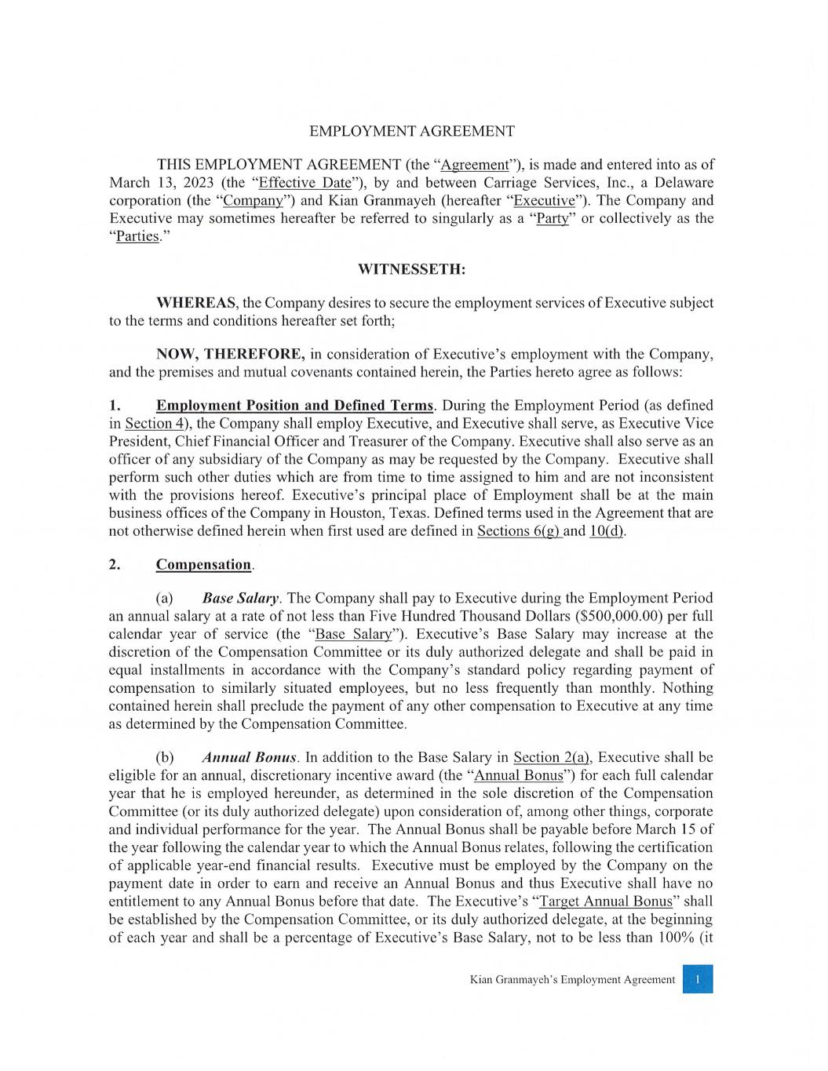
- 49 -

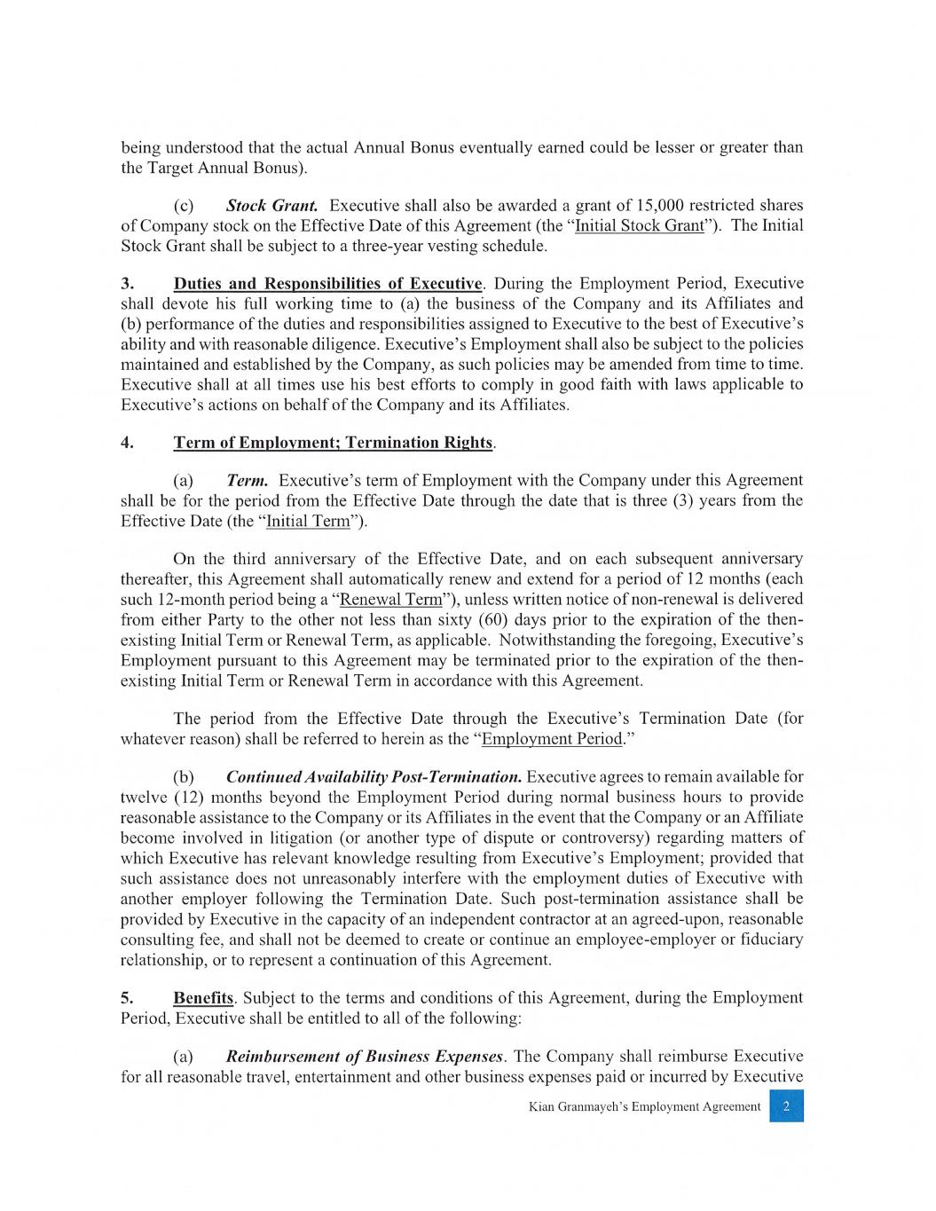

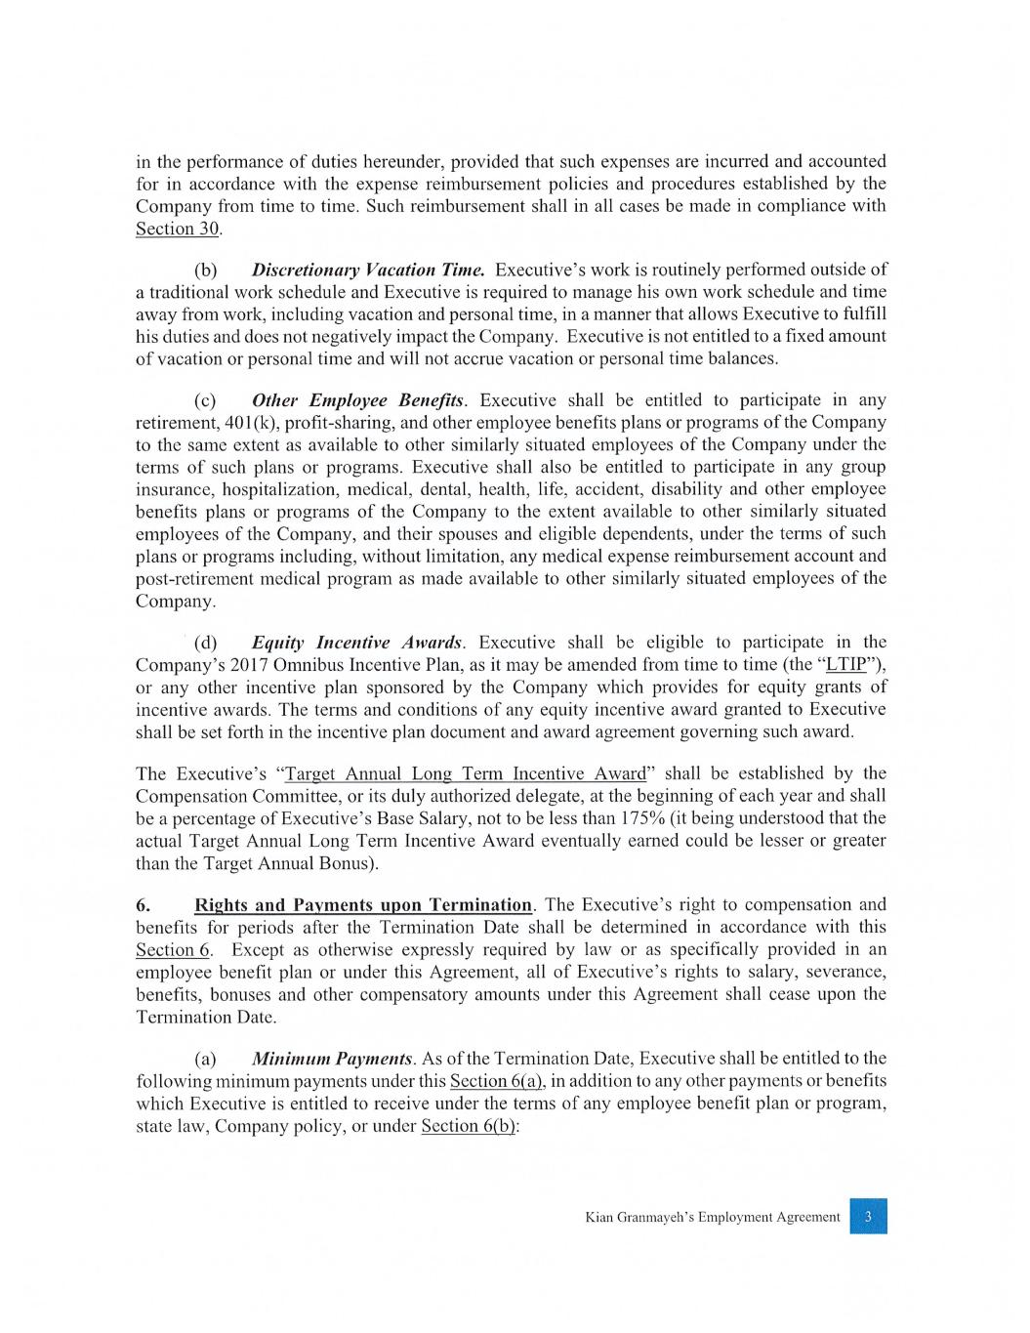

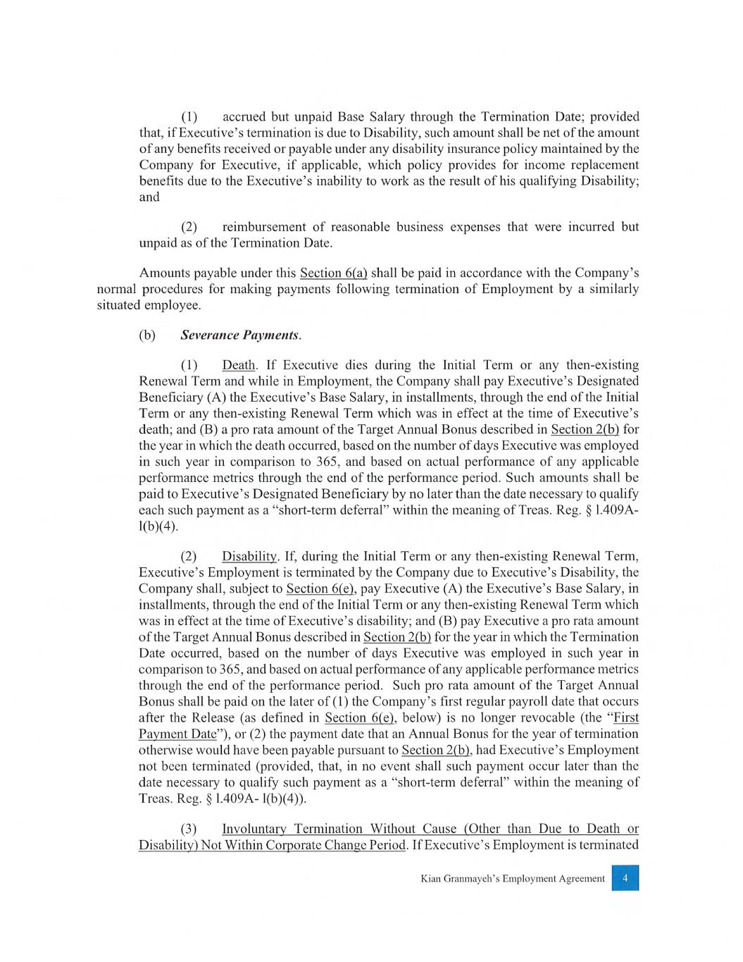

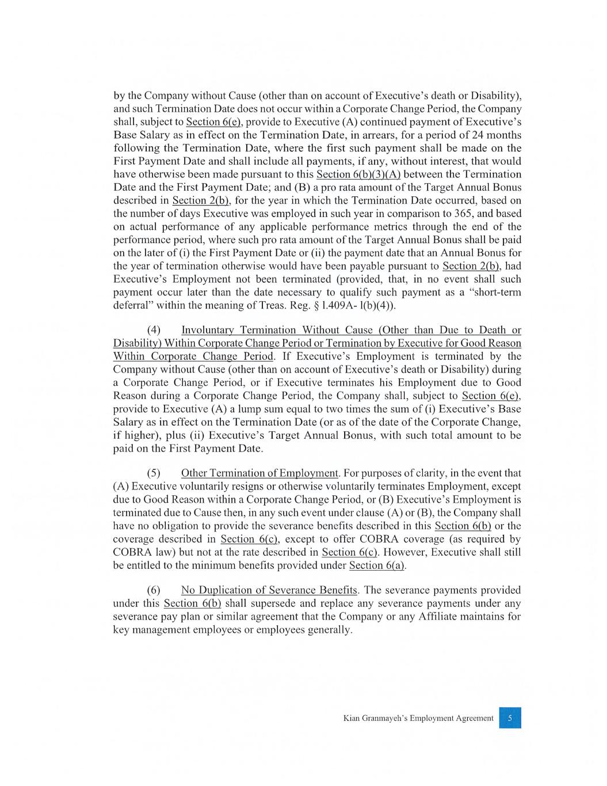

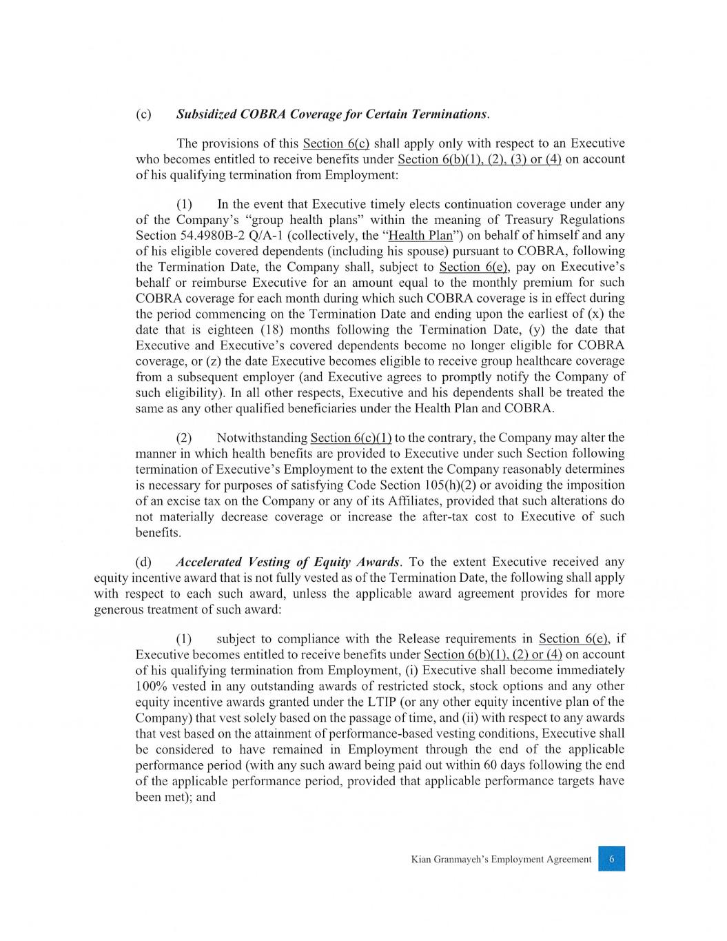

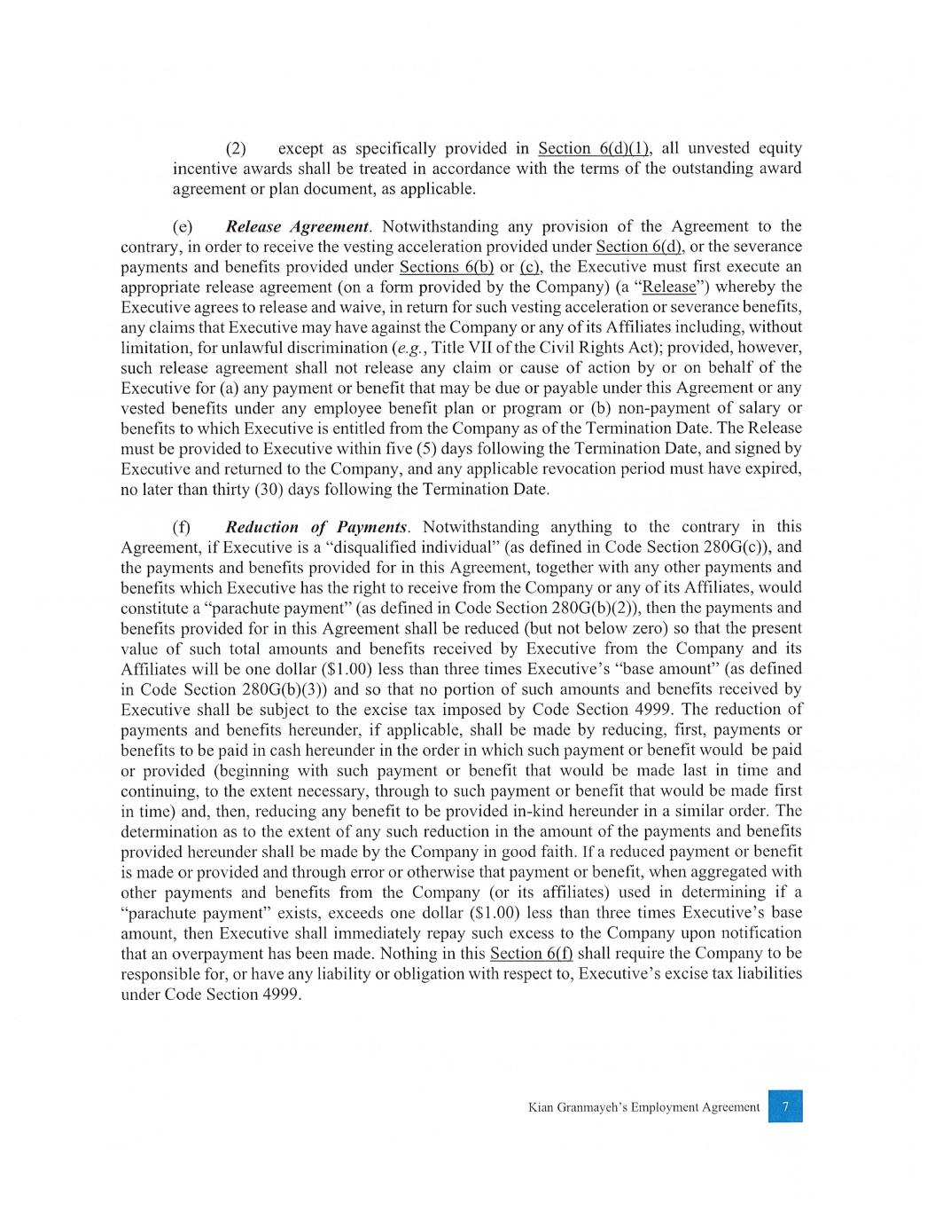

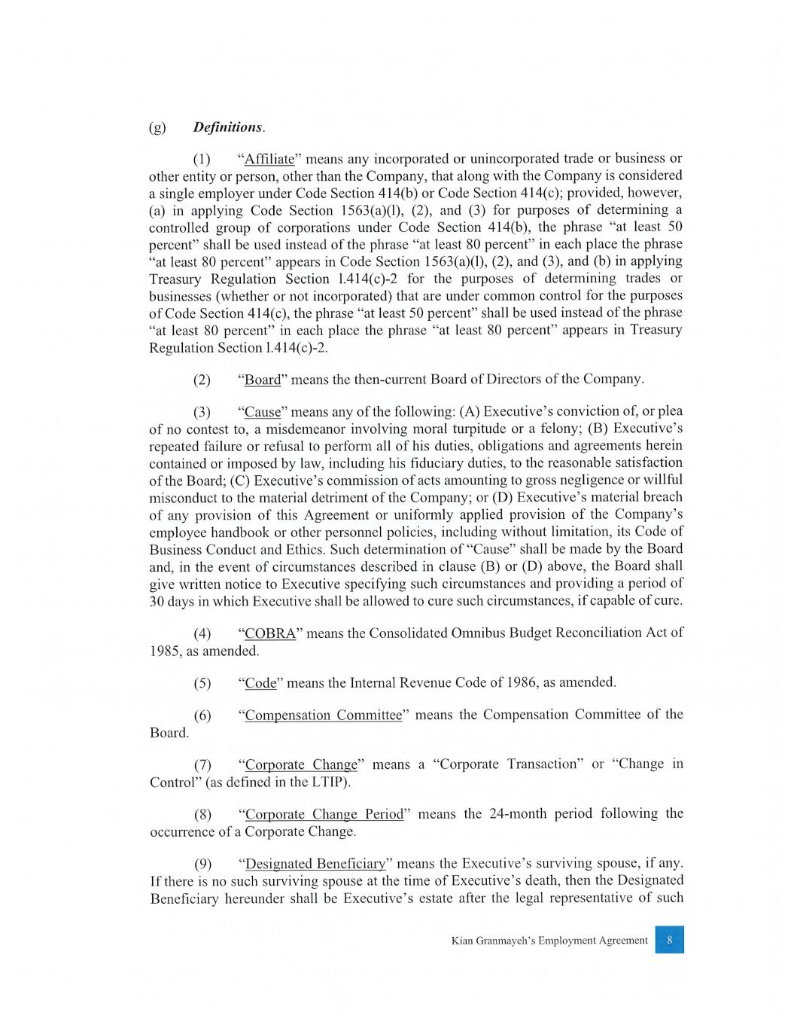

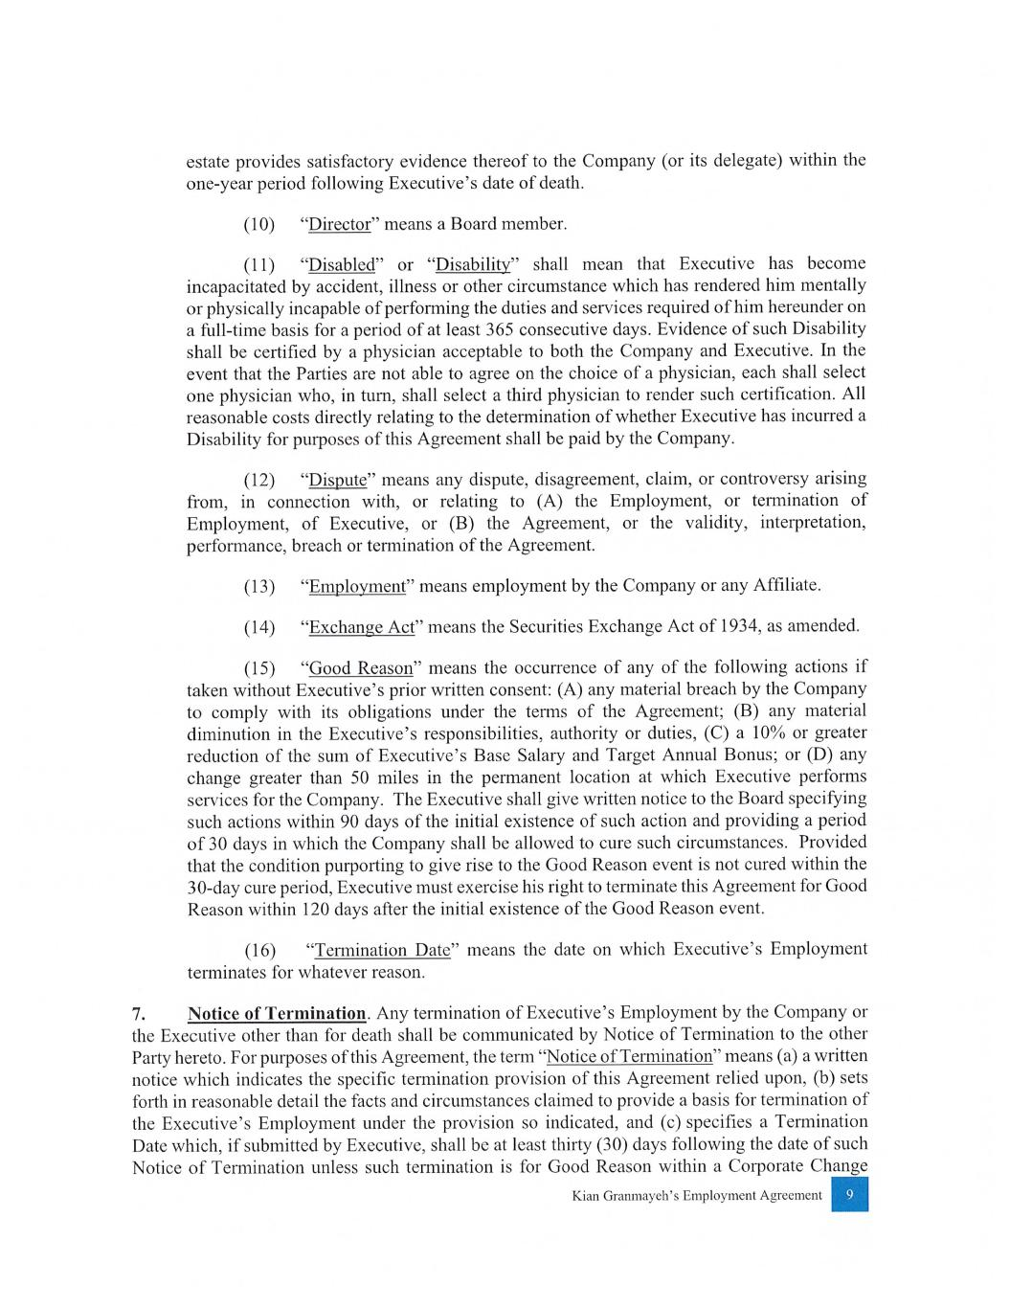

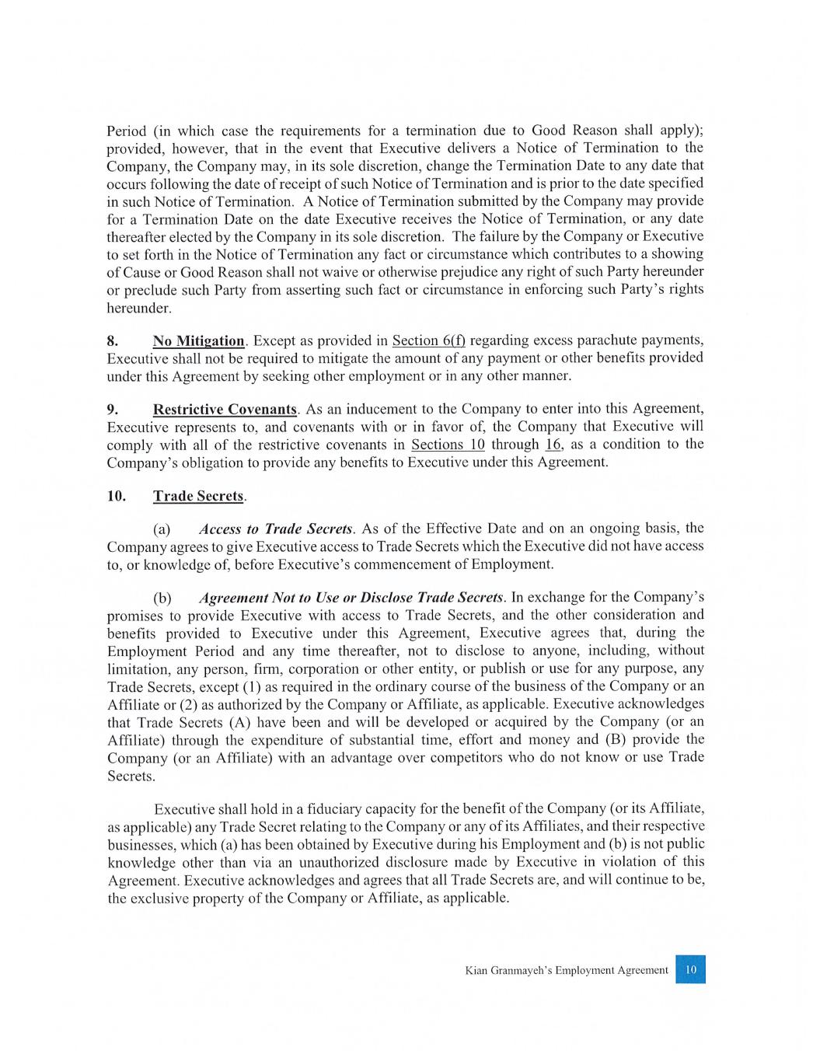

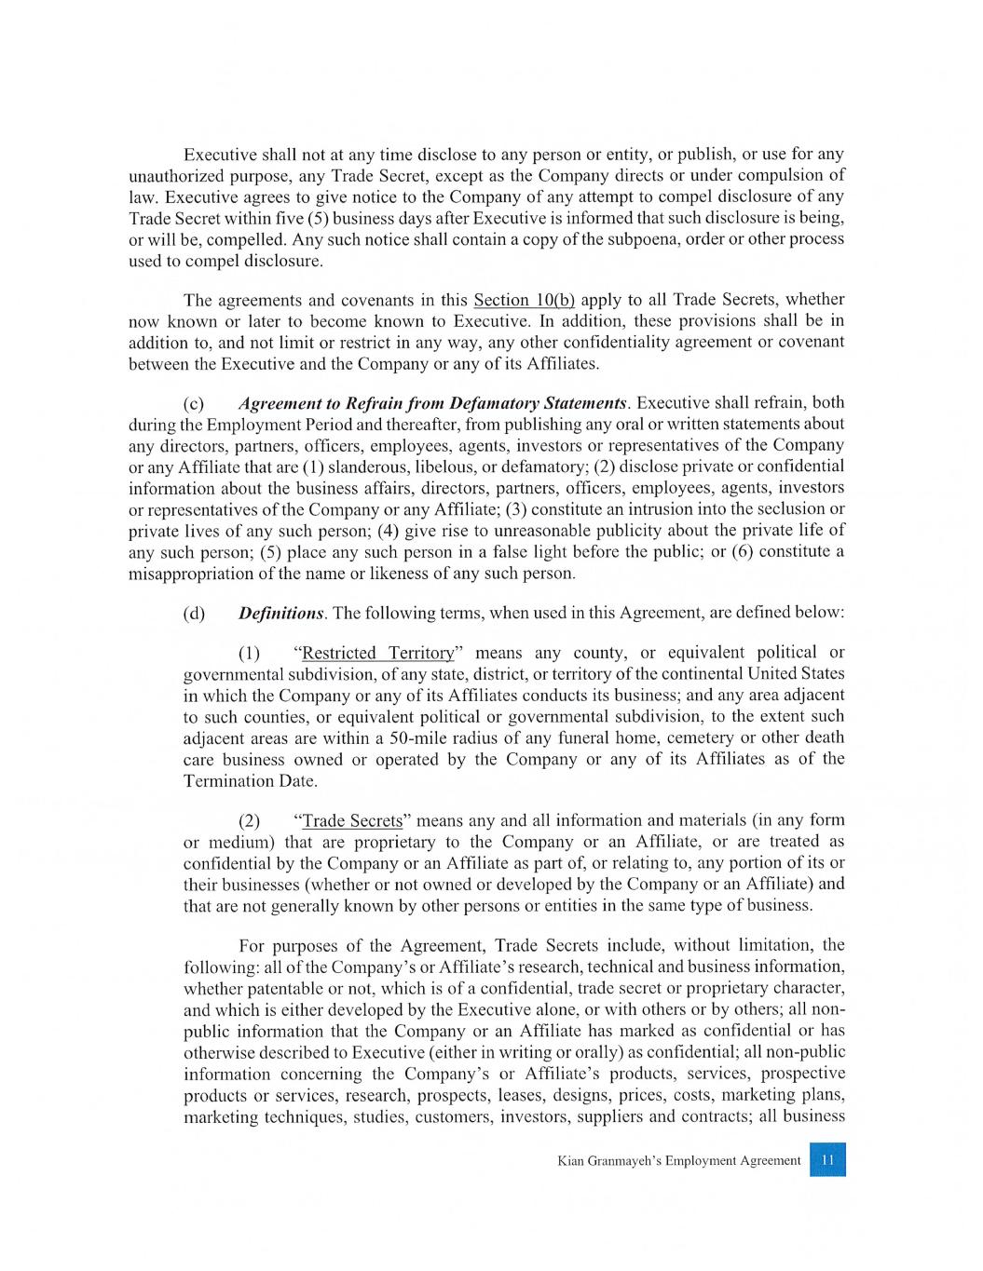

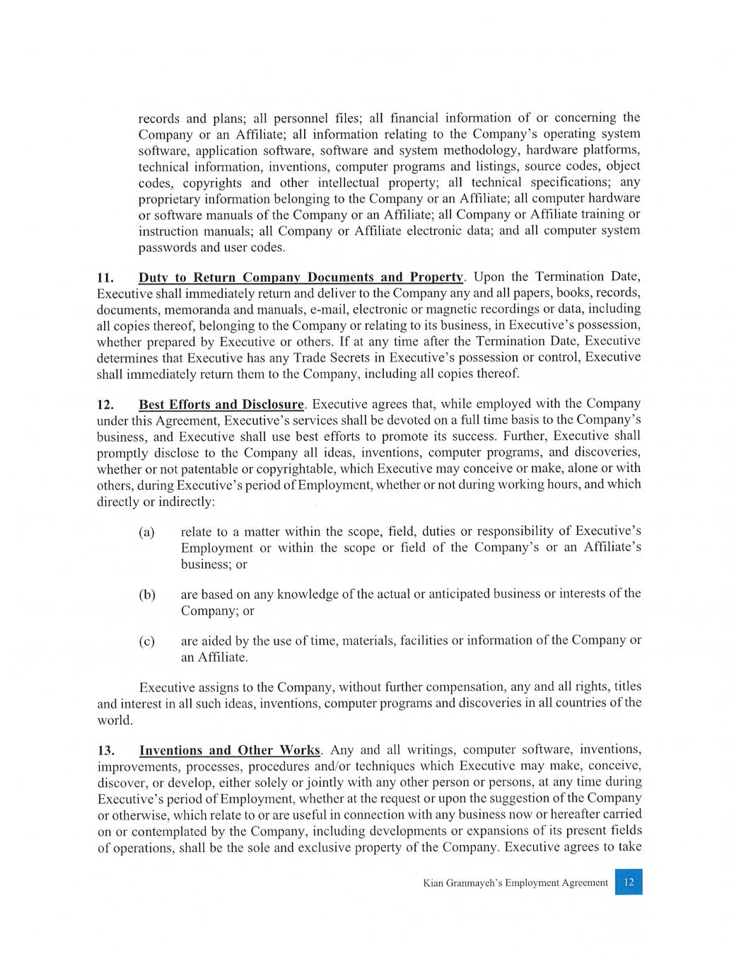

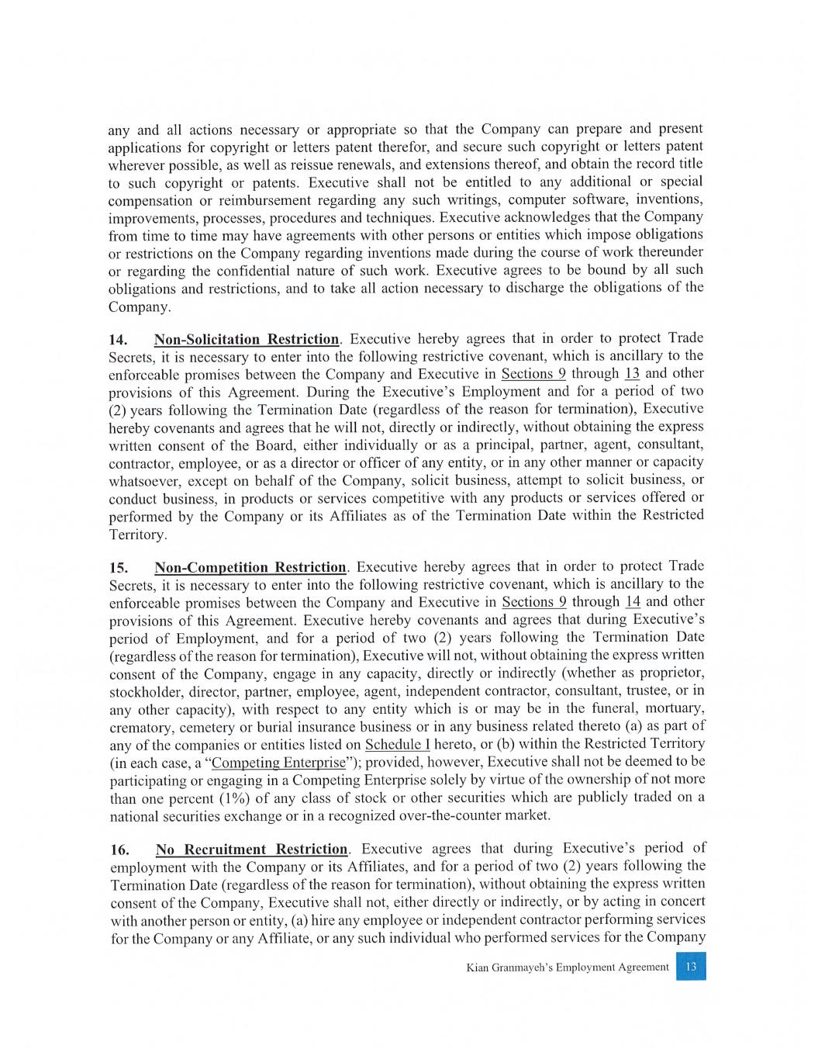

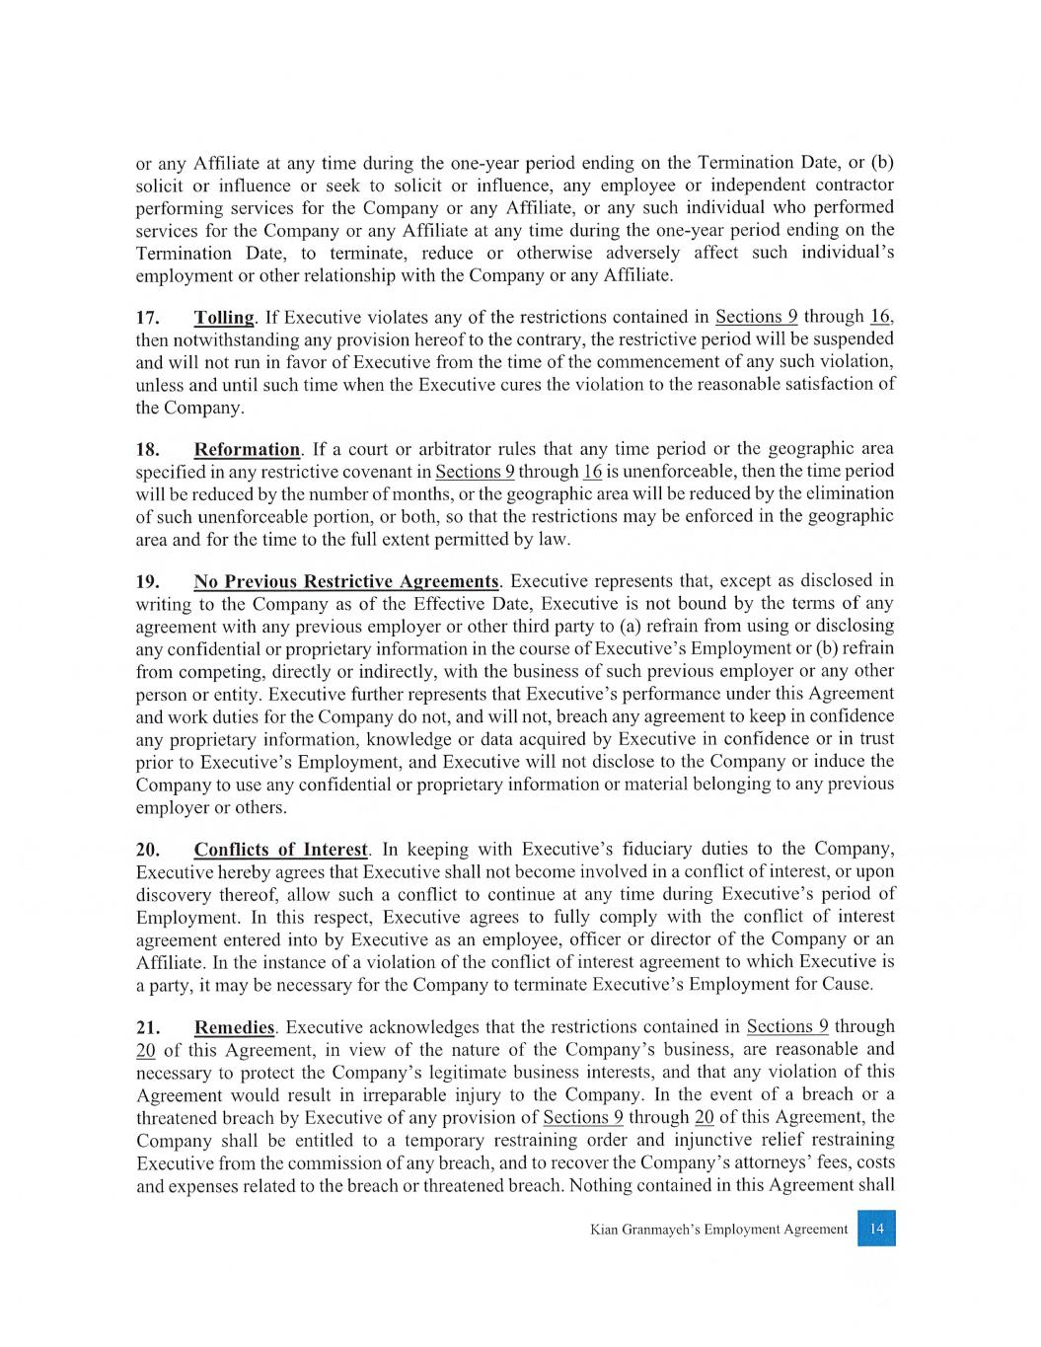

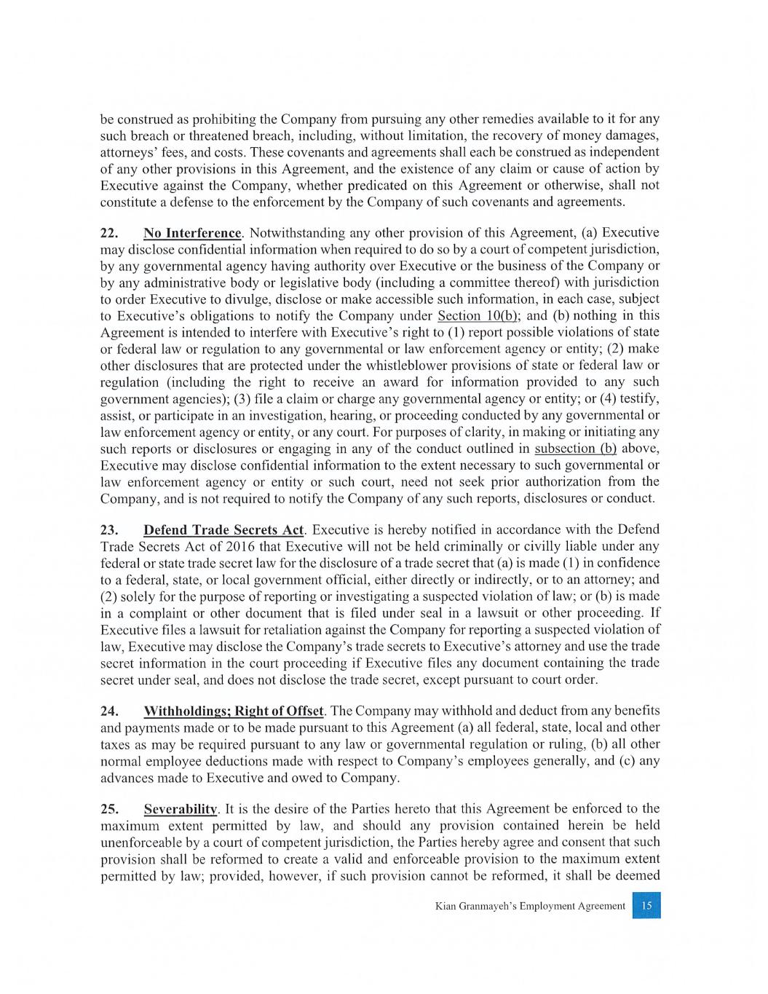

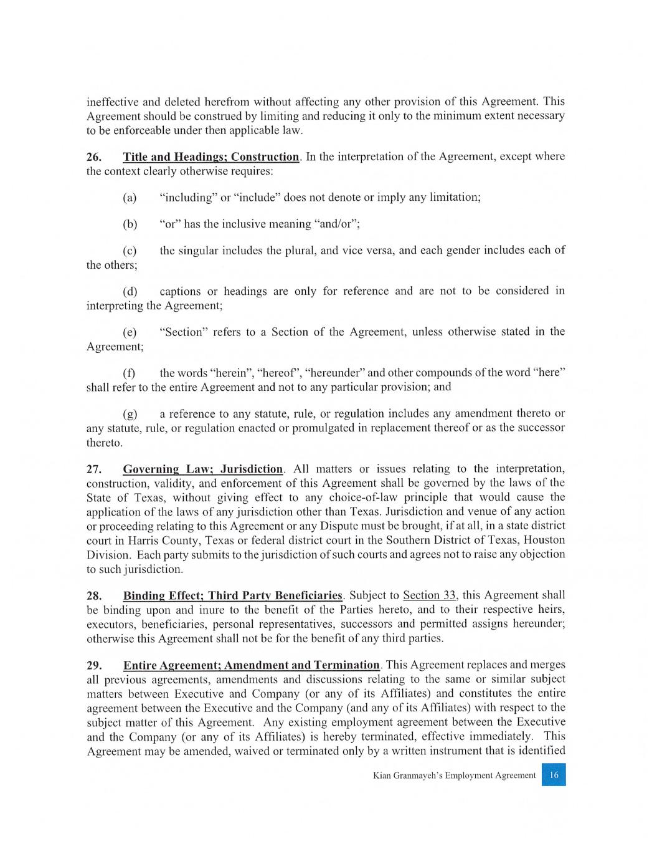

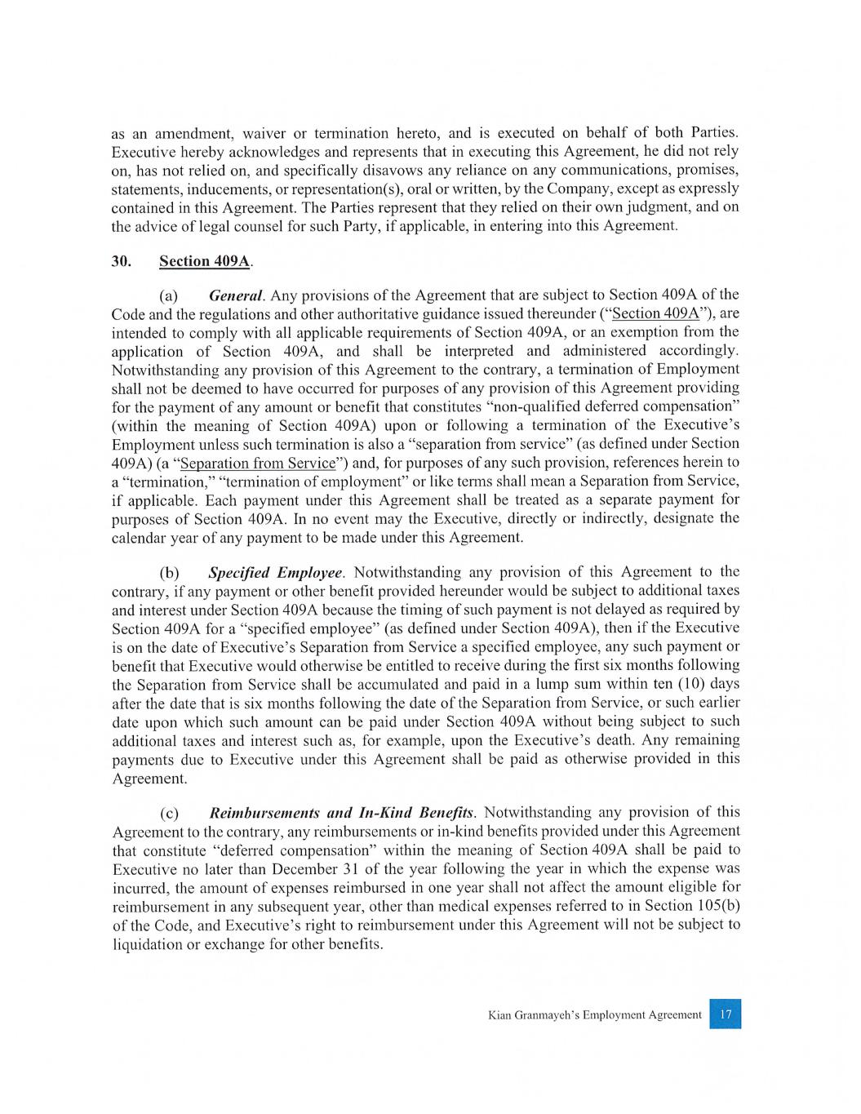

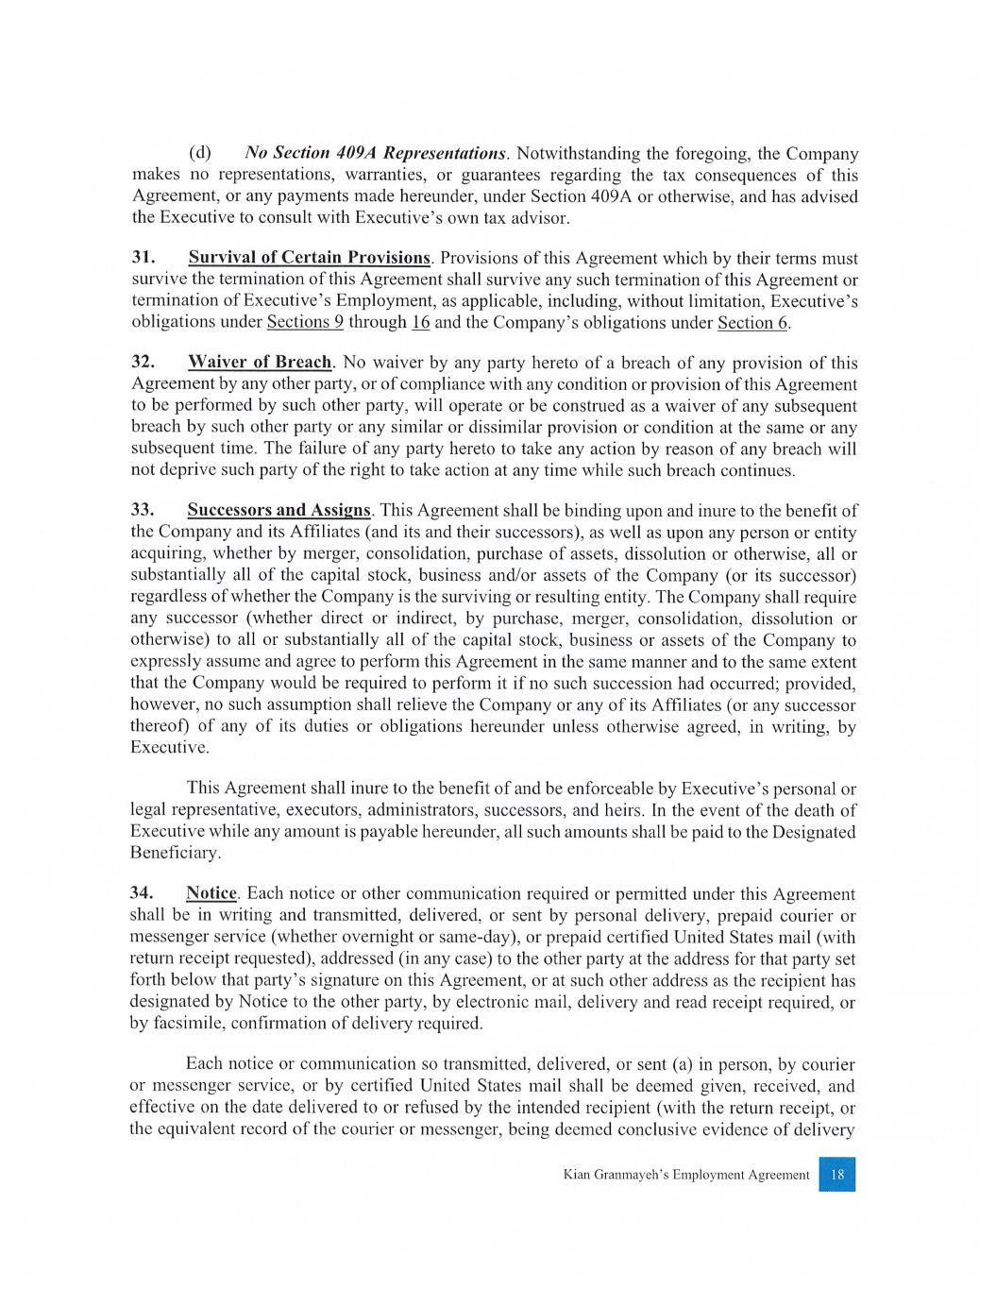

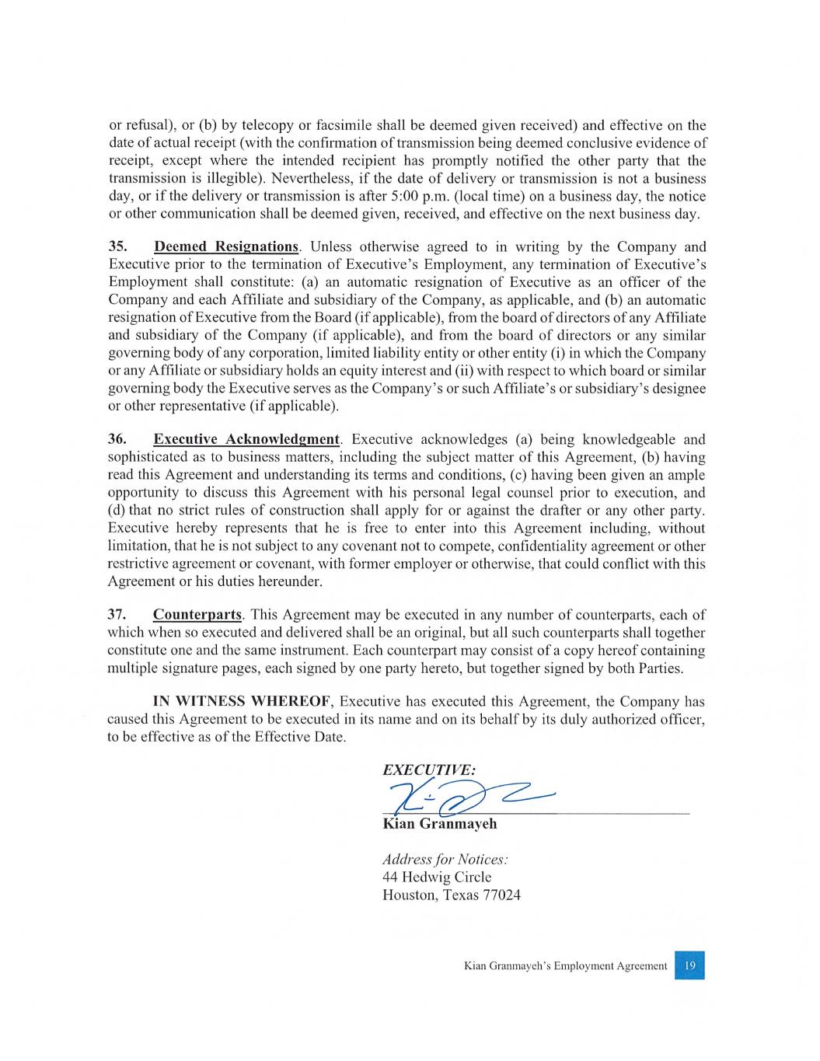

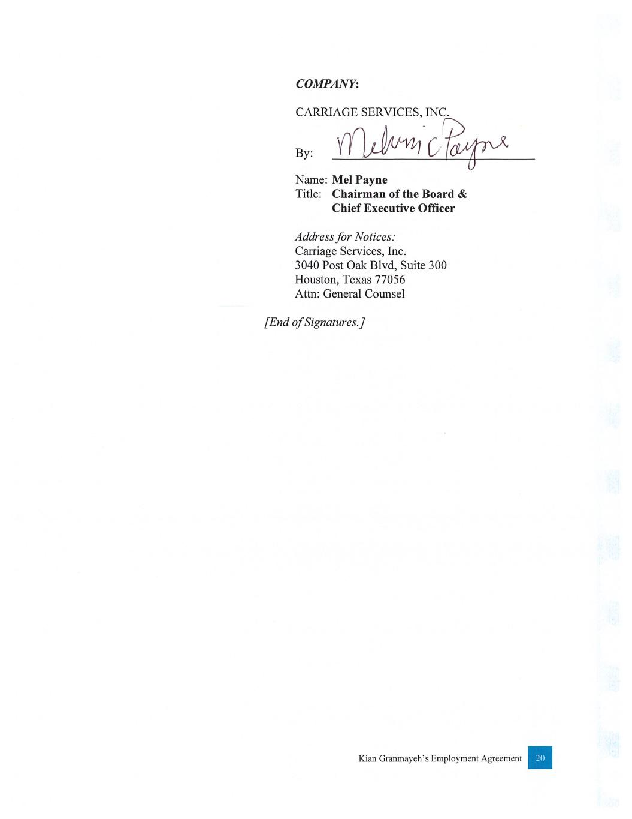

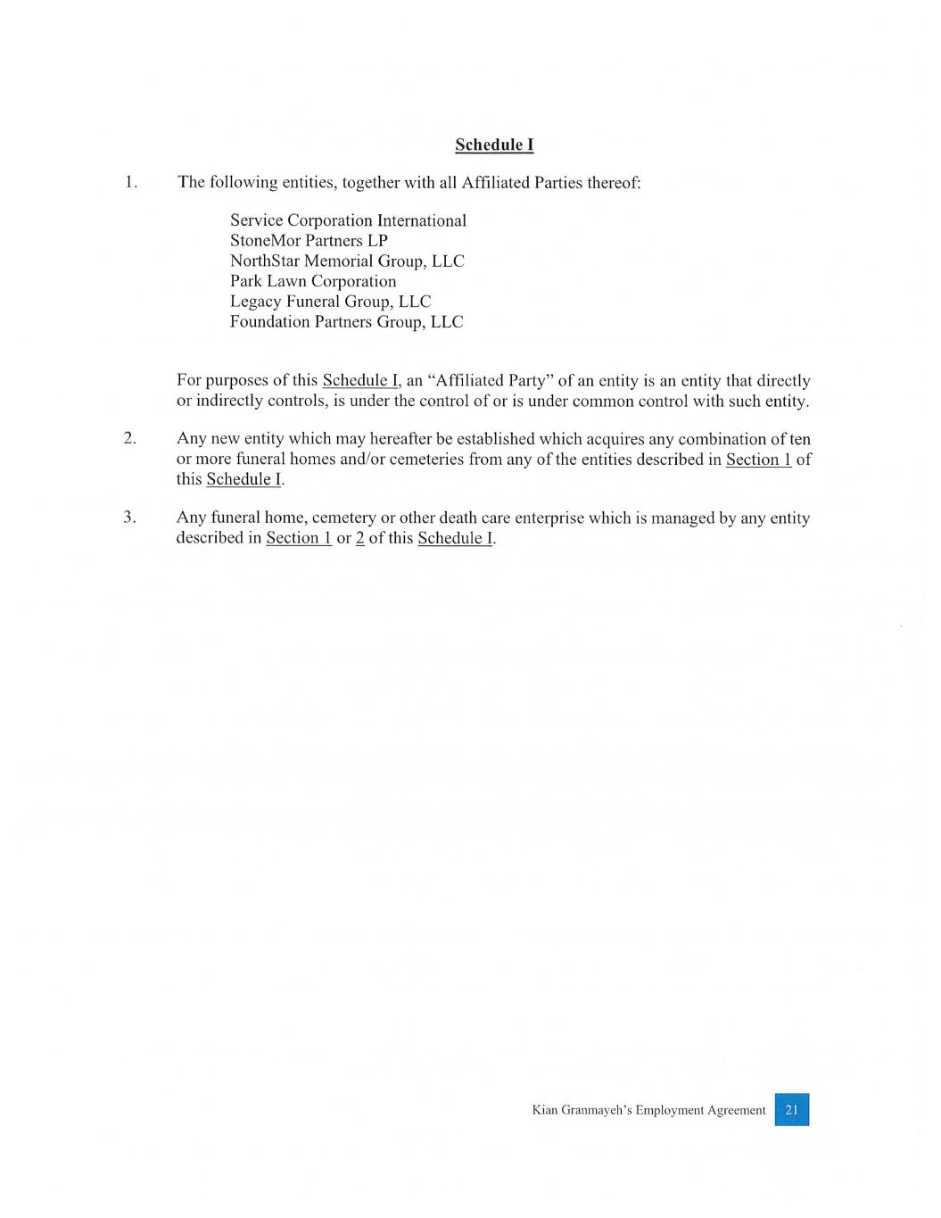

EXHIBIT 31.1
I, Melvin C. Payne, certify that:
1.I have reviewed this report on Form 10-Q of Carriage Services, Inc. (the “registrant”);
2.Based on my knowledge, this report does not contain any untrue statement of a material fact or omit to state a material fact necessary to make the statements made, in light of the circumstances under which such statements were made, not misleading with respect to the period covered by this report;
3.Based on my knowledge, the financial statements, and other financial information included in this report, fairly present in all material respects the financial condition, results of operations and cash flows of the registrant as of, and for, the periods presented in this report;
4.The registrant’s other certifying officer(s) and I are responsible for establishing and maintaining disclosure controls and procedures (as defined in Exchange Act Rules 13a-15(e) and 15d-15(e)) and internal control over financial reporting (as defined in Exchange Act Rules 13a-15(f) and 15d-15(f)) for the registrant and have:
a.Designed such disclosure controls and procedures, or caused such disclosure controls and procedures to be designed under our supervision, to ensure that material information relating to the registrant, including its consolidated subsidiaries, is made known to us by others within those entities, particularly during the period in which this report is being prepared;
b.Designed such internal control over financial reporting, or caused such internal control over financial reporting to be designed under our supervision, to provide reasonable assurance regarding the reliability of financial reporting and the preparation of financial statements for external purposes in accordance with generally accepted accounting principles;
c.Evaluated the effectiveness of the registrant’s disclosure controls and procedures and presented in this report our conclusions about the effectiveness of the disclosure controls and procedures, as of the end of the period covered by this report based on such evaluation; and
d.Disclosed in this report any change in the registrant’s internal control over financial reporting that occurred during the registrant’s most recent fiscal quarter (the registrant’s fourth fiscal quarter in the case of an annual report) that has materially affected, or is reasonably likely to materially affect, the registrant’s internal control over financial reporting; and
5.The registrant’s other certifying officer(s) and I have disclosed, based on our most recent evaluation of internal control over financial reporting, to the registrant’s auditors and the audit committee of the registrant’s board of directors (or persons performing the equivalent functions):
a.All significant deficiencies and material weaknesses in the design or operation of internal control over financial reporting which are reasonably likely to adversely affect the registrant’s ability to record, process, summarize and report financial information; and
b.Any fraud, whether or not material, that involves management or other employees who have a significant role in the registrant’s internal control over financial reporting.

Dated: |  |  | May 5, 2023 |  |  | /s/ Melvin C. Payne
 |  |  |  |  |  | Melvin C. Payne
 |  |  |  |  |  | Chief Executive Officer and Chairman of the Board
 |  |  |  |  |  | (Principal Executive Officer)

EXHIBIT 31.2
I, L. Kian Granmayeh, certify that:
1.I have reviewed this report on Form 10-Q of Carriage Services, Inc. (the “registrant”);
2.Based on my knowledge, this report does not contain any untrue statement of a material fact or omit to state a material fact necessary to make the statements made, in light of the circumstances under which such statements were made, not misleading with respect to the period covered by this report;
3.Based on my knowledge, the financial statements, and other financial information included in this report, fairly present in all material respects the financial condition, results of operations and cash flows of the registrant as of, and for, the periods presented in this report;
4.The registrant’s other certifying officer(s) and I are responsible for establishing and maintaining disclosure controls and procedures (as defined in Exchange Act Rules 13a-15(e) and 15d-15(e)) and internal control over financial reporting (as defined in Exchange Act Rules 13a-15(f) and 15d-15(f)) for the registrant and have:
a.Designed such disclosure controls and procedures, or caused such disclosure controls and procedures to be designed under our supervision, to ensure that material information relating to the registrant, including its consolidated subsidiaries, is made known to us by others within those entities, particularly during the period in which this report is being prepared;
b.Designed such internal control over financial reporting, or caused such internal control over financial reporting to be designed under our supervision, to provide reasonable assurance regarding the reliability of financial reporting and the preparation of financial statements for external purposes in accordance with generally accepted accounting principles;
c.Evaluated the effectiveness of the registrant’s disclosure controls and procedures and presented in this report our conclusions about the effectiveness of the disclosure controls and procedures, as of the end of the period covered by this report based on such evaluation; and
d.Disclosed in this report any change in the registrant’s internal control over financial reporting that occurred during the registrant’s most recent fiscal quarter (the registrant’s fourth fiscal quarter in the case of an annual report) that has materially affected, or is reasonably likely to materially affect, the registrant’s internal control over financial reporting; and
5.The registrant’s other certifying officer(s) and I have disclosed, based on our most recent evaluation of internal control over financial reporting, to the registrant’s auditors and the audit committee of the registrant’s board of directors (or persons performing the equivalent functions):
a.All significant deficiencies and material weaknesses in the design or operation of internal control over financial reporting which are reasonably likely to adversely affect the registrant’s ability to record, process, summarize and report financial information; and
b.Any fraud, whether or not material, that involves management or other employees who have a significant role in the registrant’s internal control over financial reporting.

Dated: |  |  | May 5, 2023 |  |  | /s/ L. Kian Granmayeh
 |  |  |  |  |  | L. Kian Granmayeh
 |  |  |  |  |  | Executive Vice President, Chief Financial Officer and Treasurer
 |  |  |  |  |  | (Principal Financial Officer)

EXHIBIT 32

Certification of
Chief Executive Officer and Chief Financial Officer
under Section 906 of the
Sarbanes Oxley Act of 2002, 18 U.S.C. § 1350

In connection with the Quarterly Report on Form 10-Q of Carriage Services, Inc. (the “Company”), as filed with the Securities and Exchange Commission on the date hereof (the “Report”), Melvin C. Payne, Chief Executive Officer of the Company, and L. Kian Granmayeh, Executive Vice President, Chief Financial Officer and Treasurer, each certify, pursuant to 18 U.S.C. Section 1350, as adopted pursuant to Section 906 of the Sarbanes-Oxley Act of 2002, that, to his knowledge:

(1) the Report fully complies with the requirements of Section 13(a) or 15(d) of the Securities Exchange Act of 1934, as amended; and

(2) the information contained in the Report fairly presents, in all material respects, the financial condition and results of operations of the Company.
Dated: |  |  | May 5, 2023 |  |  | /s/ Melvin C. Payne
 |  |  |  |  |  | Melvin C. Payne
 |  |  |  |  |  | Chief Executive Officer and Chairman of the Board
 |  |  |  |  |  | (Principal Executive Officer)
 |  |  |  |  |  | /s/ L. Kian Granmayeh
 |  |  |  |  |  | L. Kian Granmayeh
 |  |  |  |  |  | Executive Vice President, Chief Financial Officer and Treasurer
 |  |  |  |  |  | (Principal Financial Officer)

