UNITED STATES
SECURITIES AND EXCHANGE COMMISSION
Washington, D.C. 20549
FORM |  |  | 10-Q
(Mark One)
☒ QUARTERLY REPORT PURSUANT TO SECTION 13 OR 15(d) OF THE SECURITIES EXCHANGE ACT OF 1934
For the quarterly period ended March 31, 2024
OR
☐ TRANSITION REPORT PURSUANT TO SECTION 13 OR 15(d) OF THE SECURITIES EXCHANGE ACT OF 1934
For the transition period from ___________ to ____________
Commission File Number: |  |  | 1-11961
CARRIAGE SERVICES, INC.
(Exact name of registrant as specified in its charter)
Delaware |  |  | 76-0423828
(State or other jurisdiction of  incorporation or organization) |  |  | (I.R.S. Employer  Identification No.)
3040 Post Oak Boulevard, Suite 300
Houston, Texas, 77056
(Address of principal executive offices)
(713) 332-8400
(Registrant’s telephone number, including area code)
Securities registered pursuant to Section 12(b) of the Act:
Title of each class |  |  | Trading Symbol |  |  | Name of each exchange on which registered
Common Stock, par value $.01 per share |  |  | CSV |  |  | New York Stock Exchange
Indicate by check mark whether the registrant (1) has filed all reports required to be filed by Section 13 or 15(d) of the Securities Exchange Act of 1934 during the preceding 12 months (or for such shorter period that the registrant was required to file such reports), and (2) has been subject to such filing requirements for the past 90 days. Yes ☒ No ☐
Indicate by check mark whether the registrant has submitted electronically and posted on its corporate Web site, if any, every Interactive Data File required to be submitted and posted pursuant to Rule 405 of Regulation S-T (§ 232.405 of this chapter) during the preceding 12 months (or for such shorter period that the registrant was required to submit and post such files). Yes ☒ No ☐
Indicate by check mark whether the registrant is a large accelerated filer, an accelerated filer, a non-accelerated filer, a smaller reporting company, or an emerging growth company. See the definitions of “large accelerated filer”, “accelerated filer” and “smaller reporting company,” and “emerging growth company” in Rule 12b-2 of the Securities Exchange Act of 1934.
Large accelerated filer |  |  | ☐ |  |  |  |  |  |  |  |  |  |  |  |  |  |  |  |  |  |  |  |  | Accelerated filer |  |  | ☒
Non-accelerated filer |  |  | ☐ |  |  |  |  |  |  |  |  |  |  |  |  |  |  |  |  |  |  |  |  | Smaller reporting company |  |  | ☐
 |  |  |  |  |  |  |  |  |  |  |  |  |  |  |  |  |  |  |  |  |  |  |  | Emerging growth company |  |  | ☐

If an emerging growth company, indicate by check mark if the registrant has elected not to use the extended transition period for complying with any new or revised financial accounting standards provided pursuant to Section 13(a) of the Exchange Act. ☐
Indicate by check mark whether the registrant is a shell company (as defined in Rule 12b-2 of the Exchange Act). Yes ☐ No ☒
The number of shares of the registrant’s Common Stock, $.01 par value per share, outstanding as of April 26, 2024 was 15,165,486.

CARRIAGE SERVICES, INC.
INDEX

 |  |  | Page
PART I – FINANCIAL INFORMATION
Item 1. Financial Statements |  |  | 3
Unaudited Consolidated Balance Sheet as of December 31, 2023 and March 31, 2024 |  |  | 3
Unaudited Consolidated Statements of Operations for the Three Months ended March 31, 2023 and 2024 |  |  | 4
Unaudited Consolidated Statements of Cash Flows for the Three Months ended March 31, 2023 and 2024 |  |  | 5
Unaudited Consolidated Statements of Changes in Stockholders' Equity for the Three Months ended March 31, 2023 and 2024 |  |  | 6
Condensed Notes to Consolidated Financial Statements |  |  | 7
Cautionary Statement on Forward–Looking Statements |  |  | 31
Item 2. Management’s Discussion and Analysis of Financial Condition and Results of Operations |  |  | 33
Item 3. Quantitative and Qualitative Disclosures About Market Risk |  |  | 44
Item 4. Controls and Procedures |  |  | 45
PART II – OTHER INFORMATION
Item 1. Legal Proceedings |  |  | 46
Item 1A. Risk Factors |  |  | 46
Item 2. Unregistered Sales of Equity Securities and Use of Proceeds |  |  | 46
Item 3. Defaults Upon Senior Securities |  |  | 46
Item 4. Mine Safety Disclosures |  |  | 46
Item 5. Other Information |  |  | 46
Item 6. Exhibits |  |  | 46
SIGNATURE |  |  | 47
INDEX OF EXHIBITS |  |  | 48

- 2 -

PART I – FINANCIAL INFORMATION

Item 1.Financial Statements.

CARRIAGE SERVICES, INC.
CONSOLIDATED BALANCE SHEET
(unaudited and in thousands, except share data)
 |  |  | December 31, 2023 |  |  |  |  |  | March 31, 2024
ASSETS
Current assets:
Cash and cash equivalents |  |  | $ | 1,523 |  |  |  |  | $ | 1,689
Accounts receivable, net |  |  | 27,060 |  |  |  |  |  | 26,549
Inventories |  |  | 8,347 |  |  |  |  |  | 8,252
Prepaid and other current assets |  |  | 4,791 |  |  |  |  |  | 3,905
Total current assets |  |  | 41,721 |  |  |  |  |  | 40,395
Preneed cemetery trust investments |  |  | 96,374 |  |  |  |  |  | 98,757
Preneed funeral trust investments |  |  | 107,842 |  |  |  |  |  | 109,833
Preneed cemetery receivables, net |  |  | 35,575 |  |  |  |  |  | 36,854
Receivables from preneed funeral trusts, net |  |  | 21,530 |  |  |  |  |  | 21,632
Property, plant and equipment, net |  |  | 287,484 |  |  |  |  |  | 281,965
Cemetery property, net |  |  | 114,580 |  |  |  |  |  | 114,002
Goodwill |  |  | 423,643 |  |  |  |  |  | 414,895
Intangible and other non-current assets, net |  |  | 37,677 |  |  |  |  |  | 37,872
Operating lease right-of-use assets |  |  | 16,295 |  |  |  |  |  | 16,512
Cemetery perpetual care trust investments |  |  | 85,331 |  |  |  |  |  | 87,802
Total assets |  |  | $ | 1,268,052 |  |  |  |  | $ | 1,260,519
LIABILITIES AND STOCKHOLDERS’ EQUITY
Current liabilities:
Current portion of debt and lease obligations |  |  | $ | 3,842 |  |  |  |  | $ | 3,953
Accounts payable |  |  | 11,866 |  |  |  |  |  | 12,727
Accrued and other liabilities |  |  | 35,362 |  |  |  |  |  | 39,380
Total current liabilities |  |  | 51,070 |  |  |  |  |  | 56,060
Acquisition debt, net of current portion |  |  | 5,461 |  |  |  |  |  | 5,380
Credit facility |  |  | 177,794 |  |  |  |  |  | 152,932
Senior notes |  |  | 395,905 |  |  |  |  |  | 396,075
Obligations under finance leases, net of current portion |  |  | 5,831 |  |  |  |  |  | 5,434
Obligations under operating leases, net of current portion |  |  | 15,797 |  |  |  |  |  | 15,802
Deferred preneed cemetery revenue |  |  | 61,048 |  |  |  |  |  | 61,219
Deferred preneed funeral revenue |  |  | 39,537 |  |  |  |  |  | 39,745
Deferred tax liability |  |  | 52,127 |  |  |  |  |  | 49,785
Other long-term liabilities |  |  | 1,855 |  |  |  |  |  | 1,942
Deferred preneed cemetery receipts held in trust |  |  | 96,374 |  |  |  |  |  | 98,757
Deferred preneed funeral receipts held in trust |  |  | 107,842 |  |  |  |  |  | 109,833
Care trusts’ corpus |  |  | 84,351 |  |  |  |  |  | 88,000
Total liabilities |  |  | 1,094,992 |  |  |  |  |  | 1,080,964
Commitments and contingencies:
Stockholders’ equity:
Common stock, $0.01 par value; 80,000,000 shares authorized and 26,627,319 and 26,793,343 shares issued, respectively and 14,999,501 and 15,165,525 shares outstanding, respectively |  |  | 266 |  |  |  |  |  | 268
Additional paid-in capital |  |  | 241,291 |  |  |  |  |  | 240,811
Retained earnings |  |  | 210,256 |  |  |  |  |  | 217,229
Treasury stock, at cost; 11,627,818 shares |  |  | (278,753) |  |  |  |  |  | (278,753)
Total stockholders’ equity |  |  | 173,060 |  |  |  |  |  | 179,555
Total liabilities and stockholders’ equity |  |  | $ | 1,268,052 |  |  |  |  | $ | 1,260,519
The accompanying condensed notes are an integral part of these Consolidated Financial Statements.

- 3 -

CARRIAGE SERVICES, INC.
CONSOLIDATED STATEMENTS OF OPERATIONS
(unaudited and in thousands, except per share data)
 |  |  | Three months ended March 31,
 |  |  | 2023 |  |  |  |  |  | 2024
Revenue:
Service revenue |  |  | $ | 48,207 |  |  |  |  | $ | 49,699
Property and merchandise revenue |  |  | 40,011 |  |  |  |  |  | 45,502
Other revenue |  |  | 7,296 |  |  |  |  |  | 8,292
 |  |  | 95,514 |  |  |  |  |  | 103,493
Field costs and expenses:
Cost of service |  |  | 23,477 |  |  |  |  |  | 23,708
Cost of merchandise |  |  | 29,734 |  |  |  |  |  | 31,950
Cemetery property amortization |  |  | 1,201 |  |  |  |  |  | 1,756
Field depreciation expense |  |  | 3,357 |  |  |  |  |  | 3,467
Regional and unallocated funeral and cemetery costs |  |  | 5,437 |  |  |  |  |  | 3,842
Other expenses |  |  | 1,253 |  |  |  |  |  | 1,508
 |  |  | 64,459 |  |  |  |  |  | 66,231
Gross profit |  |  | 31,055 |  |  |  |  |  | 37,262
Corporate costs and expenses:
General, administrative and other |  |  | 10,180 |  |  |  |  |  | 16,240
Net loss on divestitures, disposals and impairments charges |  |  | 241 |  |  |  |  |  | 1,545
Operating income |  |  | 20,634 |  |  |  |  |  | 19,477
Interest expense |  |  | 8,539 |  |  |  |  |  | 8,712
Loss on property damage, net of insurance claims |  |  | 271 |  |  |  |  |  | —
Other, net |  |  | (522) |  |  |  |  |  | 43
Income before income taxes |  |  | 12,346 |  |  |  |  |  | 10,722
Expense for income taxes |  |  | 3,568 |  |  |  |  |  | 3,519
(Benefit) expense related to discrete income tax items |  |  | (66) |  |  |  |  |  | 230
Total expense for income taxes |  |  | 3,502 |  |  |  |  |  | 3,749
Net income |  |  | $ | 8,844 |  |  |  |  | $ | 6,973
Basic earnings per common share: |  |  | $ | 0.59 |  |  |  |  | $ | 0.46
Diluted earnings per common share: |  |  | $ | 0.57 |  |  |  |  | $ | 0.45
Dividends declared per common share: |  |  | $ | 0.1125 |  |  |  |  | $ | 0.1125
Weighted average number of common and common equivalent shares outstanding:
Basic |  |  | 14,758 |  |  |  |  |  | 14,876
Diluted |  |  | 15,468 |  |  |  |  |  | 15,309
The accompanying condensed notes are an integral part of these Consolidated Financial Statements.

- 4 -

CARRIAGE SERVICES, INC.
CONSOLIDATED STATEMENTS OF CASH FLOWS
(unaudited and in thousands)
 |  |  | Three months ended March 31,
 |  |  | 2023 |  |  |  |  |  | 2024
Cash flows from operating activities:
Net income |  |  | $ | 8,844 |  |  |  |  | $ | 6,973
Adjustments to reconcile net income to net cash provided by operating activities:
Depreciation and amortization |  |  | 4,769 |  |  |  |  |  | 5,460
Provision for credit losses |  |  | 699 |  |  |  |  |  | 782
Stock-based compensation expense |  |  | 2,141 |  |  |  |  |  | 489
Deferred income tax benefit |  |  | (178) |  |  |  |  |  | (2,342)
Amortization of intangibles |  |  | 321 |  |  |  |  |  | 332
Amortization of debt issuance costs |  |  | 174 |  |  |  |  |  | 176
Amortization and accretion of debt |  |  | 127 |  |  |  |  |  | 132
Net loss on divestitures, disposals and impairment charges |  |  | 241 |  |  |  |  |  | 1,545
Loss on property damage, net of insurance claims |  |  | 271 |  |  |  |  |  | —
Gain on sale of excess land |  |  | (530) |  |  |  |  |  | —
Changes in operating assets and liabilities that provided (used) cash:
Accounts and preneed receivables |  |  | 120 |  |  |  |  |  | (1,800)
Inventories, prepaid and other current assets |  |  | 884 |  |  |  |  |  | 814
Intangible and other non-current assets |  |  | (1,277) |  |  |  |  |  | (834)
Preneed funeral and cemetery trust investments |  |  | 5,356 |  |  |  |  |  | (15,255)
Accounts payable |  |  | (246) |  |  |  |  |  | 862
Accrued and other liabilities |  |  | 1,924 |  |  |  |  |  | 4,831
Deferred preneed funeral and cemetery revenue |  |  | 8,132 |  |  |  |  |  | 2,267
Deferred preneed funeral and cemetery receipts held in trust |  |  | (5,903) |  |  |  |  |  | 15,271
Net cash provided by operating activities |  |  | 25,869 |  |  |  |  |  | 19,703
Cash flows from investing activities:
Acquisitions of businesses |  |  | (44,000) |  |  |  |  |  | —
Proceeds from divestitures and sale of other assets |  |  | 1,275 |  |  |  |  |  | 10,877
Proceeds from insurance claims |  |  | 421 |  |  |  |  |  | 46
Capital expenditures |  |  | (4,982) |  |  |  |  |  | (3,551)
Net cash (used in) provided by investing activities |  |  | (47,286) |  |  |  |  |  | 7,372
Cash flows from financing activities:
Borrowings from the credit facility |  |  | 51,700 |  |  |  |  |  | 13,600
Payments against the credit facility |  |  | (28,800) |  |  |  |  |  | (38,600)
Payments on acquisition debt and obligations under finance leases |  |  | (127) |  |  |  |  |  | (152)
Proceeds from the exercise of stock options and employee stock purchase plan contributions |  |  | 526 |  |  |  |  |  | 347
Taxes paid on restricted stock vestings and exercise of stock options |  |  | (98) |  |  |  |  |  | (418)
Dividends paid on common stock |  |  | (1,661) |  |  |  |  |  | (1,686)
Net cash provided by (used in) financing activities |  |  | 21,540 |  |  |  |  |  | (26,909)
Net increase in cash and cash equivalents |  |  | 123 |  |  |  |  |  | 166
Cash and cash equivalents at beginning of period |  |  | 1,170 |  |  |  |  |  | 1,523
Cash and cash equivalents at end of period |  |  | $ | 1,293 |  |  |  |  | $ | 1,689
The accompanying condensed notes are an integral part of these Consolidated Financial Statements.

- 5 -

CARRIAGE SERVICES, INC.
CONSOLIDATED STATEMENTS OF CHANGES IN STOCKHOLDERS’ EQUITY
(unaudited and in thousands)
 |  |  | Three months ended March 31, 2023
 |  |  | Shares  Outstanding |  |  |  |  |  | Common  Stock |  |  |  |  |  | Additional  Paid-in  Capital |  |  |  |  |  | Retained  Earnings |  |  |  |  |  | Treasury  Stock |  |  |  |  |  | Total
Balance – December 31, 2022 |  |  | 14,732 |  |  |  |  |  | $ | 264 |  |  |  |  | $ | 238,780 |  |  |  |  | $ | 176,843 |  |  |  |  | $ | (278,753) |  |  |  |  | $ | 137,134
Net income |  |  | — |  |  |  |  |  | — |  |  |  |  |  | — |  |  |  |  |  | 8,844 |  |  |  |  |  | — |  |  |  |  |  | 8,844
Issuance of common stock from employee stock purchase plan |  |  | 22 |  |  |  |  |  | — |  |  |  |  |  | 526 |  |  |  |  |  | — |  |  |  |  |  | — |  |  |  |  |  | 526
Issuance of common stock to directors and board advisor |  |  | 4 |  |  |  |  |  | — |  |  |  |  |  | 112 |  |  |  |  |  | — |  |  |  |  |  | — |  |  |  |  |  | 112
Issuance of common stock to former executive |  |  | 30 |  |  |  |  |  | — |  |  |  |  |  | 826 |  |  |  |  |  | — |  |  |  |  |  | — |  |  |  |  |  | 826
Issuance of restricted common stock |  |  | 142 |  |  |  |  |  | 2 |  |  |  |  |  | (2) |  |  |  |  |  | — |  |  |  |  |  | — |  |  |  |  |  | —
Exercise of stock options |  |  | 1 |  |  |  |  |  | — |  |  |  |  |  | (21) |  |  |  |  |  | — |  |  |  |  |  | — |  |  |  |  |  | (21)
Cancellation and surrender of restricted common stock |  |  | (4) |  |  |  |  |  | — |  |  |  |  |  | (77) |  |  |  |  |  | — |  |  |  |  |  | — |  |  |  |  |  | (77)
Stock-based compensation expense |  |  | — |  |  |  |  |  | — |  |  |  |  |  | 1,203 |  |  |  |  |  | — |  |  |  |  |  | — |  |  |  |  |  | 1,203
Dividends on common stock |  |  | — |  |  |  |  |  | — |  |  |  |  |  | (1,661) |  |  |  |  |  | — |  |  |  |  |  | — |  |  |  |  |  | (1,661)
Other |  |  | 8 |  |  |  |  |  | — |  |  |  |  |  | 276 |  |  |  |  |  | — |  |  |  |  |  | — |  |  |  |  |  | 276
Balance – March 31, 2023 |  |  | 14,935 |  |  |  |  |  | $ | 266 |  |  |  |  | $ | 239,962 |  |  |  |  | $ | 185,687 |  |  |  |  | $ | (278,753) |  |  |  |  | $ | 147,162

 |  |  | Three months ended March 31, 2024
 |  |  | Shares  Outstanding |  |  |  |  |  | Common  Stock |  |  |  |  |  | Additional  Paid-in  Capital |  |  |  |  |  | Retained  Earnings |  |  |  |  |  | Treasury  Stock |  |  |  |  |  | Total
Balance – December 31, 2023 |  |  | 15,000 |  |  |  |  |  | $ | 266 |  |  |  |  | $ | 241,291 |  |  |  |  | $ | 210,256 |  |  |  |  | $ | (278,753) |  |  |  |  | $ | 173,060
Net income |  |  | — |  |  |  |  |  | — |  |  |  |  |  | — |  |  |  |  |  | 6,973 |  |  |  |  |  | — |  |  |  |  |  | 6,973
Issuance of common stock from employee stock purchase plan |  |  | 16 |  |  |  |  |  | — |  |  |  |  |  | 347 |  |  |  |  |  | — |  |  |  |  |  | — |  |  |  |  |  | 347
Issuance of common stock to directors and board advisor |  |  | 4 |  |  |  |  |  | — |  |  |  |  |  | 113 |  |  |  |  |  | — |  |  |  |  |  | — |  |  |  |  |  | 113
Issuance of restricted common stock |  |  | 157 |  |  |  |  |  | 2 |  |  |  |  |  | (2) |  |  |  |  |  | — |  |  |  |  |  | — |  |  |  |  |  | —
Cancellation and surrender of restricted common stock |  |  | (43) |  |  |  |  |  | — |  |  |  |  |  | (418) |  |  |  |  |  | — |  |  |  |  |  | — |  |  |  |  |  | (418)
Stock-based compensation expense |  |  | — |  |  |  |  |  | — |  |  |  |  |  | 376 |  |  |  |  |  | — |  |  |  |  |  | — |  |  |  |  |  | 376
Dividends on common stock |  |  | — |  |  |  |  |  | — |  |  |  |  |  | (1,686) |  |  |  |  |  | — |  |  |  |  |  | — |  |  |  |  |  | (1,686)
Other |  |  | 31 |  |  |  |  |  | — |  |  |  |  |  | 790 |  |  |  |  |  | — |  |  |  |  |  | — |  |  |  |  |  | 790
Balance – March 31, 2024 |  |  | 15,165 |  |  |  |  |  | $ | 268 |  |  |  |  | $ | 240,811 |  |  |  |  | $ | 217,229 |  |  |  |  | $ | (278,753) |  |  |  |  | $ | 179,555
The accompanying condensed notes are an integral part of these Consolidated Financial Statements.

- 6 -

CARRIAGE SERVICES, INC.
CONDENSED NOTES TO CONSOLIDATED FINANCIAL STATEMENTS
(unaudited)

1.BASIS OF PRESENTATION AND SUMMARY OF SIGNIFICANT ACCOUNTING POLICIES
The Company
Carriage Services, Inc. (“Carriage,” the “Company,” “we,” “us,” or “our”) is a leading provider of funeral and cemetery services and merchandise in the United States. Our operations are reported in two business segments: Funeral Home Operations, which currently accounts for approximately 70% of our total revenue, and Cemetery Operations, which currently accounts for approximately 30% of our total revenue. At March 31, 2024, we operated 165 funeral homes in 26 states and 31 cemeteries in 11 states.
Our funeral home operations are principally service businesses that generate revenue from sales of burial and cremation services and related merchandise, such as caskets and urns. Funeral services include consultation, the removal and preparation of remains, the sale of caskets and related funeral merchandise, the use of funeral home facilities for visitation and memorial services and transportation services. We provide funeral services and products on both an “atneed” (time of death) and “preneed” (planned prior to death) basis.
Our cemetery operations generate revenue primarily through sales of cemetery interment rights (primarily grave sites, lawn crypts, mausoleum spaces and niches), related cemetery merchandise (such as memorial markers, outer burial containers and monuments) and services (interments, inurnments and installation of cemetery merchandise). We provide cemetery services and products on both an atneed and preneed basis.
Principles of Consolidation and Interim Condensed Disclosures
Our unaudited Consolidated Financial Statements include the Company and its subsidiaries. All intercompany balances and transactions have been eliminated. Our interim Consolidated Financial Statements are unaudited, but include all adjustments, which consist of normal, recurring accruals, that are necessary for a fair presentation of our financial position and results of operations as of and for the interim periods presented.
There have been no material changes in our accounting policies previously disclosed in Part II, Item 8 “Financial Statements and Supplementary Data” in Note 1 in our Annual Report on Form 10-K for the year ended December 31, 2023. In addition, our unaudited Consolidated Financial Statements have been prepared in a manner consistent with the accounting principles described in our Annual Report on Form 10-K for the year ended December 31, 2023 unless otherwise disclosed herein, and should be read in conjunction therewith.
Use of Estimates
The preparation of our Consolidated Financial Statements requires us to make estimates and judgments that affect the reported amounts of assets, liabilities, revenue and expenses. On an ongoing basis, we evaluate our critical estimates and judgments, which include those related to the impairment of goodwill and the fair value measurements used in business combinations. These policies are considered critical because they may result in fluctuations in our reported results from period to period due to the significant judgments, estimates and assumptions about complex and inherently uncertain matters and because the use of different judgments, assumptions or estimates could have a material impact on our financial condition or results of operations. Actual results may differ from these estimates and such estimates may change if the underlying conditions or assumptions change. Historical performance should not be viewed as indicative of future performance because there can be no assurance the margins, operating income and net earnings, as a percentage of revenue, will be consistent from period to period.
Cash and Cash Equivalents
We consider all highly liquid investments purchased with an original maturity of three months or less to be cash equivalents.
Inventory
Inventory consists primarily of caskets, outer burial containers and cemetery monuments and markers and is recorded at the lower of its cost basis or net realizable value. Inventory is relieved using specific identification in fulfillment of performance obligations on our contracts.
- 7 -

Deferred Revenue
During the three months ended March 31, 2023, we withdrew $7.0 million of realized capital gains and earnings from our preneed funeral and cemetery trust investments. We did not withdraw any realized capital gains and earnings from our preneed trust investments during the three months ended March 31, 2024. In certain states, we are allowed to make these withdrawals prior to the delivery of preneed merchandise and service contracts. The realized capital gains and earnings withdrawn increase our cash flow from operations, but are not recognized as revenue in our Consolidated Statements of Operations, however, they reduce our Preneed funeral trust investments and Preneed cemetery trust investments and increase our Deferred preneed funeral revenue and Deferred preneed cemetery revenue.
Property, Plant and Equipment
Property, plant and equipment is comprised of the following (in thousands):
 |  |  | December 31, 2023 |  |  |  |  |  | March 31, 2024
Land |  |  | $ | 87,635 |  |  |  |  | $ | 86,888
Buildings and improvements |  |  | 263,522 |  |  |  |  |  | 260,864
Furniture, equipment and vehicles |  |  | 74,372 |  |  |  |  |  | 72,880
Property, plant and equipment, at cost |  |  | 425,529 |  |  |  |  |  | 420,632
Less: accumulated depreciation |  |  | (138,045) |  |  |  |  |  | (138,667)
Property, plant and equipment, net |  |  | $ | 287,484 |  |  |  |  | $ | 281,965
During the three months ended March 31, 2024, we sold six funeral homes and one cemetery that had a carrying value of property, plant and equipment of $3.1 million, which was included in the loss on sale and recorded in Net loss on divestitures, disposals and impairment charges on our Consolidated Statements of Operations.
During the three months ended March 31, 2023, we acquired $12.8 million of property, plant and equipment related to our acquisition of a business located in Bakersfield, CA, as more fully described in Note 3 to the Consolidated Financial Statements.
Our growth and maintenance capital expenditures totaled $2.9 million and $1.6 million for the three months ended March 31, 2023 and 2024, respectively. In addition, we recorded depreciation expense of $3.5 million and $3.6 million for the three months ended March 31, 2023 and 2024, respectively.
Cemetery Property
Cemetery property was $114.6 million and $114.0 million, net of accumulated amortization of $64.6 million and $66.2 million at December 31, 2023 and March 31, 2024, respectively. When cemetery property is sold, the value of the cemetery property (interment right costs) is expensed as amortization using the specific identification method in the period in which the sale of the interment right is recognized as revenue. Our growth capital expenditures for cemetery property development totaled $2.1 million and $2.0 million for the three months ended March 31, 2023 and 2024, respectively. We recorded amortization expense for cemetery interment rights of $1.2 million and $1.8 million for the three months ended March 31, 2023 and 2024, respectively.
During the three months ended March 31, 2024, we sold one cemetery that had a carrying value of cemetery property of $0.8 million, which was included in the loss on sale and recorded in Net loss on divestitures, disposals and impairment charges on our Consolidated Statements of Operations.
During the three months ended March 31, 2023, we acquired cemetery property for $9.0 million related to our acquisition of a business located in Bakersfield, CA, as more fully described in Note 3 to the Consolidated Financial Statements. We also sold two cemeteries that had a carrying value of cemetery property of $0.8 million, which was included in the loss on sale and recorded in Net loss on divestitures, disposals and impairment charges on our Consolidated Statements of Operations.
Income Taxes
Income tax expense was $3.5 million and $3.7 million for the three months ended March 31, 2023 and 2024, respectively. Our operating tax rate before discrete items was 28.9% and 32.8% for the three months ended March 31, 2023 and 2024, respectively.
Subsequent Events
We have evaluated events and transactions during the period subsequent to March 31, 2024 through the date the financial statements were issued for potential recognition or disclosure in the accompanying financial statements covered by this report.

- 8 -

2.RECENTLY ISSUED ACCOUNTING STANDARDS
Segment Reporting
In November 2023, the FASB issued ASU, Segment Reporting - Improvements to Reportable Segment Disclosures (“Topic 280”) to improve reportable segment disclosure requirements, primarily through enhanced disclosures about significant segment expenses. The amendments in this update require that a public entity disclose, on an annual and interim basis (1) significant segment expenses that are regularly provided to the chief operating decision maker (“CODM”) and included within each reported measure of segment profit or loss; and (2) an amount for other segment items, as described in the amendments, by reportable segment and a description of its composition. Additionally, the amendments require that a public entity disclose the title and position of the CODM and an explanation of how the CODM uses the reported measure(s) of segment profit or loss in assessing segment performance and deciding how to allocate resources. The amendments are effective for fiscal years beginning after December 15, 2023, and interim periods within fiscal years beginning after December 15, 2024, and therefore were effective for us for our fiscal year beginning January 1, 2024 and for interim periods within our fiscal year beginning January 1, 2025. We expect the adoption will have no impact on our Consolidated Financial Statements.
Accounting Pronouncements Not Yet Adopted
Income Taxes
In December 2023, the FASB issued ASU, Income Taxes - Improvements to Income Tax Disclosures (“Topic 740”) to enhance the transparency about income tax information through improvements to income tax disclosures primarily related to rate reconciliation and income taxes paid information. The amendments in this update require that public business entities on an annual basis (1) disclose specific categories in the rate reconciliation; and (2) provide additional information for reconciling items that meet a quantitative threshold (if the effect of those reconciling items is equal to or greater than five percent of the amount computed by multiplying pretax income (loss) by the applicable statutory income tax rate). The amendments in this update also require that all entities disclose on an annual basis (1) the amount of net income taxes paid disaggregated by federal and state taxes; and (2) the amount of net income taxes paid disaggregated by individual jurisdictions in which net income taxes paid is equal to or greater than five percent of total net income taxes paid. The amendments are effective for annual periods beginning after December 15, 2024. Early adoption is permitted. We plan to adopt the amendments of Topic 740 for our fiscal year beginning January 1, 2025. We expect the adoption will have no impact on our Consolidated Financial Statements.

3. BUSINESS COMBINATIONS
Tangible and intangible assets acquired and liabilities assumed are recorded at fair value and goodwill is recognized for any difference between the price of the acquisition and fair value. We recognize the assets acquired, the liabilities assumed and any non-controlling interest in the acquiree at the acquisition date, measured at the fair value as of that date. Acquisition related costs are recognized separately from the acquisition and are expensed as incurred. We customarily estimate related transaction costs known at closing. To the extent that information not available to us at the closing date subsequently becomes available during the measurement period, we may adjust goodwill, intangible assets, assets or liabilities associated with the acquisition.
We did not acquire any businesses during the three months ended March 31, 2024. On March 22, 2023, we acquired a business consisting of three funeral homes, two cemeteries and one cremation focused business in the Bakersfield, CA area for $44.0 million in cash. We acquired substantially all of the assets and assumed certain operating liabilities of this business.
The pro forma impact of this acquisition on prior periods is not presented, as the impact is not significant to our reported results. The results of the acquired business are reflected in our Consolidated Statements of Operations from the date of acquisition.
- 9 -

The following table summarizes the breakdown of the purchase price allocation for our Bakersfield, CA business acquisition (in thousands):
 |  |  | Initial Purchase Price Allocation |  |  |  |  |  | Adjustments |  |  |  |  |  | Adjusted Purchase Price Allocation
Current assets |  |  | $ | 7,087 |  |  |  |  | $ | 131 |  |  |  |  | $ | 7,218
Preneed trust assets |  |  | — |  |  |  |  |  | 11,428 |  |  |  |  |  | 11,428
Property, plant & equipment |  |  | 12,577 |  |  |  |  |  | 245 |  |  |  |  |  | 12,822
Cemetery property |  |  | 9,035 |  |  |  |  |  | — |  |  |  |  |  | 9,035
Goodwill |  |  | 13,612 |  |  |  |  |  | (106) |  |  |  |  |  | 13,506
Intangible and other non-current assets |  |  | 3,763 |  |  |  |  |  | — |  |  |  |  |  | 3,763
Assumed liabilities |  |  | (300) |  |  |  |  |  | (66) |  |  |  |  |  | (366)
Preneed trust liabilities |  |  | — |  |  |  |  |  | (11,428) |  |  |  |  |  | (11,428)
Deferred revenue |  |  | (1,774) |  |  |  |  |  | (204) |  |  |  |  |  | (1,978)
Purchase price |  |  | $ | 44,000 |  |  |  |  | $ | — |  |  |  |  | $ | 44,000
The current assets relate to accounts receivable and inventory. The intangible and other non-current assets relate to the fair value of tradenames and right-of-use operating lease assets. The assumed liabilities relate to operating lease obligations and commissions payable. As of December 31, 2023, our accounting for this acquisition was complete.
The following table summarizes the fair value of the assets acquired and liabilities assumed for this business (in thousands):
Acquisition Date |  |  |  |  |  | Type of Business |  |  |  |  |  | Market |  |  |  |  |  | Assets Acquired (Excluding  Goodwill) |  |  |  |  |  | Goodwill  Recorded |  |  |  |  |  | Liabilities  and Debt  Assumed
March 22, 2023 |  |  |  |  |  | Three Funeral Homes, Two Cemeteries and One Cremation Focused Business |  |  |  |  |  | Bakersfield, CA |  |  |  |  |  | $ | 44,266 |  |  |  |  | $ | 13,506 |  |  |  |  | $ | (13,772)

4.GOODWILL
The following table presents changes in goodwill in the accompanying Consolidated Balance Sheet (in thousands):
 |  |  | December 31, 2023 |  |  |  |  |  | March 31, 2024
Goodwill at the beginning of the period |  |  | $ | 410,137 |  |  |  |  | $ | 423,643
Increase in goodwill related to acquisitions |  |  | 13,506 |  |  |  |  |  | —
Decrease in goodwill related to divestitures |  |  | — |  |  |  |  |  | (8,748)
Goodwill at the end of the period |  |  | $ | 423,643 |  |  |  |  | $ | 414,895
During the three months ended March 31, 2024, we allocated $8.7 million of goodwill to the sale of six funeral homes and one cemetery for a loss recorded in Net loss on divestitures, disposals and impairments charges, of which $7.8 million was allocated to our funeral homes segment and $1.0 million was allocated to our cemetery segment.
During the three months ended March 31, 2023, we recognized $13.5 million in goodwill related to our acquisition of a business located in Bakersfield, CA, of which $4.5 million was allocated to our cemetery segment and $9.0 million was allocated to our funeral home segment.

5.DIVESTED OPERATIONS
During the three months ended March 31, 2024, we sold six funeral homes and one cemetery for an aggregate of $10.9 million. During the three months ended March 31, 2023, we sold one funeral home and two cemeteries for an aggregate of $0.8 million.
- 10 -

The operating results of these divested funeral homes and cemeteries are reflected on our Consolidated Statements of Operations as shown in the table below (in thousands):
 |  |  | Three months ended March 31,
 |  |  | 2023 |  |  |  |  |  | 2024
Revenue |  |  | $ | 66 |  |  |  |  | $ | 1,151
Operating income |  |  | 26 |  |  |  |  |  | 122
Loss on divestitures(1) |  |  | (82) |  |  |  |  |  | (1,501)
Income tax benefit |  |  | 16 |  |  |  |  |  | 452
Net loss from divested operations, after tax |  |  | $ | (40) |  |  |  |  | $ | (927)
(1) |  |  | Loss on divestitures is recorded in Net loss on divestitures, disposals and impairments charges on our Consolidated Statements of Operations.

6.RECEIVABLES
Accounts Receivable
Our funeral receivables are recorded in Accounts receivable, net and primarily consist of amounts due for funeral services already performed.
Atneed cemetery receivables and preneed cemetery receivables with payments expected to be received within one year from the balance sheet date are also recorded in Accounts receivable, net. Preneed cemetery receivables with payments expected to be received beyond one year from the balance sheet date are recorded in Preneed cemetery receivables, net.
Accounts receivable is comprised of the following (in thousands):
 |  |  | March 31, 2024
 |  |  | Funeral |  |  |  |  |  | Cemetery |  |  |  |  |  | Corporate |  |  |  |  |  | Total
Trade and financed receivables |  |  | $ | 8,412 |  |  |  |  | $ | 19,023 |  |  |  |  | $ | — |  |  |  |  | $ | 27,435
Other receivables |  |  | 388 |  |  |  |  |  | 219 |  |  |  |  |  | 112 |  |  |  |  |  | 719
Allowance for credit losses |  |  | (302) |  |  |  |  |  | (1,303) |  |  |  |  |  | — |  |  |  |  |  | (1,605)
Accounts receivable, net |  |  | $ | 8,498 |  |  |  |  | $ | 17,939 |  |  |  |  | $ | 112 |  |  |  |  | $ | 26,549
 |  |  | December 31, 2023
 |  |  | Funeral |  |  |  |  |  | Cemetery |  |  |  |  |  | Corporate |  |  |  |  |  | Total
Trade and financed receivables |  |  | $ | 8,822 |  |  |  |  | $ | 18,459 |  |  |  |  | $ | — |  |  |  |  | $ | 27,281
Other receivables |  |  | 404 |  |  |  |  |  | 595 |  |  |  |  |  | 286 |  |  |  |  |  | 1,285
Allowance for credit losses |  |  | (266) |  |  |  |  |  | (1,240) |  |  |  |  |  | — |  |  |  |  |  | (1,506)
Accounts receivable, net |  |  | $ | 8,960 |  |  |  |  | $ | 17,814 |  |  |  |  | $ | 286 |  |  |  |  | $ | 27,060
Other receivables include supplier rebates, commissions due from third party insurance companies and perpetual care income receivables. We do not provide an allowance for credit losses for these receivables as we have historically not had any collectability issues nor do we expect any in the foreseeable future.
The following table summarizes the activity in our allowance for credit losses by segment (in thousands):
 |  |  | January 1, 2024 |  |  |  |  |  | Provision for Credit Losses |  |  |  |  |  |  |  | Write Offs |  |  |  |  |  | Recoveries |  |  |  |  |  | March 31, 2024
Trade and financed receivables:
Funeral |  |  | $ | (266) |  |  |  |  | $ | (238) |  |  |  |  |  |  | $ | 459 |  |  |  |  | $ | (257) |  |  |  |  | $ | (302)
Cemetery |  |  | (1,240) |  |  |  |  |  | (208) |  |  |  |  |  |  |  | 145 |  |  |  |  |  | — |  |  |  |  |  | (1,303)
Total allowance for credit losses on trade and financed receivables |  |  | $ | (1,506) |  |  |  |  | $ | (446) |  |  |  |  |  |  | $ | 604 |  |  |  |  | $ | (257) |  |  |  |  | $ | (1,605)
Balances due on undelivered preneed funeral trust contracts have been reclassified to reduce Deferred preneed funeral revenue on our Consolidated Balance Sheet of $10.7 million at both December 31, 2023 and March 31, 2024. As these performance obligations are to be completed after the date of death, we cannot quantify the recognition of revenue in future periods. However, we estimate an average maturity period of ten years for preneed funeral contracts.

- 11 -

Cemetery Receivables
Our cemetery receivables are comprised of the following (in thousands):
 |  |  | December 31, 2023 |  |  |  |  |  | March 31, 2024
Interment rights |  |  | $ | 60,863 |  |  |  |  | $ | 63,328
Merchandise and services |  |  | 11,223 |  |  |  |  |  | 11,314
Unearned finance charges |  |  | 5,669 |  |  |  |  |  | 5,884
Cemetery receivables |  |  | $ | 77,755 |  |  |  |  | $ | 80,526
The components of our cemetery receivables are as follows (in thousands):
 |  |  | December 31, 2023 |  |  |  |  |  | March 31, 2024
Cemetery receivables |  |  | $ | 77,755 |  |  |  |  | $ | 80,526
Less: unearned finance charges |  |  | (5,669) |  |  |  |  |  | (5,884)
Cemetery receivables, at amortized cost |  |  | $ | 72,086 |  |  |  |  | $ | 74,642
Less: allowance for credit losses |  |  | (3,495) |  |  |  |  |  | (3,602)
Less: balances due on undelivered cemetery preneed contracts |  |  | (15,797) |  |  |  |  |  | (16,466)
Less: amounts in accounts receivable |  |  | (17,219) |  |  |  |  |  | (17,720)
Preneed cemetery receivables, net |  |  | $ | 35,575 |  |  |  |  | $ | 36,854
The following table summarizes the activity in our allowance for credit losses for Preneed cemetery receivables, net (in thousands):
 |  |  | January 1, 2024 |  |  |  |  |  | Provision for Credit Losses |  |  |  |  |  | Write Offs |  |  |  |  |  | March 31, 2024
Total allowance for credit losses on Preneed cemetery receivables, net |  |  | $ | (2,255) |  |  |  |  | $ | (336) |  |  |  |  | $ | 292 |  |  |  |  | $ | (2,299)
The amortized cost basis of our cemetery receivables by year of origination at March 31, 2024 is as follows (in thousands):
 |  |  | 2024 |  |  |  |  |  | 2023 |  |  |  |  |  | 2022 |  |  |  |  |  | 2021 |  |  |  |  |  | 2020 |  |  |  |  |  | Prior |  |  |  |  |  | Total
Total preneed cemetery receivables, at amortized cost |  |  | $ | 12,395 |  |  |  |  | $ | 29,871 |  |  |  |  | $ | 17,435 |  |  |  |  | $ | 8,853 |  |  |  |  | $ | 3,818 |  |  |  |  | $ | 2,270 |  |  |  |  | $ | 74,642
The aging of past due cemetery receivables at March 31, 2024 is as follows (in thousands):
 |  |  | 31-60  Past Due |  |  |  |  |  | 61-90  Past Due |  |  |  |  |  | 91-120  Past Due |  |  |  |  |  | >120  Past Due |  |  |  |  |  | Total Past  Due |  |  |  |  |  | Current |  |  |  |  |  | Total
Recognized revenue |  |  | $ | 2,418 |  |  |  |  | $ | 512 |  |  |  |  | $ | 333 |  |  |  |  | $ | 3,635 |  |  |  |  | $ | 6,898 |  |  |  |  | $ | 51,278 |  |  |  |  | $ | 58,176
Deferred revenue |  |  | 444 |  |  |  |  |  | 128 |  |  |  |  |  | 141 |  |  |  |  |  | 1,234 |  |  |  |  |  | 1,947 |  |  |  |  |  | 20,403 |  |  |  |  |  | 22,350
Total contracts |  |  | $ | 2,862 |  |  |  |  | $ | 640 |  |  |  |  | $ | 474 |  |  |  |  | $ | 4,869 |  |  |  |  | $ | 8,845 |  |  |  |  | $ | 71,681 |  |  |  |  | $ | 80,526
Balances due on undelivered preneed cemetery contracts have been reclassified to reduce Deferred preneed cemetery revenue on our Consolidated Balance Sheet. The transaction price allocated to preneed merchandise and service performance obligations that were unfulfilled were $15.8 million and $16.5 million at December 31, 2023 and March 31, 2024, respectively. As these performance obligations are to be completed after the date of death, we cannot quantify the recognition of revenue in future periods. However, we estimate an average maturity period of eight years for preneed cemetery contracts.

7.FAIR VALUE MEASUREMENTS
We evaluated our financial assets and liabilities for those that met the criteria of the disclosure requirements and fair value framework. The carrying values of cash and cash equivalents, accounts receivable and accounts payable approximate the fair values of those instruments due to the short-term nature of the instruments. The fair values of our receivables on preneed cemetery contracts are impracticable to estimate because of the lack of a trading market and the diverse number of individual contracts with varying terms. Our acquisition debt and Credit Facility (as defined in Note 11) and Senior Notes (as defined in Note 12) are classified within Level 2 of the Fair Value Measurements hierarchy.
At March 31, 2024, the carrying value and fair value of our Credit Facility was $154.1 million. We believe that our Credit Facility bears interest at a rate that approximates prevailing market rates for instruments with similar characteristics and therefore, the carrying value of our Credit Facility approximates fair value. We estimate the fair value of our acquisition debt utilizing an income approach, which uses a present value calculation to discount payments based on current market rates as
- 12 -

of the reporting date. At March 31, 2024, the carrying value of our acquisition debt was $6.0 million, which approximated its fair value. The fair value of our Senior Notes was $355.2 million at March 31, 2024 based on the last traded or broker quoted price.
We identified investments in fixed income securities, common stock and mutual funds presented within the preneed and perpetual care trust investments categories on our Consolidated Balance Sheet as having met the criteria for fair value measurement. Where quoted prices are available in an active market, investments held by the trusts are classified as Level 1 investments pursuant to the three-level valuation hierarchy. Our Level 1 investments include cash, U.S. treasury debt, common stock and equity mutual funds. Where quoted market prices are not available for the specific security, then fair values are estimated by using quoted prices of similar securities in active markets or inputs other than quoted prices that can corroborate observable market data. These investments are fixed income securities, including U.S. agency obligations, foreign debt, corporate debt, preferred stocks, certificates of deposit and fixed income mutual funds and other investments, all of which are classified within Level 2 of the valuation hierarchy.
In addition, we have an investment in a limited partnership fund, whose fair value has been estimated using the net asset value per share practical expedient described in ASC 820-10-35-59, Fair Value Measurement of Investments in Certain Entities That Calculate Net Asset Value per Share (or Its Equivalent) and therefore, has not been classified in the fair value hierarchy. The investment strategy of this fund is to generate attractive, risk-adjusted returns over a multi-year performance period through the construction of a concentrated portfolio of investments possessing certain distinct business attributes that suggest the potential for long-term value creation. Beginning March 31, 2024, the agreement permits us to withdraw a percentage of the value of the investments in this fund through quarterly withdrawal dates with the intention to permit withdrawal of the entire investment over twelve successive withdrawal dates. Our unfunded commitment for this investment at March 31, 2024 was $10.0 million.
Our receivables from preneed funeral trusts represent assets in trusts which are controlled and operated by third parties in which we do not have a controlling financial interest (less than 50%) in the trust assets. We account for these investments at cost. See Notes 8 and 9 to our Consolidated Financial Statements for the fair value hierarchy levels of our trust investments.

8.TRUST INVESTMENTS
Preneed trust investments represent trust fund assets that we are generally permitted to withdraw as the services and merchandise are provided to customers. Preneed funeral and cemetery contracts are secured by payments from customers, less amounts not required by law to be deposited into trust. These earnings are recognized in Other revenue on our Consolidated Statements of Operations, when a service is performed or merchandise is delivered. Trust management fees charged by our wholly-owned registered investment advisory firm are included as revenue in the period in which they are earned. Our investments are diversified across multiple industry segments using a balanced allocation strategy to minimize long-term risk. We do not intend to sell and it is likely that we will not be required to sell the securities prior to their anticipated recovery.
Cemetery perpetual care trust investments represent a portion of the proceeds from the sale of cemetery property interment rights that we are required by various state laws to deposit into perpetual care trust funds. The income earned from these perpetual care trusts offsets maintenance expenses for cemetery property and memorials. This trust fund income is recognized in Other revenue.
Changes in the fair value of our trust fund assets (Preneed funeral, cemetery and perpetual care trust investments) are offset by changes in the fair value of our trust fund liabilities (Deferred preneed funeral and cemetery receipts held in trust and Care trusts’ corpus) and reflected in Other, net. There is no impact on earnings until such time the services are performed or the merchandise is delivered, causing the contract to be withdrawn from the trust in accordance with state regulations and the gain or loss is allocated to the contract.
We rely on our trust investments to provide funding for the various contractual obligations that arise upon maturity of the underlying preneed contracts. Because of the long-term relationship between the establishment of trust investments and the required performance of the underlying contractual obligations, the impact of current market conditions that may exist at any given time is not necessarily indicative of our ability to generate profit on our future performance obligations.
Preneed Cemetery Trust Investments
The components of Preneed cemetery trust investments on our Consolidated Balance Sheet are as follows (in thousands):
 |  |  | December 31, 2023 |  |  |  |  |  | March 31, 2024
Preneed cemetery trust investments, at market value |  |  | $ | 99,461 |  |  |  |  | $ | 101,990
Less: allowance for contract cancellation |  |  | (3,087) |  |  |  |  |  | (3,233)
Preneed cemetery trust investments |  |  | $ | 96,374 |  |  |  |  | $ | 98,757
- 13 -

The cost and market values associated with preneed cemetery trust investments at March 31, 2024 are detailed below (in thousands):
 |  |  | Fair Value Hierarchy Level |  |  |  |  |  | Cost |  |  |  |  |  | Unrealized  Gains |  |  |  |  |  | Unrealized  Losses |  |  |  |  |  | Fair Market  Value
Cash and money market accounts |  |  | 1 |  |  |  |  |  | $ | 21,052 |  |  |  |  | $ | — |  |  |  |  | $ | — |  |  |  |  | $ | 21,052
Fixed income securities:
U.S. agency obligations |  |  | 2 |  |  |  |  |  | 664 |  |  |  |  |  | — |  |  |  |  |  | (56) |  |  |  |  |  | 608
Foreign debt |  |  | 2 |  |  |  |  |  | 7,849 |  |  |  |  |  | 1,454 |  |  |  |  |  | (14) |  |  |  |  |  | 9,289
Corporate debt |  |  | 2 |  |  |  |  |  | 15,489 |  |  |  |  |  | 257 |  |  |  |  |  | (2,508) |  |  |  |  |  | 13,238
Preferred stock |  |  | 2 |  |  |  |  |  | 11,296 |  |  |  |  |  | 492 |  |  |  |  |  | (1,790) |  |  |  |  |  | 9,998
Certificates of deposit |  |  | 2 |  |  |  |  |  | 79 |  |  |  |  |  | — |  |  |  |  |  | (7) |  |  |  |  |  | 72
Common stock |  |  | 1 |  |  |  |  |  | 34,679 |  |  |  |  |  | 2,459 |  |  |  |  |  | (5,314) |  |  |  |  |  | 31,824
Limited partnership fund |  |  |  |  |  |  |  |  | 3,611 |  |  |  |  |  | 301 |  |  |  |  |  | — |  |  |  |  |  | 3,912
Mutual funds:
Equity |  |  | 1 |  |  |  |  |  | 546 |  |  |  |  |  | 33 |  |  |  |  |  | (21) |  |  |  |  |  | 558
Fixed income |  |  | 2 |  |  |  |  |  | 12,490 |  |  |  |  |  | 34 |  |  |  |  |  | (2,279) |  |  |  |  |  | 10,245
Trust securities |  |  |  |  |  |  |  |  | $ | 107,755 |  |  |  |  | $ | 5,030 |  |  |  |  | $ | (11,989) |  |  |  |  | $ | 100,796
Accrued investment income |  |  |  |  |  |  |  |  | $ | 1,194 |  |  |  |  |  |  |  |  |  |  |  |  |  |  |  |  | $ | 1,194
Preneed cemetery trust investments |  |  |  |  |  |  |  |  |  |  |  |  |  |  |  |  |  |  |  |  |  |  |  |  |  |  | $ | 101,990
Market value as a percentage of cost |  |  |  |  |  |  |  |  |  |  |  |  |  |  |  |  |  |  |  |  |  |  |  |  |  |  | 93.5%
The estimated maturities of the fixed income securities (excluding mutual funds) included above are as follows (in thousands):
Due in one year or less |  |  | $ | 136
Due in one to five years |  |  | 12,662
Due in five to ten years |  |  | 3,303
Thereafter |  |  | 17,104
Total fixed income securities |  |  | $ | 33,205
The cost and market values associated with preneed cemetery trust investments at December 31, 2023 are detailed below (in thousands):
 |  |  | Fair Value Hierarchy Level |  |  |  |  |  | Cost |  |  |  |  |  | Unrealized  Gains |  |  |  |  |  | Unrealized  Losses |  |  |  |  |  | Fair Market  Value
Cash and money market accounts |  |  | 1 |  |  |  |  |  | $ | 9,643 |  |  |  |  | $ | — |  |  |  |  | $ | — |  |  |  |  | $ | 9,643
Fixed income securities:
U.S. agency obligations |  |  | 2 |  |  |  |  |  | 803 |  |  |  |  |  | 1 |  |  |  |  |  | (51) |  |  |  |  |  | 753
Foreign debt |  |  | 2 |  |  |  |  |  | 7,764 |  |  |  |  |  | 1,371 |  |  |  |  |  | (17) |  |  |  |  |  | 9,118
Corporate debt |  |  | 2 |  |  |  |  |  | 15,071 |  |  |  |  |  | 342 |  |  |  |  |  | (3,657) |  |  |  |  |  | 11,756
Preferred stock |  |  | 2 |  |  |  |  |  | 10,965 |  |  |  |  |  | 473 |  |  |  |  |  | (1,572) |  |  |  |  |  | 9,866
Certificate of deposit |  |  | 2 |  |  |  |  |  | 79 |  |  |  |  |  | — |  |  |  |  |  | (7) |  |  |  |  |  | 72
Common stock |  |  | 1 |  |  |  |  |  | 43,057 |  |  |  |  |  | 9,466 |  |  |  |  |  | (7,935) |  |  |  |  |  | 44,588
Limited partnership fund |  |  |  |  |  |  |  |  | 3,575 |  |  |  |  |  | — |  |  |  |  |  | (3) |  |  |  |  |  | 3,572
Mutual funds:
Equity |  |  | 1 |  |  |  |  |  | 553 |  |  |  |  |  | 10 |  |  |  |  |  | (30) |  |  |  |  |  | 533
Fixed income |  |  | 2 |  |  |  |  |  | 11,369 |  |  |  |  |  | 16 |  |  |  |  |  | (2,759) |  |  |  |  |  | 8,626
Trust Securities |  |  |  |  |  |  |  |  | $ | 102,879 |  |  |  |  | $ | 11,679 |  |  |  |  | $ | (16,031) |  |  |  |  | $ | 98,527
Accrued investment income |  |  |  |  |  |  |  |  | $ | 934 |  |  |  |  |  |  |  |  |  |  |  |  |  |  |  |  | $ | 934
Preneed cemetery trust investments |  |  |  |  |  |  |  |  |  |  |  |  |  |  |  |  |  |  |  |  |  |  |  |  |  |  | $ | 99,461
Market value as a percentage of cost |  |  |  |  |  |  |  |  |  |  |  |  |  |  |  |  |  |  |  |  |  |  |  |  |  |  | 95.8%
- 14 -

The following table summarizes our fixed income securities (excluding mutual funds) within our preneed cemetery trust investments in an unrealized loss position at March 31, 2024, aggregated by major security type and length of time in a continuous unrealized loss position (in thousands):
 |  |  | March 31, 2024
 |  |  | In Loss Position Less than 12 months |  |  |  |  |  |  |  |  |  |  |  | In Loss Position Greater than 12 months |  |  |  |  |  |  |  |  |  |  |  | Total
 |  |  | Fair Market Value |  |  |  |  |  | Unrealized Losses |  |  |  |  |  | Fair Market Value |  |  |  |  |  | Unrealized Losses |  |  |  |  |  | Fair Market Value |  |  |  |  |  | Unrealized Losses
Fixed income securities:
U.S. agency obligations |  |  | $ | — |  |  |  |  | $ | — |  |  |  |  | $ | 608 |  |  |  |  | $ | (56) |  |  |  |  | $ | 608 |  |  |  |  | $ | (56)
Foreign debt |  |  | — |  |  |  |  |  | — |  |  |  |  |  | 501 |  |  |  |  |  | (14) |  |  |  |  |  | 501 |  |  |  |  |  | (14)
Corporate debt |  |  | 685 |  |  |  |  |  | (16) |  |  |  |  |  | 5,046 |  |  |  |  |  | (2,492) |  |  |  |  |  | 5,731 |  |  |  |  |  | (2,508)
Preferred stock |  |  | 941 |  |  |  |  |  | (4) |  |  |  |  |  | 7,708 |  |  |  |  |  | (1,786) |  |  |  |  |  | 8,649 |  |  |  |  |  | (1,790)
Certificates of deposit |  |  | — |  |  |  |  |  | — |  |  |  |  |  | 73 |  |  |  |  |  | (7) |  |  |  |  |  | 73 |  |  |  |  |  | (7)
Total fixed income securities with an unrealized loss |  |  | $ | 1,626 |  |  |  |  | $ | (20) |  |  |  |  | $ | 13,936 |  |  |  |  | $ | (4,355) |  |  |  |  | $ | 15,562 |  |  |  |  | $ | (4,375)
The following table summarizes our fixed income securities (excluding mutual funds) within our preneed cemetery trust investments in an unrealized loss position at December 31, 2023, aggregated by major security type and length of time in a continuous unrealized loss position (in thousands):
 |  |  | December 31, 2023
 |  |  | In Loss Position Less than 12 months |  |  |  |  |  |  |  |  |  |  |  | In Loss Position Greater than 12 months |  |  |  |  |  |  |  |  |  |  |  | Total
 |  |  | Fair Market Value |  |  |  |  |  | Unrealized Losses |  |  |  |  |  | Fair Market Value |  |  |  |  |  | Unrealized Losses |  |  |  |  |  | Fair Market Value |  |  |  |  |  | Unrealized Losses
Fixed income securities:
U.S. agency obligations |  |  | $ | — |  |  |  |  | $ | — |  |  |  |  | $ | 613 |  |  |  |  | $ | (51) |  |  |  |  | $ | 613 |  |  |  |  | $ | (51)
Foreign debt |  |  | 284 |  |  |  |  |  | (5) |  |  |  |  |  | 209 |  |  |  |  |  | (12) |  |  |  |  |  | 493 |  |  |  |  |  | (17)
Corporate debt |  |  | 666 |  |  |  |  |  | (62) |  |  |  |  |  | 4,239 |  |  |  |  |  | (3,595) |  |  |  |  |  | 4,905 |  |  |  |  |  | (3,657)
Preferred stock |  |  | 45 |  |  |  |  |  | — |  |  |  |  |  | 7,821 |  |  |  |  |  | (1,572) |  |  |  |  |  | 7,866 |  |  |  |  |  | (1,572)
Certificates of deposit |  |  | — |  |  |  |  |  | — |  |  |  |  |  | 72 |  |  |  |  |  | (7) |  |  |  |  |  | 72 |  |  |  |  |  | (7)
Total fixed income securities with an unrealized loss |  |  | $ | 995 |  |  |  |  | $ | (67) |  |  |  |  | $ | 12,954 |  |  |  |  | $ | (5,237) |  |  |  |  | $ | 13,949 |  |  |  |  | $ | (5,304)
Preneed cemetery trust investment security transactions recorded in Other, net on our Consolidated Statements of Operations are as follows (in thousands):
 |  |  | Three months ended March 31,
 |  |  | 2023 |  |  |  |  |  | 2024
Investment income |  |  | $ | 590 |  |  |  |  | $ | 539
Realized gains |  |  | 1,273 |  |  |  |  |  | 10,576
Realized losses |  |  | (877) |  |  |  |  |  | (3,764)
Unrealized losses, net |  |  | (12,153) |  |  |  |  |  | (6,959)
Expenses and taxes |  |  | (306) |  |  |  |  |  | (634)
Net change in deferred preneed cemetery receipts held in trust |  |  | 11,473 |  |  |  |  |  | 242
 |  |  | $ | — |  |  |  |  | $ | —
Purchases and sales of investments in the preneed cemetery trusts are as follows (in thousands):
 |  |  | Three months ended March 31,
 |  |  | 2023 |  |  |  |  |  | 2024
Purchases |  |  | $ | (6,354) |  |  |  |  | $ | (4,326)
Sales |  |  | 3,045 |  |  |  |  |  | 16,560
- 15 -

Preneed Funeral Trust Investments
Preneed funeral trust investments represent trust fund assets that we are permitted to withdraw as services and merchandise are provided to customers. Preneed funeral contracts are secured by payments from customers, less retained amounts not required to be deposited into trust.
The components of Preneed funeral trust investments on our Consolidated Balance Sheet are as follows (in thousands):
 |  |  | December 31, 2023 |  |  |  |  |  | March 31, 2024
Preneed funeral trust investments, at market value |  |  | $ | 111,247 |  |  |  |  | $ | 113,377
Less: allowance for contract cancellation |  |  | (3,405) |  |  |  |  |  | (3,544)
Preneed funeral trust investments |  |  | $ | 107,842 |  |  |  |  | $ | 109,833
The cost and market values associated with preneed funeral trust investments at March 31, 2024 are detailed below (in thousands):
 |  |  | Fair Value Hierarchy Level |  |  |  |  |  | Cost |  |  |  |  |  | Unrealized  Gains |  |  |  |  |  | Unrealized  Losses |  |  |  |  |  | Fair Market  Value
Cash and money market accounts |  |  | 1 |  |  |  |  |  | $ | 39,108 |  |  |  |  | $ | — |  |  |  |  | $ | — |  |  |  |  | $ | 39,108
Fixed income securities:
U.S treasury debt |  |  | 1 |  |  |  |  |  | 405 |  |  |  |  |  | — |  |  |  |  |  | (37) |  |  |  |  |  | 368
Foreign debt |  |  | 2 |  |  |  |  |  | 7,217 |  |  |  |  |  | 1,346 |  |  |  |  |  | (13) |  |  |  |  |  | 8,550
Corporate debt |  |  | 2 |  |  |  |  |  | 13,931 |  |  |  |  |  | 237 |  |  |  |  |  | (2,162) |  |  |  |  |  | 12,006
Preferred stock |  |  | 2 |  |  |  |  |  | 10,084 |  |  |  |  |  | 455 |  |  |  |  |  | (1,645) |  |  |  |  |  | 8,894
Common stock |  |  | 1 |  |  |  |  |  | 30,277 |  |  |  |  |  | 2,170 |  |  |  |  |  | (4,557) |  |  |  |  |  | 27,890
Limited partnership fund |  |  |  |  |  |  |  |  | 3,342 |  |  |  |  |  | 278 |  |  |  |  |  | — |  |  |  |  |  | 3,620
Mutual funds:
Equity |  |  | 1 |  |  |  |  |  | 397 |  |  |  |  |  | 8 |  |  |  |  |  | (19) |  |  |  |  |  | 386
Fixed income |  |  | 2 |  |  |  |  |  | 10,353 |  |  |  |  |  | 27 |  |  |  |  |  | (1,936) |  |  |  |  |  | 8,444
Other investments |  |  | 2 |  |  |  |  |  | 3,046 |  |  |  |  |  | — |  |  |  |  |  | — |  |  |  |  |  | 3,046
Trust securities |  |  |  |  |  |  |  |  | $ | 118,160 |  |  |  |  | $ | 4,521 |  |  |  |  | $ | (10,369) |  |  |  |  | $ | 112,312
Accrued investment income |  |  |  |  |  |  |  |  | $ | 1,065 |  |  |  |  |  |  |  |  |  |  |  |  |  |  |  |  | $ | 1,065
Preneed funeral trust investments |  |  |  |  |  |  |  |  |  |  |  |  |  |  |  |  |  |  |  |  |  |  |  |  |  |  | $ | 113,377
Market value as a percentage of cost |  |  |  |  |  |  |  |  |  |  |  |  |  |  |  |  |  |  |  |  |  |  |  |  |  |  | 95.1%
The estimated maturities of the fixed income securities (excluding mutual funds) included above are as follows (in thousands):
Due in one year or less |  |  | $ | 80
Due in one to five years |  |  | 11,310
Due in five to ten years |  |  | 2,962
Thereafter |  |  | 15,466
Total fixed income securities |  |  | $ | 29,818
- 16 -

The cost and market values associated with preneed funeral trust investments at December 31, 2023 are detailed below (in thousands):
 |  |  | Fair Value Hierarchy Level |  |  |  |  |  | Cost |  |  |  |  |  | Unrealized  Gains |  |  |  |  |  | Unrealized  Losses |  |  |  |  |  | Fair Market  Value
Cash and money market accounts |  |  | 1 |  |  |  |  |  | $ | 26,707 |  |  |  |  | $ | — |  |  |  |  | $ | — |  |  |  |  | $ | 26,707
Fixed income securities:
U.S. treasury debt |  |  | 1 |  |  |  |  |  | 451 |  |  |  |  |  | — |  |  |  |  |  | (34) |  |  |  |  |  | 417
Foreign debt |  |  | 2 |  |  |  |  |  | 7,300 |  |  |  |  |  | 1,297 |  |  |  |  |  | (16) |  |  |  |  |  | 8,581
Corporate debt |  |  | 2 |  |  |  |  |  | 13,848 |  |  |  |  |  | 323 |  |  |  |  |  | (3,255) |  |  |  |  |  | 10,916
Preferred stock |  |  | 2 |  |  |  |  |  | 9,786 |  |  |  |  |  | 442 |  |  |  |  |  | (1,468) |  |  |  |  |  | 8,760
Common stock |  |  | 1 |  |  |  |  |  | 38,600 |  |  |  |  |  | 8,858 |  |  |  |  |  | (6,855) |  |  |  |  |  | 40,603
Limited partnership fund |  |  |  |  |  |  |  |  | 3,383 |  |  |  |  |  | — |  |  |  |  |  | (2) |  |  |  |  |  | 3,381
Mutual funds:
Equity |  |  | 1 |  |  |  |  |  | 401 |  |  |  |  |  | 3 |  |  |  |  |  | (29) |  |  |  |  |  | 375
Fixed income |  |  | 2 |  |  |  |  |  | 9,513 |  |  |  |  |  | 15 |  |  |  |  |  | (2,383) |  |  |  |  |  | 7,145
Other investments |  |  | 2 |  |  |  |  |  | 3,510 |  |  |  |  |  | — |  |  |  |  |  | — |  |  |  |  |  | 3,510
Trust securities |  |  |  |  |  |  |  |  | $ | 113,499 |  |  |  |  | $ | 10,938 |  |  |  |  | $ | (14,042) |  |  |  |  | $ | 110,395
Accrued investment income |  |  |  |  |  |  |  |  | $ | 852 |  |  |  |  |  |  |  |  |  |  |  |  |  |  |  |  | $ | 852
Preneed funeral trust investments |  |  |  |  |  |  |  |  |  |  |  |  |  |  |  |  |  |  |  |  |  |  |  |  |  |  | $ | 111,247
Market value as a percentage of cost |  |  |  |  |  |  |  |  |  |  |  |  |  |  |  |  |  |  |  |  |  |  |  |  |  |  | 97.3%
The following table summarizes our fixed income securities (excluding mutual funds) within our preneed funeral trust investment in an unrealized loss position at March 31, 2024, aggregated by major security type and length of time in a continuous unrealized loss position (in thousands):
 |  |  | March 31, 2024
 |  |  | In Loss Position Less than 12 months |  |  |  |  |  |  |  |  |  |  |  | In Loss Position Greater than 12 months |  |  |  |  |  |  |  |  |  |  |  | Total
 |  |  | Fair Market Value |  |  |  |  |  | Unrealized Losses |  |  |  |  |  | Fair Market Value |  |  |  |  |  | Unrealized Losses |  |  |  |  |  | Fair Market Value |  |  |  |  |  | Unrealized Losses
Fixed income securities:
U.S. treasury debt |  |  | $ | — |  |  |  |  | $ | — |  |  |  |  | $ | 368 |  |  |  |  | $ | (37) |  |  |  |  | $ | 368 |  |  |  |  | $ | (37)
Foreign debt |  |  | — |  |  |  |  |  | — |  |  |  |  |  | 464 |  |  |  |  |  | (13) |  |  |  |  |  | 464 |  |  |  |  |  | (13)
Corporate debt |  |  | 635 |  |  |  |  |  | (14) |  |  |  |  |  | 4,423 |  |  |  |  |  | (2,148) |  |  |  |  |  | 5,058 |  |  |  |  |  | (2,162)
Preferred stock |  |  | 830 |  |  |  |  |  | (4) |  |  |  |  |  | 6,817 |  |  |  |  |  | (1,641) |  |  |  |  |  | 7,647 |  |  |  |  |  | (1,645)
Total fixed income securities with an unrealized loss |  |  | $ | 1,465 |  |  |  |  | $ | (18) |  |  |  |  | $ | 12,072 |  |  |  |  | $ | (3,839) |  |  |  |  | $ | 13,537 |  |  |  |  | $ | (3,857)
The following table summarizes our fixed income securities (excluding mutual funds) within our preneed funeral trust investment in an unrealized loss position at December 31, 2023, aggregated by major security type and length of time in a continuous unrealized loss position (in thousands):
 |  |  | December 31, 2023
 |  |  | In Loss Position Less than 12 months |  |  |  |  |  |  |  |  |  |  |  | In Loss Position Greater than 12 months |  |  |  |  |  |  |  |  |  |  |  | Total
 |  |  | Fair Market Value |  |  |  |  |  | Unrealized Losses |  |  |  |  |  | Fair Market Value |  |  |  |  |  | Unrealized Losses |  |  |  |  |  | Fair Market Value |  |  |  |  |  | Unrealized Losses
Fixed income securities:
U.S. treasury debt |  |  | $ | — |  |  |  |  | $ | — |  |  |  |  | $ | 371 |  |  |  |  | $ | (34) |  |  |  |  | $ | 371 |  |  |  |  | $ | (34)
Foreign debt |  |  | 269 |  |  |  |  |  | (5) |  |  |  |  |  | 198 |  |  |  |  |  | (11) |  |  |  |  |  | 467 |  |  |  |  |  | (16)
Corporate debt |  |  | 630 |  |  |  |  |  | (59) |  |  |  |  |  | 3,802 |  |  |  |  |  | (3,196) |  |  |  |  |  | 4,432 |  |  |  |  |  | (3,255)
Preferred stock |  |  | — |  |  |  |  |  | — |  |  |  |  |  | 7,078 |  |  |  |  |  | (1,468) |  |  |  |  |  | 7,078 |  |  |  |  |  | (1,468)
Total fixed income securities with an unrealized loss |  |  | $ | 899 |  |  |  |  | $ | (64) |  |  |  |  | $ | 11,449 |  |  |  |  | $ | (4,709) |  |  |  |  | $ | 12,348 |  |  |  |  | $ | (4,773)
- 17 -

Preneed funeral trust investment security transactions recorded in Other, net on the Consolidated Statements of Operations are as follows (in thousands):
 |  |  | Three months ended March 31,
 |  |  | 2023 |  |  |  |  |  | 2024
Investment income |  |  | $ | 486 |  |  |  |  | $ | 436
Realized gains |  |  | 1,240 |  |  |  |  |  | 9,780
Realized losses |  |  | (837) |  |  |  |  |  | (3,209)
Unrealized losses, net |  |  | (10,585) |  |  |  |  |  | (5,848)
Expenses and taxes |  |  | (192) |  |  |  |  |  | (371)
Net change in deferred preneed funeral receipts held in trust |  |  | 9,888 |  |  |  |  |  | (788)
 |  |  | $ | — |  |  |  |  | $ | —
Purchases and sales of investments in the preneed funeral trusts are as follows (in thousands):
 |  |  | Three months ended March 31,
 |  |  | 2023 |  |  |  |  |  | 2024
Purchases |  |  | $ | (6,063) |  |  |  |  | $ | (4,003)
Sales |  |  | 2,943 |  |  |  |  |  | 15,118
Cemetery Perpetual Care Trust Investments
Care trusts’ corpus on our Consolidated Balance Sheet represents the corpus of those trusts plus undistributed income. The components of Care trusts’ corpus are as follows (in thousands):
 |  |  | December 31, 2023 |  |  |  |  |  | March 31, 2024
Cemetery perpetual care trust investments, at market value |  |  | $ | 85,331 |  |  |  |  | $ | 87,802
Obligations (due from) due to trust |  |  | (980) |  |  |  |  |  | 198
Care trusts’ corpus |  |  | $ | 84,351 |  |  |  |  | $ | 88,000
The following table reflects the cost and market values associated with the trust investments held in cemetery perpetual care trust funds at March 31, 2024 (in thousands):
 |  |  | Fair Value Hierarchy Level |  |  |  |  |  | Cost |  |  |  |  |  | Unrealized  Gains |  |  |  |  |  | Unrealized  Losses |  |  |  |  |  | Fair Market  Value
Cash and money market accounts |  |  | 1 |  |  |  |  |  | $ | 17,744 |  |  |  |  | $ | — |  |  |  |  | $ | — |  |  |  |  | $ | 17,744
Fixed income securities:
Foreign debt |  |  | 2 |  |  |  |  |  | 7,116 |  |  |  |  |  | 1,239 |  |  |  |  |  | (15) |  |  |  |  |  | 8,340
Corporate debt |  |  | 2 |  |  |  |  |  | 13,736 |  |  |  |  |  | 258 |  |  |  |  |  | (2,315) |  |  |  |  |  | 11,679
Preferred stock |  |  | 2 |  |  |  |  |  | 10,239 |  |  |  |  |  | 415 |  |  |  |  |  | (1,609) |  |  |  |  |  | 9,045
Common stock |  |  | 1 |  |  |  |  |  | 29,301 |  |  |  |  |  | 2,135 |  |  |  |  |  | (4,563) |  |  |  |  |  | 26,873
Limited partnership fund |  |  |  |  |  |  |  |  | 3,047 |  |  |  |  |  | 254 |  |  |  |  |  | — |  |  |  |  |  | 3,301
Mutual funds:
Equity |  |  | 1 |  |  |  |  |  | 458 |  |  |  |  |  | 24 |  |  |  |  |  | (18) |  |  |  |  |  | 464
Fixed income |  |  | 2 |  |  |  |  |  | 11,167 |  |  |  |  |  | 78 |  |  |  |  |  | (1,952) |  |  |  |  |  | 9,293
Trust securities |  |  |  |  |  |  |  |  | $ | 92,808 |  |  |  |  | $ | 4,403 |  |  |  |  | $ | (10,472) |  |  |  |  | $ | 86,739
Accrued investment income |  |  |  |  |  |  |  |  | $ | 1,063 |  |  |  |  |  |  |  |  |  |  |  |  |  |  |  |  | $ | 1,063
Cemetery perpetual care investments |  |  |  |  |  |  |  |  |  |  |  |  |  |  |  |  |  |  |  |  |  |  |  |  |  |  | $ | 87,802
Market value as a percentage of cost |  |  |  |  |  |  |  |  |  |  |  |  |  |  |  |  |  |  |  |  |  |  |  |  |  |  | 93.5%
- 18 -

The estimated maturities of the fixed income securities (excluding mutual funds) included above are as follows (in thousands):
Due in one year or less |  |  | $ | —
Due in one to five years |  |  | 10,687
Due in five to ten years |  |  | 2,905
Thereafter |  |  | 15,472
Total fixed income securities |  |  | $ | 29,064
The following table reflects the cost and market values associated with the trust investments held in cemetery perpetual care trust funds at December 31, 2023 (in thousands):
 |  |  | Fair Value Hierarchy Level |  |  |  |  |  | Cost |  |  |  |  |  | Unrealized  Gains |  |  |  |  |  | Unrealized  Losses |  |  |  |  |  | Fair Market  Value
Cash and money market accounts |  |  | 1 |  |  |  |  |  | $ | 6,688 |  |  |  |  | $ | — |  |  |  |  | $ | — |  |  |  |  | $ | 6,688
Fixed income securities:
Foreign debt |  |  | 2 |  |  |  |  |  | 7,101 |  |  |  |  |  | 1,177 |  |  |  |  |  | (18) |  |  |  |  |  | 8,260
Corporate debt |  |  | 2 |  |  |  |  |  | 13,491 |  |  |  |  |  | 334 |  |  |  |  |  | (3,367) |  |  |  |  |  | 10,458
Preferred stock |  |  | 2 |  |  |  |  |  | 10,723 |  |  |  |  |  | 415 |  |  |  |  |  | (1,435) |  |  |  |  |  | 9,703
Common stock |  |  | 1 |  |  |  |  |  | 36,413 |  |  |  |  |  | 8,098 |  |  |  |  |  | (6,580) |  |  |  |  |  | 37,931
Limited partnership fund |  |  |  |  |  |  |  |  | 3,042 |  |  |  |  |  | — |  |  |  |  |  | (2) |  |  |  |  |  | 3,040
Mutual funds:
Equity |  |  | 1 |  |  |  |  |  | 467 |  |  |  |  |  | 5 |  |  |  |  |  | (26) |  |  |  |  |  | 446
Fixed income |  |  | 2 |  |  |  |  |  | 10,326 |  |  |  |  |  | 14 |  |  |  |  |  | (2,382) |  |  |  |  |  | 7,958
Trust securities |  |  |  |  |  |  |  |  | $ | 88,251 |  |  |  |  | $ | 10,043 |  |  |  |  | $ | (13,810) |  |  |  |  | $ | 84,484
Accrued investment income |  |  |  |  |  |  |  |  | $ | 847 |  |  |  |  |  |  |  |  |  |  |  |  |  |  |  |  | $ | 847
Cemetery perpetual care investments |  |  |  |  |  |  |  |  |  |  |  |  |  |  |  |  |  |  |  |  |  |  |  |  |  |  | $ | 85,331
Market value as a percentage of cost |  |  |  |  |  |  |  |  |  |  |  |  |  |  |  |  |  |  |  |  |  |  |  |  |  |  | 95.7%
The following table summarizes our fixed income securities (excluding mutual funds) within our cemetery perpetual care trust investment in an unrealized loss position at March 31, 2024, aggregated by major security type and length of time in a continuous unrealized loss position (in thousands):
 |  |  | March 31, 2024
 |  |  | In Loss Position Less than 12 months |  |  |  |  |  |  |  |  |  |  |  | In Loss Position Greater than 12 months |  |  |  |  |  |  |  |  |  |  |  | Total
 |  |  | Fair Market Value |  |  |  |  |  | Unrealized Losses |  |  |  |  |  | Fair Market Value |  |  |  |  |  | Unrealized Losses |  |  |  |  |  | Fair Market Value |  |  |  |  |  | Unrealized Losses
Fixed income securities:
Foreign debt |  |  | $ | — |  |  |  |  | $ | — |  |  |  |  | $ | 622 |  |  |  |  | $ | (15) |  |  |  |  | $ | 622 |  |  |  |  | $ | (15)
Corporate debt |  |  | 578 |  |  |  |  |  | (13) |  |  |  |  |  | 4,588 |  |  |  |  |  | (2,302) |  |  |  |  |  | 5,166 |  |  |  |  |  | (2,315)
Preferred stock |  |  | 757 |  |  |  |  |  | (4) |  |  |  |  |  | 7,151 |  |  |  |  |  | (1,605) |  |  |  |  |  | 7,908 |  |  |  |  |  | (1,609)
Total fixed income securities with an unrealized loss |  |  | $ | 1,335 |  |  |  |  | $ | (17) |  |  |  |  | $ | 12,361 |  |  |  |  | $ | (3,922) |  |  |  |  | $ | 13,696 |  |  |  |  | $ | (3,939)
- 19 -

The following table summarizes our fixed income securities (excluding mutual funds) within our perpetual care trust investment in an unrealized loss position at December 31, 2023, aggregated by major security type and length of time in a continuous unrealized loss position (in thousands):
 |  |  | December 31, 2023
 |  |  | In Loss Position Less than 12 months |  |  |  |  |  |  |  |  |  |  |  | In Loss Position Greater than 12 months |  |  |  |  |  |  |  |  |  |  |  | Total
 |  |  | Fair Market Value |  |  |  |  |  | Unrealized Losses |  |  |  |  |  | Fair Market Value |  |  |  |  |  | Unrealized Losses |  |  |  |  |  | Fair Market Value |  |  |  |  |  | Unrealized Losses
Fixed income securities:
Foreign debt |  |  | $ | 440 |  |  |  |  | $ | (8) |  |  |  |  | $ | 178 |  |  |  |  | $ | (10) |  |  |  |  | $ | 618 |  |  |  |  | $ | (18)
Corporate debt |  |  | 567 |  |  |  |  |  | (53) |  |  |  |  |  | 3,879 |  |  |  |  |  | (3,314) |  |  |  |  |  | 4,446 |  |  |  |  |  | (3,367)
Preferred stock |  |  | — |  |  |  |  |  | — |  |  |  |  |  | 7,301 |  |  |  |  |  | (1,435) |  |  |  |  |  | 7,301 |  |  |  |  |  | (1,435)
Total fixed income securities with an unrealized loss |  |  | $ | 1,007 |  |  |  |  | $ | (61) |  |  |  |  | $ | 11,358 |  |  |  |  | $ | (4,759) |  |  |  |  | $ | 12,365 |  |  |  |  | $ | (4,820)
Cemetery perpetual care trust investment security transactions recorded in Other, net on our Consolidated Statements of Operations are as follows (in thousands):
 |  |  | Three months ended March 31,
 |  |  | 2023 |  |  |  |  |  | 2024
Realized gains |  |  | $ | 160 |  |  |  |  | $ | 1,306
Realized losses |  |  | (177) |  |  |  |  |  | (426)
Unrealized losses, net |  |  | (9,073) |  |  |  |  |  | (6,069)
Net change in care trusts’ corpus |  |  | 9,090 |  |  |  |  |  | 5,189
Total |  |  | $ | — |  |  |  |  | $ | —
Cemetery perpetual care trust investment security transactions recorded in Other revenue are as follows (in thousands):
 |  |  | Three months ended March 31,
 |  |  | 2023 |  |  |  |  |  | 2024
Investment income |  |  | $ | 3,197 |  |  |  |  | $ | 3,129
Realized losses, net |  |  | (456) |  |  |  |  |  | (374)
Total |  |  | $ | 2,741 |  |  |  |  | $ | 2,755
Purchases and sales of investments in the cemetery perpetual care trusts are as follows (in thousands):
 |  |  | Three months ended March 31,
 |  |  | 2023 |  |  |  |  |  | 2024
Purchases |  |  | $ | (4,401) |  |  |  |  | $ | (3,649)
Sales |  |  | 2,210 |  |  |  |  |  | 14,661

9.RECEIVABLES FROM PRENEED FUNERAL TRUSTS
Our receivables from preneed funeral trusts represent assets in trusts which are controlled and operated by third parties in which we do not have a controlling financial interest (less than 50%) in the trust assets. We account for these investments at cost. Receivables from preneed funeral trusts are as follows (in thousands):
 |  |  | December 31, 2023 |  |  |  |  |  | March 31, 2024
Preneed funeral trust funds, at cost |  |  | $ | 22,196 |  |  |  |  | $ | 22,301
Less: allowance for contract cancellation |  |  | (666) |  |  |  |  |  | (669)
Receivables from preneed funeral trusts, net |  |  | $ | 21,530 |  |  |  |  | $ | 21,632
The following summary reflects the composition of the assets held in trust and controlled by third parties to satisfy our future obligations related to the underlying preneed funeral contracts at December 31, 2023 and March 31, 2024. The cost basis includes reinvested interest and dividends that have been earned on the trust assets. Fair value includes unrealized gains and losses on trust assets.
- 20 -

The composition of the preneed funeral trust funds at March 31, 2024 is as follows (in thousands):
 |  |  | Historical  Cost Basis |  |  |  |  |  | Fair Value
Cash and cash equivalents |  |  | $ | 6,568 |  |  |  |  | $ | 6,568
Fixed income investments |  |  | 12,665 |  |  |  |  |  | 12,665
Mutual funds and common stocks |  |  | 3,064 |  |  |  |  |  | 2,815
Annuities |  |  | 4 |  |  |  |  |  | 4
Total |  |  | $ | 22,301 |  |  |  |  | $ | 22,052
The composition of the preneed funeral trust funds at December 31, 2023 is as follows (in thousands):
 |  |  | Historical  Cost Basis |  |  |  |  |  | Fair Value
Cash and cash equivalents |  |  | $ | 6,547 |  |  |  |  | $ | 6,547
Fixed income investments |  |  | 12,732 |  |  |  |  |  | 12,732
Mutual funds and common stocks |  |  | 2,913 |  |  |  |  |  | 2,695
Annuities |  |  | 4 |  |  |  |  |  | 4
Total |  |  | $ | 22,196 |  |  |  |  | $ | 21,978

10.INTANGIBLE AND OTHER NON-CURRENT ASSETS
Intangible and other non-current assets are as follows (in thousands):
 |  |  | December 31, 2023 |  |  |  |  |  | March 31, 2024
Tradenames |  |  | $ | 28,862 |  |  |  |  | $ | 28,713
Capitalized commissions on preneed contracts, net of accumulated amortization of $3,788 and $3,980, respectively |  |  | 4,678 |  |  |  |  |  | 4,715
Prepaid agreements not-to-compete, net of accumulated amortization of $3,158 and $3,276, respectively |  |  | 1,335 |  |  |  |  |  | 1,269
Internal-use software, net of accumulated amortization of $444 and $528, respectively |  |  | 2,422 |  |  |  |  |  | 2,835
Other |  |  | 380 |  |  |  |  |  | 340
Intangible and other non-current assets, net |  |  | $ | 37,677 |  |  |  |  | $ | 37,872
Tradenames
Our tradenames have indefinite lives and therefore are not amortized.
During the three months ended March 31, 2024, two of the funeral homes that we sold had a carrying value of tradenames of $0.2 million, which was included in the loss on sale and recorded in Net loss on divestitures, disposals and impairment charges on our Consolidated Statements of Operations.
Capitalized Commissions
We capitalize sales commissions and other direct selling costs related to preneed cemetery merchandise and services and preneed funeral trust contracts as these costs are incremental and recoverable costs of obtaining a contract with a customer. Our capitalized commissions on preneed contracts are amortized on a straight-line basis over the average maturity period of ten years for our preneed funeral trust contracts and eight years for our preneed cemetery merchandise and services contracts.
Amortization expense was $0.2 million for both the three months ended March 31, 2023 and 2024.
Prepaid Agreements
Prepaid agreements not-to-compete are amortized over the term of the respective agreements, generally ranging from one to ten years. Amortization expense was $0.1 million for both the three months ended March 31, 2023 and 2024.
Internal-use Software
Internal-use software is amortized on a straight-line basis typically over three to five years. Amortization expense was $0.1 million for both the three months ended March 31, 2023 and 2024.
- 21 -

The aggregate amortization expense for our capitalized commissions, prepaid agreements and internal-use software as of March 31, 2024 is as follows (in thousands):
 |  |  | Capitalized Commissions |  |  |  |  |  | Prepaid Agreements |  |  |  |  |  | Internal-use Software
Years ending December 31,
Remainder of 2024 |  |  | $ | 645 |  |  |  |  | $ | 345 |  |  |  |  | $ | 297
2025 |  |  | 803 |  |  |  |  |  | 390 |  |  |  |  |  | 606
2026 |  |  | 737 |  |  |  |  |  | 262 |  |  |  |  |  | 597
2027 |  |  | 653 |  |  |  |  |  | 142 |  |  |  |  |  | 591
2028 |  |  | 582 |  |  |  |  |  | 78 |  |  |  |  |  | 450
Thereafter |  |  | 1,295 |  |  |  |  |  | 52 |  |  |  |  |  | 294
Total amortization expense |  |  | $ | 4,715 |  |  |  |  | $ | 1,269 |  |  |  |  | $ | 2,835

11.CREDIT FACILITY AND ACQUISITION DEBT
At March 31, 2024, our senior secured revolving credit facility (the “Credit Facility”) was comprised of: (i) a $250.0 million revolving credit facility, including a $15.0 million subfacility for letters of credit and a $10.0 million swingline, and (ii) an accordion or incremental option allowing for future increases in the facility size by an additional amount of up to $75.0 million in the aggregate in the form of increased revolving commitments or incremental term loans. The final maturity of the Credit Facility will occur on May 13, 2026.
Our obligations under the Credit Facility are unconditionally guaranteed on a joint and several basis by the same subsidiaries which guarantee the Senior Notes (as defined in Note 12) and certain of our subsequently acquired or organized domestic subsidiaries (collectively, the “Subsidiary Guarantors”).
The Credit Facility contains customary affirmative covenants, including, but not limited to, covenants with respect to the use of proceeds, payment of taxes and other obligations, continuation of the Company’s business and the maintenance of existing rights and privileges, and the maintenance of property and insurance, among others.
In addition, the Credit Facility also contains customary negative covenants, including, but not limited to, covenants that restrict (subject to certain exceptions) the ability of the Company and the Subsidiary Guarantors to incur indebtedness, grant liens, make investments, engage in mergers and acquisitions, pay dividends and make other restricted payments, and certain financial maintenance covenants. At March 31, 2024, we were subject to the following financial covenants under our Credit Facility: (A) a Total Leverage Ratio not to exceed 5.50 to 1.00 and (B) a Fixed Charge Coverage Ratio (as defined in the Credit Facility) of not less than 1.20 to 1.00 as of the end of any period of four consecutive fiscal quarters. These financial maintenance covenants are calculated for the Company and its subsidiaries on a consolidated basis. We were in compliance with all of the covenants contained in our Credit Facility at March 31, 2024.
Our Credit Facility and acquisition debt consisted of the following (in thousands):
 |  |  | December 31, 2023 |  |  |  |  |  | March 31, 2024
Credit Facility |  |  | $ | 179,100 |  |  |  |  | $ | 154,100
Debt issuance costs, net of accumulated amortization of $2,478 and $2,616, respectively |  |  | (1,306) |  |  |  |  |  | (1,168)
Total Credit Facility |  |  | $ | 177,794 |  |  |  |  | $ | 152,932
Acquisition debt |  |  | $ | 5,998 |  |  |  |  | $ | 5,979
Less: current portion |  |  | (537) |  |  |  |  |  | (599)
Total acquisition debt, net of current portion |  |  | $ | 5,461 |  |  |  |  | $ | 5,380
At March 31, 2024, we had outstanding borrowings under the Credit Facility of $154.1 million. We also had one letter of credit for $2.6 million under the Credit Facility. The letter of credit will expire on November 25, 2024 and is expected to automatically renew annually and secures our obligations under our various self-insured policies. At March 31, 2024, we had $93.3 million of availability under the Credit Facility.
- 22 -

The interest expense and amortization of debt issuance costs related to our Credit Facility are as follows (in thousands):
 |  |  | Three months ended March 31,
 |  |  | 2023 |  |  |  |  |  | 2024
Credit Facility interest expense |  |  | $ | 3,811 |  |  |  |  | $ | 3,916
Credit Facility amortization of debt issuance costs |  |  | 138 |  |  |  |  |  | 138
Outstanding borrowings under our Credit Facility bear interest at a prime rate or the Bloomberg Short-Term Bank Yield Index (“BSBY”) rate, plus an applicable margin based on our leverage ratio. At March 31, 2024, the prime rate margin was equivalent to 2.375% and the BSBY rate margin was 3.375%. The weighted average interest rate on our Credit Facility was 7.9% and 8.9% for the three months ended March 31, 2023 and 2024, respectively.
Acquisition debt consists of deferred purchase price and promissory notes payable to sellers. A majority of the deferred purchase price and notes bear no interest and are discounted at imputed interest rates ranging from 6.5% to 7.3%. Original maturities typically range from five to twenty years.
The imputed interest expense related to our acquisition debt is as follows (in thousands):
 |  |  | Three months ended March 31,
 |  |  | 2023 |  |  |  |  |  | 2024
Acquisition debt imputed interest expense |  |  | $ | 71 |  |  |  |  | $ | 104

12. SENIOR NOTES
The carrying value of our 4.25% senior notes due 2029 (the “Senior Notes”) is reflected on our Consolidated Balance Sheet as follows (in thousands):
 |  |  | December 31, 2023 |  |  |  |  |  | March 31, 2024
Long-term liabilities:
Principal amount |  |  | $ | 400,000 |  |  |  |  | $ | 400,000
Debt discount, net of accumulated amortization of $1,309 and $1,441, respectively |  |  | (3,191) |  |  |  |  |  | (3,059)
Debt issuance costs, net of accumulated amortization of $373 and $411, respectively |  |  | (904) |  |  |  |  |  | (866)
Carrying value of the Senior Notes |  |  | $ | 395,905 |  |  |  |  | $ | 396,075
At March 31, 2024, the fair value of the Senior Notes, which are Level 2 measurements, was $355.2 million.
The Senior Notes were issued under an indenture, dated as of May 13, 2021 (the “Indenture”), among the Company, the Subsidiary Guarantors and Wilmington Trust, National Association, as trustee. The Senior Notes are unsecured, senior obligations and are fully and unconditionally guaranteed on a senior unsecured basis, jointly and severally by each of the Subsidiary Guarantors. The Senior Notes mature on May 15, 2029, unless earlier redeemed or purchased and bear interest at 4.25% per year, which is payable semi-annually in arrears on May 15 and November 15 of each year, beginning on November 15, 2021.
The Indenture contains restrictive covenants limiting our ability and the ability of our Restricted Subsidiaries (as defined in the Indenture) to, among other things, incur additional indebtedness or issue certain preferred shares, create liens on certain assets to secure debt, pay dividends or make other equity distributions, purchase or redeem capital stock, make certain investments, sell assets, agree to certain restrictions on the ability of Restricted Subsidiaries to make payments to us, consolidate, merge, sell or otherwise dispose of all or substantially all assets, or engage in transactions with affiliates. The Indenture also contains customary events of default.
The interest expense and amortization of debt discount and debt issuance costs related to our Senior Notes are as follows (in thousands):
 |  |  | Three months ended March 31,
 |  |  | 2023 |  |  |  |  |  | 2024
Senior Notes interest expense |  |  | $ | 4,250 |  |  |  |  | $ | 4,250
Senior Notes amortization of debt discount |  |  | 127 |  |  |  |  |  | 132
Senior Notes amortization of debt issuance costs |  |  | 36 |  |  |  |  |  | 38
The debt discount and the debt issuance costs are being amortized using the effective interest method over the remaining term of approximately 62 months of the Senior Notes. The effective interest rate on the unamortized debt discount and the
- 23 -

unamortized debt issuance costs for the Senior Notes for both the three months ended March 31, 2023 and 2024 was 4.42% and 4.30%, respectively.

13.LEASES
Our lease obligations consist of operating and finance leases related to real estate, vehicles and equipment. The components of lease cost are as follows (in thousands):
 |  |  |  |  |  |  |  |  | Three months ended March 31,
 |  |  | Income Statement Classification |  |  |  |  |  | 2023 |  |  |  |  |  | 2024
Operating lease cost |  |  | Facilities and grounds expense(1) |  |  |  |  |  | $ | 875 |  |  |  |  | $ | 978
Short-term lease cost |  |  | Facilities and grounds expense(1) |  |  |  |  |  | 94 |  |  |  |  |  | 18
Variable lease cost |  |  | Facilities and grounds expense(1) |  |  |  |  |  | 58 |  |  |  |  |  | 104
Finance lease cost:
Depreciation of leased assets |  |  | Depreciation and amortization(2) |  |  |  |  |  | $ | 108 |  |  |  |  | $ | 126
Interest on lease liabilities |  |  | Interest expense |  |  |  |  |  | 105 |  |  |  |  |  | 125
Total finance lease cost |  |  |  |  |  |  |  |  | 213 |  |  |  |  |  | 251
Total lease cost |  |  |  |  |  |  |  |  | $ | 1,240 |  |  |  |  | $ | 1,351
(1) |  |  | Facilities and grounds expense is included within Cost of service and General, administrative and other on our Consolidated Statements of Operations.
(2) |  |  | Depreciation and amortization expense is included within Field depreciation expense and General, administrative and other on our Consolidated Statements of Operations.
Supplemental cash flow information related to our leases is as follows (in thousands):
 |  |  | Three months ended March 31,
 |  |  | 2023 |  |  |  |  |  | 2024
Cash paid for operating leases included in operating activities |  |  | $ | 951 |  |  |  |  | $ | 1,071
Cash paid for finance leases included in financing activities |  |  | 223 |  |  |  |  |  | 277
Right-of-use assets obtained in exchange for new leases is as follows (in thousands):
 |  |  | Three months ended March 31,
 |  |  | 2023 |  |  |  |  |  | 2024
Right-of-use assets obtained in exchange for new operating lease liabilities |  |  | $ | 908 |  |  |  |  | $ | 852
Right-of-use assets obtained in exchange for new finance lease liabilities |  |  | — |  |  |  |  |  | —
Supplemental balance sheet information related to leases is as follows (in thousands):
Lease Type |  |  |  |  |  | Balance Sheet Classification |  |  |  |  |  | December 31, 2023 |  |  |  |  |  | March 31, 2024
Operating lease right-of-use assets |  |  |  |  |  | Operating lease right-of-use assets |  |  |  |  |  | $ | 16,295 |  |  |  |  | $ | 16,512
Finance lease right-of-use assets |  |  |  |  |  | Property, plant and equipment, net |  |  |  |  |  | $ | 8,249 |  |  |  |  | $ | 7,870
Accumulated depreciation |  |  |  |  |  | Property, plant and equipment, net |  |  |  |  |  | (3,059) |  |  |  |  |  | (3,162)
Finance lease right-of-use assets, net |  |  |  |  |  |  |  |  |  |  |  | $ | 5,190 |  |  |  |  | $ | 4,708
Operating lease current liabilities |  |  |  |  |  | Current portion of operating lease obligations |  |  |  |  |  | $ | 2,713 |  |  |  |  | $ | 2,840
Finance lease current liabilities |  |  |  |  |  | Current portion of finance lease obligations |  |  |  |  |  | 592 |  |  |  |  |  | 514
Total current lease liabilities |  |  |  |  |  |  |  |  |  |  |  | $ | 3,305 |  |  |  |  | $ | 3,354
Operating lease non-current liabilities |  |  |  |  |  | Obligations under operating leases, net of current portion |  |  |  |  |  | $ | 15,797 |  |  |  |  | $ | 15,802
Finance lease non-current liabilities |  |  |  |  |  | Obligations under finance leases, net of current portion |  |  |  |  |  | 5,831 |  |  |  |  |  | 5,434
Total non-current lease liabilities |  |  |  |  |  |  |  |  |  |  |  | $ | 21,628 |  |  |  |  | $ | 21,236
Total lease liabilities |  |  |  |  |  |  |  |  |  |  |  | $ | 24,933 |  |  |  |  | $ | 24,590
- 24 -

The average lease terms and discount rates at March 31, 2024 are as follows:
 |  |  | Weighted-average remaining lease term (years) |  |  |  |  |  | Weighted-average discount rate
Operating leases |  |  | 7.6 |  |  |  |  |  | 8.1 |  | %
Finance leases |  |  | 10.4 |  |  |  |  |  | 8.3 |  | %
The aggregate future lease payments for non-cancelable operating and finance leases at March 31, 2024 are as follows (in thousands):
 |  |  | Operating |  |  |  |  |  | Finance
Lease payments due:
Remainder of 2024 |  |  | $ | 3,210 |  |  |  |  | $ | 774
2025 |  |  | 3,960 |  |  |  |  |  | 964
2026 |  |  | 3,824 |  |  |  |  |  | 974
2027 |  |  | 3,583 |  |  |  |  |  | 974
2028 |  |  | 3,314 |  |  |  |  |  | 723
Thereafter |  |  | 6,854 |  |  |  |  |  | 4,512
Total lease payments |  |  | 24,745 |  |  |  |  |  | 8,921
Less: Interest |  |  | (6,103) |  |  |  |  |  | (2,973)
Present value of lease liabilities |  |  | $ | 18,642 |  |  |  |  | $ | 5,948
At March 31, 2024, we had no significant operating or finance leases that had not yet commenced.

14.STOCKHOLDERS’ EQUITY
Restricted Stock
Restricted stock activity is as follows (in thousands, except shares):
 |  |  | Three months ended March 31,
 |  |  | 2023 |  |  |  |  |  |  |  |  | 2024
 |  |  | Shares |  |  | Fair Value |  |  |  |  |  | Shares |  |  | Fair Value
Granted(1) |  |  | 142,020 |  |  | $ | 4,634 |  |  |  |  | 156,630 |  |  | $ | 3,834
Returned for payroll taxes |  |  | 1,434 |  |  | $ | 49 |  |  |  |  | 16,315 |  |  | $ | 418
Cancelled |  |  | 2,400 |  |  | $ | 79 |  |  |  |  | 26,240 |  |  | $ | 841
(1) |  |  | Restricted stock granted during the three months ended March 31 2023 and 2024 vests over a three-year period, if the employee has remained continuously employed by us during the vesting period, at a weighted average stock price of $32.63 and $24.48, respectively.
We recorded stock-based compensation expense, which is included in General, administrative and other expenses, for restricted stock awards of $0.2 million and $0.5 million, for the three months ended March 31, 2023 and 2024, respectively.
Stock Options
Stock option grants and cancellations are as follows (in thousands, except shares):
 |  |  | Three months ended March 31,
 |  |  | 2023 |  |  |  |  |  |  |  |  | 2024
 |  |  | Shares |  |  | Fair Value |  |  |  |  |  | Shares |  |  | Fair Value
Granted(1) |  |  | 214,191 |  |  | $ | 2,506 |  |  |  |  | 370,590 |  |  | $ | 3,830
Cancelled |  |  | 92,440 |  |  | $ | 1,231 |  |  |  |  | 294,728 |  |  | $ | 3,757
(1) |  |  | Stock options granted during the three months ended March 31, 2023 and 2024 had a weighted average price of $32.69 and $24.48, respectively. The fair value of these options was calculated using the Black-Scholes option pricing model. The options granted in 2023 and 2024 vest over a three-year period and have a ten-year term. These options will vest if the employee has remained continuously employed by us through the vesting period.
- 25 -

The fair value of the options granted during the three months ended March 31, 2024 was estimated using the Black-Scholes option pricing model with the following assumptions:
Grant Date |  |  |  |  |  |  |  | February 21, 2024
Expected holding period (years) |  |  |  |  |  |  |  | 6.00
Awards granted |  |  |  |  |  |  |  | 370,590
Dividend yield |  |  |  |  |  |  |  | 1.79%
Expected volatility |  |  |  |  |  |  |  | 43.59%
Risk-free interest rate |  |  |  |  |  |  |  | 4.31%
Black-Scholes value |  |  |  |  |  |  |  | $10.34
Additional stock option activity is as follows (in thousands, except shares):
 |  |  | Three months ended March 31,
 |  |  | 2023 |  |  |  |  |  |  |  |  | 2024
 |  |  | Shares |  |  | Cash |  |  |  |  |  | Shares |  |  | Cash
Exercised(1) |  |  | 12,000 |  |  | N/A |  |  |  |  |  | — |  |  | N/A
Returned for option price(2) |  |  | 10,145 |  |  | $ | — |  |  |  |  | — |  |  | $ | —
Returned for payroll taxes(3) |  |  | 729 |  |  | $ | 21 |  |  |  |  | — |  |  | $ | —
(1) |  |  | Stock options exercised during the three months ended March 31, 2023 had a weighted average exercise price of $25.43 with an aggregate intrinsic value of $0.1 million.
(2) |  |  | Represents shares withheld/cash received for the payment of the option price.
(3) |  |  | Represents shares withheld/cash paid for the payment of payroll taxes.
We recorded stock-based compensation expense, which is included in General, administrative and other expenses, for stock options of $0.7 million and $0.2 million, for the three months ended March 31, 2023 and 2024, respectively.
Performance Awards
Performance award activity is as follows (in thousands, except shares):
 |  |  | Three months ended March 31,
 |  |  | 2023 |  |  |  |  |  |  |  |  | 2024
 |  |  | Shares |  |  | Fair Value |  |  |  |  |  | Shares |  |  | Fair Value
Cancelled |  |  | 40,804 |  |  | $ | 1,119 |  |  |  |  | 80,276 |  |  | $ | 871
For the three months ended March 31, 2023 and 2024, we recorded stock-based compensation expense of $0.1 million and stock-based compensation benefit of $0.4 million, respectively, for performance awards, which is included in General, administrative and other expenses.
Employee Stock Purchase Plan
ESPP activity is as follows (in thousands, except shares):
 |  |  | Three months ended March 31,
 |  |  | 2023 |  |  |  |  |  |  |  |  | 2024
 |  |  | Shares |  |  | Price |  |  |  |  |  | Shares |  |  | Price
ESPP |  |  | 21,656 |  |  | $ | 24.28 |  |  |  |  | 16,296 |  |  | $ | 21.26
The fair value of the right (option) to purchase shares under the ESPP is estimated at the date of purchase with the four quarterly purchase dates using the following assumptions:
 |  |  | 2024
Dividend yield |  |  | 1.84%
Expected volatility |  |  | 41.15%
Risk-free interest rate |  |  | 5.46%, 5.24%, 5.02%, 4.80%
Expected life (years) |  |  | 0.25, 0.50, 0.75, 1.00
We recorded stock-based compensation expense, which is included in General, administrative and other expenses and Regional and unallocated funeral and cemetery costs, for the ESPP totaling $0.3 million and $0.2 million for the three months ended March 31, 2023 and 2024, respectively.
- 26 -

Common Stock
Former Employee
Common stock activity is as follows (in thousands, except shares):
 |  |  | Three months ended March 31,
 |  |  | 2023 |  |  |  |  |  |  |  |  | 2024
 |  |  | Shares |  |  | Fair Value |  |  |  |  |  | Shares |  |  | Fair Value
Granted(1) |  |  | 30,000 |  |  | $ | 826 |  |  |  |  | — |  |  | $ | —
Returned for payroll taxes |  |  | 1,001 |  |  | $ | 28 |  |  |  |  | — |  |  | $ | —
(1) |  |  | During the three months ended March 31, 2023, we issued 30,000 shares of common stock to a former executive at a stock price of $27.54, in accordance with his Separation and Release agreement pertaining to his resignation from his position as the Company’s Executive Vice President, Chief Financial Officer & Treasurer effective January 2, 2023.
We recorded stock-based compensation expense, which is included in General, administrative and other expenses, for common stock awards of $0.8 million, for the three months ended March 31, 2023.
Good To Great Incentive Program
Common stock issued to certain employees under this incentive program is as follows (in thousands, except shares):
 |  |  | Three months ended March 31,
 |  |  | 2023 |  |  |  |  |  |  |  |  | 2024
 |  |  | Shares |  |  | Fair Value |  |  |  |  |  | Shares |  |  | Fair Value
Granted(1) |  |  | 8,444 |  |  | $ | 276 |  |  |  |  | 31,470 |  |  | $ | 790
(1) |  |  | Common stock granted during the three months ended March 31, 2023 and 2024 had a grant date stock price of $32.69 and $25.08, respectively.
Non-Employee Director and Board Advisor Compensation
Non-Employee Director and Board Advisor common stock activity is as follows (in thousands, except shares):
 |  |  | Three months ended March 31,
 |  |  | 2023 |  |  |  |  |  |  |  |  | 2024
 |  |  | Shares |  |  | Fair Value |  |  |  |  |  | Shares |  |  | Fair Value
Board of Directors(1) |  |  | 3,518 |  |  | $ | 107 |  |  |  |  | 3,999 |  |  | $ | 108
Advisor to the Board(1) |  |  | 163 |  |  | $ | 5 |  |  |  |  | 184 |  |  | $ | 5
(1) |  |  | Common stock granted during the three months ended March 31, 2023 and 2024 had a weighted average price of $30.52 and $27.04, respectively.
We recorded compensation expense, which is included in General, administrative and other expenses, related to annual retainers, including the value of stock granted to non-employee Directors and an advisor to our Board, of $0.2 million and $0.5 million for the three months ended March 31, 2023 and 2024, respectively.
Share Repurchase
We did not repurchase any shares during the three months ended March 31, 2023 and 2024. At March 31, 2024, our share repurchase program had $48.9 million authorized for repurchases.
Cash Dividends
Our Board declared the following dividends payable on the dates below (in thousands, except per share amounts):
2024 |  |  | Per Share |  |  |  |  |  | Dollar Value
March 1st |  |  | $ | 0.1125 |  |  |  |  | $ | 1,686
2023 |  |  | Per Share |  |  |  |  |  | Dollar Value
March 1st |  |  | $ | 0.1125 |  |  |  |  | $ | 1,661

- 27 -

15.EARNINGS PER SHARE
The following table sets forth the computation of the basic and diluted earnings per share (in thousands, except per share data):
 |  |  | Three months ended March 31,
 |  |  | 2023 |  |  |  |  |  | 2024
Numerator for basic and diluted earnings per share:
Net income |  |  | $ | 8,844 |  |  |  |  | $ | 6,973
Less: Earnings allocated to unvested restricted stock |  |  | (71) |  |  |  |  |  | (101)
Income attributable to common stockholders |  |  | $ | 8,773 |  |  |  |  | $ | 6,872
Denominator:
Denominator for basic earnings per common share – weighted average shares outstanding |  |  | 14,758 |  |  |  |  |  | 14,876
Effect of dilutive securities:
Stock options |  |  | 99 |  |  |  |  |  | 17
Performance awards |  |  | 611 |  |  |  |  |  | 416
Denominator for diluted earnings per common share – weighted average shares outstanding |  |  | 15,468 |  |  |  |  |  | 15,309
Basic earnings per common share: |  |  | $ | 0.59 |  |  |  |  | $ | 0.46
Diluted earnings per common share: |  |  | $ | 0.57 |  |  |  |  | $ | 0.45
Stock options excluded from the computation of diluted earnings per share because the inclusion of such stock options would result in an antidilutive effect are as follows:
 |  |  | Three months ended March 31,
 |  |  | 2023 |  |  |  |  |  | 2024
Antidilutive stock options |  |  | 1,129,210 |  |  |  |  |  | 1,564,656
Our performance awards are considered to be contingently issuable shares because their issuance is contingent upon the satisfaction of certain performance and service conditions. At March 31, 2024, we had satisfied certain performance criteria for the first, second and third predetermined growth targets of our performance awards to be considered outstanding. Therefore, we included these awards in the computation of diluted earnings per share as of the beginning of the reporting period.

16.SEGMENT REPORTING
Revenue, disaggregated by major source for each of our reportable segments was as follows (in thousands):
Three months ended March 31, 2024
 |  |  |  |  |  | Funeral |  |  |  |  |  | Cemetery |  |  |  |  |  | Total
Services |  |  |  |  |  | $ | 44,807 |  |  |  |  | $ | 4,892 |  |  |  |  | $ | 49,699
Merchandise |  |  |  |  |  | 22,659 |  |  |  |  |  | 4,140 |  |  |  |  |  | 26,799
Cemetery property |  |  |  |  |  | — |  |  |  |  |  | 18,703 |  |  |  |  |  | 18,703
Other revenue |  |  |  |  |  | 4,365 |  |  |  |  |  | 3,927 |  |  |  |  |  | 8,292
Total |  |  |  |  |  | $ | 71,831 |  |  |  |  | $ | 31,662 |  |  |  |  | $ | 103,493

Three months ended March 31, 2023
 |  |  |  |  |  | Funeral |  |  |  |  |  | Cemetery |  |  |  |  |  | Total
Services |  |  |  |  |  | $ | 43,602 |  |  |  |  | $ | 4,605 |  |  |  |  | $ | 48,207
Merchandise |  |  |  |  |  | 22,969 |  |  |  |  |  | 3,934 |  |  |  |  |  | 26,903
Cemetery property |  |  |  |  |  | — |  |  |  |  |  | 13,108 |  |  |  |  |  | 13,108
Other revenue |  |  |  |  |  | 3,514 |  |  |  |  |  | 3,782 |  |  |  |  |  | 7,296
Total |  |  |  |  |  | $ | 70,085 |  |  |  |  | $ | 25,429 |  |  |  |  | $ | 95,514

- 28 -

The following table presents operating income (loss), income (loss) before income taxes and total assets (in thousands):
 |  |  | Funeral |  |  |  |  |  | Cemetery |  |  |  |  |  | Corporate |  |  |  |  |  | Consolidated
Operating income (loss):
Three months ended March 31, 2024 |  |  | $ | 23,074 |  |  |  |  | $ | 12,642 |  |  |  |  | $ | (16,239) |  |  |  |  | $ | 19,477
Three months ended March 31, 2023 |  |  | 22,192 |  |  |  |  |  | 8,613 |  |  |  |  |  | (10,171) |  |  |  |  |  | 20,634
Income (loss) before income taxes:
Three months ended March 31, 2024 |  |  | $ | 22,869 |  |  |  |  | $ | 12,709 |  |  |  |  | $ | (24,856) |  |  |  |  | $ | 10,722
Three months ended March 31, 2023 |  |  | 22,333 |  |  |  |  |  | 8,672 |  |  |  |  |  | (18,659) |  |  |  |  |  | 12,346
Total assets:
March 31, 2024 |  |  | $ | 790,358 |  |  |  |  | $ | 452,517 |  |  |  |  | $ | 17,644 |  |  |  |  | $ | 1,260,519
December 31, 2023 |  |  | 802,368 |  |  |  |  |  | 448,018 |  |  |  |  |  | 17,666 |  |  |  |  |  | 1,268,052

- 29 -

17.SUPPLEMENTARY DATA
Balance Sheet
The following table presents the detail of certain balance sheet accounts (in thousands):
 |  |  | December 31, 2023 |  |  |  |  |  | March 31, 2024
Prepaid and other current assets:
Prepaid expenses |  |  | $ | 3,779 |  |  |  |  | $ | 3,767
Federal income tax receivable |  |  | 454 |  |  |  |  |  | —
State income tax receivable |  |  | 421 |  |  |  |  |  | —
Other current assets |  |  | 137 |  |  |  |  |  | 138
Total prepaid and other current assets |  |  | $ | 4,791 |  |  |  |  | $ | 3,905
Current portion of debt and lease obligations:
Acquisition debt |  |  | $ | 537 |  |  |  |  | $ | 599
Finance lease obligations |  |  | 592 |  |  |  |  |  | 514
Operating lease obligations |  |  | 2,713 |  |  |  |  |  | 2,840
Total current portion of debt and lease obligations |  |  | $ | 3,842 |  |  |  |  | $ | 3,953
Accrued and other liabilities:
Incentive compensation |  |  | $ | 13,156 |  |  |  |  | $ | 4,548
Vacation |  |  | 3,647 |  |  |  |  |  | 3,758
Unrecognized tax benefit |  |  | 3,382 |  |  |  |  |  | 3,405
Insurance |  |  | 3,017 |  |  |  |  |  | 3,278
Interest |  |  | 2,409 |  |  |  |  |  | 6,626
Ad valorem and franchise taxes |  |  | 2,395 |  |  |  |  |  | 1,493
Salaries and wages |  |  | 2,285 |  |  |  |  |  | 7,061
Perpetual care trust payable |  |  | 1,358 |  |  |  |  |  | 1,529
Employee meetings and award trips |  |  | 1,185 |  |  |  |  |  | 601
Commissions |  |  | 1,144 |  |  |  |  |  | 1,258
Income tax payable |  |  | — |  |  |  |  |  | 4,732
Other accrued liabilities |  |  | 1,384 |  |  |  |  |  | 1,091
Total accrued and other liabilities |  |  | $ | 35,362 |  |  |  |  | $ | 39,380
Other long-term liabilities:
Incentive compensation |  |  | $ | 1,855 |  |  |  |  | $ | 917
Other long-term liabilities |  |  | — |  |  |  |  |  | 1,025
Total other long-term liabilities |  |  | $ | 1,855 |  |  |  |  | $ | 1,942
Cash Flow
The following information is supplemental disclosure for the Consolidated Statements of Cash Flows (in thousands):
 |  |  | Three months ended March 31,
 |  |  | 2023 |  |  |  |  |  | 2024
Cash paid for interest |  |  | $ | 3,782 |  |  |  |  | $ | 4,083
Cash paid for taxes |  |  | 230 |  |  |  |  |  | 461

- 30 -

CAUTIONARY STATEMENT ON FORWARD-LOOKING STATEMENTS
In addition to historical information, this Quarterly Report on Form 10-Q contains certain statements and information that may constitute forward-looking statements within the meaning of the Private Securities Litigation Reform Act of 1995. All statements, other than statements of historical information, should be deemed to be forward-looking statements. Words such as “may”, “will”, “estimate”, “intend”, “believe”, “expect”, “seek”, “project”, “forecast”, “foresee”, “should”, “would”, “could”, “plan”, “anticipate” and other similar words or expressions may be used to identify forward-looking statements; however, the absence of these words does not mean that the statements are not forward-looking. These forward-looking statements include, but are not limited to, statements regarding any projections of earnings, revenue, cash flow, investment returns, capital allocation, debt levels, equity performance, death rates, market share growth, cost inflation, overhead, including talent recruitment, field and corporate incentive compensation, preneed sales or other financial items; any statements of the plans, strategies, objectives and timing of management for future operations or financing activities, including, but not limited to, technology improvements, product development, capital allocation, organizational performance, execution of our strategic objectives and growth plan, planned divestitures, the ability to obtain credit or financing, anticipated integration, performance and other benefits of recently completed and anticipated acquisitions, and cost management and debt reductions; any statements of the plans, timing and objectives of management for acquisition and divestiture activities; any statements regarding future economic and market conditions or performance; any projections or expectations related to the conclusion of the Board's strategic review; any statements of belief; and any statements of assumptions underlying any of the foregoing and are based on our current expectations and beliefs concerning future developments and their potential effect on us. While we believe these assumptions concerning future events are reasonable as and when made, there can be no assurance that future developments affecting us will be those that we anticipate. All comments concerning our expectations for future revenue and operating results are based on our forecasts for our existing operations and do not include the potential impact of any future acquisitions. Our forward-looking statements involve significant risks and uncertainties (some of which are beyond our control) and assumptions that could cause actual results to differ materially from our historical experience and our present expectations or projections. Important factors that could cause actual results to differ materially from those in the forward-looking statements include, but are not limited to:
•our ability to find and retain skilled personnel;
•the effects of our talent recruitment efforts, incentive and compensation plans and programs, including such effects on our Standards Operating Model and the Company’s operational and financial performance;
•our ability to execute our strategic objectives and growth strategy, if at all;
•the potential adverse effects on the Company's business, financial and equity performance if management fails to meet the expectations of its strategic objectives and growth plan;
•our ability to execute and meet the objectives of our High Performance and Credit Profile Restoration Plan, if at all;
•the execution of our Standards Operating and Strategic Acquisition Models;
•the effects of competition;
•changes in the number of deaths in our markets, which are not predictable from market to market or over the short term;
•changes in consumer preferences and our ability to adapt to or meet those changes;
•our ability to generate preneed sales, including implementing our cemetery portfolio sales strategy, product development and optimization plans;
•the investment performance of our funeral and cemetery trust funds;
•fluctuations in interest rates, including, but not limited to, the effects of increased borrowing costs under our Credit Facility and our ability to minimize such costs, if at all;
•the effects of inflation on our operational and financial performance, including the increased overall costs for our goods and services, the impact on customer preferences as a result of changes in discretionary income, and our ability, if at all, to mitigate such effects;
•our ability to obtain debt or equity financing on satisfactory terms to fund additional acquisitions, expansion projects, working capital requirements and the repayment or refinancing of indebtedness;
•our ability to meet the timing, objectives and expectations related to our capital allocation framework, including our forecasted rates of return, planned uses of free cash flow and future capital allocation, including share repurchases, potential strategic acquisitions, internal growth projects, dividend increases, or debt repayment plans;
•our ability to meet the projected financial and equity performance goals of our full year outlook, if at all;
•the timely and full payment of death benefits related to preneed funeral contracts funded through life insurance contracts;
•the financial condition of third-party insurance companies that fund our preneed funeral contracts;
- 31 -

•increased or unanticipated costs, such as merchandise, goods, insurance or taxes, and our ability to mitigate or minimize such costs, if at all;
•our level of indebtedness and the cash required to service our indebtedness;
•changes in federal income tax laws and regulations and the implementation and interpretation of these laws and regulations by the Internal Revenue Service;
•effects of the application of other applicable laws and regulations, including changes in such regulations or the interpretation thereof;
•the potential impact of epidemics and pandemics, such as the COVID-19 coronavirus, including any new or emerging public health threats, on customer preferences and on our business;
•government, social, business and other actions that have been and will be taken in response to pandemics and epidemics, such as those that were taken with the COVID-19 coronavirus, including potential responses to any new or emerging public health threats;
•effects and expense of litigation;
•consolidation in the funeral and cemetery industry;
•our ability to identify and consummate strategic acquisitions, if at all, and successfully integrate acquired businesses with our existing businesses, including expected performance and financial improvements related thereto;
•potential adverse impacts resulting from shareholder or market perceptions of our recent announcement regarding the conclusion of our Board’s review of potential strategic alternatives;
•economic, financial and stock market fluctuations;
•interruptions or security lapses of our information technology, including any cybersecurity or ransomware incidents;
•adverse developments affecting the financial services industry;
•acts of war or terrorists acts and the governmental or military response to such acts;
•our failure to maintain effective control over financial reporting; and
•other factors and uncertainties inherent in the funeral and cemetery industry.
For additional information regarding known material factors that could cause our actual results to differ from our projected results, please see (i) Part II, Item 1A “Risk Factors” in this Quarterly Report on Form 10-Q and (ii) Part I, Item 1A “Risk Factors” in our Annual Report on Form 10-K for the year ended December 31, 2023.
Investors are cautioned not to place undue reliance on forward-looking statements, which speak only as of the date hereof. We undertake no obligation to publicly update or revise any forward-looking statements after the date they are made, whether as a result of new information, future events or otherwise.

- 32 -

Item 2.Management’s Discussion and Analysis of Financial Condition and Results of Operations.

OVERVIEW
General
We operate in two business segments: Funeral Home operations, which currently accounts for approximately 70% of our total revenue, and Cemetery operations, which currently accounts for approximately 30% of our total revenue. At March 31, 2024, we operated 165 funeral homes in 26 states and 31 cemeteries in 11 states. We compete with other publicly held, privately held and independent operators of funeral and cemetery companies.
Our funeral home operations are principally service businesses that generate revenue from sales of burial and cremation services and related merchandise, such as caskets and urns. Funeral services include consultation, the removal and preparation of remains, the sale of caskets and related funeral merchandise, the use of funeral home facilities for visitation and memorial services and transportation services. We provide funeral services and products on both an “atneed” (time of death) and “preneed” (planned prior to death) basis.
Our cemetery operations generate revenue primarily through sales of cemetery interment rights (primarily grave sites, lawn crypts, mausoleum spaces and niches), related cemetery merchandise (such as memorial markers, outer burial containers and monuments) and services (interments, inurnments and installation of cemetery merchandise). We provide cemetery services and products on both an atneed and preneed basis.
COMPANY DEVELOPMENTS
Board of Directors and Leadership Changes
On February 22, 2024, the Board of Directors (the “Board”) of the Company announced the conclusion of the Company’s review of strategic alternatives, first announced on June 29, 2023, which was overseen by the Board with assistance from experienced financial advisors and legal counsel. On February 21, 2024, the Board voted to bring the strategic review process to a close. The Board unanimously determined that continuing to execute on the Company’s strategic plan as an independent, public company is in the best interests of the Company and its stockholders at this time.
On February 22, 2024 (the “Transition Date”), the Company announced that Melvin C. Payne, the Company’s founder and former Chief Executive Officer, would cease to serve as Executive Chairman of the Board, but will remain on the Board until the Company’s 2024 annual meeting of stockholders, when the term for Class I directors is scheduled to expire. Beginning on the Transition Date, Mr. Payne began serving as a special advisor to the Board and senior management in a consulting role.
In connection with Mr. Payne’s termination of employment, the employment-related provisions of his Employment Agreement, dated as of November 5, 2019, with the Company (as amended prior to the Transition Date, the “Employment Agreement”) terminated on the Transition Date.
On February 21, 2024, the Company and Mr. Payne entered into a Transition Agreement (the “Transition Agreement”), setting forth the terms of his severance benefits and his consulting arrangement. Under the Transition Agreement, Mr. Payne is entitled to receive certain benefits, subject to the timely execution and non-revocation by Mr. Payne and his spouse of waiver and release agreements in connection with the Transition Date and the end of the 12-month consulting term set forth in the Transition Agreement (the “Releases”).
These payments and benefits include the following:
• Salary continuation for 24 months of $2.0 million;
• 2023 annual bonus of $1.25 million;
• Prorated 2024 bonus of $181,500;
• Prorated settlement of performance awards of $3.0 million payable in cash;
• Consulting payments of $1.0 million;
• Payments for maintaining health benefits for Mr. Payne and his spouse for up to 36 months; and
• Reimbursement of legal expenses up to $35,000.
All of the payments and benefits provided under the Transition Agreement are subject to Mr. Payne’s continued compliance with certain confidentiality, non-competition, non-solicitation and non-disparagement provisions of the Employment Agreement, as well as compliance by Mr. Payne and his spouse with their respective Releases. The Transition Agreement may be terminated by the Company upon the material breach of the Transition Agreement, the Employment Agreement or either of the Releases. Upon Mr. Payne’s death, any consulting fee payments would be paid to his estate.
- 33 -

On March 7, 2024, upon the recommendation of the Corporate Governance Committee of the Company, the Board realigned the Company’s classes of directors to provide for equal apportionment among the three classes as a result of the previous announcement of Mr. Payne, a current Class I director, remaining on the Board until the Company’s 2024 annual meeting of stockholders, at which time his term will expire. To facilitate the class realignment, on March 7, 2024, Julie Sanders resigned from the Board as a Class II director (term expiring in 2025), and, effective as of March 7, 2024, was re-elected by the Board to serve as a Class I director until the Company’s 2024 annual meeting of shareholders. Ms. Sanders will continue to serve on the Audit, Compensation and Corporate Governance Committees of the Board.
On March 7, 2024, upon the recommendation of the Corporate Governance Committee of the Company, the Board elected Chad Fargason to serve as the Company’s first Non-Executive Chairman of the Board, effective on that date. The election of Mr. Fargason as the Board’s Non-Executive Chairman was as a result of the previous announcement of Mr. Payne ceasing to serve as Executive Chairman of the Board of the Company, effective February 22, 2024.
Effective March 25, 2024, Kathryn Shanley was appointed to serve as the Company’s Chief Accounting Officer (Principal Accounting Officer). In connection with the appointment of Ms. Shanley as the Company’s Chief Accounting Officer (Principal Accounting Officer), effective March 25, 2024, L. Kian Granmayeh ceased serving as the Company’s Principal Accounting Officer. Mr. Granmayeh continues to serve as the Company’s Executive Vice President, Chief Financial Officer, and Treasurer (Principal Financial Officer).
Divestitures
During the three months ended March 31, 2024, we sold six funeral homes and one cemetery for an aggregate of $10.9 million for a net loss of $1.5 million.
Inflationary and Macroeconomic Trends
During the first quarter of 2024, we experienced a stabilization of inflationary costs from our vendors and suppliers for merchandise and goods, particularly as it relates to utilities, funeral supplies and merchandise costs, with costs remaining flat when compared to the same period during 2023. Although we continue to experience higher variable interest rates under our Credit Facility, we anticipate lower borrowing costs as we continue prioritizing paying down our outstanding debt throughout the year. While we are encouraged by the stabilization of inflationary costs that we have experienced thus far in 2024, we are unable to forecast with any certainty whether inflationary costs will continue to moderate in future periods, as the ultimate scope and duration of these impacts remain unknown at this time. More broadly, the U.S. economy continues to experience the impact of several years of higher rates of inflation, which has impacted a wide variety of industries and sectors, with consumers facing rising prices. Such inflation may negatively impact consumer discretionary spending, including the amount that consumers are able to spend on our services, although we have not experienced any material impacts to date and our industry has been largely resilient to similar adverse economic and market environments in the past. Although we expect these trends to continue throughout the year, we will assess these impacts and take the appropriate steps, if necessary, to mitigate any changes in consumer preferences or additional cost increases, if possible.
During the first quarter of 2024, we experienced lower volumes as compared to prior years due to fluctuations in the death rate, although overall financial performance remains at or above prior reporting periods. Although we expect fluctuations in the death rate to continue, we are unable to predict or forecast the duration or variation of the death rate with any certainty. Regardless of these fluctuations in the death rate, we continue to focus on expanding market share, cost management and executing on our strategic operational plans.

LIQUIDITY AND CAPITAL RESOURCES
Overview
Our primary sources of liquidity and capital resources are internally generated cash flows from operating activities and availability under our Credit Facility (defined below).
We generate cash in our operations primarily from atneed sales and delivery of preneed sales. We also generate cash from earnings on our cemetery perpetual care trusts. Based on our recent operating results, current cash position and anticipated future cash flows, we do not anticipate any significant liquidity constraints in the foreseeable future. We have the ability to draw on our Credit Facility, subject to its customary terms and conditions. However, if our capital allocations and expenditures or acquisition plans change, we may need to access the capital markets or seek further borrowing capacity from our lenders to obtain additional funding and we may not be able to obtain such funding on terms and conditions that are acceptable to us. Further, to the extent operating cash flow or access to and cost of financing sources are materially different than expected, future liquidity may be adversely affected. For additional information regarding known material factors that could cause cash flow or access to and cost of finance sources to differ from our expectations, please read Part I, Item 1A “Risk Factors” in our Annual Report on Form 10-K for the year ended December 31, 2023.
- 34 -

Our plan is to remain focused on integrating our recently acquired business and prioritizing our capital allocation for debt repayments, the payment of dividends and debt obligations and internal growth capital expenditures, which we expect to fund using cash on hand and borrowings under our Credit Facility, along with general corporate purposes, as allowed under our Credit Facility. We believe that our existing and anticipated cash resources, including, as needed, additional borrowings or other financings that we may be able to obtain, will be sufficient to meet our anticipated working capital requirements, capital expenditures, scheduled debt payments, commitments and dividends for the next 12 months, as well as our long-term financial obligations.
Cash Flows
We began 2024 with $1.5 million in cash and ended the first quarter with $1.7 million in cash. At March 31, 2024, we had borrowings of $154.1 million outstanding on our Credit Facility compared to $179.1 million at December 31, 2023.
The following table sets forth the elements of cash flow (in thousands):
 |  |  | Three months ended March 31,
 |  |  | 2023 |  |  |  |  |  | 2024
Cash at beginning of the year |  |  | $ | 1,170 |  |  |  |  | $ | 1,523
Net cash provided by operating activities |  |  | 25,869 |  |  |  |  |  | 19,703
Acquisitions of businesses |  |  | (44,000) |  |  |  |  |  | —
Proceeds from divestitures and sale of other assets |  |  | 1,275 |  |  |  |  |  | 10,877
Proceeds from insurance claims |  |  | 421 |  |  |  |  |  | 46
Capital expenditures |  |  | (4,982) |  |  |  |  |  | (3,551)
Net (cash used) provided by investing activities |  |  | (47,286) |  |  |  |  |  | 7,372
Net borrowings (payments) on our Credit Facility, acquisition debt and finance lease obligations |  |  | 22,773 |  |  |  |  |  | (25,152)
Net proceeds from (payments for) employee equity plans |  |  | 428 |  |  |  |  |  | (71)
Dividends paid on common stock |  |  | (1,661) |  |  |  |  |  | (1,686)
Net cash provided by (used in) financing activities |  |  | 21,540 |  |  |  |  |  | (26,909)
Cash at end of the period |  |  | $ | 1,293 |  |  |  |  | $ | 1,689
Operating Activities
For the three months ended March 31, 2024, cash provided by operating activities was $19.7 million compared to $25.9 million for the three months ended March 31, 2023, a decrease of $6.2 million primarily due to a $7.0 million withdrawal of realized capital gains and earnings from our preneed funeral and cemetery trust investments received in the first quarter of 2023.
Investing Activities
Our investing activities, resulted in a net cash inflow of $7.4 million for the three months ended March 31, 2024 compared to a net cash outflow of $47.3 million for the three months ended March 31, 2023, an increase of $54.7 million.
Acquisition and Divestiture Activity
During the three months ended March 31, 2024, we sold six funeral homes and one cemetery for an aggregate of $10.9 million.
During the three months ended March 31, 2023, we acquired a business consisting of three funeral homes, two cemeteries and one cremation focused business for $44.0 million. In addition, we sold one funeral home and two cemeteries for $0.8 million.
Capital Expenditures
For the three months ended March 31, 2024, our capital expenditures (comprised of growth and maintenance spend) totaled $3.6 million compared to $5.0 million for the three months ended March 31, 2023, a decrease of $1.4 million.
- 35 -

The following tables present our growth and maintenance capital expenditures (in thousands):
 |  |  | Three months ended March 31,
 |  |  | 2023 |  |  |  |  |  | 2024
Growth
Cemetery development |  |  | $ | 2,118 |  |  |  |  | $ | 2,000
Renovations at certain businesses |  |  | 906 |  |  |  |  |  | 362
Other |  |  | 116 |  |  |  |  |  | 27
Total Growth |  |  | $ | 3,140 |  |  |  |  | $ | 2,389

 |  |  | Three months ended March 31,
 |  |  | 2023 |  |  |  |  |  | 2024
Maintenance
General equipment and furniture |  |  | $ | 1,218 |  |  |  |  | $ | 623
Facility repairs and improvements |  |  | 89 |  |  |  |  |  | 302
Vehicles |  |  | 233 |  |  |  |  |  | 14
Paving roads and parking lots |  |  | 156 |  |  |  |  |  | 60
Other |  |  | 146 |  |  |  |  |  | 163
Total Maintenance |  |  | $ | 1,842 |  |  |  |  | $ | 1,162
Financing Activities
Our financing activities resulted in a net cash outflow of $26.9 million for the three months ended March 31, 2024 compared to a net cash inflow of $21.5 million for the three months ended March 31, 2023, a decrease of $48.4 million.
During the three months ended March 31, 2024, we had net payments on our Credit Facility, acquisition debt and finance leases of $25.2 million and paid dividends of $1.7 million.
During the three months ended March 31, 2023, we had net borrowings on our Credit Facility, acquisition debt and finance leases of $22.8 million, offset by $1.7 million of dividends paid.
Share Repurchase
We did not repurchase any shares during the three months ended March 31, 2023 and 2024. At March 31, 2024, our share repurchase program had $48.9 million authorized for repurchases.
Cash Dividends
Our Board declared the following dividends payable on the dates below (in thousands, except per share amounts):
2024 |  |  | Per Share |  |  |  |  |  | Dollar Value
March 1st |  |  | $ | 0.1125 |  |  |  |  | $ | 1,686
2023 |  |  | Per Share |  |  |  |  |  | Dollar Value
March 1st |  |  | $ | 0.1125 |  |  |  |  | $ | 1,661
Credit Facility, Lease Obligations and Acquisition Debt
The outstanding principal of our Credit Facility, lease obligations and acquisition debt at March 31, 2024 is as follows (in thousands):
 |  |  | March 31, 2024
Credit Facility |  |  | $ | 154,100
Operating leases |  |  | 18,642
Finance leases |  |  | 5,948
Acquisition debt |  |  | 5,979
Total |  |  | $ | 184,669
- 36 -

Credit Facility
At March 31, 2024, our senior secured revolving credit facility (the “Credit Facility”) was comprised of: (i) a $250.0 million revolving credit facility, including a $15.0 million subfacility for letters of credit and a $10.0 million swingline, and (ii) an accordion or incremental option allowing for future increases in the facility size by an additional amount of up to $75.0 million in the aggregate in the form of increased revolving commitments or incremental term loans. The final maturity of the Credit Facility will occur on May 13, 2026.
Our obligations under the Credit Facility are unconditionally guaranteed on a joint and several basis by the same subsidiaries which guarantee the Senior Notes (as defined in Note 12) and certain of our subsequently acquired or organized domestic subsidiaries (collectively, the “Subsidiary Guarantors”).
The Credit Facility contains customary affirmative covenants, including, but not limited to, covenants with respect to the use of proceeds, payment of taxes and other obligations, continuation of the Company’s business and the maintenance of existing rights and privileges, and the maintenance of property and insurance, among others.
In addition, the Credit Facility also contains customary negative covenants, including, but not limited to, covenants that restrict (subject to certain exceptions) the ability of the Company and the Subsidiary Guarantors to incur indebtedness, grant liens, make investments, engage in mergers and acquisitions, pay dividends and make other restricted payments, and certain financial maintenance covenants. At March 31, 2024, we were subject to the following financial covenants under our Credit Facility: (A) a Total Leverage Ratio not to exceed 5.50 to 1.00 and (B) a Fixed Charge Coverage Ratio (as defined in the Credit Facility) of not less than 1.20 to 1.00 as of the end of any period of four consecutive fiscal quarters. These financial maintenance covenants are calculated for the Company and its subsidiaries on a consolidated basis. We were in compliance with all of the covenants contained in our Credit Facility at March 31, 2024.
At March 31, 2024, we had outstanding borrowings under the Credit Facility of $154.1 million. We also had one letter of credit for $2.6 million under the Credit Facility. The letter of credit will expire on November 25, 2024 and is expected to automatically renew annually and secures our obligations under our various self-insured policies. At March 31, 2024, we had $93.3 million of availability under the Credit Facility.
The interest expense and amortization of debt issuance costs related to our Credit Facility are as follows (in thousands):
 |  |  | Three months ended March 31,
 |  |  | 2023 |  |  |  |  |  | 2024
Credit Facility interest expense |  |  | $ | 3,811 |  |  |  |  | $ | 3,916
Credit Facility amortization of debt issuance costs |  |  | 138 |  |  |  |  |  | 138
Outstanding borrowings under our Credit Facility bear interest at a prime rate or the Bloomberg Short-Term Bank Yield Index (“BSBY”) rate, plus an applicable margin based on our leverage ratio. At March 31, 2024, the prime rate margin was equivalent to 2.375% and the BSBY rate margin was 3.375%. The weighted average interest rate on our Credit Facility was 7.9% and 8.9% for the three months ended March 31, 2023 and 2024, respectively.
The interest payments on our remaining borrowings under the Credit Facility will be determined based on the average outstanding balance of our borrowings and the prevailing interest rate during that time.
Lease Obligations
Our lease obligations consist of operating and finance leases. We lease certain office facilities, certain funeral homes, vehicles and equipment under operating leases with original terms ranging from one to twenty years. Many leases include one or more options to renew, some of which include options to extend the leases for up to forty years. In addition, we lease certain other funeral homes, vehicles and equipment under finance leases with original terms ranging from three and a half to forty years. At March 31, 2024, operating and finance lease obligations were $35.5 million, with $5.5 million payable within 12 months.
- 37 -

The components of lease cost are as follows (in thousands):
 |  |  | Three months ended March 31,
 |  |  | 2023 |  |  |  |  |  | 2024
Operating lease cost |  |  | $ | 875 |  |  |  |  | $ | 978
Short-term lease cost |  |  | 94 |  |  |  |  |  | 18
Variable lease cost |  |  | 58 |  |  |  |  |  | 104
Finance lease cost:
Depreciation of leased assets |  |  | $ | 108 |  |  |  |  | $ | 126
Interest on lease liabilities |  |  | 105 |  |  |  |  |  | 125
Total finance lease cost |  |  | 213 |  |  |  |  |  | 251
Total lease cost |  |  | $ | 1,240 |  |  |  |  | $ | 1,351
Acquisition Debt
Acquisition debt consists of deferred purchase price and promissory notes payable to sellers. A majority of the deferred purchase price and notes bear no interest and are discounted at imputed interest rates ranging from 6.5% to 7.3%. Original maturities typically range from five to twenty years. At March 31, 2024, acquisition debt obligations were $9.2 million, with $0.9 million payable within 12 months.
The imputed interest expense related to our acquisition debt is as follows (in thousands):
 |  |  | Three months ended March 31,
 |  |  | 2023 |  |  |  |  |  | 2024
Acquisition debt imputed interest expense |  |  | $ | 71 |  |  |  |  | $ | 104
Senior Notes
At March 31, 2024, the principal amount of our 4.25% senior notes due in May 2029 (the “Senior Notes”) was $400.0 million. The Senior Notes were issued under an indenture, dated as of May 13, 2021 (the “Indenture”), among the Company, the Subsidiary Guarantors and Wilmington Trust, National Association, as trustee. The Senior Notes are unsecured, senior obligations and are fully and unconditionally guaranteed on a senior unsecured basis, jointly and severally by each of the Subsidiary Guarantors. The Senior Notes mature on May 15, 2029, unless earlier redeemed or purchased and bear interest at 4.25% per year, which is payable semi-annually in arrears on May 15 and November 15 of each year, beginning on November 15, 2021.
The Indenture contains restrictive covenants limiting our ability and the ability of our Restricted Subsidiaries (as defined in the Indenture) to, among other things, incur additional indebtedness or issue certain preferred shares, create liens on certain assets to secure debt, pay dividends or make other equity distributions, purchase or redeem capital stock, make certain investments, sell assets, agree to certain restrictions on the ability of Restricted Subsidiaries to make payments to us, consolidate, merge, sell or otherwise dispose of all or substantially all assets, or engage in transactions with affiliates. The Indenture also contains customary events of default.
The debt discount and the debt issuance costs are being amortized using the effective interest method over the remaining term of approximately 62 months of the Senior Notes. The effective interest rate on the unamortized debt discount and the unamortized debt issuance costs for the Senior Notes for both the three months ended March 31, 2023 and 2024 was 4.42% and 4.30%, respectively.
At March 31, 2024, the fair value of the Senior Notes, which are Level 2 measurements, was $355.2 million.
The interest expense and amortization of debt discount and debt issuance costs related to our Senior Notes are as follows (in thousands):
 |  |  | Three months ended March 31,
 |  |  | 2023 |  |  |  |  |  | 2024
Senior Notes interest expense |  |  | $ | 4,250 |  |  |  |  | $ | 4,250
Senior Notes amortization of debt discount |  |  | 127 |  |  |  |  |  | 132
Senior Notes amortization of debt issuance costs |  |  | 36 |  |  |  |  |  | 38
At March 31, 2024, our future interest payments on our outstanding balance were $93.5 million, with $17.0 million payable within 12 months.

- 38 -

FINANCIAL HIGHLIGHTS
Below are our financial highlights (in thousands except for volumes and averages):
 |  |  | Three months ended March 31,
 |  |  | 2023 |  |  |  |  |  | 2024
Revenue |  |  | $ | 95,514 |  |  |  |  | $ | 103,493
Funeral contracts |  |  | 12,415 |  |  |  |  |  | 12,091
Average revenue per funeral contract |  |  | $ | 5,527 |  |  |  |  | $ | 5,756
Preneed interment rights (property) sold |  |  | 2,504 |  |  |  |  |  | 3,437
Average price per preneed interment right sold |  |  | $ | 4,496 |  |  |  |  | $ | 4,849
Gross profit |  |  | $ | 31,055 |  |  |  |  | $ | 37,262
Net income |  |  | $ | 8,844 |  |  |  |  | $ | 6,973
Revenue for the three months ended March 31, 2024 increased $8.0 million compared to the three months ended March 31, 2023, as we experienced a 37.3% increase in the number of preneed interment rights (property) sold, a 7.9% increase in the average price per interment right sold and a 4.1% increase in the average revenue per funeral contract, offset by a 2.6% decrease in funeral contract volume. The increase in cemetery revenue highlights the effectiveness of our preneed cemetery sales growth plan, as we continue to focus on executing our strategic goals. Additionally, despite the funeral contract volume decline due to the COVID-19 related pull forward effect, we increased our average revenue per funeral contract through the successful execution of our enhanced pricing strategy, which was the primary driver in funeral revenue growth this quarter.
Gross profit for the three months ended March 31, 2024 increased $6.2 million compared to the three months ended March 31, 2023, primarily due to the increase in revenue from both our funeral and cemetery segments, as well as the continued progress we have made successfully executing on our cost management initiatives this quarter.
Net income for the three months ended March 31, 2024 decreased $1.9 million compared to the three months ended March 31, 2023, as the $6.2 million increase in profit contribution from our businesses was offset by a $6.1 million increase in general, administrative and other expenses and a $1.3 million increase in loss on divestitures.
Further discussion of revenue and the components of gross profit for our funeral home and cemetery segments is presented under “– Results of Operations.”
Further discussion of general, administrative and other expenses, interest expense, income taxes and other components of income and expenses are presented under “– Other Financial Statement Items.”

REPORTING AND NON-GAAP FINANCIAL MEASURES
We also present our financial performance in our “Condensed Operating and Financial Trend Report” (“Trend Report”) as reported in our earnings release for the three months ended March 31, 2024 issued on May 1, 2024, and discussed in the corresponding earnings conference call. The Trend Report is used as a supplemental financial statement by management and investors to compare our current financial performance with our previous results and with the performance of other companies. We do not intend for this information to be considered in isolation or as a substitute for other measures of performance prepared in accordance with United States generally accepted accounting principles (“GAAP”). The Trend Report is a non-GAAP statement that also provides insight into underlying trends in our business.
Below is a reconciliation of gross profit (a GAAP financial measure) to operating profit (a non-GAAP financial measure) (in thousands):
 |  |  | Three months ended March 31,
 |  |  | 2023 |  |  |  |  |  | 2024
Gross profit |  |  | $ | 31,055 |  |  |  |  | $ | 37,262
Cemetery property amortization |  |  | 1,201 |  |  |  |  |  | 1,756
Field depreciation expense |  |  | 3,357 |  |  |  |  |  | 3,467
Regional and unallocated funeral and cemetery costs |  |  | 5,437 |  |  |  |  |  | 3,842
Operating profit(1) |  |  | $ | 41,050 |  |  |  |  | $ | 46,327
(1) |  |  | Operating profit is defined as gross profit plus cemetery property amortization, field depreciation expense and regional and unallocated funeral and cemetery costs.
- 39 -

Our operations are reported in two business segments: Funeral Home and Cemetery. Below is a breakdown of operating profit (a non-GAAP financial measure) by segment (in thousands):
 |  |  | Three months ended March 31,
 |  |  | 2023 |  |  |  |  |  | 2024
Funeral Home |  |  | $ | 28,966 |  |  |  |  | $ | 30,602
Cemetery |  |  | 12,084 |  |  |  |  |  | 15,725
Operating profit |  |  | $ | 41,050 |  |  |  |  | $ | 46,327
Operating profit margin(1) |  |  | 43.0% |  |  |  |  |  | 44.8%
(1) |  |  | Operating profit margin is defined as operating profit as a percentage of revenue.
Further discussion of operating profit for our funeral home and cemetery segments is presented under “– Results of Operations.”

RESULTS OF OPERATIONS
The following is a discussion of our results of operations for the three months ended March 31, 2024 and 2023.
The term “operating” in the funeral home and cemetery segments refers to all funeral homes and cemeteries that we owned and operated in the current reporting period, excluding certain funeral home and cemetery businesses that we have divested in such period.
The term “divested” when discussed in the funeral home segment, refers to six funeral homes we sold in the three months ended March 31, 2024 and one funeral home we sold in the three months ended March 31, 2023. The term “divested” when discussed in the cemetery segment, refers to the sale of one cemetery in each of the three months ended March 31, 2024 and 2023.
The term “ancillary” in the funeral home segment represents our flower shop, monument business, pet cremation business and online cremation businesses.
Cemetery property amortization, field depreciation expense and regional and unallocated funeral and cemetery costs, are not included in operating profit, a non-GAAP financial measure. Adding back these items will result in gross profit, a GAAP financial measure.
- 40 -

Funeral Home Segment
The following table sets forth certain information regarding our revenue and operating profit for our funeral home operations (in thousands):
 |  |  | Three months ended March 31,
 |  |  | 2023 |  |  |  |  |  | 2024
Revenue:
Operating |  |  | $ | 65,407 |  |  |  |  | $ | 66,578
Divested |  |  | 1,164 |  |  |  |  |  | 888
Ancillary |  |  | 1,057 |  |  |  |  |  | 1,247
Other |  |  | 2,457 |  |  |  |  |  | 3,118
Total |  |  | $ | 70,085 |  |  |  |  | $ | 71,831
Operating profit:
Operating |  |  | $ | 26,327 |  |  |  |  | $ | 27,527
Divested |  |  | 275 |  |  |  |  |  | 99
Ancillary |  |  | 146 |  |  |  |  |  | 173
Other |  |  | 2,218 |  |  |  |  |  | 2,803
Total |  |  | $ | 28,966 |  |  |  |  | $ | 30,602
The following operating measures reflect the significant metrics over this comparative period:
Contract volume |  |  | 12,415 |  |  |  |  |  | 12,091
Average revenue per contract, excluding preneed funeral trust earnings |  |  | $ | 5,362 |  |  |  |  | $ | 5,580
Average revenue per contract, including preneed funeral trust earnings |  |  | $ | 5,527 |  |  |  |  | $ | 5,756
Cremation rate |  |  | 59.1% |  |  |  |  |  | 59.0%
Funeral home operating revenue increased $1.2 million for the three months ended March 31, 2024, compared to the three months ended March 31, 2023. The increase in operating revenue is primarily driven by a 4.1% increase in the average revenue per contract excluding preneed interest, which was partially offset by a 2.6% decrease in contract volume. Despite the funeral contract volume decline due to the COVID-19 related pull forward effect, we increased our average revenue per funeral contract through the successful execution of our enhanced pricing strategy, which was the primary driver in funeral revenue growth this quarter.
Funeral home operating profit for the three months ended March 31, 2024 increased $1.2 million when compared to the same period in 2023, primarily due to the increase in operating revenue, as well as a decrease in operating expenses as a percentage of revenue. The comparable operating profit margin increased 100 basis points to 41.3%. Operating expenses as a percentage of revenue decreased 1.1%, with the largest decreases in salaries and benefits expenses of 0.6% and promotional expenses of 0.2%, which reflects the continued progress we have made successfully executing on our cost management initiatives this quarter.
Ancillary revenue, which represents revenue from our flower shop, monument business, pet cremation business and online cremation businesses, increased $0.2 million, while ancillary operating profit remained flat for the three months ended March 31, 2024, compared to the three months ended March 31, 2023. The increase in ancillary revenue is primarily due to our Bakersfield, CA business, which was acquired during the last week of March 2023 and therefore was not fully present in the comparative period.
Other revenue and other operating profit, which consists of preneed funeral insurance commissions and earnings from delivered preneed funeral trust and insurance contracts, increased $0.7 million and $0.6 million, respectively, for the three months ended March 31, 2024, compared to the same period in 2023. These increases are primarily due to our continued focus on growth of our preneed funeral sales through our strategic partnership with a national insurance provider that began during the second quarter of 2023. As a result, we have experienced a 25.7% increase in preneed insurance contracts sold during the first quarter of 2024, compared to the same period in 2023.
- 41 -

Cemetery Segment
The following table sets forth certain information regarding our revenue and operating profit for our cemetery operations (in thousands):
 |  |  | Three months ended March 31,
 |  |  | 2023 |  |  |  |  |  | 2024
Revenue:
Operating |  |  | $ | 21,317 |  |  |  |  | $ | 27,581
Divested |  |  | 330 |  |  |  |  |  | 154
Other |  |  | 3,782 |  |  |  |  |  | 3,927
Total |  |  | $ | 25,429 |  |  |  |  | $ | 31,662
Operating profit (loss):
Operating |  |  | $ | 8,312 |  |  |  |  | $ | 11,952
Divested |  |  | 93 |  |  |  |  |  | (35)
Other |  |  | 3,679 |  |  |  |  |  | 3,808
Total |  |  | $ | 12,084 |  |  |  |  | $ | 15,725
The following operating measures reflect the significant metrics over this comparative period:
Preneed revenue as a percentage of operating revenue |  |  | 58.0% |  |  |  |  |  | 65.0%
Preneed revenue (in thousands) |  |  | $ | 12,324 |  |  |  |  | $ | 17,932
Atneed revenue (in thousands) |  |  | $ | 8,993 |  |  |  |  | $ | 9,649
Number of preneed interment rights sold |  |  | 2,504 |  |  |  |  |  | 3,437
Average price per interment right sold |  |  | $ | 4,496 |  |  |  |  | $ | 4,849
Cemetery operating revenue increased $6.3 million for the three months ended March 31, 2024, compared to the three months ended March 31, 2023, as we experienced a 37.3% increase in the number of preneed interment rights (property) sold and a 7.9% increase in the average price per interment right sold. Cemetery atneed revenue, which represents 35.0% of our total operating revenue, increased $0.6 million for the three months ended March 31, 2024, compared to the same period in 2023, primarily due to an increase in delivered merchandise and services across our cemetery portfolio. The increase in cemetery revenue highlights the effectiveness of our preneed cemetery sales growth plan, as we continue to focus on executing our strategic goals.
Cemetery operating profit increased $3.6 million for the three months ended March 31, 2024, compared to the three months ended March 31, 2023, primarily due to the increase in operating revenue, as well as a decrease in operating expenses as a percentage of revenue. The comparable operating profit margin increased 430 basis points to 43.3%. Operating expenses as a percentage of revenue decreased 4.3%, with the largest decreases in salaries and benefits expenses of 2.9%, merchandise costs of 1.2%, and facilities and grounds expenses of 0.6%, which reflects the continued progress we have made successfully executing on our cost management initiatives this quarter.
Other revenue and other operating profit, which consist of preneed cemetery trust revenue and preneed cemetery finance charges, both increased $0.1 million for the three months ended March 31, 2024, compared to the three months ended March 31, 2023, primarily due to an increase in finance charge revenue related to the increase in cemetery sales during the first quarter of 2024, compared to the same period in 2023.
Cemetery property amortization. Cemetery property amortization totaled $1.8 million for the three months ended March 31, 2024, an increase of $0.6 million compared to the same period in 2023, primarily due to the increase in property sold across our cemetery portfolio.
Field depreciation. Depreciation expense for our field businesses totaled $3.5 million for the three months ended March 31, 2024, an increase of $0.1 million compared to the same period in 2023.
Regional and unallocated funeral and cemetery costs. Regional and unallocated funeral and cemetery costs consist of salaries and benefits for regional management, field incentive compensation and other related costs for field infrastructure. Regional and unallocated funeral and cemetery costs totaled $3.8 million for the three months ended March 31, 2024, a decrease of $1.6 million compared to the same period in 2023, primarily due to an $0.8 million decrease in cash incentives and equity compensation costs and an $0.8 million decrease in incentive award trip costs.
- 42 -

Other Financial Statement Items
General, administrative and other. General, administrative and other expenses, which includes salaries and benefits and cash and equity incentive compensation for the Houston support office, totaled $16.2 million for the three months ended March 31, 2024, an increase of $6.1 million compared to the same period in 2023, which is primarily due to the following: (1) a $4.2 million increase in salary and benefits expenses and cash and equity incentive compensation costs, primarily driven by the termination expense recorded during the first quarter of 2024 for our former Executive Chairman of the Board pursuant to his Transition Agreement effective February 22, 2024; (2) a $1.5 million increase in professional fees related to the Board’s review of strategic alternatives; and (3) a $0.4 million increase in all other expenses.
Net loss on divestitures, disposals and impairments charges. The components of Net loss on divestitures, disposals and impairment charges are as follows (in thousands):
 |  |  | Three months ended March 31,
 |  |  | 2023 |  |  |  |  |  | 2024
Net loss on divestitures |  |  | $ | 82 |  |  |  |  | $ | 1,501
Net loss on disposals of fixed assets |  |  | 159 |  |  |  |  |  | 44
Total |  |  | $ | 241 |  |  |  |  | $ | 1,545
During the three months ended March 31, 2024, we sold six funeral homes and one cemetery for an aggregate loss of $1.5 million. During the three months ended March 31, 2023, we sold one funeral home and two cemeteries for an aggregate loss of $0.1 million.
Interest expense. Interest expense related to its respective debt arrangement is as follows (in thousands):
 |  |  | Three months ended March 31,
 |  |  | 2023 |  |  |  |  |  | 2024
Senior Notes |  |  | $ | 4,413 |  |  |  |  | $ | 4,420
Credit Facility |  |  | 3,949 |  |  |  |  |  | 4,054
Finance leases |  |  | 105 |  |  |  |  |  | 125
Acquisition debt |  |  | 71 |  |  |  |  |  | 104
Other |  |  | 1 |  |  |  |  |  | 9
Total |  |  | $ | 8,539 |  |  |  |  | $ | 8,712
Net loss on property damage, net of insurance claims. During the three months ended March 31, 2023, we recorded a $0.3 million loss, net of insurance proceeds, for property damaged by a fire that occurred during first quarter of 2023. We did not record any gain or loss activity during the three months ended March 31, 2024.
Other, net. During the three months ended March 31, 2023, we recorded a $0.5 million gain on the sale of other real estate not used in business operations. We did not record any gain or loss activity during the three months ended March 31, 2024.
Income taxes. Income tax expense totaled $3.7 million for the three months ended March 31, 2024, an increase of $0.2 million compared to the same period in 2023, primarily due to an increase in tax expense on discrete items. Our operating tax rate before discrete items was 32.8% and 28.9% for the three months ended March 31, 2024 and 2023, respectively.

- 43 -

CRITICAL ACCOUNTING ESTIMATES
The preparation of our Consolidated Financial Statements requires us to make estimates and assumptions that affect the reported amounts of assets, liabilities, revenue and expenses. Understanding our accounting policies and the extent to which our management uses judgment, assumptions and estimates in applying these policies is integral to understanding our Consolidated Financial Statements. Our critical accounting policies are more fully described in Part II, Item 8 “Financial Statements and Supplementary Data” in Note 1 in our Annual Report on Form 10-K for the year ended December 31, 2023.
We have identified Business Combinations and Goodwill as those accounting policies that require significant judgments, assumptions and estimates and that have a significant impact on our financial condition and results of operations. These policies are considered critical because they may result in fluctuations in our reported results from period to period due to the significant judgments, estimates and assumptions about complex and inherently uncertain matters and because the use of different judgments, assumptions or estimates could have a material impact on our financial condition or results of operations. Actual results may differ from these estimates and such estimates may change if the underlying conditions or assumptions change. Historical performance should not be viewed as indicative of future performance because there can be no assurance the margins, operating income and net earnings, as a percentage of revenue, will be consistent from period to period. We evaluate our critical accounting estimates and judgments required by our policies on an ongoing basis and update them as appropriate based on changing conditions.

SEASONALITY
Our business can be affected by seasonal fluctuations in the death rate, with number of deaths generally higher during the winter months due to the higher incidences of death from influenza and pneumonia as compared to other periods of the year. Seasonal fluctuations in the death rate may be further affected by epidemics and pandemics, like COVID-19, including any new or emerging public health threats. These unexpected fluctuations may not only increase death rates during the affected period, but also may subsequently decrease death rates following the affected period as a result of an acceleration of death rates (also referred to as a “pull forward effect”). As a result, we are unable to predict or forecast the duration or variation of the current death rate with any certainty.

Item 3.Quantitative and Qualitative Disclosures About Market Risk.
In the ordinary course of business, we are typically exposed to a variety of market risks. Currently, these are primarily related to interest rate risk and changes in the values of securities associated with the preneed and perpetual care trusts. Management is actively involved in monitoring exposure to market risk and developing and utilizing appropriate risk management techniques when appropriate and when available for a reasonable price. We are not exposed to any other significant market risks other than those related to the impact of health and safety concerns from epidemics and pandemics and inflation, which are described in more detail in Part 1, Item 1A “Risk Factors” in our Annual Report on Form 10-K for the year ended December 31, 2023.
The following quantitative and qualitative information is provided about financial instruments to which we are a party at March 31, 2024 and from which we may incur future gains or losses from changes in market conditions. We do not enter into derivative or other financial instruments for speculative or trading purposes.
Hypothetical changes in interest rates and the values of securities associated with the preneed and perpetual care trusts chosen for the following estimated sensitivity analysis are considered to be reasonable near-term changes generally based on consideration of past fluctuations for each risk category. However, since it is not possible to accurately predict future changes in interest rates, these hypothetical changes may not necessarily be an indicator of probable future fluctuations.
The following information about our market-sensitive financial instruments constitutes a “forward-looking statement.”
In connection with our preneed funeral operations and preneed cemetery merchandise and service sales, the related funeral and cemetery trust funds own investments in equity and debt securities and mutual funds, which are sensitive to current market prices. Cost and market values of such investments at March 31, 2024 are presented in Part 1, Item 1, Financial Statements, Note 8 to our Consolidated Financial Statements in this Quarterly Report on Form 10-Q. The sensitivity of the fixed income securities is such that a 0.25% change in interest rates causes an approximate 0.87% change in the value of the fixed income securities.
We monitor current and forecasted interest rate risk in the ordinary course of business and seek to maintain optimal financial flexibility, quality and solvency. At March 31, 2024, we had outstanding borrowings under the Credit Facility of $154.1 million. Any further borrowings or voluntary prepayments against the Credit Facility or any change in the floating rate would cause a change in interest expense. We have the option to pay interest under the Credit Facility at either prime rate or the BSBY rate plus an applicable margin based on our leverage ratio. At March 31, 2024, the prime rate margin was equivalent to 2.375% and the BSBY rate margin was 3.375%. Assuming the outstanding balance remains unchanged, a change of 100 basis
- 44 -

points in our borrowing rate would result in a change in income before taxes of $1.5 million. We have not entered into interest rate hedging arrangements in the past. Management continually evaluates the cost and potential benefits of interest rate hedging arrangements.
Our Senior Notes bear interest at the fixed annual rate of 4.25%. We may redeem the Senior Notes, in whole or in part, at the redemption price of 102.13% on or after May 15, 2024, 101.06% on or after May 15, 2025 and 100% on or after May 15, 2026, plus accrued and unpaid interest, if any, to, but excluding, the redemption date. At any time before May 15, 2024, we may also redeem all or part of the Senior Notes at the redemption prices described in the Indenture, plus accrued and unpaid interest, if any, to (but excluding) the date of redemption. At March 31, 2024, the carrying value of the Senior Notes on our Consolidated Balance Sheet was $396.1 million and the fair value of the Senior Notes was $355.2 million based on the last traded or broker quoted price, reported by Financial Industry Regulatory Authority. Increases in market interest rates may cause the value of the Senior Notes to decrease, but such changes will not affect our interest costs.
The remainder of our long-term debt and leases consist of non-interest bearing notes and fixed rate instruments that do not trade in a market and do not have a quoted market value. Any increase in market interest rates causes the fair value of those liabilities to decrease, but such changes will not affect our interest costs.

Item 4.Controls and Procedures.
Management’s Evaluation of Disclosure Controls and Procedures
Our management, including our principal executive and principal financial officers, has evaluated the effectiveness of the design and operation of our disclosure controls and procedures (as defined in Rules 13a-15(e) and 15d-15(e) of the Exchange Act) as of the end of the period covered by this Quarterly Report on Form 10-Q. Our disclosure controls and procedures are designed to ensure that the information required to be disclosed by us in reports that we file or submit under the Exchange Act is recorded, processed, summarized and reported within the time periods specified in the SEC's rules and forms, and to ensure that such information is accumulated and communicated to management, including our principal executive and principal financial officers, as appropriate, to allow timely decisions regarding required disclosure. Based on such evaluation, our principal executive and principal financial officers have concluded that our disclosure controls and procedures are effective at March 31, 2024 and that the unaudited condensed consolidated financial statements included in this Quarterly Report on Form 10-Q fairly present, in all material respects, our financial condition, results of operations, and cash flows for the periods presented in conformity with US GAAP.
Changes in Internal Control over Financial Reporting
There was no change in our system of internal control over financial reporting (defined in Rules 13a-15(f) or 15d-15(f) under the Exchange Act) during the fiscal quarter covered by this Quarterly Report on Form 10-Q that has materially affected, or is reasonably likely to materially affect, our internal control over financial reporting.

- 45 -

PART II – OTHER INFORMATION

Item 1.Legal Proceedings.
We and our subsidiaries are parties to a number of legal proceedings that arise from time to time in the ordinary course of our business. While the outcome of these proceedings cannot be predicted with certainty, we do not expect these matters to have a material adverse effect on our financial statements.
We self-insure against certain risks and carry insurance with coverage and coverage limits for risk in excess of the coverage amounts consistent with our assessment of risks in our business and of an acceptable level of financial exposure. Although there can be no assurance that self-insurance reserves and insurance will be sufficient to mitigate all damages, claims, or contingencies, we believe that the reserves and our insurance provides reasonable coverage for known asserted and unasserted claims. In the event we sustain a loss from a claim and the insurance carrier disputes coverage or coverage limits, we may record a charge in a different period than the recovery, if any, from the insurance carrier.

Item 1A.Risk Factors.
There have been no material changes in our risk factors as previously disclosed in Part I, Item 1A “Risk Factors” in our Annual Report on Form 10-K for the year ended December 31, 2023. Readers should carefully consider the factors discussed in Part I, Item 1A “Risk Factors” in our Annual Report on Form 10-K for the year ended December 31, 2023, which could materially affect our business, financial condition or future results. The risks described in our Annual Report on Form 10-K for the year ended December 31, 2023 are not the only risks we face. Additional risks and uncertainties not currently known to us or that we currently deem to be immaterial also may materially adversely affect our business, financial condition or future results.

Item 2. Unregistered Sales of Equity Securities and Use of Proceeds.
The following table sets forth certain information with respect to repurchases of our common stock during the quarter ended March 31, 2024:
Period |  |  |  |  |  | Total Number of Shares Purchased(1) |  |  |  |  |  | Average Price Paid Per Share |  |  |  |  |  | Total Number of Shares Purchased as Part of Publicly Announced Program |  |  |  |  |  | Dollar Value of Shares That May Yet Be Purchased Under the Program(2)
January 1, 2024 - January 31, 2024 |  |  |  |  |  | — |  |  |  |  |  | $ | — |  |  |  |  | — |  |  |  |  |  | $ | 48,898,769
February 1, 2024 - February 29, 2024 |  |  |  |  |  | 14,597 |  |  |  |  |  | $ | 25.58 |  |  |  |  | — |  |  |  |  |  | $ | 48,898,769
March 1, 2024 - March 31, 2024 |  |  |  |  |  | 1,718 |  |  |  |  |  | $ | 26.14 |  |  |  |  | — |  |  |  |  |  | $ | 48,898,769
Total for quarter ended March 31, 2024 |  |  |  |  |  | 16,315 |  |  |  |  |  |  |  |  |  |  |  | —
(1) |  |  | Represents shares surrendered by employees to pay taxes withheld upon the vesting of restricted stock awards.
(2) |  |  | See Part I, Item 1, Financial Statements, Note 14 for additional information on our publicly announced share repurchase program.

Item 3.Defaults Upon Senior Securities.
Not applicable.

Item 4.Mine Safety Disclosures.
Not applicable.

Item 5.Other Information.
Not applicable.

Item 6.Exhibits.
The exhibits required to be filed pursuant to the requirements of Item 601 of Regulation S-K are set forth in the Exhibit Index accompanying this Quarterly Report on Form 10-Q and are incorporated herein by reference.

- 46 -

SIGNATURE
Pursuant to the requirements of the Securities Exchange Act of 1934, as amended, the registrant has duly caused this report to be signed on its behalf by the undersigned thereunto duly authorized.
 |  |  |  |  |  | CARRIAGE SERVICES, INC.
Date: |  |  | May 3, 2024 |  |  | /s/ L. Kian Granmayeh
 |  |  |  |  |  | L. Kian Granmayeh
 |  |  |  |  |  | Executive Vice President, Chief Financial Officer and Treasurer
 |  |  |  |  |  | (Principal Financial Officer)

- 47 -

CARRIAGE SERVICES, INC.
INDEX OF EXHIBITS
Exhibit No. |  |  |  |  |  | Description
3.1 |  |  |  |  |  | Amended and Restated Certificate of Incorporation, as amended, of the Company. Incorporated by reference to Exhibit 3.1 to the Company’s Annual Report on Form 10-K for its fiscal year ended December 31, 1996, filed on March 20, 1997.
3.2 |  |  |  |  |  | Certificate of Amendment dated May 7, 1997. Incorporated by reference to Exhibit 10.2 to the Company’s Quarterly Report on Form 10-Q for its fiscal quarter ended September 30, 1997, filed on November 14, 1997.
3.3 |  |  |  |  |  | Certificate of Amendment dated May 7, 2002. Incorporated by reference to Exhibit 3.1 to the Company’s Quarterly Report on Form 10-Q for its fiscal quarter ended June 30, 2002, filed on August 13, 2002.
3.4 |  |  |  |  |  | Amended and Restated By-Laws of Carriage Services, Inc. dated June 21, 2023. Incorporated by reference to Exhibit 3.1 to the Company’s Current Report on Form 8-K filed on June 22, 2023.
10.1 |  |  |  |  |  | Employment Agreement dated March 25, 2024, by and between the Company and Kathryn Shanley. Incorporated by reference to Exhibit 10.1 to the Company’s Current Report on Form 8-K filed on March 25, 2024. †
10.2 |  |  |  |  |  | Employment Agreement dated November 5, 2019, by and between the Company and Paul D. Elliott. Incorporated by reference to Exhibit 10.3 to the Company’s Current Report on Form 8-K filed on November 8, 2019. †
*10.3 |  |  |  |  |  | First Amendment to Employment Agreement dated September 30, 2022, by and between the Company and Paul D. Elliott. †
*10.4 |  |  |  |  |  | Fourth Amendment to Employment Agreement dated February 21, 2024, by and between the Company and Carlos R. Quezada. †
*10.5 |  |  |  |  |  | Fourth Amendment to Employment Agreement dated February 21, 2024, by and between the Company and Steven D. Metzger. †
*10.6 |  |  |  |  |  | First Amendment to Employment Agreement dated February 21, 2024, by and between the Company and L. Kian Granmayeh. †
*10.7 |  |  |  |  |  | Second Amendment to Employment Agreement dated February 21, 2024, by and between the Company and Shawn R. Phillips. †
10.8 |  |  |  |  |  | Transition Agreement, dated February 21, 2024, by and between the Company and Melvin C. Payne. Incorporated by reference to Exhibit 99.2 to the Company’s Current Report on Form 8-K filed on February 22, 2024. †
*31.1 |  |  |  |  |  | Certification of Periodic Financial Reports by Carlos R. Quezada in satisfaction of Section 302 of the Sarbanes-Oxley Act of 2002.
*31.2 |  |  |  |  |  | Certification of Periodic Financial Reports by L. Kian Granmayeh in satisfaction of Section 302 of the Sarbanes-Oxley Act of 2002.
**32 |  |  |  |  |  | Certification of Periodic Financial Reports by Carlos R. Quezada and L. Kian Granmayeh in satisfaction of Section 906 of the Sarbanes-Oxley Act of 2002 and 18 U.S.C. Section 1350.
*101.INS |  |  |  |  |  | XBRL Instance Document - the instance document does not appear in the Interactive Data File because XBRL tags are embedded within the Inline XBRL document.
*101.SCH |  |  |  |  |  | Inline XBRL Taxonomy Extension Schema Documents.
*101.CAL |  |  |  |  |  | Inline XBRL Taxonomy Extension Calculation Linkbase Document.
*101.LAB |  |  |  |  |  | Inline XBRL Taxonomy Extension Label Linkbase Document.
*101.PRE |  |  |  |  |  | Inline XBRL Taxonomy Extension Presentation Linkbase Document.
*101.DEF |  |  |  |  |  | Inline XBRL Taxonomy Extension Definition Linkbase Document.
*104 |  |  |  |  |  | Cover Page Interactive Data File (formatted as Inline XBRL and contained in Exhibit 101).
(*) |  |  | Filed herewith.
(**) |  |  | Furnished herewith.
(†) |  |  | Management contract or compensatory plan or arrangement.
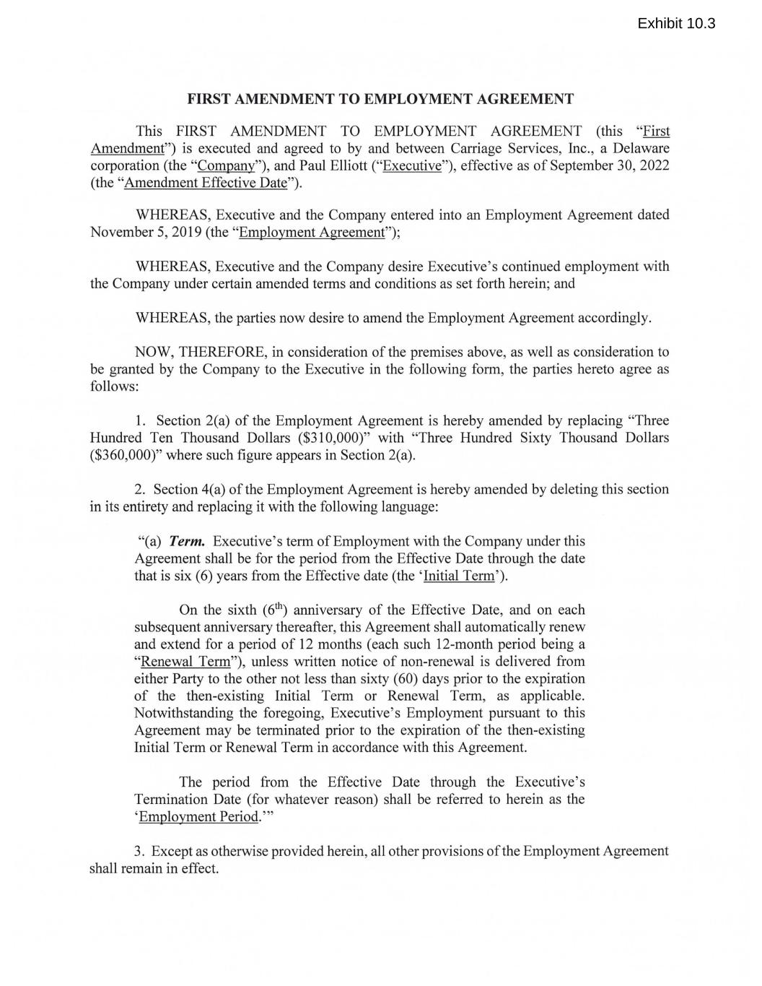
- 48 -
FIRST AMENDMENT TO EMPLOYMENT AGREEMENT This FIRST AMENDMENT TO EMPLOYMENT AGREEMENT (this "First Amendment") is executed and agreed to by and between Carriage Services, Inc., a Delaware corporation (the "Company"), and Paul Elliott ("Executive"), effective as of September 30, 2022 (the "Amendment Effective Date"). WHEREAS, Executive and the Company entered into an Employment Agreement dated November 5, 2019 (the "Employment Agreement"); WHEREAS, Executive and the Company desire Executive ' s continued employment with the Company under certain amended terms and conditions as set forth herein; and WHEREAS, the parties now desire to amend the Employment Agreement accordingly. NOW, THEREFORE, in consideration of the premises above, as well as consideration to be granted by the Company to the Executive in the following form, the parties hereto agree as follows: 1. Section 2(a) of the Employment Agreement is hereby amended by replacing "Three Hundred Ten Thousand Dollars ($310,000)" with "Three Hundred Sixty Thousand Dollars ($360,000)" where such figure appears in Section 2(a). 2. Section 4(a) of the Employment Agreement is hereby amended by deleting this section in its entirety and replacing it with the following language: "(a) Term. Executive' s term of Employment with the Company under this Agreement shall be for the period from the Effective Date through the date that is six (6) years from the Effective date (the ' Initial Term'). On the sixth (61h) anniversary of the Effective Date, and on each subsequent anniversary thereafter, this Agreement shall automatically renew and extend for a period of 12 months (each such 12-month period being a "Renewal Term"), unless written notice of non-renewal is delivered from either Party to the other not less than sixty (60) days prior to the expiration of the then-existing Initial Term or Renewal Term, as applicable. Notwithstanding the foregoing, Executive' s Employment pursuant to this Agreement may be terminated prior to the expiration of the then-existing Initial Term or Renewal Term in accordance with this Agreement. The period from the Effective Date through the Executive ' s Termination Date (for whatever reason) shall be referred to herein as the 'Employment Period. "' 3. Except as otherwise provided herein, all other provisions of the Employment Agreement shall remain in effect.

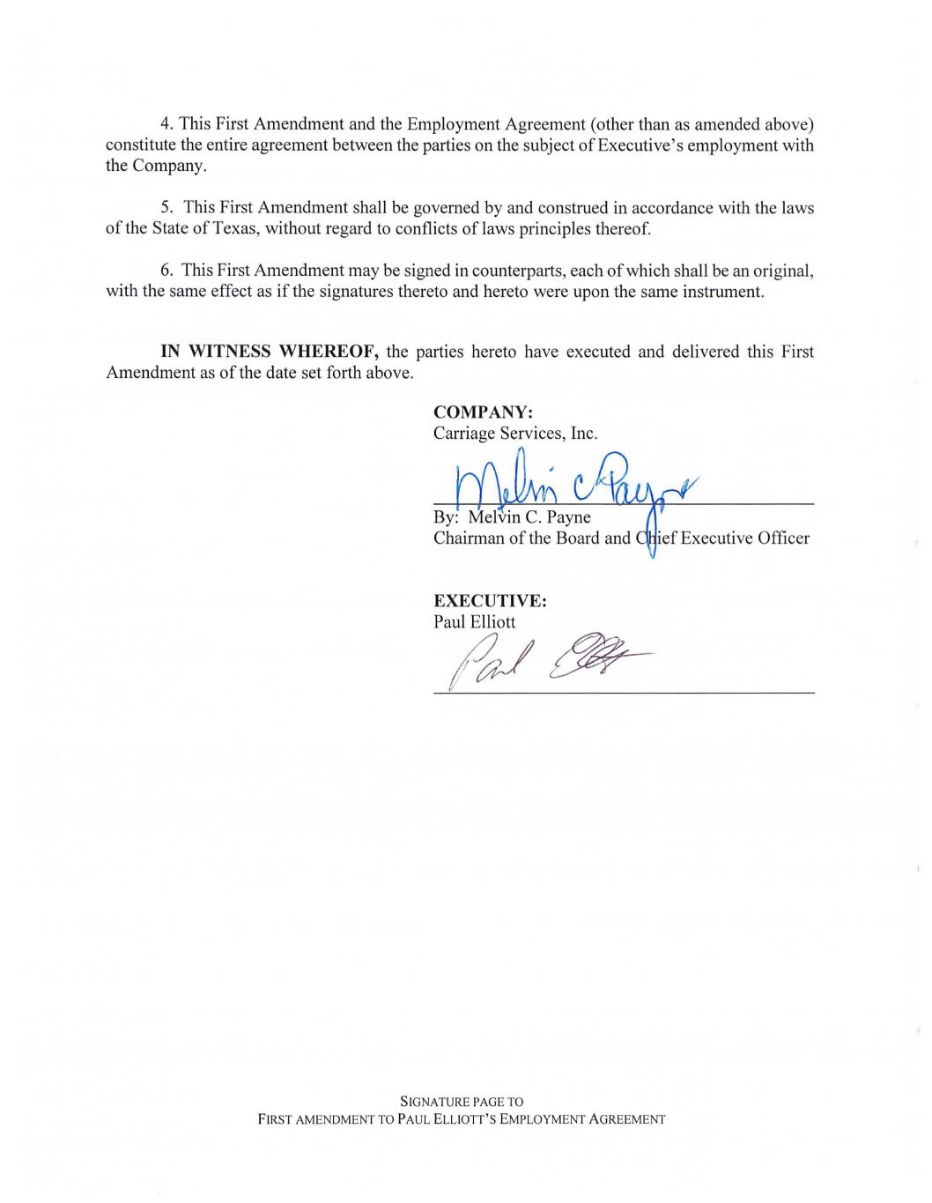
4. This First Amendment and the Employment Agreement (other than as amended above) constitute the entire agreement between the parties on the subject of Executive' s employment with the Company. 5. This First Amendment shall be governed by and construed in accordance with the laws of the State of Texas, without regard to conflicts of laws principles thereof. 6. This First Amendment may be signed in counterpaiis, each of which shall be an original, with the same effect as if the signatures thereto and hereto were upon the same instrument. IN WITNESS WHEREOF, the parties hereto have executed and delivered this First Amendment as of the date set forth above. COMPANY: Carriage Services, Inc. ; By: Melvin C. Payne Chairman of the Board and ief Executive Officer EXECUTIVE: Paul Elliott 11~~ SIGNATURE PAGE TO FIRST AMENDMENT TO PAUL ELLIOTT'S EMPLOYMENT AGREEMENT

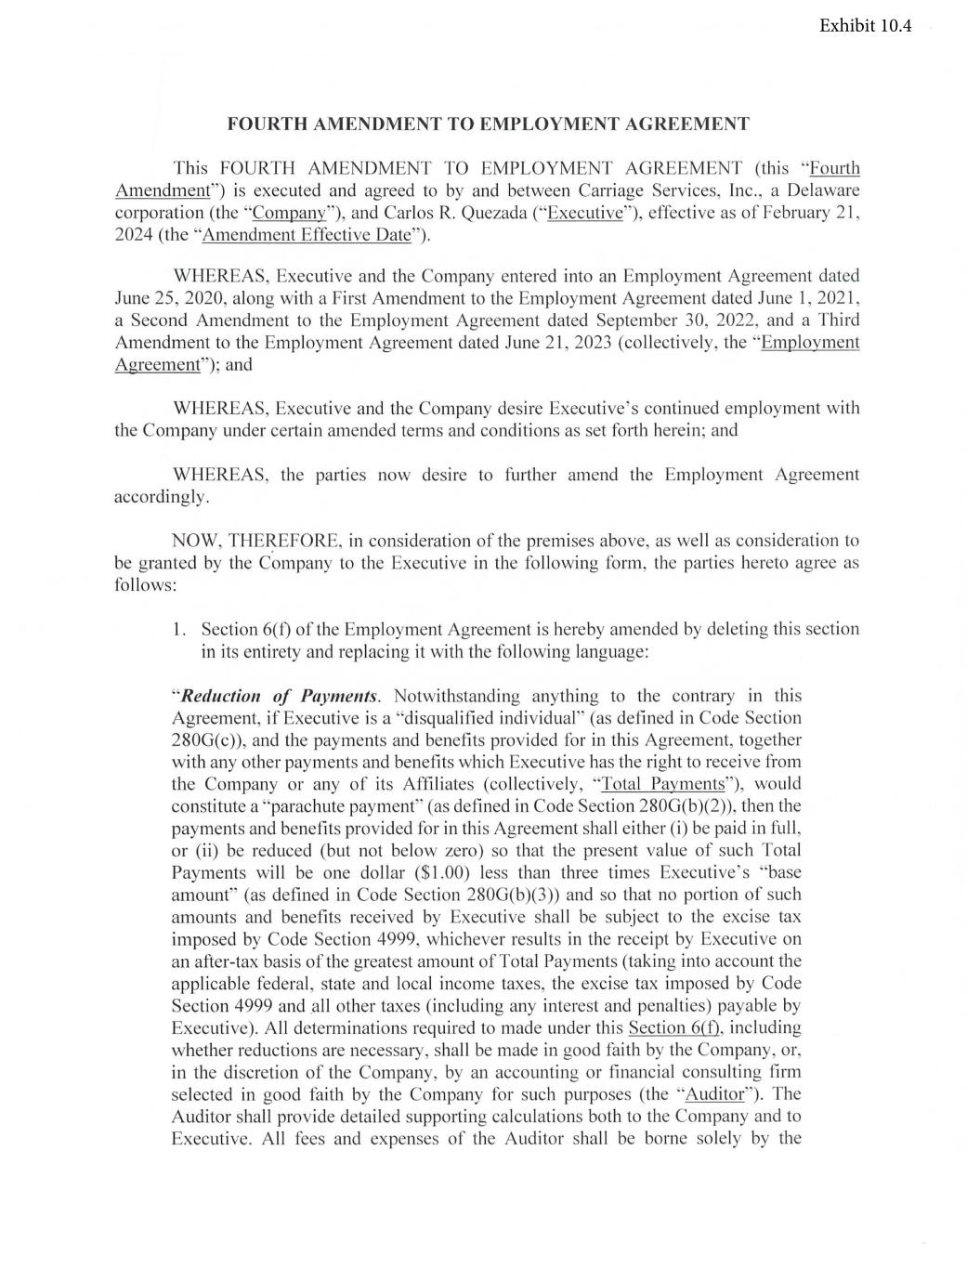
FOURTH AMENDMENT TO EMPLOYMENT AGREEMENT This FOURTH AMENDMENT TO EMPLOYMENT AGREEMENT (this "Fourth Amendment") is executed and agreed to by and between Carriage Services, Inc. , a Delaware corporation (the "Company"), and Carlos R. Quezada ("Executive"), effective as of February 21 , 2024 (the "Amendment Effective Date"). WHEREAS, Executive and the Company entered into an Employment Agreement dated June 25 , 2020, along with a First Amendment to the Employment Agreement dated June 1, 2021 , a Second Amendment to the Employment Agreement dated September 30, 2022, and a Third Amendment to the Employment Agreement dated June 21 , 2023 (collectively, the "Employment Agreement"); and WHEREAS, Executive and the Company desire Executive 's continued employment with the Company under certain amended terms and conditions as set forth herein ; and WHEREAS, the parties now desire to further amend the Employment Agreement accordingly. NOW, THE~EFORE, in consideration of the premises above, as well as consideration to be granted by the Company to the Executive in the following form , the parties hereto agree as follows: 1. Section 6(f) of the Employment Agreement is hereby amended by deleting this section in its entirety and replacing it with the following language: "Reduction of Payments. Notwithstanding anything to the contrary in this Agreement, if Executive is a "disqualified individual" (as defined in Code Section 280G(c)), and the payments and benefits provided for in this Agreement, together with any other payments and benefits which Executive has the right to receive from the Company or any of its Affiliates (collectively, "Total Payments"), would constitute a "parachute payment" (as defined in Code Section 280G(b)(2)), then the payments and benefits provided for in this Agreement shall either (i) be paid in full , or (ii) be reduced (but not below zero) so that the present value of such Total Payments will be one dollar ($1.00) less than three times Executive's "base amount" (as defined in Code Section 280G(b)(3)) and so that no portion of such amounts and benefits received by Executive shall be subject to the excise tax imposed by Code Section 4999, whichever results in the receipt by Executive on an after-tax basis of the greatest amount of Total Payments (taking into account the applicable federal, state and local income taxes, the excise tax imposed by Code Section 4999 and .all other taxes (including any interest and penalties) payable by Executive). All determinations required to made under this Section 6(f), including whether reductions are necessary, shall be made in good faith by the Company, or, in the discretion of the Company, by an accounting or financial consulting firm selected in good faith by the Company for such purposes (the "Auditor"). The Auditor shall provide detailed supporting calculations both to the Company and to Executive. All fees and expenses of the Auditor shall be borne solely by the

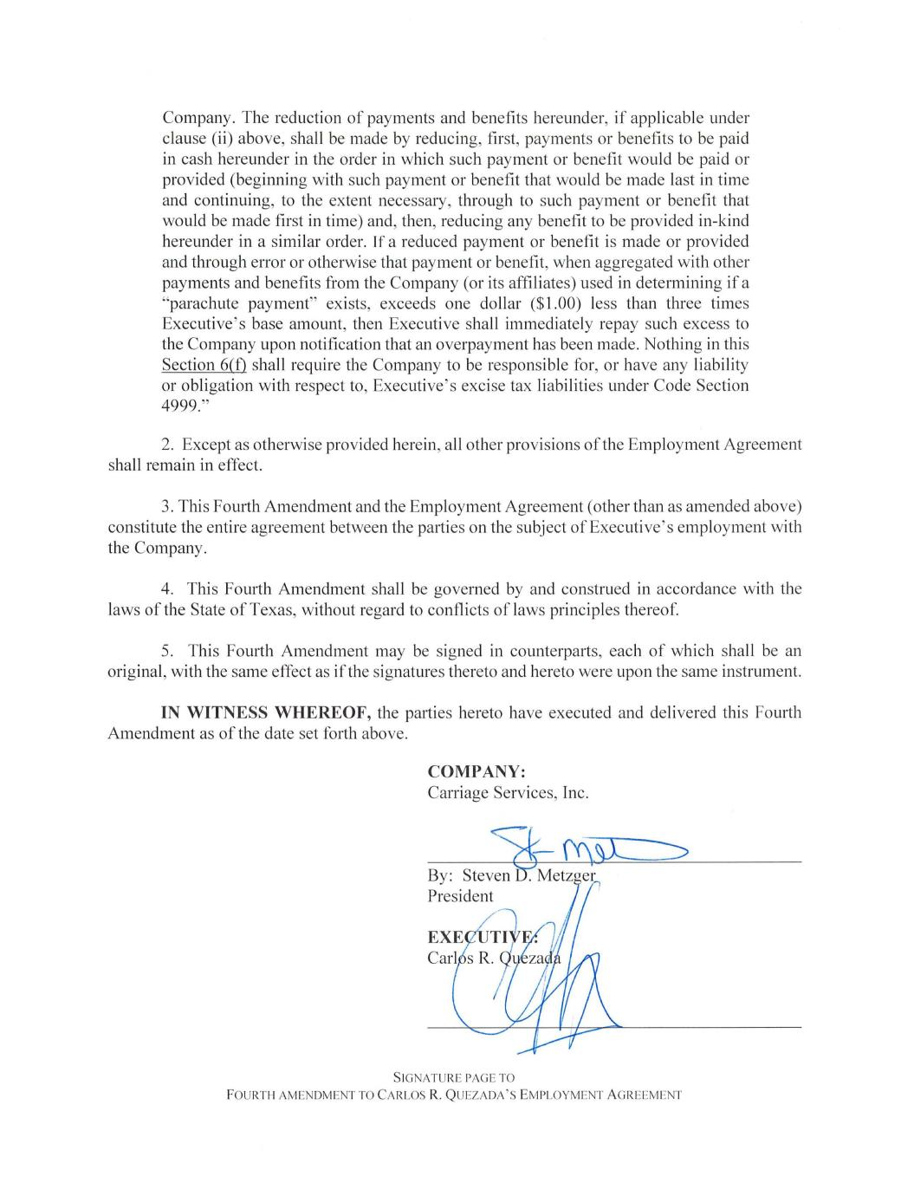
Company. The reduction of payments and benefits hereunder, if applicable under clause (ii) above, shall be made by reducing, first, payments or benefits to be paid in cash hereunder in the order in which such payment or benefit would be paid or provided (beginning with such payment or benefit that would be made last in time and continuing, to the extent necessary, tlu·ough to such payment or benefit that would be made first in time) and, then, reducing any benefit to be provided in-kind hereunder in a similar order. If a reduced payment or benefit is made or provided and through error or otherwise that payment or benefit, when aggregated with other payments and benefits from the Company (or its affiliates) used in determining if a "parachute payment" exists, exceeds one dollar ($1.00) less than three times Executive ' s base amount, then Executive shall immediately repay such excess to the Company upon notification that an overpayment has been made. Nothing in this Section 6(f) shall require the Company to be responsible for , or have any liability or obligation with respect to, Executive ' s excise tax liabilities under Code Section 4999." 2. Except as otherwise provided herein, all other provisions of the Employment Agreement shall remain in effect. 3. This Fourth Amendment and the Employment Agreement (other than as amended above) constitute the entire agreement between the parties on the subject of Executive ' s employment with the Company. 4. This Fourth Amendment shall be governed by and construed in accordance with the laws of the State of Texas, without regard to conflicts oflaws principles thereof. 5. This Fourth Amendment may be signed in counterparts, each of which shall be an original , with the same effect as if the signatures thereto and hereto were upon the same instrument. IN WITNESS WHEREOF, the parties hereto have executed and delivered this Fourth Amendment as of the date set forth above. COMPANY: Carriage Services, Inc. SIGNATURE PAGE TO FOURTH AM ENDM ENT TO CA RLOS R. Q UEZADA 'S EMPLOYMENT AGR EEMENT

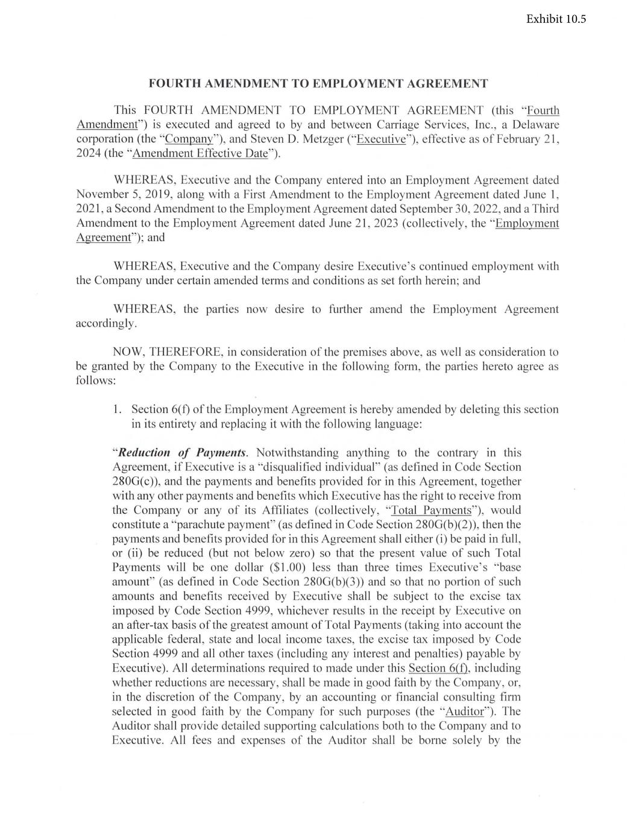
FOURTH AMEN DMENT TO EMPLOYMENT AGREEMENT This FOURTH AMENDMENT TO EMPLOYMENT AGREEMENT (thi s "Fourth Amendment") is executed and agreed to by and between Carri age Services, Inc. , a Delaware corporation (the "Company"), and Steven D. Metzger ("Executive"), effecti ve as of February 2 1, 2024 (the "Amendment Effecti ve Date"). WHEREAS, Executive and the Company entered into an Employment Agreement dated November 5, 201 9, along with a First Amendment to the Employment Agreement dated June 1, 202 1, a Second Amendment to the Employment Agreement dated September 30, 2022, and a Third Amendment to the Employment Agreement dated June 2 1, 2023 (co llective ly, the "Employment Agreement"); and WHEREAS, Executi ve and the Company des ire Executi ve ' s continued employment with the Company under certain amended terms and conditions as set fo rth herein; and WHEREAS, the parties now desire to fu rther amend the Employment Agreement accordingly. NOW, THEREFORE, in consideration of the premises above, as we ll as consideration to be granted by the Company to the Executive in the fo llowing fo rm, the parties hereto agree as fo llows: 1. Section 6(f) of the Employment Agreement is hereby amended by deleting this section in its entirety and replacing it with the fo llowing language: "Reduction of Payments. Notwithstanding anything to the contrary in this Agreement, if Executive is a "di squali fied individual" (as defined in Code Section 280G(c)), and the payments and benefits provided fo r in thi s Agreement, together with any other payments and benefits which Executive has the ri ght to receive from the Company or any of its Affi li ates (co llective ly, "Total Pay ments"), would constitute a "parachute payment" (as defined in Code Section 280G(b)(2)), then the payments and benefits provided fo r in thi s Agreement shall either (i) be paid in full , or (ii) be reduced (but not below zero) so that the present value of such Total Payments will be one dollar ($ 1.00) less than three times Executi ve ' s "base amount" (as defined in Code Section 280G(b)(3)) and so that no portion of such amounts and benefits received by Executi ve shall be subj ect to the excise tax imposed by Code Section 4999, whichever results in the receipt by Executive on an after-tax basis of the greatest amount of Total Payments (taking into account the applicable federal , state and local income taxes, the excise tax imposed by Code Section 4999 and all other taxes (including any interest and penalties) payable by Executive). All determinations required to made under thi s Secti on 6(f), including whether reducti ons are necessary, shall be made in good fa ith by the Company, or, in the discretion of the Company, by an accounting or fi nancial consulting firm selected in good fa ith by the Company fo r such purposes (the "Auditor"). The Auditor shall provide detailed supporting calculations both to the Company and to Executive . All fees and expenses of the Auditor shall be borne so lely by the

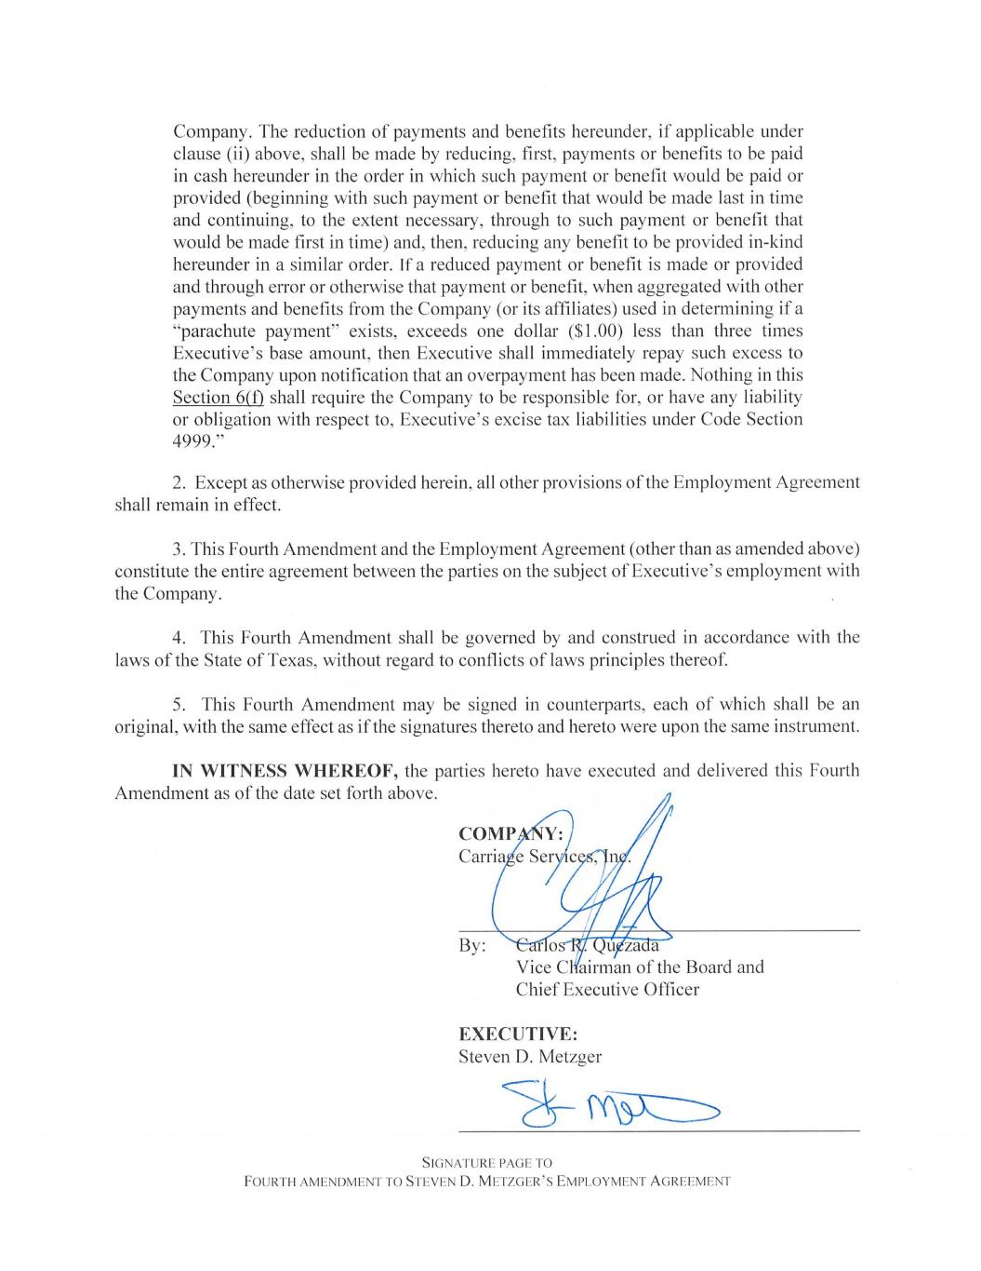
Company. The reduction of payments and benefits hereunder, if applicable under clause (ii) above, shall be made by reducing, first, payments or benefits to be paid in cash hereunder in the order in which such payment or benefit would be paid or provided (beginning with such payment or benefit that would be made last in time and continuing, to the extent necessary, through to such payment or benefit that would be made first in time) and, then, reducing any benefit to be provided in-kind hereunder in a similar order. If a reduced payment or benefit is made or provided and through error or otherwise that payment or benefit, when aggregated with other payments and benefits from the Company (or its affiliates) used in determining if a "parachute payment" exists, exceeds one dollar ($1.00) less than three times Executive's base amount, then Executive shall immediately repay such excess to the Company upon notification that an overpayment has been made. Nothing in this Section 6(f) shall require the Company to be responsible for, or have any liability or obligation with respect to, Executive's excise tax liabilities under Code Section 4999." 2. Except as otherwise provided herein, all other provisions of the Employment Agreement shall remain in effect. 3. This Fourth Amendment and the Employment Agreement (other than as amended above) constitute the entire agreement between the parties on the subject of Executive ' s employment with the Company. 4. This Fourth Amendment shall be governed by and construed in accordance with the laws of the State of Texas, without regard to conflicts of laws principles thereof. 5. This Fourth Amendment may be signed in counterparts, each of which shall be an original , with the same effect as if the signatures thereto and hereto were upon the same instrument. IN WITNESS WHEREOF, the parties hereto have executed and delivered this Fourth Amendment as of the date set forth above. By: EXECUTIVE: Steven D. Metzger SIG NATU RE PAGE TO FOURTH AMENDMENT TO STEVEN D. METZGER'S EMPLOYMENT AGR EEM ENT

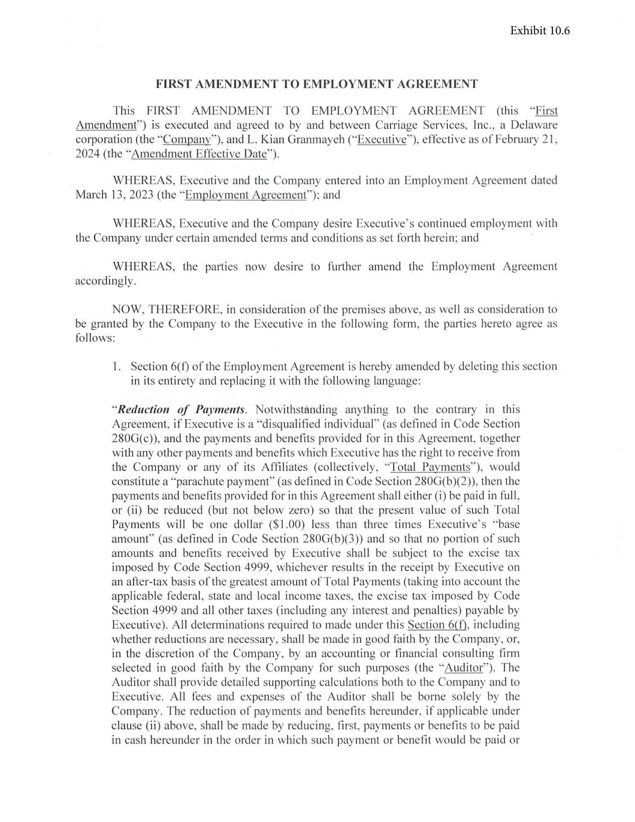
FIRST AMENDMENT TO EMPLOYMENT AGREEMENT This FIRST AMENDMENT TO EMPLOYMENT AGREEMENT (thi s "First Amendment") is executed and agreed to by and between Carriage Services, Inc., a Delaware corporation (the "Company"), and L. Kian Granmayeh ("Executi ve"), effecti ve as of February 2 1, 2024 (the "Amendment Effective Date"). WHEREAS, Executi ve and the Company entered into an Employment Agreement dated March 13, 2023 (the "Employment Agreement"); and WHEREAS , Executive and the Company desire Executive ' s continued employment with the Company under certain amended terms and conditions as set fo rth herein ; and WHEREAS, the parties now desire to further amend the Employment Agreement accordingly. NOW, THEREFORE, in consideration of the premises above, as we ll as considerat ion to be granted by the Company to the Executive in the fo llowing fo rm, the parties hereto agree as fo llows : 1. Section 6(f) of the Employment Agreement is hereby amended by deleting thi s section in its entirety and replacing it with the fo llowing language: "Reduction of Payments. Notwithstanding anything to the contrary in this Agreement, if Executive is a "di squalified individual" (as defined in Code Section 280G(c)), and the payments and benefi ts provided fo r in thi s Agreement, together with any other payments and benefi ts which Executi ve has the ri ght to receive from the Company or any of its Affili ates (co llectively, "Total Payments"), would constitute a "parachute payment" (as defined in Code Section 280G(b )(2)), then the payments and benefi ts provided fo r in thi s Agreement shall either (i) be paid in full , or (ii) be reduced (but not below zero) so that the present value of such Total Payments will be one dollar ($ 1.00) less than three times Executive ' s "base amount" (as defined in Code Section 280G(b)(3)) and so that no portion of such amounts and benefi ts received by Executi ve shall be subject to the excise tax imposed by Code Secti on 4999, whichever results in the receipt by Executive on an after-tax basis of the greatest amount of Total Payments (tak ing into account the applicable federal, state and local income taxes, the excise tax imposed by Code Section 4999 and all other taxes (including any interest and penalti es) payable by Executive). All determinations required to made under thi s Secti on 6(f), including whether reductions are necessary, shall be made in good faith by the Company, or, in the di scretion of the Company, by an accounting or fi nancial consulting firm selected in good fa ith by the Company fo r such purposes (the "Auditor"). The Auditor shall provide detailed supporting calculations both to the Company and to Executive. All fees and expenses of the Auditor shall be borne solely by the Company. The reduction of payments and benefi ts hereunder, if appli cable under clause (ii ) above, shall be made by reducing, first, payments or benefits to be paid in cash hereunder in the order in whi ch such pay ment or benefit would be paid or

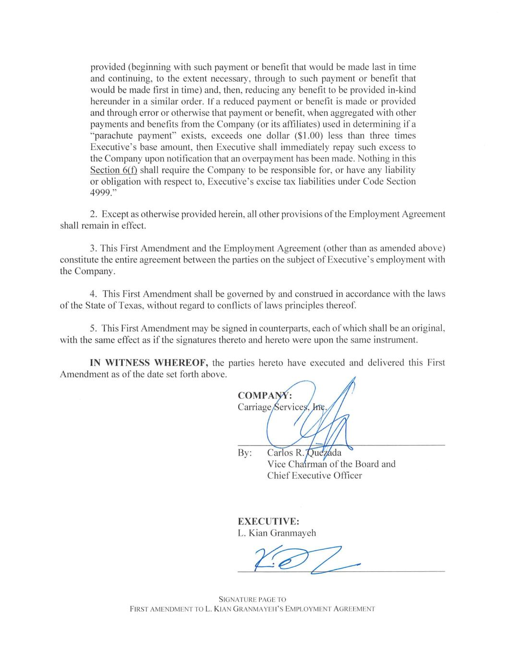
provided (beginning with such payment or benefi t that would be made last in time and continuing, to the extent necessary, through to such pay ment or benefi t that would be made fi rst in time) and, then, reducing any benefi t to be provided in-kind hereunder in a similar order. If a reduced payment or benefi t is made or provided and through error or otherwise that pay ment or benefit , when aggregated with other payments and benefits from the Company (or its affili ates) used in determining if a "parachute pay ment" exists, exceeds one doll ar ($ 1.00) less than three times Executive ' s base amount, then Executive shall immediately repay such excess to the Company upon notification that an overpayment has been made. Nothing in thi s Section 6(f) sha ll require the Company to be responsible for, or have any liability or obligation with respect to, Executive ' s exc ise tax liabilities under Code Section 4999." 2. Except as otherwise provided herein, a ll other provisions of the Employment Agreement shall remain in effect. 3. Thi s First Amendment and the Employment Agreement (other than as amended above) constitute the entire agreement between the parti es on the subject of Executi ve ' s employment with the Company. 4. This First Amendment shall be governed by and construed in accordance with the laws of the State of Texas, without regard to conflicts of laws principles thereof. 5. This First Amendment may be signed in counterparts, each of which shall be an original, with the same effect as if the signatures thereto and hereto were upon the same instrument. IN WITNESS WHEREOF, the parti es hereto have executed and deli vered this First Amendment as of the date set fo rth above. By: u Vice Cha rman of the Board and Chief Executive Officer EXECUTIVE: L. Kian Granmayeh SIGNATU RE PAGE TO FIRST AM EN DM ENT TO L. KI AN GR ANMA YEl-l 'S EMPLOYMENT A GREEMENT

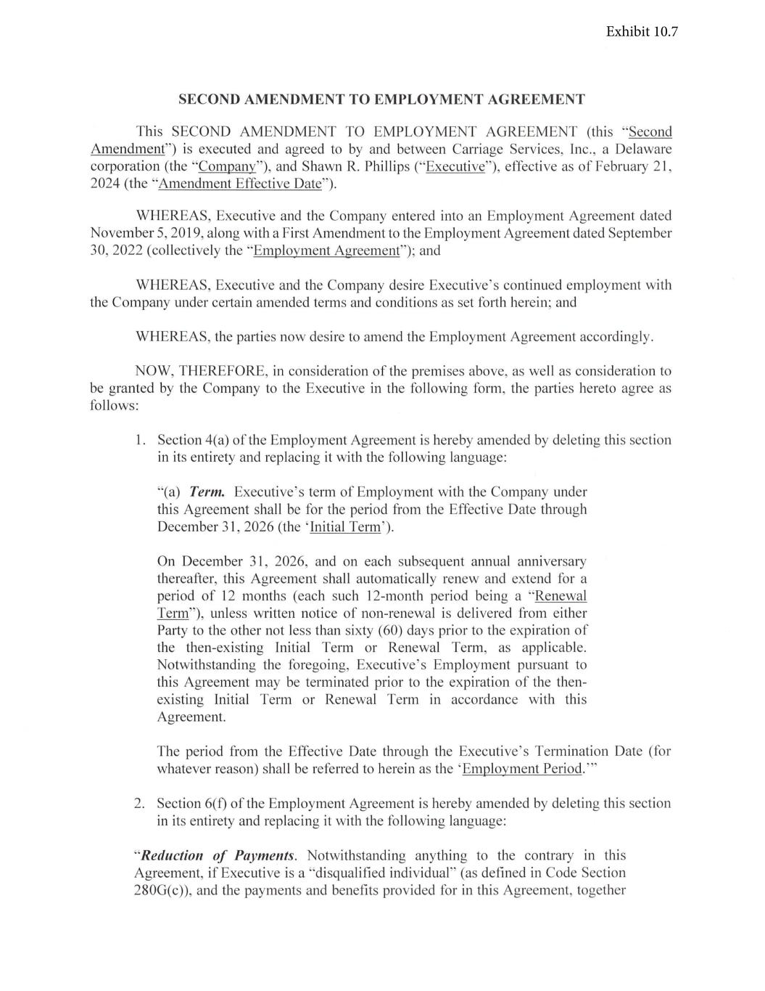
SECOND AMENDMENT TO EMPLOYMENT AGREEMENT This SECOND AMENDMENT TO EMPLOYMENT AGREEMENT (this " Second Amendment") is executed and agreed to by and between Carriage Services, Inc., a Delaware corporation (the "Company"), and Shawn R. Phillips ("Executi ve"), effective as of February 2 1, 2024 (the "Amendment Effecti ve Date"). WHEREAS, Executi ve and the Company entered into an Employment Agreement dated November 5, 201 9, along with a First Amendment to the Employment Agreement dated September 30, 2022 (co llecti vely the "Employment Agreement"); and WHEREAS, Executi ve and the Company desire Executive ' s continued employment with the Company under certain amended terms and conditions as set forth herein; and WHEREAS , the parties now desire to amend the Employment Agreement accordingly. NOW, THEREFORE, in consideration of the premises above, as well as consideration to be granted by the Company to the Executive in the fo llowing fo rm, the parties hereto agree as fo llows: 1. Section 4(a) of the Employment Agreement is hereby amended by deleting this section in its entirety and replacing it with the fo llowing language: "(a) Term. Executive ' s term of Employment with the Company under thi s Agreement shall be fo r the period from the Effective Date thro ugh December 31, 2026 (the ' Initial Term'). On December 31, 2026, and on each subsequent annual anniversary thereafter, thi s Agreement shall automatically renew and extend fo r a period of 12 months (each such 12-month period being a "Renewal Term"), unless written notice of non-renewal is deli vered from either Party to the other not less than sixty (60) days prior to the expiration of the then-ex isting Initial Term or Renewal Term, as applicable. Notwithstanding the foregoing, Executive ' s Employment pursuant to thi s Agreement may be terminated prior to the expiration of the then existing Initial Term or Renewal Term in accordance with thi s Agreement. The period from the Effective Date through the Executi ve ' s Termination Date (for whatever reason) shall be referred to herein as the 'Employment Peri od." ' 2 . Section 6(f) of the Employment Agreement is hereby amended by deleting this section in its entirety and replacing it with the fo llowing language: "Reduction of Payments. Notwithstanding anything to the contrary in this Agreement, if Executi ve is a "di squali fied individual" (as defined in Code Section 280G(c)), and the payments and benefi ts provided for in thi s Agreement, together

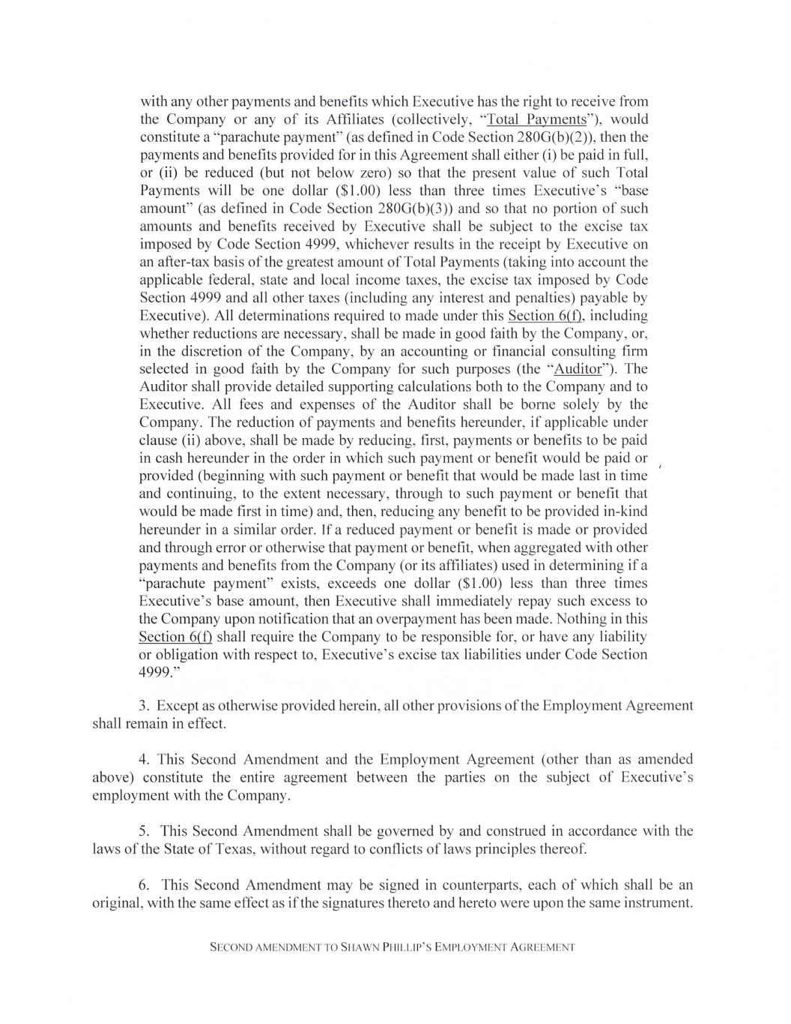
with any other payments and benefits which Executive has the right to receive from the Company or any of its Affiliates (collectively, "Total Payments"), would constitute a "parachute payment" (as defined in Code Section 280G(b)(2)), then the payments and benefits provided for in this Agreement shall either (i) be paid in full , or (ii) be reduced (but not below zero) so that the present value of such Total Payments will be one dollar ($1.00) less than three times Executive ' s "base amount" (as defined in Code Section 280G(b)(3)) and so that no portion of such amounts and benefits received by Executive shall be subject to the excise tax imposed by Code Section 4999, whichever results in the receipt by Executive on an after-tax basis of the greatest amount of Total Payments (taking into account the applicable federal , state and local income taxes, the excise tax imposed by Code Section 4999 and all other taxes (including any interest and penalties) payable by Executive). All determinations required to made under this Section 6(f), including whether reductions are necessary, shall be made in good faith by the Company, or, in the discretion of the Company, by an accounting or financial consulting firm selected in good faith by the Company for such purposes (the "Auditor"). The Auditor shall provide detailed supporting calculations both to the Company and to Executive. All fees and expenses of the Auditor shall be borne solely by the Company. The reduction of payments and benefits hereunder, if applicable under clause (ii) above, shall be made by reducing, first, payments or benefits to be paid in cash hereunder in the order in which such payment or benefit would be paid or provided (beginning with such payment or benefit that would be made last in time and continuing, to the extent necessary, through to such payment or benefit that would be made first in time) and, then, reducing any benefit to be provided in-kind hereunder in a similar order. If a reduced payment or benefit is made or provided and tlu·ough error or otherwise that payment or benefit, when aggregated with other payments and benefits from the Company (or its affiliates) used in determining if a "parachute payment" exists, exceeds one dollar ($1.00) less than three times Executive ' s base amount, then Executive shall immediately repay such excess to the Company upon notification that an overpayment has been made. Nothing in this Section 6(f) shall require the Company to be responsible for , or have any liability or obligation with respect to, Executive ' s excise tax liabilities under Code Section 4999." 3. Except as otherwise provided herein , all other provisions of the Employment Agreement shall remain in effect. 4. This Second Amendment and the Employment Agreement (other than as amended above) constitute the entire agreement between the parties on the subject of Executive ' s employment with the Company. 5. This Second Amendment shall be governed by and construed in accordance with the laws of the State of Texas, without regard to conflicts of laws principles thereof. 6. This Second Amendment may be signed in counterparts, each of which shall be an original , with the same effect as if the signatures thereto and hereto were upon the same instrument. SECOND AMENDMENT TO SHAWN Pl-l lLLIP 'S EMPLOYM ENT A GREEMENT

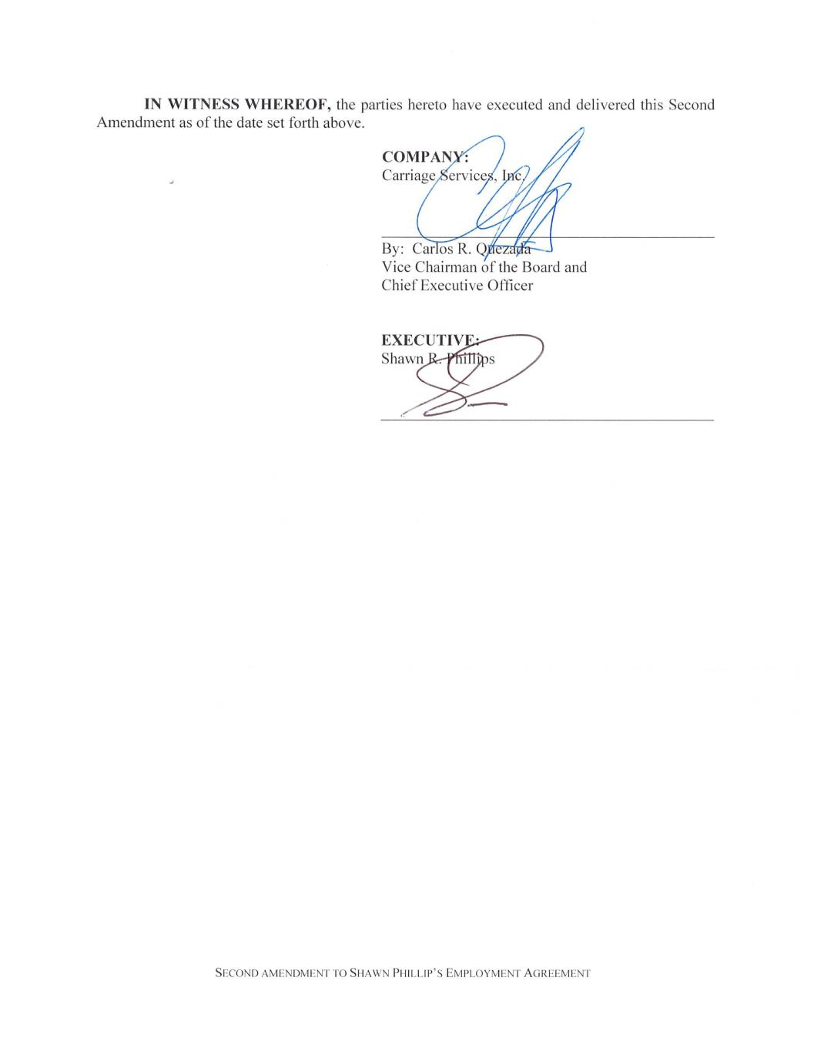
IN WITNESS WHEREOF, the parties hereto have executed and delivered this Second Amendment as of the date set forth above. J By: Car os R. Olfi~ita..:.. Vice Chairman of the Board and Chief Executive Officer SECOND AMENDM ENT TO SHAWN PHILL IP' S EMPLOYM ENT A GREEM ENT

EXHIBIT 31.1
I, Carlos R. Quezada, certify that:
1.I have reviewed this report on Form 10-Q of Carriage Services, Inc. (the “registrant”);
2.Based on my knowledge, this report does not contain any untrue statement of a material fact or omit to state a material fact necessary to make the statements made, in light of the circumstances under which such statements were made, not misleading with respect to the period covered by this report;
3.Based on my knowledge, the financial statements, and other financial information included in this report, fairly present in all material respects the financial condition, results of operations and cash flows of the registrant as of, and for, the periods presented in this report;
4.The registrant’s other certifying officer(s) and I are responsible for establishing and maintaining disclosure controls and procedures (as defined in Exchange Act Rules 13a-15(e) and 15d-15(e)) and internal control over financial reporting (as defined in Exchange Act Rules 13a-15(f) and 15d-15(f)) for the registrant and have:
a.Designed such disclosure controls and procedures, or caused such disclosure controls and procedures to be designed under our supervision, to ensure that material information relating to the registrant, including its consolidated subsidiaries, is made known to us by others within those entities, particularly during the period in which this report is being prepared;
b.Designed such internal control over financial reporting, or caused such internal control over financial reporting to be designed under our supervision, to provide reasonable assurance regarding the reliability of financial reporting and the preparation of financial statements for external purposes in accordance with generally accepted accounting principles;
c.Evaluated the effectiveness of the registrant’s disclosure controls and procedures and presented in this report our conclusions about the effectiveness of the disclosure controls and procedures, as of the end of the period covered by this report based on such evaluation; and
d.Disclosed in this report any change in the registrant’s internal control over financial reporting that occurred during the registrant’s most recent fiscal quarter (the registrant’s fourth fiscal quarter in the case of an annual report) that has materially affected, or is reasonably likely to materially affect, the registrant’s internal control over financial reporting; and
5.The registrant’s other certifying officer(s) and I have disclosed, based on our most recent evaluation of internal control over financial reporting, to the registrant’s auditors and the audit committee of the registrant’s board of directors (or persons performing the equivalent functions):
a.All significant deficiencies and material weaknesses in the design or operation of internal control over financial reporting which are reasonably likely to adversely affect the registrant’s ability to record, process, summarize and report financial information; and
b.Any fraud, whether or not material, that involves management or other employees who have a significant role in the registrant’s internal control over financial reporting.

Dated: |  |  | May 3, 2024 |  |  | /s/ Carlos R. Quezada
 |  |  |  |  |  | Carlos R. Quezada
 |  |  |  |  |  | Chief Executive Officer and Vice Chairman of the Board
 |  |  |  |  |  | (Principal Executive Officer)

EXHIBIT 31.2
I, L. Kian Granmayeh, certify that:
1.I have reviewed this report on Form 10-Q of Carriage Services, Inc. (the “registrant”);
2.Based on my knowledge, this report does not contain any untrue statement of a material fact or omit to state a material fact necessary to make the statements made, in light of the circumstances under which such statements were made, not misleading with respect to the period covered by this report;
3.Based on my knowledge, the financial statements, and other financial information included in this report, fairly present in all material respects the financial condition, results of operations and cash flows of the registrant as of, and for, the periods presented in this report;
4.The registrant’s other certifying officer(s) and I are responsible for establishing and maintaining disclosure controls and procedures (as defined in Exchange Act Rules 13a-15(e) and 15d-15(e)) and internal control over financial reporting (as defined in Exchange Act Rules 13a-15(f) and 15d-15(f)) for the registrant and have:
a.Designed such disclosure controls and procedures, or caused such disclosure controls and procedures to be designed under our supervision, to ensure that material information relating to the registrant, including its consolidated subsidiaries, is made known to us by others within those entities, particularly during the period in which this report is being prepared;
b.Designed such internal control over financial reporting, or caused such internal control over financial reporting to be designed under our supervision, to provide reasonable assurance regarding the reliability of financial reporting and the preparation of financial statements for external purposes in accordance with generally accepted accounting principles;
c.Evaluated the effectiveness of the registrant’s disclosure controls and procedures and presented in this report our conclusions about the effectiveness of the disclosure controls and procedures, as of the end of the period covered by this report based on such evaluation; and
d.Disclosed in this report any change in the registrant’s internal control over financial reporting that occurred during the registrant’s most recent fiscal quarter (the registrant’s fourth fiscal quarter in the case of an annual report) that has materially affected, or is reasonably likely to materially affect, the registrant’s internal control over financial reporting; and
5.The registrant’s other certifying officer(s) and I have disclosed, based on our most recent evaluation of internal control over financial reporting, to the registrant’s auditors and the audit committee of the registrant’s board of directors (or persons performing the equivalent functions):
a.All significant deficiencies and material weaknesses in the design or operation of internal control over financial reporting which are reasonably likely to adversely affect the registrant’s ability to record, process, summarize and report financial information; and
b.Any fraud, whether or not material, that involves management or other employees who have a significant role in the registrant’s internal control over financial reporting.

Dated: |  |  | May 3, 2024 |  |  | /s/ L. Kian Granmayeh
 |  |  |  |  |  | L. Kian Granmayeh
 |  |  |  |  |  | Executive Vice President, Chief Financial Officer and Treasurer
 |  |  |  |  |  | (Principal Financial Officer)

EXHIBIT 32

Certification of
Chief Executive Officer and Chief Financial Officer
under Section 906 of the
Sarbanes Oxley Act of 2002, 18 U.S.C. § 1350

In connection with the Quarterly Report on Form 10-Q of Carriage Services, Inc. (the “Company”), as filed with the Securities and Exchange Commission on the date hereof (the “Report”), Carlos R. Quezada, Chief Executive Officer of the Company, and L. Kian Granmayeh, Executive Vice President, Chief Financial Officer and Treasurer, each certify, pursuant to 18 U.S.C. Section 1350, as adopted pursuant to Section 906 of the Sarbanes-Oxley Act of 2002, that, to his knowledge:

(1) the Report fully complies with the requirements of Section 13(a) or 15(d) of the Securities Exchange Act of 1934, as amended; and

(2) the information contained in the Report fairly presents, in all material respects, the financial condition and results of operations of the Company.
Dated: |  |  | May 3, 2024 |  |  | /s/ Carlos R. Quezada
 |  |  |  |  |  | Carlos R. Quezada
 |  |  |  |  |  | Chief Executive Officer and Vice Chairman of the Board
 |  |  |  |  |  | (Principal Executive Officer)
 |  |  |  |  |  | /s/ L. Kian Granmayeh
 |  |  |  |  |  | L. Kian Granmayeh
 |  |  |  |  |  | Executive Vice President, Chief Financial Officer and Treasurer
 |  |  |  |  |  | (Principal Financial Officer)

