UNITED STATES

SECURITIES AND EXCHANGE COMMISSION

Washington, D.C. 20549

FORM 8-K

CURRENT REPORT

Pursuant to Section 13 or 15(d) of the

Securities Exchange Act of 1934

Date of Report (Date of earliest event reported): December 12, 2022 (December 9, 2022)

Carriage Services, Inc.

(Exact name of registrant as specified in its charter)

Delaware | 1-11961 | 76-0423828
(State or other jurisdiction | (Commission | (IRS Employer
of incorporation) | File Number) | Identification No.)
 | 3040 Post Oak Boulevard, Suite 300
 | Houston, Texas 77056
 | (Address, including zip code, of principal executive offices)
 | Registrant's telephone number, including area code:
 | (713) 332-8400

Check the appropriate box below if the Form 8-K filing is intended to simultaneously satisfy the filing obligation of the registrant under any of the following provisions (see General Instruction A.2. below):

- Written communication pursuant to Rule 425 under the Securities Act (17 CFR 230.425)

- Soliciting material pursuant to Rule 14a-12 under the Exchange Act (17 CFR 240.14a-12)

- Pre-commencement communications pursuant to Rule 14d-2(b) under the Exchange Act (17 CFR 240.14d-2(b))

- Pre-commencement communications pursuant to Rule 13e-4(c) under the Exchange Act (17 CFR 240.13e-4(c))

Securities registered pursuant to Section 12(b) of the Act:

Title of each class | Trading Symbol | Name of each exchange on which registered
Common Stock, par value $.01 per share | CSV | New York Stock Exchange

Indicate by check mark whether the registrant is an emerging growth company as defined in Rule 405 of the Securities Act of 1933 (§230.405 of this chapter) or Rule 12b-2 of the Securities Exchange Act of 1934 (§240.12b-2 of this chapter).

Emerging growth company ☐

If an emerging growth company, indicate by check mark if the registrant has elected not to use the extended transition period for complying with any new or revised financial accounting standards provided pursuant to Section 13(a) of the Exchange Act. ☐

ITEM 1.01 ENTRY INTO A MATERIAL DEFINITIVE AGREEMENT

On December 9, 2022, Carriage Services, Inc. (the “Company”) entered into a third amendment (the “Credit Agreement Amendment”) to its first amended and restated credit agreement dated May 13, 2021 (as amended, the “Amended Credit Agreement”), with the financial institutions party thereto, as lenders, and Bank of America, N.A., as administrative agent. The Credit Agreement Amendment provides, among other things, for (i) modifications to the definitions of “Applicable Rate” and “Applicable Fee Rate” to change the applicable rates and pricing levels set forth in each pricing grid; (ii) an increase in the maximum Total Leverage Ratio (as defined in the Amended Credit Agreement) covenant as follows: a Total Leverage Ratio not to exceed (a) 6.00 to 1.00 from the effective date of the Credit Agreement Amendment through the quarter ended June 30, 2023, (b) 5.75 to 1.00 for the quarters ended September 30, 2023, and December 31, 2023, (c) 5.50 to 1.00 for the quarters ended March 31, 2024 and June 30, 2024, (d) 5.25 to 1.00 for the quarter ended September 30, 2024, and (e) 5.00 and 1.00 for the quarter ended December 31, 2024 and each quarter ended thereafter; (iii) modifications to the permitted investments covenant, relating to the Company’s ability to make certain acquisitions, subject to the satisfaction of certain conditions therein; (iv) modifications to the restricted payments covenant related to the Company’s ability to make stock repurchases, subject to the satisfaction of certain conditions therein; and (v) a modification to the Total Leverage Ratio level which constitutes a Real Property Collateral Trigger Event (as defined in the Amended Credit Agreement).

As of the effective date of the Credit Agreement Amendment and through and including the date the Company’s compliance certificate is delivered for the fiscal year ending December 31, 2022, interest accrues on amounts outstanding under the Amended Credit Agreement based on Pricing Level 6 set forth below, and thereafter based on the Company’s Total Leverage Ratio (as defined in the Amended Credit Agreement) commencing with the delivery of the Company’s compliance certificate for the fiscal quarter ending March 31, 2023, in accordance with the following pricing grid:


Applicable Rate

Pricing Level | Total Leverage Ratio | BSBY Rate / Letter of Credit Fees | Base Rate
1 | < 3.00 : 1.0 | 1.500% | 0.500%
2 | < 3.50: 1.00 but ≥ 3.00: 1. | 1.625% | 0.625%
3 | < 4.00: 1.00 but ≥ 3.50: 1. | 1.750% | 0.750%
4 | < 4.50: 1.00 but ≥ 4.00: 1. | 1.875% | 0.875%
5 | < 5.00: 1.00 but ≥ 4.50: 1. | 3.125% | 2.125%
6 | < 5.50: 1.00 but ≥ 5.00: 1. | 3.375% | 2.375%
7 | ≥ 5.50: 1.0 | 3.625% | 2.625%

Immediately after giving effect to the Credit Agreement Amendment, the Company had borrowings of approximately $194.3 million in principal amount outstanding and had approximately $53.4 million available for additional borrowing under the Amended Credit Agreement after giving effect to approximately $2.3 million of outstanding letters of credit.

The foregoing description of the Credit Agreement Amendment is qualified in its entirety by reference to the Credit Agreement Amendment, a copy of which is attached hereto as Exhibit 10.1, and incorporated by reference herein.

ITEM 2.03 CREATION OF A DIRECT FINANCIAL OBLIGATION OR AN OBLIGATION UNDER AN OFF-BALANCE SHEET ARRANGEMENT OF A REGISTRANT

The disclosures above under Item 1.01 of this Current Report on Form 8-K are also responsive to Item 2.03 of this Current Report on Form 8-K and are hereby incorporated by reference into this Item 2.03.

ITEM 7.01 REGULATION FD.

On December 12, 2022, the Company issued a press release containing certain information regarding the Company and the transaction contemplated by the Credit Agreement Amendment. The press release is attached hereto as Exhibit 99.1 of this Current Report on Form 8-K and is incorporated by reference herein.

In accordance with General Instruction B.2 of Form 8-K, the foregoing information, including Exhibit 99.1, shall not be deemed “filed” for the purposes of Section 18 of the Securities Exchange Act of 1934, as amended (the “Exchange Act”) or otherwise subject to the liabilities of that section, nor shall such information, including Exhibit 99.1, be deemed incorporated by reference in any filing under the Securities Act or the Exchange Act, except as shall be expressly set forth by specific reference in such a filing.

ITEM 9.01 FINANCIAL STATEMENTS AND EXHIBITS.

The following are furnished as part of this Current Report on Form 8-K:

Exhibit |  | Description
 | 10.1 | Third Amendment and Commitment Increase to First Amended and Restated Credit Agreement dated as of December 9, 2022, among Carriage Services, Inc., the financial
 |  | institutions party thereto, as lenders, and Bank of America, N.A., as administrative agent, swing line lender and L/C issuer.
99.1 |  | Press Release of Carriage Services, Inc. dated December 12, 2022 (furnished herewith pursuant to Item 7.01)
101 |  | Cover Page Interactive Data File - the cover page XBRL tags are embedded within the Inline XBRL document
104 |  | The cover page from this Current Report on Form 8-K, formatted as Inline XBRL

SIGNATURE

Pursuant to the requirements of the Securities Exchange Act of 1934, as amended, the registrant has duly caused this report to be signed on its behalf by the undersigned hereunto duly authorized.

CARRIAGE SERVICES, INC.

Dated: December 12, 2022 By: /s/ Steven D. Metzger

Steven D. Metzger

Executive Vice President, Chief Administrative Officer, General Counsel and Secretary

 |  |  | INDEX TO EXHIBITS
Exhibit |  | Description
 | 10.1 | Third Amendment and Commitment Increase to First Amended and Restated Credit Agreement dated as of December 9, 2022, among Carriage Services, Inc., the financial
 |  | institutions party thereto, as lenders, and Bank of America, N.A., as administrative agent, swing line lender and L/C issuer.
99.1 |  | Press Release of Carriage Services, Inc. dated December 12, 2022 (furnished herewith pursuant to Item 7.01)
101 |  | Cover Page Interactive Data File - the cover page XBRL tags are embedded within the Inline XBRL document
104 |  | The cover page from this Current Report on Form 8-K, formatted as Inline XBRL

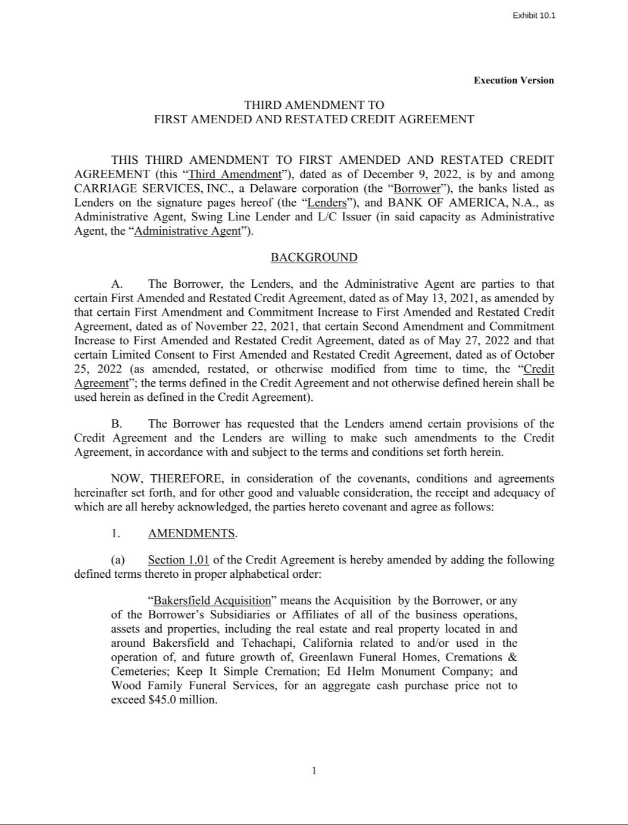

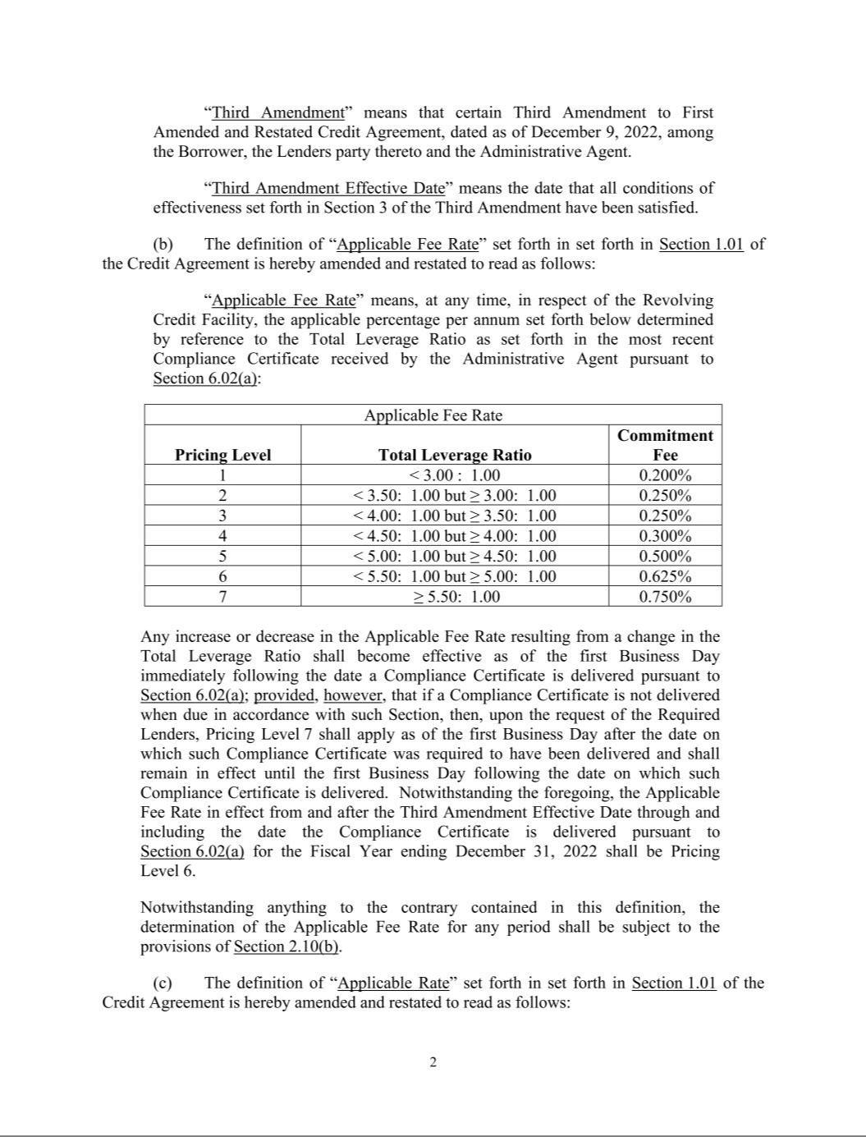

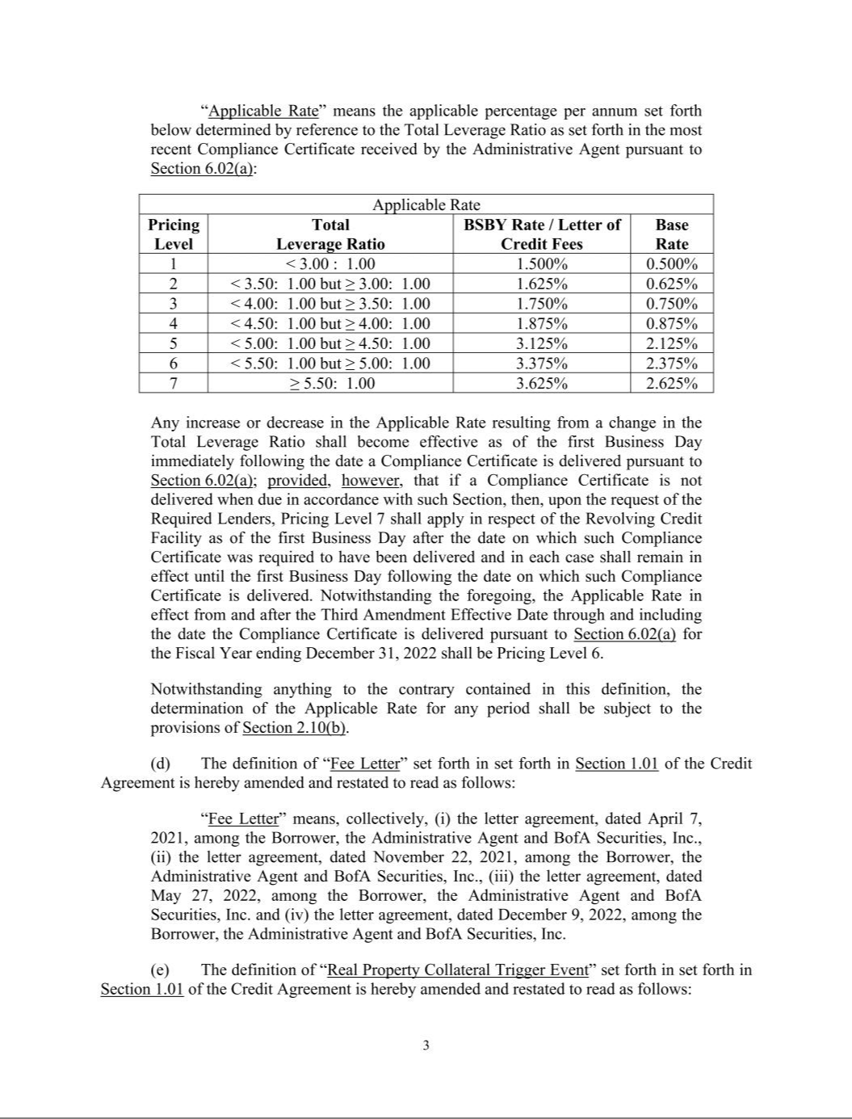

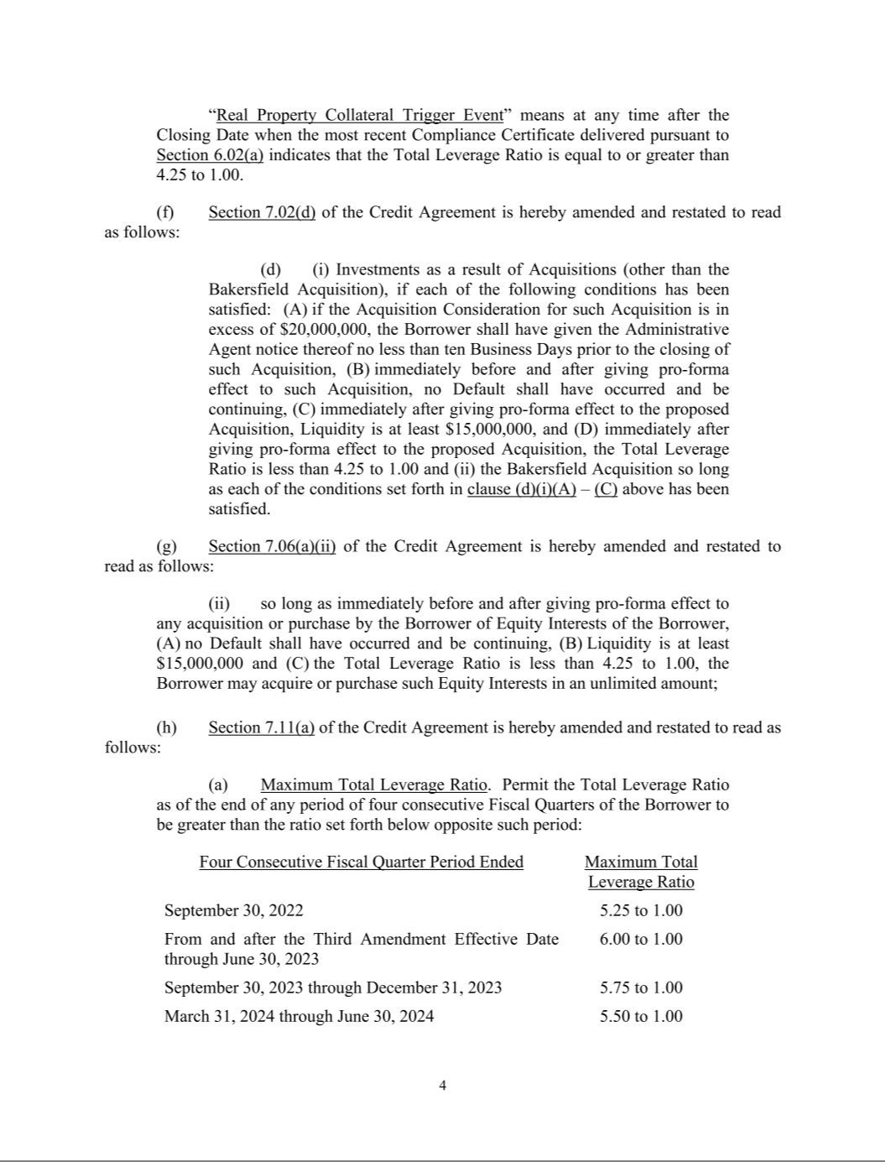

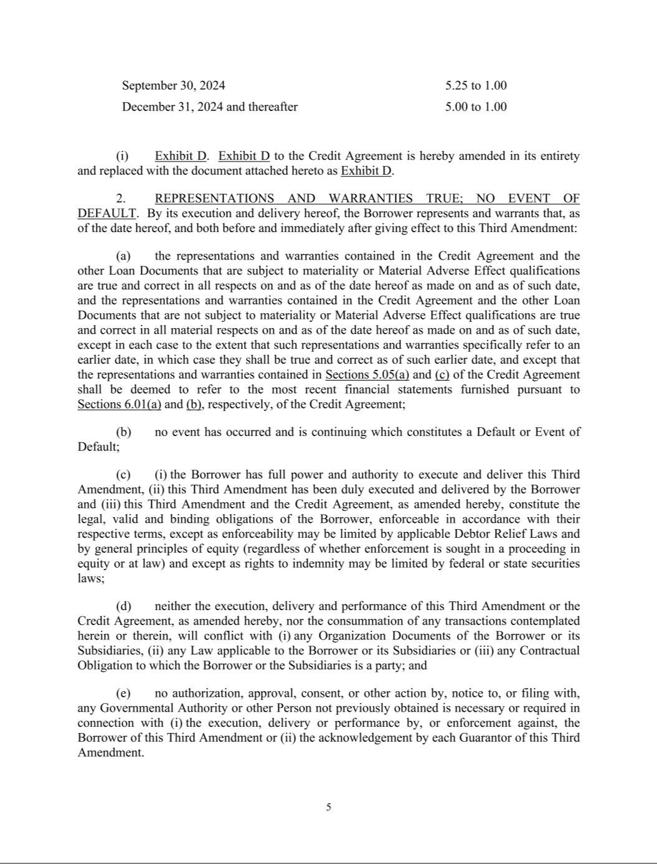



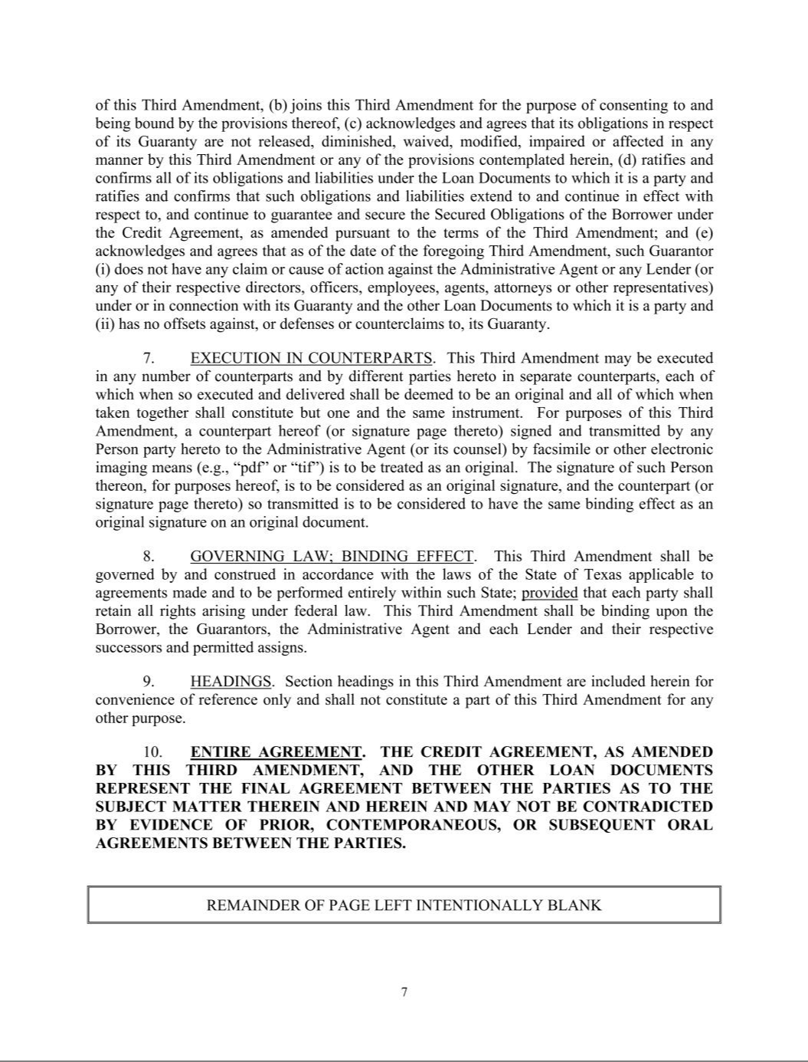

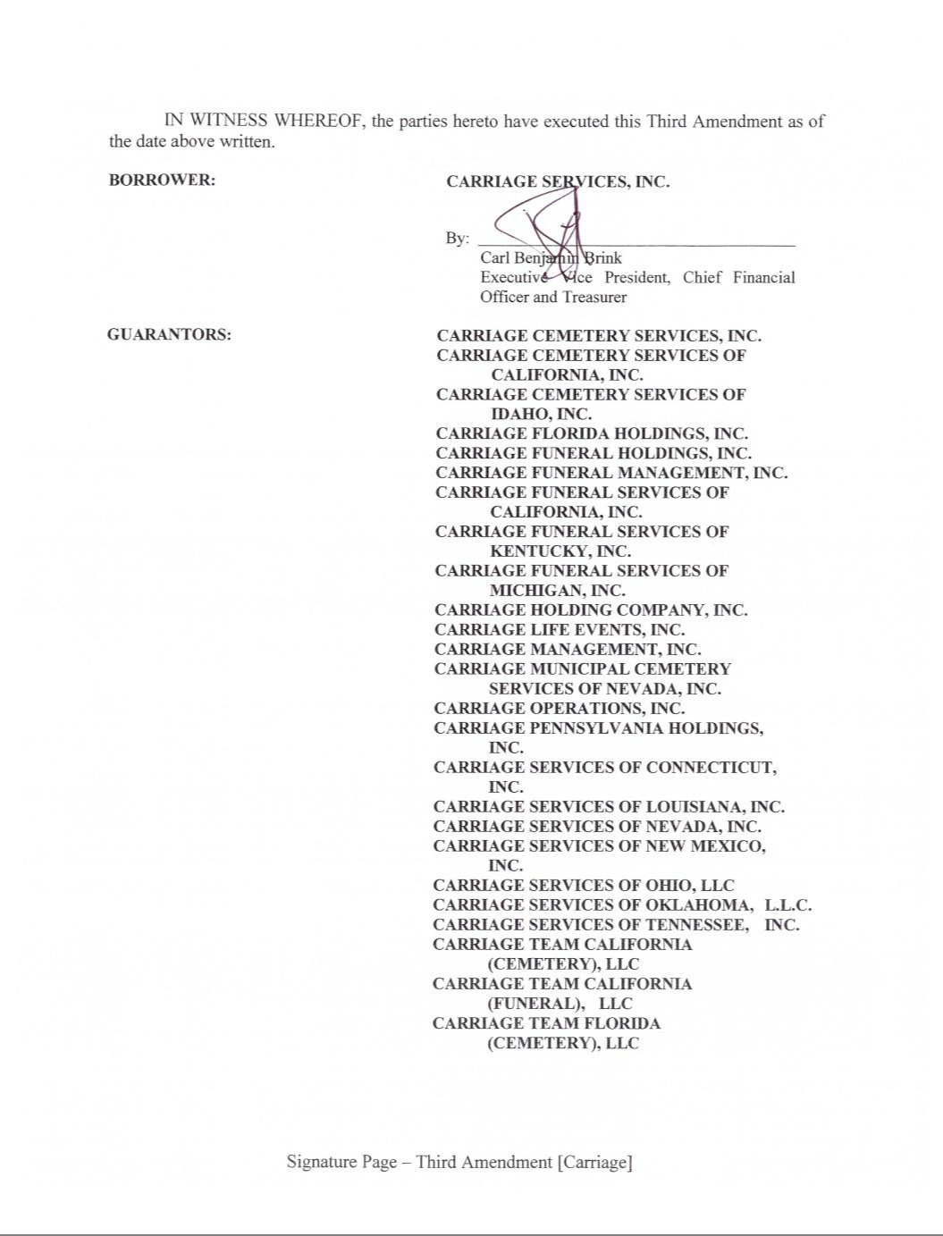

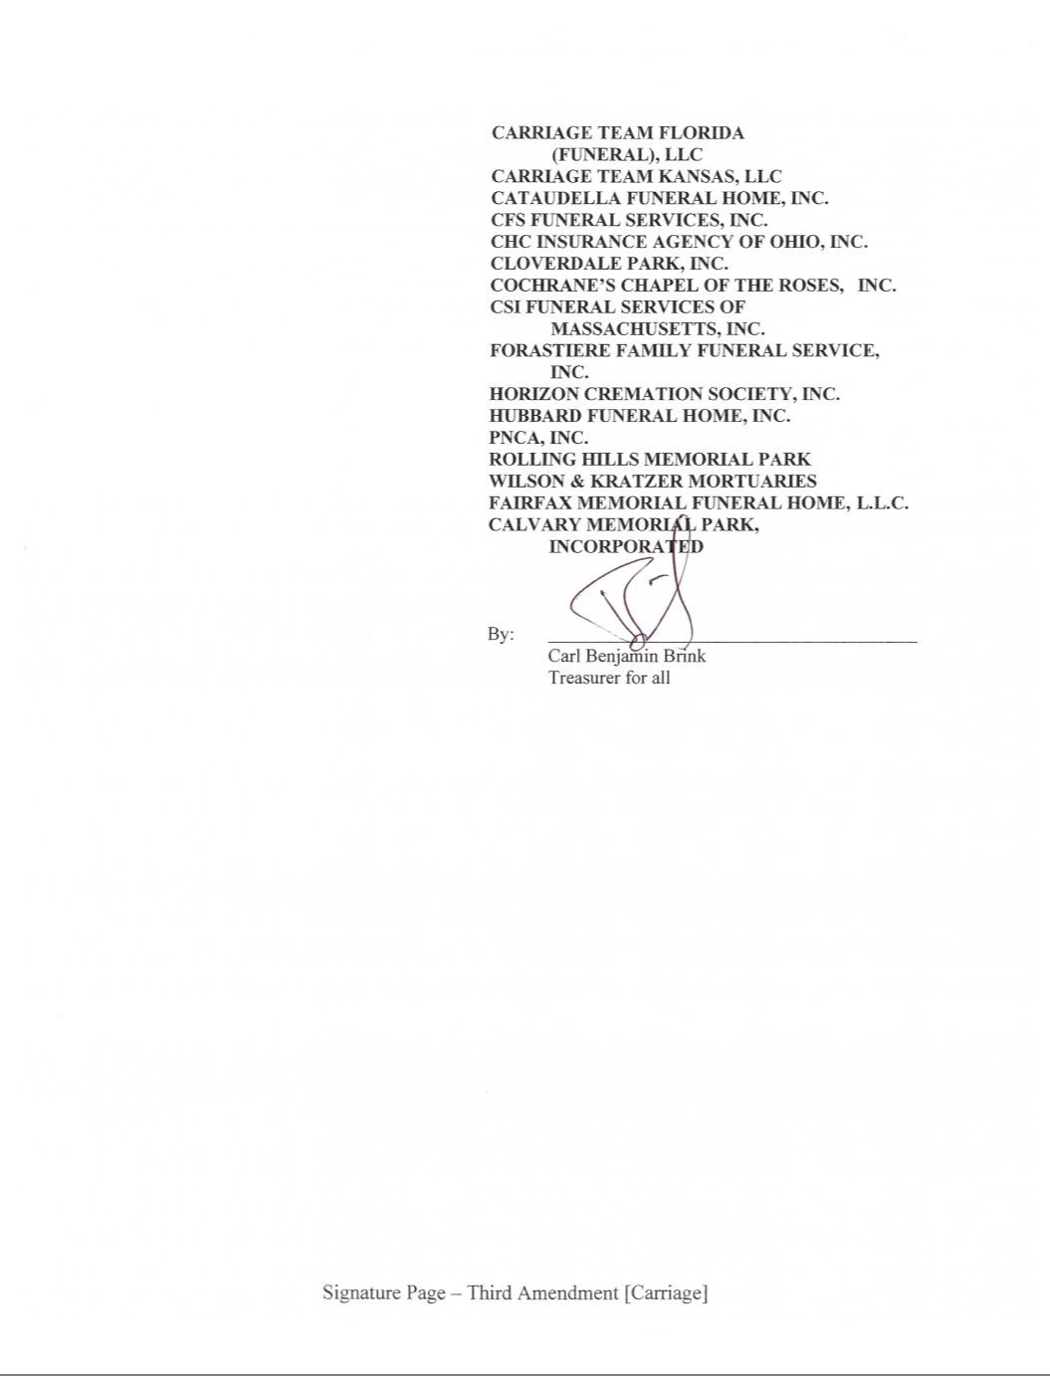











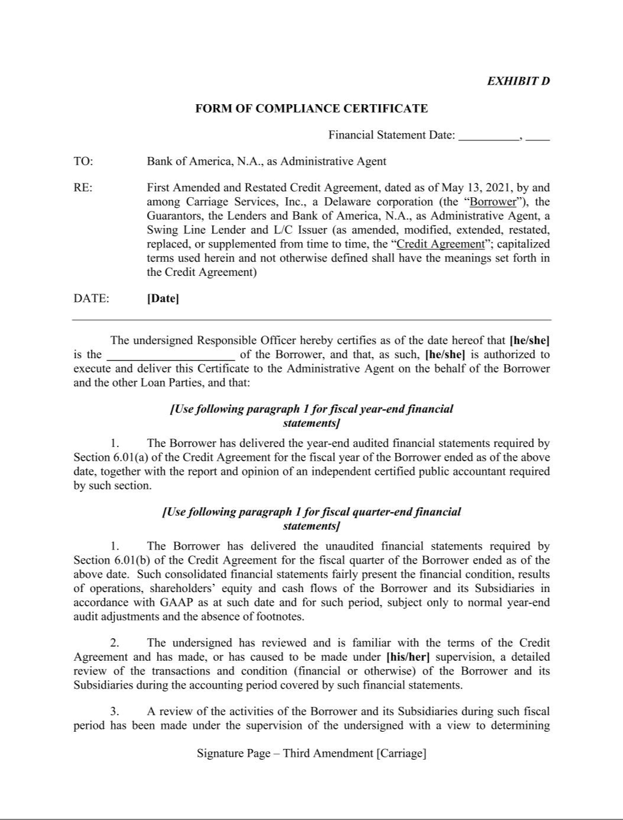

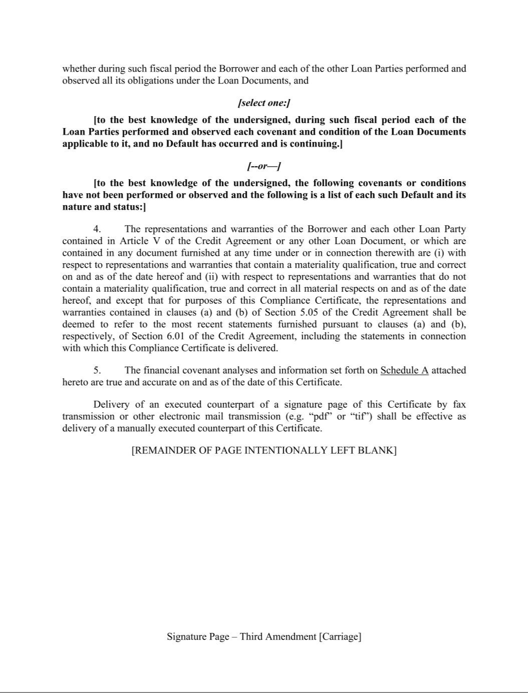



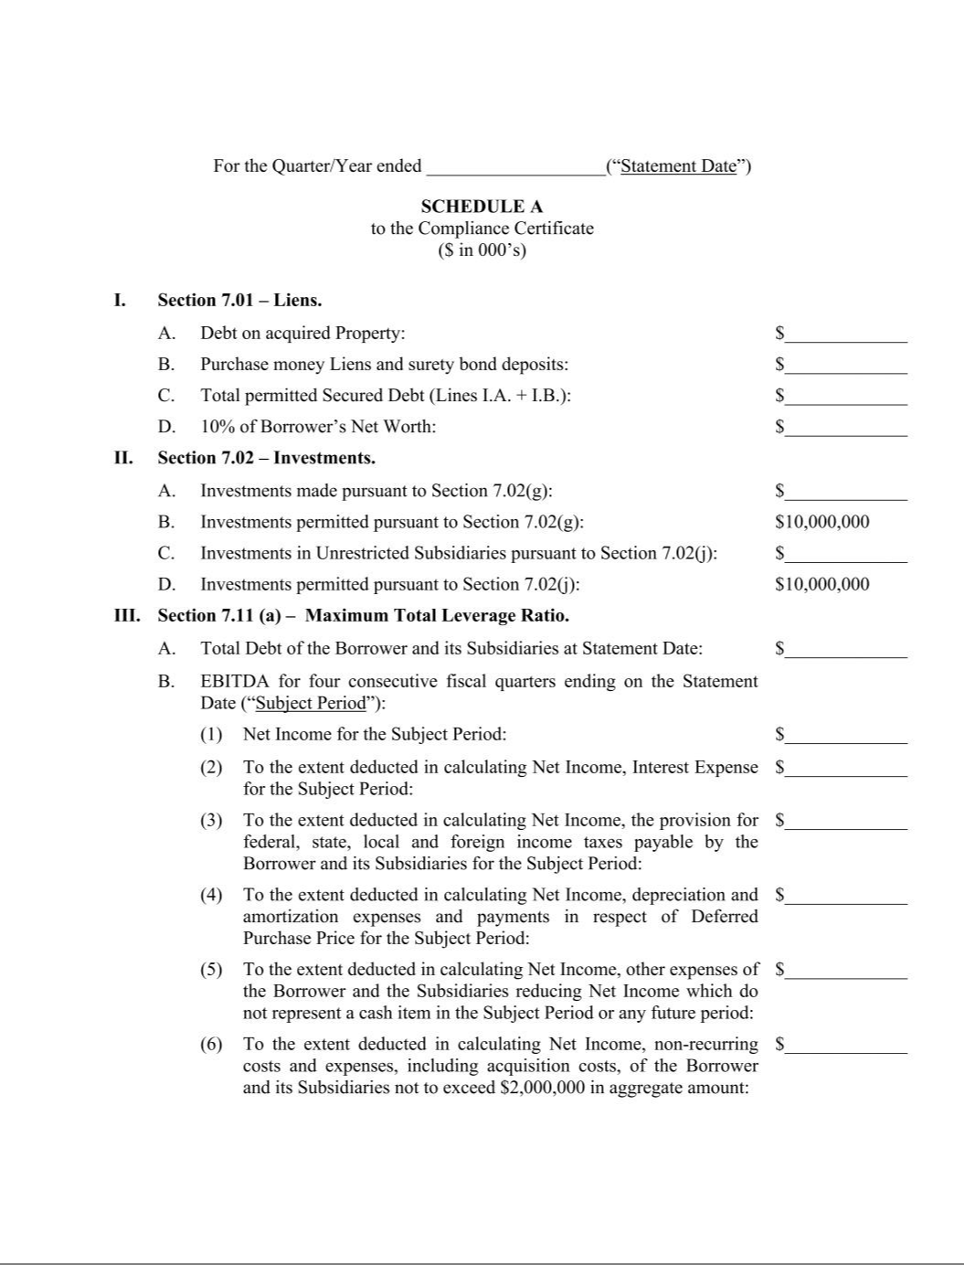

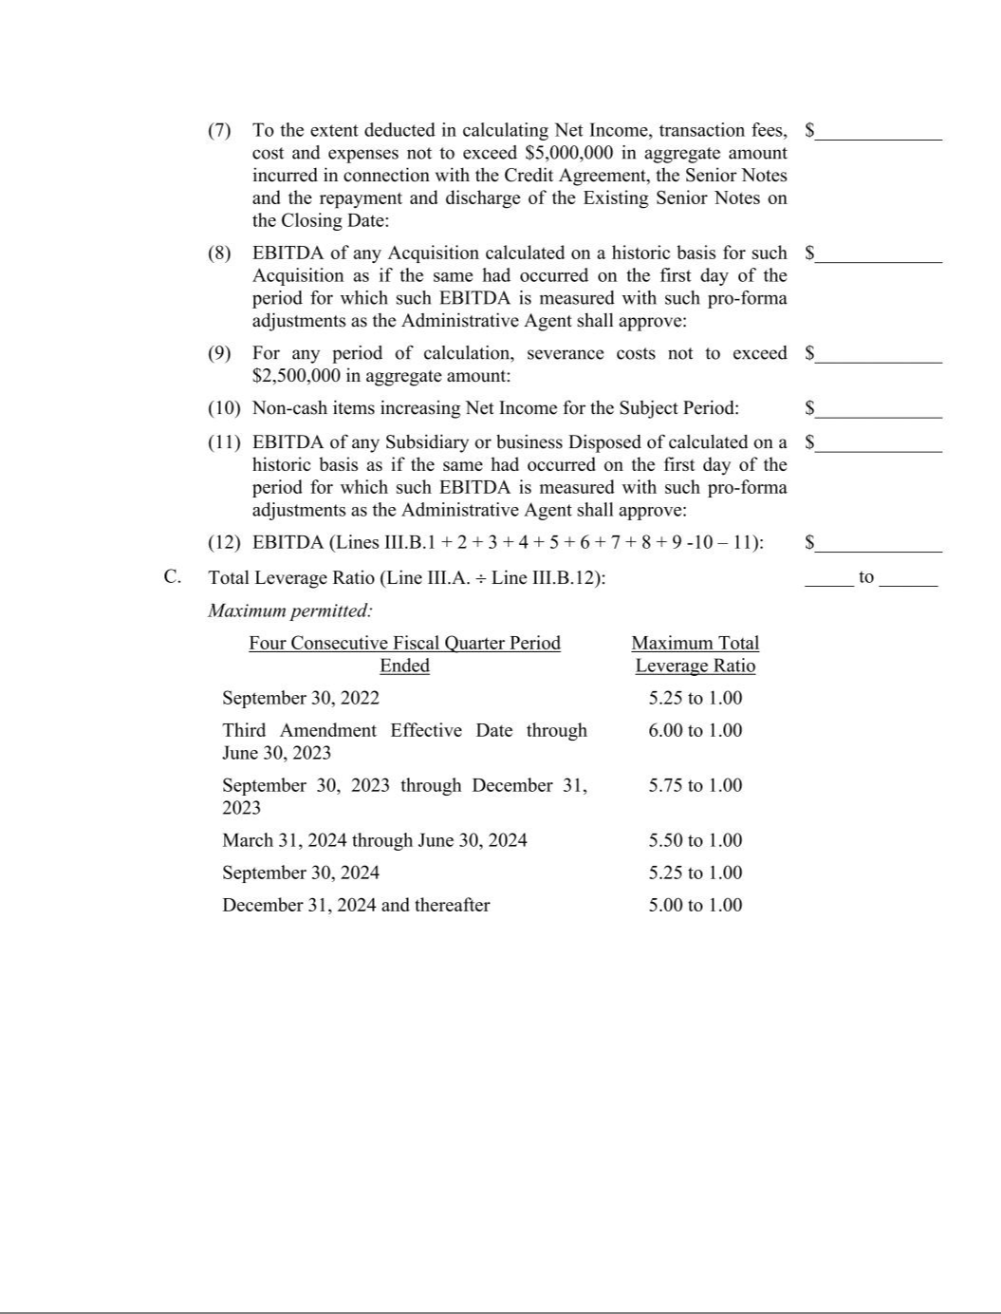


Carriage Services Announces High Performance and Credit Profile Restoration Plan

Conference call on Tuesday, December 13, 2022, at 9:30 a.m. Central Time

HOUSTON – Monday, December 12, 2022 – (GLOBE NEWSWIRE) Carriage Services, Inc. (NYSE: CSV) today made several important announcements. The Company will host a conference call on Tuesday, December 13, 2023 at 9:30 a.m. Central Standard Time to discuss this press release.

- Announcing High Performance and Credit Profile Restoration Plan (“HPCPRP”);

- Announcing Definitive Agreement to acquire Greenlawn Funeral Homes and Cemeteries in Bakersfield, CA (“Greenlawn”);

- Announcing 2024 Goals for Performance Metrics including Total Revenue of $390 million to $400 million, Consolidated EBITDA of $120 million to $126 million, GAAP Net Income of $46 million to $50 million, GAAP Diluted EPS of $2.95 to $3.05 per share, and a deleveraging goal of 4.0 times to 4.3 times Total Debt to Consolidated EBITDA by the end of 2024; and

- Announcing full support by our bank group of an Amendment to our $250 million Credit Facility tailored to execution of HPCPRP.

Mel Payne, Chairman and CEO, stated, “In our third quarter earnings release dated October 27, 2022, we didn’t provide our customary Rolling Four Quarter Outlook for the four quarters ending September 30, 2023, primarily because of a lack of deathrate trend data from which to reasonably predict normalized post-COVID funeral volumes and atneed cemetery revenues in our portfolio. Since our 2022 record first quarter, we had experienced a gradual year over year decline in deathrates (still materially elevated over pre-COVID levels) throughout the second and third quarter until September, when we experienced a sudden and dramatic year over year decline in same store funeral volumes and revenues (77.0% Same Store Volumes, 79.8% Same Store Revenue). Yet since September we have experienced a monthly material uptick in the comparative percentage of same store funeral volumes and revenue this year to the peak levels last year, as follows: October (84.3% Same Store Volumes, 90.2% Same Store Revenue) and an even greater increase in November (95.5% Same Store Volumes, 96.4% Same Store Revenue).

After a prolonged two plus years COVID Pandemic, year over year monthly deathrate comparisons to peak levels in 2021 can be very misleading as to sustainable longer-term trends in the future. Even more relevant and impressive data are the September to November 2022 Same Store Funeral Volumes and Revenue comparisons to 2019 pre-COVID levels, which are all materially higher as follows: September 2022/2019 (113.7% Same Store Volumes, 115.8% Same Store Revenue); October 2022/2019 (106.8% Same Store Volumes, 111.7% Same Store Revenue) and November 2022/2019 (113.8% Same Store Volumes, 117.0% Same Store Revenue).

Our fourth quarter 2022 performance is trending stronger than expected against a tough record comparable performance last year. Our guidance plan is to issue our customary Full Year Outlook for 2023 when we report full year 2022 performance results at the end of February 2023, when we should have a much clearer picture of a post-COVID normalized deathrate environment and its near-term impact on our performance, especially compared to our record first quarter 2022 performance.

Given no near-term guidance in our third quarter release combined with a weak comparative third quarter 2022 performance and an elevated leverage ratio of 5.14 times Total Debt to Consolidated EBITDA, investors seemed to believe bad news would follow by selling our shares in volume with the result that our share price plummeted to below $25 per share. Finding this external high-risk perception of our company inexcusable and

1

unacceptable, we went to work with Bank of America and our credit facility bank group on a comprehensive plan of both offensive and defensive actions.

I am pleased to announce on behalf of our Executive Team and Board of Directors that we have developed, organized and launched an operating and financial plan for 2023 and 2024 titled High Performance and Credit Profile Restoration Plan (HPCPRP).

HPCPRP Goals:

- Optimize performance in a normalizing COVID deathrate environment from existing portfolio of funeral homes and cemeteries (after three strategic acquisitions including Greenlawn, which is expected to close in early 2023) during 2023 and achieve 2024 performance metrics in the following ranges: Total Revenue of $390 to $400 million; Consolidated EBITDA of $120 million to $126 million; GAAP Net Income of $46 million to $50 million; GAAP Diluted EPS of $2.95 to $3.05 per share; and Free Cash Flow of $68 million to $73 million.

- Lead and manage Carriage to maximize Free Cash Flow for rapid paydown of our Credit Facility borrowings over 2023 and 2024, with a goal of reducing outstanding borrowings by a range of $90 million to $100 million from peak borrowings of about $205 to $215 million in the first quarter of 2023 (maximum 5.4 times Total Debt/EBITDA proforma three strategic acquisitions) to $110 million to $120 million by the end of 2024.

- Produce at least $10 million of internal cash from divesting low performing businesses or withdrawing cash from over-funded trust funds, cash sources that are included in the planned $90 million to $100 million reduction in bank borrowings.

- Achieve a Total Debt to Consolidated EBITDA Ratio of 4.0 - 4.3 times by the end of 2024.

Major Elements of HPCPRP:

- Amended Credit Facility with package of covenants tailored to HPCPRP, together with larger interest rate spreads during higher leverage ratio timeframes.

- Pursuant to the announced definitive purchase agreement, acquire Greenlawn subject to California regulatory approvals, estimated to be completed in January/early February 2023. Our three new strategic acquisitions include San Juan in Orlando and Heritage in Charlotte (both closed) and now prospectively Greenlawn in Bakersfield, California in January/February 2023. The proforma total 2023 Revenue for these three acquisitions is about $23 million to $24 million and proforma total EBITDA is about $8 million to $9 million. We believe all three have significant upside in 2024 compared to our underwriting performance after full integration into Carriage’s Operating Model Framework.

- No share repurchases, increase in dividends or cash acquisitions to December 31, 2024, if such allocation of capital would increase our Total Debt to Consolidated EBITDA Ratio to over 4.25 times, which takes us back to our stated normalized leverage ratio policy of about 4.0 times. Major internal use of capital will be to build high margin cemetery product inventory in our largest cemeteries to increase Cemetery Revenue and EBITDA.

- Grow funeral volumes through market share gains and revenue averages per unit of volume through price increases to offset cost inflation, and offer and deliver more service options to increase our contract revenue averages, especially on cremation contracts representing about 56% of our total funeral contracts.

- Grow cemetery revenue through substantial increases in preneed cemetery property sales and price increases to offset inflationary cost increases.

- Gradually increase Funeral and Cemetery Field EBITDA Margins in 2023/2024 from operating leverage of more revenue flowing over high local fixed costs, while tightly managing variable costs in each

2

business consistent with achieving Field EBITDA Margins within the High Performance Field EBITDA Margin ranges for each business under our Managing Partner Being The Best annual incentive program.

- Materially increase Financial Revenue and EBITDA by integrating about $13.3 million of preneed trust funds from Heritage and Greenlawn into our trust fund partnership pool, which will primarily be reflected in higher GAAP Financial Revenue and EBITDA (93% to 94% margin) from higher recurring annual income allocated primarily to Cemetery Perpetual Care Trust Funds.

- Reduce Overhead to approximately 13% of Total Revenue on an annualized basis by the end of 2024. This focus will be driven by a variety of areas, ranging from lower incentive compensation to a reduction in cost for performance recognition trips, general travel and other opportunities.

- Tightly manage maintenance capital expenditures across our portfolio of businesses and allocate growth capex only where we get an immediate high cash return on invested capital.

- Substantially reduced stock and option grants for our senior leadership ranks until we have restored our consolidated and per share performance metrics in 2023 and 2024 consistent with HPCPRP.

Big Picture Takeaways:

I have taken sole responsibility for too aggressively repurchasing our shares after our eight year $400 million 4.25% Senior Notes refinancing on May 13, 2021 (3.6 million shares for approximately $175 million equal to almost 20% of shares outstanding at $49.06 per share). Given our record performance throughout FYE 2021 and the first quarter of FYE 2022, combined with the historically low inflation and interest rate environment at the time, I believed we were repurchasing these shares at well below Carriage’s Intrinsic Value Per Share.

The “Big Picture Goal” of HPCPRP is to substantially increase our consolidated and per share performance metrics during 2023 and 2024 (20% less common shares) to levels approaching our record performance metrics in 2021, while simultaneously rapidly paying down our debt under our $250 million Credit Facility to substantially deleverage our balance sheet, much like we achieved from the beginning of 2020 at 6.0 times Debt to EBITDA proforma four large acquisitions to 3.8 times by March 31, 2021 just prior to our Senior Notes refinancing.

We believe the successful execution of HPCPRP through 2023 and 2024 will create Intrinsic Value Per Share that exceeds the $49.06 per share average price of the 3.6 million shares repurchased since May 13, 2021. Moreover, notwithstanding the external macroeconomic environment, we believe that the valuation multiples applied to our increasing consolidated and per share performance metrics during this period by equity investors (Mr. Market Price Per Share) will expand in direct correlation to the success of our balance sheet deleveraging program under HPCPRP.

Our industry and our Company have proven over many decades of self-inflicted crises (1999-2003 near death experience) and adverse external economic and market crises (2000/2001 internet bubble bursting followed by 9/11, the 2008/2009 Credit Crisis and Great Recession, and more recently the COVID-19 Pandemic and recession) that we can navigate difficult economic and market environments and emerge stronger than ever. Whatever happens next in the world and the U.S. economy, these external challenges and risks won’t change the fact that we have an outstanding Company in a resilient industry, and we will get past this overleverage bump in the road and thrive in the years ahead,” concluded Mr. Payne.

CONFERENCE CALL AND INVESTOR RELATIONS CONTACT

Carriage Services has scheduled a conference call for tomorrow, December 13, 2022 at 9:30 a.m. central time. To participate live over the phone via audio conferencing click link or live over the Internet via webcast click link. An audio archive of the call will be available on demand via the Company's website at www.carriageservices.com. For any investor relations questions, please email InvestorRelations@carriageservices.com.

3

NON-GAAP FINANCIAL MEASURES

This press release uses Non-GAAP financial measures to present the financial performance of the Company. Our Non-GAAP reporting provides a transparent framework of our operating and financial performance that reflects the earning power of the Company as an operating and consolidation platform.

Non-GAAP financial measures should be viewed in addition to, and not as an alternative for, the Company’s reported operating results or cash flow from operations or any other measure of performance as determined in accordance with GAAP. We believe the Non-GAAP results are useful to investors to compare our results to previous periods, to provide insight into the underlying long-term performance trends in our business and to provide the opportunity to differentiate ourselves as the best consolidation platform in the industry against the performance of other funeral and cemetery companies.

Reconciliations of the Non-GAAP financial measures to GAAP measures are also provided in this press release.

The Non-GAAP financial measures used in this press release and the definitions of them used by the Company for our internal management purposes in this press release are described below.

- Consolidated EBITDA is defined as net income before income taxes, interest expenses, non-cash stock compensation, depreciation and amortization, and interest income and other, net.

- Free Cash Flow is defined as net cash provided by operating activities less cash for maintenance capital expenditures.

- Total Debt Outstanding is defined as indebtedness under our bank credit facility, senior notes due 2029, acquisition debt and finance leases.

- Total Debt to Consolidated EBITDA is defined as Total Debt Outstanding to Consolidated EBITDA.

RECONCILIATION OF ESTIMATED RESULTS FOR THE YEAR ENDED DECEMBER 31, 2024

Earlier in this press release, we present goals for performance metrics which reflects management’s opinion on the performance of the portfolio of existing businesses, including performance of existing trusts, and excludes size and timing of acquisitions unless we have a signed Letter of Intent with a high likelihood of a closing within 90 days. These are not intended to be management estimates or forecasts of our future performance, as we believe precise estimates will be precisely wrong all the time. The following reconciliations are presented within the ranges of our performance metric goals.

Reconciliation of Net Income to Consolidated EBITDA (in thousands):
 |  |  | 2024E
Net Income |  | $ | 48,000
Total Tax Expense |  |  | 19,100
Pretax Income |  | $ | 67,100
Net Interest Expense |  |  | 27,900
Depreciation & Amortization, Non-Cash Stock Compensation and Other, Net |  |  | 29,000
Consolidated EBITDA |  | $ | 124,000
Reconciliation of Cash Flow Provided by Operating Activities to Free Cash Flow (in thousands):
 |  |  | 2024E
Cash Flow Provided by Operating Activities | $ |  | 80,000
Cash used for Maintenance Capital Expenditures |  |  | (9,000)
Free Cash Flow | $ |  | 71,000

4

CAUTIONARY STATEMENT ON FORWARD-LOOKING STATEMENTS

Certain statements made herein or elsewhere by, or on behalf of, the Company that are not historical facts are intended to be forward-looking statements within the meaning of Section 27A of the Securities Act of 1933, as amended, and Section 21E of the Securities Exchange Act of 1934, as amended. In addition to historical information, this Press Release contains certain statements and information that may constitute forward-looking statements within the safe harbor provisions of the Private Securities Litigation Reform Act of 1995. All statements, other than statements of historical information, should be deemed to be forward-looking statements. These statements include, but are not limited to, statements regarding any projections of earnings, revenue, cash flow, investment returns, capital allocation, debt levels, equity performance, death rates, market share growth, overhead, including talent recruitment, field and corporate incentive compensation, or other financial items; any statements of the plans, strategies and objectives of management for future operations or financing activities, including, but not limited, to capital allocation, the ability to obtain credit or financing, organizational performance, anticipated integration, performance and other benefits of recently completed and anticipated acquisitions, and cost and debt reductions; any statements of the plans, timing and objectives of management for acquisition activities; any statements regarding future economic conditions or performance; any statements of belief; and any statements of assumptions underlying any of the foregoing and are based on our current expectations and beliefs concerning future developments and their potential effect on us. The words “may”, “will”, “estimate”, “intend”, “believe”, “expect”, “seek”, “project”, “forecast”, “foresee”, “should”, “would”, “could”, “plan”, “anticipate” and other similar words or expressions are intended to identify forward-looking statements, which are generally not historical in nature. While management believes that these forward-looking statements are reasonable as and when made, there can be no assurance that future developments affecting us will be those that we anticipate. All comments concerning our expectations for future revenue and operating results are based on our forecasts for our existing operations and do not include the potential impact of any future acquisitions, except where specifically noted. Our forward-looking statements involve significant risks and uncertainties (some of which are beyond our control) and assumptions that could cause actual results to differ materially from our historical experience and our present expectations or projections. Important factors that could cause actual results to differ materially from those in the forward-looking statements include, but are not limited to, those summarized below:

- our ability to find and retain skilled personnel;

- the effects of our talent recruitment efforts, incentive and compensation plans and programs, including such effects on our Standards Operating Model and the Company’s operational and financial performance;
- our ability to execute our growth strategy;

- our ability to execute and meet the objectives of our High Performance and Credit Profile Restoration Plan, if at all;

- the execution of our Standards Operating, 4E Leadership and Standard Acquisition Models;

- the effects of competition;

- changes in the number of deaths in our markets;

- changes in consumer preferences and our ability to adapt to or meet those changes;

- our ability to generate preneed sales, including implementing our cemetery portfolio sales strategy, product development and optimization plans;

- the investment performance of our funeral and cemetery trust funds;

- fluctuations in interest rates;

- the effects of inflation on our business and financial condition and performance, including increased overall costs for our goods and services, the impact on customer preferences as a result of changes in discretionary income, and our ability, if at all, to mitigate such effects;
- our ability to obtain debt or equity financing on satisfactory terms to fund additional acquisitions, expansion projects, working capital requirements and the repayment or refinancing of indebtedness;

5

- our ability to meet the timing, objectives and expectations related to our capital allocation framework, including our forecasted rates of return, planned uses of free cash flow and future capital allocation, including share repurchases, potential strategic acquisitions, internal growth projects, dividend increases, or debt repayment plans;

- our ability to meet the projected financial and equity performance metrics to our updated rolling four quarter outlook, if at all;

- the timely and full payment of death benefits related to preneed funeral contracts funded through life insurance contracts;

- the financial condition of third-party insurance companies that fund our preneed funeral contracts;

- increased or unanticipated costs, such as insurance or taxes;

- our level of indebtedness and the cash required to service our indebtedness;

- changes in federal income tax laws and regulations and the implementation and interpretation of these laws and regulations by the Internal Revenue Service;

- effects of the application of other applicable laws and regulations, including changes in such regulations or the interpretation thereof;

- the potential impact of epidemics and pandemics, including the COVID-19 coronavirus, including new variants of COVID-19, such as the Delta and Omicron variants, on customer preferences and on our business;
- government, social, business and other actions that have been and will be taken in response to pandemics, including potential responses to new variants of COVID-19, such as the Delta and Omicron variants;
- effects and expense of litigation;

- consolidation of the funeral and cemetery industry;

- our ability to identify and consummate strategic acquisitions, if at all, and successfully integrate acquired businesses with our existing businesses, including expected performance and financial improvements related thereto;
- economic, financial and stock market fluctuations,

- interruptions or security lapses of our information technology, including any cybersecurity or ransomware incidents,

- our failure to maintain effective control over financial reporting; and

- other factors and uncertainties inherent in the funeral and cemetery industry.

For additional information regarding known material factors that could cause our actual results to differ from our projected results, please see “Risk Factors” in our Annual Report on Form 10-K for the year ended December 31, 2021, our Quarterly Reports on Form 10-Q, and other public filings and press releases, available at www.carriageservices.com.

Investors are cautioned not to place undue reliance on forward-looking statements, which speak only as of the date hereof. We undertake no obligation to publicly update or revise any forward-looking statements after the date they are made, whether as a result of new information, future events or otherwise.

6

